D365FO License Log Utility v2 – Improved Data Modification Logging
Recently, I released the D365FO License Usage Log Utility, a tool designed to compare assigned user licenses with their actual system usage.
After sharing it, I received valuable feedback from professionals working in licensing consulting:
- André Arnaud de Calavon highlighted the importance of correctly identifying modified tables to determine whether a Read or Write license is required.
- Nikolaj Sørensen raised the same concern and suggested a practical approach to address it.
Then this proposal was fed into GitHub Copilot, which generated an initial implementation. (You can review the Copilot pull request to check the current status of AI for X++. In summary, Copilot created a good form UI, but didn’t fully understand the SQL logic or produce a correct implementation, so that part still required manual work).
Problem Definition
When analysing user activity, we can identify which forms a user has used. However, many forms require different license levels depending on the type of access: Read or Write.
The key question is:
👉 Does the user actually modify data on those forms?
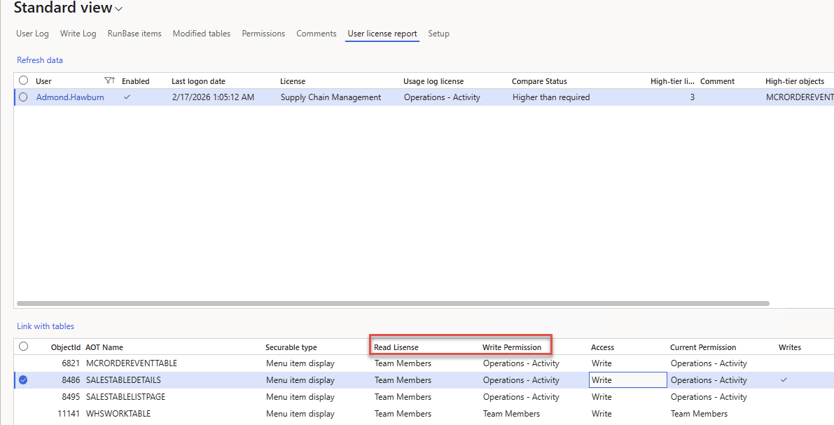
In version 1 of the License Log Utility, the system attempted to detect modifications by:
- Checking CreatedBy / ModifiedBy table fields on tables from this form
- Using the SysDatabaseLog table
While this approach works in many cases, it may be not accurate in all cases.
Proposed Solution in v2
Version 2 introduces a more reliable approach with a new parameter “Write operations log”
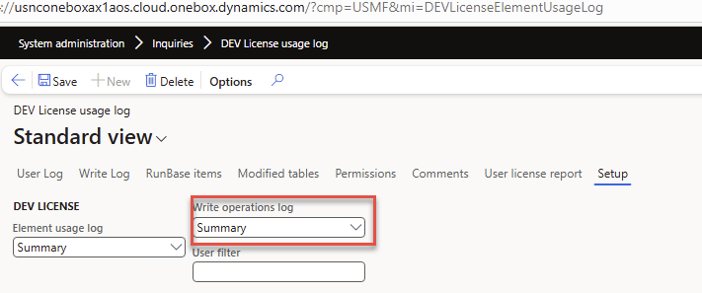
When enabled, the system dynamically tracks user modifications using event handlers on form data sources:
- Event handlers are attached to form Insert, Update, and Delete events
- A log entry is created whenever a modification occurs
- Only one record per user session per table is logged
- Logging can be enabled for specific users only
For example If a user modifies data on a Sales Order form, the system logs the corresponding table interactions:
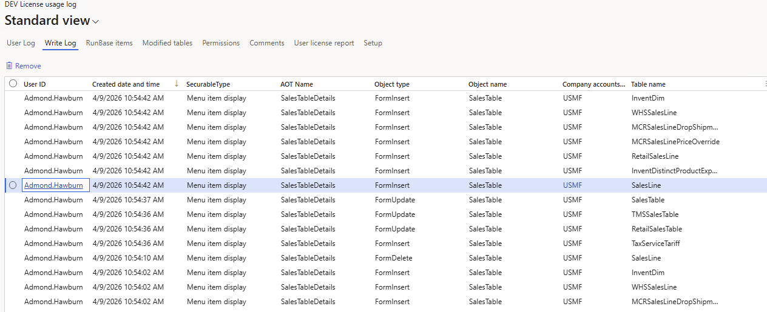
When generating the license report, you can configure it to:
- Use only the Write log. This will ignores SysDatabaseLog and table Modified/Created fields tracking
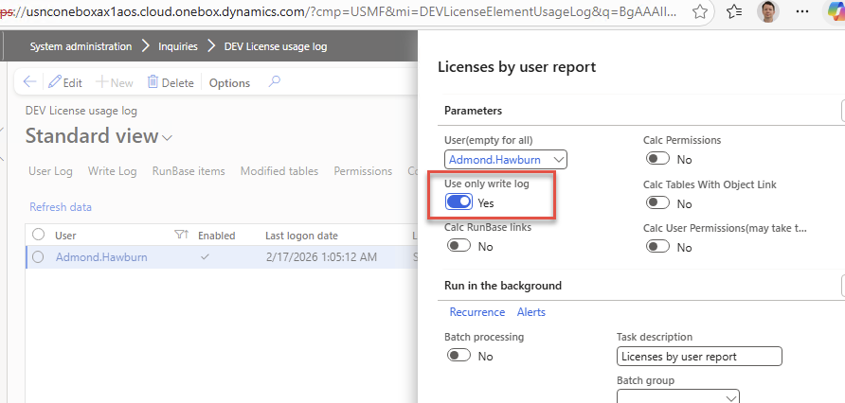
This change directly improves the accuracy of license evaluation:
- If the Write log field is populated → the user is confirmed to perform write operations
- Therefore → a Write license is assigned correctly
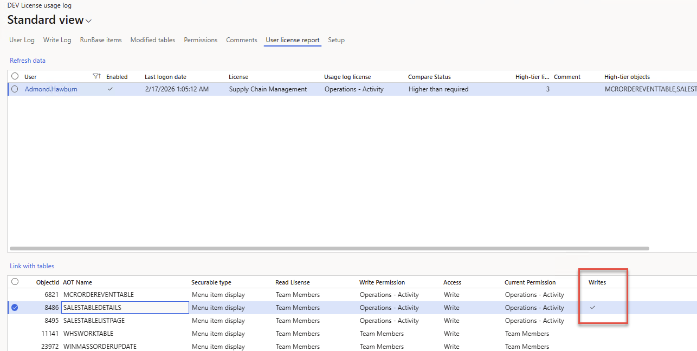
This removes ambiguity and provides a much more defensible licensing position.
Summary
Version 2 of the D365FO License Log Utility was heavily influenced by community feedback — which is fantastic to see. The new data logging approach improves accuracy of license analysis.
The tool is available on GitHub.
Feel free to try it out, ask questions, or suggest improvements.

