From the first release of Visual Studio for X++ development one of the top ideas was to improve – Add a Read/Write modifier in a Cross-Reference form
https://experience.dynamics.com/ideas/idea/?ideaid=acff0162-ef3e-e711-80c0-00155d7cb38d
I don’t know why Microsoft has been ignoring this for so long. In the latest release 10.0.47 they introduced a new cross-reference form(with Model and Type grouping), but do not address the main issue: Read-Write reference for table fields
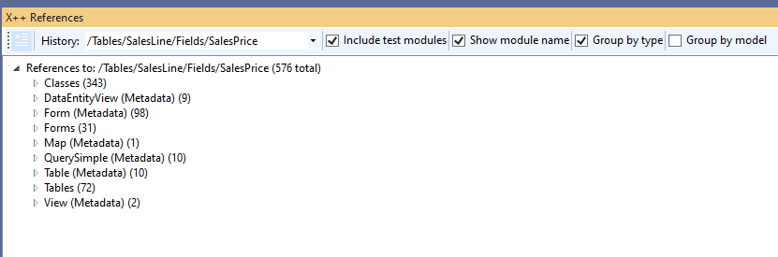
This is quite a typical task in X++ development: you have a Table field and want to know the code that updates this field.
Recently, I connected Claude Code to the TRUDUtilsD365 DevTools project, and it was able to figure out this task(the main complexity was to teach Claude how to work with standard DLLs)
So a new release of TRUDUtilsD365 DevTools includes a Show cross-reference that display Read-Write field the modified

The idea is simple: find a code that is related to a cross-reference, extract the code line from it and then analyse this line – whether it is Read or Write. Currently, it is just a search of “=” symbol, if the position of this symbol is right, this is Write; all others are Read
I tested it on couple of popular fields like SalesLine.SalesPrice and it works perfectly
Also the tool displays the actual code line(one of several), so you can visually confirm the code
View for 1 line

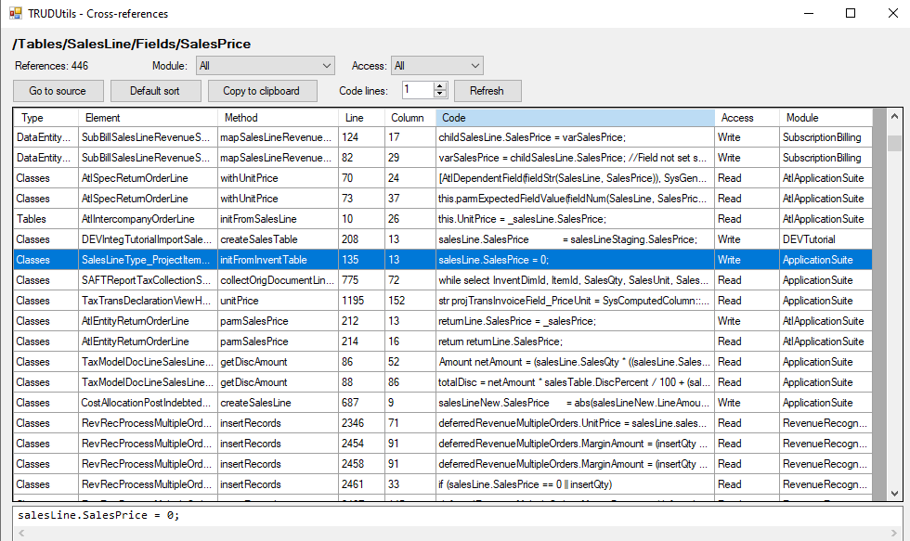
View for 3 lines
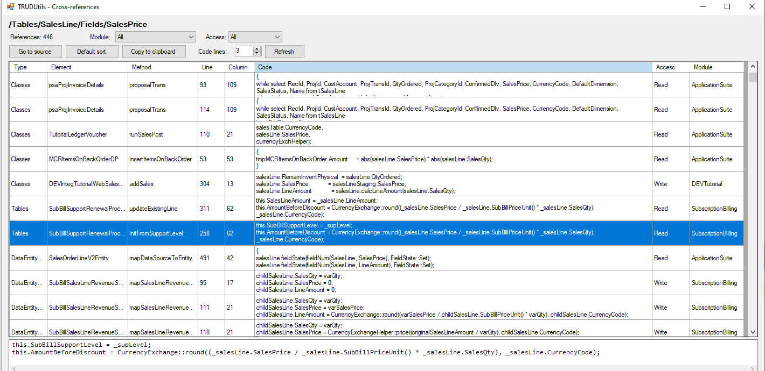

The tool is Open-Source and 100% AI written, so if you miss something, it can be simply added by asking Claude
I hope you find this tool useful. Install it from here https://github.com/TrudAX/TRUDUtilsD365/tree/master?tab=readme-ov-file#installation
Feel free to ask questions

