Bring the Power of AI into D365FO with Native X++

Recently, Adrià Ariste Santacreu (<https://www.linkedin.com/in/aariste/>) published a series of excellent articles on how to connect and extend Copilot Studio integration <https://ariste.info/2025/08/copilot-studio-extend-d365-fo-copilot> . The current issue is that it may not be applicable to most FinOps projects due to complex setup and licensing requirements.

Can we utilise AI with the native X++? And the answer is yes, with two open-source solutions, it is possible.

You need to install the following packages:

* MXT - X++ Interpreter (<https://github.com/milnet92/MXTXppInterpreter>)
* External Integration <https://github.com/TrudAX/XppTools?tab=readme-ov-file#devexternalintegration-submodel>

And then setup a connection string for the API key (<https://denistrunin.com/integration-importpurchpdf/#connection-type> )

And then the power of AI will be in your hands 😊

Let’s define some task, for example, we want to create a personalized greeting for our customers with the upcoming new year, based on our sales to them.

Let’s create a new script for this in MXT - X++ Interpreter

CustTable custTable;

SalesLine salesLine;

Dialog d = new Dialog("Generate AI test");

DialogField dfPrompt = d.addFieldValue(extendedTypeStr(Notes), "Based on the last sold products to this customer(do not use exact names), generate an e-mail text for a 2026 New year greeting message for this customer.", "Prompt");

DialogField dfCustomer = d.addField(extendedTypeStr(CustAccount));

if (d.run())

{

CustAccount custAccount = dfCustomer.value();

custTable = CustTable::find(custAccount);

str promptFull, items;

int num;

container usedItems;

while select salesLine

order by CreatedDateTime desc

where salesLine.CustAccount == custAccount

{

if (! confind(usedItems, salesLine.ItemId))

{

items += salesLine.itemName() + '; ';

num++;

if (num > 5) break;

}

}

promptFull = strFmt("%1. Customer name: %2, Last sold items: %3, Our company name: %4", dfPrompt.value(), custTable.name(), items, CompanyInfo::find().Name );

DEVIntegAIProviderBase aiProvider = DEVIntegAIProviderBase::construct(DEVIntegAIProvider::find("GeminiFlash"));

aiProvider.parmPromptText(promptFull);

aiProvider.parmResponseFormat(DEVIntegAIPromptResponseFormat::Text);

str res = aiProvider.callAPIText();

info(strFmt("RESULT(Customer:%1, Company:%2): %3", custTable.AccountNum, curext(), res));

}

That asks for the customer, and then checks last items they bought and generates a greeting message. The script is quite simple and can be easily modified to your needs

On execution it displays a dialog, asking for a customer and then display results in Infolog

Some tests for the standard Demo data for USMF and USRT companies. looks quite good at first sight, customers should be happy to get such personalized greeting about their sports equipment and audio cables and maybe they buy more in a new year 😊:

*RESULT(Customer:DE-001, Company:usmf): Subject: Happy New Year, Contoso Europe! Here's to an Amazing 2026! Dear Contoso Europe, As 2025 draws to a close, the team at Contoso Entertainment System USA wants to extend our warmest wishes for a spectacular New Year! We hope you had a wonderful holiday season. We've truly valued our partnership this past year, and we're excited about what 2026 holds. We remember how much you appreciated the clarity and depth our audio solutions brought to your setups, from the powerful sound of our premium speakers to the balanced tones of our versatile mid-range options. And of course, ensuring everything was perfectly connected with our reliable cables and optimized for the best acoustics with our specialized panels was key. As you look ahead to new projects and experiences in 2026, we're here to help you continue to achieve exceptional results. Whether you're aiming to elevate your soundscapes even further or seeking innovative ways to enhance your environments, we're constantly developing new technologies to meet your evolving needs. Thank you for being a valued part of the Contoso Entertainment System USA family. We wish you and your team a prosperous, joyful, and incredibly successful 2026! Warmest regards, The Team at Contoso Entertainment System USA*

*RESULT(Customer:1001, Company:usrt): Subject: Happy New Year, Basketball Stadium! Here's to a Winning 2026! Dear Basketball Stadium, As the final buzzer sounds on 2025, the team at Contoso Retail USA wants to extend our warmest wishes for a spectacular New Year! We hope 2026 brings you even more success, excitement, and unforgettable moments. We've truly enjoyed being a part of your journey this past year, helping you gear up for both on and off-court endeavors. From your recent selections of stylish formal wear and high-performance inline skates to your practical and spacious team bags and fashionable headwear, we're always thrilled to see you equipped for whatever comes next. May the coming year be filled with energy, achievement, and all the best for your team and your patrons. We look forward to continuing to support your needs in 2026 and beyond. Happy New Year! Sincerely, The Contoso Retail USA Team*

One note about security, in this example, it may be some consent that data leaves the Microsoft perimeter(to Google in this case), but the situation will be similar with the latest Copilot Studio release, where Microsoft introduced the Anthropic model, you need to trust these model providers.

<https://www.linkedin.com/posts/matthew-devaney_copilotstudio-activity-7377047479705518080-0NXh?utm_source=social_share_send&utm_medium=member_desktop_web&rcm=ACoAAAK6DbsBuX38GeUUpjcHvecQ3v_WXi-CQHw>

The code may run in any environment type, the idea that you can prototype and test different options and then include this in the main codebase

So, what do you think of such approach? The main complexity is the find tasks where it will produce a valuable result

Questions and suggestions always welcome

I explore how to integrate AI directly into Dynamics 365 Finance & Operations with X++ using open-source tools like MXT X++ Interpreter and External Integration. Check it out, and feel free to share your thoughts

**Bring the Power of AI into D365FO with Native X++**

**[Denis Trunin](https://www.linkedin.com/in/denis-trunin-3b73a213/)**

Dynamics AX / Dynamics 365 FO Technical Consultant

September 27, 2025

Recently, [Adrià Ariste Santacreu](https://www.linkedin.com/in/aariste/) published an excellent [series of articles](https://ariste.info/2025/08/copilot-studio-extend-d365-fo-copilot) on how to connect and extend Copilot Studio integration with D365FO. The challenge is that this approach may not be applicable to most Finance & Operations projects due to complex setup and licensing requirements.

So, can we leverage AI with **native X++** instead? The answer is **YES**— with two open-source solutions, it’s entirely possible.

**Required Packages**

You’ll need to install the following packages:

* MXT - X++ Interpreter([GitHub link](https://github.com/milnet92/MXTXppInterpreter))
* External Integration ([GitHub link](https://github.com/TrudAX/XppTools?tab=readme-ov-file#devexternalintegration-submodel))

Then, configure a connection string for the API key (see [example](https://denistrunin.com/integration-importpurchpdf/#connection-type))

Once set up, the power of AI will be in your hands. 😊

**Example Task: Personalized Greetings**

Let’s walk through a practical example: generating personalised **New Year greetings** for customers based on their recent purchases.

Using **MXT - X++ Interpreter**, we can create the following script:

CustTable custTable;

SalesLine salesLine;

Dialog d = new Dialog("Generate AI test");

DialogField dfPrompt = d.addFieldValue(extendedTypeStr(Notes), "Based on the last sold products to this customer(do not use exact names), generate an e-mail text for a 2026 New year greeting message for this customer.", "Prompt");

DialogField dfCustomer = d.addField(extendedTypeStr(CustAccount));

if (d.run())

{

CustAccount custAccount = dfCustomer.value();

custTable = CustTable::find(custAccount);

str promptFull, items;

int num;

container usedItems;

while select salesLine

order by CreatedDateTime desc

where salesLine.CustAccount == custAccount

{

if (! confind(usedItems, salesLine.ItemId))

{

items += salesLine.itemName() + '; ';

num++;

if (num > 5) break;

}

}

promptFull = strFmt("%1. Customer name: %2, Last sold items: %3, Our company name: %4", dfPrompt.value(), custTable.name(), items, CompanyInfo::find().Name );

DEVIntegAIProviderBase aiProvider = DEVIntegAIProviderBase::construct(DEVIntegAIProvider::find("GeminiFlash"));

aiProvider.parmPromptText(promptFull);

aiProvider.parmResponseFormat(DEVIntegAIPromptResponseFormat::Text);

str res = aiProvider.callAPIText();

info(strFmt("RESULT(Customer:%1, Company:%2): %3", custTable.AccountNum, curext(), res));

}

This script:

* Prompts for a customer.
* Looks up their last purchased items.
* Sends a custom AI prompt to generate a New Year greeting message.

On execution, it displays a dialog, asks for a customer, and then shows the AI-generated result in the Infolog.

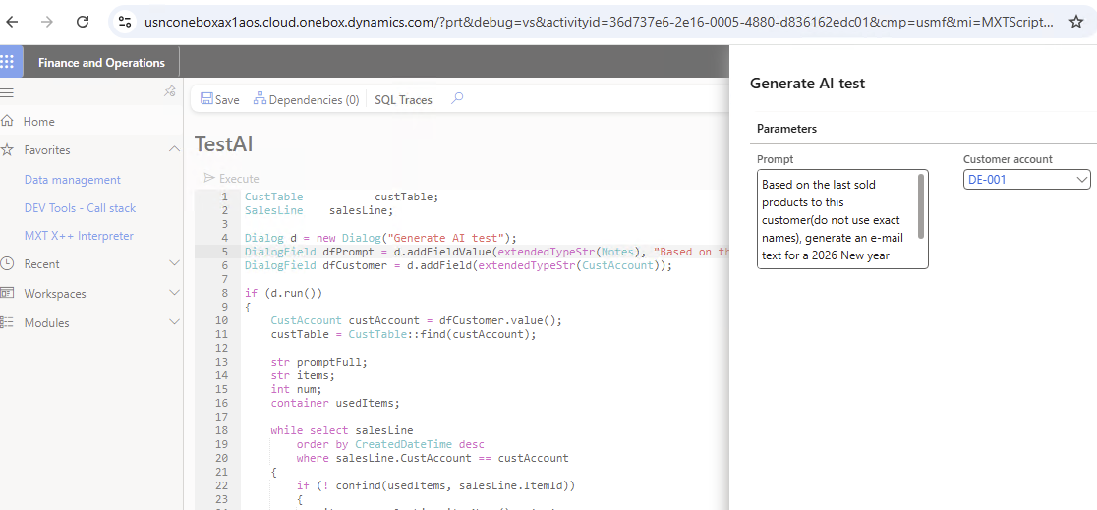

**Sample Results**

Here are some tests with standard demo data for **USMF** and **USRT** companies. At first glance, the messages look promising — customers would likely enjoy receiving such personalized greetings about their sports equipment or audio cables, potentially encouraging new purchases in the new year. 😊

***RESULT(Customer:DE-001, Company:usmf):*** *Subject: Happy New Year, Contoso Europe! Here's to an Amazing 2026! Dear Contoso Europe, As 2025 draws to a close, the team at Contoso Entertainment System USA wants to extend our warmest wishes for a spectacular New Year! We hope you had a wonderful holiday season. We've truly valued our partnership this past year, and we're excited about what 2026 holds. We remember how much you appreciated the clarity and depth our audio solutions brought to your setups, from the powerful sound of our premium speakers to the balanced tones of our versatile mid-range options. And of course, ensuring everything was perfectly connected with our reliable cables and optimized for the best acoustics with our specialized panels was key. As you look ahead to new projects and experiences in 2026, we're here to help you continue to achieve exceptional results. Whether you're aiming to elevate your soundscapes even further or seeking innovative ways to enhance your environments, we're constantly developing new technologies to meet your evolving needs. Thank you for being a valued part of the Contoso Entertainment System USA family. We wish you and your team a prosperous, joyful, and incredibly successful 2026! Warmest regards, The Team at Contoso Entertainment System USA*

***RESULT(Customer:1001, Company:usrt):*** *Subject: Happy New Year, Basketball Stadium! Here's to a Winning 2026! Dear Basketball Stadium, As the final buzzer sounds on 2025, the team at Contoso Retail USA wants to extend our warmest wishes for a spectacular New Year! We hope 2026 brings you even more success, excitement, and unforgettable moments. We've truly enjoyed being a part of your journey this past year, helping you gear up for both on and off-court endeavors. From your recent selections of stylish formal wear and high-performance inline skates to your practical and spacious team bags and fashionable headwear, we're always thrilled to see you equipped for whatever comes next. May the coming year be filled with energy, achievement, and all the best for your team and your patrons. We look forward to continuing to support your needs in 2026 and beyond. Happy New Year! Sincerely, The Contoso Retail USA Team*

**A Note on Security:** In this example, customer data may leave the Microsoft perimeter (to Google, in this case). The same applies with the latest Copilot Studio release, where Microsoft introduced the Anthropic model — meaning you must trust the model providers. See [Matthew Devaney’s post](https://www.linkedin.com/posts/matthew-devaney_copilotstudio-activity-7377047479705518080-0NXh?utm_source=social_share_send&utm_medium=member_desktop_web&rcm=ACoAAAK6DbsBuX38GeUUpjcHvecQ3v_WXi-CQHw)

**Conclusion**

This approach works in any environment, allowing for the quick **prototyping and testing of AI features** before integrating them into your main codebase.

What do you think about this approach? The biggest challenge now lies in identifying the right tasks where AI adds real value.

As always — questions, feedback, and suggestions are welcome!