**Initial setup**

Create a SFTP server

<https://docs.microsoft.com/en-us/azure/storage/blobs/secure-file-transfer-protocol-support>

I used the following credentials

**Server name:** denissftp.blob.core.windows.net

**User name:** denissftp.salestestbt

**Password:** aCiVY2JZ1LYPHQg5b7xkjIvXKD9e5faWWSYMw8tWn59TvqZ9XNm4cl6etTzitEot1sN4cCmipA2brXN84nuxig==

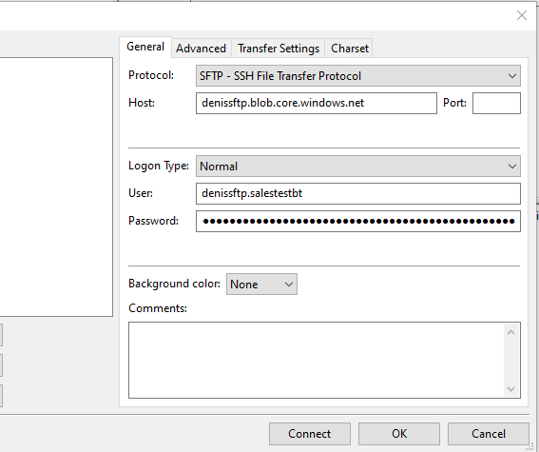

## Create a new connection type

[Connections -- Finance and Operations (dynamics.com)](https://tile-dev56565110c584ee72adevaos.axcloud.dynamics.com/?cmp=twhe&mi=DEVIntegConnectionType)

External integration – Connection types

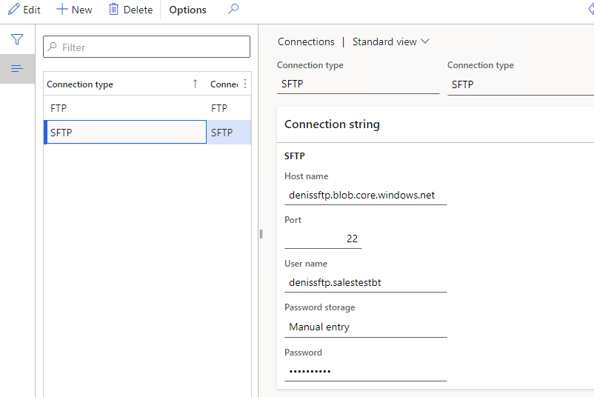

## Create new Outbound message type

External integration – Outbound Connection types

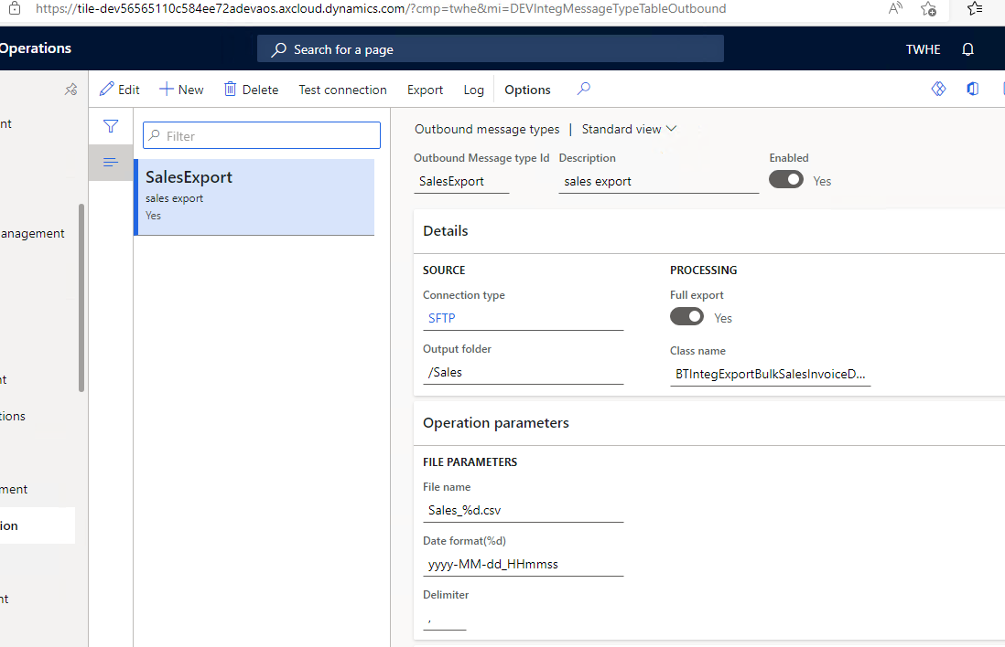

To run the export press Export button

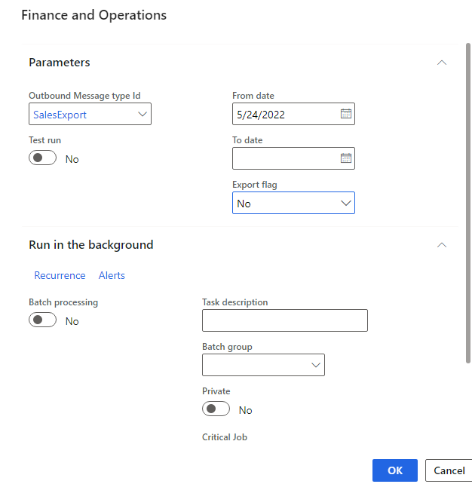

The file should be created in SFTP directory

To test without SFTP, set a tick **Test run,** in this case the file will be downloaded to the user