**15-3_SQL_Trushkova_Managing_views**

Asks for the N largest or smallest values in a column**-TOP-N Analysis**

Removes a view**-DROP VIEW**

Subquery with an alias that can be used within a SQL statement**-INLINE VIEW**

**Try it/Solve it**

1. Create a view from the copy_d_songs table called view_copy_d_songs that includes only the title and artist. Execute a SELECT * statement to verify that the view exists.

1. Issue a DROP view_copy_d_songs. Execute a SELECT * statement to verify that the view has been deleted.

1. Create a query that selects the last name and salary from the Oracle database. Rank the salaries from highest to lowest for the top three employees.

1. Construct an inline view from the Oracle database that lists the last name, salary, department ID, and maximum salary for each department. Hint: One query will need to calculate maximum salary by department ID.

1. Create a query that will return the staff members of Global Fast Foods ranked by salary from lowest to highest.

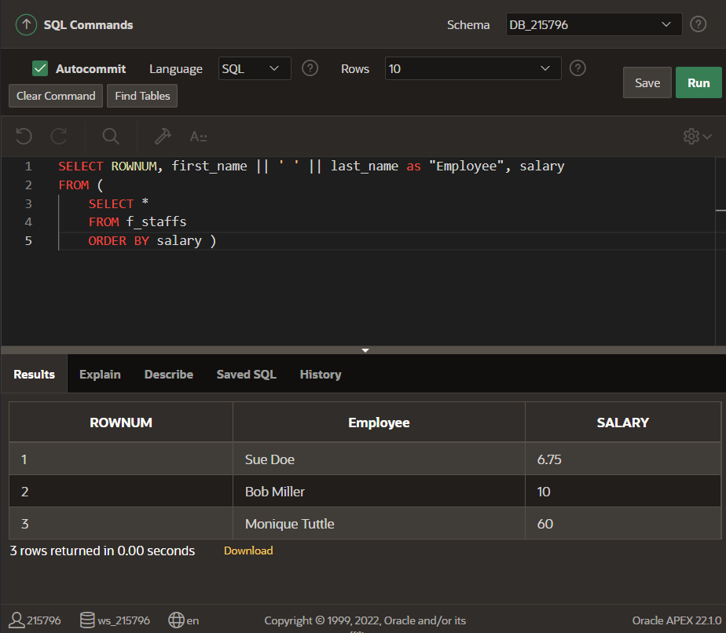

Extras:

1. Create a new table called my_departments and add all columns and all rows to it using a subquery from the Oracle departments table. Do a SELECT * from my_departments to confirm that you have all the columns and rows.

1. To view any constraints that may affect the my_departments table, DESCRIBE my_departments to check if any constraints were carried over from the departments table. If there are constraints on my_departments, use an ALTER TABLE command to DISABLE all constraints on my_departments.

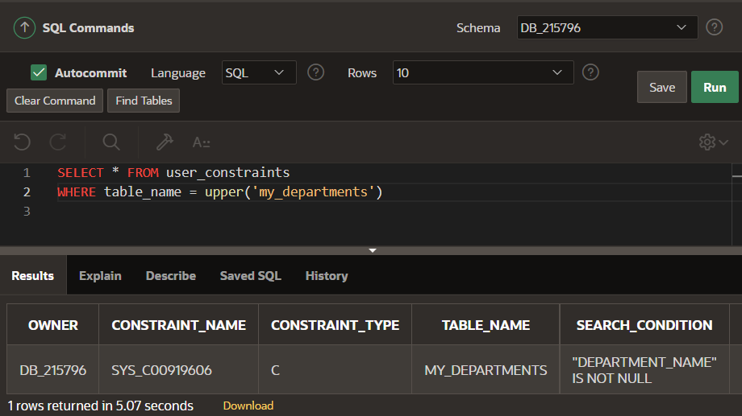

1. Create a view called view_my_departments that includes: department_id and department_name.

1. Add the following data to the my_departments table using view_my_departments.

|  |  |
| --- | --- |
| department_id | department_name |
| 105 | Advertising |
| 120 | Custodial |
| 130 | Planning |

1. Create or enable the department_id column as the primary key.

1. Enter a new department named Human Resources into the my_departments table using view_my_departments. Do not add a new department ID.

1. Add the Human Resources department, department ID 220, to my_departments using view_my_departments.
2. Verify that the new additions to my_departments were added using view_my_departments.

1. Modify view_my_departments to include location ID. Do a SELECT * command to show what columns are present and a DESCRIBE command to view the columns and associated constraints.

1. Make location_id a NOT NULL column in the my_departments table.

1. Using the Oracle database, create a complex view between locations and departments with only the following columns: department_name, street_address, city, and state. Include only U.S. cities. Verify that the view was created using a SELECT * statement.

