 "Cloud Computing" course

Department of CSIE,

National University of Tainan

Document of Final Project of AWS

|  |  |  |
| --- | --- | --- |
| Class | ： | 資工三 |
| Name | ： | 卓楚庭 |
| Student ID | ： | S11159020 |

114 / 06 / 09

1. First Page: your landing page (including your Name and Student ID)

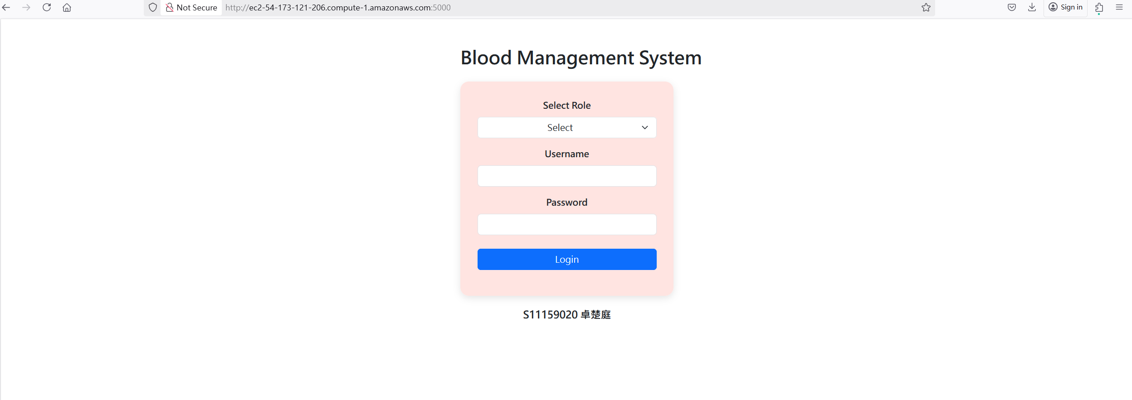

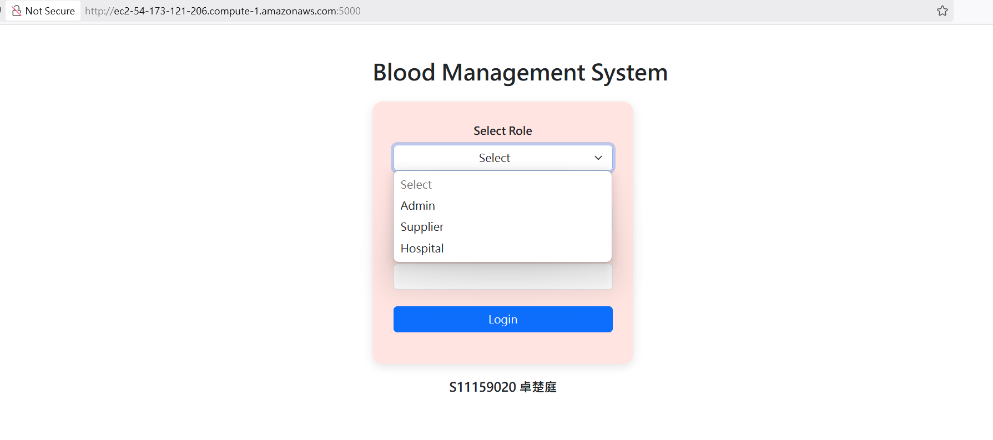

1. Page 2. The table in your database or the folder in your S3 buckets

Database :

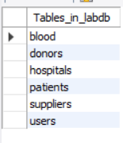

* blood :

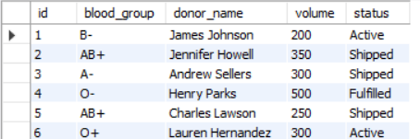

* donors :

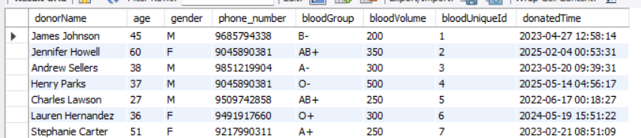

* hospitals :

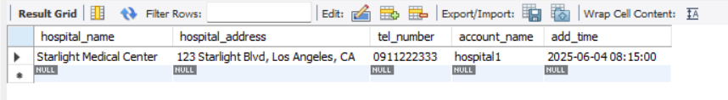

* patients :

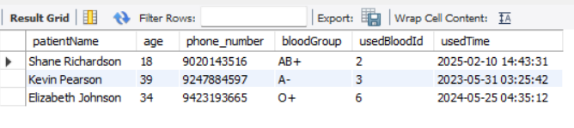

* suppliers :

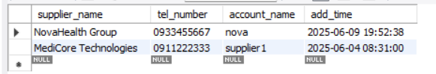

* users :

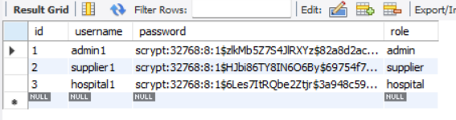

S3 :

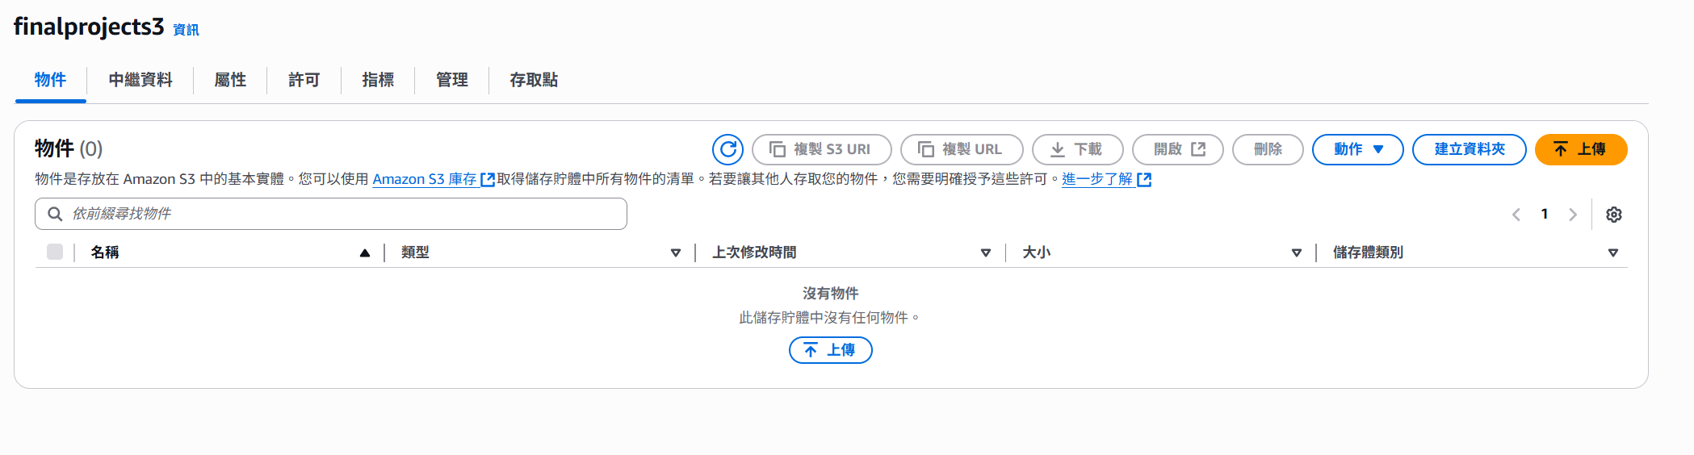

1. The web page of your DB connection/file operations (choose one)

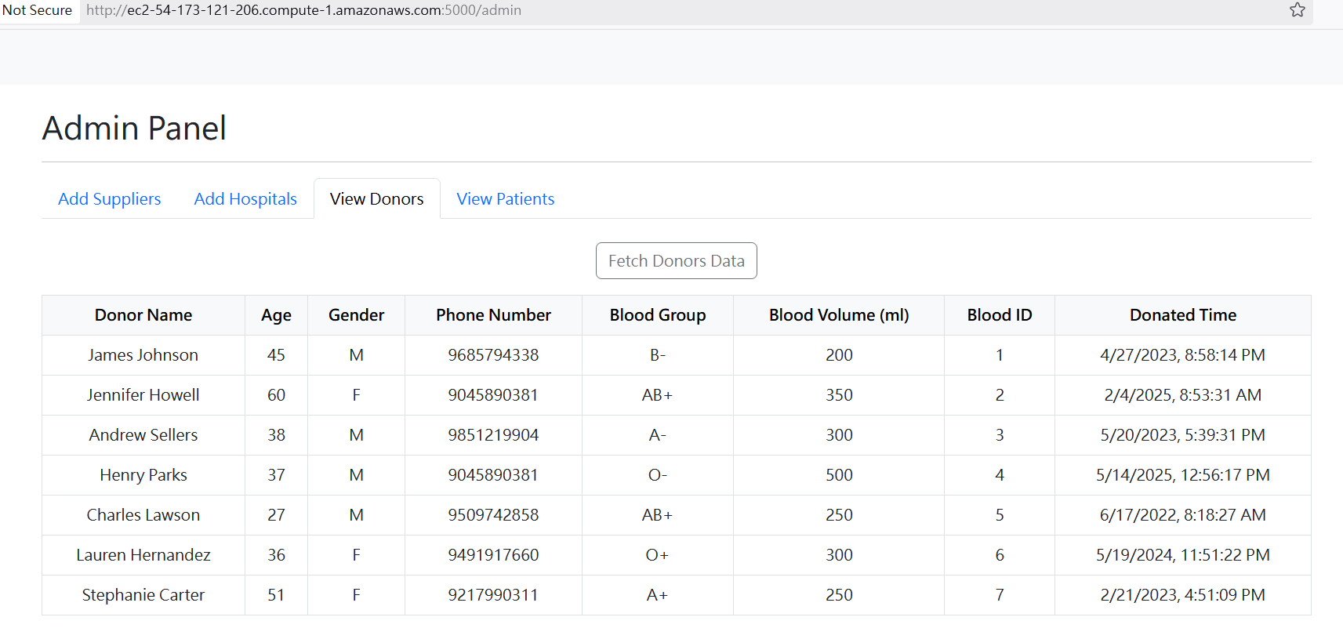

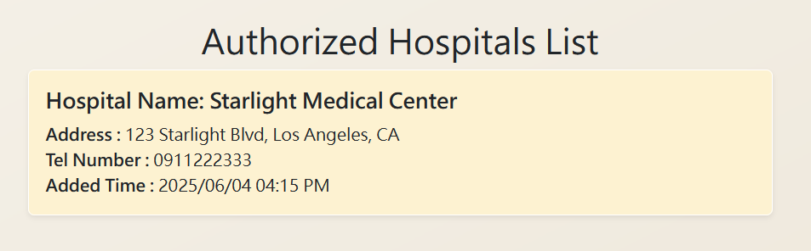

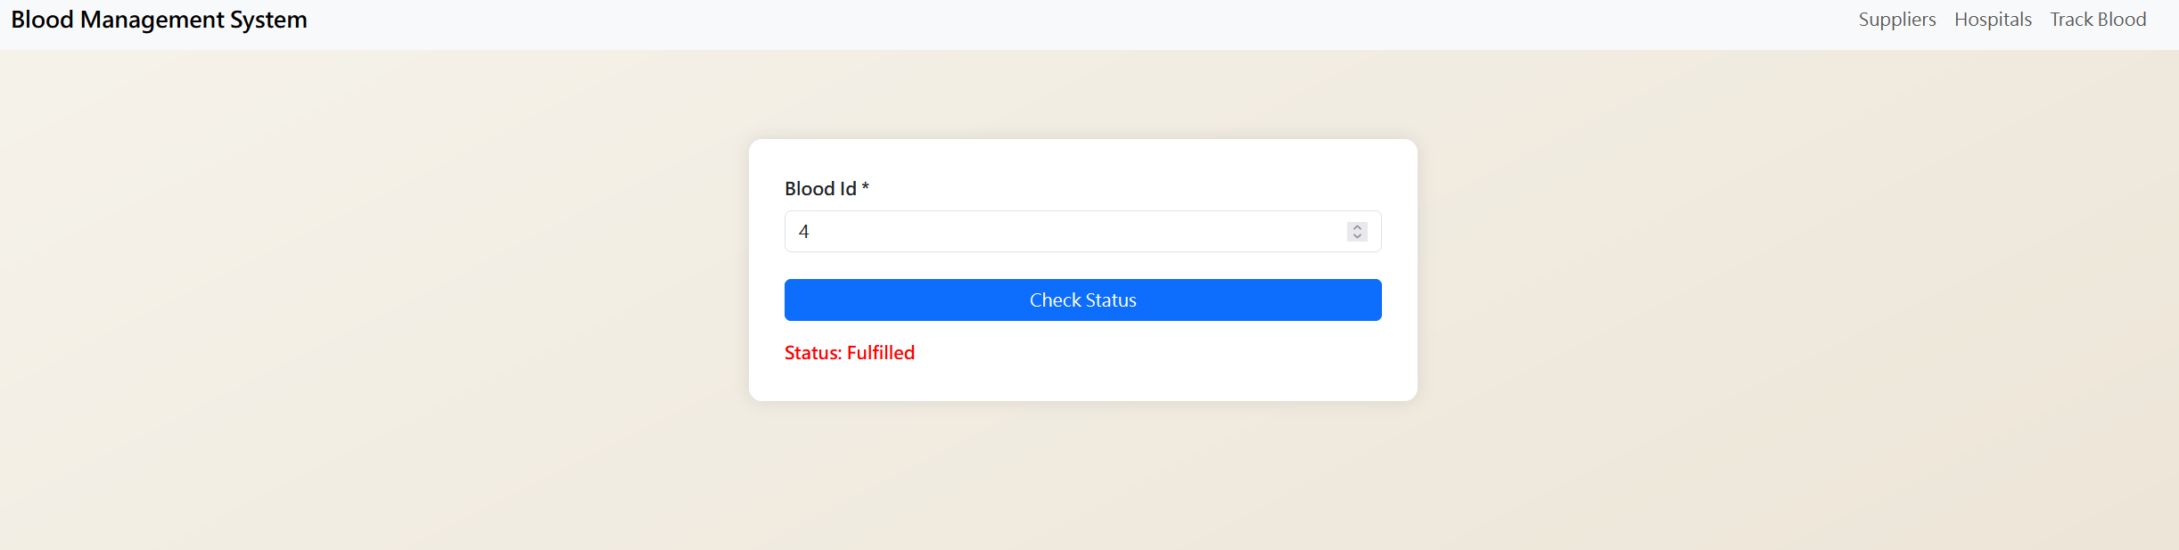

1. One snapshot of your cloud watch

