**What is Boolean? Write down 3 different expression that results a Boolean type.**

Boolean is a binary variable, having two possible values called “True” and “False.”.

5 == 3 + 2

5 != 6

6 > 5

**What is a flow chart? Draw flow chart for the following code snippet:**

A graphical representation of a computer program in relation to its sequence of functions.

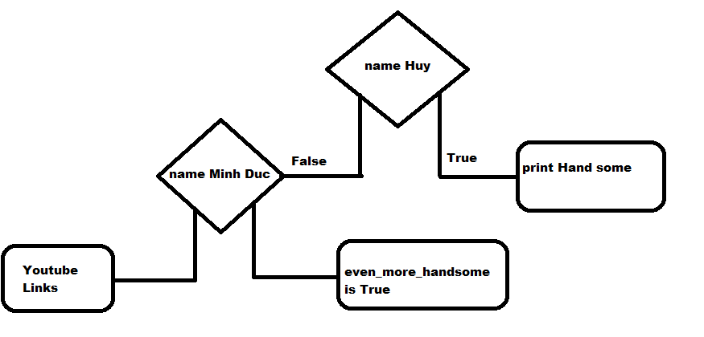

**What is nested conditionals? Write a piece of code that uses nested conditionals.**

Nested conditionals is when a conditional nested within another.