# Cash Register

**Running Application**

With the application running, currently used as a console application, but could be ported as a windows service or process. Upon opening there will be the statement, “Press ‘q’ to quit”, otherwise it is ready to use.

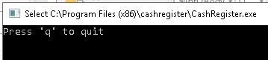

The pre-loaded folder location it is watching is “C:/tmp/” with 3 subfolders “Errors”, “Processed”, and “OutPut”. Errors are the original file that gets moved to if an error occurs while processing. If no errors occur, the file is instead moved to “Processed”, and the resulting file is created in “OutPut”. **[Figure1]**

Figure 1

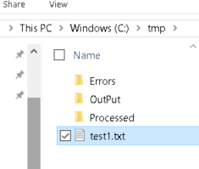

For example, if you have the file “test1.txt”, you can drop it into the folder “C:/tmp/”. **[Figure1]**

Figure 2

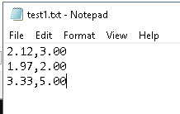

A message will appear annotating the file was found and had 3 lines in it. **[Figure3]**

Figure 3

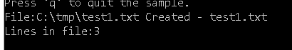

If you navigate to “C:/tmp/OutPut/” you will see the results. **[Figure4] [Figure5]**

Figure 4

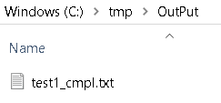

Figure 5

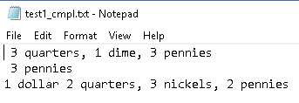

Note: the last line had no dimes, this is due to the requirement stating “If the "owed" amount is divisible by 3, the app should randomly generate the change denominations”. This line may vary on subsequent runs as it will either skip quarters, dimes, or nickels.

The original file will be in the folder “C:/tmp/Processed/”, these files are no longer needed and may be archived or removed as you see fit.