True Haven Press — Brand Kit
truehavenpress.com
Colour palette
Swatch | Name | Role | Hex | Where it shows up
 | Warm Brown | Primary / Accent | #754633 | Buttons, hover, link color, headline accents
 | Deep Brown | Primary Dark | #5A3527 | Button hover state
 | Navy | Secondary | #182470 | Headings, dark hero backgrounds, body text on light
 | Cream / Tan | Tertiary | #CBB299 | Tan CTA panel background, soft accents, hover tints
 | Olive | Contrast | #4B5236 | Footer band, dark surfaces, side borders
 | White | Background | #FFFFFF | Main page background
 | Light Cream | Background (alt) | #F6F3EE | Alternating section backgrounds, callout boxes
 | Deep Navy | Body Text | #1F2647 | Default body copy text color
 | Cool Gray | Body Text (light) | #666670 | Secondary text, captions, helper text
 | Warm Tan | Border | #E6DFD1 | Hairline borders, card outlines, dividers

Fonts
Poppins — used for headlines, article titles, section headings
Free on Google Fonts: https://fonts.google.com/specimen/Poppins
Weights used on the website: 600 (Semi-Bold) for headings.
All weights available (100 Thin through 900 Black, in regular and italic). Pair with anything close in modern web tools: Montserrat or Manrope are reasonable substitutes if Poppins is unavailable.
Plus Jakarta Sans — used for body text, navigation, buttons, forms
Free on Google Fonts: https://fonts.google.com/specimen/Plus+Jakarta+Sans
Weights used on the website: 400 (Regular) for body, 600-700 for buttons and emphasis.
Reasonable substitutes if unavailable: Inter, Source Sans 3, or system sans.
Quick-start combinations
The patterns the site repeats most often, in case you need to recreate them:
• Warm brown buttons (#754633) with white text — primary call-to-action everywhere.
• Navy headlines (#182470) on white or cream backgrounds — most body pages.
• Cream / tan panels (#CBB299) with navy pill buttons — the bottom CTA strip on article pages.
• Olive green band (#4B5236) with white text — the footer, with brand info and contact links.
• Light cream (#F6F3EE) for alternating section backgrounds — keeps long pages from feeling flat.
Primary Logo
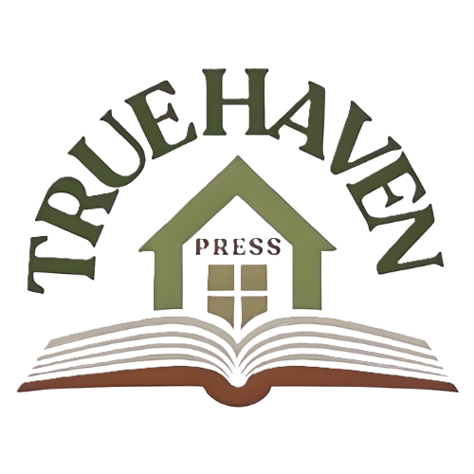
Secondary Logo (background image, extra image)
