Goron

Simple mountain-dwelling folk, wielding immense physical might.
RACIAL TRAITS
Average Height: 6'4”-6'10”
Average Weight: 280-340 lbs

Ability Score: +2 Constitution, +2 Strength or +2 Wisdom
Size: Medium
Speed: 5
Vision: Low-light

Languages: Hyrulean, Goron
Skill Bonuses: +2 Dungeoneering, +2 Athletics
Boulder Dash: You have the boulder dash power.
Mineral Diet: Your diet consists solely of nutrient-rich stones. You gain temporary hit points equal to 1 + one-half your level at the end of any short rest spent in a mountain or otherwise rocky environment.
Mountain Dweller: You have your choice of either resist fire 5 + one-half your level or resist cold 5 + one-half your level.

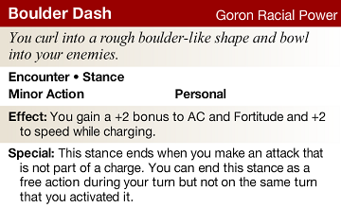

Play a goron if you want...
- to tower over the other races.
- to be at home in icy peaks or boiling volcanoes.

Deku
Sneaky little bastards who appear more plant than person.
RACIAL TRAITS
Average Height: 2'10”-3'5”
Average Weight: 20-35 lbs.

Ability Score: +2 Charisma, +2 Dexterity or +2 Constitution
Size: Small
Speed: 6
Vision: Normal

Languages: Hyrulean, Lost
Skill Bonuses: +2 Nature, +2 Bluff
Camouflage: You gain a +2 racial bonus to stealth checks made amongst plants.
Lost Woods Dweller: You are considered a fey creature for the purposes of effects that relate to creature origin.
Surface Skip: You can move across the surface of any still body of water as if it were normal terrain so long as you end your movement on solid ground.
Seed Spit: You have the seed spit power.
Sway in the Breeze: You gain a +2 racial bonus to AC vs. opportunity attacks.

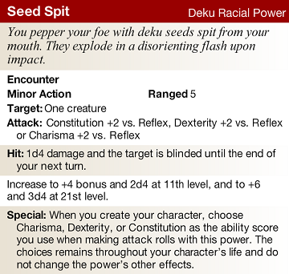

Play a deku if you want...
- to have one of the oddest physicalities in Hyrule.
- to be mistrusted.
Zora
A graceful and elegant race at home beneath the waves.
RACIAL TRAITS
Average Height: 5'5”-6'1”
Average Weight: 110-170 lbs.

Ability Score: +2 Wisdom, +2 Intelligence or +2 Dexterity
Size: Medium
Speed: 6 (Swim 6)
Vision: Low-light

Languages: Hyrulean, Zoran, Choice of one language
Skill Bonuses: +2 Acrobatics, +2 Heal
Gilled: You are considered an aquatic creature. You can breathe underwater and do not suffer any penalties for attacking while underwater.
Smooth Skin: You have the smooth skin power.
Strong Swimmer: You grant any non-zora ally within 10 squares of you a +1 racial bonus to Athletics checks and Endurance checks related to swimming.
Zoran Weapon Proficiency: You gain proficiency with the longspear, javelin, spear and trident.

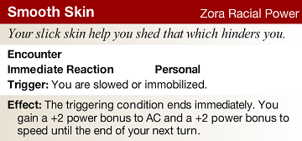

Play a zora if you want...
- swim circles around your opponents.
- to have a deep appreciation for art and music.

Kokiri
Secretive race of children who have only recently dared to step outside their forest haven.
RACIAL TRAITS
Average Height: 3'3”-4'3”
Average Weight: 75-85 lbs.

Ability Score: +2 Dexterity, +2 Charisma or +2 Wisdom
Size: Small
Speed: 6
Vision: Normal

Languages: Hyrulean, Lost
Guardian Fairy: You have the Arcane Familiar feat and the fairy racial familiar. You can take any other feats that have Arcane Familiar feat prerequisite, even if your are not of an arcane class.
Lost Woods Dweller: You are considered a fey creature for the purpose of effects that relate to creature origin.

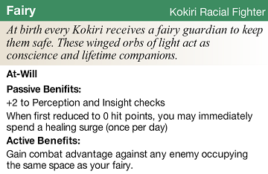

Play a kokiri if you want...
- to embody childlike curiosity.
- to have a fairy companion.

Gerudo
An isolationist race of bandits and thieves, living on the fringe of society.
RACIAL TRAITS
Average Height: 5'6-6'0
Average Weight: 120-160 lbs.

Ability Score: +2 Strength, +2 Charisma or +2 Dexterity
Size: Medium
Speed: 6
Vision: Normal

Languages: Hyrulean, Gerudo
Skill Bonuses: +2 Thievery, +2 Intimidate
Desert Conditioning: You gain a +5 bonus to endurance checks made to survive in extreme environments.
Expert Opportunist: You have the expert opportunist power.
Gerudo Weapon Training: You gain proficiency with the kopesh, scimitar and the halberd.
Mounted Combat: You gain the Mounted Combat (PHB1 p.199) feat for free.

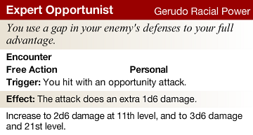

Play a gerudo if you want...
- to thrive in harsh environments.
- to belong to a nearly all-female race.

Hylian
The high society of Hyrule. Legend has it their pointed ears allow them to hear the voices of gods.
RACIAL TRAITS
Average Height: 5'0” - 6'0”
Average Weight: 120-180 lbs.

Ability Score: +2 Wisdom, +2 Constitution or +2 Intelligence
Size: Medium
Speed: 6
Vision: Normal

Languages: Hyrulean, choice of two other languages
Skill Bonuses: +2 Religion, +2 Diplomacy
Divine Resistance: You have resistance to necrotic damage and radiant damage equal to 5 + one-half your level.
Goddesses' Favour: You have the din's fire, farore's wind and nayru's love powers. You may only use one of these powers per encounter.
Higher Education: You gain training in one skill of your choice.

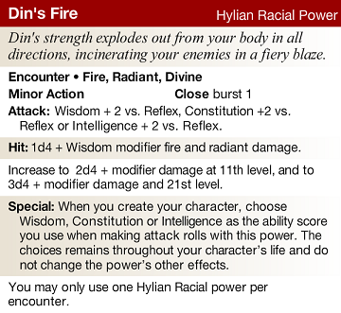

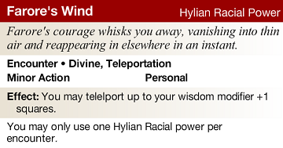

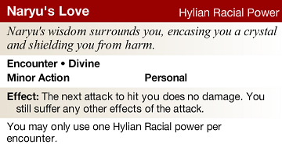

Play a hylian if you want...
- to be close to the goddesses
- to come from a long line of royalty and heroes.

HEROIC RACIAL FEATS

Biggoron Weapon Training [Goron]
Prerequisite: Goron, Str 13
Benefit: You gain proficiency with all two-handed heavy blades and two-handed light blades. You also gain a +2 feat bonus to damage rolls with these weapons.

Bottom Heavy [Goron]
Prerequisite: Goron
Benefit: When an effect knocks you prone, you may make a saving throw. On a success, you remain standing.

Dodongo's Bane [Goron]
Prerequisite: Goron
Benefit: You gain a +2 feat bonus to attack when you target at least one creature of large size or bigger with an area attack.

Eruptive Stance [Goron]
Prerequisite: Goron, boulder dash racial power
Benefit: When you make an attack which ends the boulder dash stance, that attack gains a +2 feat bonus to attack rolls and a +2 feat bonus to damage rolls.

Mountain Settler [Goron]
Prerequisite: Goron, Con 15
Benefit: You have both resist 5 fire and resist 5 cold.

Buoyant [Deku]
Prerequisite: Deku, Dex 13
Benefit: You gain a +5 feat bonus to Athletics checks related to swimming.

Distance Spit [Deku]
Prerequisite: Deku, seed spit racial power, Dex 13
Benefit: Your seed spit power has range 10/20.

Petal Fall [Deku]
Prerequisite: Deku
Benefit: You subtract 10 feet from the total distance fallen before determining damage after a fall.

Swamp-born [Deku}
Prerequisite: Deku
Benefit: You gain resist 5 acid and +5 feat bonus to saving throws against poison.

Rapid Spit [Deku}
Prerequisite: Deku, seed spit racial power, Dex 13
Benefit: Your seed spit power can target one or two creatures within range, but no longer blinds the target on a hit.

Cleansing Current [Zora]
Prerequisite: Zora
Benefit: Whenever you use a healing power on an ally or use Heal to allow an ally to spend his or her second wind, that ally can also make a saving throw.

Eel Skin [Zora]
Prerequisite: Zora, smooth skin racial power
Benefit: When you use the smooth skin power, any enemy adjacent to you at the end of your turn takes 1d6 lighting damage. The damage increases to 2d6 at 11th level and 3d6 at 21st level.

Fin-blade Fighter [Zora]
Prerequisite: Zora, Dex 13
Benefit:When you make a melee weapon attack, you can use your arm fin, which is a weapon in the light blade weapon group. This weapon has the off-hand weapon property and a +3 proficiency bonus, and it deals 1d6 damage. While you aren’t holding anything, you are considered to have this weapon in each hand. You can enchant and disenchant your fins. When you disenchant your fins, they do not turn to dust.

Fin-blade Hurler [Zora]
Prerequisite: Zora, Dex 13
Benefit: When you make a ranged weapon attack, you can use your arm fin, which is a weapon in the light thrown weapon group. This weapon has the off-hand property, a +3 proficiency bonus and it deals 1d6 damage. While you aren’t holding anything, you are considered to have this weapon in each hand. You can enchant and disenchant your fins. When you disenchant your fins, they do not turn to dust. When thrown, this weapon always returns to you, even if not enchanted.

Jabu Jabu's Boon [Zora}
Prerequisite: Zora, bard class or any divine class
Benefit: You may replace any utility power of 2rd level or higher with the ballad of the wind fish power.

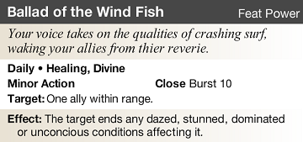

Fairy Knowledge [Kokiri]
Prerequisite: Kokiri, fairy racial familiar, arcane familiar feat
Benefit: You gain a +3 feat bonus to monster knowledge checks while your fairy familiar is active.

Forest Playground [Kokiri]
Prerequisite: Kokiri, Dex 13
Benefit: You ignore difficult terrain as a result of trees, underbrush, plants, or natural growth. You also gain a +2 feat bonus to acrobatics checks made in forest environments. This feat does not allow you to ignore challenging or hindering terrain.

Friendly Fairy [Kokiri]
Prerequisite: Kokiri, fairy racial familiar, arcane familiar feat
Benefit: When an ally within 5 squares of you is reduced to 0 hit points, he or she may immediately spend a healing surge as per you fairy familiar's passive benefit. This counts as the “once per day” use.

Great Deku Tree's Boon [Kokiri]
Prerequisite: Kokiri, any divine class or any primal class
Benefit: You receive a +4 feat bonus to saving throws against poison and Endurance checks made to resist disease.

Lost in the Woods [Kokiri]
Prerequisite: Kokiri
Benefit: You gain a +2 feat bonus to AC while adjacent to at least two enemies larger than you.

Acrobatic Attack [Gerudo]
Prerequisite: Gerudo, trained in acrobatics, Dex 13
Benefit: When you use an encounter power with the weapon keyword or the expert opportunist power, you may shift 1 square before and/or after the attack.

Femme Fatale [Gerudo]
Prerequisite: Gerudo, Cha 13, female
Benefit: You and you have a +2 feat bonus to damage rolls against male humanoid enemies.

Gerudo Magic [Gerudo]
Prerequisite: Gerudo, Any arcane class
Benefit: Once per encounter when you hit an enemy with an arcane attack that does not deal ongoing damage, the target gains ongoing 5 fire damage (save ends) or ongoing 5 cold damage (save ends). The ongoing damage increases to 10 at 11th level and 15 at 21st level.

Loner [Gerudo]
Prerequisite: Gerudo
Benefit: Gain a +2 feat bonus to attack rolls while not adjacent to an ally. This bonus does not stack with the attack bonus granted by combat advantage.

Stick to the Shadows [Gerudo]
Prerequisite: Gerudo
Benefit: You receive +1 feat bonus to your Reflex defence when in an area of low light or darker.

Divine Whispers [Hylian]
Prerequisite: Hylian
Benefit: You may preform the Hand of Fate ritual at half the usual component cost, even if you do not have the ritual caster feat.

Hyrule Knight [Hylian]
Prerequisite: Hylian, any martial class
Benefit: You have proficiency with shortswords, longswords, bastard swords and light shields and gain a +1 feat bonus to attack rolls and a +1 feat bonus to AC when wielding a short sword, long sword or bastard sword and using a light shield.

Improved Goddesses' Favour [Hylian]
Prerequisite: Hylian, din's fire racial power, farore's wind racial power, nayru's love racial power
Benefit: You may use two different hylian racial powers per encounter.

Royal Aura [Hylian]
Prerequisite: Hylian
Benefit: All allies adjacent to you gain resist 3 necrotic and resist 3 radiant. The resistance increases to 5 at 11th level and 10 at 21st level.

Shared Healing [Hylian]
Prerequisite: Hylian
Benefit: Once per turn, whenever you regain hit points, each ally within 3 squares of you regains hit points equal to your level.

DEITIES

The Golden Goddesses
Good
The Golden Goddesses are a collection of three deities attributed with the creation of Hyrule. Each represents a virtue of hylian society; power, wisdom and courage. The three are usually worshiped as a group, though some tend to lean more toward the values of one goddess over the others. As a whole, the Golden Goddesses teach their followers to:

- Seek out balance. When power, wisdom and courage are pulled together, the impossible can be achieved.
- Do not resist your destiny. To refuse its call is to deny yourself our greatest gift.
- Do not abuse the goddesses gifts, to do so is to inspire retribution.

Domains: Creation, Fate, Protection

Din, Goddess of Power
Unaligned
Din represents power. In the creation of Hyrule, she used her might to form and shape the mountains and valleys of the land out of the empty void. Din is most often worshiped by warriors and those who hold physical strength in high regard. Gorons especially feel a connection to Din because of her association with earth and fire. She encourages her worshipers to:

- Obtain and maintain peek physical condition.
- Test your might in competition and battle. Only the strongest will prevail.
- Respect rock and fire, for they are her gifts to hyrule and powerful weapons.

Domains: Strength, Earth, Sun

Farore, Goddess of Courage
Good
Of the three Golden Goddesses, Farore represents courage. When Din created Hyrule’s form, it was Farore who populated it with life. Most hyrulians worship her, especially farmers and those native to lost woods such as the kokiri and deku. Her teachings are these:

- Be honorable in all things you do.
- Seek to defend those who cannot defend themselves.
- Respect nature and life in all its forms.

Domains: Life, Freedom, Luck

Nayru, Goddess of Wisdom
Lawful Good
Nayru represents the virtue of wisdom. As Farore finished spreading life throughout Hyrule, Nayru created the laws and morals to govern them. Nayru is held in high regard by scholars, nobles and the Zora. Those who are faithful should:

- Understand and follow the law.
- Bring civilization to the far reaches of the world.
- Study the past and present so that you may know your future.

Domains: Knowledge, Justice, Civilization

Lord Jabu Jabu
Unailgned
Lord Jabu Jabu is a demigod and the protector of the zoran race. Unlike the Golden Goddesses, Jabu Jabu inhabits the mortal realm, living in Zora’s Fountain. Obviously, Jabu Jabu is almost exclusively worshiped by the zora, though a few members of other races who rely of the ocean’s bounty might also recognise him. He appears as a whale or giant fish, decorated in jewelry and other finery.

Domains: Sea, Art, Protection

The Great Deku Tree
Good
The Great Deku Tree is a demigod and protector of the kokiri. He lives amongst them in Kokiri Forest and watches over them as they play. Most kokiri and the occasional deku revere him but for the most part the other races do not even know of his existence. He appears to be a giant tree with a masculine face embedded in it’s trunk.

Domains: Life, Hope, Protection

