MassGrid Ubuntu Mining Setup Guide
www.massgrid.com
Only support Ubuntu PC with AMD or Nvidia GPU installed

For Nvidia GPU, install cuda 8 or cuda 9 :
https://developer.nvidia.com/cuda-zone
For AMD GPU, install AMD APP OpenCL SDK:
https://developer.amd.com/amd-accelerated-parallel-processing-app-sdk/

Step 1, Install Wallet:

- Open Terminal in Ubuntu 16.04

- Add bitcoin dependences source: sudo add-apt-repository ppa:bitcoin/bitcoin

- Update system: sudo apt-get update

- Install bitcoin dependences: sudo apt-get install bitcoin-qt

Step 2, Install Miner:

- Install GPU miner dependences: sudo apt-get install libjansson-dev

- Unzip miner to a folder

- Copy massgrid.conf from miner folder to wallet folder

- Open miner.sh file in bfgminer folder with gedit, you will see a one line command as below，replace the address (marked as red) with your wallet address which you could find in MassGrid wallet by click “request payment”button：

bfgminer -o http://127.0.0.1:9442 -u mgdcoinrpc -p mgdcoinpassword --generate-to MF2LBCCSEt56rXPKTG8hXvcPFTrQQrjPfr -S opencl:auto

- Save miner.sh

- Restart MassGrid wallet and wait until synchronize complete

- Run miner : cd bfgminer&&./miner.sh

if everything goes well ,the miner will be running as below：

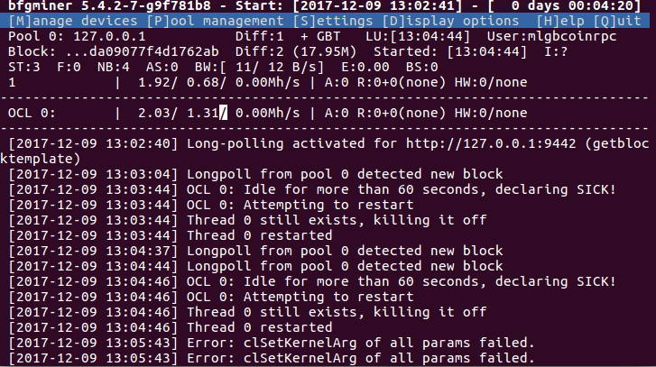
At the first time , miner need some time to initialize and compile OpenCL Kernel, it will take few minutes.

After a while, the mining will be stable, you will see real-time hash rate showing marked as below：
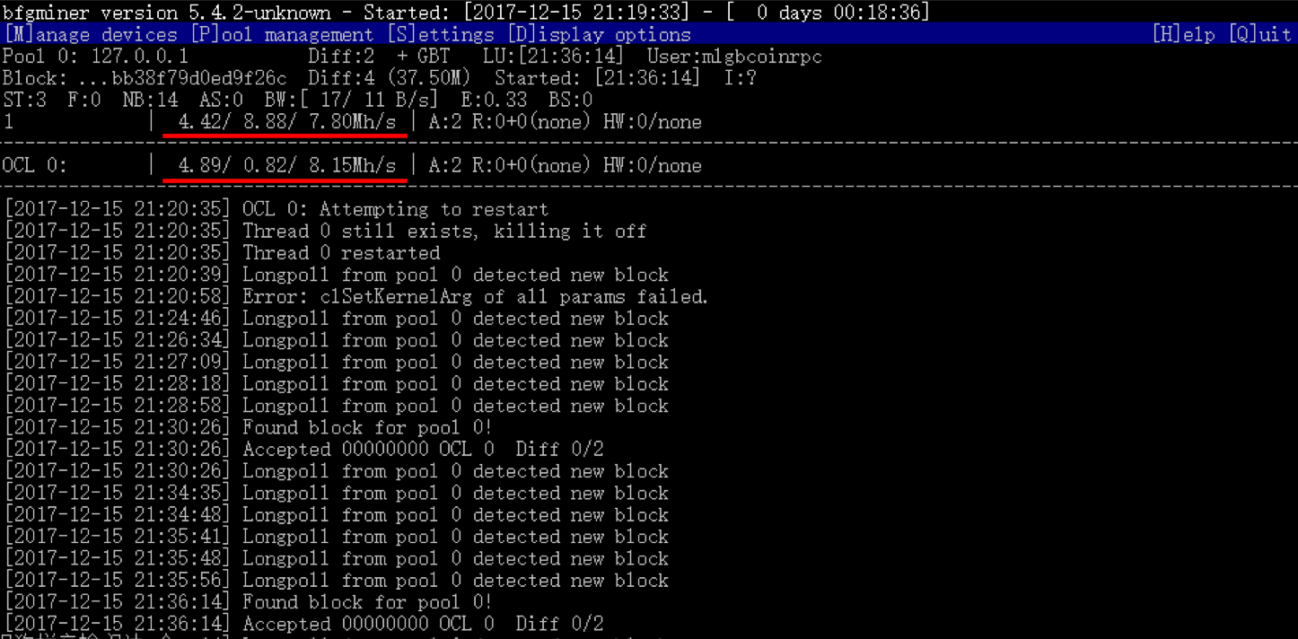

If you see this error message: “NO DEVICES FOUND: Press 'M' and '+' to add”, that normally because GPU device is not properly installed, you will need reinstall GPU driver, and CUDA/OpenCL SDK.

