**TRUMPCHANGE WHITEPAPER v1.0 (DEC 2024)**

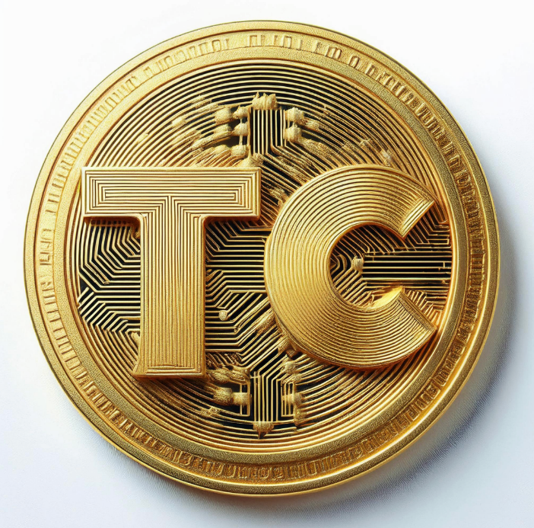

**TrumpChange (TCHNG)**

**“Make Your Wallet Great Again”**

**Introduction**

In a world dominated by serious investments and complicated financial systems, we thought, "Why not inject some humor and a dash of personality into crypto?" Introducing **TrumpChange (TCHNG)** — “Sounds like CH-CHING!”, a meme coin inspired by the one and only Donald J. Trump, the most crypto friendly president in history. With its slogan, **"Make Your Wallet Great Again,"** TrumpChange aims to bring fun, community, and the most **beautiful** gains in the crypto world.

**What is TrumpChange?**

TrumpChange is an **ERC-20 token** on the Ethereum mainnet. TrumpChange was created for ease-of-use, to unite like-minded cryptocurrency enthusiasts, meme lovers, and value seekers. Whether you’re here for the memes, the potential profits, or to own a piece of internet gold, TrumpChange has something for everyone. It is a deflationary* meme coin token (we will be dynamically burning tokens based on transaction volume, this is something we plan to vote on as a community)

At its core, TrumpChange represents more than just a coin; it’s a community-driven movement!

**Tokenomics: The Economics of Greatness**

We’ve structured TrumpChange with a tokenomics model that’s both fun and functional:

* **Total Supply:** **100,000,004,547 TCHNG** (~One Hundred Billion)

**Allocation:**

* + **70% Public Sale & Liquidity:** For trading and public participation
  + **15% Marketing, Airdrops, & Partnerships:** To fuel growth, spread the word, and reward early adopters, rewards for contests, and of course to fund the airdrops!
  + **15% Founders’ Allocation:** Split equally among the creators. (Who will strategically lock amounts of tokens dynamically based on transaction volume)
* **Burn Mechanism:** An amount of TrumpChange will be burned regularly to make TrumpChange scarcer over time. Supply goes down, value goes up. *We plan on figuring out the right amount as a community. This is truly a community project.

**Features That Make TrumpChange Great, Again and Again:**

**Fixed Supply**

The supply is fixed. With the burn mechanics in place, it makes TrumpChange deflationary by nature. (That means no inflation, EVER, and you don’t have to take my word for it, it’s proven!)

**Burnable Tokens**

Burn, baby, burn! With every transaction, a portion of TrumpChange will be burned, creating scarcity and increasing the value of every remaining token. The team will be monitoring and analyzing transactions and pledge provide a plan on a burn regularly burning tokens.

**Roadmap to Greatness**

**Phase 1: Build the Wall (Token Launch)**

* Deploy the TrumpChange smart contract on Ethereum.
* List on **Uniswap V3** with a robust liquidity pool.
* Create a simple, yet glorious, website: **trumpchangecoin.com**.
* Build our social media empire on **Twitter**, **Discord, Telegram**, and **Reddit**. Use #TrumpChangeCoin, #TCHNG, #MakeWalletsGreatAgain, and #TrumpChange of course to spread the word.

**Phase 2: Meme Army Mobilization**

* Host meme contests that are free to enter with cryptocurrency rewards!
* Airdrops! Two airdrops are planned: one for **4,500,000** **TCHNG** on **the week of New Years (Jan 1-Jan 6th)** and another for **47,000,000 TCHNG** tokens on **Inauguration Day (Jan 20, 2025)** to celebrate! (The numbers 45 and 47 are significant, as Donald Trump was our 45th and will be our 47th President of the United States! Join our discord and sign up (it’s free) to join the airdrops**! No purchase necessary, you just need to join the community and spread the word!**
* Partner with influencers and creators to spread the word.
* Build a loyal community that anybody can be a part of! (Except Hillary and Crooked Joe..let’s drain the swamp while we’re at it!)

**Phase 3: Tremendous Growth**

* List TrumpChange on **CoinMarketCap** and **CoinGecko**.
* Introduce staking opportunities for TrumpChange holders.
* Collaborate with other meme tokens for cross-community events.
* Develop limited-edition TrumpChange NFTs (some will be made from the meme contestant winners!)

**Phase 4: The Moonshot**

* Explore centralized exchange listings such as KuCoin and others!
* Global adoption and domination!

**Why TrumpChange?**

Because the internet runs on memes, and crypto thrives on community. TrumpChange combines both into a single token that’s:

1. **Relatable**: Everyone wants to turn their chump change into something that can potentially give them financial independence, and TrumpChange is that something.
2. **Accessible**: Low barriers to entry make it easy for anyone to join the movement.
3. **Fun**: Whether you’re holding it, trading it, or memeing it, TrumpChange will always have action, whether it be on X with memes or the markets!

**Get Started with TrumpChange**

1. **Buy TrumpChange**: Visit Uniswap, connect your wallet, and trade ETH or WETH for TCHNG. Easy as "believe me." – Join our [discord](https://discord.gg/KPB5NQMw) or visit our website <https://www.TrumpChangeCoin.com> for an in-depth guide on how to buy and sell the cryptocurrency TrumpChange.
2. **Join the Community**: Follow us on social media and join the conversation. Share memes, participate in giveaways, and engage with other holders.
3. **Spread the Word**: The more people know about TrumpChange, the greater its value. Tell your friends and everyone else who understands or wants to learn about the power of crypto.

**Final Words**

With TrumpChange, we’re not just making wallets great again—we’re building a community. Together, we’ll turn fiat "chump change" into the cryptocurrency **TrumpChange**. This is just the first project of a 2-part bigger picture project that we are working on. Join us on the journey!

**Disclaimer**

TrumpChange is a meme coin created for fun and community building. It is not a financial investment or security. As with any cryptocurrency, only invest what you can afford to lose, and always do your own research!