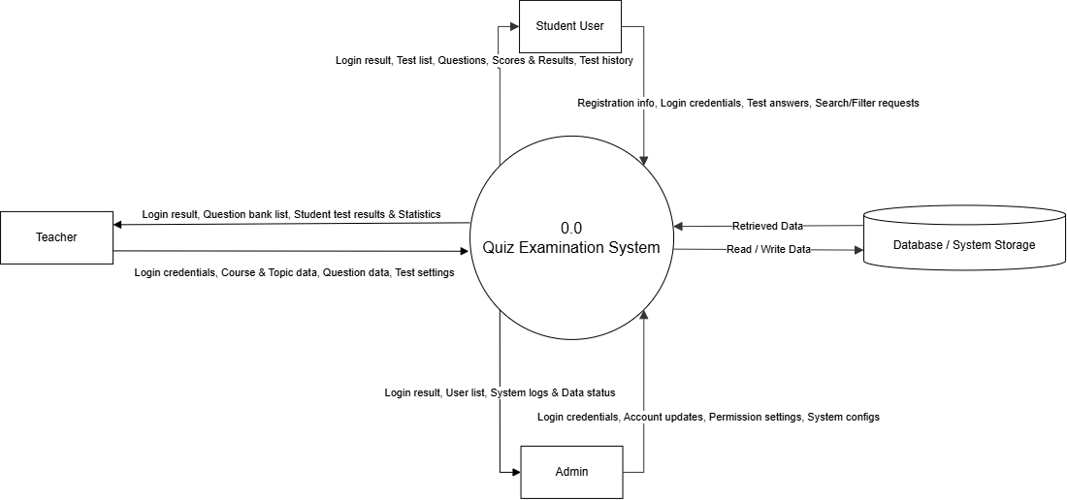

Figure 1: Data Flow Diagrams Level 0

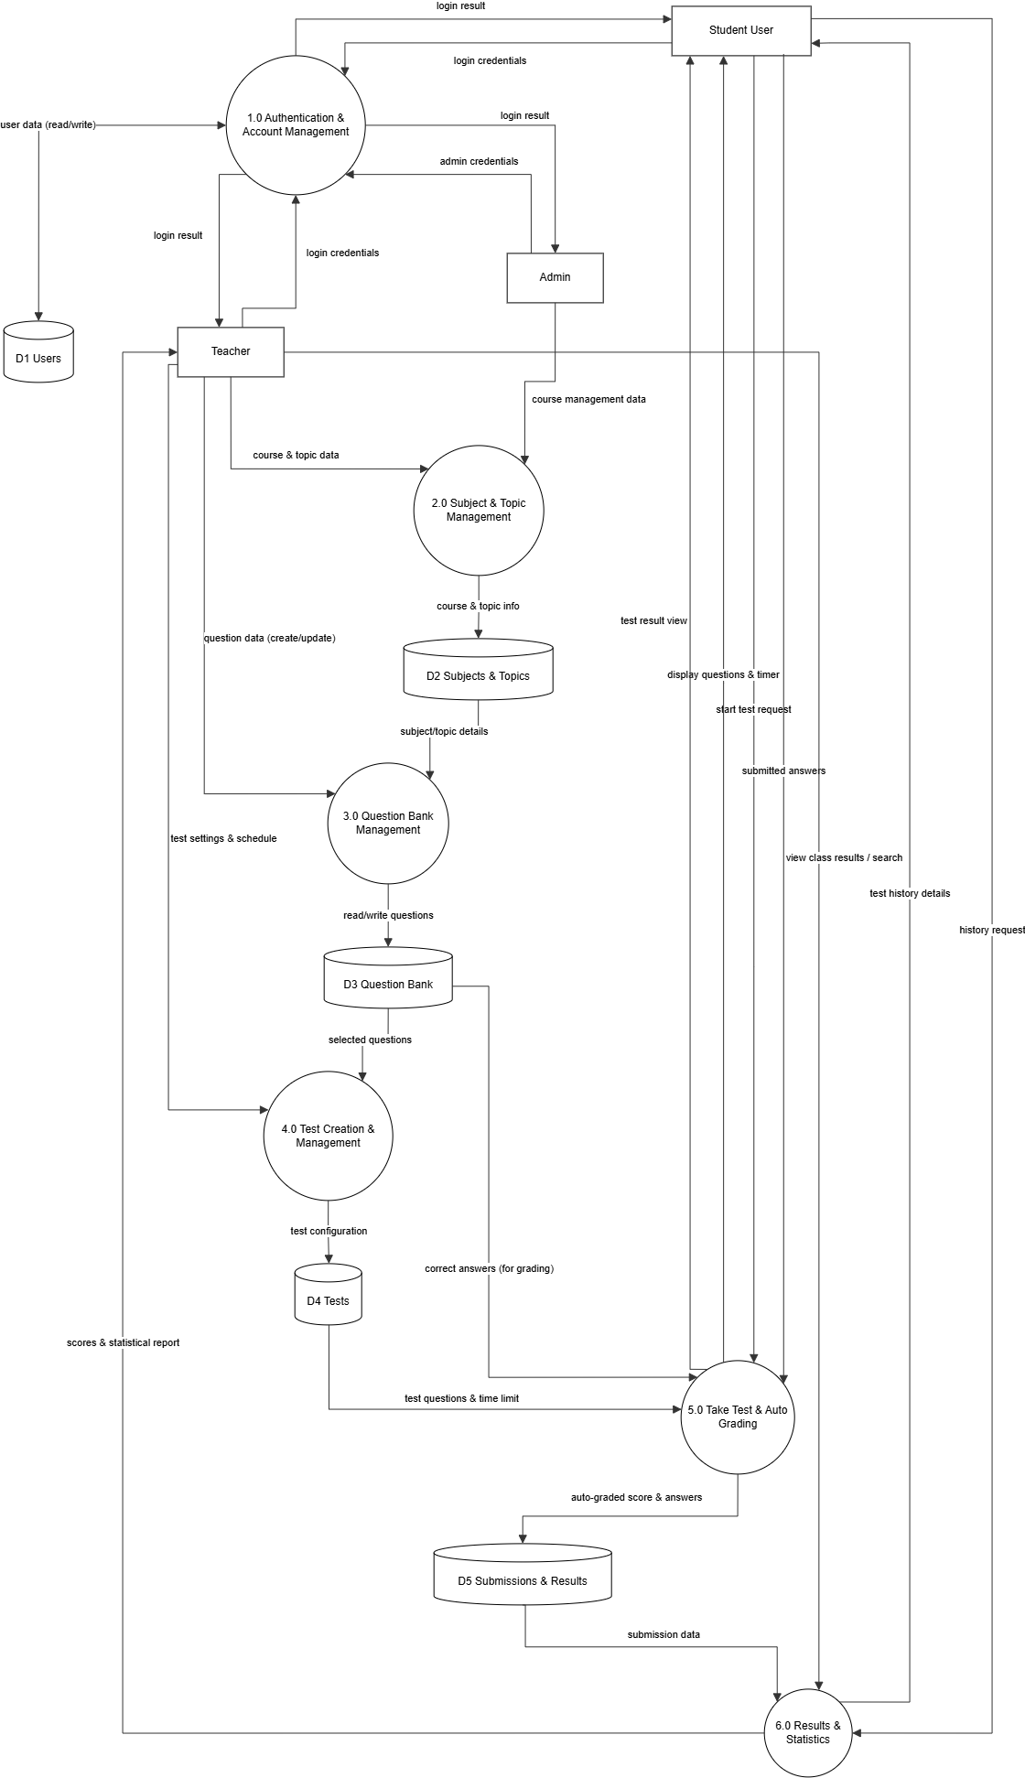

Figure 2: Data Flow Diagrams Level 1

