The Fundamental Statistics and Data Visualization
Group Assignment

Chang Jia Qian ANQSCL
Nguyen Hong Gia Bao ELS9CY
Nguyen Thanh Trung I6P5GG
Zhanbolat Baiekenov EL8SVB

Dataset chose: Cars

Table of content
Background 3
Introduction 4
Central Tendencies and Distribution Characteristics 5
Measures of Dispersion (overall data) 7
Box plot analysis 7
Histogram analysis and market implications (overall) 8
Market concentration 9
Understanding the effect of the fuel efficiency on the price 10
Understanding the effect of the number of vehicle ages on the prices 13
Understanding the effect of brand reputation on price 14
Understanding the relationship between brand and fuel type 15
Understanding the relationship between origin of brand and transmission type 16
Understanding how kilometer driven affect the selling price 19
Dashboard: Conclusion 20

Background
Our group has chosen the Cars dataset for the Fundamentals of Statistics and Data Visualization group assignment. Our task is to analyze the dataset and make a report based on the observations. We can also Discuss some relevant social and/or economic questions that can be answered through statistical analysis.

Inspired by an Instagram reels showing a successful airplane dealer showing his clients the right private airplane for them based on his huge dataset, our group has decided to imagine ourselves as the biggest and best car dealer in the world to make things fun and creative.:) The analysis our group has done can help to understand our imaginary company better for internal management and also provide a suitable car for our imaginary clients based on their needs and wants. Our group will also use the data provided to address economic and environmental issues.

From this point onwards, members of this group assignment will name ourselves as “our company”, “the company”, “our group”, “we” interchangeably and we will call our readers “clients” or “professors” interchangeably. Since this is an imaginary company, names of the departments of the company can also be used throughout this report to describe the analysis. For example, the marketing department found out that most people would buy a car for a price of 500,000HUF (mode) and so we can market our cars to most of our clients that are priced around this number. capitalism is bad but okay :D

Introduction
Our company is selling cars from a total of 38 brands. These cars can be divided into 2 main categories, luxury cars and normal cars. The luxury brands include Land Rover, BMW, Jaguar, Volvo, Mercedes-Benz, Porsche, Bentley, Lexus, Audi, Maserati, Mercedes-AMG and Mini. The rest are labeled as normal.

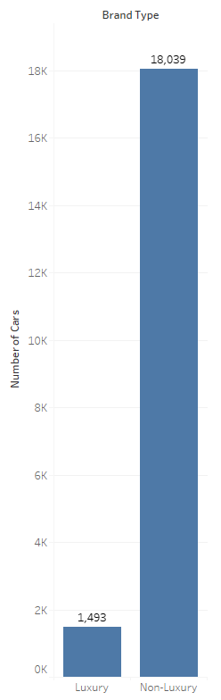
Graph 1. Number of cars of each brand type

this bar chart is not that informative, would be better if there were more categories on the x axis for example
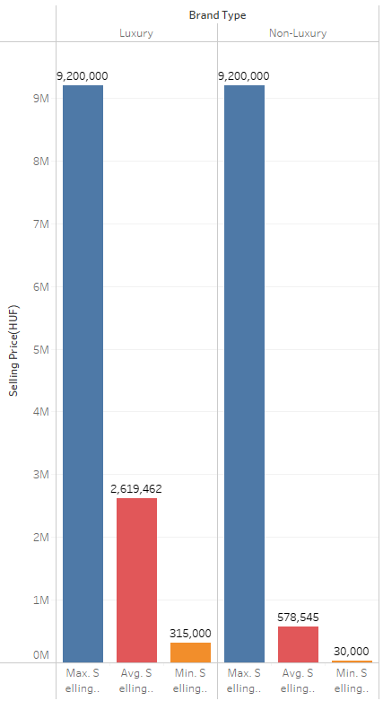
Graph 2. Highest, average and lowest price of the cars of each brand type – for this I would rather suggest you using a stacked graph format

There are a total of 1,493 luxury cars and 18,039 economical or non-luxury cars. The highest price for the luxury and non-luxury cars in our company is priced at HUF 9,200,000. However the average price and lowest price for the luxury cars are HUF 2,19,462 and HUF 315,000 respectively which are higher than the average price and lowest price of the economic cars which are HUF 578,645 and HUF 30,000 respectively.

Central Tendencies and Distribution Characteristics (overall data)
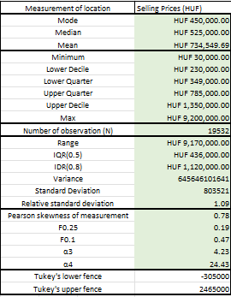
Table 1.
you did not calculate all the measures we learnt about e.g. K, Pearson’s P or at least they are not in table1The dataset reveals that the mode of car prices is HUF 450,000 indicating the most frequently occurring price point – is it really meaningful to calculate the mode for such a continuous dataset? see the presetation from w4. This reflects a concentration of lower-priced cars that likely appeal to budget-conscious customers. The median, at HUF 525,000, signifies the midpoint of the dataset, with half of the prices falling below and half above this value. Notably, the mean is significantly higher at HUF 734,549.69, highlighting the influence of high-value outliers. The disparity among the mean, median, and mode suggests a positively skewed distribution, where a small number of high-priced cars elevated the average.
The positive skewness is confirmed by a Pearson skewness coefficient of 0.78 and an α₃ value of 4.23, which both indicate a pronounced rightward tail. explain the different results between a3 and PThis distribution implies that while most cars are relatively affordable, the presence of high-priced models plays a significant role in shaping the overall price structure. for this it would be good to insert here the distribution of pricesA further examination of kurtosis reveals an α₄ value of 24.43, indicating a leptokurtic distribution. this is a really large a4 value – what can be the deeper reason behind this? this explanation is not deep enoughThis sharp peak and heavy tails suggest that most prices are tightly clustered around the central tendency, with substantial outliers influencing the upper range. I would really suggest you doing an outlier filtering based on the box plot and then re-calculating all the descriptive stat measures

Measures of Dispersion (overall data)
The range of HUF 9,170,000, calculated from HUF 30,000 to HUF 9,200,000 demonstrates the large variability in selling prices. This reflects a diverse inventory catering to different market segments, from economy models to luxury vehicles. The interquartile range (IQR), at HUF 436,000, narrows the focus to the middle 50% of prices, providing a clearer picture of central price variation. Additionally, the standard deviation of HUF 803,521 emphasizes significant variability, further evidencing the influence of outliers in the company’s dataset. more concrete interpretations needed like an average car price is 803 th huf away from the mean
Analysis of quartiles and deciles provides deeper insights. The lower quartile (HUF 349,000) and upper quartile (HUF 785,000) indicate that the central 50% of prices fall within this range. Meanwhile, the lower decile (HUF 230,000) and upper decile (HUF 1,350,000) show that 80% of prices span a broader of course it broader but BY HOW MUCH broader?range. These findings underscore the importance of understanding price dispersion to address varying customer needs effectively.I like this roleplay it makes the whole essay a lot more practical

Box plot analysis
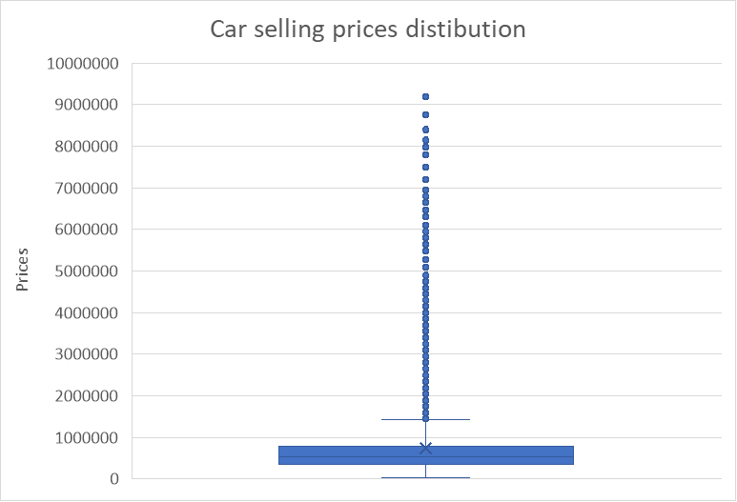
Graph 3. Car selling prices using box plot
Based on calculation, Tukey’s lower fence is -305,000 HUF. However in real life, this is impossible as no car will be sold with a negative price, hence in reality the Tukey’s lower fence is 0 HUF. The Tukey’s upper fence is at 2,465,000 HUF. This means that all the 788 cars that are priced higher than the Tukey’s upper fence are considered outliers. Therefore the prices are not common and it would increase the mean of the price of the cars. 788 cars – it is what percent of the whole observations? you should filter a max of 5% of the upper outliers ALSO I am really missing from the beginning: some research questions and the short and informative introduction of the dataset’s variables like a codebook/metadata book

Histogram analysis and market implications (overall)
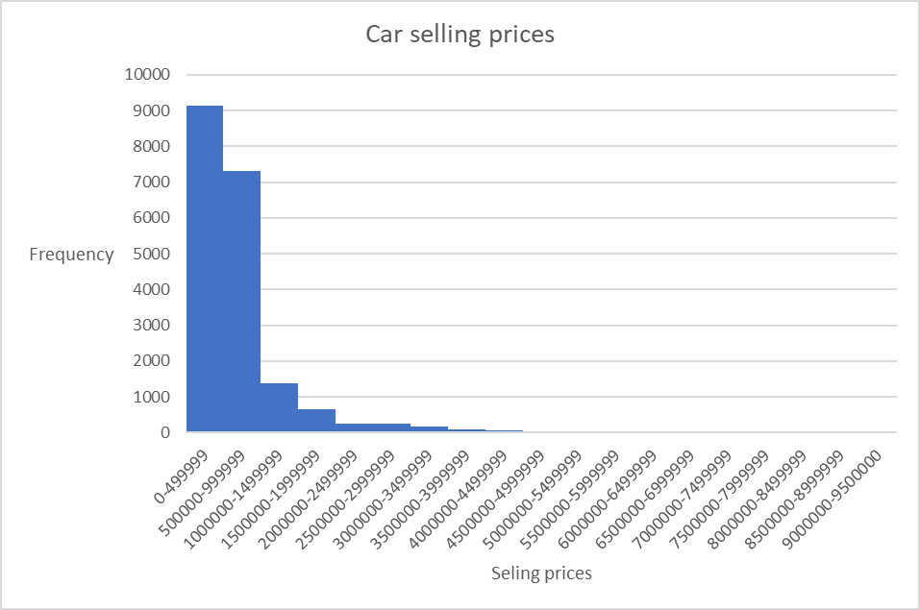
Graph 4. Distribution of Car selling prices
A positively skewed histogram would depict most prices clustered near the lower end, around the mode and median, with a long tail extending to higher price points. This visual representation aligns with the data’s characteristics, highlighting the affordability of most cars while showcasing the impact of high-value models.
From the company’s business perspective, the pricing structure reveals distinct opportunities. The clustering of prices near the lower end indicates a high demand for affordable models. To cater to this segment, the company should ensure consistent inventory levels and competitive pricing. Conversely, the high-value outliers represent an opportunity to market premium vehicles more effectively, emphasizing their unique features and justifying their higher prices.

Market concentration
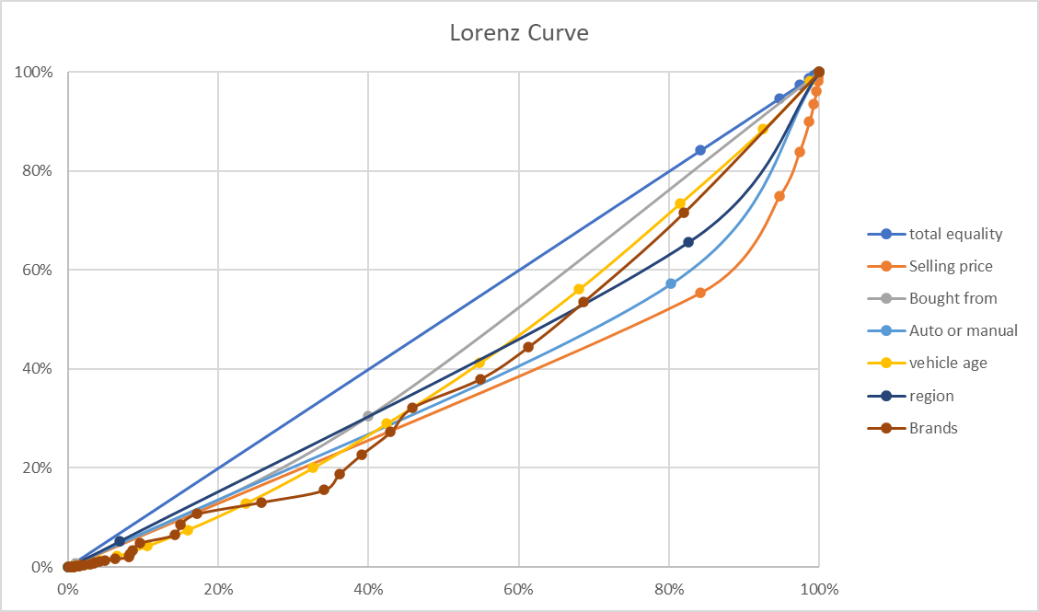
Graph 5. Lorenz Curve with different variables

Gini coefficient value has been calculated through cumulative relative frequency and sum value table. More specifically for nominal values, a Gini coefficient of 0.2216 indicates moderate based on what do you say it is moderate?inequality in the distribution of brand sales or preferences. This suggests that while the market is relatively balanced, some brands have a slightly larger share than others, but no single brand overwhelmingly dominates. It reflects a competitive market with it is just your company, based on your company’s selling palette you should not make statements on the whole market with 1000 other reseller companies and many other brands some concentration among a few leading brands. A Gini coefficient of 0.0953 for the "bought from" category indicates very low inequality in the distribution. This means sales are fairly evenly distributed across sources (e.g., individuals, Trustmark dealers, and dealers), with no single source dominating significantly.you should have calculated the lorenz curve for only price grouped by a qualitative variable e.g. lorenz curve of prices of different brands – I think here you did something else that is not the requirement of the task – at least the color labels of the visualization are not the different outcomes of one qualitative variable as it is should be The market appears balanced and competitive, suggesting our customers utilize all sources relatively equally. A Gini coefficient of 0.1716 for "origin" (America, Asia, Europe) indicates low inequality in distribution. This suggests that car sales or preferences are relatively evenly spread among these regions, with no region dominating excessively. However, there may still be a slight preference for cars from one region over others. A Gini coefficient of 0.2302 for "manual or automatic" indicates moderate inequality in preference or sales distribution. This suggests that one type (in our company’s case is manual) is somewhat more favored, but the market still reflects a reasonable balance between the two options.

Understanding the effect of the fuel efficiency on the price

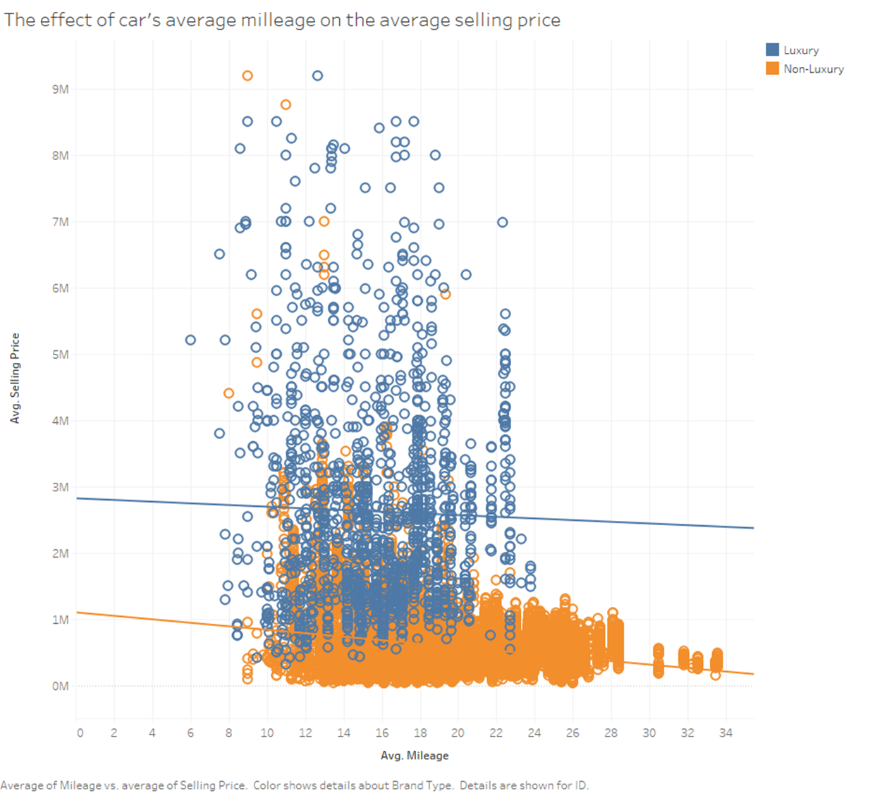
Graph 6. Relationship between the average mileage and average selling price for each brand type

The relationship between a car's mileage and its price is an important factor in the car market. From the visualization, in general, we can see both trend lines have a negative slope, which means the price of both luxury cars and non-luxury cars decreases as the mileage increases. in the subtitle there is fuel efficiency not milage The reason is higher mileage typically indicates more wear and tear, reducing the vehicle's overall condition and appeal to buyers

However, the decline is more noticeable in non-luxury brands compared to luxury ones. This could be due to several factors. For non-luxury cars, higher mileage may significantly impact their value, as they typically don’t have the same level of durability or high-end features as luxury brands, so higher mileage tends to negatively affect their resale value more significantly. Additionally, non-luxury cars often have fewer features and lower build quality, meaning that their long-term value is more heavily impacted by high mileage, making them less appealing in the market. As a result, the price drop for non-luxury brands is steeper compared to luxury cars -very good – you should also highlight the evident fact that the trend line of luxury cars starts from a higher point than the one for the non lux cars

On the other hand, the decline in luxury cars is less significant compared to non-luxury cars. Luxury cars are often built with superior materials, advanced technology, and high-quality engineering, which contribute to their durability and long lifespan. Even though fuel efficiency improves with higher mileage, the brand’s reputation, the quality of the car, and its advanced features still help maintain its value. Buyers may still consider these factors valuable and are often willing to pay a premium for a well-maintained luxury vehicle, even if it has a higher mileage. Therefore, while the price does drop, it’s less steep compared to non-luxury brands.

Understanding the effect of the number of vehicle ages on the prices
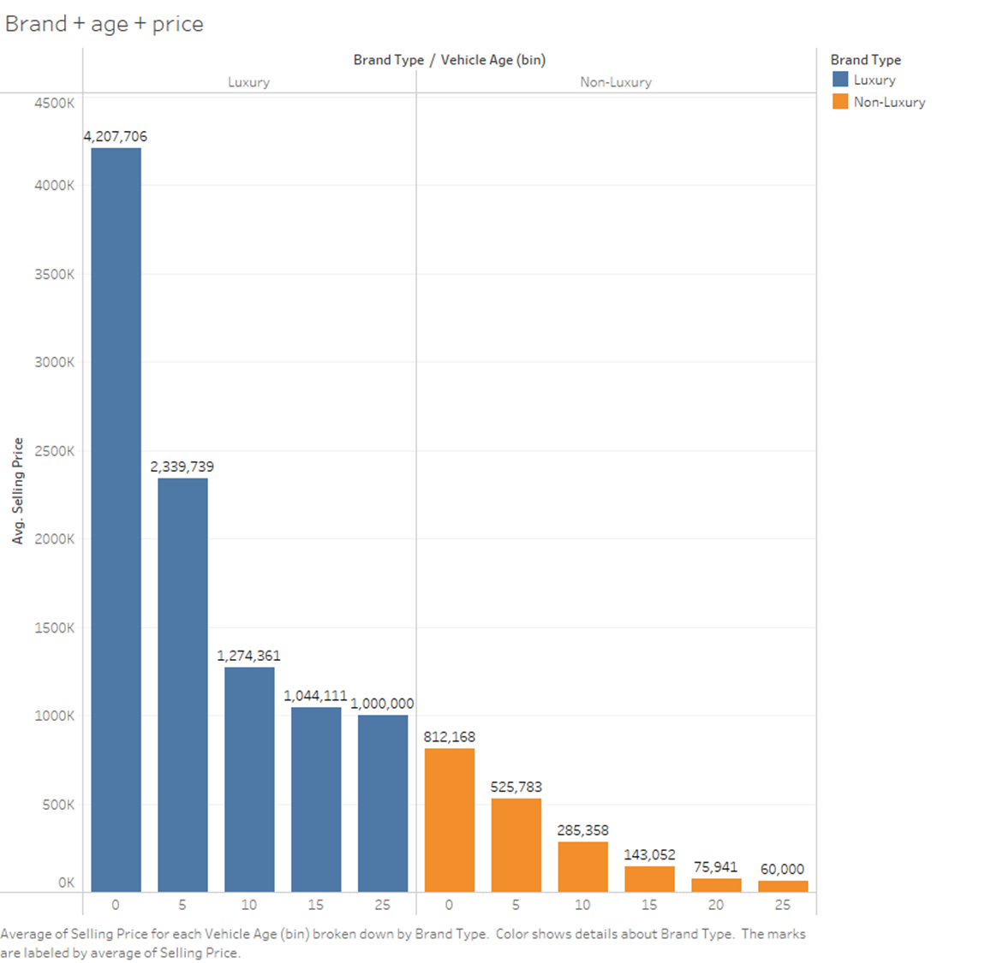
Graph 7. Relationship between vehicle age and average selling price based on brand type
a stacked graph would be better here as well – also no x axis label: age
By using a side-by-side bar chart, we can see a significant trend in the depreciation of luxury brands. For luxury cars, there appears to be a critical age when the price experiences a dramatic dropvery good, with an approximate decrease of 1,900,000 units after 5 years. This sharp decline suggests that luxury vehicles, although they maintain their value well during the initial years, face a significant drop in price once they pass this key age. This could be due to various factors such as market perception, the high cost of maintenance, or the introduction of newer models with advanced features, all of which may contribute to a faster depreciation rate in the later years of a luxury vehicle's life cycle.in this part you should refer back to the previous part where you had some similar statement on the differences between lux non lux

In contrast, the depreciation of non-luxury brands follows a much more consistent trend. When observing the data for non-luxury models, we can see that the price decreases steadily by about HUF 250,000 for the first 5 years; HUF 200,000 units for the next 5 years; and HUF 150,000 in the following 5 years, which shows no significant change in the depreciation rate as the vehicle ages. This consistent decline suggests that economy cars tend to lose value at a stable rate over time.”linear relationship” Unlike luxury cars, non-luxury vehicles do not experience sharp drops in price after a certain age, indicating that they depreciate steadily rather than drastically.

In conclusion, while luxury cars may depreciate slower in their initial years, they experience a sharp depreciation after reaching a certain age, whereas non-luxury cars exhibit a more predictable and gradual depreciation pattern over time.

Understanding the effect of brand reputation on price
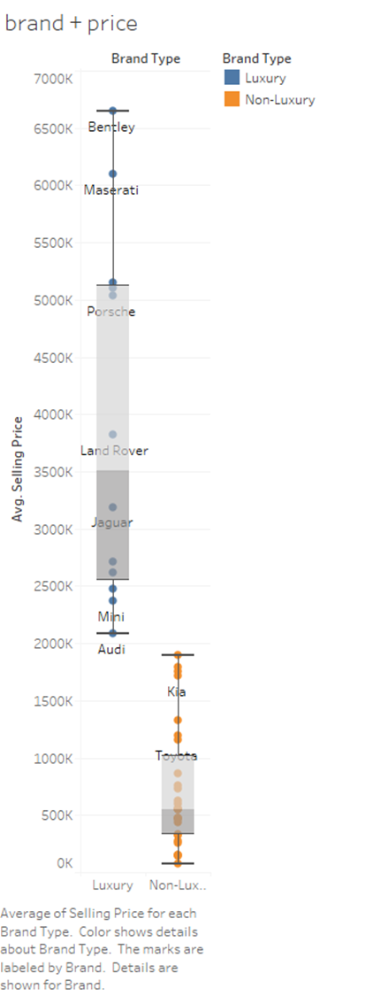
In the third visualization, we can see that the average selling price for luxury brands, such as Bentley, Maserati, and Porsche, is significantly higher compared to non-luxury brands.

The chart highlights the economic distinction between luxury and non-luxury car markets. Buyers of luxury cars care less about price and more about things like brand reputation value and performance. Non-luxury brands, on the other hand, target cost-conscious consumers, with affordability being a primary factor in purchasing decisions. I think at this point this distinction between luxury non luxury is a bit overhighlighted, and evident: of course if a car is luxury it will cost more – you should find/highlight other important aspects as well

Graph 8. Relationship of the reputation of different brands and their average selling price

Understanding the relationship between brand and fuel type

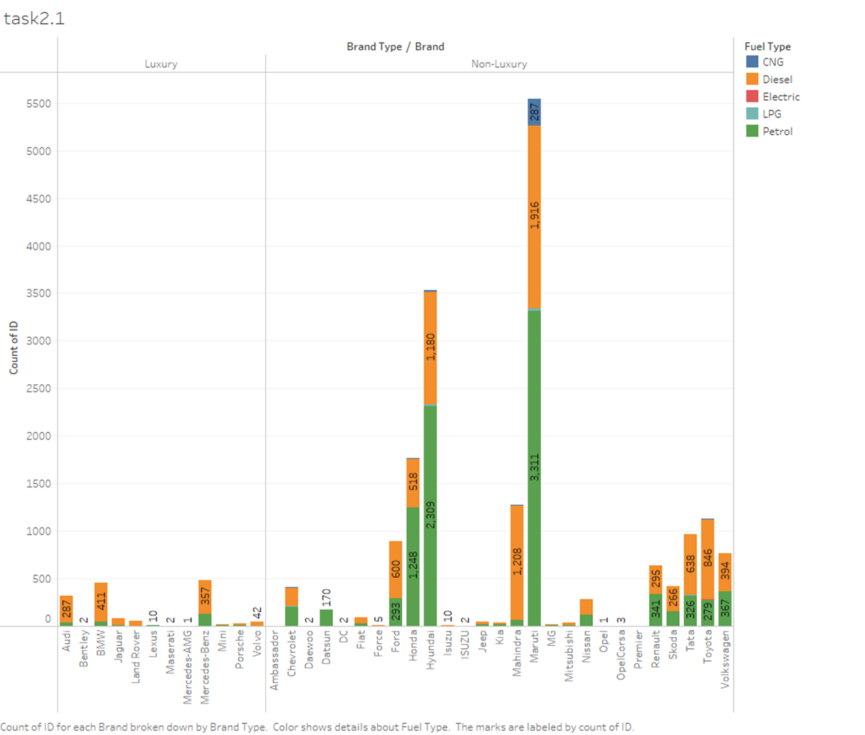
Graph 9. Relationship between Brand and Fuel Type
for this qual/qual I would chose a different visualization format, it is hard to interpret/read it: also it is an overkill if here you put a third dimension: luxury/non lux –-y only visualize 2 qual variables at once
From the visualization, we can see that the most common fuel type of both luxury brand cars and non-luxury brand cars are petrol and diesel. But there is a significant difference between the behavior of both types of brand. For some non- luxury brands such as Maruti, Hyundai, Honda, Toyota, most of the cars use petrol, but somehow they can control the balance between petrol and diesel. why? do some research on that on the internet with references But for luxury brands, most cars are using diesel which is affecting the environment negatively. why? do some research on that on the internet with references
The relationship between brand and fuel type reveals some interesting patterns. From the visualization, it's clear that petrol and diesel are the most common fuel types for both luxury and non-luxury brand cars. However, the behavior of these two brand categories differs significantly. For non-luxury brands like Maruti, Hyundai, Honda, and Toyota, petrol is the dominant fuel type, although these brands manage a balance between petrol and diesel vehicles. On the other hand, luxury brands tend to favor diesel cars, with most of their vehicles running on this fuel type.
This shift toward diesel in luxury brands can have a considerable impact on the environment. Diesel engines are typically more fuel-efficient than petrol engines, but they also produce higher levels of nitrogen oxide, which are harmful to both air quality and public health. Diesel emissions contribute to smog formation and respiratory issues, which are a growing concern in urban areas. While luxury brands may argue that diesel's higher fuel efficiency justifies their use, the long-term environmental consequences of increased diesel use cannot be ignored. Therefore, while luxury cars are more likely to use petrol for performance and efficiency, their preference for diesel fuel type still poses environmental challenges, especially in cities already grappling with air pollution.good

Understanding the relationship between origin of brand and transmission type

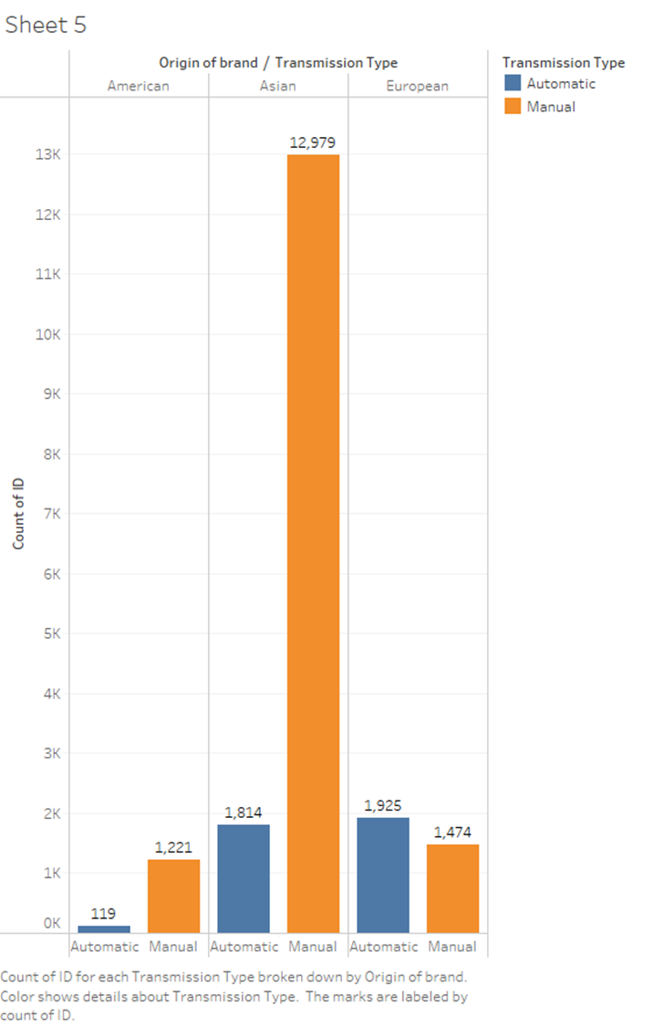
Graph 10. Relationship between origin of brand and transmission type
stacked graph would be better – or u should experiment a bit more creatively with other tableau visualiations we learnt The relationship between the origin of the brand and transmission type reveals interesting insights about regional preferences and trends. In Asia, manual transmission cars are significantly more popular, with 12,979 manual cars compared to just 1,814 automatic cars. This preference could be influenced by factors such as cost, fuel efficiency, and the practicality of manual transmissions in crowded urban areas where more control over the vehicle can be beneficial.how about some cultural aspects? do some research
In the American market, the data shows that manual cars are more prevalent than automatics. In reality, this idea is actually quite unusual because America has been leading the world in the car industry for many years . However, if we are considering specific segments of the market or certain trends, it may be due to their lower cost, better fuel efficiency, and preference among drivers for control in specific conditions.you should refer to some sources in these questions I think
Europe, on the other hand, shows a preference for automatic transmissions, but the difference is not as pronounced. This could be driven by the growing trend towards convenience and technology in European markets, where automatic cars offer smoother driving experiences in busy cities with heavy traffic.
Overall, the data shows that while manual transmissions remain popular in Asia and are still significant in America, Europe is leading the shift toward automatic transmissions. This shift reflects broader trends in regional driving habits, vehicle preferences, and technological advancements that prioritize ease of use and fuel efficiency.

Understanding how kilometer driven affect the selling price
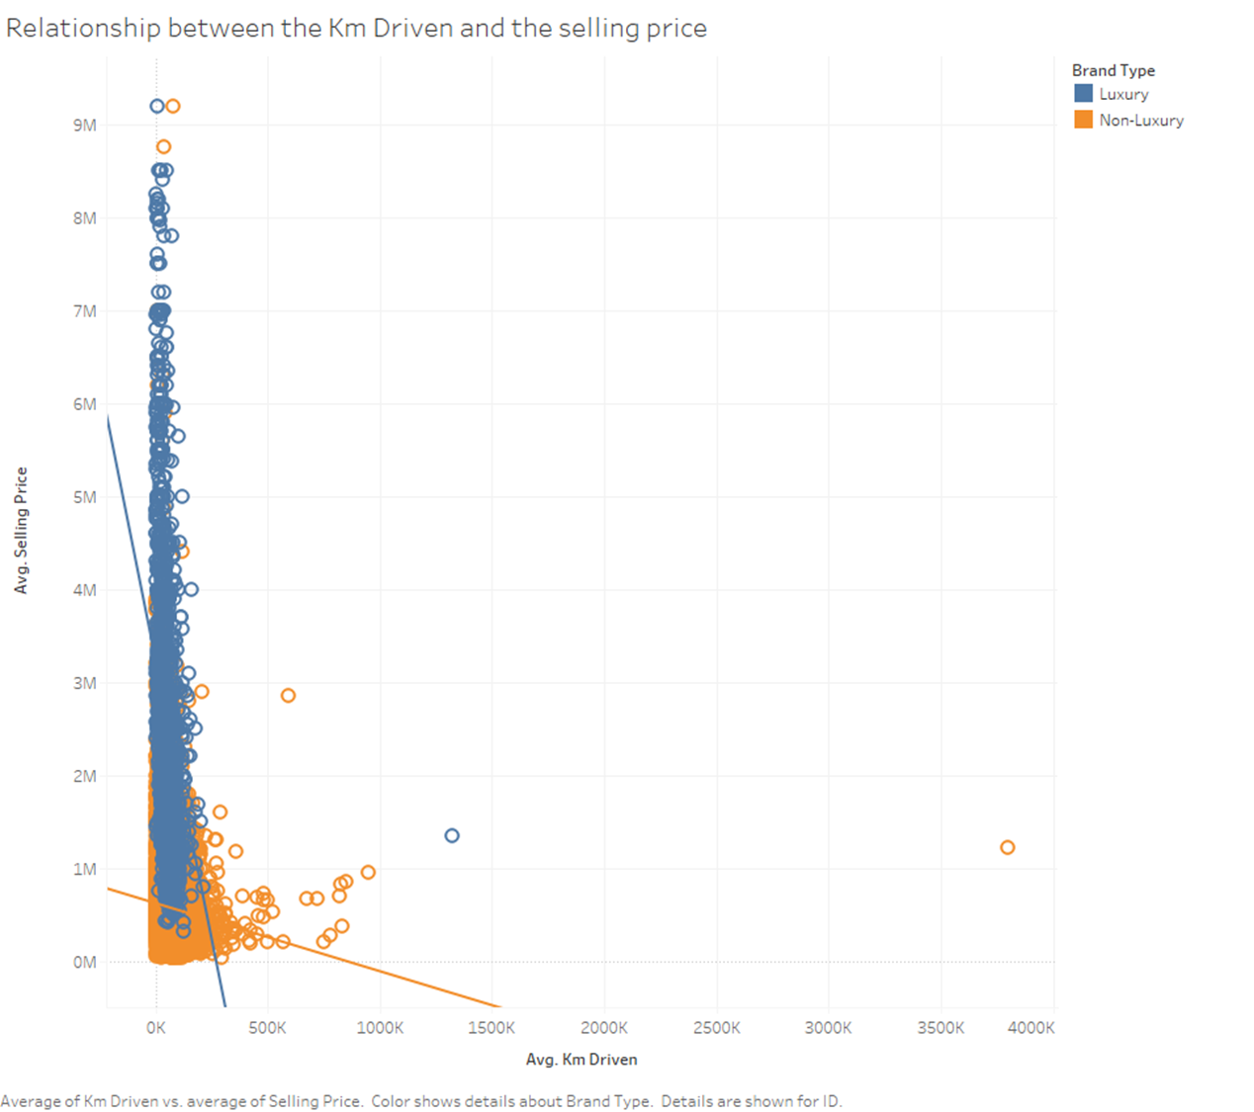
Graph 11. Relationship between km driven and price
if you do some outlier filtering this graph will be 100% better – also have you tried taking the logarithms of the quant variables? also in the beginning of your essay you already dealed with scatter plot – why not putting this thereFrom the graph, we can see that both luxury and non-luxury please choose a different coloring qualitative variable here :D – what is the difference between km drive and milage? it seems you have both variables seperately? arent these two synonyms? car prices tend to decrease as the number of kilometers driven increases. This is because higher mileage usually means the car is older and has more wear and tear, which reduces its value. Buyers might also expect higher repair costs, less reliability, and a shorter lifespan for high-mileage cars.
For luxury cars, the price drop is steeper compared to non-luxury cars. This happens because luxury cars come with higher maintenance costs, and buyers expect them to be in almost perfect condition. When they’re not, they lose value quickly. On the other hand, non-luxury cars show a slower decline in price because buyers of these cars usually focus more on practicality and affordability rather than brand or condition.
In summary, the graph shows that kilometer driven has a big impact on car prices. Luxury cars lose value faster because of their reliance on condition and brand reputation, while non-luxury cars drop in price more gradually since they are aimed at cost-conscious buyers. This highlights the negative relationship between kilometer driven and resale value for all types of cars.

Dashboard: Conclusion
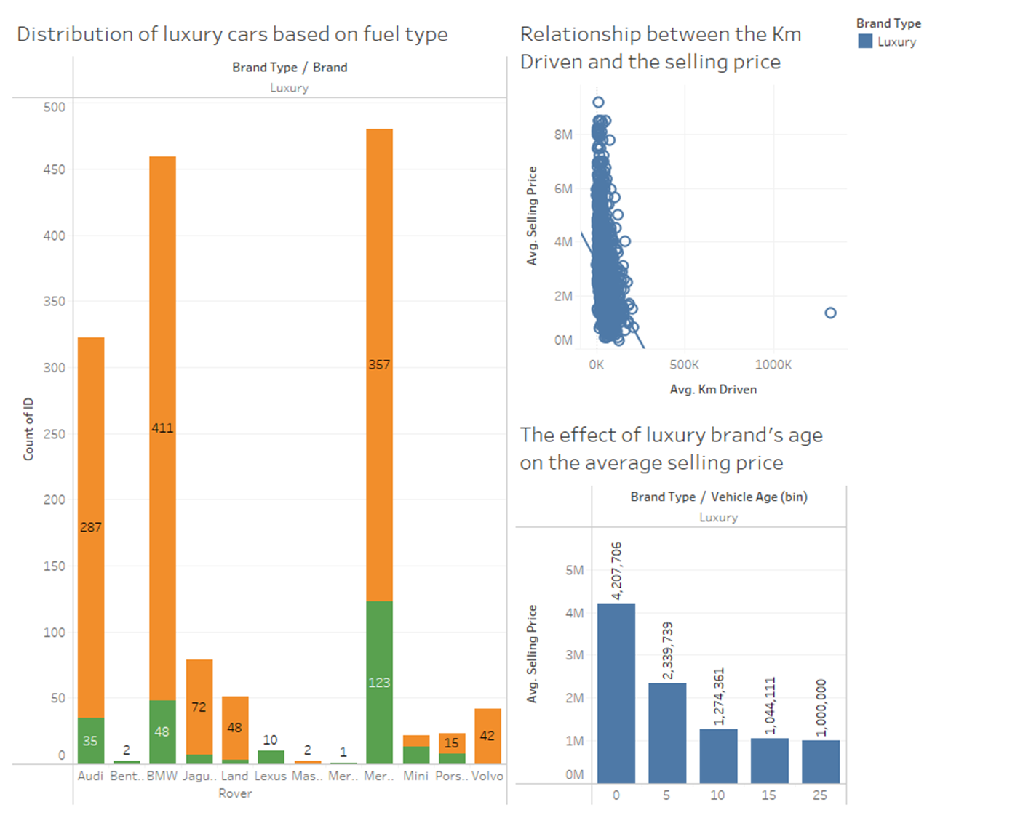
Graph 12. Dashboard
The dashboard highlights key factors affecting luxury car prices, fuel type distribution, and the potential for environmental impact, providing insights for strategic action.
Both kilometers driven and vehicle age significantly reduce the selling price of luxury cars. As the number of kilometers driven increases, the selling price of the car decreases significantly. Similarly, cars under five years old maintain average prices above HUF 4,000,000, while those over 10 years old fall to around HUF 1,000,000. The reason for these declines probably is because cars with high kilometers driven and older age mean the car is old, which makes it more prone to having problems with its internal mechanisms. Even though luxury cars have high reputation value, the usage and age clearly affect their depreciation.
The “Distribution of cars based on fuel type” graph shows diesel and petrol dominate the luxury market, with brands like BMW relying heavily on diesel (411 vehicles compared to only 48 petrol). Diesel engines, while efficient, release high levels of nitrogen oxides (NOx) and particulate matter, which contribute to air pollution and smog. This can lead to respiratory issues in humans and exacerbate climate change. Similarly, petrol engines produce significant amounts of carbon dioxide (CO2), a major greenhouse gas responsible for global warming. The reliance on these two fuel types not only harms the environment but also increasingly conflicts with consumer demand for sustainable and eco-friendly alternatives. maybe it would be good to build up some story behind the dashboard as well – for example: it could be interactive and the story could be the following: the dashboard helps the costumers after giving some parameters (how much money they have, what is their desired fuel type etc.) it suggests them an ideal brand
Therefore, to answer the question of how these numbers can help our company increase revenue, we would suggest that, to boost profits and promote environmental sustainability, our company should consider expanding into electric vehicles. EVs produce no emissions and appeal to eco-conscious buyers, enhancing the company’s reputation. A stronger focus on sustainability will attract more customers, boost loyalty, and grow profits, positioning the company as a forward-thinking market leader.
By linking depreciation trends, fuel type dominance, and environmental concerns, our company can take strategic action. Introducing electric vehicles aligns profitability with sustainability, benefiting both the company and the environment.

these aspects I think are missing
- Interpret the results of each statistical analysis in the context of the dataset’s topic and compare the results to one another (e.g., what does the relationship between the mean and the median indicate, and how can this be read from the histogram)!
- Group the selected dataset based on an arbitrary nominal or ordinal variable. In each group, analyse the concentration of the variable in yellow using a Lorenz curve based on deciles! Present the Lorenz curves of the groups on one unified diagram!
also when it comes to the visualizations you should write some more sentences on each graph answering the question: how do these special visualizations help your company increase profit?
The dashboard should include at least one interactive filter!

