**EXPLAIN in MySQL**

The EXPLAIN statement in MySQL is a powerful tool that helps you understand how a query will be executed by the database. It provides insights into the execution plan, showing which indexes will be used, the join methods, and the cost of each part of the query.

For example, if you want to analyze how the following query is executed:

sql

Copy code

EXPLAIN SELECT * FROM hotelbookingdb.users WHERE email = 'example@example.com';

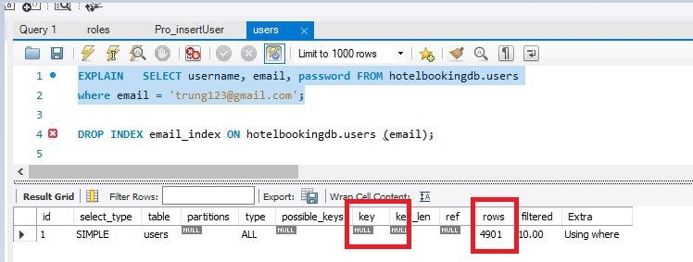

The output will contain several important columns:

* **id**: The query identifier, showing the order in which parts of the query are executed.
* **select_type**: Indicates whether the query is a simple query or a more complex one (e.g., SIMPLE, PRIMARY, SUBQUERY).
* **table**: The name of the table used in the query.
* **type**: The join type, showing how rows are selected. Common values are:
  + ALL: Full table scan (inefficient).
  + index: Full index scan (faster than ALL).
  + range: Scans a range of index values (efficient).
  + ref and eq_ref: Lookups using indexes (very efficient).
* **possible_keys**: The possible indexes that MySQL might consider for the query.
* **key**: The actual index that MySQL decided to use.
* **rows**: An estimate of the number of rows MySQL expects to scan.
* **extra**: Additional information like "Using where", "Using index", etc.

**Example Output of EXPLAIN:**

| **id** | **select_type** | **table** | **type** | **possible_keys** | **key** | **rows** | **Extra** |
| --- | --- | --- | --- | --- | --- | --- | --- |
| 1 | SIMPLE | users | const | email_index | email | 1 | Using where |

In this example:

* MySQL uses the email_index (index on the email column).
* The query type is const because it is looking for an exact match (email = 'example@example.com'), which is very efficient.
* MySQL expects to scan only 1 row.

You can create an index on the email column to speed up the search:

sql

CREATE INDEX email_index ON hotelbookingdb.users (email);

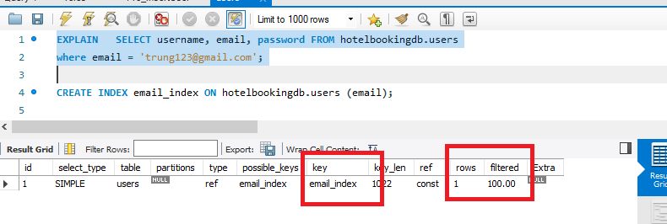

**How Indexing Works:**

* **B-trees**: Most MySQL indexes are implemented as B-trees. This allows efficient lookups, insertions, and deletions, with logarithmic time complexity (O(log n)).
* **Improved search**: When you search for email = 'example@example.com', MySQL can quickly navigate through the index to find the exact match, instead of scanning every row in the table.
* **Cost of indexes**: While indexes improve read performance, they do add overhead to insert, update, and delete operations, because the index must be maintained whenever data is modified.

**Benefits of Indexing:**

* **Faster search**: Indexes help speed up queries that filter rows (WHERE clause).
* **Efficient sorting**: Indexes can be used to speed up sorting operations (ORDER BY).
* **Reduces full table scans**: MySQL can directly jump to the relevant rows using the index, avoiding the need to scan the entire table.

**Drawbacks of Indexing:**

* **Storage cost**: Indexes require additional storage.
* **Insert/update cost**: Adding, updating, or deleting rows requires maintaining the index, which adds overhead to write operations.

**Conclusion:**

* **EXPLAIN** helps you understand how MySQL executes a query and whether the index is being used effectively.
* Indexing the email column is a crucial optimization for queries filtering by email, as it allows MySQL to avoid a full table scan and quickly retrieve the relevant rows.