VIETNAM GENERAL CONFEDERATION OF LABOR
TON DUC THANG UNIVERSITY
FACULTY OF INFORMATION TECHNOLOGY


FINAL REPORT
Topic 12 : Esports Analytics

Instructor: Võ Thị Kim Anh
Student: Đàm Trung Hiếu-523K0004
Class:23K50201
Huỳnh Nhật Tiến-523K0027
Class:23K50201
Phạm Minh Hiếu-523V0001
Class:23K50201

HO CHI MINH CITY, 2026

GROUP SECTION

Business Analysis

Scenario description
The Esports League Analytics system is a full-stack Polyglot Persistence platform designed to manage and analyze professional esports tournament data for League of Legends (LoL). In professional esports, league managers need to track team rosters, enforce eligibility rules, and generate performance leaderboards. Analysts require deep statistical insights into player KDA (Kills/Deaths/Assists) performance and champion usage patterns across tournaments.
The system addresses two fundamentally different data concerns: (1) structured, transactional data such as team rosters, player registrations, and match results that require ACID guarantees; and (2) flexible, high-velocity match statistics including nested player performance data that require schema flexibility and fast aggregation.
This dual requirement justifies a Polyglot Persistence architecture where MS SQL Server handles the structured source-of-truth layer and MongoDB handles the flexible analytics layer. The system is demonstrated using data from teams T1, Cloud9, Fnatic, and G2 Esports across two tournaments: LCK Spring 2025 and Worlds 2024.

User Requirements
-Fan/Viewer Requirements:
View a global player leaderboard ranked by win rate using DENSE_RANK() SQL window function
Filter leaderboard by season (LCK Spring 2025 or Worlds 2024)
Search for specific players by name, team, or role
View KDA analytics for all players sorted by KDA score

-Analyst Requirements:
View aggregated KDA statistics per player calculated via MongoDB $unwind + $group pipeline
Filter KDA analytics by tournament using MongoDB $match optimization
View team performance statistics including win rate, average kills/deaths/assists per tournament
View champion analytics — pick rate, win rate, KDA per champion — across all matches
Search and sort champion data by pick count, win rate, KDA, or gold

-Manager/Admin Requirements:
Register players to team rosters via Stored Procedure (sp_register_player) with eligibility validation
System must prevent duplicate registrations — one player cannot belong to two teams in the same season
View complete roster listing with player, team, season, and jersey number information
Trigger (TR_Roster_PreventDuplicate) automatically enforces roster constraints at database level

Workflow
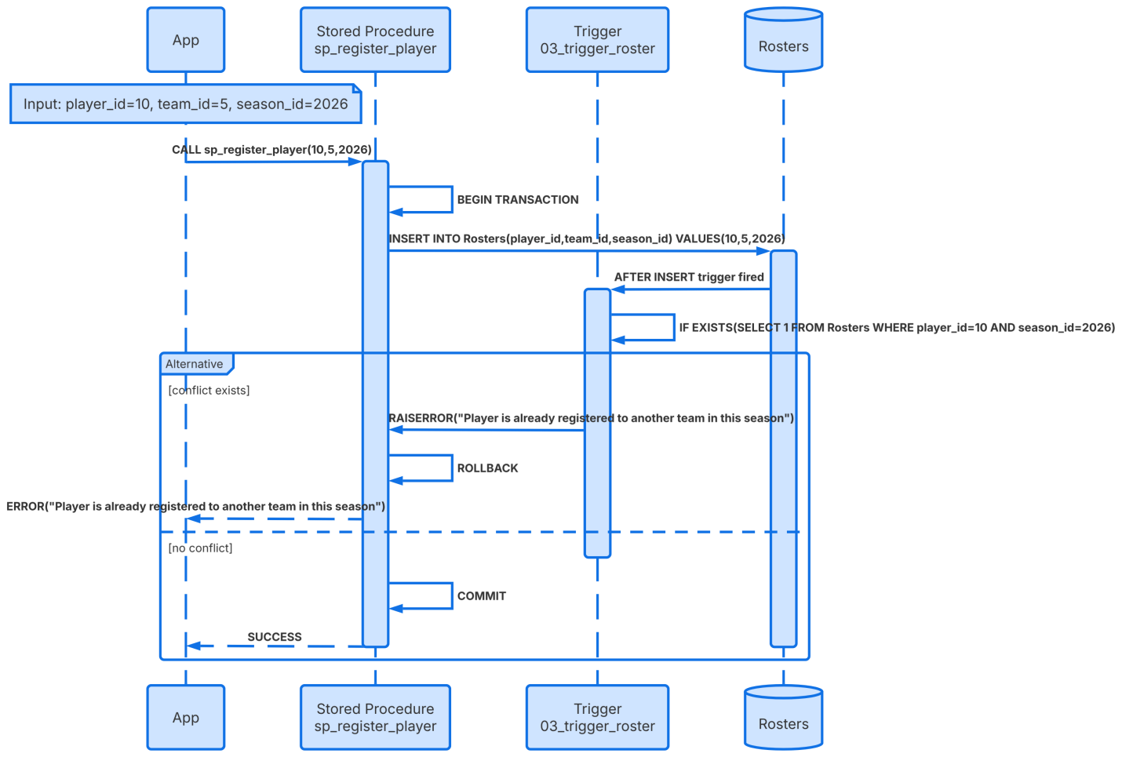

System Architecture
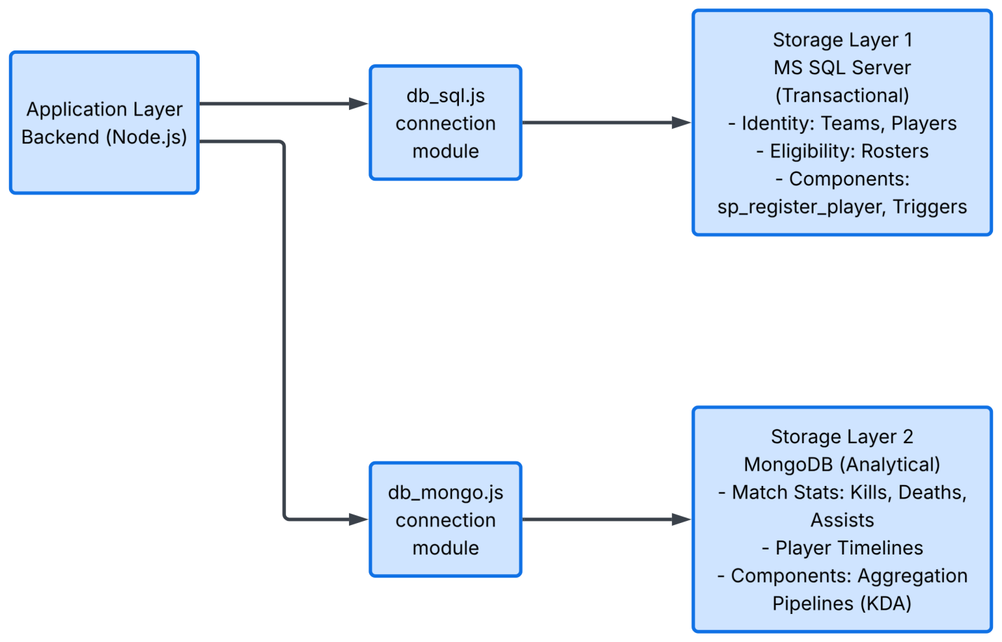
Layer | Technology | Responsibility
Database (SQL) | MS SQL Server Express | Teams, Players, Rosters, Seasons, Matches -ACID transactions
Database (NoSQL) | MongoDB Community Server | MatchStats collection - nested player stats, flexible schema
Backend API | Node.js + Express.js | REST API bridging SQL and MongoDB to frontend
Frontend UI | React.js | 4-page dashboard: Leaderboard, KDA Analytics, Champions, Roster Admin

Note:
Our Polyglot architecture applies the CAP theorem as follows:
-MS SQL Server (CP - Consistency): Guarantees 100% accuracy for rosters, instantly preventing duplicate player registrations
-MongoDB (AP - Availability): Processes massive match logs incredibly fast. A slight delay in updates (Eventual Consistency) is perfectly acceptable for analytics

Database Design

Full ERD
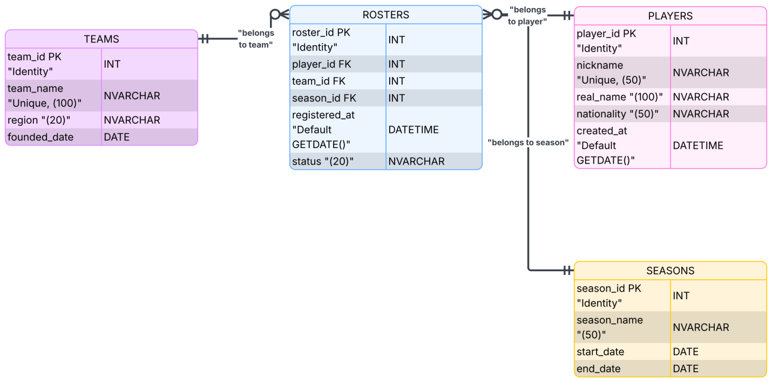
Table | Key Columns | Purpose
Seasons | season_id (PK), season_name, start_date, end_date, is_active | Tournament seasons (LCK Spring 2025, Worlds 2024)
Teams | team_id (PK), team_code, team_name, region, founded_year | Esports organizations (T1, Cloud9, Fnatic, G2)
Players | player_id (PK), player_code, nickname, real_name, role, nationality | Individual players (Faker, Caps, Rekkles...)
Rosters | roster_id (PK), player_id (FK), team_id (FK), season_id (FK), jersey_number | Player-team-season registrations — enforced by Trigger
Matches | match_id (PK), match_code, season_id (FK), team_winner_id (FK), team_loser_id (FK), mongo_match_id | Match results + link to MongoDB

NoSQL Collection structures
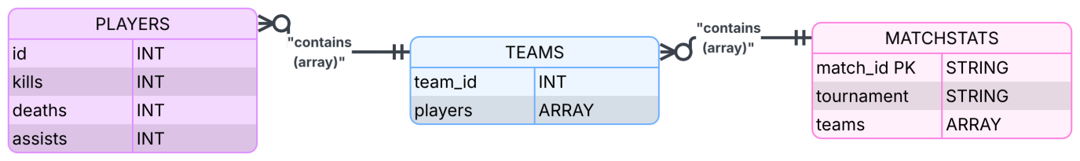
Field | Type | Description
match_id | String | Unique identifier (M001-M022) - links to SQL mongo_match_id
tournament | String | Tournament name (LCK Spring 2025 / Worlds 2024)
date | String | Match date
duration_minutes | Number | Match duration in minutes
teams | Array | Array of 2 team objects, each containing result and players array
teams[].team_id | String | Team code (T1, C9, FNC, G2)
teams[].result | String | win / loss / no_contest
teams[].players | Array | Array of 5 player objects with stats
teams[].players[].player_id | String | Player code (T101, T103...)
teams[].players[].champion | String | Champion picked (Faker, Lee Sin...)
teams[].players[].kills | Number | Kills in this match
teams[].players[].deaths | Number | Deaths in this match
teams[].players[].assists | Number | Assists in this match
teams[].players[].gold_earned | Number | Total gold earned
teams[].players[].damage_dealt | Number | Total damage dealt

INDIVIDUAL SECTION

Technical Defense

Student 1:
Full Name: Đàm Trung Hiếu | Student ID: 523K0004 | Class: 23K50201
- Ownership
Assumed the dual role of NoSQL Analyst and Full-Stack Developer. Core responsibilities included designing the nested JSON structure for MongoDB, constructing Aggregation Pipelines ($unwind, $group), developing the REST API using Node.js, building the user interface with React.js, and compiling the final project report
- Justification
A nested JSON document model was selected for the MongoDB database to completely eliminate the need for costly JOIN operations when querying Match and Player statistics. React.js and Node.js were chosen for the Full-Stack implementation because they natively communicate using JSON, creating a seamless and high-performance data pipeline from the NoSQL database directly to the frontend
- LogicWalkthrough
When the client requests leaderboard data, the Node.js backend connects to MongoDB and executes the Aggregation Pipeline. The pipeline first uses $unwind to deconstruct the nested arrays, flattening the player data. It then applies $group to aggregate total kills, deaths, and assists for specific champions or players. Node.js sends this calculated JSON payload to React.js, which dynamically renders the Leaderboard UI
- AI Critique
During development, the AI provided an incorrect formula for calculating the Win Rate. I identified the mathematical flaw in the AI's logic and manually corrected the formula within the aggregation pipeline to ensure accurate statistical outputs

Student 2:
Full Name: Phạm Minh Hiếu | Student ID: 523V0001 | Class: 23K50201
- Ownership
Acted as the System Architect. Primary responsibilities involved designing the overarching Polyglot Architecture, creating detailed System Diagrams, and programming Stored Procedures and Transactions within the MS SQL Server environment
- Justification
A Polyglot Architecture was implemented to utilize the strengths of two distinct database systems: MS SQL Server enforces strict ACID compliance for sensitive tournament registration data, while MongoDB handles the massive, read-heavy load of post-match analytics. Stored procedures were utilized to encapsulate complex registration logic, ensuring that database operations are secure and modular
- LogicWalkthrough
For a player registration event, the backend triggers a specific Stored Procedure. This procedure executes within a Transaction block. It verifies system constraints and attempts to insert the record. If all conditions are met, the transaction commits. If any error occurs or a constraint is violated, the transaction rolls back, ensuring no partial or corrupted data is saved to the SQL database
- AI Critique
When generating the Stored Procedure code, the AI completely missed incorporating error handling. I critiqued this oversight and manually added the necessary TRY/CATCH blocks to ensure the system could gracefully catch and handle SQL execution errors

Student 3:
Full Name: Huỳnh Nhật Tiến | Student ID: 523K0027 | Class: 23K50201
- Ownership
Served as the SQL Core Developer. Core tasks included designing the relational SQL Schema, writing INSTEAD OF Triggers, and implementing Window Functions for data ranking
- Justification
A normalized SQL Schema was strictly required for the Roster Management side to maintain data integrity. INSTEAD OF triggers were explicitly chosen because they intercept INSERT statements before they affect the table, which is the most optimal way to block invalid actions like duplicate player registrations across different teams. Window Functions like DENSE_RANK() were used to efficiently generate leaderboards directly at the database level
- LogicWalkthrough
When an admin attempts to register a player into a team roster, the INSTEAD OF trigger fires before the INSERT occurs. The trigger queries the Roster table to check if the target player_id is already associated with another active team_id in the same season. If a duplicate is found, the trigger explicitly raises an error and aborts the insert. If no duplicate exists, it executes the INSERT statement
- AI Critique
The AI generated an AFTER trigger instead of an INSTEAD OF trigger for the duplicate-blocking logic. I recognized this as a critical logic error, as an AFTER trigger allows bad data to be temporarily written before rolling back, whereas the INSTEAD OF trigger correctly intercepts and prevents the bad data from being written in the first place

APPENDIX

AI Tools Used
Tool: Claude (Anthropic) — Primary AI assistant for code generation and architecture advice
Tool: GitHub Copilot — Inline code suggestions during development

AI Prompt Log
Prompt Summary | AI Output | Manual Correction | Prompt Summary
1 | Generate SQL schema for Esports analytics with Teams, Players, Rosters, Seasons, Matches tables | Correct schema with FK constraints | Added IX_Roster_Player_Season index for Trigger performance
2 | Write INSTEAD OF INSERT Trigger to prevent duplicate player registrations in same season | Generated AFTER INSERT trigger (wrong type) | Changed to INSTEAD OF INSERT to prevent data being written before validation
3 | Generate MongoDB seed data with nested teams and players arrays for 20 LOL matches | Correct structure with T1, Cloud9, Fnatic, G2 | Added 2 edge case documents (empty array, zero kills/deaths)
4 | Write MongoDB aggregation pipeline to calculate average KDA per player using $unwind | Correct 7-stage pipeline | Added preserveNullAndEmptyArrays: true for edge case handling
5 | Write team average pipeline calculating win rate per team per tournament | Win rate calculation missing /5 divisor for wins field | Fixed: (wins/5) / (total_player_entries/5) to produce correct percentages
6 | Generate Stored Procedure sp_register_player with eligibility checks | Missing TRY/CATCH and SCOPE_IDENTITY() | Added transaction management and roster_id return value
7 | Write Node.js Express backend connecting to SQL Server and MongoDB | Used wrong connection config for named instance SQLEXPRESS | Added instanceName: 'SQLEXPRESS' and enabled SQL Server Browser service
8 | Generate champion analytics pipeline grouping by champion name | Correct pipeline structure | Added players_used $addToSet to show which players use each champion

Race Condition Testing
Trigger Test: Attempted concurrent INSERT of same player (Zeus, player_id=1) to two different teams (T1 and Cloud9) in the same season. Trigger successfully blocked the second INSERT with error message identifying the conflicting team.
SP Test: Called sp_register_player with player already registered in season. Procedure returned success=0 and descriptive error message naming the existing team.
MongoDB Edge Case Test: Inserted document with empty players array (M021), verified pipeline did not crash with preserveNullAndEmptyArrays. Inserted document with kills=0/deaths=0 (M022 support player), verified KDA calculation used max(deaths, 1) = 1 to avoid division by zero.

