  - INFORMATION SYSTEM ANALYSIS AND DESIGN

Assignment 06

Multimodal Search System for E-Commerce
Submission detail | Value
Student name | Nguyễn Gia Đức Trung
Student ID | B23DCVT423
Class | D23TTNT01

Abstract
This report presents a three-layer prototype for e-commerce product search using text, simulated voice, and image input. Each mode is normalized into a common query object. Candidate retrieval and result ranking are implemented as separate operations. The prototype searches a 12-product JSON dataset and a small in-memory image vector index; it also demonstrates a combined text-and-image query and customer-scoped order lookup. A 13-query Top-1 evaluation produced 12 successful results (92.31%). The remaining failure illustrates the limits of keyword matching when the customer uses synonyms. The report includes Visual Paradigm diagrams and program-output figures generated from the executable prototype.

Keywords
multimodal search; three-layer architecture; UML; keyword retrieval; image similarity; ranking

1. Introduction and Problem Description

1.1 Context
Online customers may express the same shopping need in different ways: typed keywords, a spoken sentence, or a picture of a desired product. A search system must convert these inputs into comparable representations, find candidate items, and present the most useful results. The assignment focuses on the system design and a working small prototype, rather than a production e-commerce platform.

1.2 Problem and objective
The problem is to support several input modes without creating a separate end-to-end architecture for each mode. The proposed solution uses one SearchUI, modality-specific conversion services, a common query dictionary, retrieval services, and a distinct ranking service. Products and orders are stored behind repositories. The user receives item names, prices, and ranking scores, or an order result when a known order ID is supplied.

1.3 Scope
- Required modes: English keyword search, voice search simulated from transcript text, and image-similarity search from a local PNG/JPEG file.
- Additional demonstrations: a weighted text-and-image query, a basic price ceiling, and order lookup constrained by customer ID.
- Dataset: 12 products, 12 product illustrations, two separate query illustrations, and three sample orders.
- Interface: a command-line SearchUI. No web server, microphone capture, or persistent database is required for this prototype.

1.4 Design principle
The processing path is: input → common query representation → candidate retrieval → ranking → results. The presentation layer collects input and displays output; the application layer interprets and searches; the data layer stores products, orders, and vectors. This layering prevents direct UI-to-database access and makes each search method replaceable.

2. Requirements Analysis

2.1 Actor, inputs, and outputs
The primary actor is the Customer. Inputs are (1) English keyword or natural-language text, (2) transcript text representing a voice request, (3) a local product image, and optionally (4) an order ID plus customer ID. Product-search output consists of ranked product records with product ID, name, price, and score. Order-search output consists of a matching order ID, status, total, and items, or an explicit not-found response.

2.2 Functional requirements
ID | Requirement | Implementation
FR1 | Search products by typed text | Text query + keyword retrieval
FR2 | Accept simulated voice input | SpeechService transcript + voice query
FR3 | Search products by image | ImageService + cosine vector index
FR4 | Use a common query format | QueryService dictionaries with type field
FR5 | Rank and show product results | RankingService + SearchUI scores
FR6 | View product information | Product records hold details; the CLI displays name and price (no separate detail command)
FR7 | Search and view own order | OrderRepository checks customer ID
FR8 | Combine text and image signals | Weighted multimodal ranking

2.3 Non-functional requirements
Maintainability: the system is divided into presentation, application, and data modules, and services have narrow responsibilities. Reproducibility: the sample data and illustration generator are included, with exact run commands in README.md. Usability: command output reports the input, processing path, candidate count, and scores. Reliability: missing image files and empty voice transcripts produce explicit errors. Privacy: a sample order is returned only when both its ID and customer ID match; this is a prototype constraint, not a replacement for authentication. Performance: the in-memory design is appropriate only for a small product set.

3. Use Case Model
The Customer may search for products using keyword, voice, or image input. These are three specialized forms of Search Product. The customer may then View Product. Separately, the customer may Search Order and View Order. The use cases state the customer's goals; the internal services that realize them appear in the component and sequence diagrams.
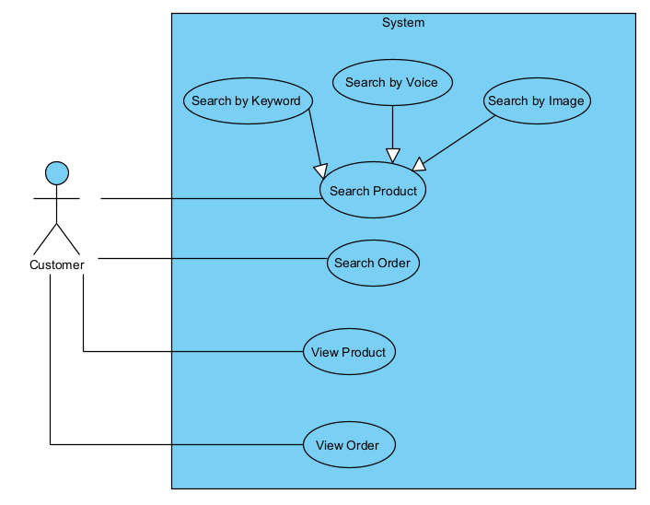

3.1 Use case descriptions
Use case | Precondition | Main outcome
Search by Keyword | Text entered | Ranked product list
Search by Voice | Transcript supplied | Transcript converted to text, then ranked products
Search by Image | Image file supplied | Visually similar ranked products
Search Order | Order ID and customer ID supplied | Matching order or not-found result

The voice branch uses a simulated transcript. In the UML model it may still be labeled voice search because the component boundary is the same as a future speech-to-text service. View Product and View Order are optional follow-up interactions after a search result is available.

4. Three-Layer Component Diagram with Packages
UML package | Components / modeled elements | Responsibility
Presentation Layer | SearchUI; VoiceInput; ImageUpload; SearchResultView | Collect mode-specific input and present output
Application / Intelligence Layer | QueryService; SpeechService; ImageService; SearchService; RankingService | Normalize, encode, retrieve, combine, and rank
Data Layer | ProductRepository; OrderRepository; VectorIndex; ProductDatabase; OrderDatabase; ImageStorage | Provide product, order, and vector data

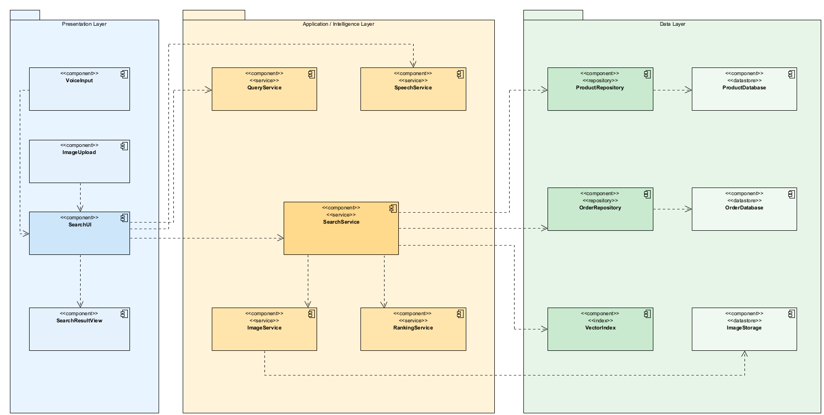

4.1 Components and dependencies
The Component Diagram shows the components recommended by the handout inside three packages. The Presentation Layer contains SearchUI, VoiceInput, ImageUpload, and SearchResultView. The Application / Intelligence Layer contains QueryService, SpeechService, ImageService, SearchService, and RankingService. The Data Layer contains ProductRepository, OrderRepository, VectorIndex, ProductDatabase, OrderDatabase, and ImageStorage. The storage components represent JSON files and image files in the prototype.
Dependencies follow Presentation -> Application / Intelligence -> Data. SearchUI uses QueryService, SpeechService, and SearchService; SearchService uses the repositories, VectorIndex, ImageService, and RankingService. SearchUI does not read JSON files or the vector index directly. ImageService computes image vectors, while ProductRepository and OrderRepository read their JSON files. The Python entry point wires these components together.

4.2 Retrieval versus ranking
Retrieval chooses a candidate set C(q) based on word overlap or cosine similarity. Ranking then orders C(q) using normalized relevance and a small stock signal. Keeping these steps separate makes the architecture visible in code and allows a later semantic retriever or business rule to be substituted without changing SearchUI.

5. Voice-Search Sequence Diagram
This interaction demonstrates the required sequence with Customer as a UML actor and six system lifelines: SearchUI, SpeechService, QueryService, SearchService, ProductRepository, and RankingService. SearchUI has the boundary stereotype; SpeechService, QueryService, SearchService, and RankingService have the control stereotype; ProductRepository has the entity stereotype. The Customer supplies transcript text as the simulated audio input. SearchUI asks SpeechService to transcribe it, creates a voice query via QueryService, and asks SearchService to retrieve and rank products.
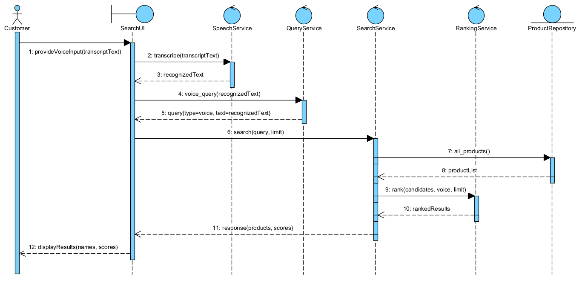

Step | Message / result
1–3 | Customer → SearchUI → SpeechService; recognized text returns
4–5 | SearchUI → QueryService; normalized voice query returns
6–8 | SearchUI → SearchService → ProductRepository; product list returns
9–10 | SearchService → RankingService; ranked results return
11–12 | SearchService → SearchUI → Customer; scored results displayed

The same application service receives a text query when the customer types a search. The image branch instead calls ImageService and VectorIndex. The voice sequence is therefore one concrete path through the shared architecture.

6. Python Implementation

6.1 Modules and data
Module | Purpose
presentation/search_ui.py | Input methods and result display
application/query_service.py | Common query dictionaries
application/speech_service.py | Simulated speech-to-text
application/image_service.py | Pixel-based visual vector
application/search_service.py | Candidate retrieval and modality routing
application/ranking_service.py | Final score and ordering
data/*_repository.py | Read product and order JSON data
data/vector_index.py | In-memory cosine candidate search

The product dataset contains 12 items across shoes, bags, clothing, electronics, and accessories. Each record stores an ID, name, brand, category, color, price, stock, description, and image path. The sample images were generated specifically for this prototype. Two additional query illustrations introduce slight visual changes so that the image demonstration is not a byte-for-byte lookup of a stored file.
Example product image and separate image query
 | 
Stored product: Red Travel Backpack | Separate query illustration: red backpack

6.2 Execution flow
The main.py entry point builds repositories and vectors, then routes the selected command to SearchUI. For a text or voice query, SearchService normalizes words and retrieves products with overlapping tokens. An English price phrase such as ‘under 100’ filters products before ranking. For an image query, ImageService reads the file, generates a vector, and VectorIndex returns products with the greatest cosine similarity. SearchUI prints the final score and component scores.

7. Multimodal Search Method

7.1 Common representation
QueryService produces a dictionary with a type field. Text and voice queries contain query text, image queries contain an image path, and combined queries contain both. This common envelope lets SearchService route the input without exposing the data layer to presentation details. Voice input first passes through SpeechService, which simply returns the provided transcript in this version.

7.2 Text and image signals
Text retrieval tokenizes lowercase English words, removes a small stop-word list, performs minimal singular normalization, and checks the product's name, brand, color, category, and description. Matches in the name, brand, or color receive more weight. A small category bonus makes a shoe search favor shoes over unrelated black products. The resulting text relevance St is capped at 1.
ImageService resizes each image to 96 × 96 pixels and extracts foreground color difference from white, a 12 × 12 spatial color grid, a 12 × 12 shape grid, mean foreground color, and foreground fraction. The descriptor is normalized to unit length. Cosine similarity is Si(q,p) = (zq · zp) / (||zq|| ||zp||). Because the vectors are normalized, VectorIndex can use their dot product to retrieve the closest products. This is a handcrafted image feature, not a learned image embedding.

7.3 Candidate retrieval and ranking
For text and voice, candidate products have at least one matching query term. For image, VectorIndex supplies the ten nearest products. Multimodal search merges the two candidate lists by product ID. RankingService then uses the following scores, with stock normalized to min(stock/20, 1):
- Text or voice: S = 0.98 St + 0.02 Sstock.
- Image: S = 0.98 Si + 0.02 Sstock.
- Text + image: S = 0.49 St + 0.49 Si + 0.02 Sstock.
The combined weights sum to 1. The equal text and image weights follow the assignment's suggested λt = λi = 0.5, while reserving a small share for an observable business signal. In the demonstration, ‘black running shoes’ and a separate black-shoe illustration jointly rank Nike Black Running Shoes first with score 0.9911.

8. Experimental Results

8.1 Evaluation setup
The evaluation uses 13 predefined queries. Success means the Top-1 product ID equals the expected ID; for the optional order lookup, the returned order ID must match. Query text, expected ID, actual result, score, and success are saved in results/evaluation.csv and results/evaluation.json. The demo transcript is in results/demo_results.txt. Image test queries use separate drawings from the stored product drawings.
Query | Mode | Expected | Top-1 | Score | Success
black running shoes | text | 1 | 1 | 0.992 | Yes
red backpack | text | 6 | 6 | 0.993 | Yes
Nike shoes under 100 dollars | text | 1 | 1 | 0.992 | Yes
blue cotton t-shirt | text | 7 | 7 | 1.0 | Yes
find white sneakers | voice | 2 | 2 | 0.995 | Yes
find black headphones | voice | 10 | 10 | 0.994 | Yes
find brown leather watch | voice | 11 | 11 | 0.987 | Yes
red backpack query illustration | image | 6 | 6 | 0.9928 | Yes
black shoe query illustration | image | 1 | 1 | 0.9902 | Yes
black running shoes + black s… | multimodal | 1 | 1 | 0.9911 | Yes
red backpack + red backpack i… | multimodal | 6 | 6 | 0.9929 | Yes
footwear for jogging | text | 1 | — | — | No
order O001 for customer C001 | order | O001 | O001 | N/A | Yes

Successful queries: 12/13. Success rate = 92.31%. The failed query ‘footwear for jogging’ returned no result even though Nike Black Running Shoes was the predefined target. Neither ‘footwear’ nor ‘jogging’ appears as a searchable term in the product record; the current text method does not interpret those synonyms.

8.2 Demonstration of Required Search Modes
Each row below gives the actual input, processing path, returned products, and final ranking scores from the executable prototype. The voice input is a transcript supplied to the simulated SpeechService. The image input is a separate query illustration, not a stored product file.
Mode | Input | Processing | Returned products and final scores
Text | black running shoes | normalize words -> retrieve keyword matches -> rank with stock signal | 1. Nike Black Running Shoes — 0.9920  2. Puma Blue Training Shoes — 0.4173  3. Black Sports T-Shirt — 0.3427
Voice (simulated) | find white sneakers | simulated speech-to-text → normalize words -> retrieve keyword matches -> rank with stock signal | 1. Adidas White Sneakers — 0.9950  2. Canvas Red Sneakers — 0.5010
Image | data/query_images/query_red_backpack.png | read image -> extract visual vector -> cosine retrieval -> rank with stock signal | 1. Red Travel Backpack — 0.9928  2. Black Leather Backpack — 0.9350  3. Black Sports T-Shirt — 0.8691

The full command-line transcript, including candidate counts and text/image/stock score components, is saved in results/demo_results.txt. The combined text-and-image demonstration is also present there and is explained in Section 7.
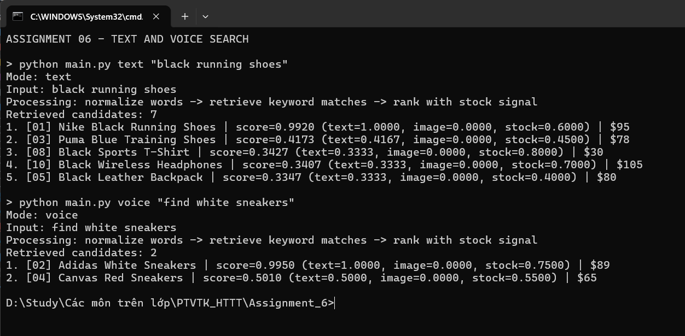
Screenshot: Text and simulated voice searches running in the terminal; input, processing, returned products, and scores are visible.

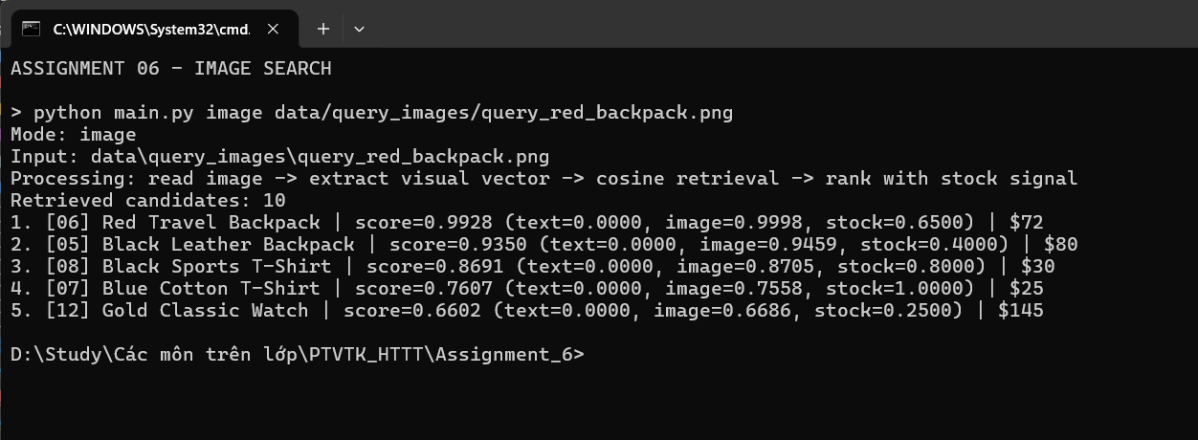
Screenshot: Image search running in the terminal with visual similarity and final ranking scores.

9. Discussion and Limitations

9.1 Interpretation
The results show that one application architecture can accept three input forms and return a consistently ranked product list. The separate query images ranked their intended products first, suggesting that the simple color-and-shape descriptor is adequate for the included illustrations. The experiment is small and controlled, so its 92.31% success rate should not be interpreted as expected performance on real customer photos or broad natural language.
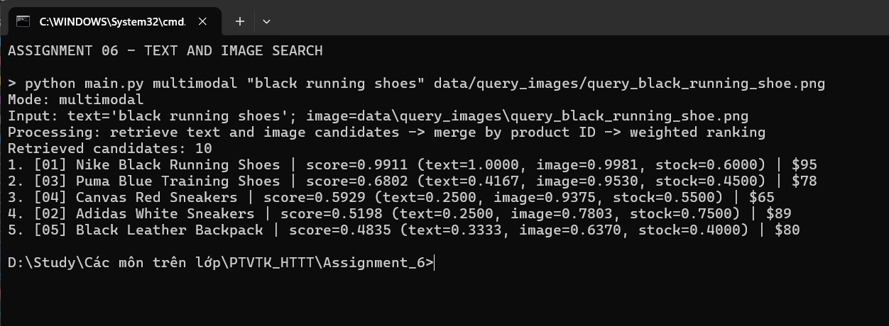
Screenshot: Combined text-and-image search running in the terminal with component and final scores.

9.2 Known limitations and possible extensions
Speech recognition is simulated, so the system does not handle microphone audio or recognition errors. The handcrafted image descriptor is sensitive to backgrounds and changes in viewpoint. Keyword search misses semantic equivalents such as ‘jogging’ for ‘running.’ The CLI has no dedicated product-detail screen; full product fields remain in the repository. The JSON repository and linear vector scan are appropriate only for a tiny dataset. Stock is a deliberately small ranking signal, and the price parser recognizes only simple English phrases. A future version could add a real speech-to-text model, learned image/text embeddings, a scalable vector index, authenticated order access, and a web interface.
Order lookup in this classroom prototype checks the supplied customer ID but does not authenticate who supplied it. Production deployment would require account identity and authorization before returning order details. This matters because the Use Case Diagram includes order viewing, even though the principal assessment focus is product search.

10. Conclusion and Submission Map
The project satisfies the main technical requirements through a working three-layer Python prototype. Text, simulated voice, and image input are mapped to one query format; retrieval selects candidates and ranking orders them. The implementation includes 12 products, real pixel-based image descriptors, a weighted multimodal mode, order lookup, and saved demonstration results. The evaluation records both successful examples and a concrete failure. The supplied ass6.vpp contains the Use Case Diagram, three-layer Component Diagram, and voice-search Sequence Diagram. The report includes the three UML diagrams and the program-output figures for the required search modes.

10.1 Requirements traceability
Assignment task | Evidence in submission
Requirements analysis | Section 2 and functional requirements table
Use Case Diagram | Use Case Diagram in ass6.vpp and its figure in Section 3
Three-layer component diagram | Three-Layer Component Diagram in ass6.vpp and its figure in Section 4
Voice sequence diagram | Voice Search Sequence Diagram in ass6.vpp and its figure in Section 5
Python implementation | main.py, application/, presentation/, data/
Three-mode demonstration | Section 8.2, results/demo_results.txt, and three program-output figures
Experimental evaluation | evaluate.py, results/evaluation.csv/json

10.2 Files to submit
Submit the exported PDF report, the completed Visual Paradigm project (ass6.vpp), Python source code, data/products.json and data/orders.json, sample PNG images, README.md, and the results/ folder. Keep the editable DOCX for any final wording or layout edits. The submission also contains VISUAL_PARADIGM_GUIDE.md as a diagram checklist.

Reference
Course handout: Information System Analysis and Design, “Assignment 06: Multimodal Search System for E-Commerce,” 23-page PDF supplied with this assignment. All product data, sample illustrations, source code, and measured results in this report were created for this project.

