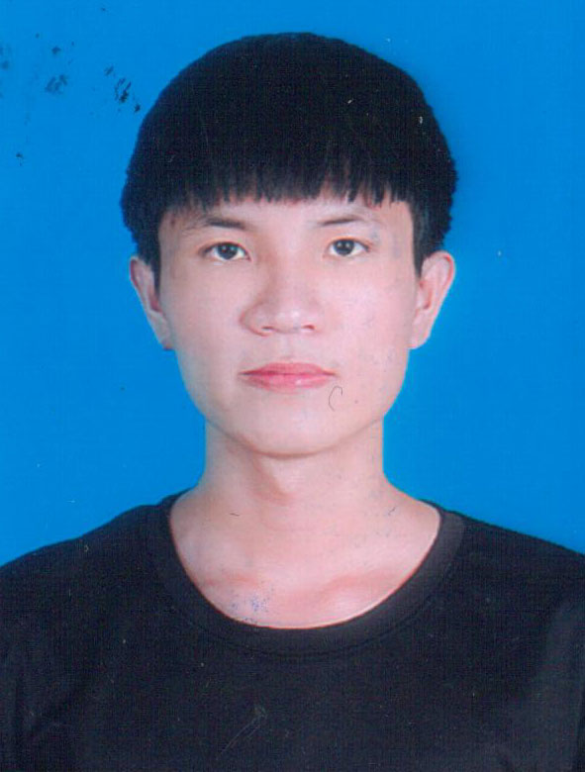

**PHONE:** 0385566904

**FACEBOOK:**

facebook.com/nguyenne010102

**GITHUB:**

github.com/PhamTrungNguyen

**EMAIL:**

[trungnguyen010102hl@gmail.com](mailto:Trungnguyen010102hl@gmail.com)

**ADDRESS:**

DaNang, VietNam

**ACTIVITY & AWARDS**

- 2019: The second-class prized in the municipal math contest

-2021: Entrance scholarship - 50% tuition fee for the first term

-2020 – Persent: Encourage academic scholarship (GPA : 3.38/4.0)

**OBJECTIVE**

- I hope to join web projects and gain more knowlege in web develop field

PHẠM TRUNG NGUYÊN

FRONT END DEVELOPER

# EDUCATION

**PROJECT**

**DANANG UNIVERSITY OF SCIENCE AND TECHNOLOGY**

**Major : Information Technology**

2020 **-** PRESENT

I am currently a third-year student

**Project 1**: **https://github.com/TrungNguyen0101/StoreAPP**

TecTechnologies used:

+ Front-end: ReactJS + Redux toolkit , TypeScript

+ Back-end: NodeJS, ExpressJS

+ DataBase: MongoDB

Team size: Only me

**Project 2**: **https://github.com/TrungNguyen0101/Tu-thien**

TecTechnologies used:

+ Front-end: ReactJS + Redux toolkit

+ Back-end: NodeJS, ExpressJS

+ DataBase: MySQL

Team size: Only me

**Project 3**: **https://github.com/TrungNguyen0101/Blogging**

TecTechnologies used:

+ Front-end: ReactJS

+ DataBase: Firebase

Team size: Only me

# SKILLS

## Programming Language:

- Javascript

## Frameworks:

-ReactJS ,NextJs, NodeJS ,Angular basic(2023)

## Database:

-MySQL , Firebase basic, Mongodb

## Version Control:

-Git,Github, Sourcetree

## Knowlegde:

-HTML/CSS (SCSS), Tailwind, Responsive,

Cut HTML+CSS from Figma,TypeScript

## Other:

- C++ basic, Java basic, C# basic