PHAM TRUNG NGUYEN

**F R O N T E N D D E V E L O P E R**

# A B O U T M E

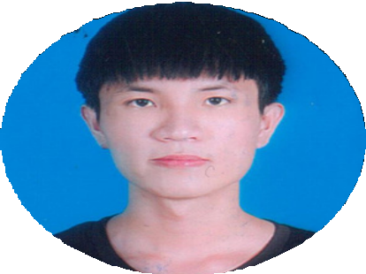

- 2019: The second-class prized in the municipal math contest

-2021: Entrance scholarship - 50% tuition fee for the first term

-2020 – Persent: Encourage academic scholarship (GPA : 3.38/4.0)

**C O N T A C T**

0385566904

[trung nguyen010102hl@gmail.com](mailto:Trungnguyen010102hl@gmail.com) github.com/TrungNguyen0101

[DaNang, VietNam](mailto:Trungnguyen010102hl@gmail.com)

**S K I L L S**

***Programming Language:***

- JavaScript

Frameworks:

- NextJS,AngularJS basic

***Database:***

- MySQL ,,Mongodb

Version Control:

- Git,Github, Sourcetree

#### Knowlegde:

- NodeJS ,ReactJs, TypeScript,

HTML/CSS (SCSS), Tailwind, Responsive, Cut HTML+CSS from Figma

#### Other:

- C++ basic, Java basic, C# basic

# E D U C A T I O N

## DANANG UNIVERSITY OF SCIENCE AND TECHNOLOGY

### Major : Information Technology

**2020 - PRESENT**

**I am currently a third-year student**

**P R O J E C T**

**Project 1:** [**https://github.com/TrungNguyen0101/StoreAPP**](https://github.com/TrungNguyen0101/StoreAPP)

TecTechnologies used:

+ Front-end: ReactJS + Redux toolkit , TypeScript

+ Back-end: NodeJS, ExpressJS

+ DataBase: MongoDB Team size: Only me

### Project 2: https://github.com/TrungNguyen0101/Tu-thien

TecTechnologies used:

+ Front-end: ReactJS + Redux toolkit

+ Back-end: NodeJS, ExpressJS

+ DataBase: MySQL Team size: Only me

### Project 3: https://github.com/TrungNguyen0101/Blogging

TecTechnologies used:

+ Front-end: ReactJS

+ DataBase: Firebase Team size: Only me

# O B J E C T I V E

## - I hope to join web projects and gain more knowledge in the web development field