**HCMC UNIVERSITY OF TECHNOLOGY AND EDUCATION**

**FACULTY FOR HIGH-QUALITY TRAINING**

**____________________________________**

 

**Web Programming**

Topic

**Pet Shop**

Course: Web Programming

Lecturer: Mai Anh Tho

|  |  |
| --- | --- |
| GROUP 8 | |
| Student name | ID |
| Cao Văn Ngọc | 20110385 |
| Nguyễn Trung Nguyên | 20110388 |

*HCMC Dec, 2022  
Last update: Dec 08 , 2022*

**Thank you**

In order to successfully complete this topic and this report, we would like to extend our sincere thanks to our lecturer, Mrs. Mai Anh Tho, who directly supported us throughout the process of making the topic. Thank you for giving us advices from his practical experience to guide us in the right direction with the requirements of the selected topic, always answer questions and give suggestions and corrections in time to help us overcome my shortcomings and complete the project on schedule.

We also would like to express our sincere thanks to the teachers in the High Quality Education Department in general and the Information Technology faculty in particular for their dedicated knowledge to help us gain a foundation to make this project. This topic has created conditions for us to learn and perform well on the topic. Along with that, we would like to thank our classmates for providing useful information and knowledge to help us improve our report.

The topic and report are made by ourselves in a short time, with limited knowledge and many other limitations in terms of technical and experiences in managing university. Therefore, in the process of creating this topic with shortcomings is inevitable, we look forward to receiving valuable comments from the teachers to make our knowledge more complete and we can do even better next time. We sincerely thank you.

Contents

Introduction 4

Part I – System survey and analysis 5

I. Analysis of topic requirements 5

1. Function 5

2. Requirements 5

3. System analysis 6

Part II: Analytical design and analysis 13

I. Model 13

II. Some program interface images (View) 13

1. Home page 14

2. Admin 14

3. Shop 15

III. Controller 15

IV. Cart 17

V. Design 18

1. View and select products 18

2. Checkout 19

3. User Account 19

4. Search product 20

Part III: Summary of assessment and development direction of the app. 20

I. What the program does. 20

1. For the user, the program has given: 20

2. For the administrator, the program has given: 20

II. Points of failure and solutions: 21

III. The development direction of the program: 21

Reference 22

# Introduction

Today, the application of information technology and computerization is considered as one of the decisive factors in the activities of governments, organizations, as well as companies, it plays a very important role. important, can create powerful breakthroughs.

Along with the continuous development of computer technology and electronic networks, information technology also has high-class technologies and in turn conquers from one peak to another. The Internet is one of the products of great value and is increasingly becoming an indispensable tool, the main foundation for the transmission and exchange of information globally.

Now, everything related to information becomes easy for the user: just have a computer connected to the internet and a stream of data to search almost instantly… the whole world about your subject matter. interested will appear, full of information, pictures and sometimes even sounds if you need…

Through the internet, we have done many jobs at a much faster speed and at a much lower cost than the traditional way. It is this, which has promoted the birth and development of e-commerce and e-government around the world, significantly changed the face of culture, and improved the quality of people's lives.

In production and business activities, now, e-commerce has affirmed its role in promoting and promoting the development of enterprises. For a store or shop, it is necessary to promote and introduce to customer new products that meet the needs of customers. So how to promote is to build a Website for your store to promote all your products for sale.

So, I have done the project "build a website for a pet shop".

# Part I – System survey and analysis

## I. Analysis of topic requirements

SUBJECT NAME:

“Building a Pet Store Website”

### 1. Function

- This is a website to sell and introduce products of the store and company to people

Consumers with item details with accurate prices. Has the following functions:

- Allow to update rows in the database.

- Displays a list of items by category.

- Display the goods the customer has selected to buy.

- Manage orders

- Update goods, manufacturers, types of goods, news.

- Order processing.

- Statistics of customers who bought during the day

### 2. Requirements

a. Equipment and software

- Computer can design web

- MySQL database management system

- Web design IDE: IntelliJ, NetBeans, Eclipse...

b. Request a Website

- The system has 2 parts:

+ First: Customer section:

* Customers are people who have a need to buy goods, they will look for

necessary items from the system and order these items. So there must be

the following functions:

* Display a list of store items for customers to view and choose and buy.
* After the customer selects and places an order directly, it must be displayed orders so that customers can enter purchase information and view invoices

+ Second : For administrators: Application owners can control over all system operations. This person has been given a username and password to login the system to perform its function:

* Function to update, edit, delete items and types of goods.
* Receiving and checking customer orders. Display orders.
* Statistics by date, time period.

### 3. System analysis

Website online sale

|  |  |  |  |  |  |  |  |  |  |  |  |
| --- | --- | --- | --- | --- | --- | --- | --- | --- | --- | --- | --- |
| Category | | |  | Order | | | |  | Bill |  | Statistic |
|  |  | | | | |  | | | |  | |
|  | **Commodities** | | |  |  | Check order | | |
|  |
|  |
|  | | | |
|  | | | | |
|  | brands | | |  |  | Check items | | |
|  |  |
|  | | | | |  | | | |
|  | Price | | |  |  | Item handling | | |
|  |
|  |
|  | | | | |  | | | |

#### 3.1 Customer functional diagram

Payment via account

Items

Order

Search

sign up

**Commodities**

quote

Select item

View product information

**Customer**

⬄ View Product Information function.

- Allows viewing of product-related information.

- Input : + Name of items

+ Product group

- Processing processes:

+ Module to enter information (Name, group) of the item to be viewed.

+ Module displays the list of goods on demand.

- Output : + list of items as required .

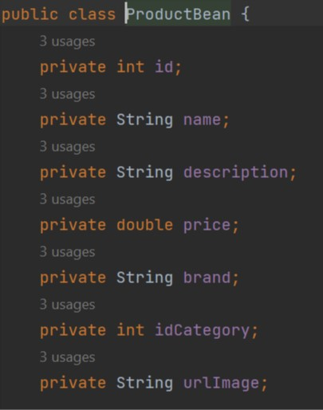

⬄ Item Select function

- List the list of product items by group, category, details...for

- Allows customers to select and add items to the cart (Shopping

cart).

- Input (Input): Information related to the product :( Item name )

- Processes to perform (Processes):

+ Module list, display item list by group, type, details.

+ Module add items to the cart.

+ Module remove items in the cart.

+ Module displays the list of items currently in the cart.

- Output: List of items to be ordered.

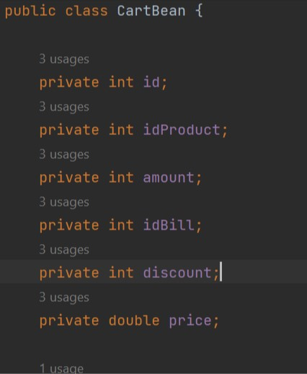

⬄ Membership Registration function

- Customers can register to become a regular customer (to become a regular customer).

member) of the company and is granted a user account (Account) to register

Enter when ordering, payment, technical support ...

- Input: - Customer's personal information

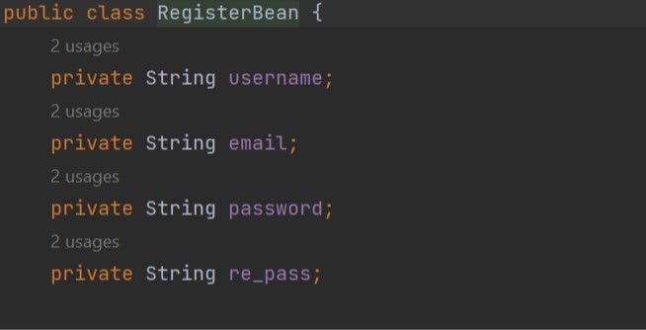

- Output :

+ Notify the customer and ask to re-enter the account or

Email if the account or Email already exists in the database.

+ Notice and request to re-enter information in case of notification

The information entered is not correct , does not match .

+ Notify registration results, customer code is issued.

⬄ Search function

- Search for product information (by product group type)

- Input : + word or phrase to search

+ Search form (search for products)

Products).

- Execution processes:

+ Module search in the database.

+ Module displays search results.

- Output: Search results

⬄ Order function

- Input (Input):

+ List of items in the shopping cart.

+ Personal information of customers (Full name, address, ...)

+ Information related to the purchase (date of purchase, time of delivery

, quantity of each ordered item, method of payment, where to receive

goods, recipients, total amount, exchange rate USD/VND ...)

- Execution processes:

+ Module displays full information related to customer products

selected item.

+ The module calculates the total amount of goods (in USD and VND) according to the unit price and exchange rate (USD/VND) of the date of purchase.

+ Module to enter order information.

+ Module updates orders to the database.

+ Module notifies customers of successful orders, payment procedures, receipt of goods, ordering instructions or unsuccessful order notifications. 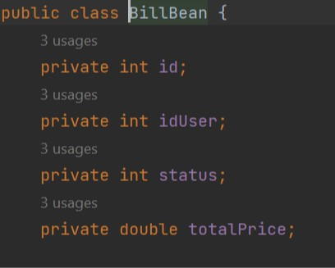

- Output :

+ Notification of order status (success\failure), payment procedures, receipt of goods, or instructions for re-ordering in case the order information does not match.

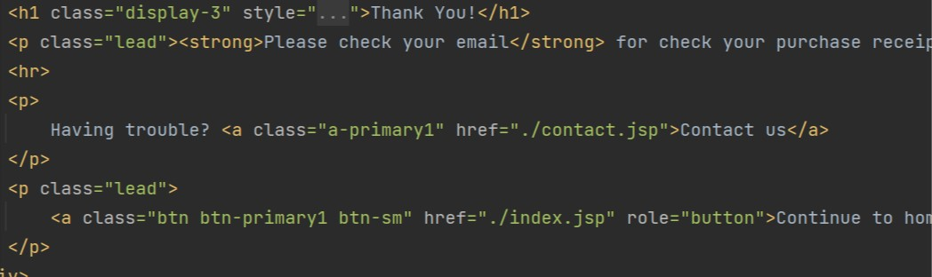

#### 3.2 Admin function diagram

Delete employee

Edit employee

Add new employee

Update employee

**ADMIN**

Update Items

Add new product

Edit product

Delete product

#### 3.3 Some tables of data elements

User table

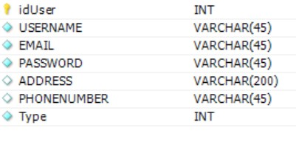

Product table

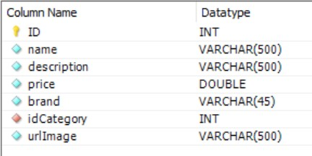

Bill table

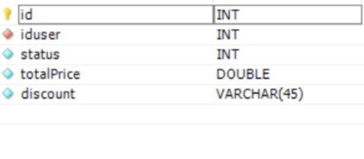

# Part II: Analytical design and analysis

## I. Model

- The model component stores the data and its associated logic. Includes class functions that handle tasks such as querying, adding, editing, or deleting data.

 

## II. Some program interface images (View)

### 1. Home page

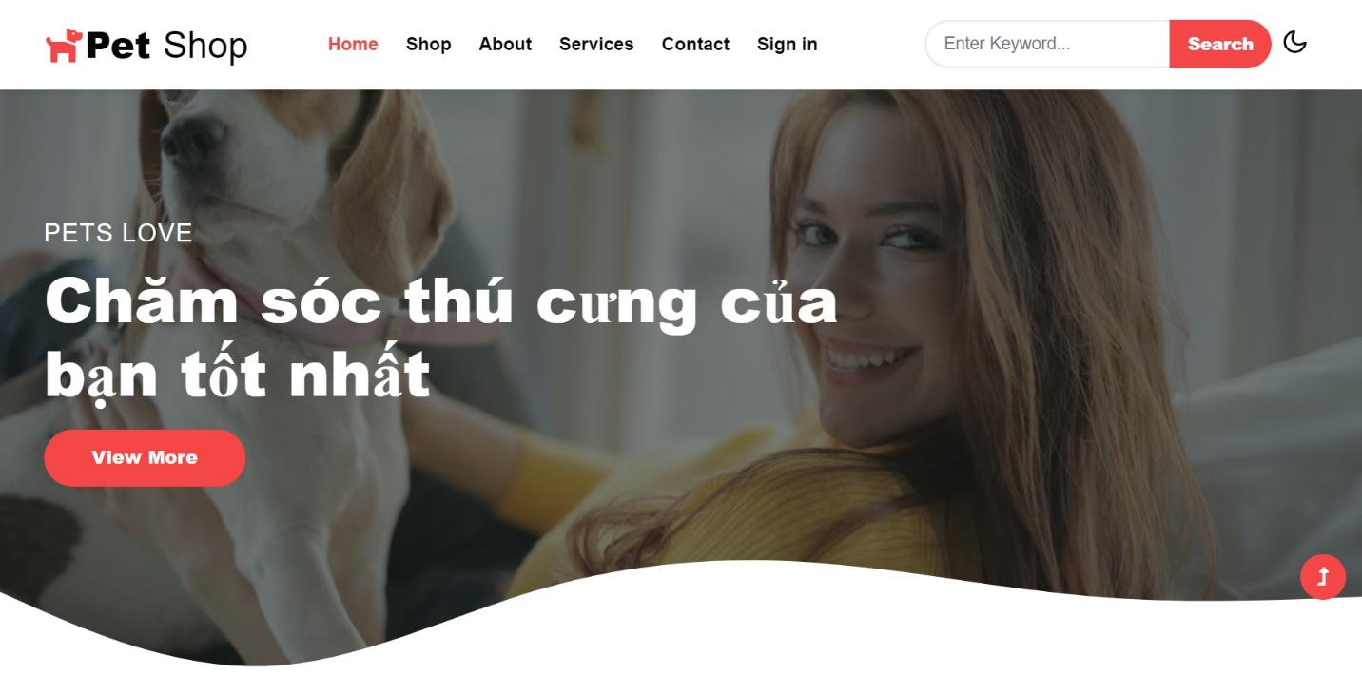

### 2. Admin

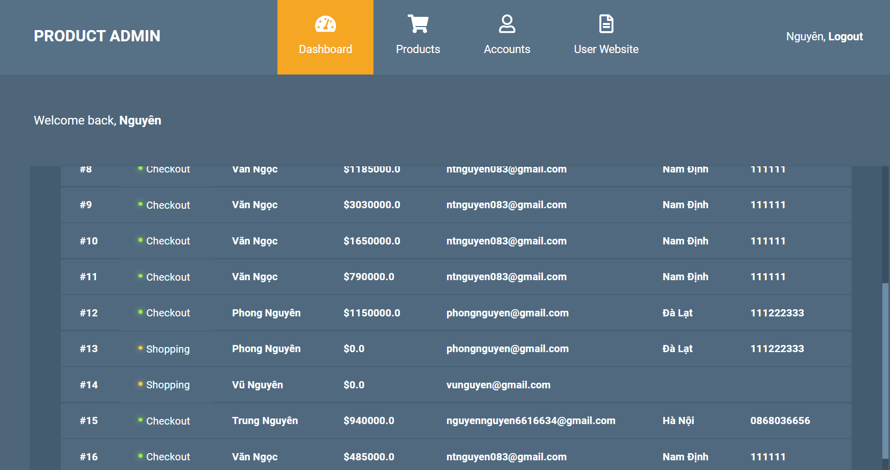

### 3. Shop

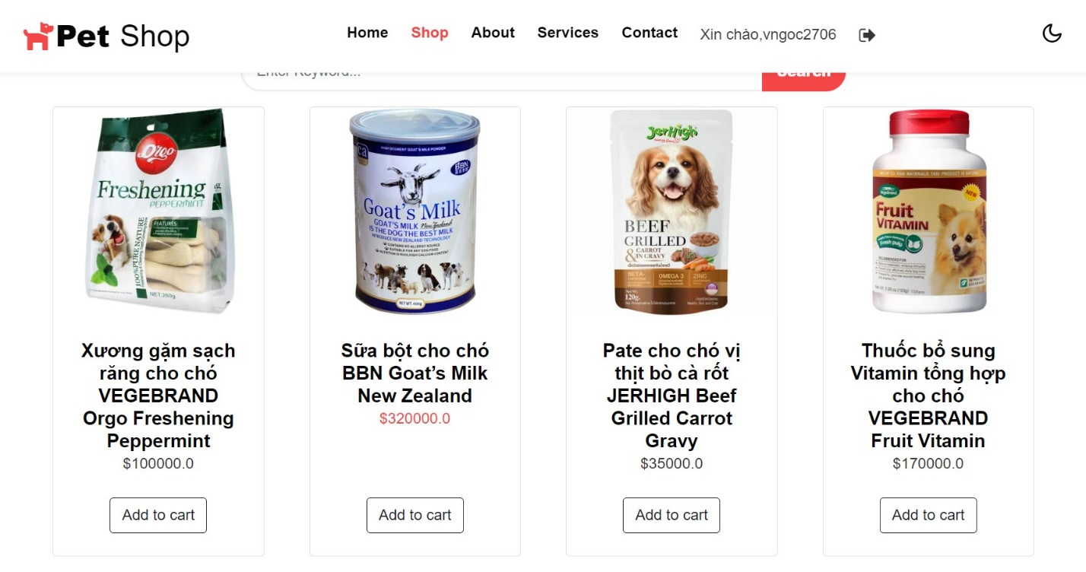

## III. Controller

- Acting as an intermediary between the Model and the View, it is responsible for receiving requests from the client, then processing the request, loading the model and sending data through the corresponding view and returning the results to the client.

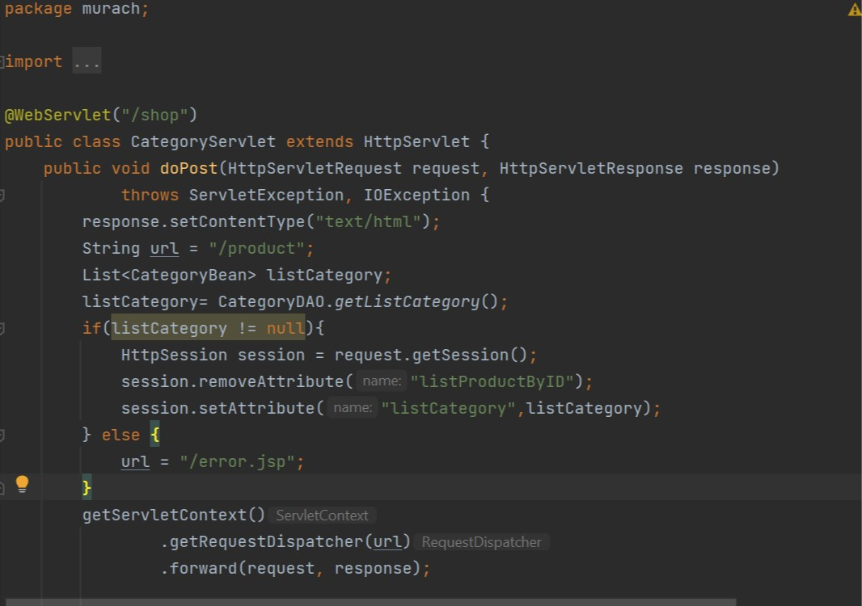

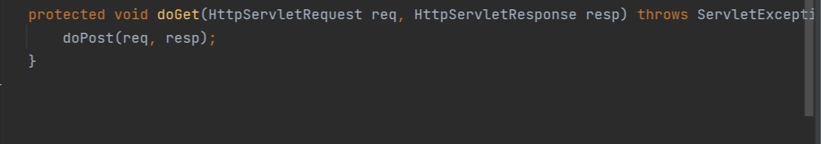

- Get:

* requests can be cached
* requests remain in the browser history
* requests can be bookmarked
* requests should never be used when dealing with sensitive data
* requests have length restrictions
* requests are only used to request data (not modify)

- Post:

* requests are never cached
* requests do not remain in the browser history
* requests cannot be bookmarked
* requests have no restrictions on data length

- The @WebServlet annotation is used to define a Servlet component in a web application. This annotation is specified on a class and contains metadata about the Servlet being declared. When we use @WebServlet annotation then deployment descriptor (web. xml file) is not required.

- Request: request from client up server

- Response: The server returns the results to the client

## IV. Cart

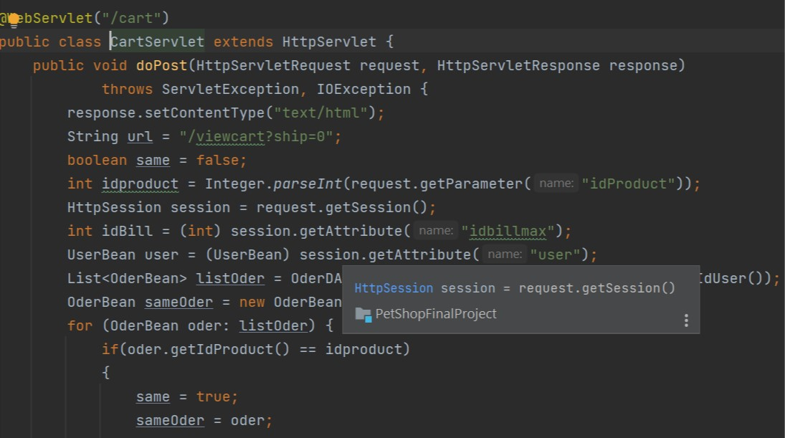

- The products will be saved in the shopping cart by session and upon checkout it will be saved to the database, saving data and operations. The session ends if the user hasn’t requested any pages for a given amount of time (timeout). The session timeout varies, depend on server configuration – typically from 15 to 30 minutes.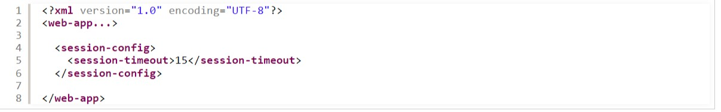

- Using sessions for a certain period of time is more convenient as customers can also choose products or other activities from there.

## V. Design

### 1. View and select products

Order

Save order

Register

unregistered

Register

Add to cart

**LIST OF PRODUCTS**



products

**View products**

### 2. Checkout



**checkout**

**information, address**

**check**

order

**payment confirmation**

**send email**

**Sign in**

### 3. User Account



**information**

**Check**

**Register**

**Save user in mysql**

**user**

### 4. Search product

look for information

product

MySQL

Result

# Part III: Summary of assessment and development direction of the app.

## I. What the program does.

### 1. For the user, the program has given:

- Ways to search, look up by different topics, combine many topics according to customers' preferences.

- View detailed commercial product information and complete door information Pet Shop

- Allow customers to register information to make product purchases.

- Check the validity of the client login to the system.

- Create an order.

- Can run on many operating systems.

### 2. For the administrator, the program has given:

- View information of items to be managed such as products, orders…

- Provide forms to enter new data of different types of documents.

- The above data can be modified or updated.

- In adding a new product, the program automatically generates a product code

- This is convenient for the administrator and the data is always consistent.

- These functions are performed through the web interface.

- Can run on many operating systems.

## II. Points of failure and solutions:

- The connection between the server and the database is slow.

- This is also understandable because establishing the bridge has to go through many levels. Only the solution is to let the server run on a machine with strong configuration, high speed fast disc output. The number of products sold in a month or a year has not been reported.

## III. The development direction of the program:

- The development direction of the Web site is towards an e-commerce with full functions of online payment. But because in our country,

- Currently, the problem of paying money online is still difficult and not very popular, so the function of the Web site used to support administrators is still limited. The main problem of the Web site is serving advertising. From there, the besides commercial, the problem needs to focus on attracting customers to contact and agree to design and install a certain work in the specialized field department of the company, store. Therefore, in the future, it is necessary to add inventory functions:

- Statistics of database accesses, statistics of import and export prices, inventory, statistics

revenue, automatic invoice processing.

- Warehouse management (checking product inventory automatically), payment electronics that use Edit card. Add some functions to check input data, change password

user and administrator access.

Despite the best efforts to complete the requirements, the report is still very many shortcomings, hope to receive guidance from other teachers help to review, suggest additional ideas as well as add issues to fix service for building Web site so that I can be more complete. I would like to thank you ladies and gentlemen.

# Reference