**Heat delivered VS Temperature**

1. **Heat delivered VS Outdoor Temperature**

The graphs in section 2 will show information on Heat demand vs Outdoor Temperature, Heat demand vs Radiator Temperature and plot of indoor temperature. Read HP_Launch WP4 report for more information.

1. **Heat delivered VS Radiator Temperature**

A summary of the simulation are show in the table and graphs below:

|  |  |  |  |  |  |  |
| --- | --- | --- | --- | --- | --- | --- |
| Controller | Kwh use by boiler | Kwh user by heat pump | Heat Pump Average COP | Heat Pump max heating capacity | Temperature SP | Simulation |
| P(high gain) | 2943 | 8252 | 4 | 4kw | 20 | 1 |
| P (low gain) | 239 | 10521 | 4 | 4kw | 20 | 2 |
| P(high gain) | 3586 | 6558 | 4 | 4kw | 17 - 20 | 3 |
| P (low gain) | 1829 | 7857 | 4 | 4kw | 17 - 20 | 4 |

* **Simulation 1**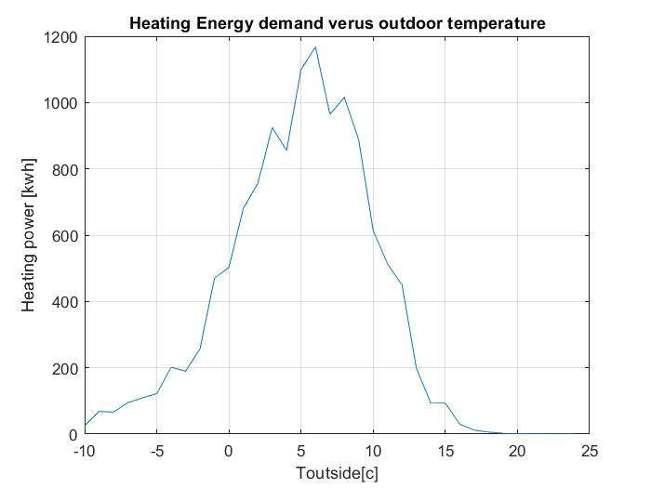

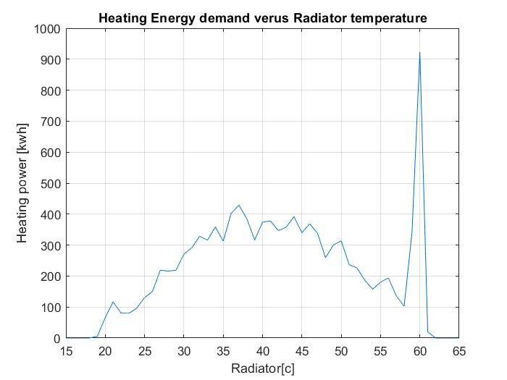

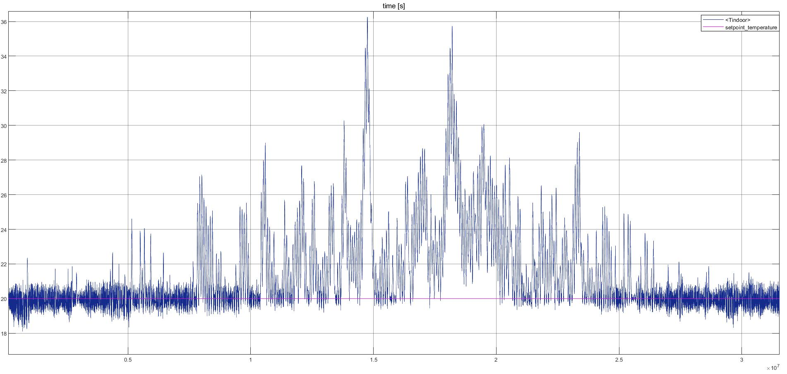

* **Simulation 2**

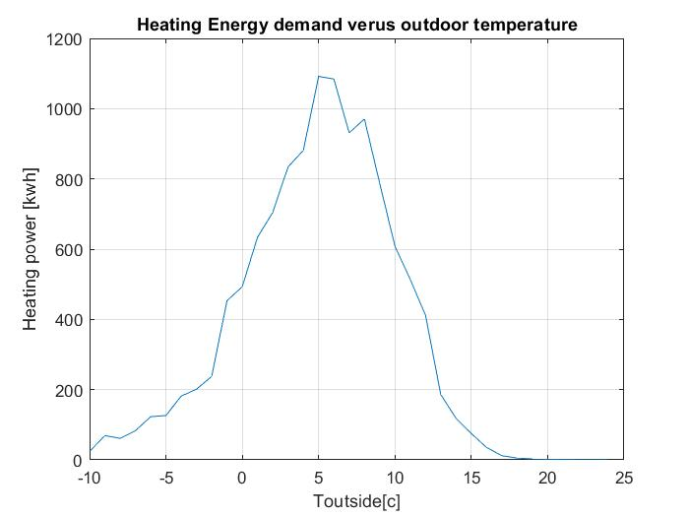

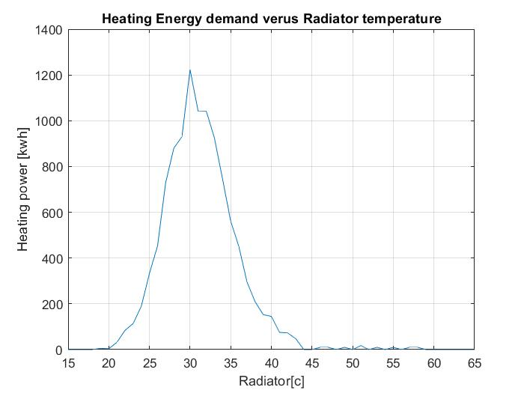

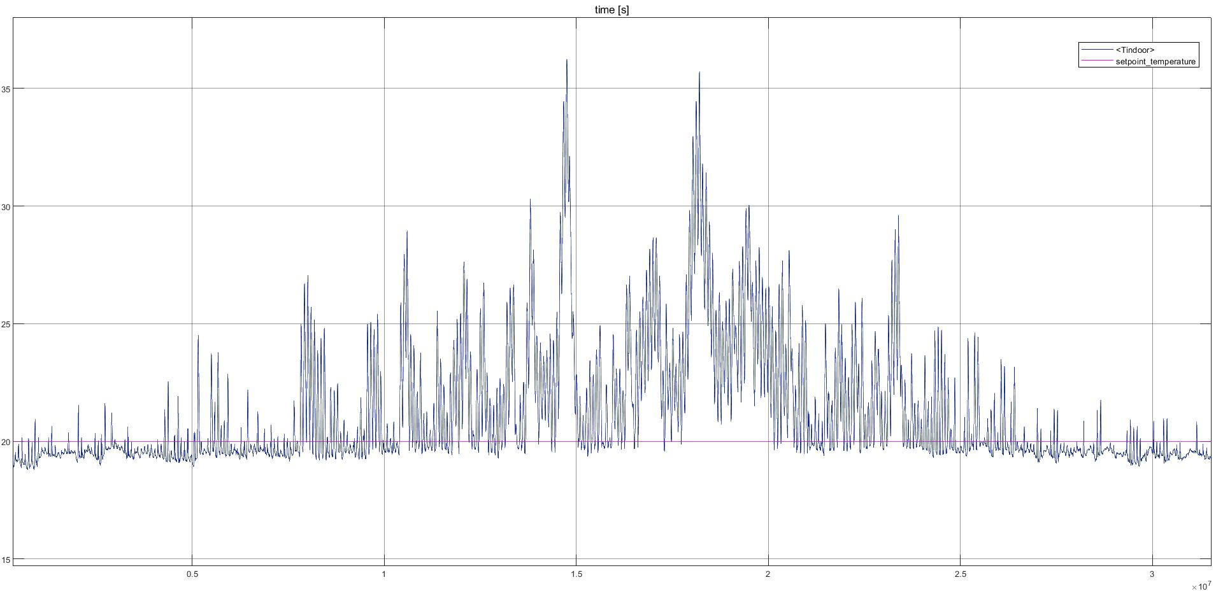

* **Simulation 3**

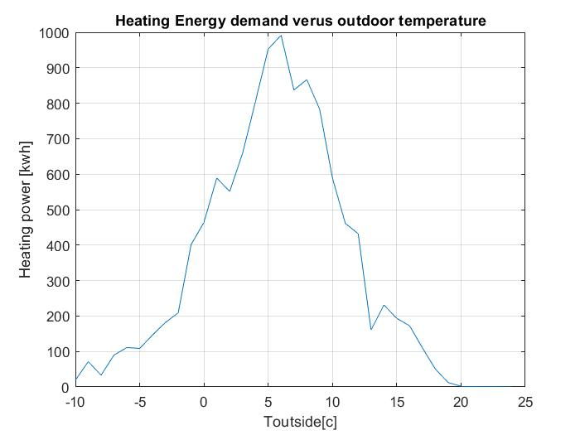

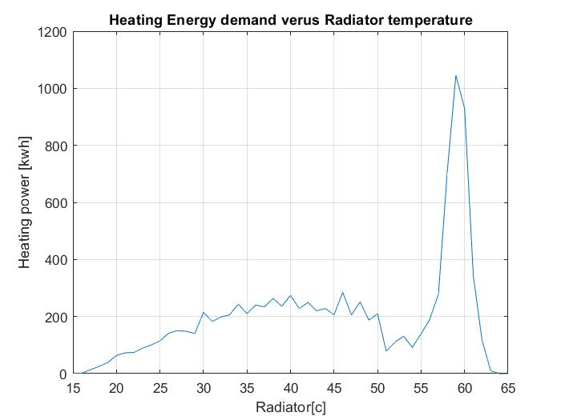

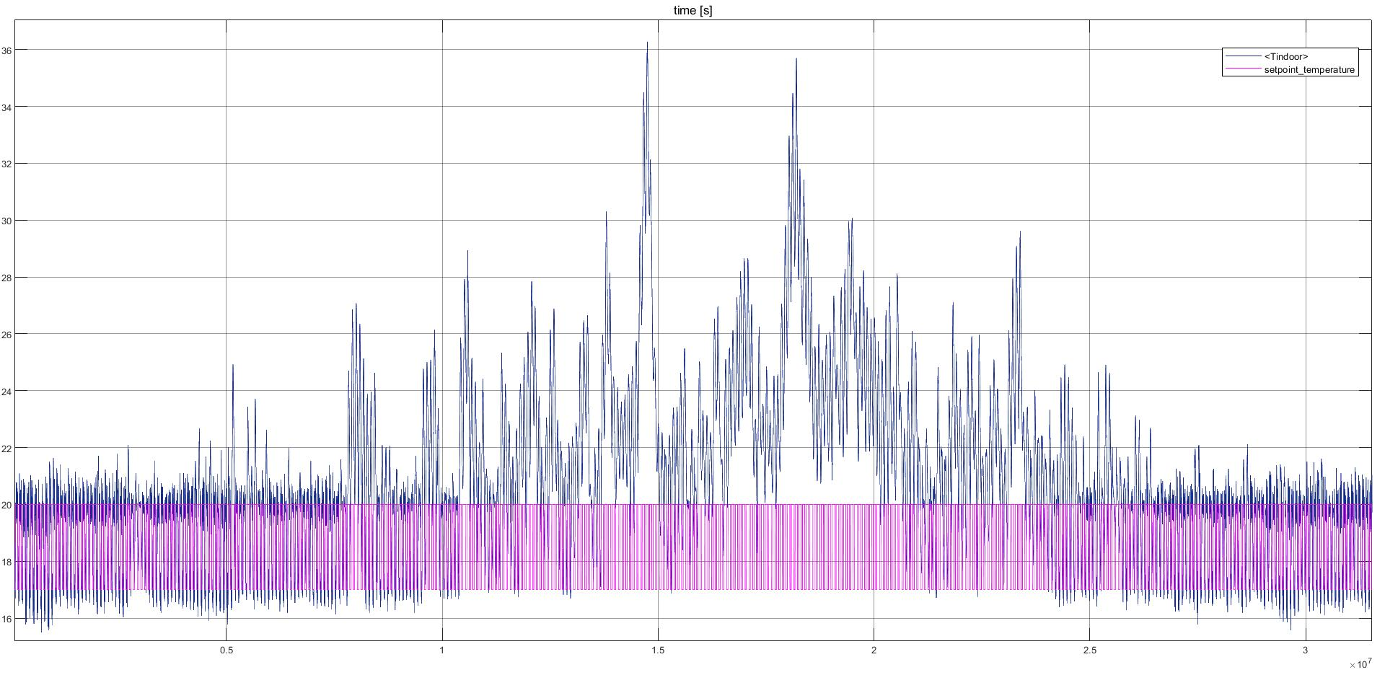

* **Simulation 4**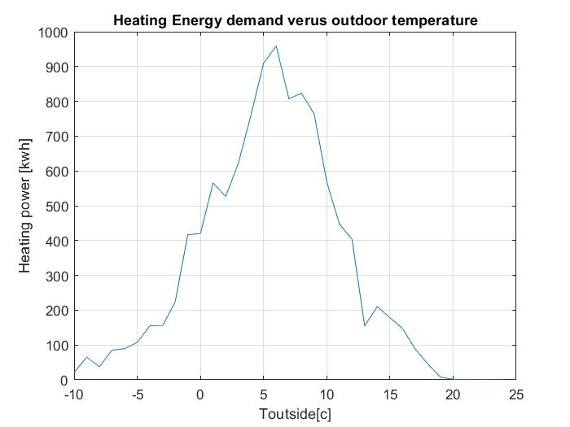

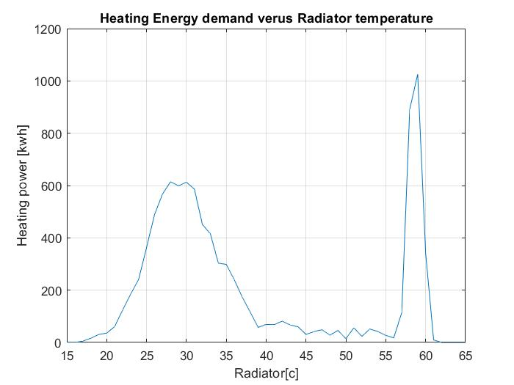

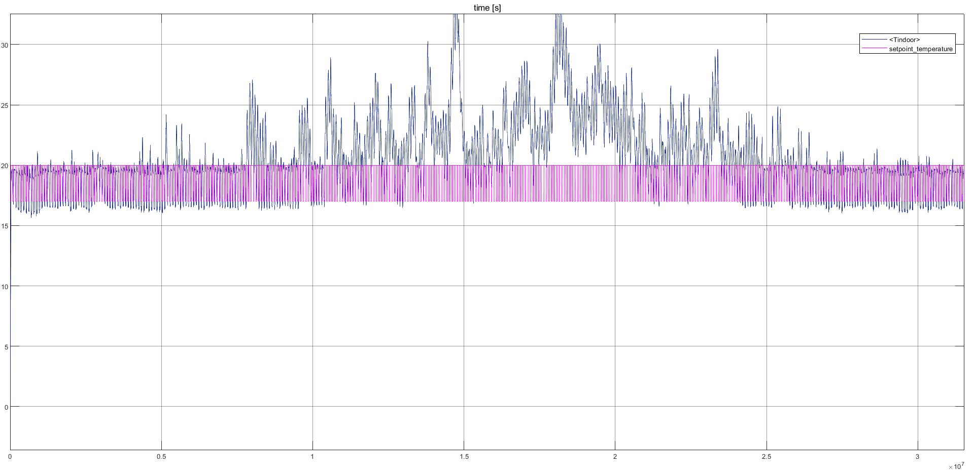

|  |  |  |  |  |  |  |
| --- | --- | --- | --- | --- | --- | --- |
| Controller | Kwh use by boiler | Kwh user by heat pump | Heat Pump Average COP | Heat Pump max heating capacity | Temperature SP | Simulation |
| P (low gain) | 1829 | 7857 | 4 | 4kw | 17 - 20 |  |
| P (low gain)  with heat model prediction | 1379 (25% improvement) | 8000 | 4 | 4kw | 17 - 20 |  |
| P (low gain) Setpoint look ahead | 1432 | 8440 | 4 | 4kw | 17 - 20 |  |
| P (low gain) with heat model prediction and SP look ahead | 1363 | 8503 | 4 | 4kw | 17-20 |  |

|  |  |  |  |  |  |  |
| --- | --- | --- | --- | --- | --- | --- |
| Controller | Kwh use by boiler | Kwh user by heat pump | Heat Pump Average COP | Heat Pump max heating capacity | Temperature SP | Simulation |
| P (low gain) Setpoint look ahead | 1392 | 8957 | 4 | 4kw | 17 - 20 |  |
| P (low gain) with heat model prediction and SP look ahead | 702 | 8776 | 4 | 4kw | 17-20 |  |

Setpoint planning (Ramp control)

Smaller step. Temperature at 8.00pm (19.2 degree) compare with 18.7 with Temp planning. Slower controller

|  |  |  |  |  |  |  |
| --- | --- | --- | --- | --- | --- | --- |
| Controller | Kwh use by boiler | Kwh user by heat pump | Heat Pump Average COP | Heat Pump max heating capacity | Temperature SP | Simulation |
| P(high gain) with Tem planning + SP_Planning | 1102 | 8817 | 4 | 4kw | 17 - 20 |  |
| P(high gain) with Tem planning | 1572 | 8359 |  |  | 17 - 20 |  |
|  |  |  |  |  |  |  |
| low | 994 | 8808 |  |  |  |  |

Implementation of

Control Strategy and Simulation on Open source MPC

Discuss on How to control Temperature, On-off situation due to people go out for work from 8 to 5

Setpoint scheduling technique with heat prediction at a pointing time and convert back to SP. By the time of SP change. An example of 8 hour : 16 degree at 12.00 and 20 degree at 8:00 pm.

Need 10kw at 8. With 1kw at an heat limit predict an amount of heat that the HP need to delivered over the time, 10 – sum(COPattime*Pheatpump)=0

Inform ECOVAT on Defrosting cycle of HP.