|  |  |  |  |
| --- | --- | --- | --- |
|  | Current | Opened set (Stack) | Closed set |
| B0 |  | A |  |
| B1 | A | [B,E,F] | A |
| B2 | F | [B,E] | F |
| B3 | E | [B,C] | E |
| B4 | C | [B,B,D] | C |
| B5 | D | [B,B] | D |
| B6 | B | [B] | B |
| B7 |  | [] |  |

DFS

D

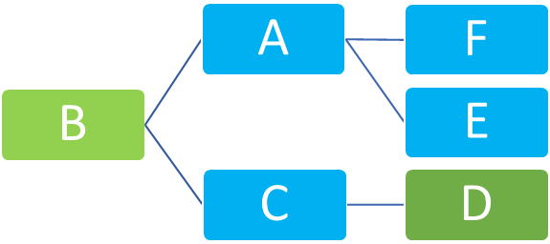

BFS

|  |  |  |  |
| --- | --- | --- | --- |
|  | Current | Opened set | Closed set |
| B0 |  | [A] |  |
| B1 | A | [B,E,F] | A |
| B2 | B | [E,F,C] | B |
| B3 | E | [F,C] | E |
| B4 | F | [C] | F |
| B5 | C | [D] | C |
| B6 | D | [] | D |