HANOI UNIVERSITY OF SCIENCE AND TECHNOLOGY
SCHOOL OF INFORMATION AND COMMUNICATION TECHNOLOGY
——————– o0o ———————


CAPSTONE PROJECT REPORT
Ô Ăn Quan – Traditional Vietnamese Board Game

Instructor: |  | Nguyen Thi Thu Trang
Course: | Object-Oriented Programming (IT3100E)
Group: | 13
Students: | Tran Trung Son - 202417192
 | Ta Xuan Hieu Anh - 202417094
 | Nguyen Nhat Nam - 202417174
 | Dao Tuan Anh - 202417098
 | Nguyen Minh Phuc - 202417180
Class: | 166241
Hanoi 2026

TABLE OF CONTENTS
1. Assignment of Members 3
1.1. Tran Trung Son – 202417192 3
1.2. Ta Xuan Hieu Anh – 202417094 3
1.3. Nguyen Nhat Nam – 202417174 3
1.4. Dao Tuan Anh – 202417098 4
1.5. Nguyen Minh Phuc – 202417180 4
2. Capstone Project Description 4
2.1. Project Overview 4
2.2. Gameplay Rules 5
2.3. Use Case Diagram 6
2.4. Use Case Diagram Explanation 6
3. Design 7
3.1. General Class Diagram 7
3.2. Explanation of the Design 8
3.2.1. Model Package 8
3.2.2. View Package 10
3.2.3. Controller Package 11

1. Assignment of Members
Member | Student ID | Main Responsibility
Tran Trung Son (leader) | 202417192 | Project Framework, GUI Design, and Team Code Review & Integration
Ta Xuan Hieu Anh | 202417094 | Gameplay animation and visual rendering
Nguyen Nhat Nam | 202417174 | Player class, input handling and move-guidance system
Dao Tuan Anh | 202417098 | Board class and UML design
Nguyen Minh Phuc | 202417180 | Game logic and controller system

1.1. Tran Trung Son – 202417192
Role: Project Framework, GUI Design, and Team Code Review & Integration.
- Designed the overall project architecture and class framework.
- Developed the static GUI layout and styling (.fxml and .css files).
- Reviewed, evaluated, and provided feedback on team members' code.
- Refactored and reorganized the code structure to improve encapsulation, maintainability, and overall code quality; fixed bugs and implementation issues when necessary.
- Classes: App.java, all .fxml files, application.css.
- Methods: onPlayerMove(),postGameVisualEffect(),
(MainGameController.java)

1.2. Ta Xuan Hieu Anh – 202417094
Role: Gameplay animation and visual rendering.
- Designed and implemented the graphical representation of gems and board cells.
- Developed the rendering system responsible for creating, positioning, updating, and removing visual game objects during gameplay.
- Applied inheritance and polymorphism through the gem hierarchy and renderer architecture to support different rendering behaviors for regular and mandarin cells.
- Implemented animation and visual updates using JavaFX Timeline.
- Classes: SmallGem.java, SmallCellRenderer.java, GemLayoutUtil.java, CellRenderer.java, CastleCellRenderer.java, BigGem.java, BaseGem.java, GemRenderer.java.
- Methods: animateMove(),updateScoreUI(),postGameVisualEffect(), (MainGameController.java)

1.3. Nguyen Nhat Nam – 202417174
Role: Player class, input handling and move-guidance system.
- Implemented the player profile system, including random name and avatar generation.
- Developed the user input handling mechanism for square selection, deselection, and direction selection.
- Designed and implemented a dynamic move-guidance system that combines input validation with visual highlighting to assist players in selecting valid squares and movement directions.
- Classes: Player.java, SquareHighlighter.java.
- Methods: getInput() (MainGameController.java).

1.4. Dao Tuan Anh – 202417098
Role: Board class and UML design.
- Designed the use case diagram and all the class diagrams.
- Implemented the Board class and core board-state management functionalities.
- Developed board-related gameplay mechanics, including gem movement, empty-board detection, gem refilling, and game-ending conditions.
- Classes: Board.java.
- Diagrams: Use case diagram, general class diagram, package diagram.

1.5. Nguyen Minh Phuc – 202417180
Role: Game logic and controller system.
- Implemented the Game class, including turn processing, move validation, capturing mechanics, score management, and winner determination.
- Designed and implemented a BaseController architecture using inheritance to provide shared functionalities for scene navigation and common controller interactions.
- Implemented interactive controller features such as game instructions, player information display, end-game result presentation, and exit confirmation handling.
- Classes:Game.java,BaseController.java,EndingController.java, InstructionController.java, MenuController.java.
- Methods:initializePlayerData(),loadEndingScene(), (MainGameController.java).

2. Capstone Project Description

2.1. Project Overview
The project implements Ô Ăn Quan, a traditional Vietnamese board game for two players, as an interactive JavaFX application following object-oriented programming principles.
When the application starts, users are presented with a Main Menu containing three options: Play, Instruction, and Exit. The Play option starts a new game, the Instruction option displays the game rules and controls, and the Exit option closes the application after user confirmation.
When a new game is created, players are shown a GUI interface containing each player's name, avatar, and initial score, along with the game board. The game board consists of 10 small squares arranged in two rows and 2 Mandarin squares (half-circles) located at the two ends of the board. At the beginning of the game, each small square contains 5 small gems, while each Mandarin square contains 1 big gem. A small gem is worth 1 point, whereas a big gem is worth 5 points.

2.2. Gameplay Rules
During gameplay, players take turns selecting one of their available squares and choosing a movement direction (clockwise or counterclockwise). All gems in the selected square are collected and redistributed one by one into consecutive squares.
- If the last distributed gem lands before a non-empty small square (not a half-circle), the player continues the move by collecting all gems from that square and redistributing them.
- If the last distributed gem lands before an empty square and the following square contains gems, those gems are captured and added to the player's score. Capturing can happen in a streak.
- If all five small squares on a player's side become empty, the player must spend 5 points from their score to refill those squares with one gem each before continuing the game.
The application dynamically updates the board state, gem positions, and player scores during and after every move. The current player's turn is clearly indicated by the squares lighting up the available selection on their side.
The game ends when both Mandarin squares become empty. At that point, the remaining gems on each player's side are added to their score, the final scores are calculated, and the player with the higher score is declared the winner. If both players have the same score, the game ends in a draw.

2.3. Use Case Diagram
The use case diagram below describes how the player interacts with the application. The Player actor can start a new game, view the instructions, exit the game, return to the main menu, play a turn, and view the result. The Play Turn use case includes three sub-use cases – Select Square, Deselect Square, and Choose Direction – which together make up a single move.
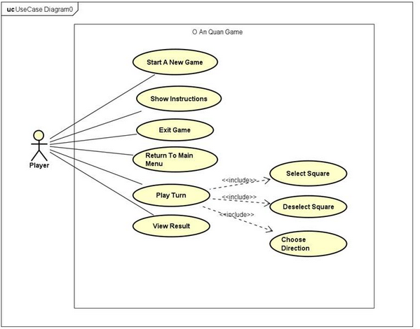
Figure 1 – Use case diagram of the Ô Ăn Quan game

2.4. Use Case Diagram Explanation
Upon opening the application, the user is met with a menu interface. The user can click the Exit button, which prompts an exit confirmation. The user can click on the Instruction button to view the instructions. Most importantly, the user can click on the Play button to create a new game.
In the game scene, players take turns making moves. On their turn, a player clicks one of the available squares highlighted by the system to select it. The player then chooses their desired direction by clicking either the left or right square, corresponding to the direction. Alternatively, if the player changes their mind, they may click the selected square again to deselect it and choose a different square.
Once a valid square and direction have been chosen, the system automatically performs the move according to the game rules, including gem distribution, capturing mechanics, score updates, and turn switching.
When the game ends, the player can view the result screen, which displays the final outcome of the match and the winner.
At any point during the application, the user may return to the Main Menu using the Home button available in the top-left corner.

3. Design

3.1. General Class Diagram
The project is organized into three main packages following the Model–View–Controller (MVC) architectural pattern: Model, View, and Controller. The general class diagram below shows all classes grouped by package, together with the relationships between them.
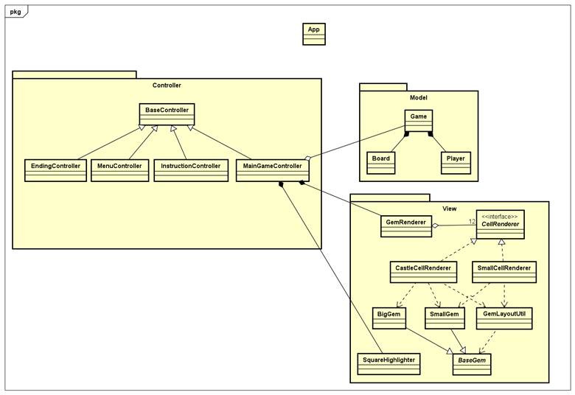
The Model package contains the core game data and game logic. The Player class represents an individual player and stores player-related information, while the Board class manages the state of the game board and its cells. The Game class controls the main flow of the game logic by holding an instance of Board and two instances of Player. Since the Board and Player objects are parts of a game session and are managed by the Game class, composition relationships are used between Game, Board, and Player.
The View package is responsible for the graphical representation of the game state, including gem rendering and visual highlighting. Inheritance is used to create BigGem and SmallGem from BaseGem. To support different rendering behaviors, CastleCellRenderer and SmallCellRenderer both implement the CellRenderer interface. This design allows different types of cells to be rendered through a common interface while providing their own implementations, illustrating polymorphism. The GemLayoutUtil class functions as a helper class responsible for calculating and assigning the position of a particular gem within a cell. GemRenderer aggregates twelve CellRenderer instances to render the board cells, while SquareHighlighter provides visual feedback by highlighting valid squares and movement directions during gameplay.
The Controller package manages user interactions and coordinates communication between the View and Model packages. Each FXML scene is associated with a dedicated controller class. Because these controllers share common functionalities, they inherit from a BaseController. The MainGameController is the primary controller responsible for gameplay interactions. It interacts with SquareHighlighter and GemRenderer in the View package to synchronize visual highlighting and board rendering with the underlying game logic. Furthermore, MainGameController aggregates an instance of Game to interact with the game logic.

3.2. Class Diagrams for Packages

3.2.1. Model Package

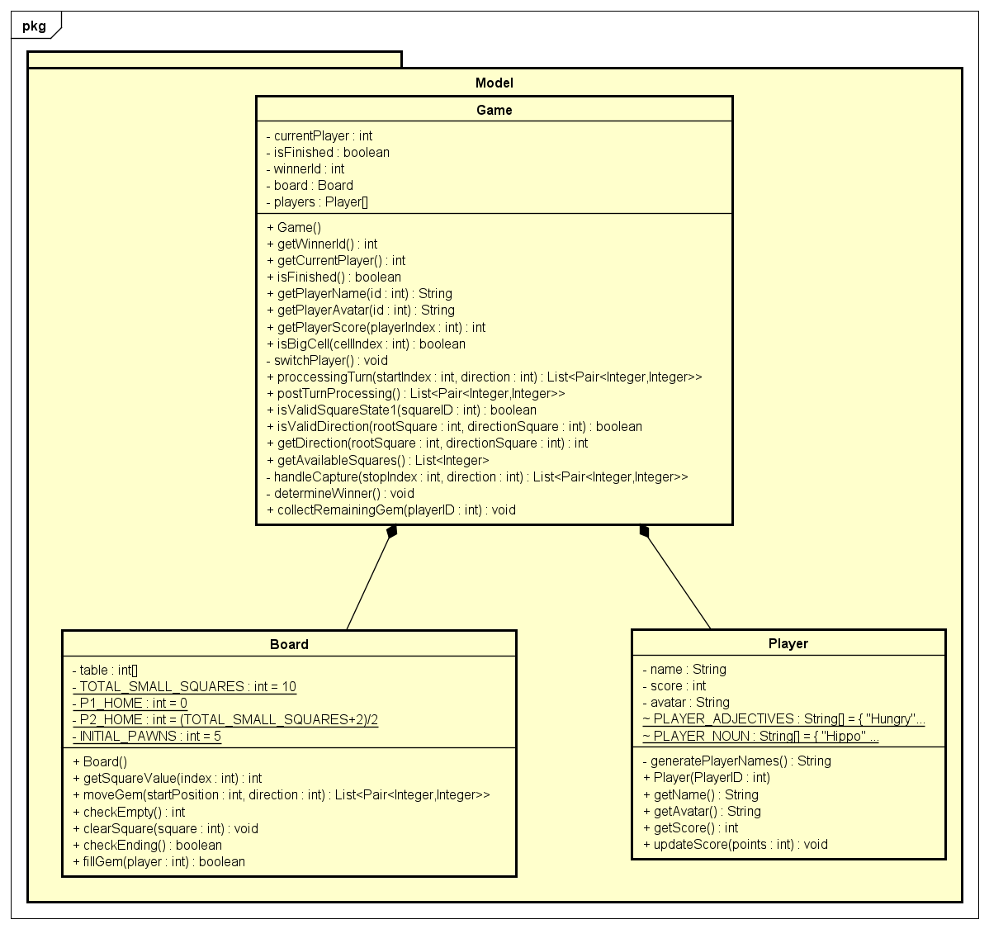
The Board class manages the value of each cell by an array table[], indexed from the left Mandarin square and continuing in the clockwise direction around the board. One of the most important methods in the Board class is moveGem(), which implements the gem distribution mechanics based on the input. It returns a list of pairs <cell, value>, where cell is the index of the modified cell and value is its new value after the change. For example, from the initial state, if the user chooses the 3rd cell and the clockwise direction, the sequence will be <3,0>, <4,6>, <5,6>, <6,6>, <7,6>, <8,6>, <9,0>, <10,6>, <11,6>, <0,6>, <1,6>, <2,6>. The method terminates when the distribution phase reaches a stopping condition defined by the game rules.
The most important methods are processingTurn() and postTurnProcessing() in the Game class, which together manage the majority of the game logic. processingTurn() handles the turn after receiving the input. It first calls the moveGem() method from the Board class to receive a move sequence. It then performs the capturing logic based on the final position of the move, before returning a full move sequence from the start until the end of a turn. This move sequence is later used by the Controller to update the GUI and animate the gameplay.
postTurnProcessing() is responsible for handling the game state after a turn has been completed, including the ending check, the empty-squares check, and switching the player's turn. By separating turn execution and post-turn processing into two methods, the game logic remains modular and easier to maintain.

3.2.2. View Package

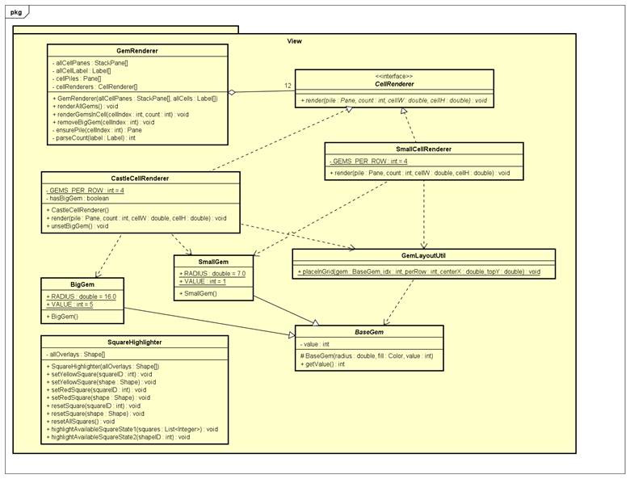
GemRenderer is responsible for rendering the visual state of the game board. It aggregates twelve CellRenderer objects, consisting of both SmallCellRenderer and CastleCellRenderer instances stored through upcasting to the CellRenderer interface. This design allows GemRenderer to treat all cell renderers uniformly while still supporting different rendering behaviors through polymorphism.
When the renderGemsInCell() method is invoked, GemRenderer selects the appropriate CellRenderer corresponding to the target cell and calls its render() method. Due to dynamic binding, the actual method executed depends on the runtime type of the object. For the two Mandarin cells (indices 0 and 6), the render() method of CastleCellRenderer is executed, which renders a BigGem and arranges any remaining SmallGem objects beneath it. For all other cells, the render() method of SmallCellRenderer is executed, which renders the SmallGem objects in a grid layout. This approach eliminates the need for conditional rendering logic inside GemRenderer and makes the rendering system easily extensible.

3.2.3. Controller Package

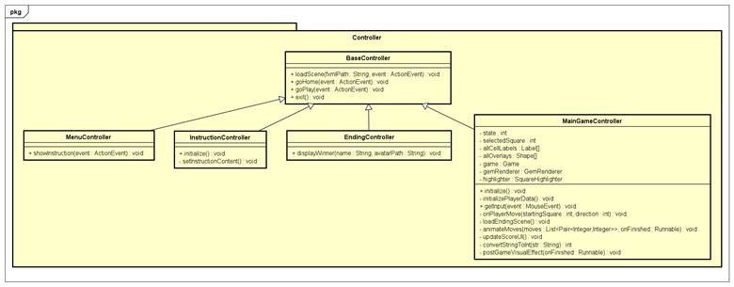
The main gameplay flow within the Controller package is managed by MainGameController. User input is handled through the getInput() method, which processes mouse-click events generated by the player. This method utilizes two important attributes: state and selectedSquare. The selectedSquare attribute stores the square currently chosen by the player, while state tracks the current stage of the input process.
Initially, state is set to 1, representing the square-selection phase. In this state, getInput() validates whether the clicked square is a valid choice by calling the corresponding validation methods in the Game class. If the selection is valid, the selected square is stored and state is updated to 2. In state 2, the controller waits for the player to choose a movement direction. If the player clicks the selected square again, the square is deselected and state returns to 1. Otherwise, if a valid adjacent square is chosen to indicate a direction, the onPlayerMove() method is invoked to execute the move. The instance of SquareHighlighter helps to show the available squares in every state to the players.
At the beginning of onPlayerMove(), state is set to -1 to temporarily disable further user interaction while the move is being processed and animated. The method first calls processingTurn() in the Game class to obtain the complete sequence of board changes resulting from the player's move, including any captures. This sequence is then passed to animateMoves(), which uses a JavaFX Timeline to display the movement step by step. This approach prevents the board from immediately updating to its final state and allows players to observe the progression of the move.
After the animation finishes, the controller updates the score display and calls postTurnProcessing() in the Game class. If the game has ended, postGameVisualEffect() is executed to clear the board visually and highlight the winner by making the winning score flicker. Finally, the ending scene is loaded to display the game result. processingTurn() and postTurnProcessing() are intentionally implemented in the Game class rather than in MainGameController. This separation ensures that the controller manages user interaction and presentation, while the Game class remains responsible for the game rules and logic, following the MVC architecture.

