Server (including mobile web and admin)

内容

1 DB設計 1

2 Screens 4

2.1. Mobile web 4

2.2. Admin 5

# DB設計

See DB/MoreCoServer.xlsx for detail.





# Screens

## Mobile web

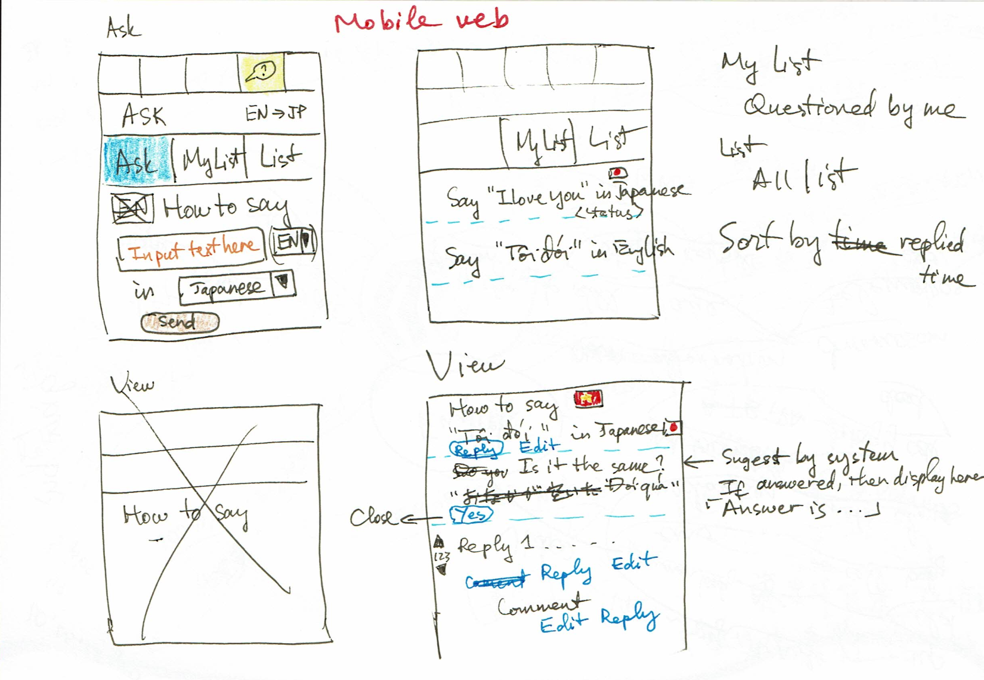

## Admin

