VIETNAM GENERAL CONFEDERATION OF LABOR

**TON DUC THANG UNIVERSITY**

**FACULTY OF INFORMATION TECHNOLOGY**



**ANALYSIS AND DESIGN AS REQUIRED**

**FINAL REPORT**

*Instructor*:  **PHAM THAI KY TRUNG**

*Performer*: **NGUYEN TRUNG THANG – 519H0231**

**TRAN LE THAI SON – 521H0477**

Class: **19H50202**

Course**: 23**

**HO CHI MINH CITY, 2023**

VIETNAM GENERAL CONFEDERATION OF LABOR

**TON DUC THANG UNIVERSITY**

**FACULTY OF INFORMATION TECHNOLOGY**



**ANALYSIS AND DESIGN AS REQUIRED**

**FINAL REPORT**

*Instructor*:  **PHAM THAI KY TRUNG**

*Performer*: **NGUYEN TRUNG THANG – 519H0231**

**TRAN LE THAI SON – 521H0477**

Class: **19H50202**

Course**: 23**

**HO CHI MINH CITY, 2023**

THANK YOU

First of all, we would like to express our gratitude to Ton Duc Thang University for creating favorable conditions for me to have facilities including a modern library system, a rich collection of books and documents, creating favorable conditions for me. beneficial for me to continue learning, acquiring and researching knowledge. Thanks a lot! Here, we would like to express our gratitude to Mr. Pham Thai Ky Trung, who patiently guided and guided us throughout the process of writing the essay, but our paper still had many errors and limitations. limited due to our limited knowledge and reasoning ability. We are looking forward to the help and contribution of our guide to improve our essay. Sincerely thank!

TABLE OF CONTENTS

THANK YOU 1

CHAPTER 1 – DESCRIPTION OF PROBLEM REQUIREMENTS 3

CHAPTER 2 – IDENTIFIES THE ACTOR 4

**CHAPTER 3: IDENTIFY USE CASE** 5

CHAPTER 4: ORGANIZATION CHART 6

CHAPTER 5: BUILDING USE CASE DIAGRAM 6

CHAPTER 6: DESCRIPTION OF USE CASE 7

CHAPTER 7: CLASS DIAGRAM 18

CHAPTER 8: SEQUENCE DIAGRAM 18

CHAPTER 9: UI/UX DESIGN 28

CHAPTER 1 – DESCRIPTION OF PROBLEM REQUIREMENTS

* Requirements to build an electronic purchase and sale management system
* The manager understands the sales situation, the supermarket's revenue, statistics are made monthly, quarterly and sometimes ad hoc as required.
* The accountant manages the quantity of goods in the warehouse according to the product code, inventorying the goods in the warehouse.
* Sales staff will charge the items that customers buy and make invoices to customers.
* Customers are the purchasers of the store system. There are two types of customers: regular customers and friendly customers. If the customer is a loyal customer, the customer code will be saved in the system and enjoy the benefits of this program.
* The purchase and sale management is carried out as follows:
* Managers directly contact manufacturers to import goods into supermarkets, as well as relationships with partners to sell goods out. The manager will manage customer-friendly information, monthly and quarterly sales statistics of the supermarket.
* When the goods are imported, the accountant will create a goods receipt with full information about the import of that goods. When goods are sold directly to large partners or goods are put on the counter, the accountant will create a delivery note. The accountant takes inventory of the goods on the warehouse, when there is an expired item, he creates a return slip for the manufacturer.
* Sales staff work in shifts, when they come to their shifts, employees must log in to the system. When the customer selects the purchased goods and asks for the payment, the staff will calculate the money and make an invoice for the customer.

CHAPTER 2 – IDENTIFIES THE ACTOR

1. Customers

* As a direct purchaser, attracted by the management system to calculate points (if the customer is loyal), get paid, receive purchase invoices.
* Customers are responsible for responding to the management department if there are any errors affecting the interests of customers.

1. **Salespersons**

* An employee works in an electronics store. Sales staff standing in front of the cashier counter and charging customers. Through the management bar code on each item, the salesperson enters the information system through the barcode reader.

**3. Accounting**

- Is the person responsible for creating the receipt when the goods are imported, creating the release note when the goods are delivered to the counter, inventorying the goods in the warehouse, creating the return slip if the item is expired or has an error.

**4. Management**

**-** Being the person who understands the business situation and revenue of the supermarket, manages the staff. The statistics are done monthly, quarterly or sometimes and hoc.

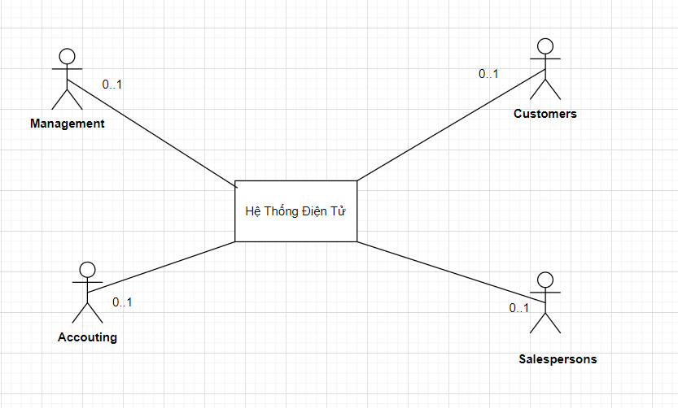

**CHAPTER 3: IDENTIFY USE CASE**

1. Customers

None

2. Salespersons

- Invoicing

- Login

3. Accounting

- Create a receipt

- Create delivery note

- Product inventory

- Create a pay slip

4. Management

- Import management

- Shipment management

- Friendly customer management

- Statistical

CHAPTER 4: ORGANIZATION CHART

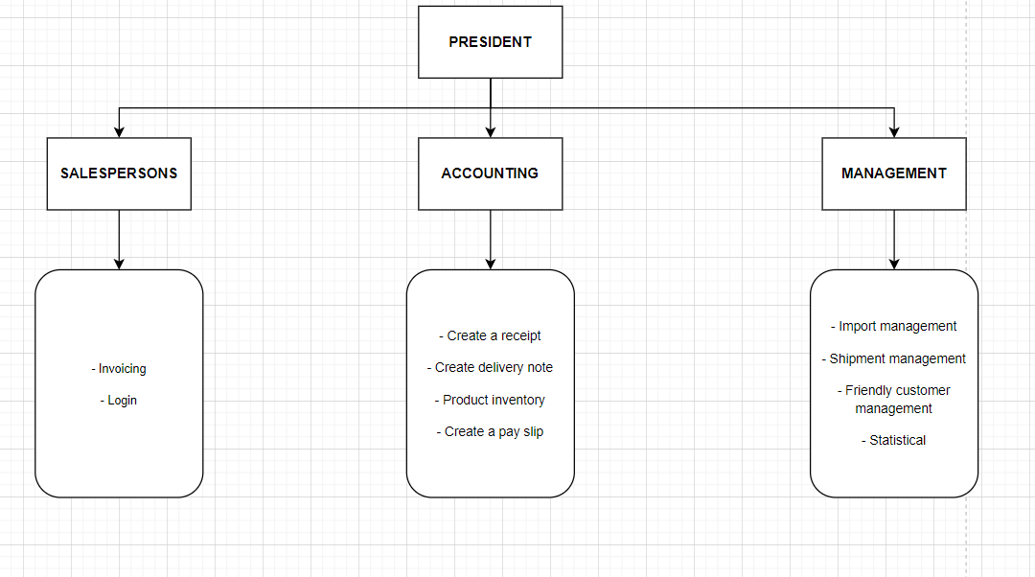

CHAPTER 5: BUILDING USE CASE DIAGRAM

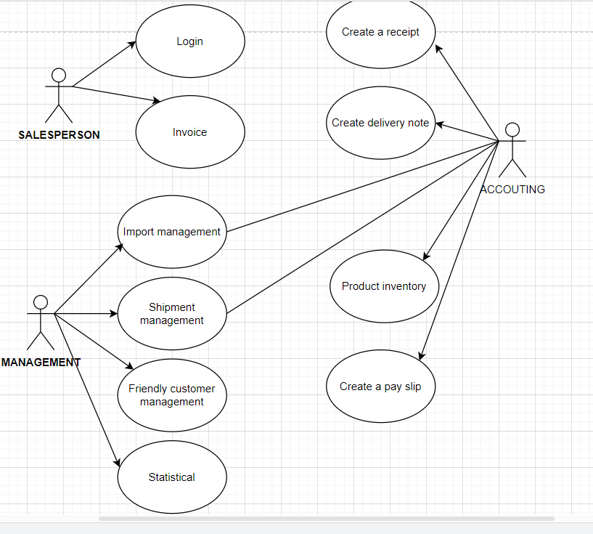

CHAPTER 6: DESCRIPTION OF USE CASE

LOGIN

1. Identifier Summary

Title: Login to the system.

Summary: This use case allows accountants and agents to log in to the system

Actor: Salesman

2. Scenario Description

a) Prerequisites:

- Employee profile has been updated on the system.

- Employees must have an employee card

b) Normal scenario:

- The salesperson holds the employee card close to the scanner.

- Employee Barcode Validation Check System

- Login successfully.

c) Alternative scenarios

- The barcode on the card is invalid

- The system allows to rescan the employee's barcode or choose to end.

MONEY BILLING

1. Identifier Summary

Title: Invoice

Summary: This use case starts when the employee chooses the invoicing function to calculate money and issue invoices to customers

Actor: Salesman

2. Scenario Description

a) Prerequisites:

- Customers have a need to buy goods and have a need to pay money

- The item codes, unit prices have been updated on the system

b) Normal scenario:

- Staff scans the barcode of each item

- The system automatically calculates the total amount that the customer has to pay based on the unit price of the item, the quantity purchased by the customer, and the value added tax that has been saved in the system

- Customer gives a friendly loyalty card

- The salesperson will scan the barcode of the card

- The system checks the validity of the card.

- The system will accumulate points for customers

- Staff will print invoices for customers

c) Alternative scenarios

- Customers who do not have a loyalty card

Starting from step 3 of the normal scenario, the system will skip step 4,5,6

- Invalid loyalty card barcode

Starting from step 4 of the normal scenario, the system allows to rescan the code or choose to end.

IMPORT MANAGEMENT

1. Identifier Summary:

Title: Management of imported goods.

Summary: This use case allows the manager to import goods. When the goods are out of stock or there is a need to import more goods, the manager will enter the goods to be imported, this information will serve as the basis for the accountant to import the goods into the warehouse.

Actor: Manager.

2. Scenario Description

a) Decision conditions:

- Item code and manufacturer information have been updated in the system.

b) Normal version:

- The manager chooses the input management function of the system.

- The system asks for the item code to be entered.

- The manager of the input code.

- The system checks the validity of the product code.

- The system asks to enter the quantity.

- The manager enters the quantity of goods to be imported.

- Quantity recording system.

- The system asks to enter the manufacturer code.

- The manager enters the manufacturer code.

- The system checks the validity of the manufacturer's code.

- The system transfers the entered information to the accountant.

c) Options:

Al - Manager entered invalid item code:

Sequence A1 starts from step 4 of the normal scenario.

- The system asks the manager if he wants to add this item to the system.

- The manager selects more rows.

- The system asks to enter the item name.

- The manager enters the name of the item.

- The system saves item codes and goods names.

Go back to step 5 of the normal scenario.

Al.1 − The manager did not select additional rows.

The sequence A1.1 starts from step 5 of the alternative scenario A1.

- The manager did not select more rows.

Return to step 2 of the normal scenario.

A2 - The manager entered the wrong manufacturer code:

The A2 series starts from step 10 of the normal scenario.

- The system asks the manager if he wants to add this manufacturer code to the system.

- The manager chooses to add the manufacturer code.

- The system asks to enter the manufacturer's name.

- The manager enters the manufacturer.

- System to save manufacturer code and production name. Go back to step 10 of the normal scenario.

A2.1 – The manager did not select more rows.

The A2.1 series starts from step 11 of the A2 replacement scenario.

- The manager did not choose to add the manufacturer code. Go back to step 8 of the normal scenario.

EXPORT MANAGEMENT

1. Identifier Summary

Title: Export management.

Summary: This use case allows the manager to manage the delivery of goods from the warehouse to the counter. When the goods on the counter are sold out, the manager tells us the information of the items that need to be displayed on the counter, this information will serve as the basis for the accountant to ship the goods to the counter.

Actor: The manager.

2. Scenario Description

a) Prerequisites:

- Goods to be exported to the counter are already in stock.

b) Normal scenario:

- The manager selects the System's Export Management function.

- The system asks to enter the product code to be exported to the counter.

- The manager enters the item code.

- The system checks the validity of the product code.

- The system asks to enter the quantity.

- The manager enters the quantity of goods to be exported.

- The system checks whether the quantity meets the quantity of goods in stock.

- The system transfers the entered information to the accountant.

c) Alternative scenarios:

Al - Manager entered invalid item code:

A1 string started from the step 4 of the normal script.

- The system notifies the item code that is not in the system.

Return to step 2 of the normal scenario.

A2 - The manager imported invalid goods to be exported:

A2 string started from the step 7 of the normal script.

- The system notices that the quantity that has just been imported exceeds the number of goods currently in stock.

- Return to the 5 of the normal script.

FRIENDLY CUSTOMER MANAGEMENT

1. List definition summary

Title: Friendly customer management.

Summary: This use case allows the manager to add Customer Friendly information.

Actor: Manager.

2. Scenario Description

a) Prerequisites:

- Customers want to make Customer Friendly card.

- Customers with invoices greater than 50000

b) Normal scenario:

- The manager chooses the system's function of adding Friendly Customers.

- The system asks the manager to enter the customer's name.

- The manager enters the customer's name.

- The system asks to enter the customer's name.

- The manager enters the customer's name.

- The system checks the validity of the customer's name and asks to enter the address.

- The manager enters the address.

- The system checks all information entered.

- The system automatically updates the card creation date, issues customer codes and saves information.

c) Alternative scenarios:

A1 - Invalid date of birth:

Sequence A1 starts from step 6 of the normal scenario.

- Invalid date entered. Go back to step 4 of the normal scenario.

A2 - The customer information just entered is already in the system:

Sequence A2 starts from step 8 of the normal scenario.

- Notice that this customer already exists in the Customer Friendly system.

- The system cancels all entered information.

The use case end.

STATISTICAL

1. List definition summary

Title: Revenue statistics.

Summary: This use case allows the manager to statistics the system's revenue at the present time

Actor: Manager.

2. Scenario Description

a) Decision conditions:

- Do not have.

b) Normal version:

- The manager chooses the system function.

- The system asks to select the statistical configuration.

- The manager chooses the statistical expression (month, quarter, current time)

- The system displays statistics and revenue tables.

- The system asks the manager if he wants to be included in the statistics table.

- The manager requests in the statistics table.

- The system in the statistics table for the manager.

c) Alternative scenarios:

A1 - Manager is not in the statistics table:

- Sequence A1 starts from step 5 of the normal scenario.

- The manager does not ask in the statistics table

The use case end.

CREATE IMPORT COLLECTIONS

1. Identifier Summary

- Title: Create entry slip.

- Summary: This use case allows the accountant to create a receipt for goods entering the warehouse.

- Actor: Accountant

2. Scenario Description

a) Prerequisites:

- There are imported goods.

- There is management information to import goods from the manager.

b) Normal scenario:

- The accountant chooses the system's Create Invoice function.

- The system requires the accountant to fill in the goods' information in the Goods Entry slip.

- The accountant fills in the goods import slip.

- System to issue goods receipt code and save information

- The system asks the storekeeper if he has printed the Import Voucher.

- The accountant chooses to print the Goods Entry slip.

- The system prints the goods import slip for accountants.

c) Alternative scenarios:

A1 - The accountant does not print the Goods Receipt:

- Sequence A1 starts from step 5 of the normal scenario.

- Accountants do not require printing receipts.

- Use case end.

CREATE SHIPPING COLLECTIONS

1. Summary of title definition:

- Create purchase order.

Summary: This use case allows the accountant to make a note to release goods from the warehouse.

Actor: Accountant.

2. Scenario Description

a) Decision conditions:

- There is information on management of shipments from the manager.

b) Normal version:

- The accountant chooses the system's Create Warehouse and Export function.

- The system asks the Accountant to fill in invoice information in the Goods Release Note.

- The accountant fills in the information on the Goods Release.

- The system issues the delivery slip code and saves the information.

- The system asks the accountant whether to print the Export Voucher.

- The accountant chooses to print the Delivery Note.

- The system to print the Goods Release for the accountant.

c) Alternative scenarios:

A1 - The accountant does not print the Goods Release:

Sequence A1 starts from step 5 of the normal scenario.

- Accountants do not require printing of delivery notes.

- The use case end.

INVENTORY

1. Identifier Summary

Title: Inventory of goods in stock.

Summary: This use case allows accountants to inventory goods in stock, quantity of each type of goods, expiry date of each item.

Actor: Accountant

2. Scenario Description

a) Prerequisites:

- Do not have.

b) Normal scenario:

- The accountant chooses the Inventory function.

- The system asks to choose the form of inventory (by item code, all).

- Accountants choose the form of inventory.

- The system displays the item code, the number of corresponding items.

- The system asks the accountant if he wants to print the inventory.

- The accountant chooses to print the Inventory sheet.

- Inventory printing system for accountants.

c) Alternative scenarios:

A1 - Accounting does not require printing of the Inventory: Series A1 starts from step 5 of the normal scenario.

- Accounting does not require printing of statistical tables

The use case ends.

CREATE PAYMENTS

1. List definition summary

Title: Create payment slip.

Summary: This use case allows accountants to prepare Returns to manufacturers.

Actor: Accountant

2. Scenario Description

a) Prerequisites:

- The item you want to pay must be in the system.

b) Normal scenario:

- The accountant chooses the system's Create Return Voucher function.

- The system asks to enter the item code to be paid.

- The accountant enters the code of goods to be paid.

- The system checks the validity of the product code.

- The system asks to choose a reason for returning goods (defective goods, expired goods).

- The accountant chooses the reason for the payment.

- The system automatically assigns the order number of the Order Creation Voucher, saves information.

- The system asks the accountant whether to print the Return Voucher.

- The accountant chooses to print the Return Voucher.

- The system prints Return Vouchers for accountants.

c) Alternative scenarios:

A1 - The accountant entered the wrong item code to pay: The A1 series starts from step 4 of the normal scenario.

- The system notifies the wrong product code.

Return to step 2 of the normal scenario.

A2 - Accounting does not require printing of Return Voucher: Series A2 starts from step 8 of the normal scenario.

- Accounting does not require printing of statistical table.

- Use case end.

CHAPTER 7: CLASS DIAGRAM

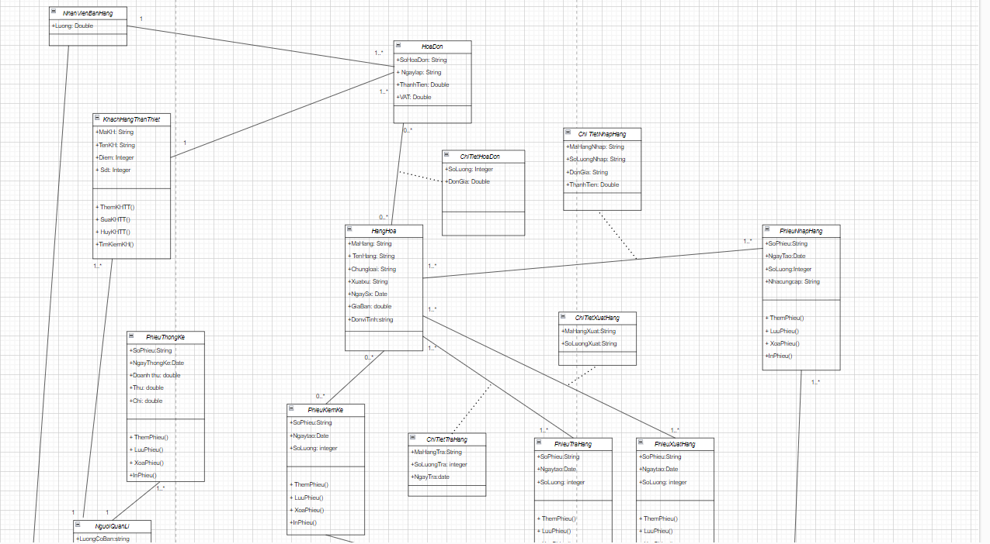

Link Diagram: <https://app.diagrams.net/#G1AG46luMkeGREMKRlofdaHNr0mvGXd0QW>

CHAPTER 8: SEQUENCE DIAGRAM

Login Chart:

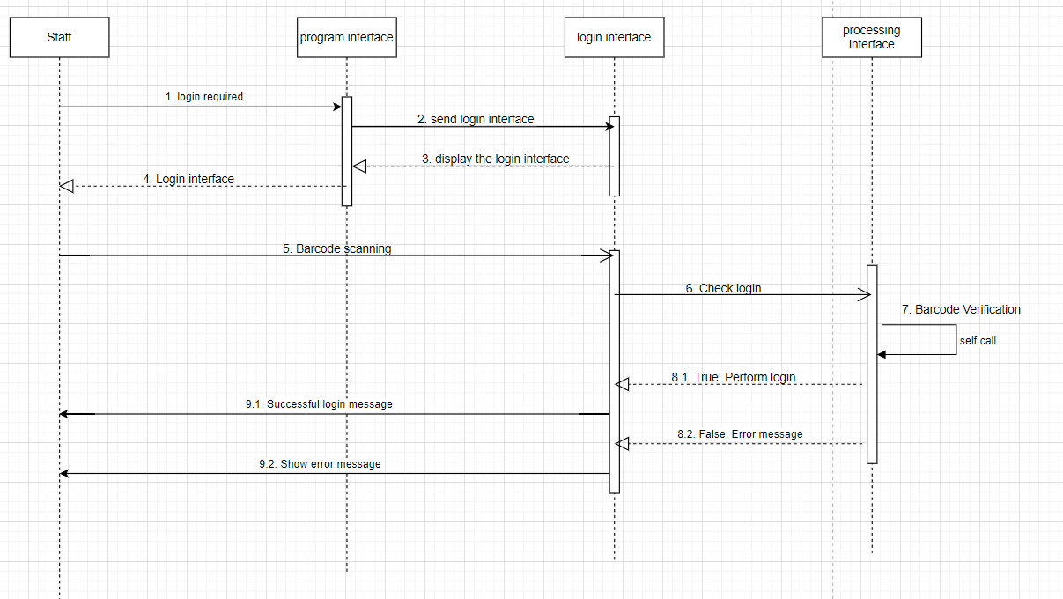

* Login behavior specification:
* Salesperson chooses the login function
* Login interface and barcode scanning request
* Bar code scanning staff
* Barcode validity checking system
* If yes, then login successfully
* If wrong error message

Invoicing chart:

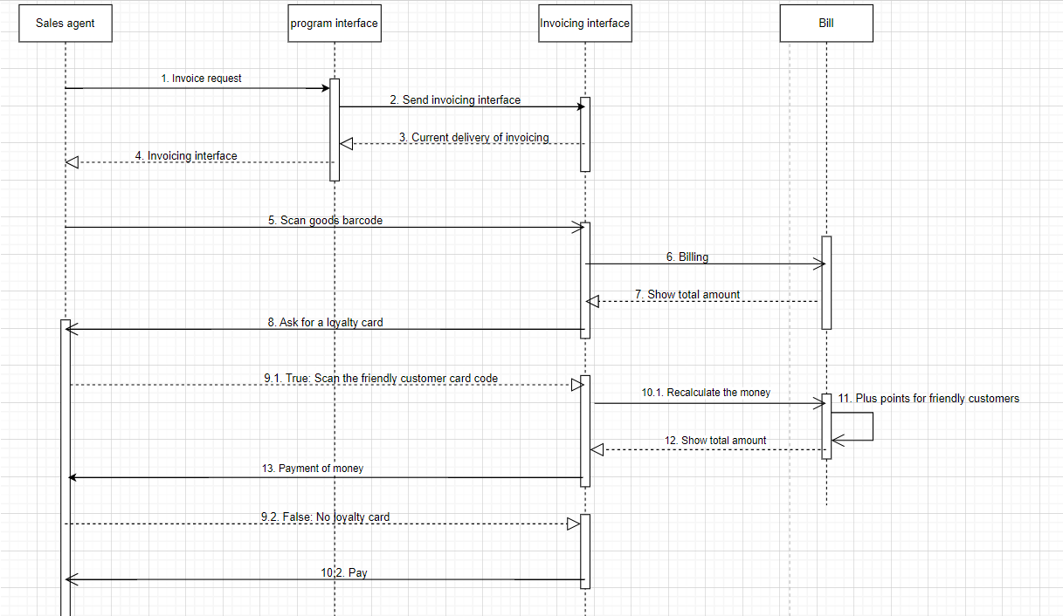

1. Employees scan the barcode of each item.

2. The system automatically calculates the total amount to be paid by the customer based on the unit price of the item, the quantity of goods purchased by the customer, and the added value of VAT that has been saved in the system.

3. Customer gives Customer Friendly card.

4. The salesperson scans the barcode of the Customer Friendly card. 5. The system checks the validity of the barcode.

6. System of accumulating points for customers.

7. The salesperson in the invoice to the customer.

Import management chart:

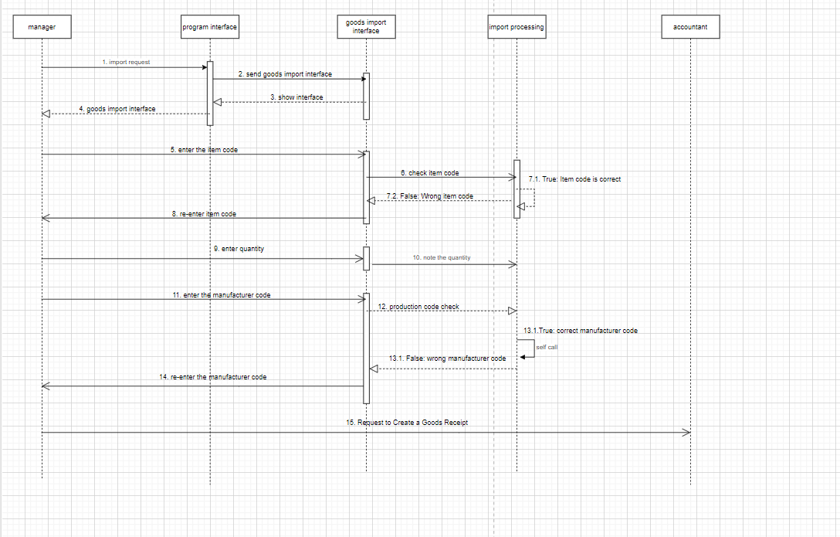

Behavioral specification “Incoming management”

- The manager selects the system's Import Management function.

- The system asks for the item code to be entered.

- The manager enters the item code.

- The system checks the validity of the product code.

- The system asks to enter the quantity.

- The manager enters the quantity of goods to be imported.

- Quantity recording system.

- The system asks to enter the manufacturer code.

- The manager enters the manufacturer code

- Manufacturer's validity check system

- The system transfers the information just entered to the accountant

Export management chart:

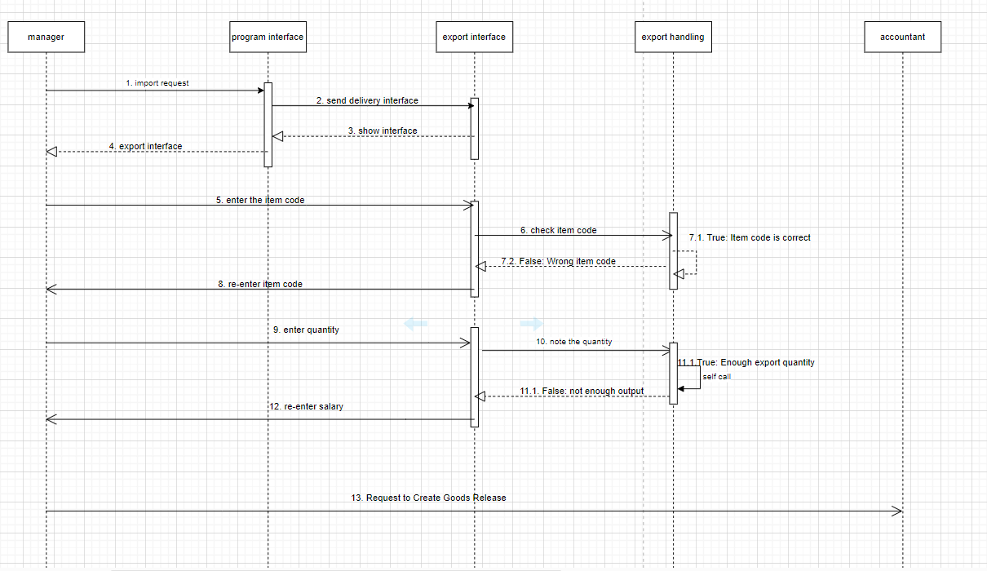

Behavioral specification “Shipment management”

- The manager selects the System's Export Management function.

- The system asks to enter the product code to be exported.

- The manager enters the item code.

- The system checks the validity of the product code.

- The system asks to enter the quantity.

- The manager enters the quantity of goods to be exported

- The system checks whether the quantity meets the inventory quantity or not.

- The system transfers the entered information to the accountant

Chart of creating receipts:

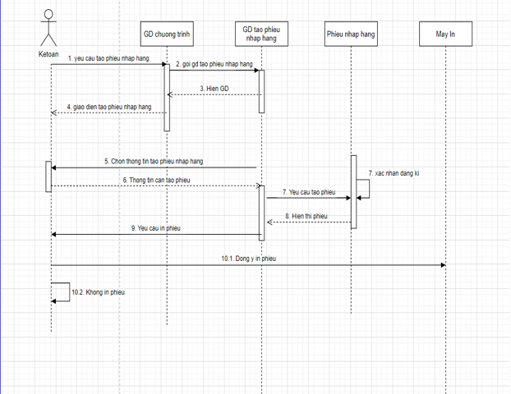

Behavioral specification “Create a Goods Receipt”

1. The accountant chooses the system's Create Order Entry function.

2. The system requires the accountant to fill in the goods' information in the Goods Import Note.

3. The accountant fills in the goods import slip.

4. System for issuing goods receipt code and saving information

5. The system asks the accountant whether to print the Air Entry Voucher.

6. The accountant chooses to print the Goods Entry slip.

7. The system prints the Goods Entry slip for accountants.

Graph of creating a bill of lading:

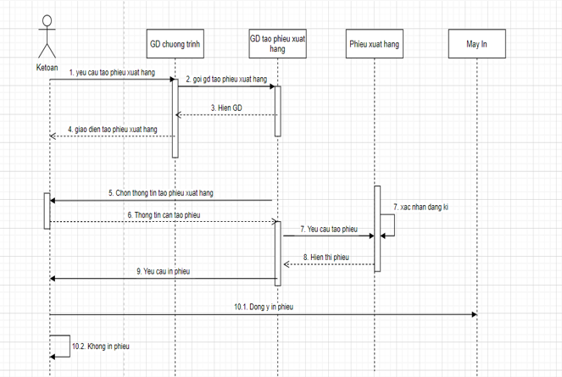

Behavioral specification “Create delivery note”

1. The accountant chooses the system's Create Export Voucher function.

2. The system requires the accountant to fill in the goods' information in the Good Release.

3. The accountant fills in the Goods Release slip.

4. The system issues the delivery slip code and saves the information.

5. The system asks the accountant whether to print the Export Voucher.

6. The accountant chooses to print the Delivery Note.

7. The system prints the Goods Release for accountants.

Statistical Chart:

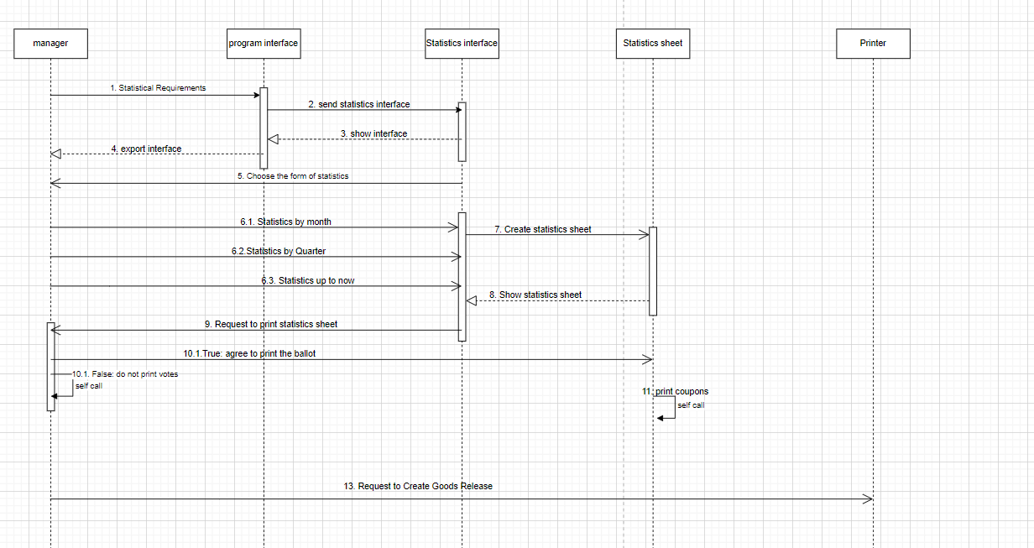

"Statistics" Behavior Specification

1. The manager chooses the statistical function

2. The system asks to choose the form of statistics

3. The manager chooses the form of statistics

4. The system displays the statistics table

Inventory chart:

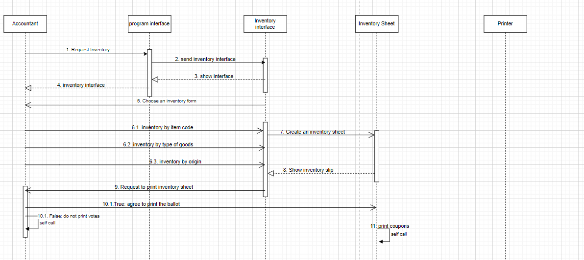

Behavioral specification “Inventory of Goods”

1. The accountant selects the Inventory function.

2. The system asks to choose the form of inventory (by item code, all).

3. Accountants choose the form of inventory.

4. The system displays the item code and the corresponding item quantity.

5. The system asks the accountant if he wants to print the Inventory sheet.

6. The accountant chooses to print the Inventory sheet.

7. Inventory printing system for accountants.

Return Voucher Creation Chart:

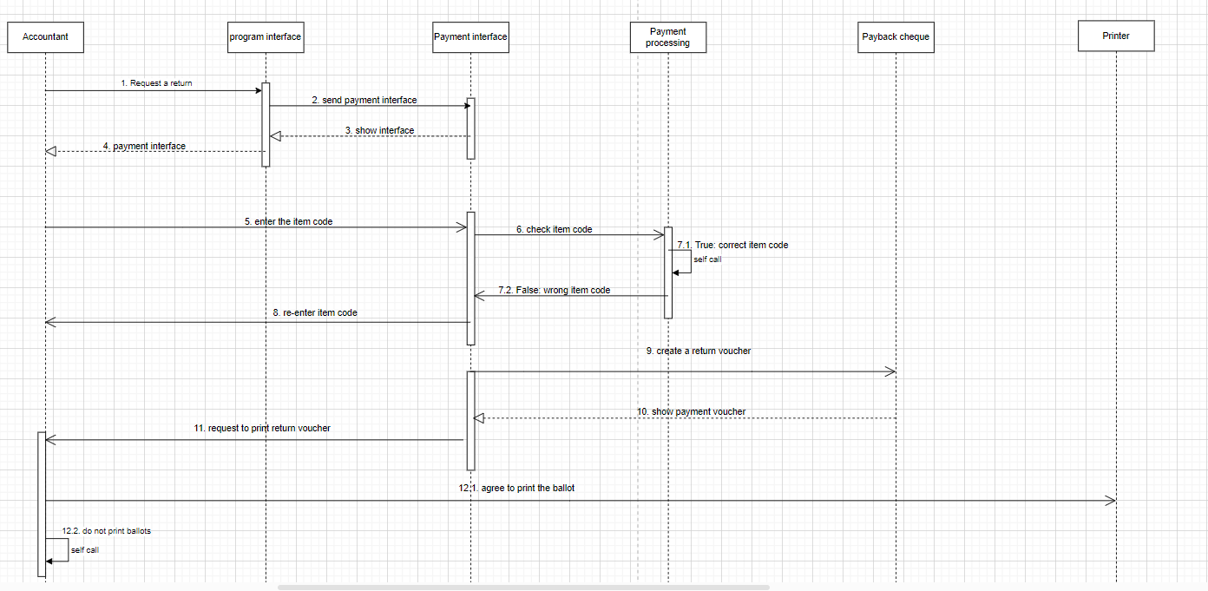

Behavioral specification “Create return slip”

1. The accountant chooses the system's Create Return Voucher function.

2. The system asks to enter the item code to be paid.

3. The accountant enters the code of goods to be returned.

4. The system checks the validity of the item code.

5. The system asks the reason for the return.

6. The accountant chooses the reason for the return.

7. Automatic numbering system Create rows, save information.

8. The system asks the accountant whether to include the return slip.

9. The accountant chooses in the Return Voucher.

10. The system enters the Return Voucher for the accountant.

Customers Loyalty Chart:

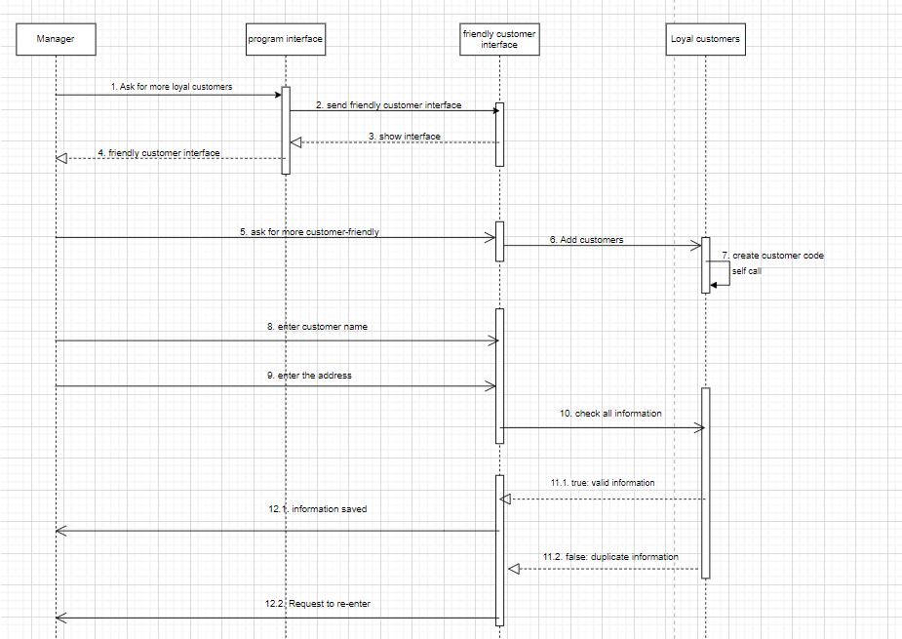

Behavioral specification “Loyalty customer”

1. The manager selects the system's additional Customer Friendly function.

2. The system asks the manager to enter the customer's name.

3. The manager enters the customer's name.

5. The system asks to enter the address.

