GENERAL CONFEDERATION OF LABOR OF VIETNAM
TON DUC THANG UNIVERSITY
FACULTY OF INFORMATION TECHNOLOGY

SOFTWARE ENGINEERING
FINAL REPORT

Instructing Lecturer: PHẠM THÁI KỲ TRUNG
The Executor: NGUYỄN CHÁNH TÍN – 520H0587
NGUYỄN TRUNG TÍN – 520H0589
Course:24
HO CHI MINH CITY, 2022
GENERAL CONFEDERATION OF LABOR OF VIETNAM
TON DUC THANG UNIVERSITY
FACULTY OF INFORMATION TECHNOLOGY
SOFTWARE ENGINEERING
FINAL REPORT

Instructing Lecturer: PHẠM THÁI KỲ TRUNG
The Executor: NGUYỄN CHÁNH TÍN – 520H0587
NGUYỄN TRUNG TÍN – 520H0589
Course:24
HO CHI MINH CITY, 2022

ACKNOWLEDGEMENT
In order to get a complete and good report like this, our team has received enthusiastic help from lectures and classmates.
My team would also like to thank for the helpful knowledge and enthusiastic help from lecturer Mrs. Phạm Thái Kỳ Trung. Thank you, Mr. Trung, for being so enthusiastic in teaching, educating, equipping us with the necessary knowledge and creating the most favorable conditions for us to complete this report.
And also thank Ton Duc Thang University for giving us a modern and
developed educational environment.
With hard work and effort we have successfully completed this report. But surely, this report cannot avoid mistakes. We are looking forward to receiving from teacher so that we can improve it better.
We sincerely thank you!

THE PROJECT WAS COMPLETED

AT TON DUC THANG UNIVERSITY
We pledge that this is a product of our own project and is under the guidance of Mrs. Phạm Thái Kỳ Trung. The content of research, results in this subject is honest and not published in any form before. The data in the tables used for the analysis, comment, and evaluation were collected by the authors themselves from various sources indicated in the reference section.
In addition, many comments and assessments as well as data from other authors and organizations have been used in the project, with references and annotations.
If any fraud is found, I am fully responsible for the content of my project. Ton Duc Thang University is not involved in any copyright infringement or copyright infringement in the course of implementation (if any).
Ho Chi Minh, December 11th 2022
Author

Nguyễn Chánh Tín
Nguyễn Trung Tín

EVALUATION OF INSTRUCTING LECTURER
Instructor endorsement
_______________________________________________________________________________________________________________________________________________________________________________________________________________________________________________________________________________________________________________________________________________________________________________________________________________
Ho Chi Minh City, 2022
(Sign and write your name)
Evaluation section of the teacher marking the test
_______________________________________________________________________________________________________________________________________________________________________________________________________________________________________________________________________________________________________________________________________________________________________________________________________________
Ho Chi Minh City, 2022
(Sign and write your name)

SUMMARY
In the era of technology 4.0, with the strong development of science and technology, the need to systematize in the field of sports is essential, so the application of Information Technology to the system is not far away. strange to us. Therefore, the problem is how to meet the needs of shortening the processing time of administrative procedures, increasing work efficiency, handling a large amount of information increasingly and requiring quick response. timely in the process of operation as well as management.
Going from the above issues and realizing the importance of mini football field management, I will carry out with the topic: “A company selling Supplement Facts products”.

TABLE OF CONTENTS

ACKNOWLEDGEMENT 3
THE PROJECT WAS COMPLETED 4
AT TON DUC THANG UNIVERSITY 4
EVALUATION OF INSTRUCTING LECTURER 5
SUMMARY 6
TABLE OF CONTENTS 1
LIST OF TABLES, FIGURES 3
PART 1 – INTRODUCTION 6
1.1 Purpose and Scope 6
1.2 Product Overview 6
1.3 Terms, Acronyms, and Abbreviations 7
PART 2 – PROJECT MANAGEMENT PLAN 8
2.1 Project organization 8
2.2 Lifecycle Model Used 8
PART 3 – REQUIREMENT SPECIFICATIONS 12
3.1 Stakeholders for the system 12
3.2 Use case model 13
3.2.1 Graphic use case model 13
3.2.2 Textual Description for each use case 13
3.3 Functional requirements 18
3.4 Non – functional requirements 18
PART 4– ARCHITECTURAL 19
4.1 Architectural styles used 19
4.2 Architectural model 19
4.3 Technology, software, and hardware used 21
4.4 Rationale for your architectural style and model 21
PART 5 – DESIGN 23
5.1 Database design 23
5.2 Static model – class diagrams 27
5.3 Dynamic model – sequence diagrams 27
PART 6– TEST PLAN 30
6.1 Windows Form 30
6.2 MVC Web 37
REFERENCES 42

LIST OF TABLES, FIGURES
LIST OF TABLES
Table 1 : Scenarios for using the product 6
Table 2 : Use case create Goods Received 14
Table 3 : Use case create Goods Delivery 15
Table 4 : Use case view Storage 16
Table 5 : Use case view Report 17
Table 6 : Functional requirements 18
Table 7 : Non - functional requirements 18

LIST OF FIGIURES
Figure 1 : VModel 8
Figure 2 : Relative cost to fix, based on time of detection 9
Figure 3 : Stakeholder diagram 11
Figure 4 : Use case diagram 12
Figure 5 : MVC model 19
Figure 6 : Create database 25
Figure 7 : Database Diagram 25
Figure 8 : Static model 26
Figure 9 : Sequence Diagram – Create Goods Received 27
Figure 10 : Sequence Diagram – Create Goods Delivery 27
Figure 11 : Report 28
Figure 12 : Login by Username and Password 29
Figure 13 : Create Goods Received 31
Figure 14 : ListReceived 32
Figure 15 : Bill Received 32
Figure 16 : Goods Delivery 33
Figure 17 : ListDelivery 33
Figure 18 : Bill Delivery 34
Figure 19 : Bill Delivery 34
Figure 20 : RevenueReport 35
Figure 21 : https://github.com/tinchanh2002/FinalProjectCNPM.git 35
Figure 22 : Login interface 36
Figure 23 : Products 37
Figure 24 : Order 38
Figure 25 : History Order 39
Figure 26 : Admin Account 40

PART 1 – INTRODUCTION

1.1 Purpose and Scope
This project provides an architectural overview for the whole software function of a corporation that sells Supplement Facts products to agents. It builds and develops the functionality of the platform as well as the technology for its users. The report describes in detail the functions, data design, architectural model, fulfills the requirements in terms of functional development, and builds the scenario for each role.

1.2 Product Overview
Scenario | Description
Create Goods Received  (for Accountant) | - The accountant needs to create a receipt every time the company receives more products  - Products can be added, deleted or edited quantity when the company buys and sells by an accountant.  - Receipt includes ReceiptCode, Product, Price, Quantity, Date,… printed after the goods are imported
Print Delivery Slips  (for Accountant) | - The accountant needs to create a receipt every time the company receives more products  - Products can be added, deleted or edited quantity when the company buys and sells by an accountant.  - Receipt includes ReceiptCode, Product, Price, Quantity, Date,… printed after the goods are imported
View incoming/outgoing stock report and revenue report monthly  (for Accountant) | - The accountant can view stock reports and venue reports monthly  - Return list of incoming/ outgoing products of picked month and sum revenue a month
Table 1: Scenarios for using the product

1.3 Terms, Acronyms, and Abbreviations
SDLC Systems Development Life Cycle
MVC Model-View-Controller
HTTP Hyper Text Transfer Protocol
JSON JavaScript Object Notation
XML Extensible Markup Language

PART 2 – PROJECT MANAGEMENT PLAN

2.1 Project organization
A company selling Supplement Facts products to agents needs software with the following functions:
- Accountants shall be able to create Goods Received when the company imports goods (a warehouse receipt will include many items)
- Agents shall be able to place an order of items and choose a payment method (Cash, bank transfer, Momo...)
- Accountants shall be able to create Goods Delivery Note to deliver goods to agents (print delivery slips), update the status of orders as being transferred and update the payment status of agents.
- Accountants shall be able to view incoming/outgoing stock report and revenue report monthly.

2.2 Lifecycle Model Used
2.2.1 SDLC V-Model
- Use V-Model which is an extension of the waterfall model.
- Instead of moving down in a linear manner, the V-Model of SDLC implements its execution in a V-shaped structure. Here, each phase must be completed before the next one can begin. In parallel to the software development phase, a corresponding series of test phases also runs in this model. Each stage comprises a specific type of testing done, and once that testing is passed, only then the next phase starts. A sequential design progression is followed like that of the waterfall model.

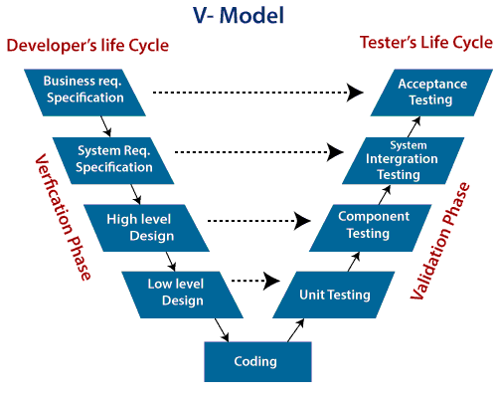
Figure 1: VModel
2.2.2 Problem with the Waterfall Model
As you may observe, that testing in the model starts only after implementation is done. But if you are working in a large project, where the systems are complex, it’s easy to miss out the key details in the requirements phase itself. In such cases, an entirely wrong product will be delivered to the client and you might have to start afresh with the project OR if you manage to note the requirements correctly but make serious mistakes in design and architecture of your software you will have to redesign the entire software to correct the error.
Assessments of thousands of projects have shown that defects introduced during requirements & design make up close to half of the total number of defects.
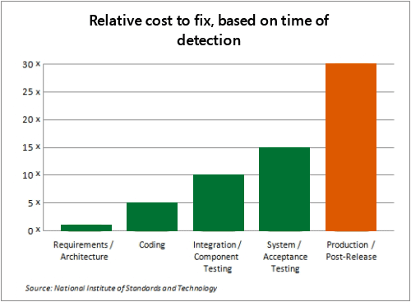
Figure 2: Relative cost to fix, based on time of detection
Also, the costs of fixing a defect increase across the development lifecycle. The earlier in life cycle a defect is detected, the cheaper it is to fix it.
2.2.3 Why use the V model instead?
- It is easy to manage due to the rigidity of the model. Each phase of V-Model has specific deliverables and a review process.
- Proactive defect tracking – that is defects are found at early stage.
2.2.4 When to use?
- Where requirements are clearly defined and fixed.
- The V-Model is used when ample technical resources are available with technical expertise.
2.2.5 Advantages
- This is a highly disciplined model and Phases are completed one at a time.
- V-Model is used for small projects where project requirements are clear.
- Simple and easy to understand and use.
- This model focuses on verification and validation activities early in the life cycle thereby enhancing the probability of building an error-free and good quality product.
- It enables project management to track progress accurately.
2.2.6 Disadvantages
- High risk and uncertainty.
- It is not good for complex and object-oriented projects.
- It is not suitable for projects where requirements are not clear and contains high risk of changing.
- This model does not support iteration of phases.
- It does not easily handle concurrent events.

PART 3 – REQUIREMENT SPECIFICATIONS

3.1 Stakeholders for the system
2 Stakeholders for the system:
- Accountant: internal stakeholder
→ Create Goods Received, create Goods Delivery, view incoming/ outgoing stock report and revenue report monthly on Windows Form
- Agents: external stakeholder.
→ Order of items and choose a payment method by MVC Web
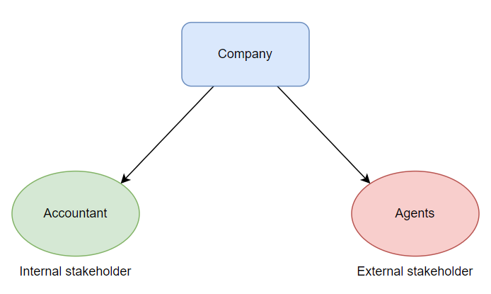
Figure 3: Stakeholder diagram

3.2 Use case model

3.2.1 Graphic use case model
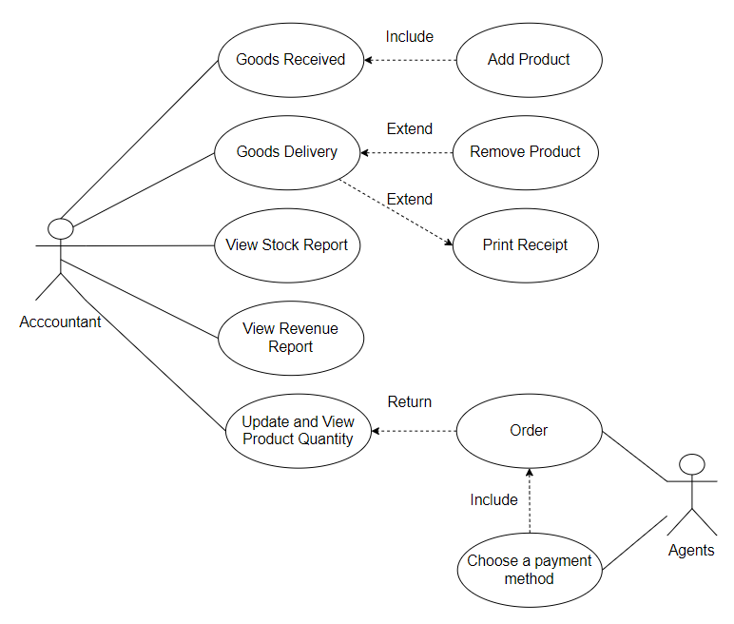
Figure 4: Use case diagram

3.2.2 Textual Description for each use case
- Use case create Goods Received
ID | Create Goods Received
Title | Create Goods Receive Note
Description | - The accountant needs to create a receipt every time the company receives more products  - Products can be added, deleted or edited quantity when the company buys and sells by an accountant.  - Receipt includes ReceiptCode, Product, Price, Quantity, Date,… printed after the goods are imported
Primary Actor | Accountant
Preconditions | List of products must be available before
Postconditions | Incoming products’ details will be added to the database in  order for the accountant to view the stock report
Main Success Scenario | Clicks on Import of menu  Fill information in the form  Enter the quantity of products  Click on Add to add recently chosen product
Extensions | If the Accountant doesn’t add any product, he/ she cannot click on Receive Button to Create Goods Received Note.
Frequency of Use | Frequently
Status | [Development status]
Priority | [Priority of this use case]
Table 2: Use case create Goods Received
- Use case create Goods Delivery
ID | createGoodsDelivery
Title | Create Goods Delivery
Description | - The accountant needs to print the delivery slips every time the company buys and sells to the agent, customer.  - Accountant can update order status, delivery status, product quantity, payment status.  - Delivery Goods includes DeliveryCode, Product, Price, Quantity, Date, PaymentMethod,…printed after the goods are delivered
Primary Actor | Accountant
Preconditions | List of products such as productName, productID, price, quantity must be available before
Postconditions | Incoming products’ details will be update in database in  order for Accountant to view stock report
Main Success Scenario | Accountant clicks on item Import of menu.  Choose an order to view its detail products  - Click on Delivery/ Print receipt
Extensions | If Accountant doesn’t add any product, he/ she will receive an error message box require fill out.
Frequency of Use | Frequently
Status | [Development status]
Priority | [Priority of this use case]
Table 3: Use case create Goods Delivery
- Use case View Storage
ID | Storage
Title | Storage
Description | - The accountant can view stock reports and venue reports monthly  - Return list of incoming/ outgoing products of picked month and sum revenue a month
Primary Actor | Accountant
Preconditions | List of products must be available before
Postconditions | The full information of revenue for the product when remove or add and quantity product which will be presented on the screen
Main Success Scenario | Accountant clicks on item Storage of menu  See information of Storage.  If you want to see the monthly report, choose month and press Report button.
Extensions | If Accountant doesn’t choose month, he/ she will receive an error message box require fill out.
Frequency of Use | Not frequently, just few times every month
Status | [Development status]
Priority | [Priority of this use case]
Table 4: Use case view Storage
- Use case View Report
ID | Report
Title | Report
Description | - When a Company wants to see incoming/outgoing stock report and revenue report monthly.  - This action contains see information about import/export and revenue monthly.  - The result of this action is that the software will return a Revenue Report which has full information such as CodeRecevied, product, price, quantity, date,….
Primary Actor | Accountant
Preconditions | List of products must be available before
Postconditions
Main Success Scenario | Accountant choose Month on comboBox and press Report button.  See information about this month report.
Extensions | If Accountant doesn’t choose month, he/ she will receive an error message box require choose month.
Frequency of Use | Frequently
Status | [Development status]
Priority | [Priority of this use case]
Table 5: Use case view Report

3.3 Functional requirements
Web | Win Form
- Full product list  - TextBox for Agent can fill quantity of products  - Must have payment method function such as Momo, Cash, Banking,…  - Only admin has permission to view the orders of all agents. | - ComboBox product name  - Must have fill information when create Goods Received  - Must have list view invoice details  - Must be a total price for the invoice both Received and Delivery  - ComboBox to choose month on Report  - Must have database update function
Table 6: Functional requirements

3.4 Non – functional requirements
Web | Win Form
- The time payment should not be delay more than 5 minutes. | - Report must not be presented immediately after accountant executes
Table 7: Non - functional requirements

PART 4– ARCHITECTURAL

4.1 Architectural styles used
- The architectural style used a variety of powerful extensible (extensible model) product software.
- This software architecture model is very easy to use. Whether building small, simple software or large, complex software.
- Engineers can consider using templates.
- Architectural style is made up of event processing components that receive and process events asynchronously.

4.2 Architectural model
- Using MVC model (Model – View – Controller) to design web have functional for Agents to place orders
- Divide the interactive application into 3 parts, including:
+ Model – contains functions and error data
+ View – display information to the user (Can define multuple views)
+ Controller – handle input from the user
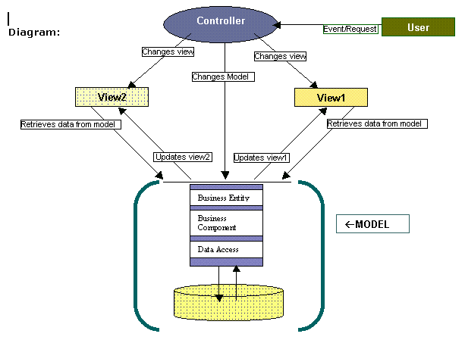
Figure 5: MVC model
- This model helps to separate the layers that present internal information from the information presented to and accepted by users. It separates component dependencies and allows for more efficient code.
- In an MVC application, each component is only in charge of one array. When components combine and interact with each other, the user interface is created.
- In general, the order of events that occur when an application responds to a user interaction/request is as follows:
- Controller receives the request.
- The controller gets data from the model, or updates the model's data.
- The model's data is passed to the view by the controller, which also chooses the right view to display the data.
- The view uses the model's data to produce the interface.
- The controller assumes the role of the interaction's reception point in the MVC architecture as described above. The user talks to the controller to initiate an interaction.
An HTTP query represents this interaction in a web application. Therefore, the controller will handle any HTTP requests that come to the application. Depending on the query, the controller can perform many different operations. However, the model is virtually always used in conjunction with these activities.
The model is entirely independent of how the view presents the data on the interface.
Testing is made easier by the model and view's independence. It is typically challenging to test the interface. The remaining model component is simpler to test when there is no interface present.
This independence also allows the controller to select the view to suit the requirements. That is, with the same data (model), the controller can choose different ways of displaying (view). For example, in a typical web application, the controller would select the HTML view. If the query is coming from another application, the controller can select a special view type in JSON or XML form.

4.3 Technology, software, and hardware used
- Softwar: Visual Studio 2022, Microsoft SQL Server Management Studio
- Localhost: 7229.

4.4 Rationale for your architectural style and model
- Microservices is structured as a collection of small, loosely coupled services that collaborate to accomplish a common objective using the architectural pattern known as microservices. They can be added, removed, or upgraded without interfering with other applications because they operate independently.
- There are numerous advantages to microservices architecture, including ease of deployment and testing, increased productivity, adaptability, and scalability. However, they also have some drawbacks, as standalone microservices cannot function as a larger application without a seamless communication method.
- Event-driven microservices make it possible to communicate with other microservices in real time, allowing data to be consumed as events before they are needed.
- When we are in the data center, our primary concern is the current state of the data.
- When using an event-driven architecture, event producers make and send event notifications. There can be one or more event information receivers, and event receivers will cause handling logic to be triggered.
- Example: Web example recently received a new order; it's possible that Accounting's application is waiting for that notification and listening for it before triggering their own internal system to publish their own data. to their customers about the event.

PART 5 – DESIGN

5.1 Database design
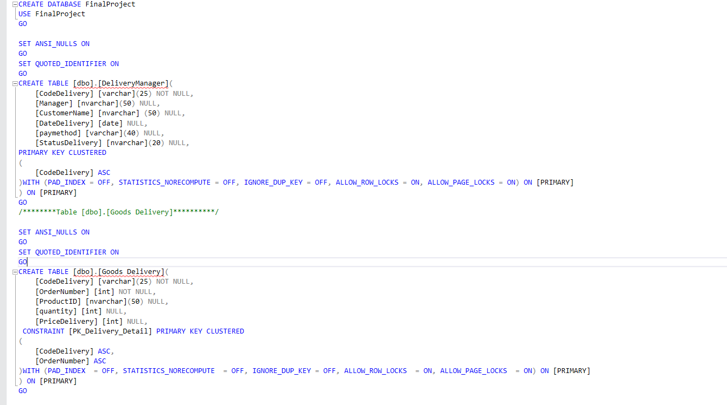
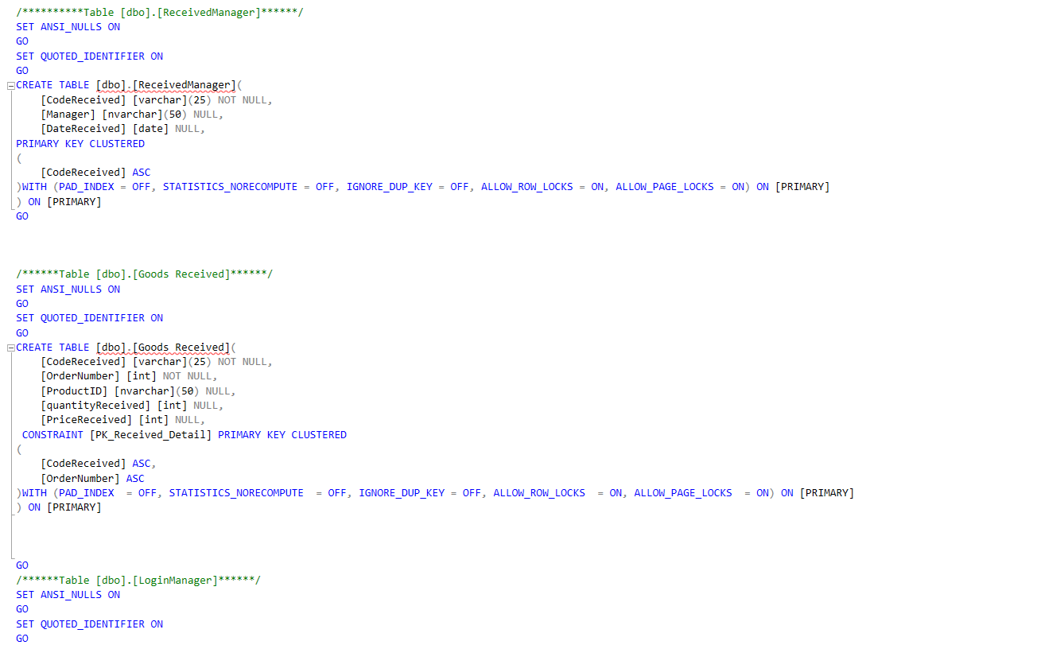
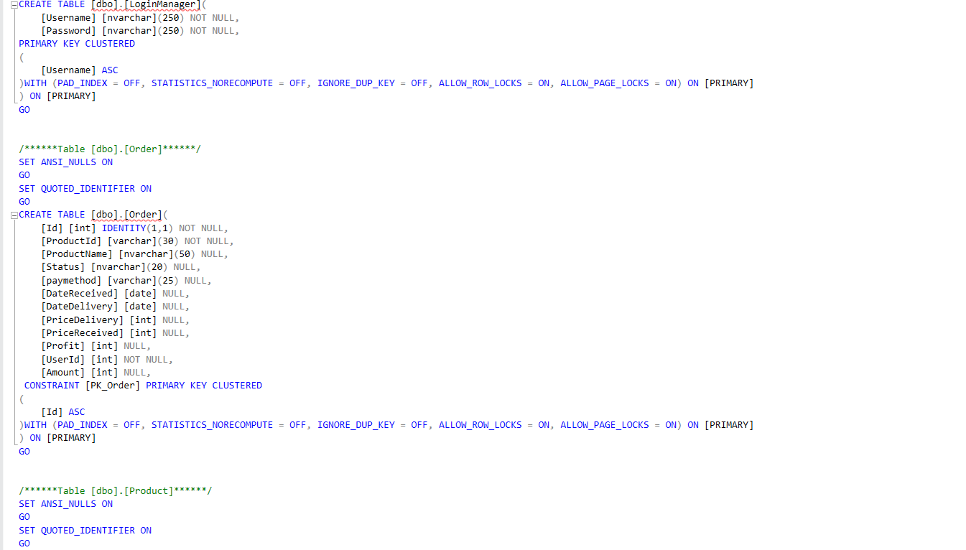
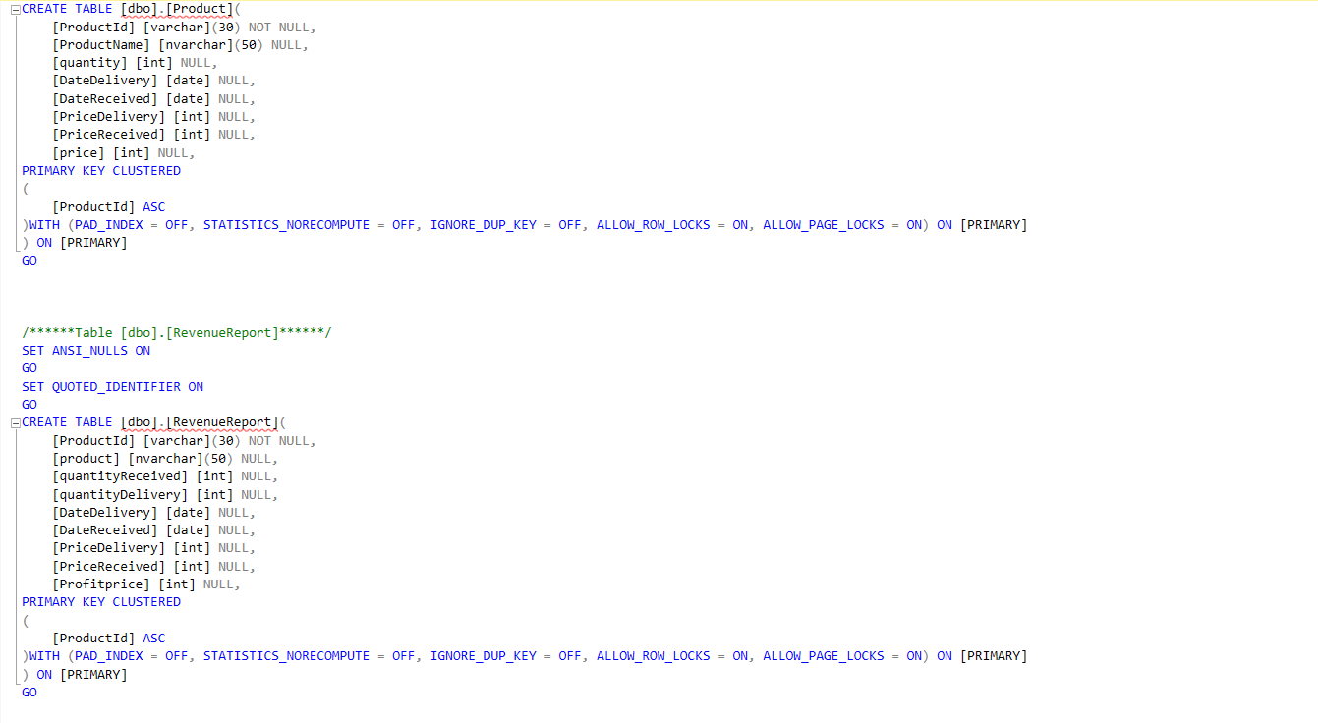
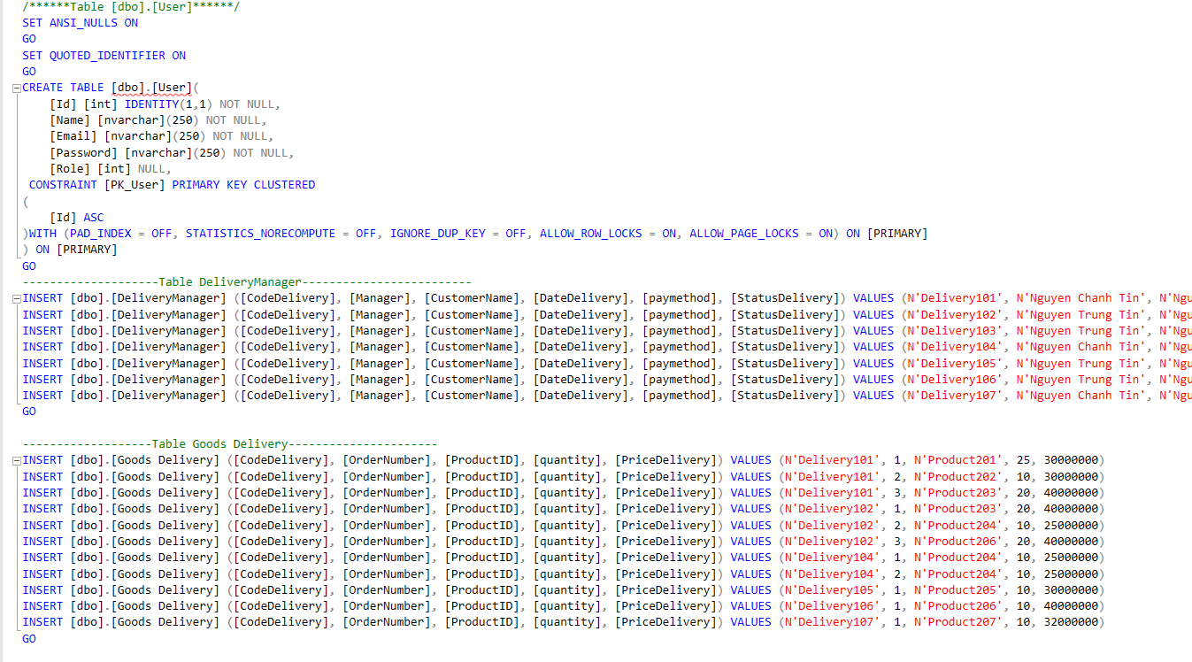
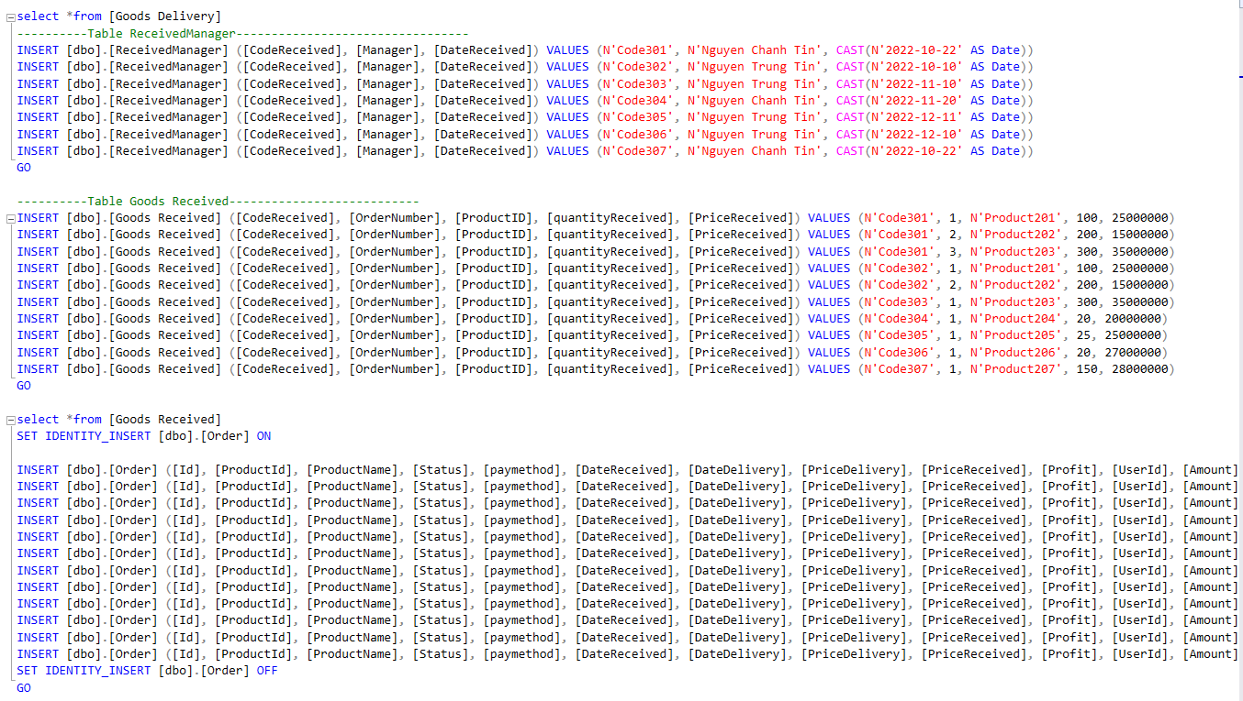
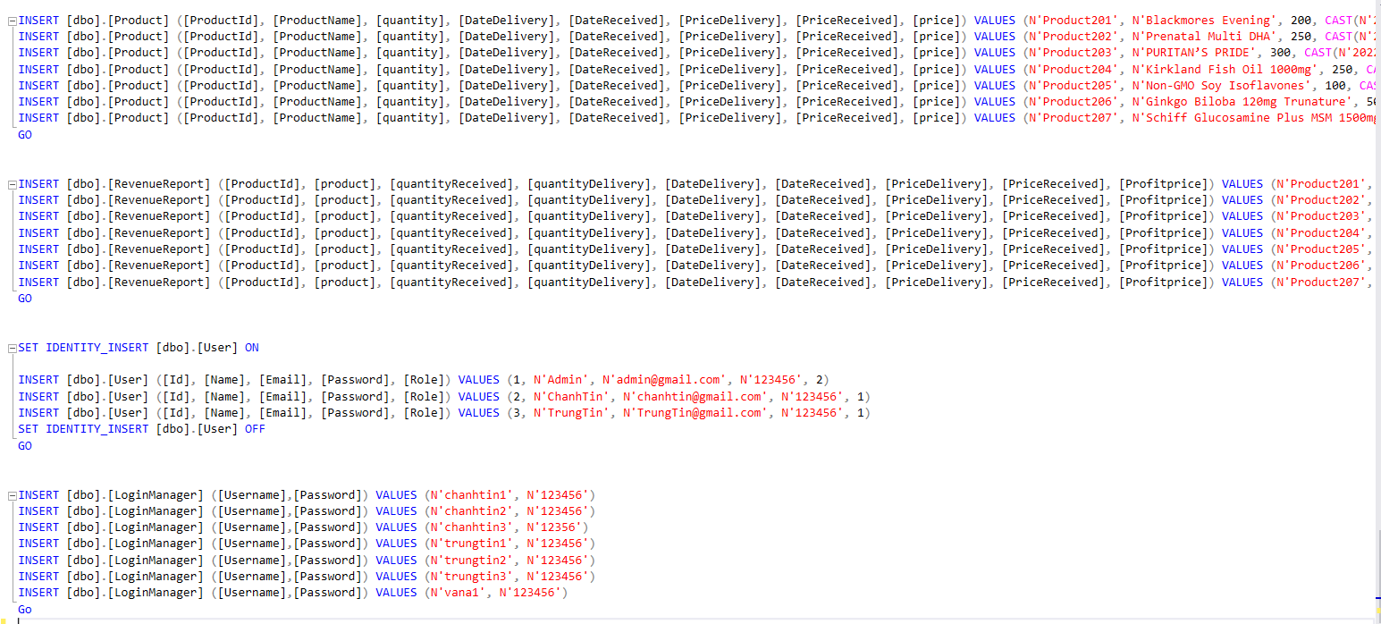
Figure 6: Create database
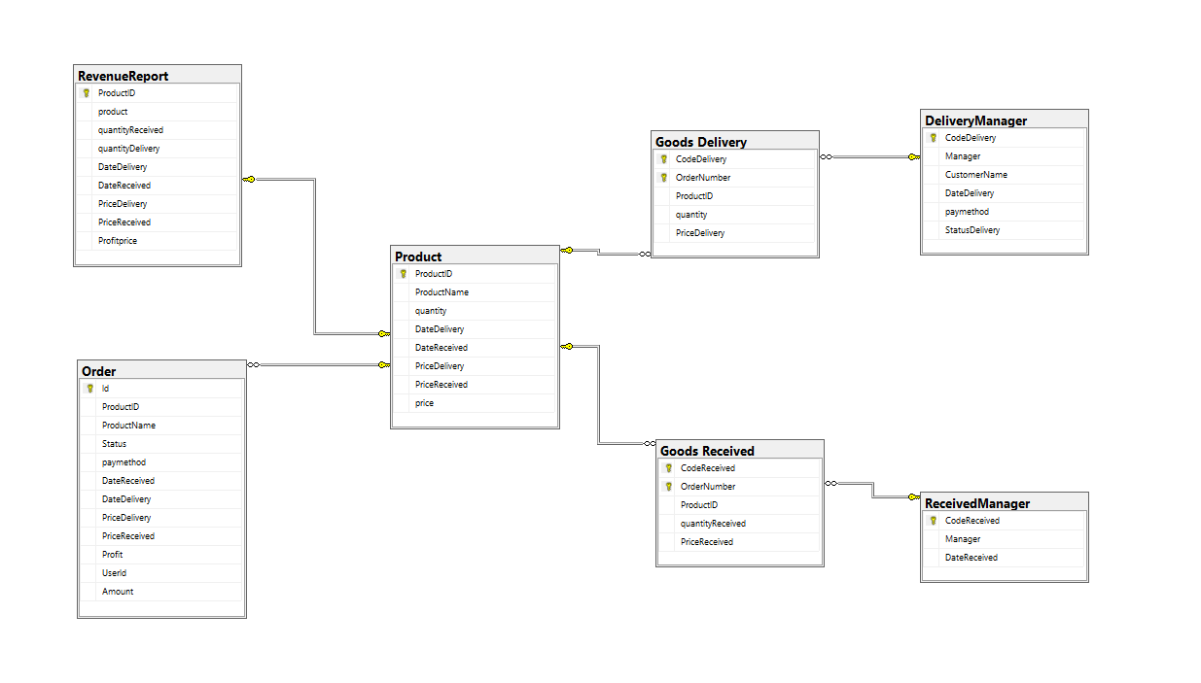
Figure 7: Database Diagram

5.2 Static model – class diagrams
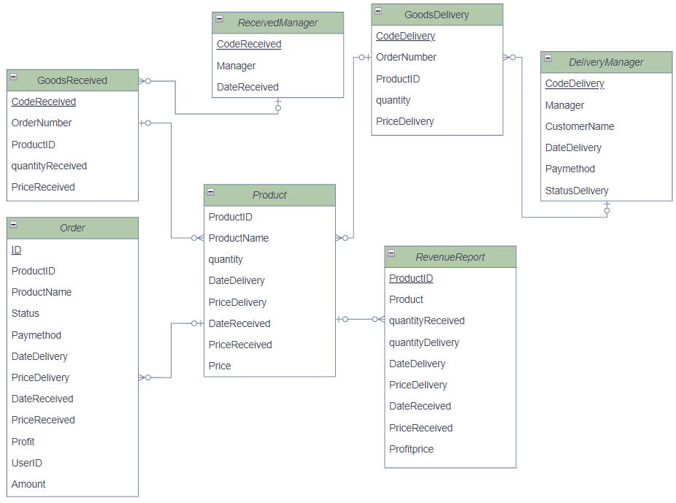
Figure 8: Static model

5.3 Dynamic model – sequence diagrams
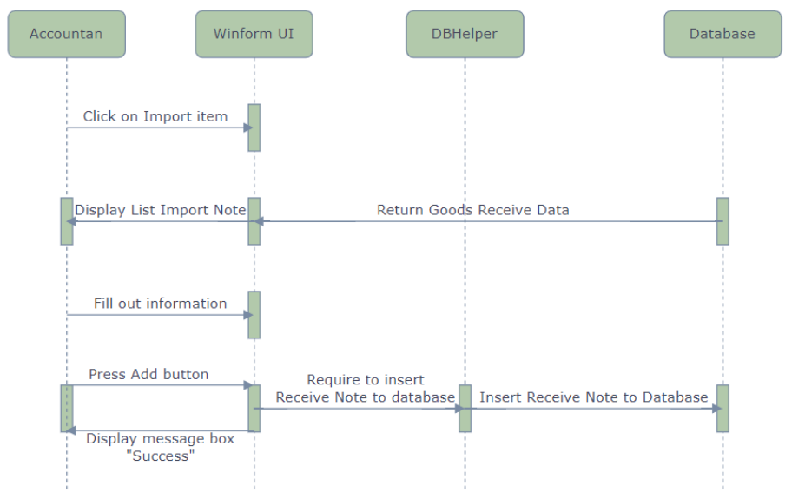
Figure 9: Sequence Diagram – Create Goods Received 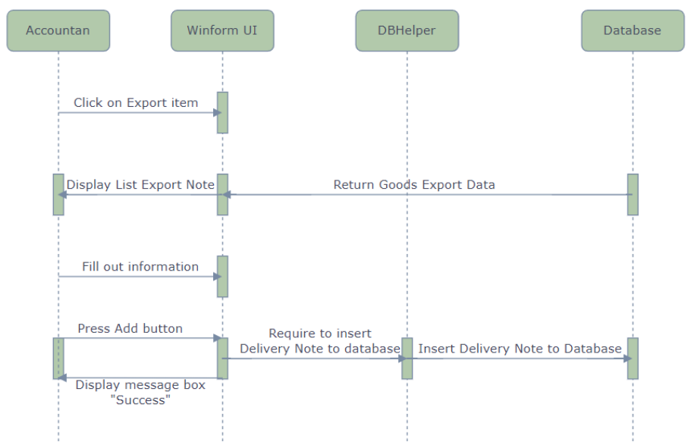
Figure 10: Sequence Diagram – Create Goods Delivery
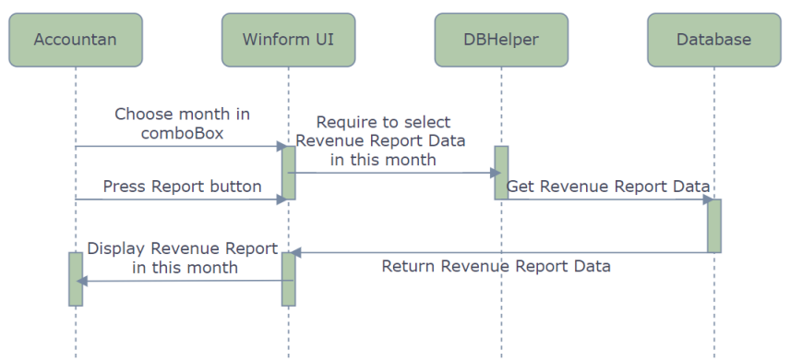
Figure 11: Report

PART 6– TEST PLAN

6.1 Windows Form
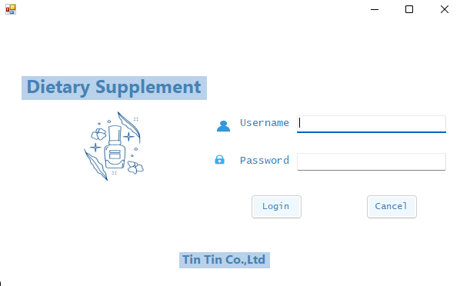
Figure 12: Login by Username and Password
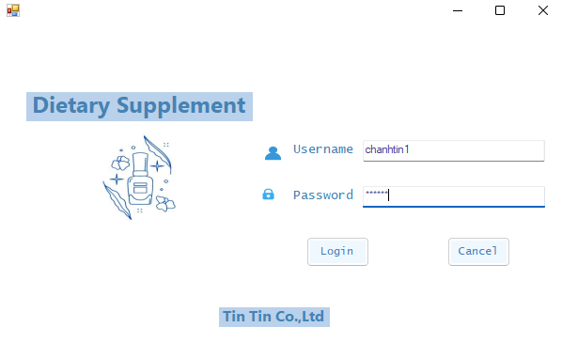
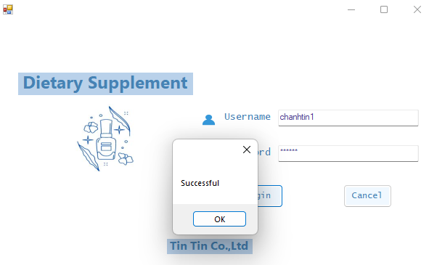
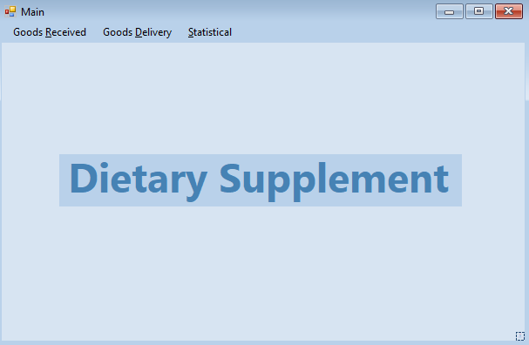

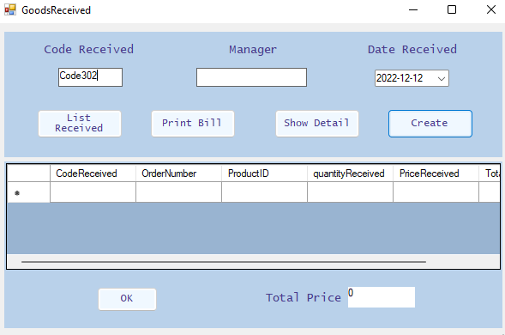
Figure 13: Create Goods Received
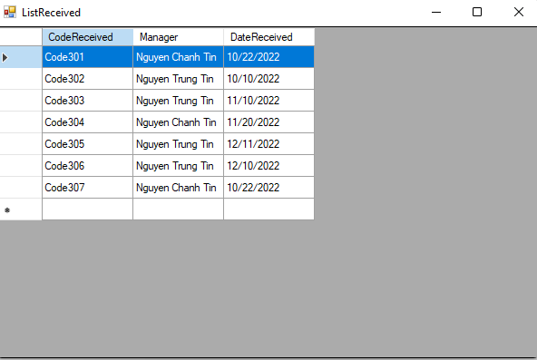
Figure 14: ListReceived
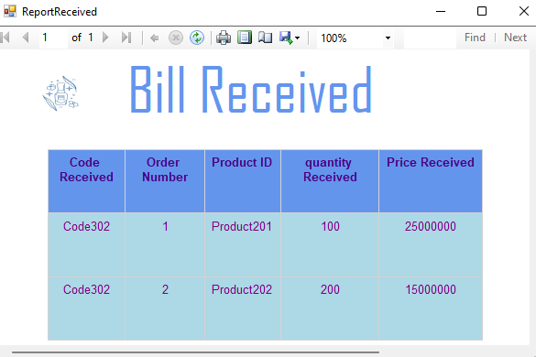
Figure 15: Bill Received

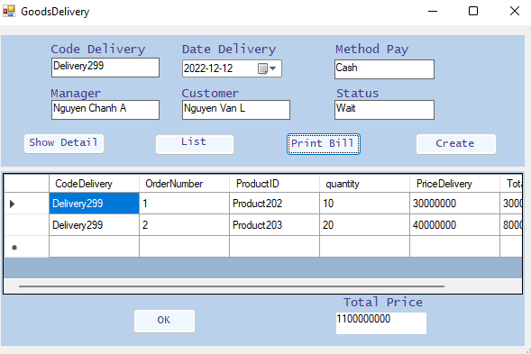
Figure 16: Goods Delivery
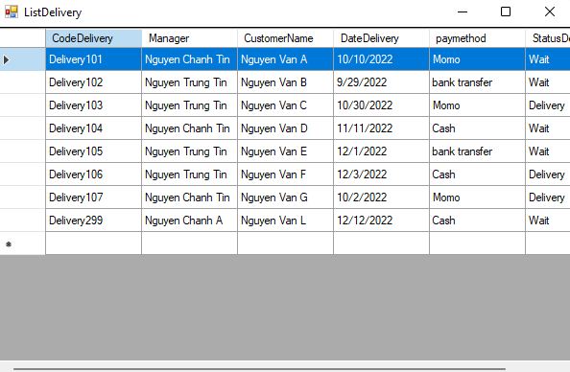
Figure 17: ListDelivery

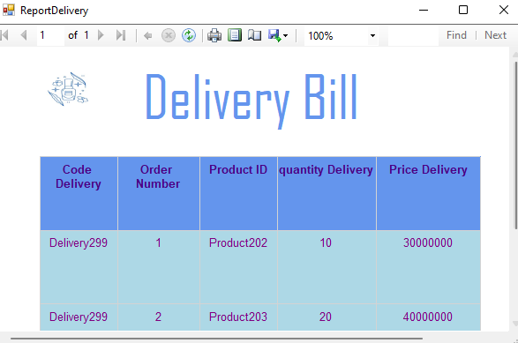
Figure 18: Bill Delivery
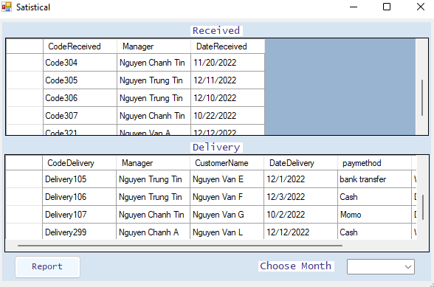
Figure 19: Bill Delivery
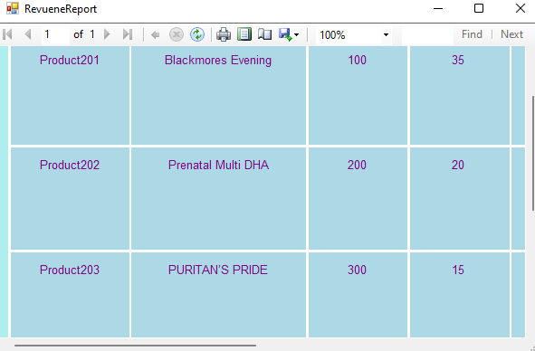
Figure 20: RevenueReport
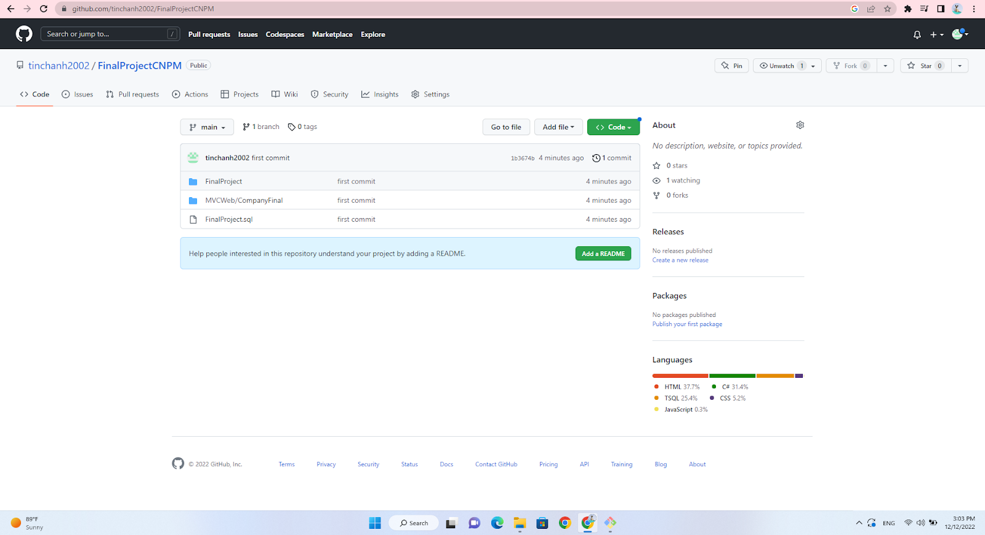
Figure 21: https://github.com/tinchanh2002/FinalProjectCNPM.git

MVC Web
Step 1: Log in
- Log in to the system
- Allow 2 types of login accounts: agent account and admin account.
Account Login 1:
Email: chanhtin@gmail.com
Password: 123456
Account Login 2:
Email: Trungtin@gmail.com
Password: 123456
Account Login 3:
Email: admin@gmail.com
Password: 123456
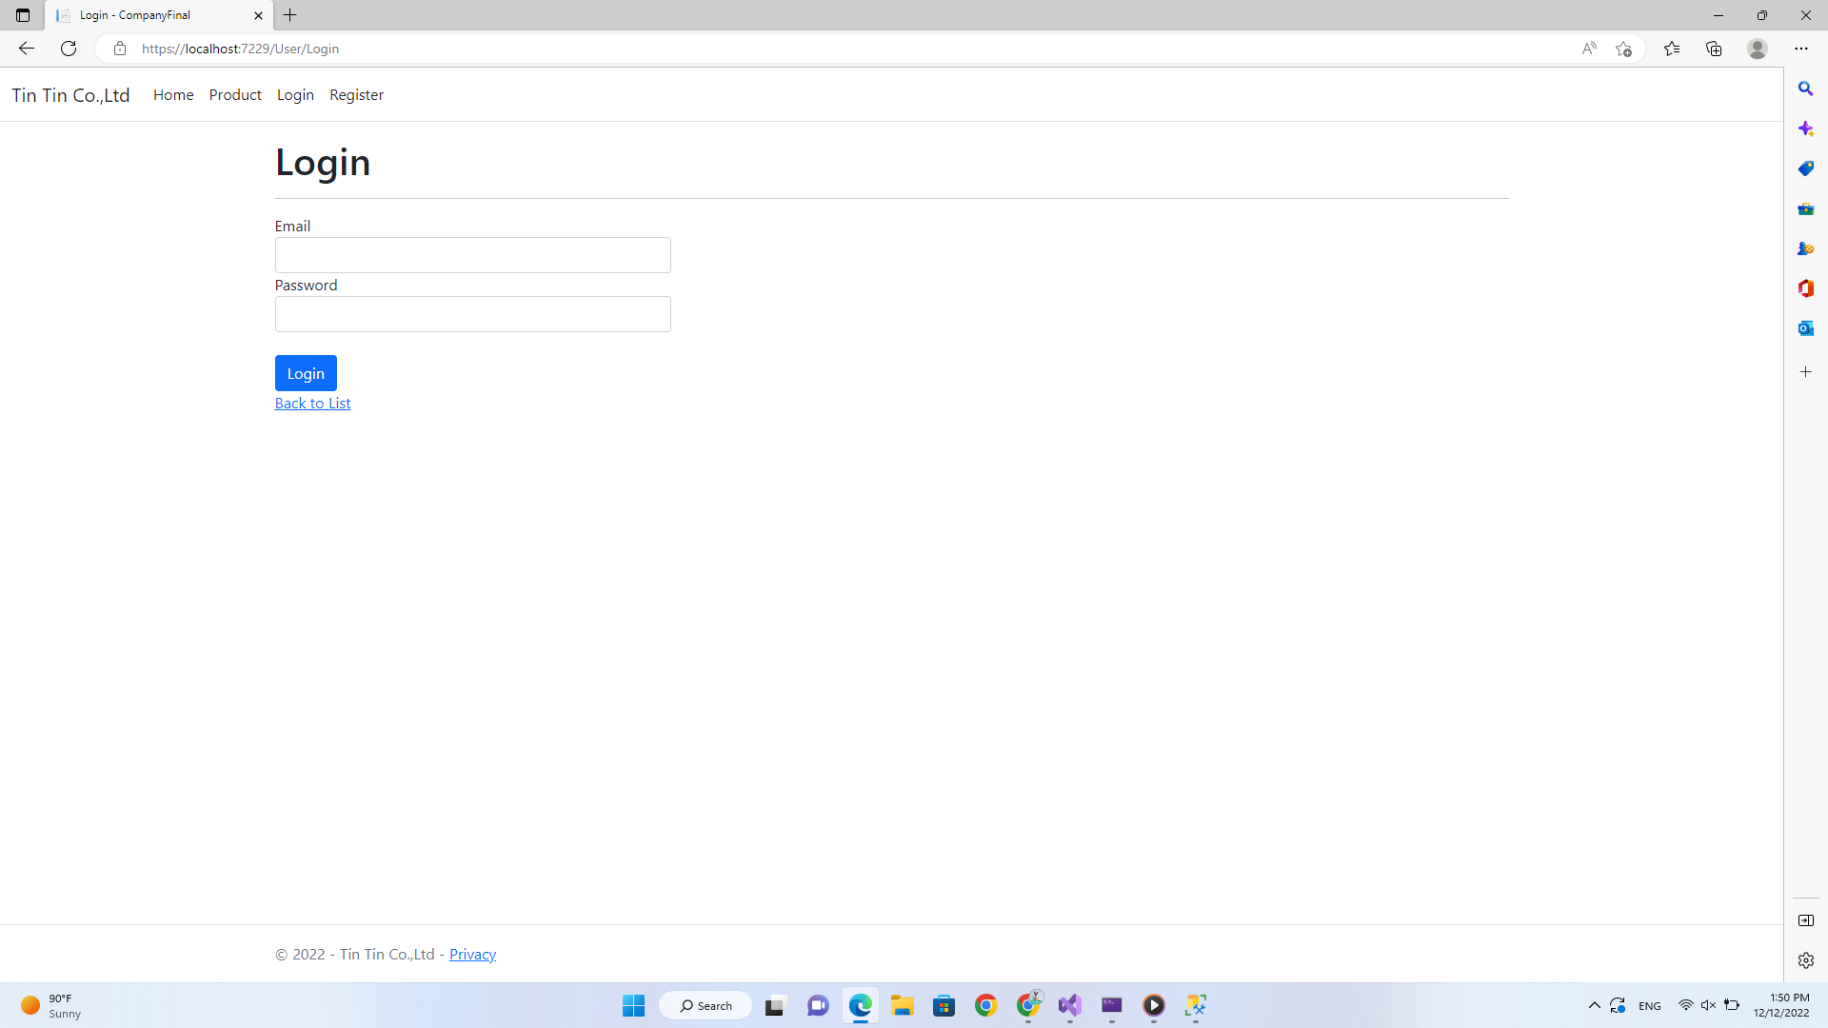
Figure 22: Login interface
Step 2: Product
- This is the product display interface
- Agents can order at this interface
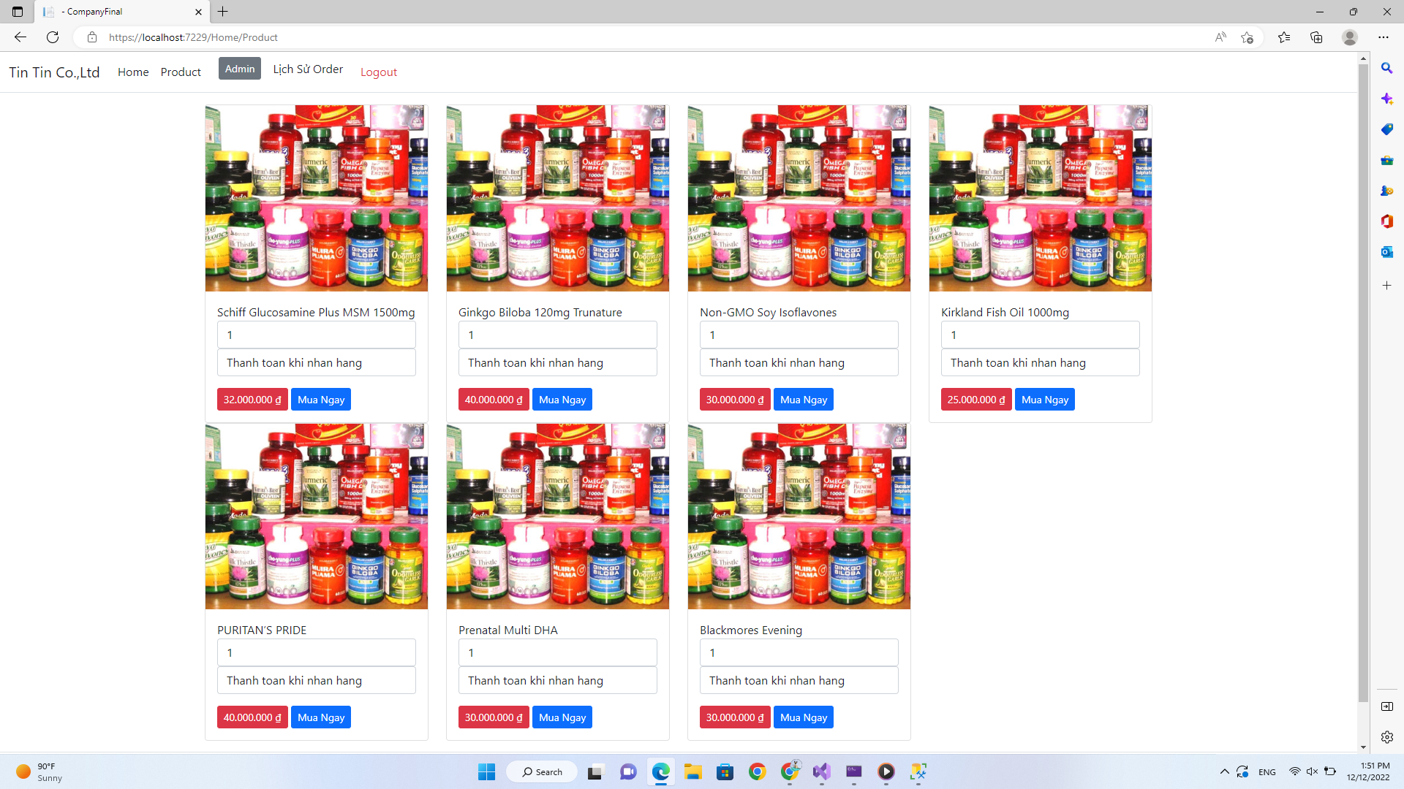
Figure 23: Products
Step 3: Order
- At the product interface, the agent can place an order to import products, at each product can enter the product quantity and payment method.
- If the ordered product is already placed in the previous order, the quantity in the previous order will automatically accumulate with the ordered product.
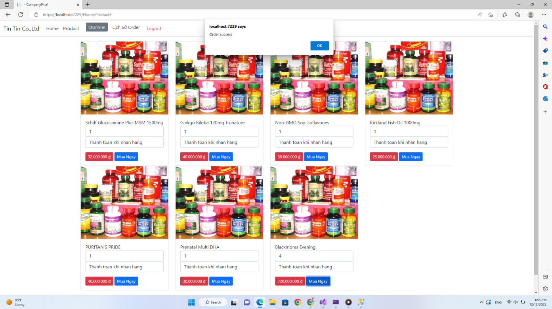
Figure 24: Order
Step 4: History Order
- After placing an order, dealers can view their order history
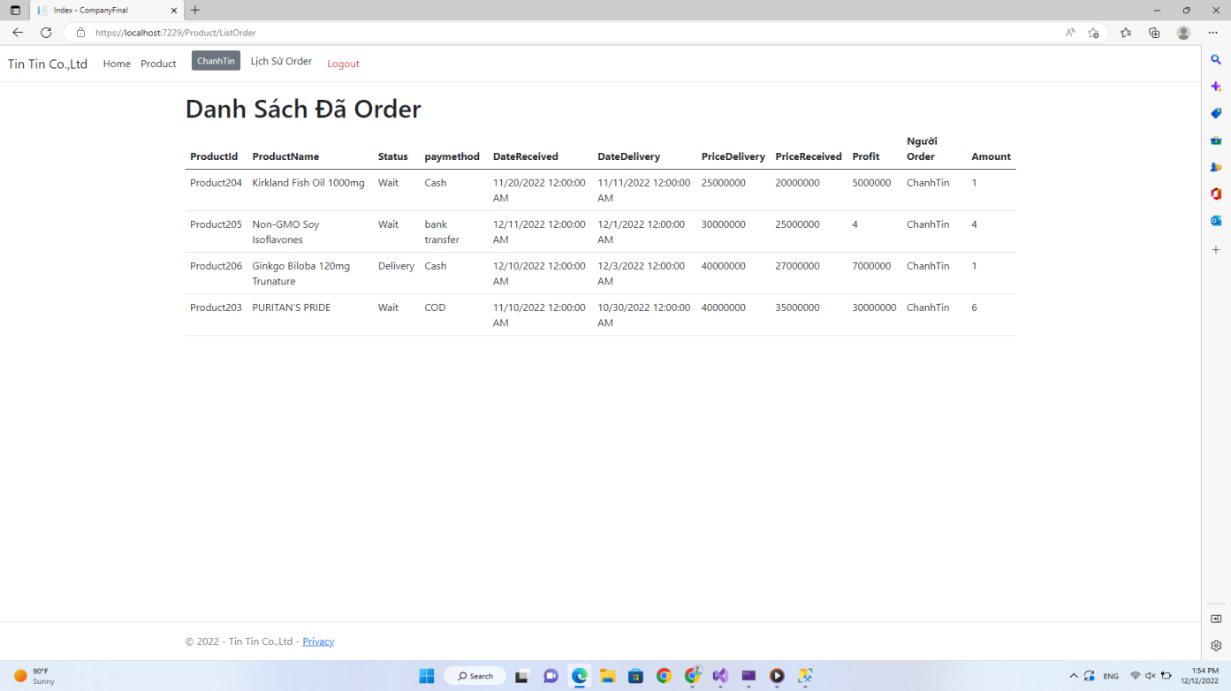
Figure 25: History Order
Step 6: Admin
- Particularly, the admin account (the company's accountant) can view the orders of all agents to plan the export and import for the agents, and make the delivery note.

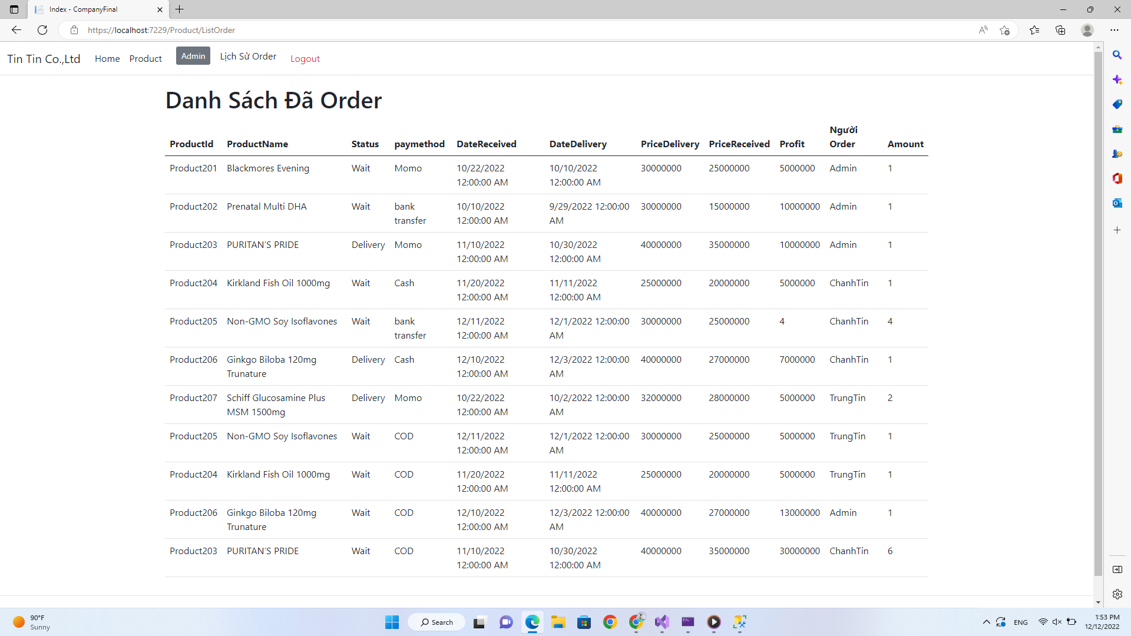
Figure 26: Admin Account

REFERENCES
- https://viblo.asia/p/tim-hieu-v-model-trong-kiem-thu-phan-mem-GrLZDJbn5k0
- https://viblo.asia/p/v-model-trong-kiem-thu-phan-mem-la-gi-tim-hieu-voi-vi-du-sdlc-stlc-Qbq5QMEL5D8
- https://www.tutorialspoint.com/sdlc/sdlc_v_model.htm
- https://www.researchgate.net/figure/Use-case-textual-description-template_fig2_290219988
- https://shapingsoftware.com/2009/02/09/architectural-styles/
- https://codelearn.io/sharing/sequence-diagram-trong-uml
- https://topdev.vn/blog/http-la-gi/

