**Lab 2**

You need to know at least one programming language to perform reasonably well on certain exam questions.

**Question 1**: Review the following method and find (at least) 5 issues in the code (i.e., coding practice, compile errors, potential logical issues, etc.)

(using template 1)

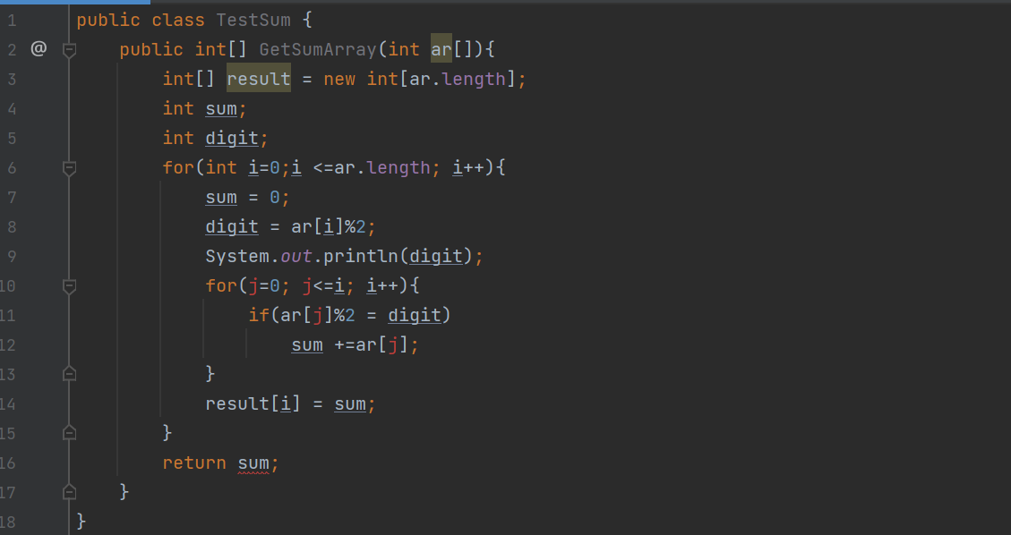

**Question 2**: Create a TDD project, which test PrintEvenNumbers class with array of integers number, the class just prints all integers which are less than a given integer.