**SMART CITY**

**APARTMENT SERVICES WEBSITE**

**Software Design Specification**

– Ho Chi Minh City, May 2023 –

**Record of changeS**

| **Date** | **A* M, D** | **In charge** | **Change Description** | **Version** |
| --- | --- | --- | --- | --- |
| 12/06/2023 | A | QuyHX | Add Code package/ Namespace and Package description & package class naming conventions | 1.0 |
| 16/06/2023 | A | QuyHX | Add class diagram, class specifications and database queries to Login function | 1.0 |
| 17/06/2023 | A | QuyHX | Add class diagram, class specifications and database queries to Register function | 1.0 |
| 18/06/2023 | A | QuyHX | Add class diagram, class specifications and database queries to Reset Password function | 1.0 |
| 19/06/2023 | M | QuyHX | Modify class diagram for Register function | 1.1 |
| 20/06/2023 | A | QuyHX | Add class diagram, class specifications and database queries to Change Password function | 1.1 |
| 20/06/2023 | M | QuyHX | Modify class diagram for Register function | 1.1 |
| 20/6/2023 | M | QuyHX | Modify class diagram for Reset Password function | 1.1 |
| 20/06.2023 | M | QuyHX | Modify class diagram for Change Password function | 1.1 |
| 21/06/2023 | A | QuyHX | Add class diagram, class specifications and database queries to User Profile function | 1.1 |
| 24/06.2023 | A | QuyHX | Add class diagram, class specifications and database queries to Service List function | 1.1 |
| 24/06/2023 | A | QuyHX | Add class diagram, class specifications and database queries to Service Detail function | 1.1 |
| 26/06/2023 | A | QuyHX | Add class diagram, class specifications and database queries to Customer List function | 1.1 |
| 27/06/2023 | A | QuyHX | Add class diagram, class specifications and database queries to Customer Detail function | 1.1 |
| 27/06/2023 | A | QuyHX | Add class diagram, class specifications and database queries to Booking List function | 1.1 |
| 27/06/2023 | A | QuyHX | Add class diagram, class specifications and database queries to Booking Detail function | 1.1 |
| 27/06/2023 | A | QuyHX | Add class diagram, class specifications and database queries to Staff List function | 1.1 |
| 27/06/2023 | A | QuyHX | Add class diagram, class specifications and database queries to Staff Detail function | 1.1 |
| 24/6/2023 | A | TuongNV | Add class diagram, class specifications and database queries to Home Page function | 1.2 |
| 25/6/2023 | A | TuongNV | Add class diagram, class specifications and database queries to Blog List function | 1.2 |
| 25/6/2023 | A | TuongNV | Add class diagram, class specifications and database queries to Blog Details function | 1.2 |
| 27/6/2023 | A | TuongNV | Add class diagram, class specifications and database queries to Service List function | 1.2 |
| 27/6/2023 | A | TuongNV | Add class diagram, class specifications and database queries to Service Detail function | 1.2 |
| 28/6/2023 | A | TuongNV | Add class diagram, class specifications and database queries to Admin Dashboard function | 1.2 |
| 29/6/2023 | A | TuongNV | Add class diagram, class specifications and database queries to User List function | 1.2 |
| 29/6/2023 | A | TuongNV | Add class diagram, class specifications and database queries to User Details function | 1.2 |
| 30/6/2023 | A | TuongNV | Add class diagram, class specifications and database queries to Staff List function | 1.2 |
| 30/6/2023 | A | TuongNV | Add class diagram, class specifications and database queries to Staff Details function | 1.2 |
| 28/06/2023 | A | ThangLQ | Add class diagram, class specifications and database queries to Staff Order Details function | 1.3 |
| 1/7/2023 | A | ThangLQ | Add class diagram, class specifications and database queries to Feedback function | 1.3 |
| 1/7/2023 | A | ThangLQ | Add class diagram, class specifications and database queries to Customer Order Details function | 1.3 |
| 2/7/2023 | A | ThangLQ | Add class diagram, class specifications and database queries to Customer Order Completion function | 1.3 |
| 2/7/2023 | A | ThangLQ | Add class diagram, class specifications and database queries to Contact function | 1.3 |

*A - Added M - Modified D - Deleted

**Table of Contents**

**I. Overview** **5**

1. Code Package/ Namespace 5

2. Database Design 6

a. Database Schema 6

b. Table Description 7

**II. Code Designs** **8**

1. Common/Login 8

2. Common/Register 9

3. Common/Reset Password 10

4. Common/Change Password 11

5. Common/User Profile 12

6. Manager/Booking List 13

7. Manager/Booking Details 16

8. Manager/Service List 18

9. Manager/Service Details 19

10. Manager/Staff List 22

11. Manager/Staff Detail 23

12. Manager/Customer List 25

13. Manager/Customer Details 27

14. Public/Home Page 29

15. Public/Blog List 31

16. Public/Blog Details 32

17. Public/Service List 34

18. Public/Service Details 36

19 . Staff/Order details 37

20. Customer/Order Details 38

21. Customer/Contact 40

22. Customer/Order Completion 41

23. Customer/Feedback 42

24. Admin/Dashboard 43

25. Admin/User List 45

26. Admin/User details 47

# I. Overview

## 1. Code Package/ Namespace

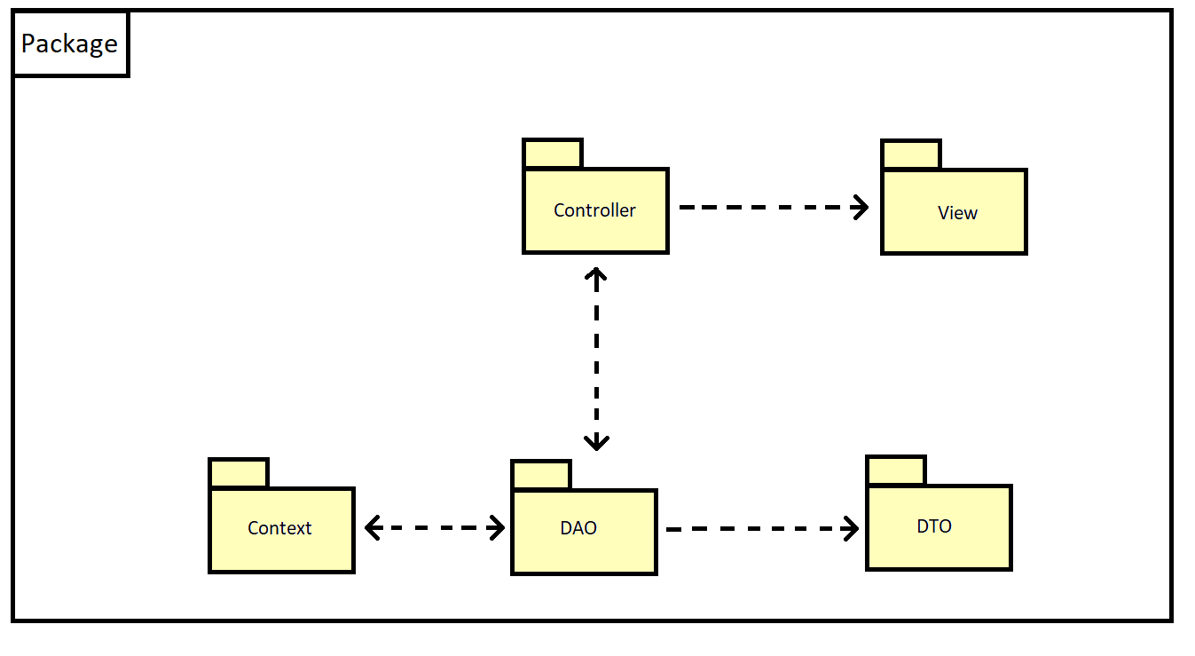

***Package descriptions***

| No | Package | Description |
| --- | --- | --- |
| 1 | Controller | Controllers manage and control interactions between the "DAO" section and the "View" section. |
| 2 | View | View helps display user interface |
| 3 | Context | Context helps connect to database |
| 4 | DAO | DAO provides methods to perform CRUD |
| 5 | DTO | DTO contains properties and used to transmit data |

## 2. Database Design

### a. Database Schema

### b. Table Description

| **No** | **Table** | **Description** |
| --- | --- | --- |
| **1** | **Account** | **Contains information of user account** |
| **2** | **RoleAccount** | **Contains type of user account** |
| **3** | **Blog** | **Contains information of blogs** |
| **4** | **BlogCate** | **Contains type of blog** |
| **5** | **BlogRating** | **Contains rating of blog** |
| **6** | **Booking** | **Contains status of the services are booked** |
| **7** | **BookingDetail** | **Contains information of the services are booked** |
| **8** | **Service** | **Contains information of the services** |
| **9** | **CateService** | **Contains type of service** |
| **10** | **Comment** | **Contains comment** |
| **11** | **Feedback** | **Contains feedback of customer after finish order** |
| **12** | **Notification** | **Contains website announcements** |
| **13** | **Question** | **Contains question of customer** |

# II. Code Designs

## 1. Common/Login

### Class Diagram

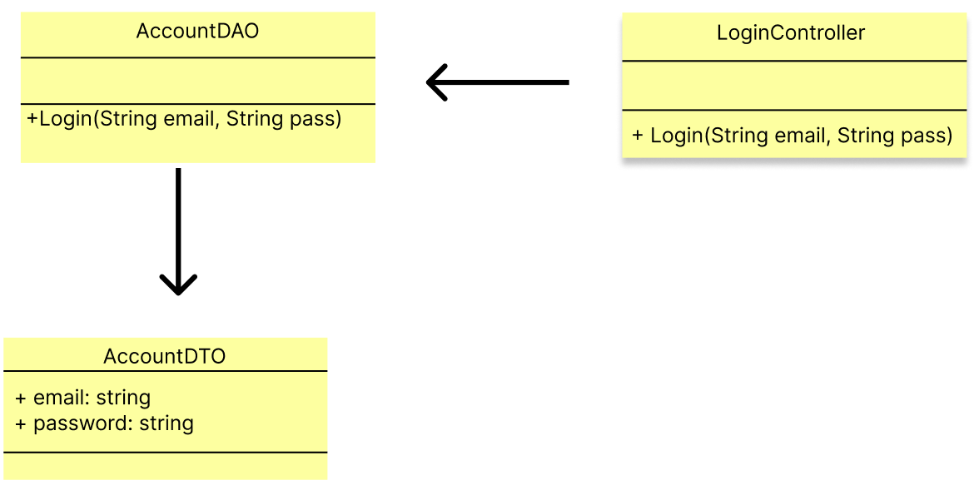

1. **Class Specifications**

| No | Method | Description |
| --- | --- | --- |
| 1 | Login | Used to login to the website |
| 2 | checkAccount | Used to check account in database |

1. **Database Queries**

**String query = "SELECT * \n"**

**+ "FROM Account \n"**

**+ "WHERE Email = ? AND Password = ?";**

## 2. Common/Register

1. **Class Diagram**

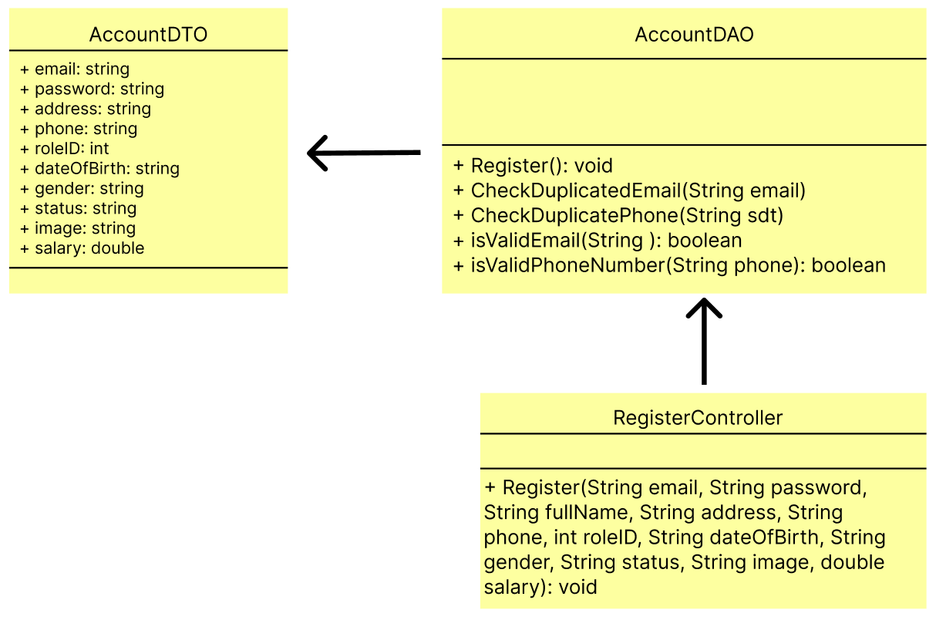

1. **Class Specification**

| No | Method | Description |
| --- | --- | --- |
| 1 | Register() | Used to create a new account for guest |
| 2 | CheckDuplicatedEmail() | Used to check existing email in database |
| 3 | isValidEmail() | The regex of email |
| 4 | CheckDuplicatePhone() | Used to check existing phone number in database |
| 5 | isValidPhoneNumber() | The regex of phone number |

1. **Database Queries**

* **String query = "SELECT * FROM Account WHERE Email = ?";**
* **String query = "SELECT * FROM Account WHERE Phone = ?";**
* **String query = "INSERT INTO Account VALUES ('1', ?, ?, ?, ?, ?, ?, ?, ?, ?, ?, ?);";**

## 3. Common/Reset Password

1. **Class Diagram**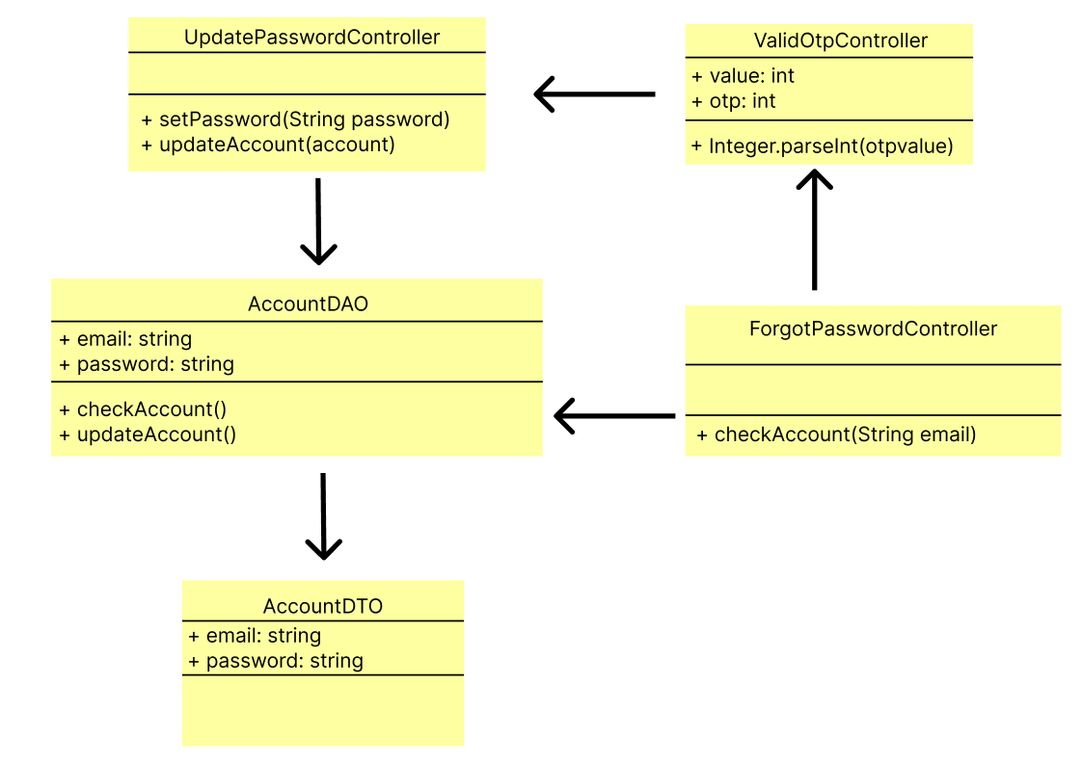
2. **Class Specification**

| No | Method | Description |
| --- | --- | --- |
| 1 | checkAccount(email) | Used to check account in database |
| 2 | Integer.parseInt() | Convert OTP from request parameter to integer |
| 3 | setPassword(password) | Change the old password into a new password |
| 4 | updateAccount(password) | Update a new password for the account |

1. **Database Queries**

* **String query = "SELECT * FROM Account WHERE email = ?";**
* **String query = "UPDATE Account SET Password = ? WHERE email=?";**

## 4. Common/Change Password

1. **Class Diagram**

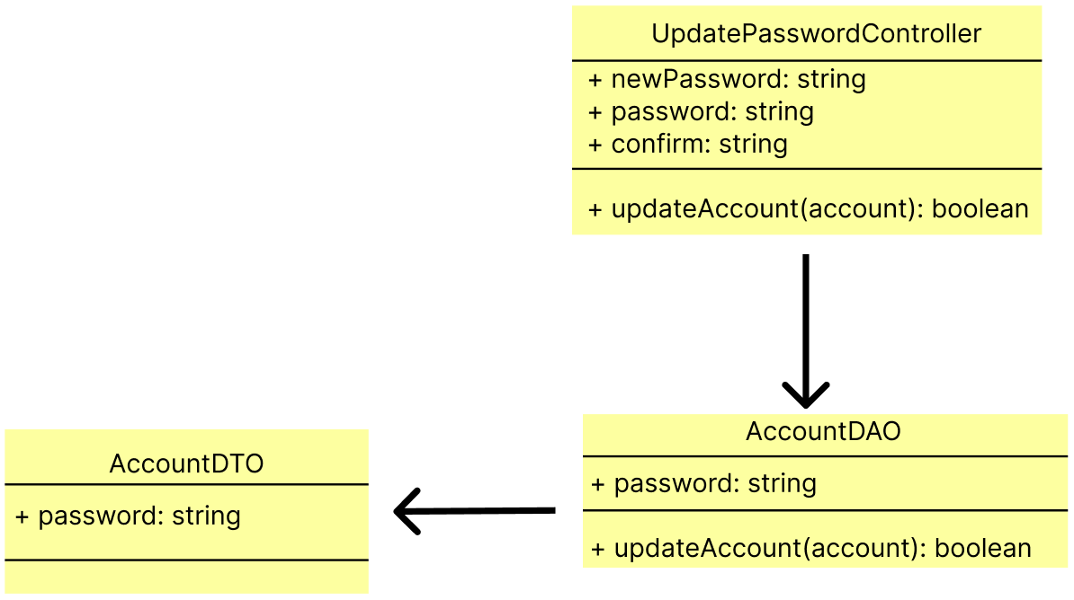

1. **Class Specification**

| No | Method | Description |
| --- | --- | --- |
| 1 | updateAccount() | Update a new password for account |

1. **Database Queries**

**String query = "UPDATE Account SET Password = ? WHERE email=?";**

## 5. Common/User Profile

1. **Class Diagram**

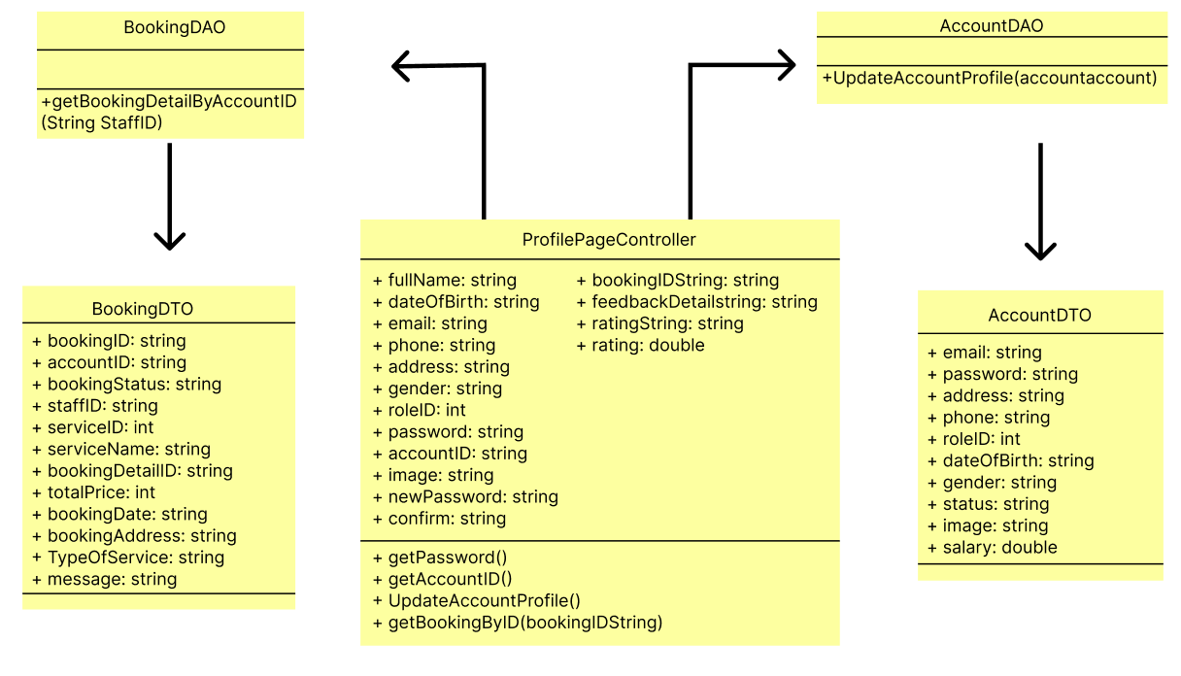

1. **Class Specification**

| No | Method | Description |
| --- | --- | --- |
| 1 | getPassword() | Get the value of Password |
| 2 | getAccountID() | Get the value of Account ID |
| 3 | UpdateAccountProfile() | Update profile of the user when they change the profile |
| 4 | GetBookingDetailByAccountID() | Get all booking by ID |

1. **Database Queries**

* **String query = "SELECT b.BookingID, b.AccountID, b.BookingStatus, b.StaffID, b.ServiceID, s.ServiceName ,bd.BookingDetail_ID, bd.TotalPrice, bd.BookingDate, bd.BookingAddress, bd.TypeOfService, bd.Message\n"**

**+ "FROM Booking b, BookingDetail bd , Service s\n"**

**+ "WHERE b.BookingID = bd.BookingID AND b.ServiceID = s.ServiceID AND b.AccountID = ?";**

* **String query = "UPDATE Account\n"**
* **+ "SET \n"**
* **+ " Email = ?,\n"**
* **+ " Password = ?,\n"**
* **+ " FullName = ?,\n"**
* **+ " Address = ?,\n"**
* **+ " Phone = ?,\n"**
* **+ " RoleID = ?,\n"**
* **+ " Gender = ?,\n"**
* **+ " DateOfBirth = ?,\n"**
* **+ " Image = ?,\n"**
* **+ " Salary = ?\n"**
* **+ "WHERE AccountID = ?;";**

## 6. Manager/Booking List

1. **Class Diagram**

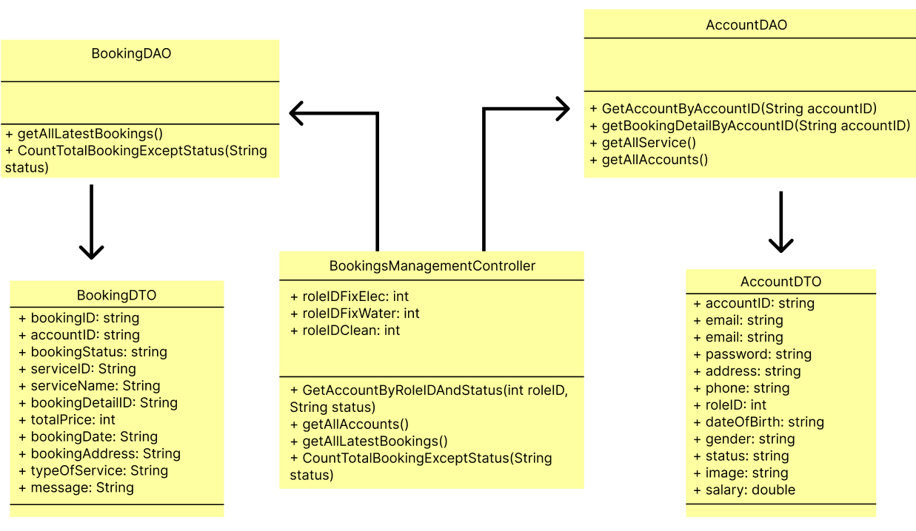

1. **Class Specification**

| No | Method | Description |
| --- | --- | --- |
| 1 | GetAccountByRoleIDAndStatus() | Get value of staff |
| 2 | getAllAccounts() | Get all account |
| 3 | getAllLatestBookings() | Get the lastest booking |
| 4 | CountTotalBookingExceptStatus() | Get all booking that in process |

1. **Database Queries**

* **String query = "SELECT * FROM Account WHERE RoleID = ? and status = ?";**
* **String query = "SELECT * FROM Account";**
* **String query = "SELECT b.BookingID, b.AccountID, b.BookingStatus, b.StaffID, b.ServiceID, s.ServiceName, bd.BookingDetail_ID, bd.TotalPrice, bd.BookingDate, bd.BookingAddress, bd.TypeOfService, bd.Message\n"**

**+ "FROM Booking b\n"**

**+ "JOIN BookingDetail bd ON b.BookingID = bd.BookingID\n"**

**+ "JOIN Service s ON b.ServiceID = s.ServiceID\n"**

**+ "WHERE b.BookingStatus != 'hủy'\n"**

**+ "ORDER BY ABS(DATEDIFF(day, bd.BookingDate, GETDATE()))";**

* **String query = "SELECT COUNT(*) AS TotalBookings\n"**

**+ "FROM Booking\n"**

**+ "WHERE BookingStatus != ?";**

## 7. Manager/Booking Details

1. **Class Diagram**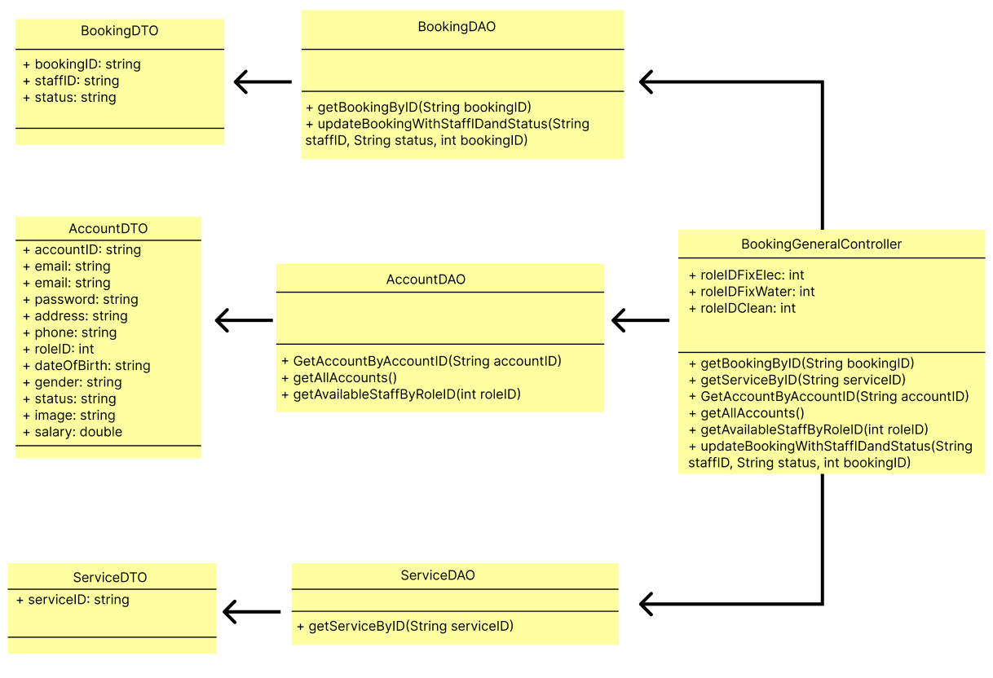
2. **Class Specification**

| No | Method | Description |
| --- | --- | --- |
| 1 | getBookingByID() | Get the booking ID value |
| 2 | getServiceByID() | Get the service ID value |
| 3 | GetAccountByAccountID() | Get Account information by Account User |
| 4 | getAllAccounts() | List all customer account |
| 5 | getAvaiableStaffByRoleID() | Get the staff that are not in process |
| 6 | updateBookingWithStaffIDandStatus() | Assign work for staff |

1. **Database Queries**

* **String query = "SELECT b.BookingID, b.AccountID, b.BookingStatus, b.StaffID, b.ServiceID, s.ServiceName ,bd.BookingDetail_ID, bd.TotalPrice, bd.BookingDate, bd.BookingAddress, bd.TypeOfService, bd.Message\n"**

**+ "FROM Booking b, BookingDetail bd , Service s\n"**

**+ "WHERE b.BookingID = bd.BookingID AND b.ServiceID = s.ServiceID AND b.BookingID = ?";**

* **String query = "SELECT ServiceID, ServiceName, Price, ServiceDetail, Image, Status, CateName \n"**

**+ "FROM Service s, CateService c\n"**

**+ "WHERE s.CateID = c.CateID and ServiceID = ?";**

* **String query = "SELECT * FROM Account WHERE AccountID = ?";**
* **String query = "SELECT * FROM Account";**
* **String query = "SELECT *\n"**

**+ "FROM Account\n"**

**+ "WHERE RoleID = (SELECT RoleID FROM RoleAccount WHERE RoleID = ?)\n"**

**+ "AND (\n"**

**+ " AccountID NOT IN (SELECT StaffID FROM Booking)\n"**

**+ " OR (\n"**

**+ " AccountID IN (SELECT StaffID FROM Booking WHERE BookingStatus = 'Hoàn thành')\n"**

**+ " AND AccountID NOT IN (SELECT StaffID FROM Booking WHERE BookingStatus != 'Hoàn thành')\n"**

**+ " )\n"**

**+ ");";**

* **String query = "UPDATE Booking\n"**

**+ "SET StaffID = ?, BookingStatus = ?\n"**

**+ "WHERE BookingID = ?";**

## 8. Manager/Service List

1. **Class Diagram**

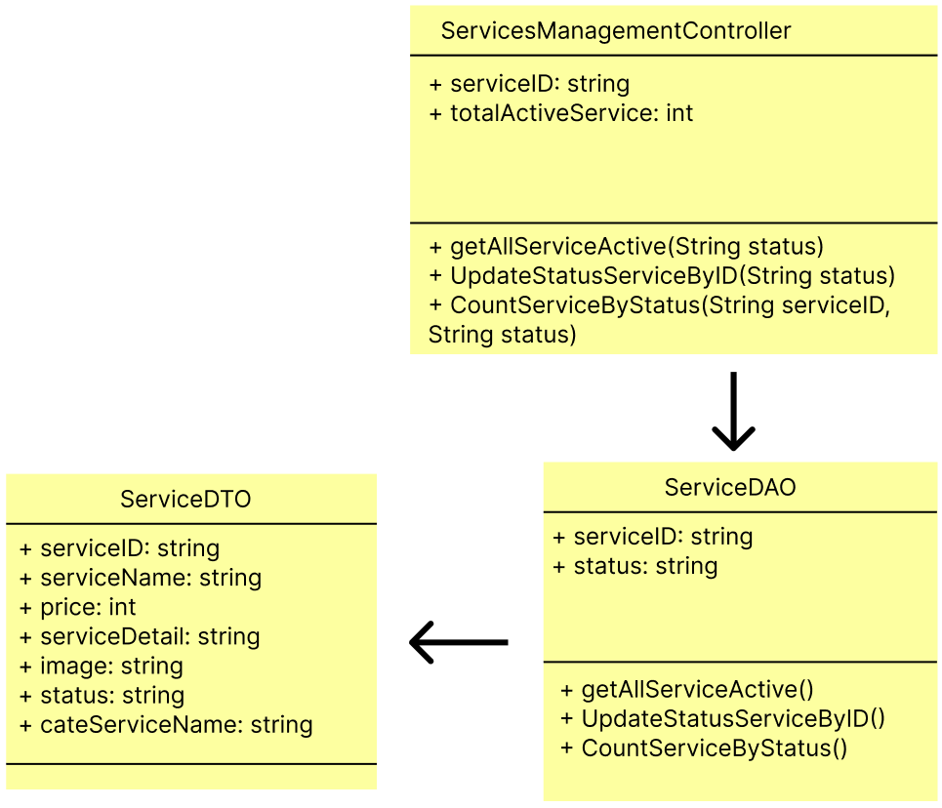

1. **Class Specification**

| No | Method | Description |
| --- | --- | --- |
| 1 | getAllServiceActive() | List out the list of active services |
| 2 | CountServiceStatus() | Showing the number of operating services |
| 3 | UpdateStatusServiceByID() | Disable or Enable service |

1. **Database Queries**

* **String query = "UPDATE Service\n"**

**+ "SET Status = ?\n"**

**+ "WHERE ServiceID = ?";**

* **String query = "SELECT ServiceID, ServiceName, Price, ServiceDetail, Image, Status, CateName\n"**

**+ "FROM Service s, CateService c\n"**

**+ "WHERE s.CateID = c.CateID AND s.Status = ?";**

* **String query = "SELECT COUNT(*) AS total_count FROM Service WHERE Status = ?";**

## 9. Manager/Service Details

1. **Class Diagram**

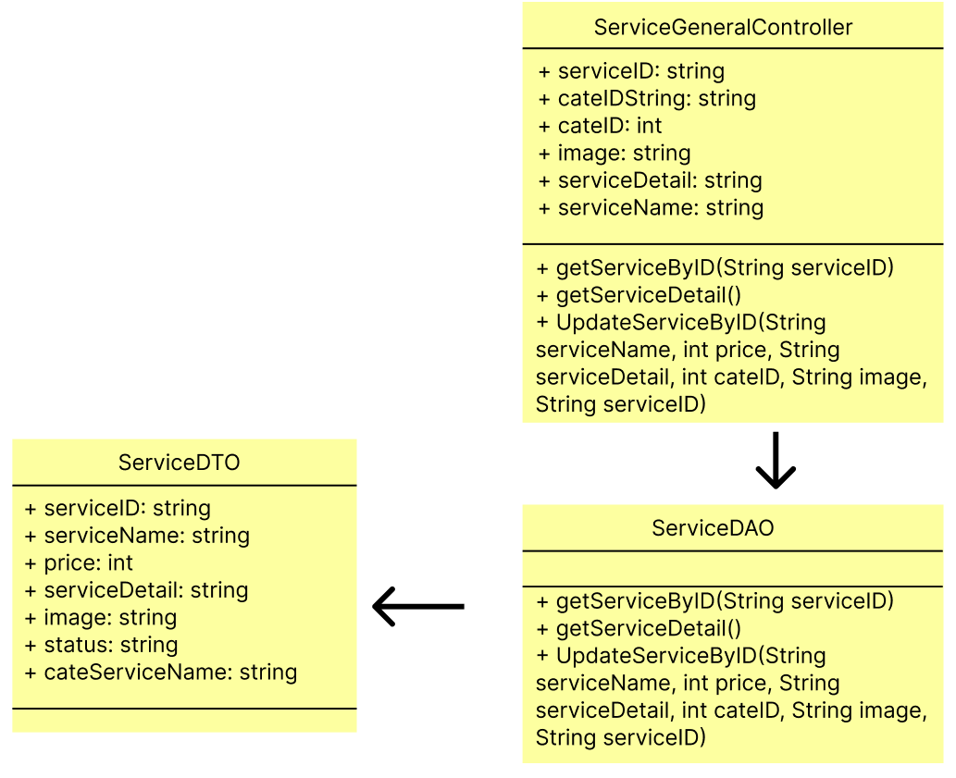

1. **Class Specification**

| No | Method | Description |
| --- | --- | --- |
| 1 | getServiceDetail() | Get the Service Detail value |
| 2 | getServiceByID() | Get the service ID value |
| 3 | UpdateServiceByID() | Update information of the Service |

1. **Database Queries**

* **String query = "UPDATE Service\n"**

**+ "SET ServiceName = ?,\n"**

**+ " Price = ?,\n"**

**+ " ServiceDetail = ?,\n"**

**+ " CateID = ?,\n"**

**+ " Image = ?\n"**

**+ "WHERE ServiceID = ?;";**

## 10. Manager/Staff List

1. **Class Diagram**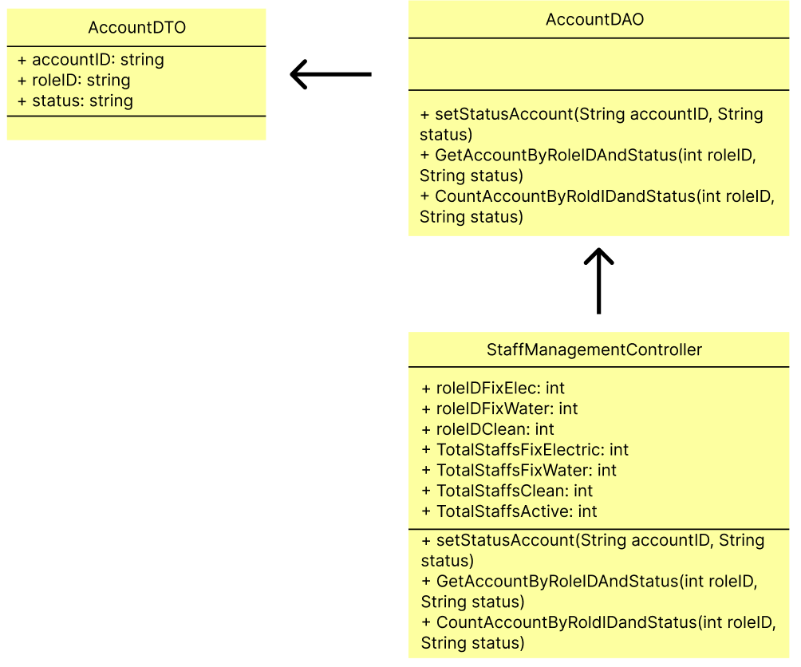
2. **Class Specification**

| No | Method | Description |
| --- | --- | --- |
| 1 | setStatusAccount() | Disable or enable staff account |
| 2 | GetAccountByRoleIDAndStatus() | Get staff account that in active |
| 3 | CountAccountByRoldIDandStatus() | Count staff account that in active |

1. **Database Queries**

* **String query = "UPDATE Account\n"**

**+ "SET Status = ?\n"**

**+ "WHERE AccountID = ?";**

* **String query = "SELECT * FROM Account WHERE RoleID = ? and status = ?";**
* **String query = "SELECT COUNT(AccountID) AS TotalCount FROM Account WHERE RoleID = ? AND status = ?";**

## 11. Manager/Staff Detail

1. **Class Diagram**

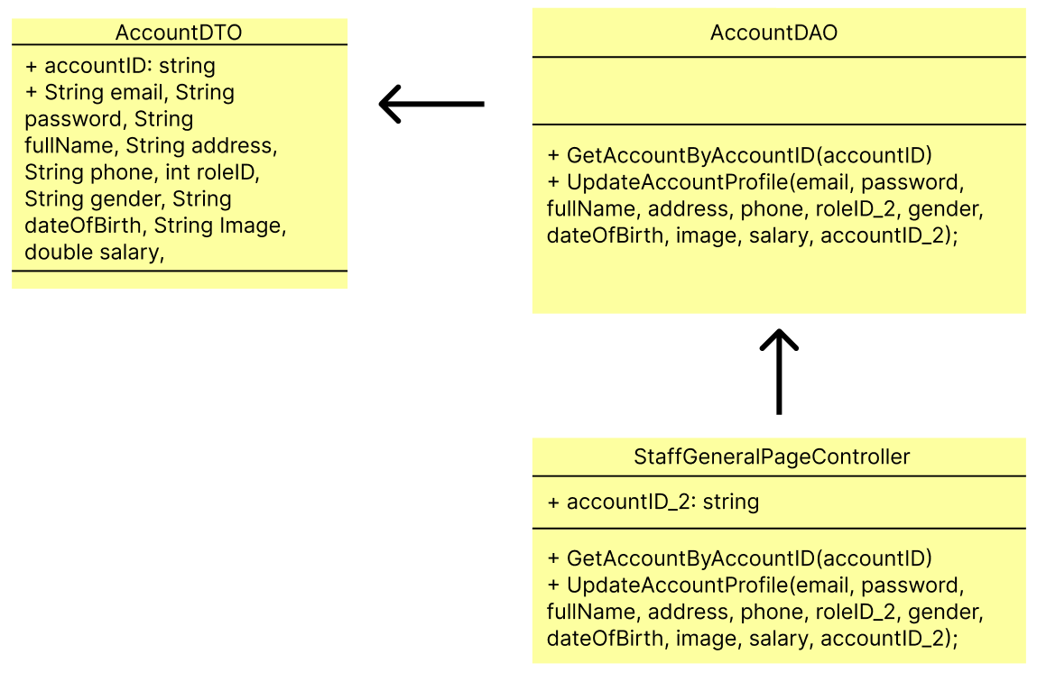

1. **Class Specification**

| No | Method | Description |
| --- | --- | --- |
| 1 | GetAccountByAccountID() | Show staff profile |
| 2 | UpdateAccountProfile() | Update staff profile |

1. **Database Queries**

* **String query = "SELECT * FROM Account WHERE AccountID = ?";**
* **String query = "UPDATE Account\n"**

**+ "SET \n"**

**+ " Email = ?,\n"**

**+ " Password = ?,\n"**

**+ " FullName = ?,\n"**

**+ " Address = ?,\n"**

**+ " Phone = ?,\n"**

**+ " RoleID = ?,\n"**

**+ " Gender = ?,\n"**

**+ " DateOfBirth = ?,\n"**

**+ " Image = ?,\n"**

**+ " Salary = ?\n"**

**+ "WHERE AccountID = ?;";**

## 12. Manager/Customer List

1. **Class Diagram**

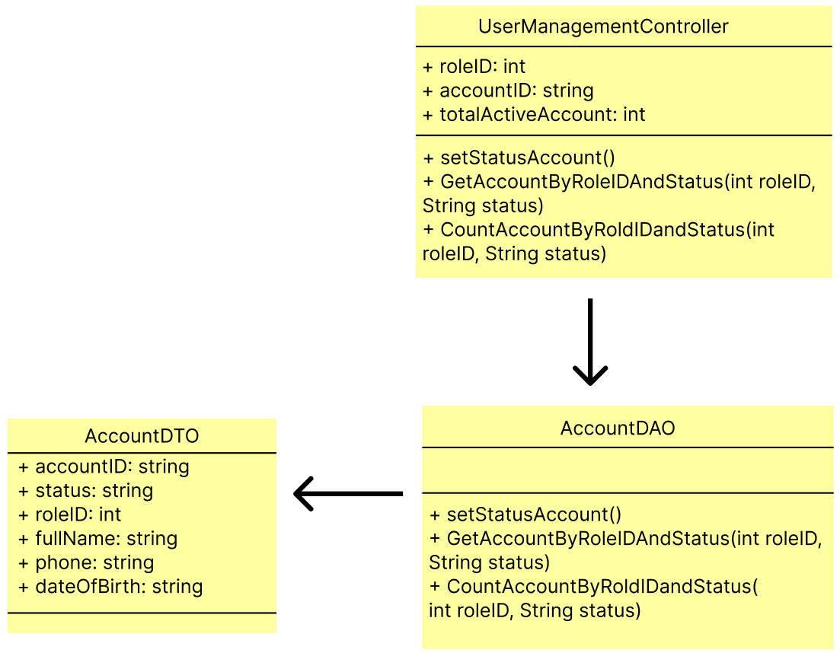

1. **Class Specification**

| No | Method | Description |
| --- | --- | --- |
| 1 | setStatusAccount() | Disable or Enable account |
| 2 | GetAccountByRoleIDAndStatus() | List account of customer |
| 3 | CountAccountByRoldIDandStatus() | Count customer account |

1. **Database Queries**

* **String query = "UPDATE Account\n"**

**+ "SET Status = ?\n"**

**+ "WHERE AccountID = ?";**

* **String query = "SELECT * FROM Account WHERE RoleID = ? and status = ?";**
* **String query = "SELECT COUNT(AccountID) AS TotalCount FROM Account WHERE RoleID = ? AND status = ?";**

## 13. Manager/Customer Details

**a.Class Diagram**

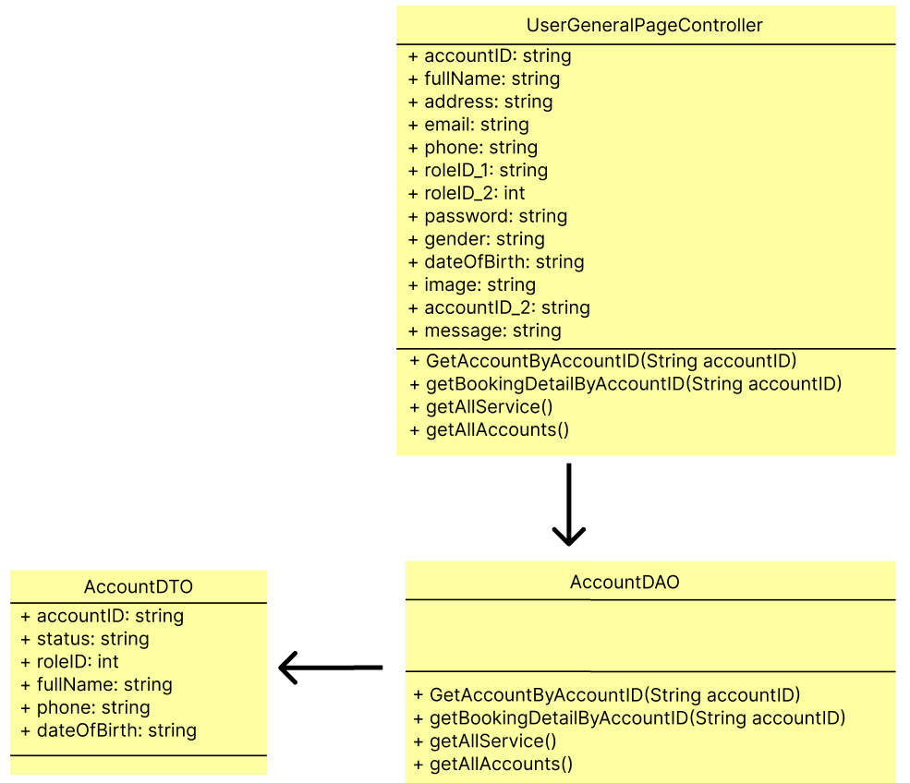

**b. Class Specification**

| No | Method | Description |
| --- | --- | --- |
| 1 | GetAccountByAccountID() | Get customer account |
| 2 | getBookingDetailByAccountID() | Get service detail that booked by customer account |
| 3 | getAllService() | List all service |
| 4 | getAllAccounts() | List all customer account |

**c. Database Queries**

* **String query = "SELECT * FROM Account WHERE AccountID = ?";**
* **String query = "SELECT b.BookingID, b.AccountID, b.BookingStatus, b.StaffID, b.ServiceID, s.ServiceName ,bd.BookingDetail_ID, bd.TotalPrice, bd.BookingDate, bd.BookingAddress, bd.TypeOfService, bd.Message\n"**

**+ "FROM Booking b, BookingDetail bd , Service s\n"**

**+ "WHERE b.BookingID = bd.BookingID AND b.ServiceID = s.ServiceID AND b.AccountID = ?";**

* **String query = "SELECT ServiceID, ServiceName, Price, ServiceDetail, Image, Status, CateName \n"**

**+ "FROM Service s, CateService c \n"**

**+ "WHERE s.CateID = c.CateID AND Status = 'true'";**

* **String query = "SELECT * FROM Account";**

## 14. Public/Home Page

1. **Class Diagram**

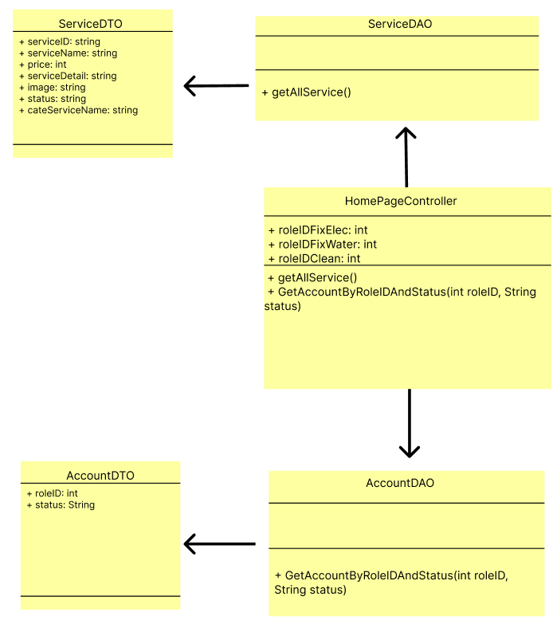

1. **Class Specification**

| No | Method | Description |
| --- | --- | --- |
| 1 | getAllService() | Get a list of all Services in the database |
| 2 | GetAccountByRoleIDAndStatus(int roleID, String status) | Get Account by roleID and status |

1. **Database Queries**

* **String query = "SELECT ServiceID, ServiceName, Price, ServiceDetail, Image, Status, CateName \n"**

**+ "FROM Service s, CateService c \n"**

**+ "WHERE s.CateID = c.CateID AND Status = 'true'";**

* **String query = "SELECT * FROM Account WHERE RoleID = ? and status = ?";**

## 15. Public/Blog List

1. **Class Diagram**

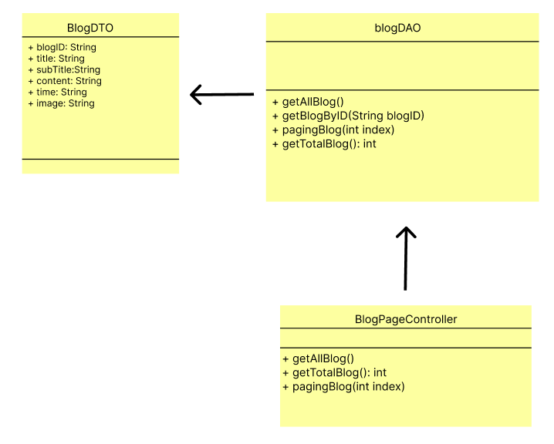

1. **Class Specification**

| No | Method | Description |
| --- | --- | --- |
| 1 | getAllBlog() | Get all Blog in the database order by Date descending |
| 2 | getBlogByID(String blogID) | Get Blog by blogID |
| 3 | getTotalBlog() | Get the total blog in database |
| 4 | papingBlog(int index) | Get only 6 blogs on a page |

1. **Database Queries**

* **String query = "SELECT b.BlogID, b.Title, b.SubTitle, b.Content, b.AccountID, b.Time, b.Image, bc.cateName\n"**

**+ "FROM Blog b\n"**

**+ "INNER JOIN BlogCate bc ON b.BlogCateID = bc.BlogCateID\n"**

**+ "ORDER BY b.Time DESC";**

* **String query = "SELECT BlogID, Title, SubTitle, Content, AccountID, Time, Image, cateName, b.BlogCateID FROM Blog b, BlogCate bc WHERE b.BlogCateID = bc.BlogCateID and blogID = ?";**
* **String query = "SELECT COUNT(*) From Blog";**
* **String query = "SELECT BlogID, Title, Subtitle, Content, AccountID, Time, Image, CateName, b.BlogCateID \n"**

**+ "FROM Blog b, BlogCate bc \n"**

**+ "WHERE b.BlogCateID = bc.BlogCateID ORDER BY BlogID OFFSET ? ROWS FETCH NEXT 6 ROWS ONLY;";**

## 16. Public/Blog Details

1. **Class Diagram**

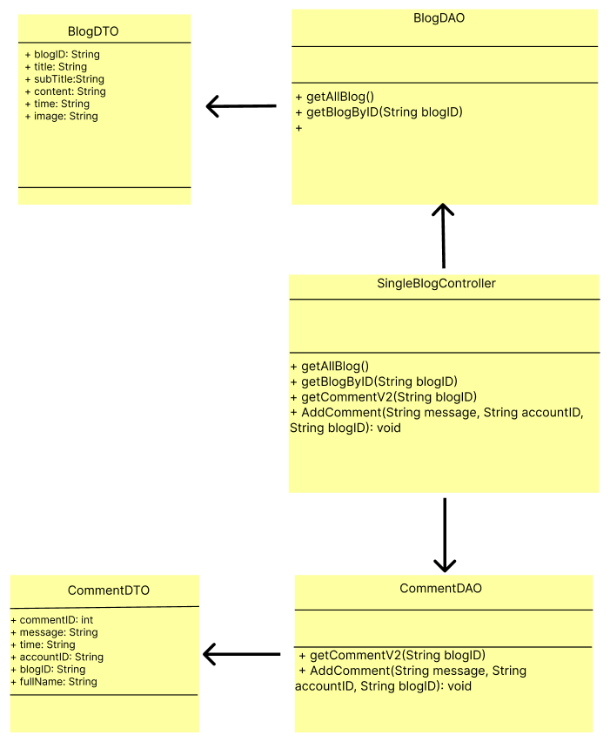

1. **Class Specification**

| No | Method | Description |
| --- | --- | --- |
| 1 | getAllBlog() | Get all Blog in the database order by Date descending |
| 2 | getBlogByID(String blogID) | Get Blog by blogID |
| 3 | getCommentV2(String blogID) | Get the comments in the blog |
| 4 | AddComment(String message, String accountID, String blogID) | Insert Blog comments into the database |

1. **Database Queries**

* **String query = "SELECT b.BlogID, b.Title, b.SubTitle, b.Content, b.AccountID, b.Time, b.Image, bc.cateName\n"**

**+ "FROM Blog b\n"**

**+ "INNER JOIN BlogCate bc ON b.BlogCateID = bc.BlogCateID\n"**

**+ "ORDER BY b.Time DESC";**

* **String query = "SELECT BlogID, Title, SubTitle, Content, AccountID, Time, Image, cateName, b.BlogCateID FROM Blog b, BlogCate bc WHERE b.BlogCateID = bc.BlogCateID and blogID = ?";**
* **String query = "SELECT c.CommentID,c.Message, c.Time,c.AccountID, c.BlogID, a.FullName\n"**

**+ "FROM Comment c\n"**

**+ "INNER JOIN Account a ON a.AccountID = c.AccountID\n"**

**+ "WHERE c.BlogID = ?;";**

* **String query = "INSERT INTO Comment (Message, Time, AccountID, BlogID)\n"**

**+ "VALUES (?, GETDATE(), ?, ?);";**

## 17. Public/Service List

1. **Class Diagram**

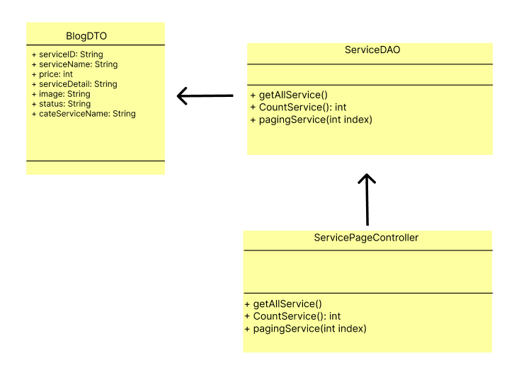

1. **Class Specification**

| No | Method | Description |
| --- | --- | --- |
| 1 | getAllService() | Get a list of all Services in the database |
| 2 | CountService() | Get the total of Services in the database |
| 3 | pagingService(int index) | Paging Service, Show only 6 services on a page. |

1. **Database Queries**

* **String query = "SELECT ServiceID, ServiceName, Price, ServiceDetail, Image, Status, CateName \n"**

**+ "FROM Service s, CateService c \n"**

**+ "WHERE s.CateID = c.CateID AND Status = 'true'";**

* **String query = "SELECT COUNT(*) AS total_count FROM Service;";**
* **String query = "SELECT ServiceID, ServiceName, Price, ServiceDetail, Image, Status, CateName \n"**

**+ "FROM Service s,CateService c\n"**

**+ "WHERE s.CateID = c.CateID ORDER BY ServiceID OFFSET ? ROWS FETCH NEXT 6 ROWS ONLY;";**

## 18. Public/Service Details

1. **Class Diagram**

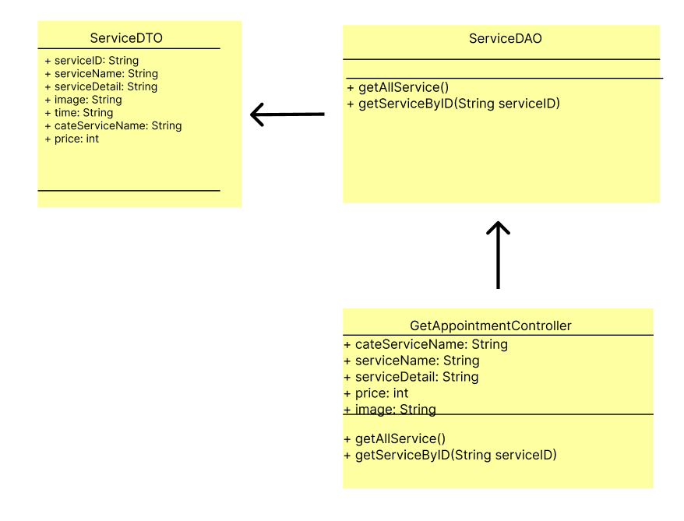

1. **Class Specification**

| No | Method | Description |
| --- | --- | --- |
| 1 | getAllService() | Get a list of all Services in the database |
| 2 | getServiceByID(String serviceID) | Get Service detail |

1. **Database Queries**

* **String query = "SELECT ServiceID, ServiceName, Price, ServiceDetail, Image, Status, CateName \n"**

**+ "FROM Service s, CateService c \n"**

**+ "WHERE s.CateID = c.CateID AND Status = 'true'";**

* **String query = "SELECT ServiceID, ServiceName, Price, ServiceDetail, Image, Status, CateName \n"**

**+ "FROM Service s, CateService c\n"**

**+ "WHERE s.CateID = c.CateID and ServiceID = ?";**

## 19. Staff/Order details

1. **Class Diagram**

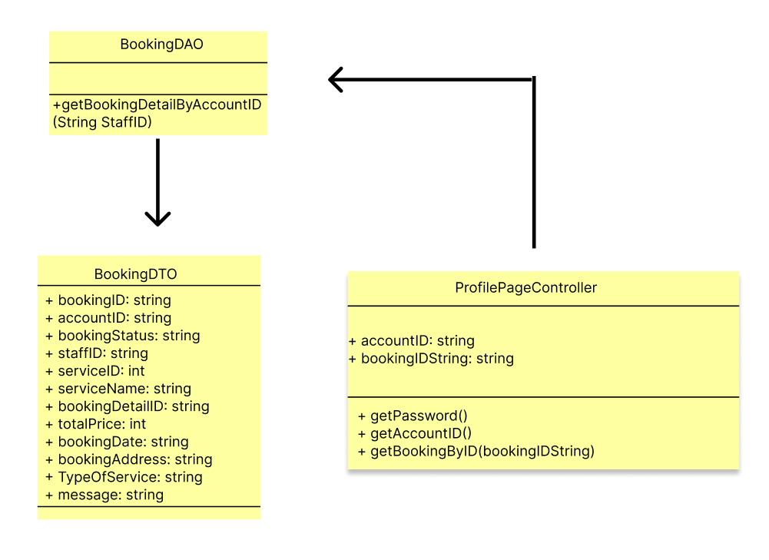

1. **Class Specification**

| No | Method | Description |
| --- | --- | --- |
| 1 | getPassword() | Get the value of Password |
| 2 | getAccountID() | Get the value of Account ID |
| 3 | GetBookingDetailByAccountID() | Get all booking by ID |

1. **Database Queries**

**String query = "SELECT b.BookingID, b.AccountID, b.BookingStatus, b.StaffID, b.ServiceID, s.ServiceName ,bd.BookingDetail_ID, bd.TotalPrice, bd.BookingDate, bd.BookingAddress, bd.TypeOfService, bd.Message\n"**

**+ "FROM Booking b, BookingDetail bd , Service s\n"**

**+ "WHERE b.BookingID = bd.BookingID AND b.ServiceID = s.ServiceID AND b.BookingID = ?";**

## 20. Customer/Order Details

1. **Class Diagram**

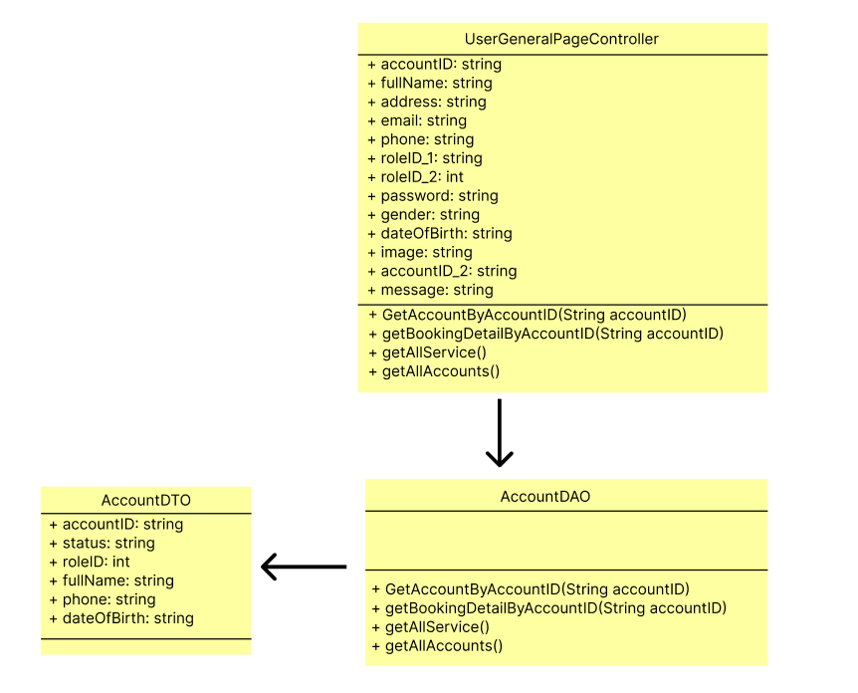

1. **Class Specification**

| No | Method | Description |
| --- | --- | --- |
| 1 | GetAccountByAccountID() | Get staff account |
| 2 | getBookingDetailByAccountID() | Get service detail that receive by staff |
| 3 | getAllService() | List all service |
| 4 | getAllAccounts() | List all staff account |

1. **Database Queries**

**String query = "SELECT * FROM Account WHERE AccountID = ?";**

**String query = "SELECT b.BookingID, b.AccountID, b.BookingStatus, b.StaffID, b.ServiceID, s.ServiceName ,bd.BookingDetail_ID, bd.TotalPrice, bd.BookingDate, bd.BookingAddress, bd.TypeOfService, bd.Message\n"**

**+ "FROM Booking b, BookingDetail bd , Service s\n"**

**+ "WHERE b.BookingID = bd.BookingID AND b.ServiceID = s.ServiceID AND b.AccountID = ?";**

**String query = "SELECT ServiceID, ServiceName, Price, ServiceDetail, Image, Status, CateName \n"**

**+ "FROM Service s, CateService c \n"**

**+ "WHERE s.CateID = c.CateID AND Status = 'true'";**

**String query = "SELECT * FROM Account";**

## 21. Customer/Contact

1. **Class Diagram**

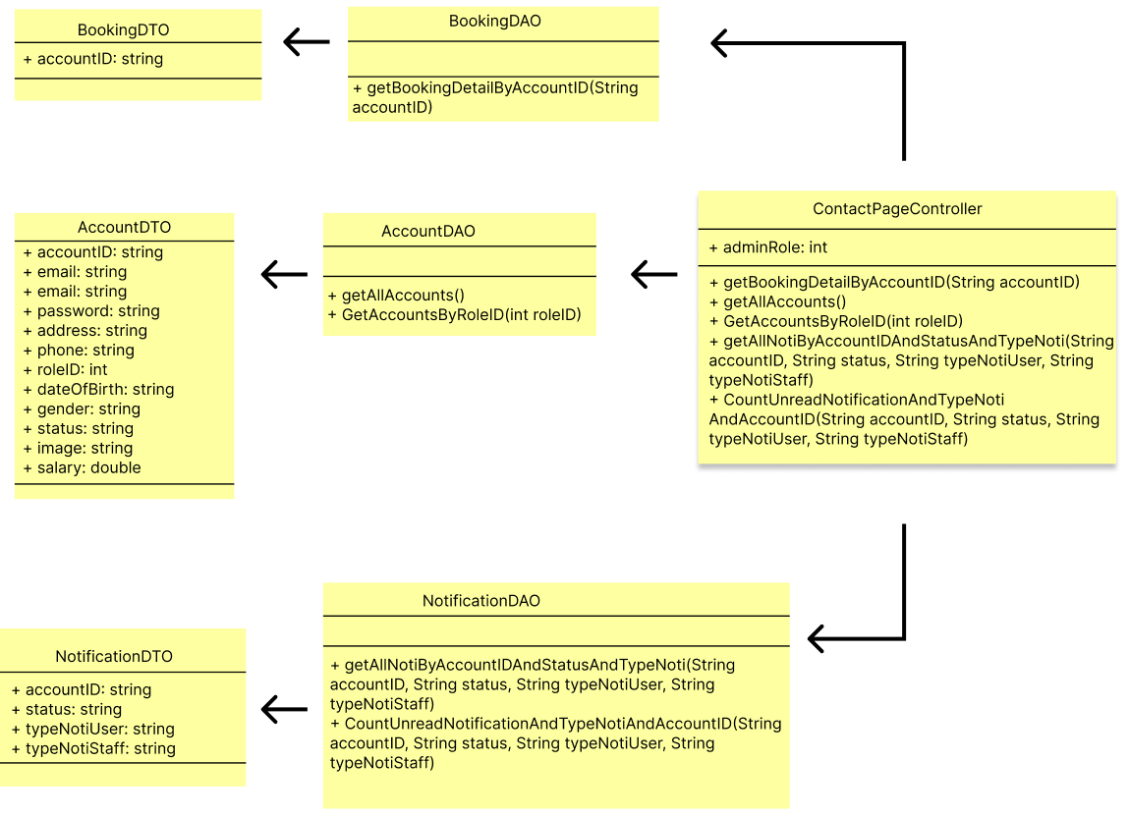

1. **Class Specification**

| No | Method | Description |
| --- | --- | --- |
| 1 | getBookingDetailByAccountID() | Get service detail that receive by staff |
| 2 | getAllAccounts() | Used to supports display notification |
| 3 | GetAccountsByRoleID() | List all admin information to contact |
| 4 | getAllNotiByAccountIDAndStatusAndTypeNoti() | Get notification and status when staff receive service |
| 5 | CountUnreadNotificationAndTypeNotiAndAccountID() | Count notification that unread |

1. **Database Queries**

**String query = "SELECT * FROM Account";**

**String query = "SELECT *\n"**

**+ "FROM Notification\n"**

**+ "WHERE AccountID = ? AND Status = ? AND (TypeNoti = ? OR TypeNoti = ?)\n"**

**+ "ORDER BY ABS(DATEDIFF(minute, Create_at, GETDATE()))";**

**String query = "SELECT COUNT(*) AS CountByStatus\n"**

**+ "FROM Notification\n"**

**+ "WHERE AccountID = ? AND Status = ? AND TypeNoti IN (?, ?)";**

**int total = 0;**

**String query = "SELECT b.BookingID, b.AccountID, b.BookingStatus, b.StaffID, b.ServiceID, s.ServiceName ,bd.BookingDetail_ID, bd.TotalPrice, bd.BookingDate, bd.BookingAddress, bd.TypeOfService, bd.Message\n"**

**+ "FROM Booking b, BookingDetail bd , Service s\n"**

**+ "WHERE b.BookingID = bd.BookingID AND b.ServiceID = s.ServiceID AND b.AccountID = ?";**

## 22. Customer/Order Completion

1. **Class Diagram**

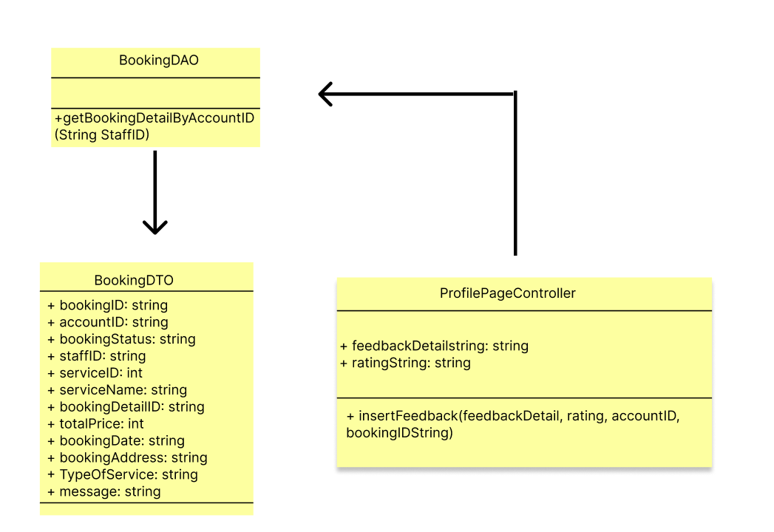

1. **Class Specification**

| No | Method | Description |
| --- | --- | --- |
| 1 | insert Feedback() | Type feedback for staff |
| 2 | getBookingDetailByAccountID() | Get service detail that receive by customer |

1. **Database Queries**

**String query = "INSERT INTO Feedback (Date, Feedback_Text, Rating, AccountID, BookingID)\n"**

**+ "VALUES (GETDATE(), ?, ?, ?, ?);";**

**String query = "SELECT b.BookingID, b.AccountID, b.BookingStatus, b.StaffID, b.ServiceID, s.ServiceName ,bd.BookingDetail_ID, bd.TotalPrice, bd.BookingDate, bd.BookingAddress, bd.TypeOfService, bd.Message\n"**

**+ "FROM Booking b, BookingDetail bd , Service s\n"**

**+ "WHERE b.BookingID = bd.BookingID AND b.ServiceID = s.ServiceID AND b.AccountID = ?";**

## 23. Customer/Feedback

1. **Class Diagram**



1. **Class Specification**

| No | Method | Description |
| --- | --- | --- |
| 1 | insertFeedback() | Type feedback for staff |
| 2 | getBookingDetailByAccountID() | Get service detail that receive by staff |

1. **Database Queries**

**String query = "INSERT INTO Feedback (Date, Feedback_Text, Rating, AccountID, BookingID)\n"**

**+ "VALUES (GETDATE(), ?, ?, ?, ?);";**

## 24. Admin/Dashboard

1. **Class diagram**

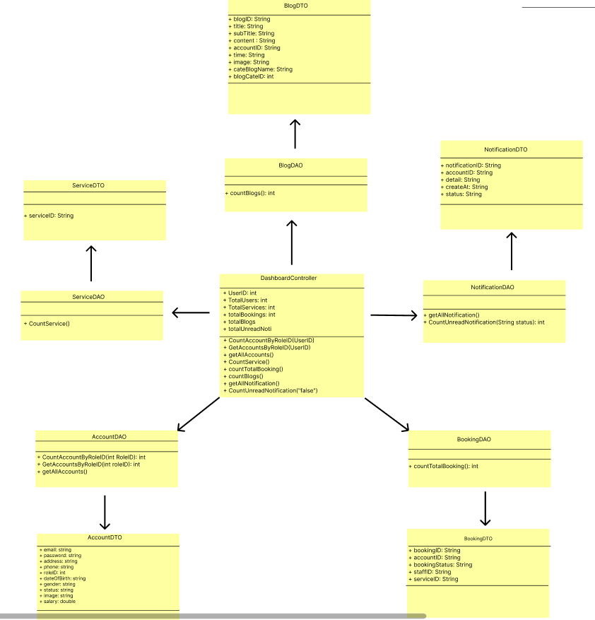

1. **Class Specification**

| No | Method | Description |
| --- | --- | --- |
| 1 | CountAccountByRoleID(int RoleID): int | Count the total accountID by RoleID |
| 2 | GetAccountByAccountID(String accountID) | Get Account by AccountID |
| 3 | getAllAccounts() | Get all account in the database |
| 4 | CountService(): int | Count the total Service in the database |
| 5 | countTotalBooking(): int | Count the total services booked |
| 6 | countBlogs(): int | Count the total blogs in the database |
| 7 | getAllNotification() | Get all notification in the database |
| 8 | CountUnreadNotification(String status): int | Count unread notifications |

1. **Database Queries**

* **String query = "SELECT COUNT(AccountID) AS TotalCount FROM Account WHERE RoleID = ?;";**
* **String query = "SELECT * FROM Account WHERE AccountID = ?";**
* **String query = "SELECT * FROM Account";**
* **String query = "SELECT COUNT(*) AS total_count FROM Service;";**
* **String query = "SELECT COUNT(*) AS TotalBookings FROM Booking";**
* **String query = "SELECT COUNT(*) AS TotalBlogs FROM Blog";**
* **String query = "SELECT *\n"**

**+ "FROM Notification\n"**

**+ "ORDER BY ABS(DATEDIFF(minute, Create_at, GETDATE()))";**

* **String query = "SELECT COUNT(*) AS CountByStatus\n"**

**+ "FROM Notification\n"**

**+ "WHERE Status = ?";**

## 25. Admin/User List

1. **Class Diagram**

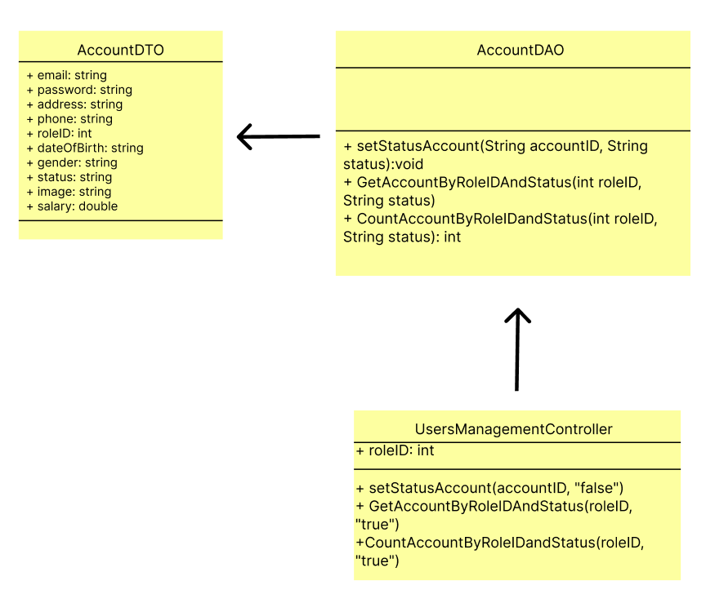

1. **Class Specification**

| No | Method | Description |
| --- | --- | --- |
| 1 | setStatusAccount(String accountID, String status): void | Set status of Account |
| 2 | GetAccountByRoleIDAndStatus(int roleID, String status) | Get Account by roleID and Status |
| 3 | CountAccountByRoleIDandStatus(int roleID, String status): int | Count all account by RoleID and Status in the database |

1. **Database Queries**

* **String query = "UPDATE Account\n"**

**+ "SET Status = ?\n"**

**+ "WHERE AccountID = ?";**

* **String query = "SELECT * FROM Account WHERE RoleID = ? and status = ?";**
* **String query = "SELECT COUNT(AccountID) AS TotalCount FROM Account WHERE RoleID = ? AND status = ?";**

## 26. Admin/User details

1. **Class Diagram**

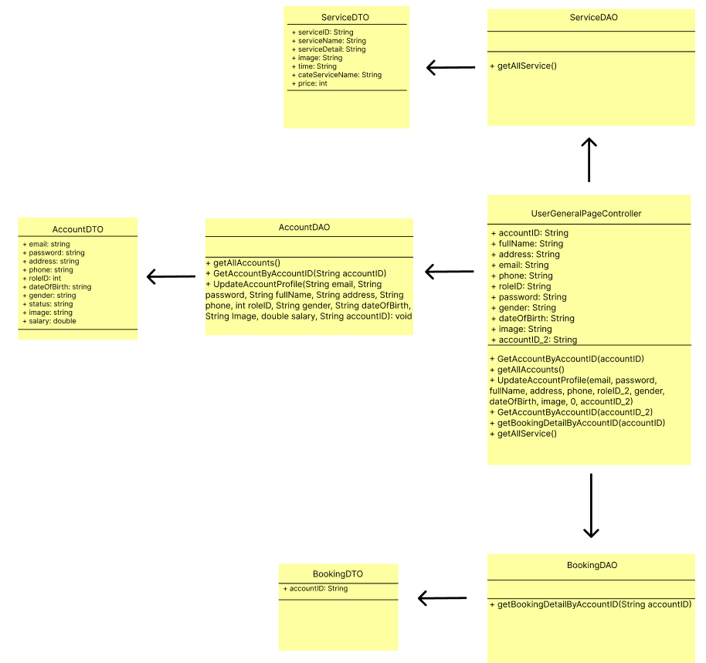

1. **Class Specification**

| No | Method | Description |
| --- | --- | --- |
| 1 | GetAccountByAccountID() | Get Account information by Account User |
| 2 | getAllAccounts() | Get all account |
| 3 | UpdateAccountProfile(String email, String password, String fullName, String address, String phone, int roleID, String gender, String dateOfBirth, String Image, double salary, String accountID): void | Using for Update account User |
| 4 | GetBookingDetailByAccountID() | Get all booking by ID |
| 5 | getAllService() | Get all Services in the database |

1. **Database Queries**

* **String query = "SELECT * FROM Account WHERE AccountID = ?";**
* **String query = "SELECT * FROM Account";**
* **String query = "UPDATE Account\n"**

**+ "SET \n"**

**+ " Email = ?,\n" //1**

**+ " Password = ?,\n" //2**

**+ " FullName = ?,\n" //3**

**+ " Address = ?,\n" //4**

**+ " Phone = ?,\n" //5**

**+ " RoleID = ?,\n" //6**

**+ " Gender = ?,\n" //7**

**+ " DateOfBirth = ?,\n" //8**

**+ " Image = ?,\n" //9**

**+ " Salary = ?\n" //10**

**+ "WHERE AccountID = ?;"; //11**

* **String query = "SELECT b.BookingID, b.AccountID, b.BookingStatus, b.StaffID, b.ServiceID, s.ServiceName ,bd.BookingDetail_ID, bd.TotalPrice, bd.BookingDate, bd.BookingAddress, bd.TypeOfService, bd.Message\n"**

**+ "FROM Booking b, BookingDetail bd , Service s\n"**

**+ "WHERE b.BookingID = bd.BookingID AND b.ServiceID = s.ServiceID AND b.AccountID = ?";**

* **String query = "SELECT ServiceID, ServiceName, Price, ServiceDetail, Image, Status, CateName \n"**

**+ "FROM Service s, CateService c \n"**

**+ "WHERE s.CateID = c.CateID AND Status = 'true'";**

## 27. Admin/Staff list

1. **Class Diagram**

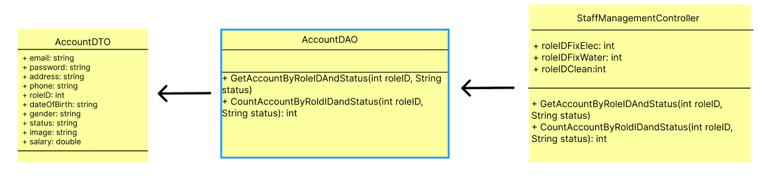

1. **Class Specification**

| No | Method | Description |
| --- | --- | --- |
| 1 | GetAccountByRoleIDAndStatus(int roleID, String status) | Get Account by roleID and status |
| 2 | CountAccountByRoldIDandStatus(int roleID, String status): int | Get total account by roleID and Status |

1. **Database Queries**

* **String query = "SELECT * FROM Account WHERE RoleID = ? and status = ?";**
* **String query = "SELECT COUNT(AccountID) AS TotalCount FROM Account WHERE RoleID = ? AND status = ?";**

## 28. Admin/Staff Details

1. **Class Diagram**

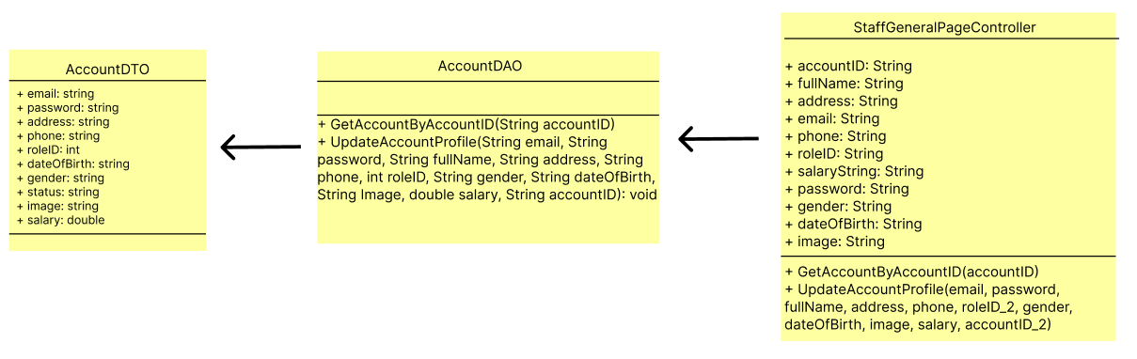

1. **Class Specification**

| No | Method | Description |
| --- | --- | --- |
| 1 | GetAccountByAccountID(String accountID) | Get Account information by Account User |
| 2 | UpdateAccountProfile(String email, String password, String fullName, String address, String phone, int roleID, String gender, String dateOfBirth, String Image, double salary, String accountID): void | Using for Update account User |

1. **Database Queries**

* **String query = "SELECT * FROM Account WHERE AccountID = ?";**
* **String query = "UPDATE Account\n"**

**+ "SET \n"**

**+ " Email = ?,\n" //1**

**+ " Password = ?,\n" //2**

**+ " FullName = ?,\n" //3**

**+ " Address = ?,\n" //4**

**+ " Phone = ?,\n" //5**

**+ " RoleID = ?,\n" //6**

**+ " Gender = ?,\n" //7**

**+ " DateOfBirth = ?,\n" //8**

**+ " Image = ?,\n" //9**

**+ " Salary = ?\n" //10**

**+ "WHERE AccountID = ?;"; //11**