**SMART CITY**

**APARTMENT SERVICES WEBSITE**

**Software Design Specification**

– Ho Chi Minh City, May 2023 –

**Record of changeS**

| **Date** | **A* M, D** | **In charge** | **Change Description** | **Version** |
| --- | --- | --- | --- | --- |
| 12/06/2023 | A | QuyHX | Add Code package/ Namespace and Package description & package class naming conventions | 1.0 |
| 16/06/2023 | A | QuyHX | Add class diagram, class specifications and database queries to Login function | 1.0 |
| 17/06/2023 | A | QuyHX | Add class diagram, class specifications and database queries to Register function | 1.0 |
| 18/06/2023 | A | QuyHX | Add class diagram, class specifications and database queries to Reset Password function | 1.0 |
| 19/06/2023 | M | QuyHX | Modify class diagram for Register function | 1.1 |
| 20/06/2023 | A | QuyHX | Add class diagram, class specifications and database queries to Change Password function | 1.1 |
| 20/06/2023 | M | QuyHX | Modify class diagram for Register function | 1.1 |
| 20/6/2023 | M | QuyHX | Modify class diagram for Reset Password function | 1.1 |
| 20/06.2023 | M | QuyHX | Modify class diagram for Change Password function | 1.1 |
| 21/06/2023 | A | QuyHX | Add class diagram, class specifications and database queries to User Profile function | 1.1 |
| 24/06.2023 | A | QuyHX | Add class diagram, class specifications and database queries to Service List function | 1.1 |
| 24/06/2023 | A | QuyHX | Add class diagram, class specifications and database queries to Service Detail function | 1.1 |
| 26/06/2023 | A | QuyHX | Add class diagram, class specifications and database queries to Customer List function | 1.1 |
| 27/06/2023 | A | QuyHX | Add class diagram, class specifications and database queries to Customer Detail function | 1.1 |
| 24/6/2023 | A | TuongNV | Add class diagram, class specifications and database queries to Home Page function |  |
|  |  |  |  |  |

*A - Added M - Modified D - Deleted

Table of Contents

1. Overview
2. Code Package/Namespace
3. Database Schema
4. Code Design

I. Overview

**1. Code Package/ Namespace**

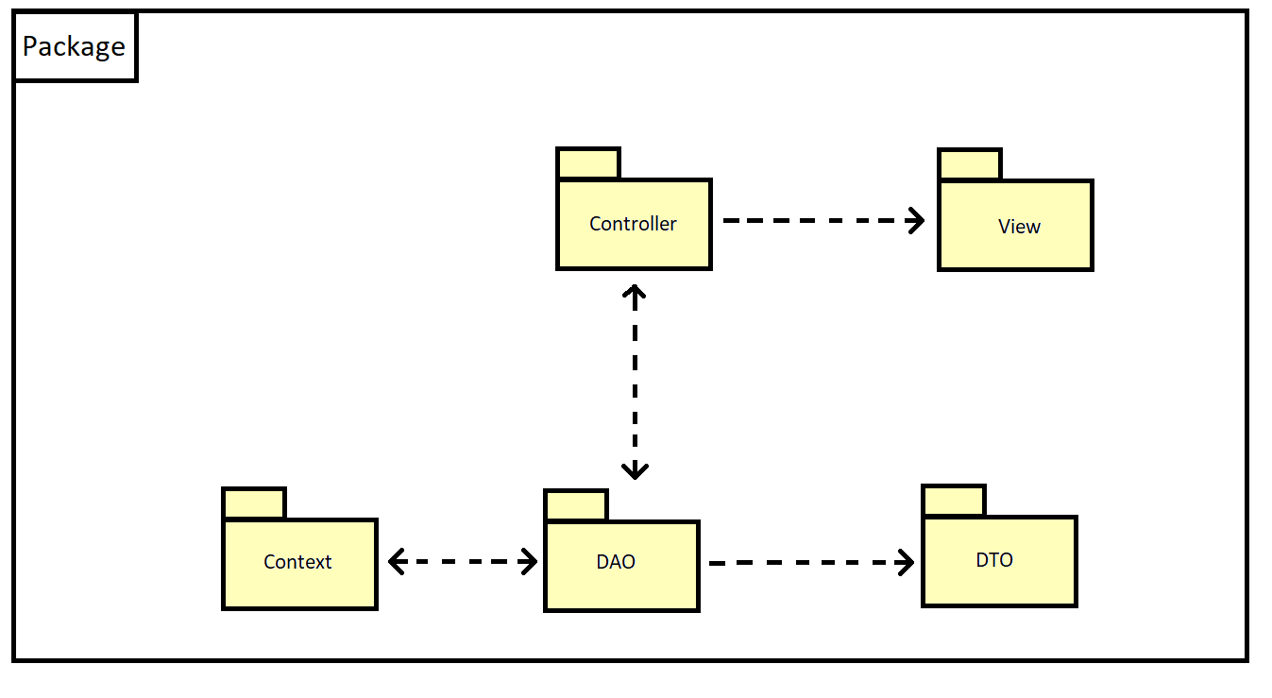

***Package descriptions***

| No | Package | Description |
| --- | --- | --- |
| 1 | Controller | Controllers manage and control interactions between the "DAO" section and the "View" section. |
| 2 | View | View helps display user interface |
| 3 | Context | Context helps connect to database |
| 4 | DAO | DAO provides methods to perform CRUD |
| 5 | DTO | DTO contains properties and used to transmit data |

**2. Database Design**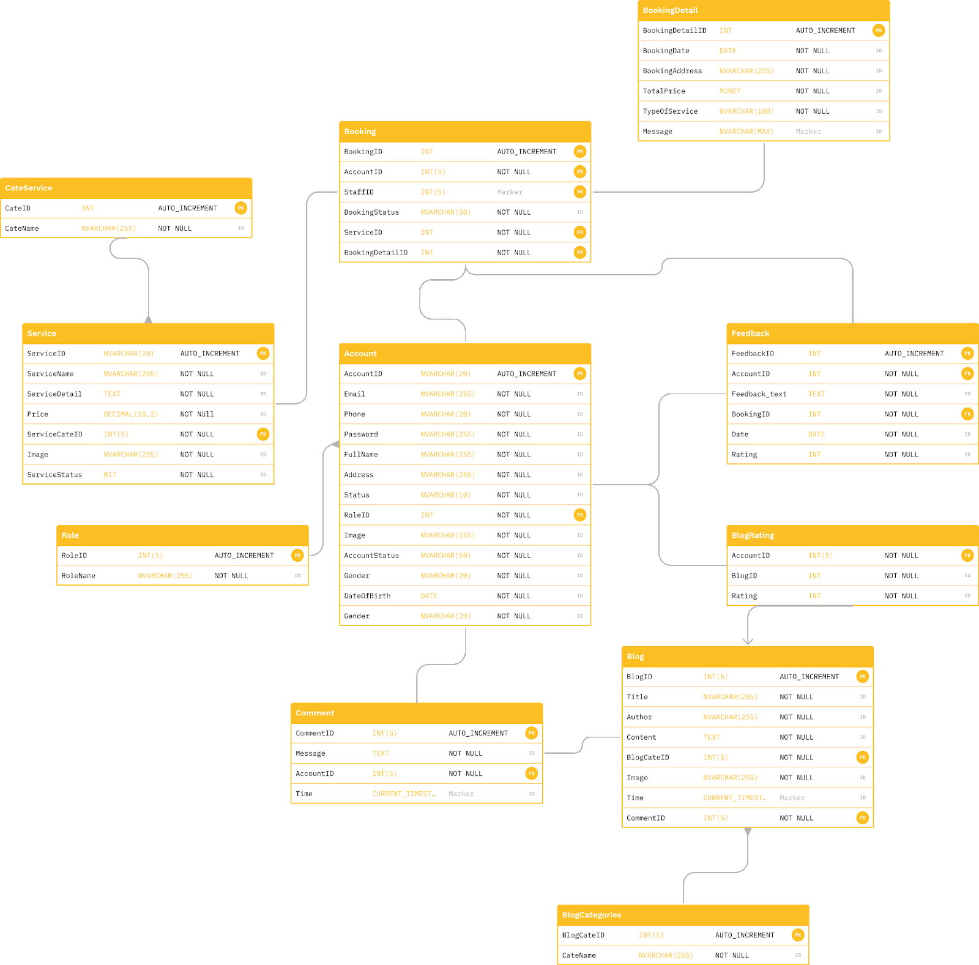

1. **Database Schema**

II. Code Designs

1. **Common/Login**
2. **Class Diagram**

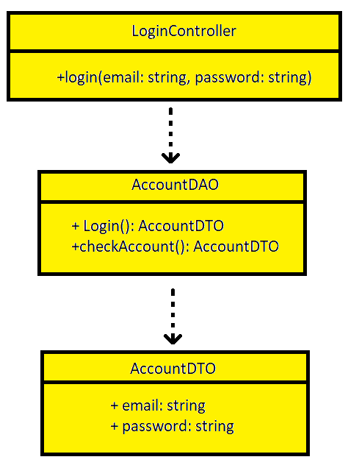

1. **Class Specifications**

| No | Method | Description |
| --- | --- | --- |
| 1 | Login | Used to login to the website |
| 2 | checkAccount | Used to check account in database |

1. **Database Queries**

**String query = "SELECT * \n"**

**+ "FROM Account \n"**

**+ "WHERE Email = ? AND Password = ?";**

**2. Common/Register**

1. **Class Diagram**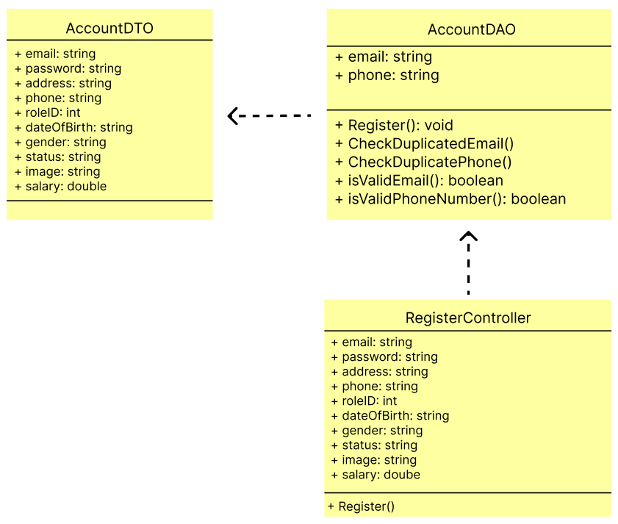
2. **Class Specification**

| No | Method | Description |
| --- | --- | --- |
| 1 | Register() | Used to create a new account for guest |
| 2 | CheckDuplicatedEmail() | Used to check existing email in database |
| 3 | isValidEmail() | The regex of email |
| 4 | CheckDuplicatePhone() | Used to check existing phone number in database |
| 5 | isValidPhoneNumber() | The regex of phone number |

1. **Database Queries**

* **String query = "SELECT * FROM Account WHERE Email = ?";**
* **String query = "SELECT * FROM Account WHERE Phone = ?";**
* **String query = "INSERT INTO Account VALUES ('1', ?, ?, ?, ?, ?, ?, ?, ?, ?, ?, ?);";**

**3. Common/Reset Password**

1. **Class Diagram**

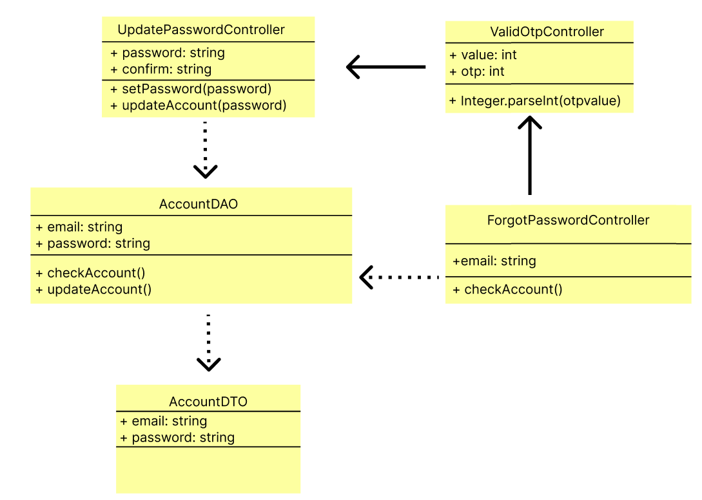

1. **Class Specification**

| No | Method | Description |
| --- | --- | --- |
| 1 | checkAccount(email) | Used to check account in database |
| 2 | Integer.parseInt() | Convert OTP from request parameter to integer |
| 3 | setPassword(password) | Change the old password into a new password |
| 4 | updateAccount(password) | Update a new password for the account |

1. **Database Queries**

* **String query = "SELECT * FROM Account WHERE email = ?";**
* **String query = "UPDATE Account SET Password = ? WHERE email=?";**

**4. Common/Change Password**

1. **Class Diagram**

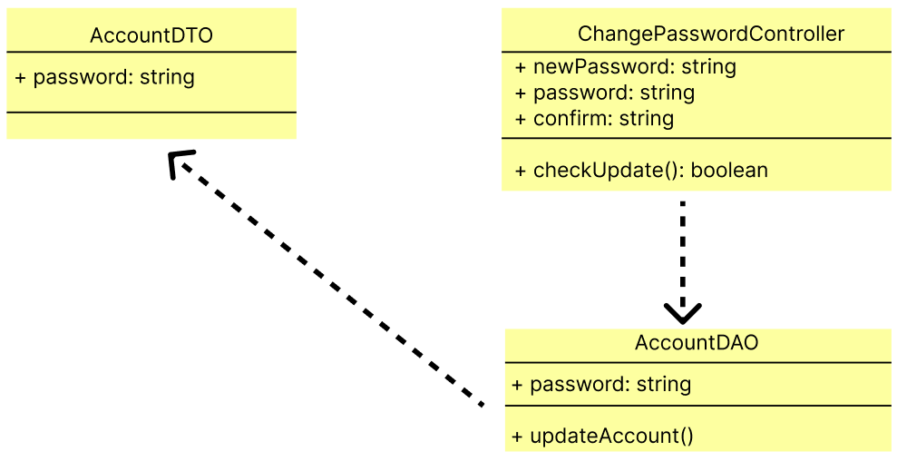

1. **Class Specification**

| No | Method | Description |
| --- | --- | --- |
| 1 | updateAccount() | Update a new password for account |

1. **Database Queries**

**String query = "UPDATE Account SET Password = ? WHERE email=?";**

**5. Common/User Profile**

1. **Class Diagram**

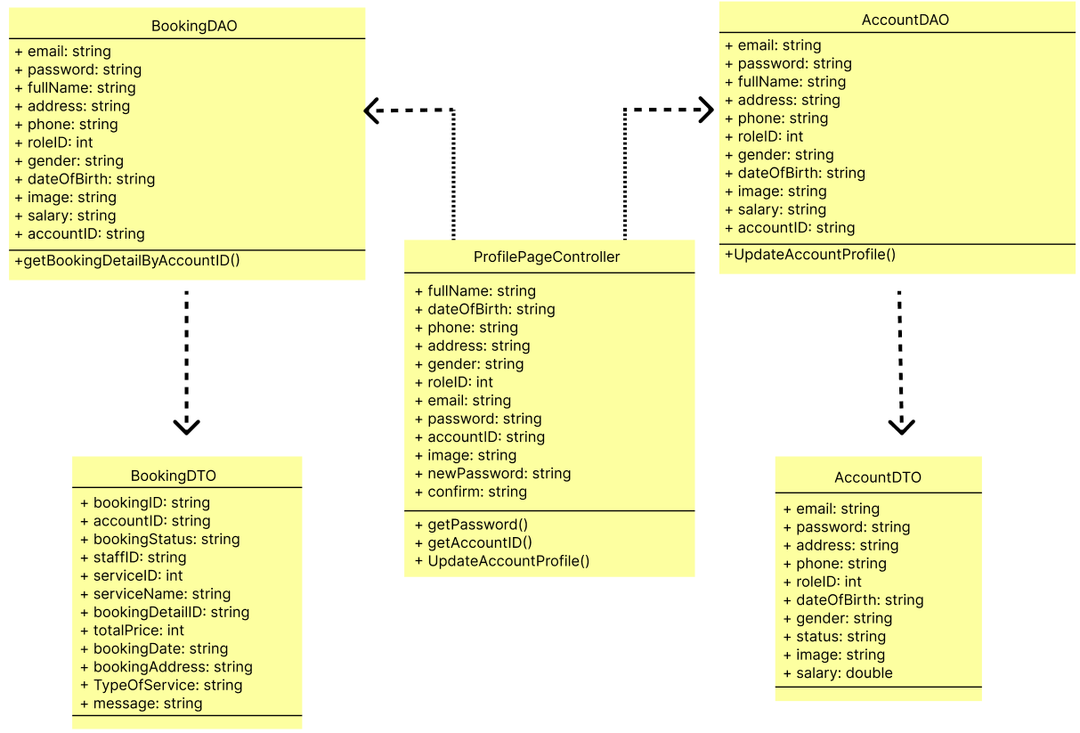

1. **Class Specification**

| No | Method | Description |
| --- | --- | --- |
| 1 | getPassword() | Get the value of Password |
| 2 | getAccountID() | Get the value of Account ID |
| 3 | UpdateAccountProfile() | Update profile of the user when they change the profile |
| 4 | GetBookingDetailByAccountID() | Get all booking by ID |

1. **Database Queries**

* **String query = "SELECT b.BookingID, b.AccountID, b.BookingStatus, b.StaffID, b.ServiceID, s.ServiceName ,bd.BookingDetail_ID, bd.TotalPrice, bd.BookingDate, bd.BookingAddress, bd.TypeOfService, bd.Message\n"**

**+ "FROM Booking b, BookingDetail bd , Service s\n"**

**+ "WHERE b.BookingID = bd.BookingID AND b.ServiceID = s.ServiceID AND b.AccountID = ?";**

* **String query = "UPDATE Account\n"**
* **+ "SET \n"**
* **+ " Email = ?,\n"**
* **+ " Password = ?,\n"**
* **+ " FullName = ?,\n"**
* **+ " Address = ?,\n"**
* **+ " Phone = ?,\n"**
* **+ " RoleID = ?,\n"**
* **+ " Gender = ?,\n"**
* **+ " DateOfBirth = ?,\n"**
* **+ " Image = ?,\n"**
* **+ " Salary = ?\n"**
* **+ "WHERE AccountID = ?;";**

**6. Manager/Booking List**

1. **Class Diagram**
2. **Class Specification**
3. **Database Queries**

**7. Manager/Booking Details**

1. **Class Diagram**
2. **Class Specification**
3. **Database Queries**

**8. Manager/Feedback List**

1. **Class Diagram**
2. **Class Specification**
3. **Database Queries**

**9. Manager/Service List**

1. **Class Diagram**

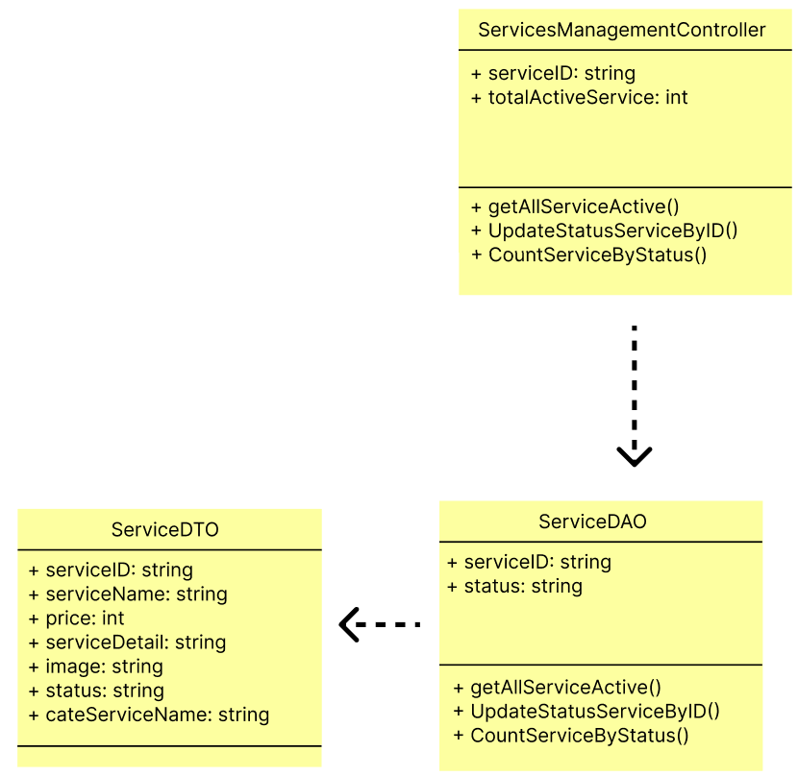

1. **Class Specification**

| No | Method | Description |
| --- | --- | --- |
| 1 | getAllServiceActive() | List out the list of active services |
| 2 | CountServiceStatus() | Showing the number of operating services |
| 3 | UpdateStatusServiceByID() | Disable or Enable service |

1. **Database Queries**

* **String query = "UPDATE Service\n"**

**+ "SET Status = ?\n"**

**+ "WHERE ServiceID = ?";**

* **String query = "SELECT ServiceID, ServiceName, Price, ServiceDetail, Image, Status, CateName\n"**

**+ "FROM Service s, CateService c\n"**

**+ "WHERE s.CateID = c.CateID AND s.Status = ?";**

* **String query = "SELECT COUNT(*) AS total_count FROM Service WHERE Status = ?";**

**10. Manager/Service Details**

1. **Class Diagram**

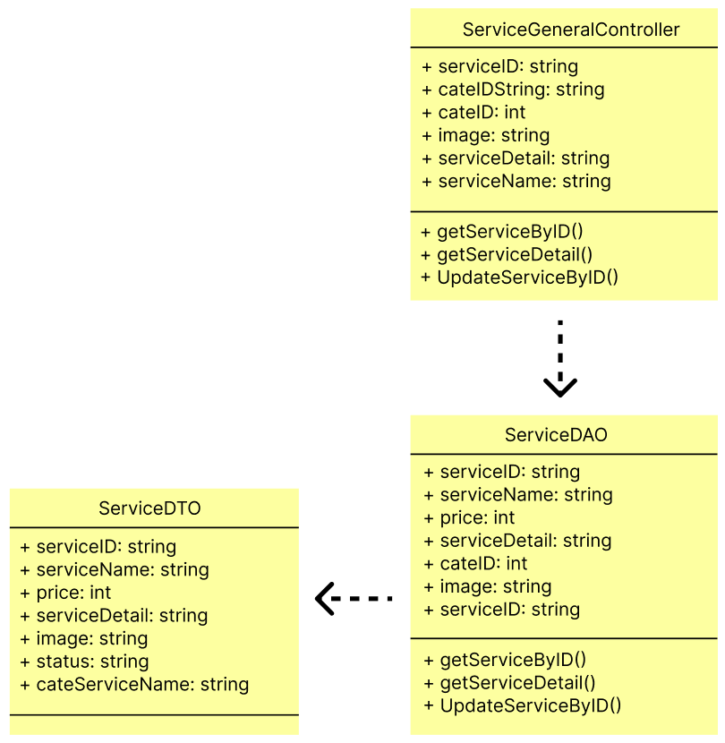

1. **Class Specification**

| No | Method | Description |
| --- | --- | --- |
| 1 | getServiceDetail() | Get the Service Detail value |
| 2 | getServiceByID() | Get the service ID value |
| 3 | UpdateServiceByID() | Update information of the Service |

1. **Database Queries**

* **String query = "UPDATE Service\n"**

**+ "SET ServiceName = ?,\n"**

**+ " Price = ?,\n"**

**+ " ServiceDetail = ?,\n"**

**+ " CateID = ?,\n"**

**+ " Image = ?\n"**

**+ "WHERE ServiceID = ?;";**

**11. Manager/Staff List**

1. **Class Diagram**
2. **Class Specification**

| **No** | **Method** | **Description** |
| --- | --- | --- |
| **1** |  |  |

1. **Database Queries**

**12. Manager/Customer List**

1. **Class Diagram**

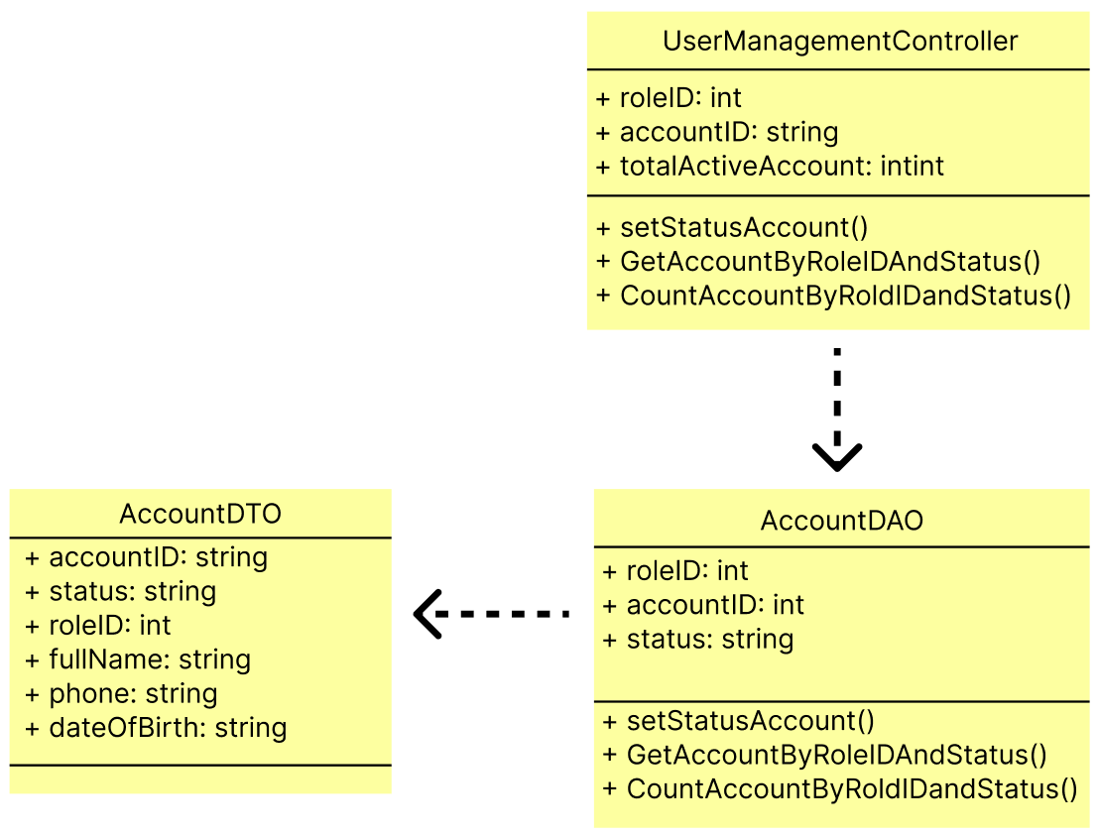

1. **Class Specification**

| No | Method | Description |
| --- | --- | --- |
| 1 | setStatusAccount() | Disable or Enable account |
| 2 | GetAccountByRoleIDAndStatus() | List account of customer |
| 3 | CountAccountByRoldIDandStatus() | Count customer account |

1. **Database Queries**

* **String query = "UPDATE Account\n"**

**+ "SET Status = ?\n"**

**+ "WHERE AccountID = ?";**

* **String query = "SELECT * FROM Account WHERE RoleID = ? and status = ?";**
* **String query = "SELECT COUNT(AccountID) AS TotalCount FROM Account WHERE RoleID = ? AND status = ?";**

**13. Manager/Customer Details**

**a.Class Diagram**

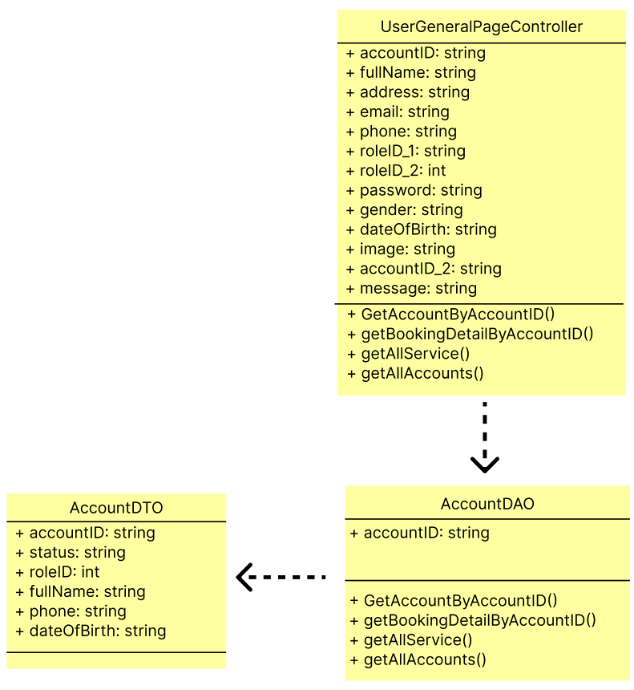

**b. Class Specification**

| No | Method | Description |
| --- | --- | --- |
| 1 | GetAccountByAccountID() | Get customer account |
| 2 | getBookingDetailByAccountID() | Get service detail that booked by customer account |
| 3 | getAllService() | List all service |
| 4 | getAllAccounts() | List all customer account |

**c. Database Queries**

* **String query = "SELECT * FROM Account WHERE AccountID = ?";**
* **String query = "SELECT b.BookingID, b.AccountID, b.BookingStatus, b.StaffID, b.ServiceID, s.ServiceName ,bd.BookingDetail_ID, bd.TotalPrice, bd.BookingDate, bd.BookingAddress, bd.TypeOfService, bd.Message\n"**

**+ "FROM Booking b, BookingDetail bd , Service s\n"**

**+ "WHERE b.BookingID = bd.BookingID AND b.ServiceID = s.ServiceID AND b.AccountID = ?";**

* **String query = "SELECT ServiceID, ServiceName, Price, ServiceDetail, Image, Status, CateName \n"**

**+ "FROM Service s, CateService c \n"**

**+ "WHERE s.CateID = c.CateID AND Status = 'true'";**

* **String query = "SELECT * FROM Account";**

**14. Public/Home page**

1. **Class Diagram**
2. **Class Specification**
3. **Database Queries**

**15. Staff/Service List**

1. **Class Diagram**
2. **Class Specification**

| **No** | **Method** | **Description** |
| --- | --- | --- |
| **1** |  |  |

1. **Database Queries**

String query = "SELECT ServiceID, ServiceName, Price, ServiceDetail, Image, Status, CateName \n"

+ "FROM Service s, CateService c \n"

+ "WHERE s.CateID = c.CateID AND Status = 'true'";

String query = "SELECT ServiceID, ServiceName, Price, ServiceDetail, Image, Status, CateName \n"

+ "FROM Service s, CateService c\n"

+ "WHERE s.CateID = c.CateID and ServiceID = ?";

String query = "SELECT COUNT(*) AS total_count FROM Service;";

String query = "SELECT ServiceID, ServiceName, Price, ServiceDetail, Image, Status, CateName \n"

+ "FROM Service s,CateService c\n"

+ "WHERE s.CateID = c.CateID ORDER BY ServiceID OFFSET ? ROWS FETCH NEXT 6 ROWS ONLY;";

String query = "SELECT COUNT(*) AS total_count FROM Service WHERE Status = ?";

String query = "SELECT ServiceID, ServiceName, Price, ServiceDetail, Image, Status, CateName\n"

+ "FROM Service s, CateService c\n"

+ "WHERE s.CateID = c.CateID AND s.Status = ?";

String query = "UPDATE Service\n"

+ "SET Status = ?\n"

+ "WHERE ServiceID = ?";

String query = "UPDATE Service\n"

+ "SET ServiceName = ?,\n"

+ " Price = ?,\n"

+ " ServiceDetail = ?,\n"

+ " CateID = ?,\n"

+ " Image = ?\n"

+ "WHERE ServiceID = ?;";

String query = "INSERT INTO Service (ServiceName, Price, ServiceDetail, CateID, Image, Status)\n"

+ "VALUES (?, ?, ?, ?, ?, ?);";

String query = "SELECT ServiceID, ServiceName, Price, ServiceDetail, Image, Status, CateName \n"

+ "FROM Service s, CateService c \n"

+ "WHERE s.CateID = c.CateID AND ServiceName = ?";