

**SMART CITY**

**APARTMENT SERVICES WEBSITE**

**Software Requirement Specification**

– Ho Chi Minh City, May 2023 –

**Record of changeS**

| **Date** | **A* M, D** | **In charge** | **Change Description** |
| --- | --- | --- | --- |
| 18/05 | A | KienNT | Thêm mô tả Introduction về Cleaning services Website(I, 1) |
| 18/05 | A | HieuDT | Thêm hình vẽ mô tả ở Introduction(I,1) |
|  |  |  |  |
|  |  |  |  |
|  |  |  |  |
|  |  |  |  |
|  |  |  |  |
|  |  |  |  |
|  |  |  |  |
|  |  |  |  |
|  |  |  |  |
|  |  |  |  |

*A - Added M - Modified D - Deleted

**Table of Contents**

I. Overview 5

1. Introduction 5

2. System Functions 6

a. Screen Flow 6

b. Screen Details 7

c. User Authorization 8

d. Non-Screen Functions 9

3. Entity Relationship Diagram 9

II. Functional Requirements 11

1. Public Feature 11

a. Home Page 11

b. Web Blog List 12

c. Blog details 13

d. Service list 14

e. Service details 15

2. Common Feature 16

a. User Login 16

b. User register 17

c. Reset password 18

d. Change password 20

e. User Profile 20

3. Customer feature 22

a. Order Details 22

b. Order Contact 24

c. Order Completion 26

d. Feedback 27

4. Admin feature 28

a. Admin Dashboard 28

b. User list 29

c. User details 30

d. Staff list 31

5. Manager feature 31

a. Post list 31

b. Post details 32

c. Feedbacks List 33

d. Service list 34

e. Service details 35

f. Staff list 36

h. Customer list 36

k. Customer details 37

6. Staff feature 38

a.Service List 38

b. Service Details 39

c .Order Details 40

e. Feedback List 41

# I. Overview

General information about the project

* Project name: SmartCity
* Project code: SC
* Group name: Group 3
* Software type: Website

## 1. Introduction

* The Vinhomes Cleaning Services Website is a software system designed to streamline the management of cleaning services offered by Vinhomes, one of the leading real estate developers in Vietnam. The website serves as a platform for residents and staff to access cleaning services and manage service requests efficiently. The website aims to provide a user-friendly experience to the residents and staff of Vinhomes, enabling them to easily request cleaning services. The system will assist the management of cleaning services by providing detailed information on the number of requests, response times, and other key performance indicators.

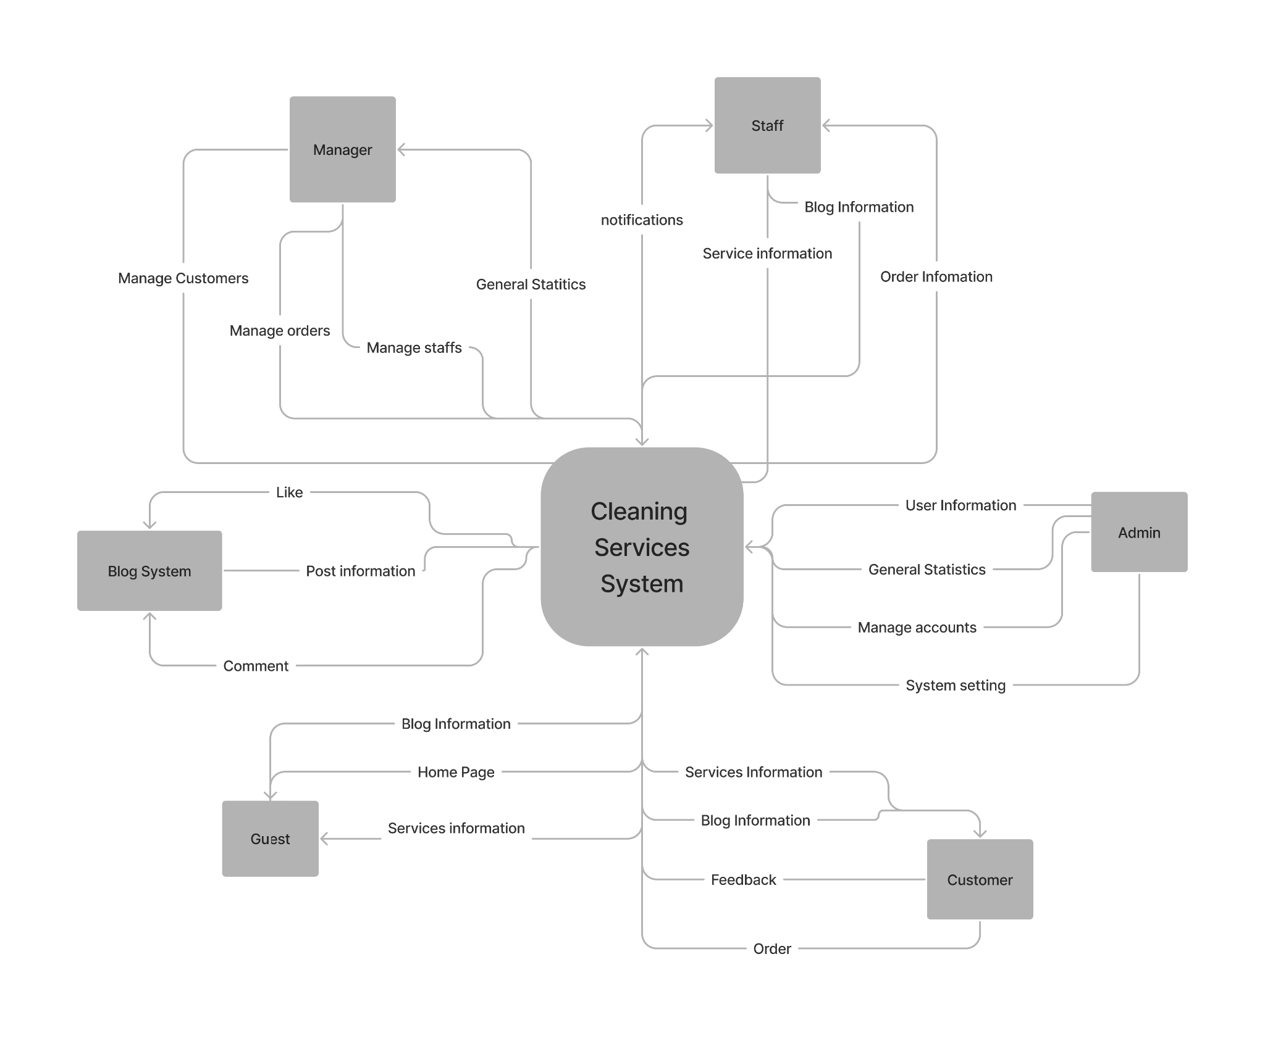

## 2. System Functions

### **a. Screen Flow**

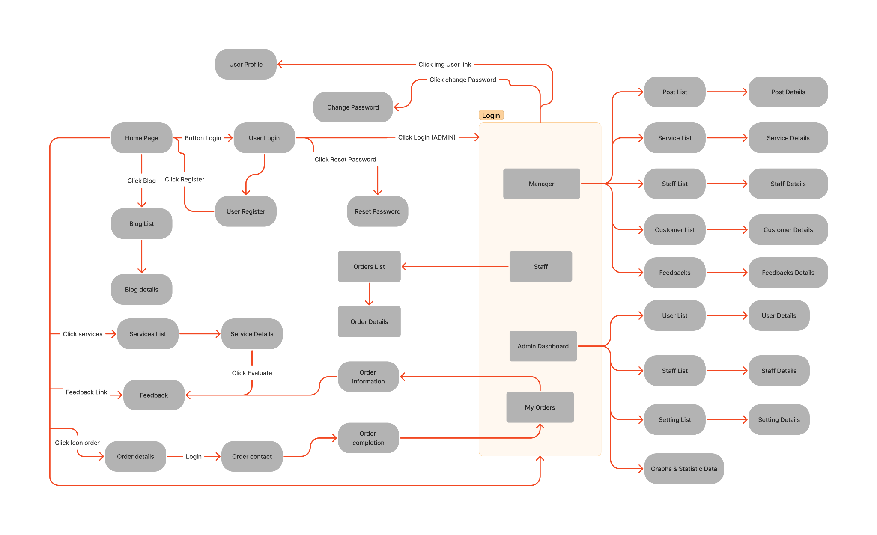

### 

### 

### 

### 

### 

### 

### 

### 

### 

### 

### 

### 

### 

### 

### 

### 

### **b. Screen Details**

| **No** | **Feature** | **Screen** | **Description** |
| --- | --- | --- | --- |
| 1 | Public | Home Page | The starting page of the system. |
| 2 | Public | Blog List | List of shared blogs. |
| 3 | Public | Blog details | Detail of the shared blogs. |
| 4 | Public | Services List | List of the active types of services. |
| 5 | Public | Service Details | Details of the selected service. |
| 6 | Customer | Order Details | Details of the user orders (the list of selected services to reserve). |
| 7 | Customer | Order Contact | Screen that allows the user to input/edit the order receiver. |
| 8 | Customer | Order Completion | Order completion screen. |
| 9 | Customer | Feedback | Screen that allows user to input/edit their comment |
| 10 | Common | User Login | Authenticate the user to give him/her access to authorized features later on. |
| 11 | Common | User Register | Register a new user into the system, verified by the registered email. |
| 12 | Common | Reset Password | Use in case the user forgot his/her password. |
| 13 | Common | Change Password | change the user's login password. |
| 14 | Common | User Profile | View & Edit/Update user profile. |
| 15 | Common | User Authorization | Authorization user into the system functions based on his/her role. |
| 16 | Staff | Services List | filter, view service(s). |
| 17 | Staff | Service Details | View the details of a specific service. |
| 18 | Staff | Order List | List, filter, search, show, hide, view order(s) that are assigned for this staff. |
| 19 | Staff | Order Details | View the details of a specific assigned order. |
| 20 | Staff | Feedback List | List, filter, search, show, hide, view feedback(s). |
| 21 | Manager | Post List | List, filter, search, show, hide, view, add new or edit existing blog(s). |
| 22 | Manager | Post Details | View & edit the details of a specific blog. |
| 23 | Manager | Feedbacks List | List feedback of users. |
| 24 | Manager | Feedback details | View and categorize feedback (negative and positive). |
| 25 | Manager | Service List | List, filter, search, show, hide, view, add new or edit existing services. |
| 26 | Manager | Service Details | View & edit the details of a specific service. |
| 27 | Manager | Staff List | List, filter, search, show, hide, view, add new or edit existing staff. |
| 28 | Manager | Staff Details | View & edit the details of a specific staff. |
| 29 | Manager | Customer List | List, filter, search, show, hide, view, add new or edit existing customer. |
| 30 | Manager | Customer Details | View & edit the details of a specific customer. |
| 31 | Admin | Admin Dashboard | View general statistics & trends about the management-related data. |
| 32 | Admin | User List | List, filter, search, show, hide, view, add new or edit existing user. |
| 33 | Admin | User Details | View & edit the details of a specific user. |
| 34 | Admin | Staff List | List, filter, search, show, hide, view, add new or edit existing staff. |
| 35 | Admin | Staff Details | View & edit the details of a specific staff. |
| 36 | Admin | Graphs & Statistic Data | Graphs and Statistics of Staff, Customers, Appointments, and Revenue. |

### **c. User Authorization**

| **Screen** | **Admin** | **Manager** | **Customer** | **Staff** | **Guest** |
| --- | --- | --- | --- | --- | --- |
| Home Page | X | X | X | X | X |
| Blog List | X | X | X | X | X |
| Blog Details | X | X | X | X | X |
| Services List | X | X | X | X | X |
| Service Details | X | X | X | X | X |
| Order Details |  | X | X | X |  |
| Order contact |  | X | X | X |  |
| User Login | X | X | X | X | X |
| User Register | X | X | X | X | X |
| Forgot Password | X | X | X | X | X |
| Change Password | X | X | X | X |  |
| User Profile | X | X | X | X |  |
| Dashboard (Graphs & Statistic Data) | X | X |  |  |  |
| Accounts List | X |  |  |  |  |
| Account Details | X |  |  |  |  |
| Add/remove Blog |  | X |  |  |  |
| Add new Blog |  | X |  |  |  |
| Update Blog |  | X |  |  |  |
| Customer List | X | X |  |  |  |
| Customer Details | X | X |  |  |  |
| Staff List |  | X |  |  |  |
| Staff Details |  | X |  |  |  |
| Feedback List |  | X | X | X | X |
| Feedback Details |  | X |  |  |  |
| Orders History |  | X | X | X |  |
| Setting List | X |  |  |  |  |
| Setting Details | X |  |  |  |  |

In which:

* **Admin**: The administrator has the highest authority in the system and is responsible for managing all functions and data of the cleaning services application.
* **Customer**: The customer is the user who utilizes the house cleaning and electronic device cleaning services.
* **Manager**: The manager is responsible for supervising and managing the tasks of the staff members in the cleaning services.
* **Guest:** Users who access the system without registering or logging in.
* **Staff:** Staff members are responsible for performing the house cleaning and electronic device cleaning tasks.

### **d. Non-Screen Functions**

| **#** | **Feature** | **System Function** | **Description** |
| --- | --- | --- | --- |
| 1 | Common | Sign out | Users sign out of the system |
| 2 | Common | User Authorization | This is the authorization mechanism in the system, |
|  |  |  |  |

## 3. Entity Relationship Diagram

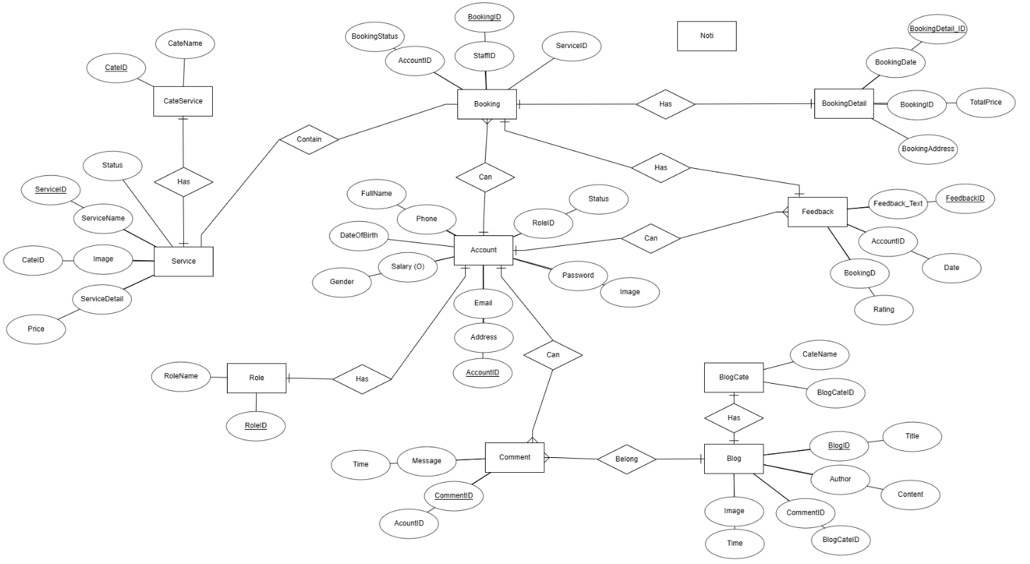

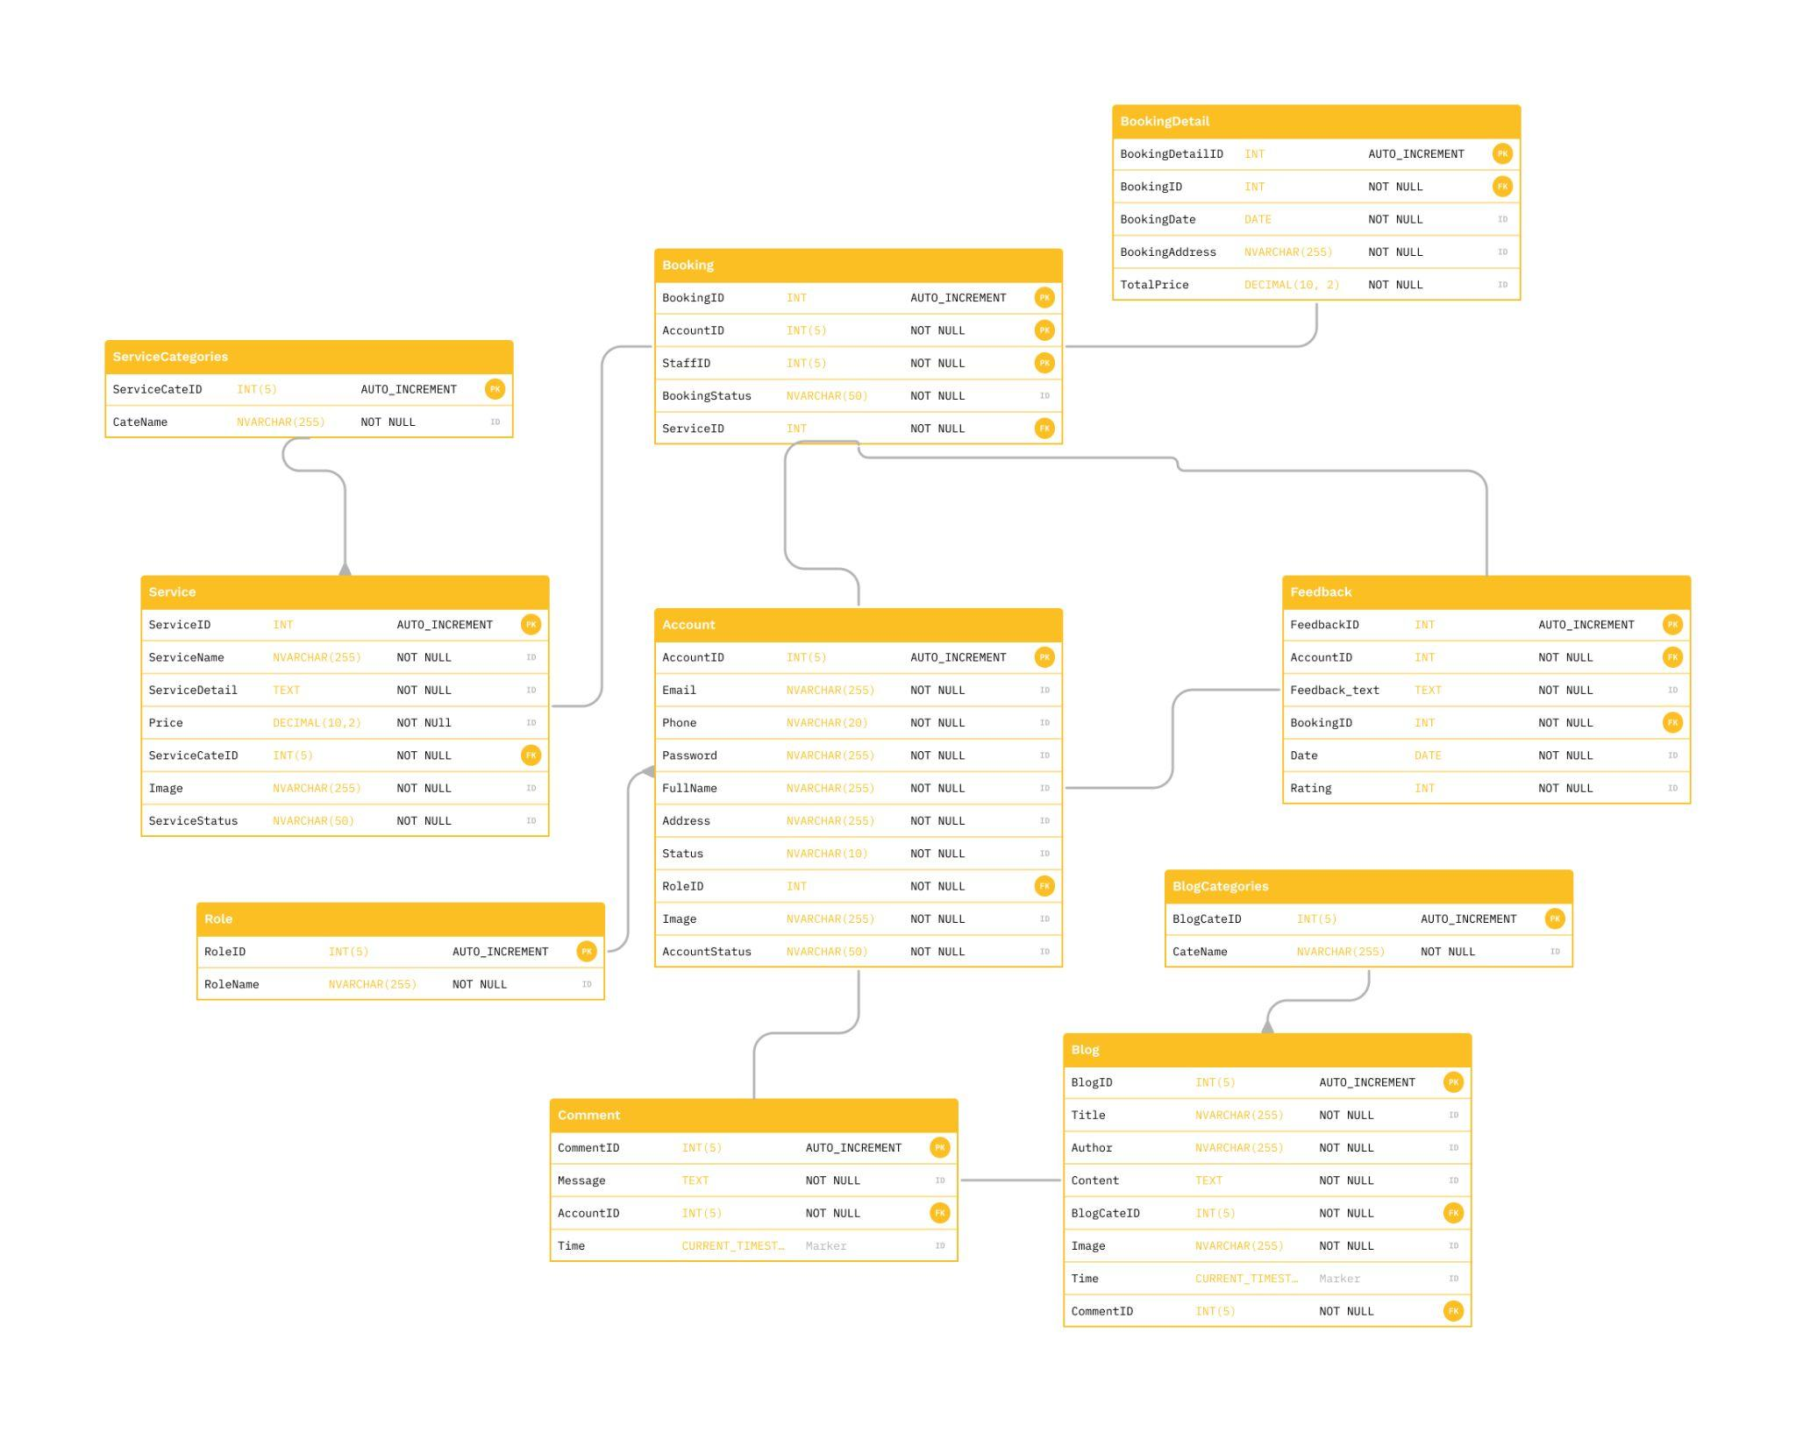

**Entities Description**

| **#** | **Entity** | **Description** |
| --- | --- | --- |
| 1 | Account | Contain user’s information: Fullname, password, address,... |
| 2 | Role | Grant permission to user account |
| 3 | Booking | Provide process for service that user choose on the website |
| 4 | BookingDetail | Provide information about date, price, address for service that user booked |
| 5 | Service | Provide services that website has |
| 6 | CategoryService | Classification of services |
| 7 | Blog | Where the website's blogs are written |
| 8 | CategoryBlog | Classification of blogs |
| 9 | Comment | Where user can comment on the website |
| 10 | Feedback | User reviews after each successful booking |

# II. Functional Requirements

## 1. Public Feature

### **a. Home Page**

* **Function trigger**: This function is triggered when user enter the website
* **Function description**: users can see summary of service, user can click on the image or detail button that the website will lead you the detail of service that you have clicked
* **Screen layout**: mockup prototype of the screen, sample below is for Home Page screen

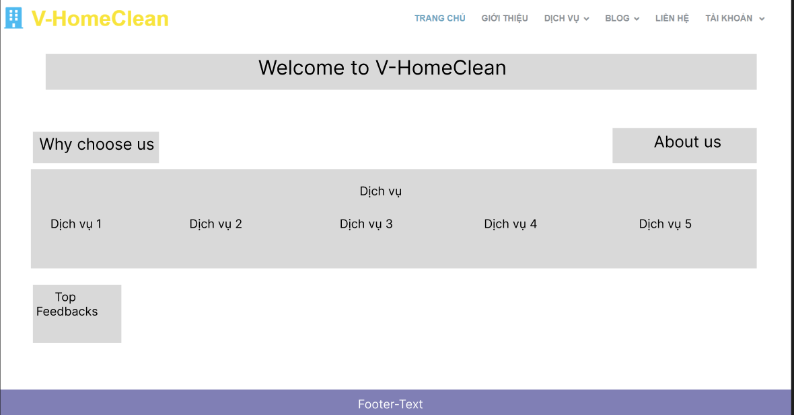

* **Function details**:
* Navigation menu:
* ABOUT US: introduce about service team
* OUR SERVICES: introduce services that the website provides
* PAGES: provide links to subpages and sections of the site
* CONTACT US: provide phone number, email and address that user can contact with owner website
* Banner: An attractive banner or featured image that will grab the visitor's attention
* Search: A search box allows users to quickly search for information or service on the site.
* Register or login: The form login or register will display when user click on “Đăng nhập ” button

### **b. Web Blog List**

● **Function trigger**: This function is triggered when the user clicks blogs in navbar

● **Function description**: Show the paginated list of blogs

● **Screen layout**: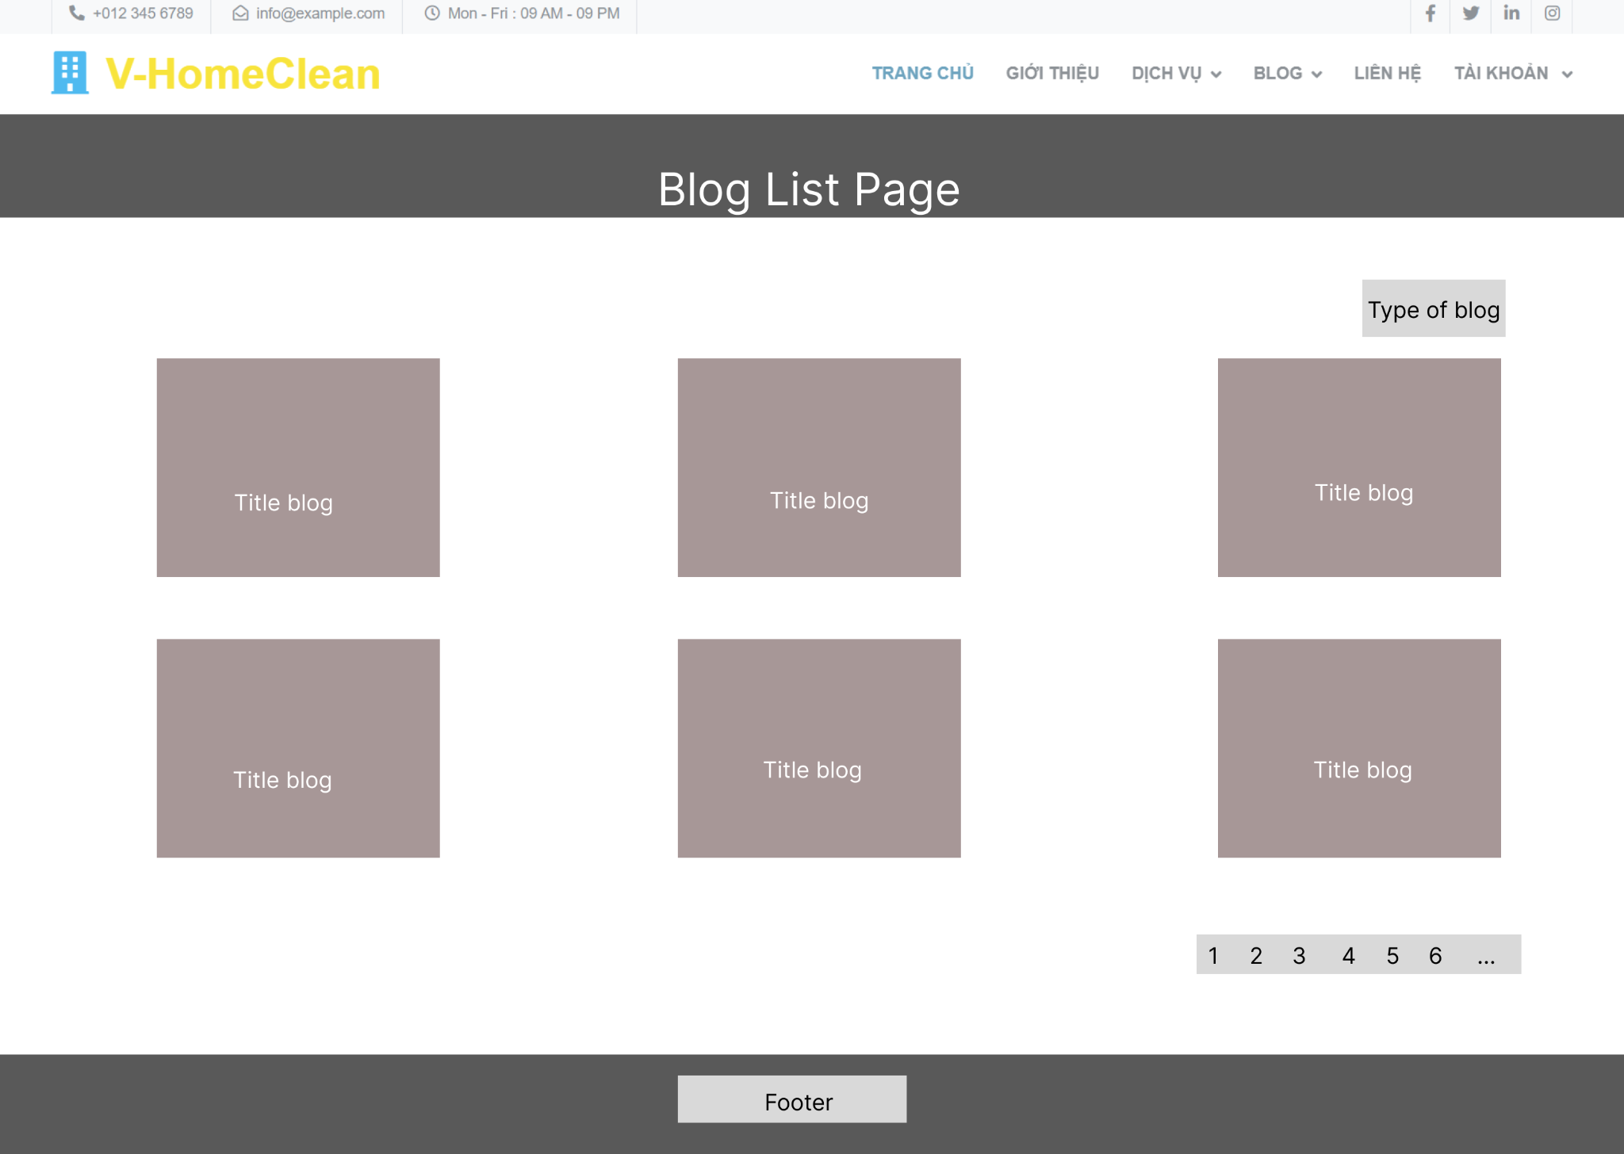

* **Function details**:
* Display: The article list page displays articles in order of newest or by other criteria such as popularity, category, or keyword. Articles are usually presented in the form of titles, short descriptions, and other information such as publication date and author.
* Filter and sort: Provides filtering and sorting options so that users can narrow the results displayed based on criteria such as category, blog date, author, popularity, or keyword.
* Pagination: Split into smaller pages to reduce page load and increase user experience.

### **c. Blog details**

* **Function trigger**: This function is triggered when user clicks a title of the blog list that display on the Blog List website
* **Function description**: Display the detail of the selected blog
* **Screen layout**:

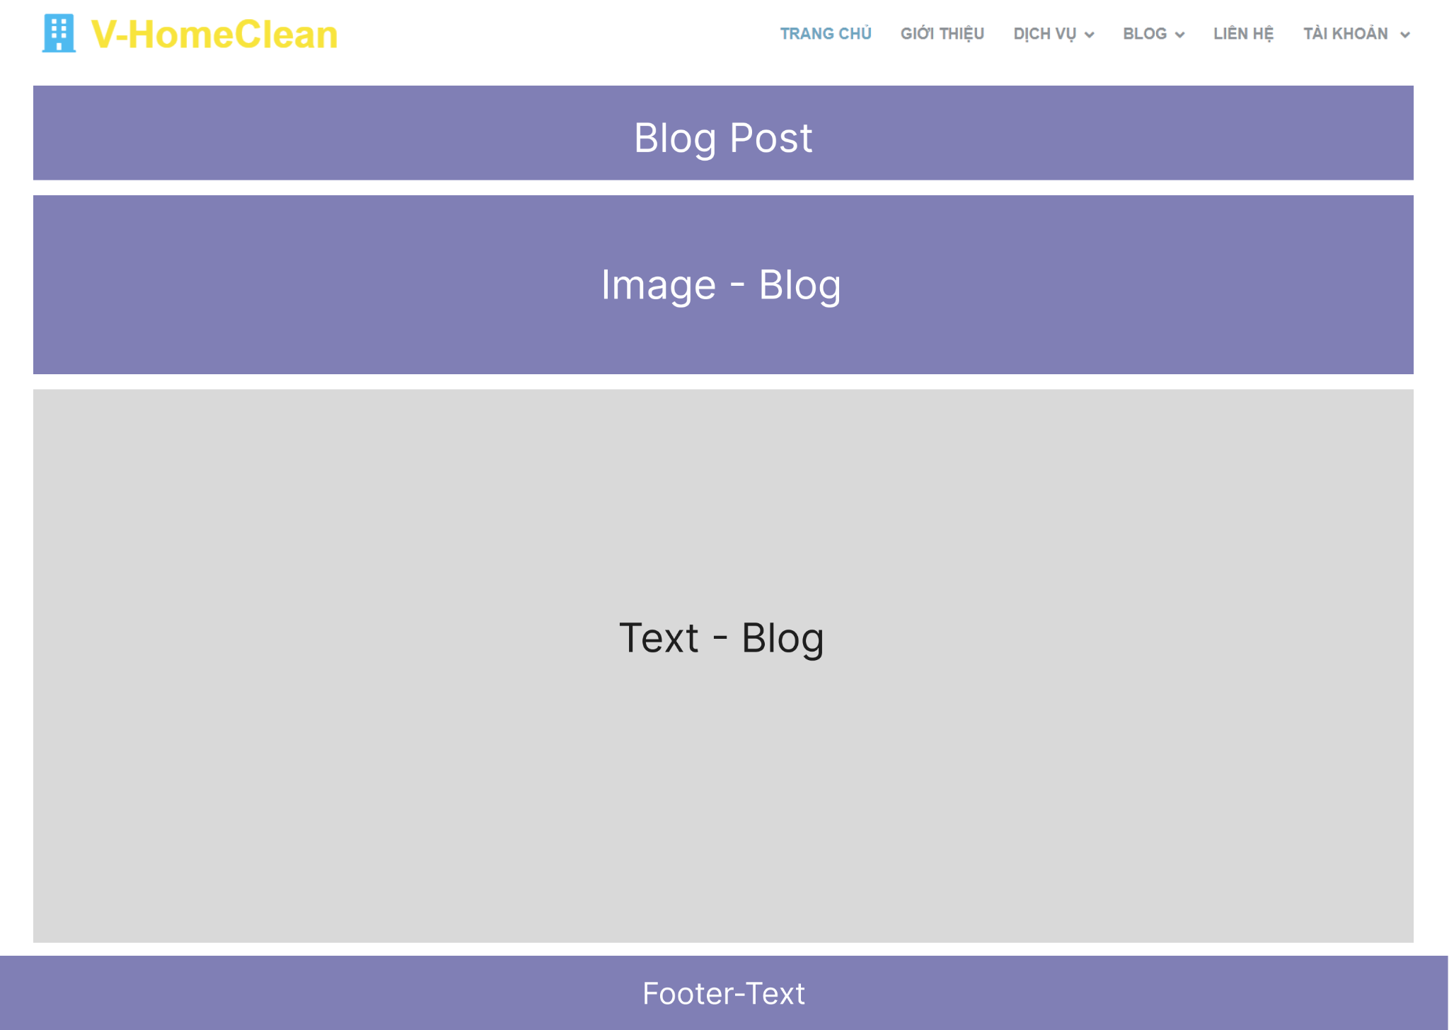

* **Function detail**:
* Display: displays the title and full body of the blog.
* Blog date and author: Information about the blog date and author is displayed on the details page. This helps the reader to know the source and author of the article.
* Related Articles: To increase the discoverability of other content, the article details page often offers a "Related Articles" section that displays similar or related articles that may be of interest to readers.

### **d. Service list**

* **Function trigger**: This function is triggered when user clicks a OUR SERVICE on the Menu Navigation
* **Function description**: Show the paginated list of services
* **Screen layout**:

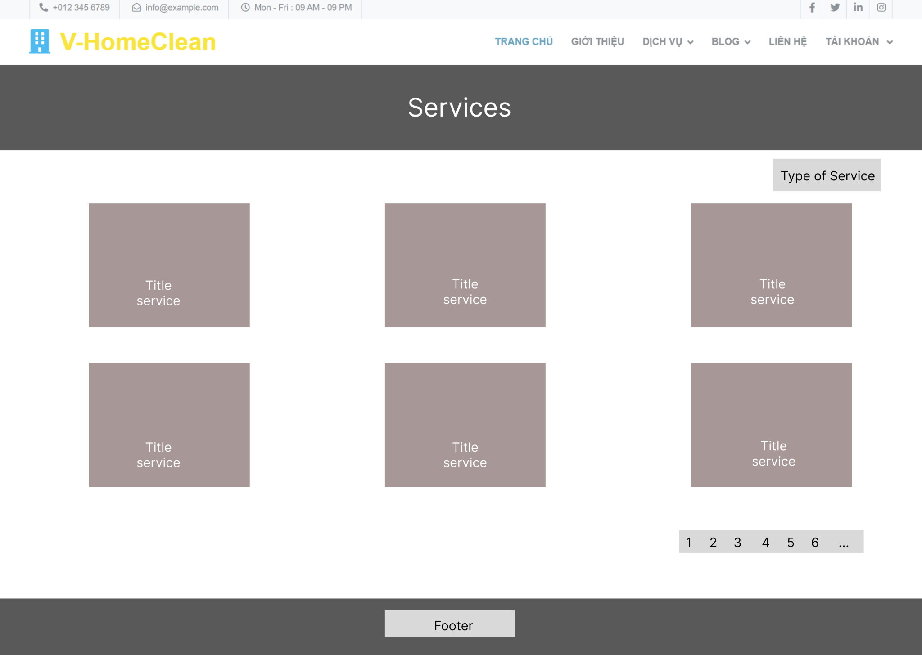

* **Function details**:
* Display: shows the services that the website offers. Each service is usually displayed in the form of a title, a short description.
* Filter and sort: The website provides filtering and sorting options so users can narrow the results displayed based on criteria.
* Search: A search box allows users to search for services by keyword.

### **e. Service details**

* **Function trigger**: This function is triggered when user clicks a title of the service list that display on the OUR SERVICE website
* **Function description**: Display the detail of the selected service
* **Screen layout**:

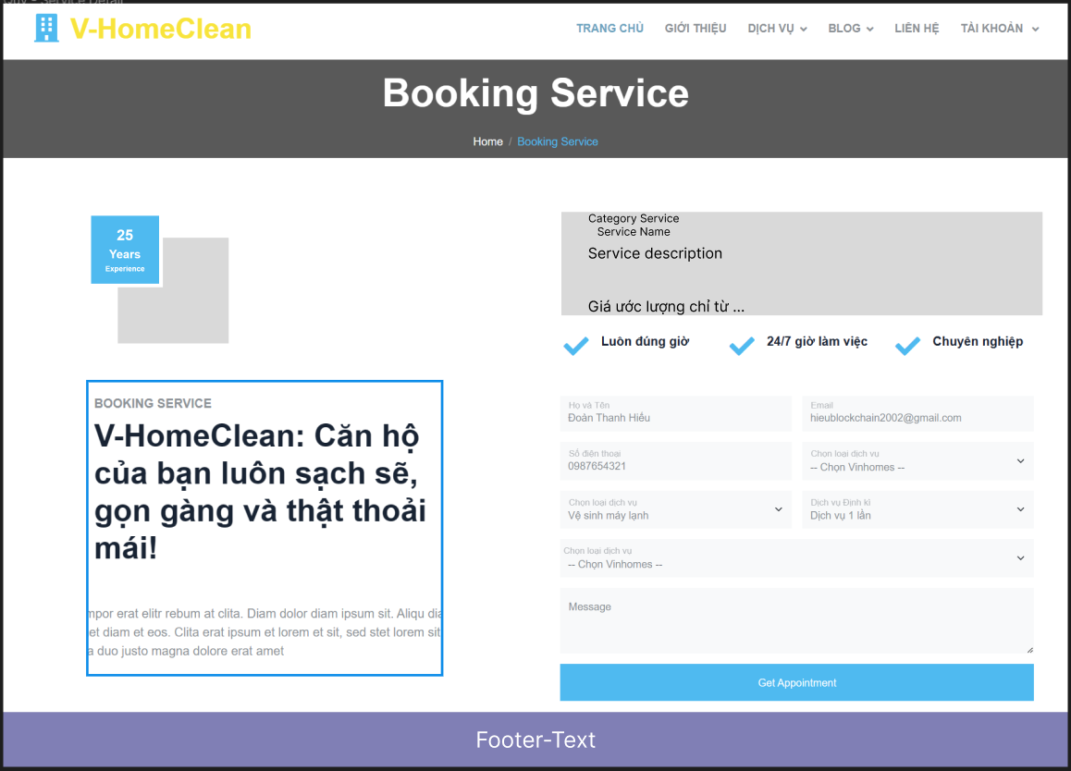

* **Function details**:
* Display: shows the title of the service and its details.
* Reviews and Comments: Allows users to rate the service and write a review about it.
* Images: Display images related to the service to help users have a more intuitive and specific view of the service.
* Booking: Provide online booking. Users can select date, time and other related details to book service directly from the page.
* Contact Information: Provide the service provider's contact information, including a phone number, email address, or contact form, so that users can contact and receive more information about the service.
* Related Services: Displays a list of related services or other service recommendations.

## 2. Common Feature

### **a. User Login**

● **Function trigger:** This function is triggered when the user clicks “Đăng Nhập” on “Trang Chủ”.

● **Function description:** User sign in into the system.

● **Screen layout:**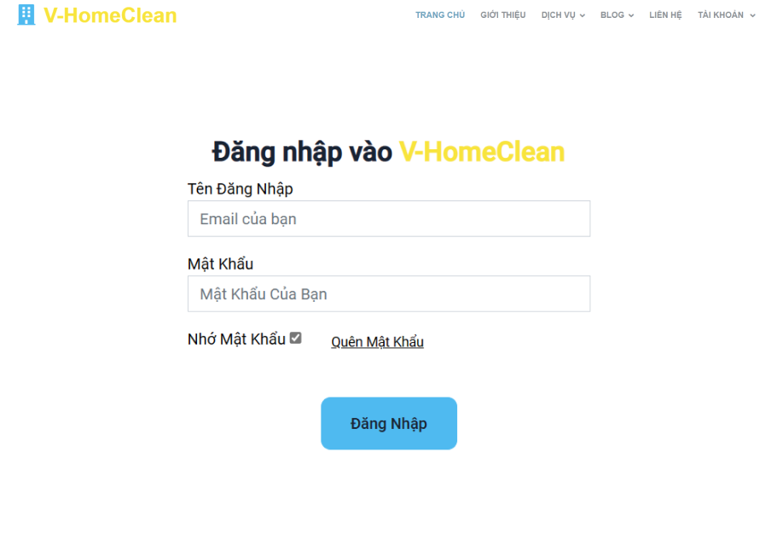

● **Function Details**:

○ When the page loads for the first time, it will display the homepage.

○ When clicking on the login button on the homepage, have a login pop-up.

○ When entering username and password, then click on button login.

○ If username or password are correct, the page will return homepage and have a button logout.

○ If username or password are incorrect, the message "Username or password are incorrect" will be displayed.

### **b. User register**

● **Function trigger:** This function is triggered when the user clicks “Đăng ký” on “Trang chủ” or on “Đăng nhập” form.

● **Function description:** The guest can create an account.

● **Screen layout:**

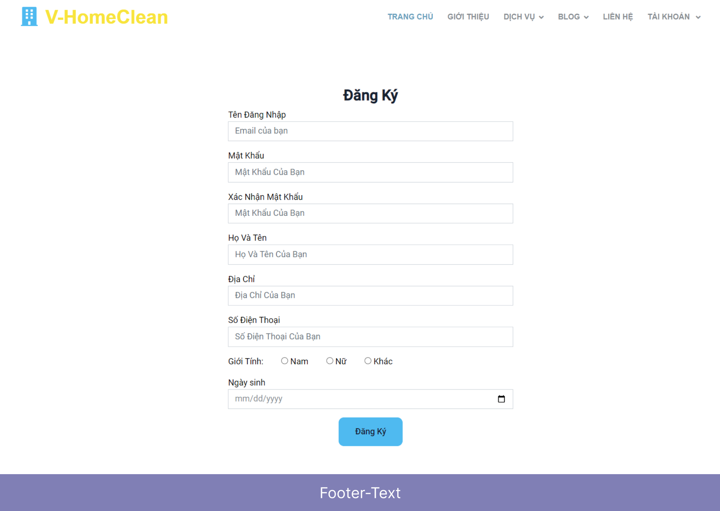

● **Function Details**:

○ When the page loads for the first time, it will display the homepage.

○ When a user clicks on the button “Đăng nhập” on the homepage, has a login pop-up, and clicks on the button “Đăng kí” to have a register pop-up.

○ User enters username and password, then click button “Đăng kí”.

○ If the username already exists, the message "Username exists" will be displayed.

○ If password and re-password aren't the same, have a notify "password and repassword aren't the same"

○ If the username is valid, the message “register successfully” will be displayed.

### 

### **c. Reset password**

● **Function trigger**: This function is triggered when the user clicks “Quên mật khẩu” on “Đăng nhập” form.

● **Function description**: The user can Reset Password to an account.

● **Screen layout**: 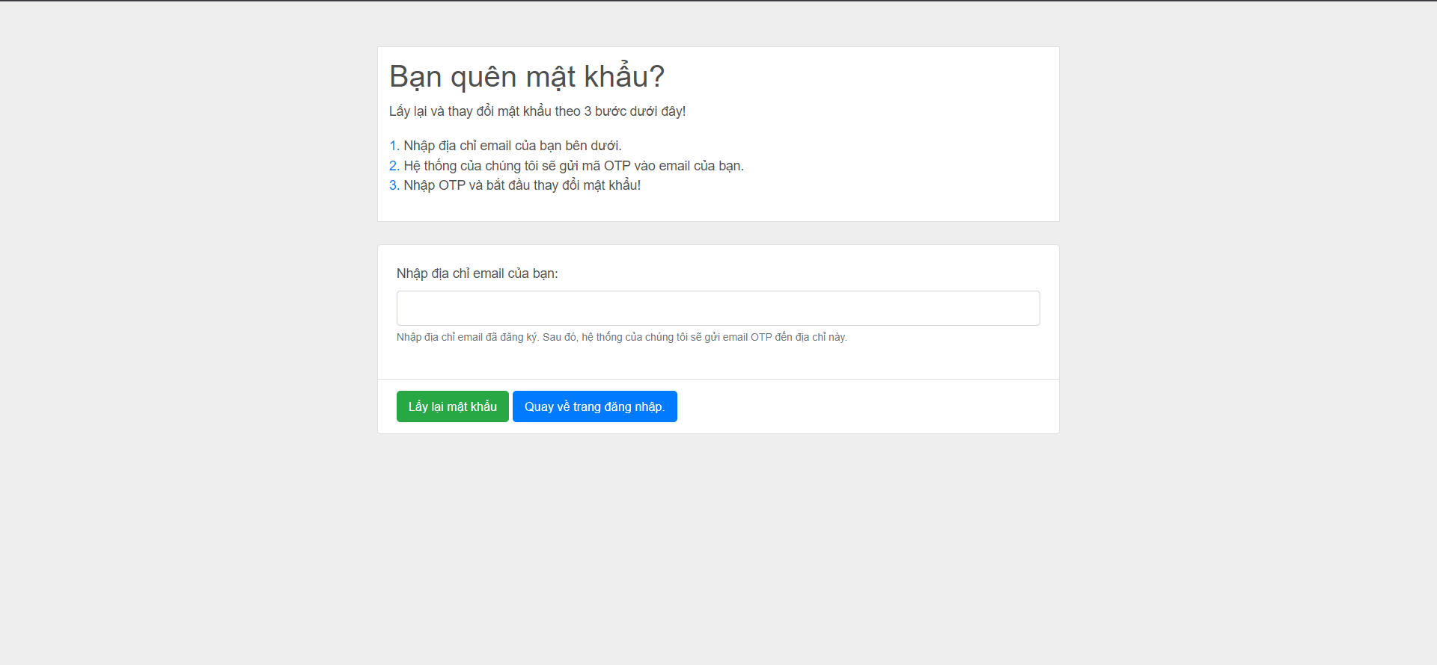

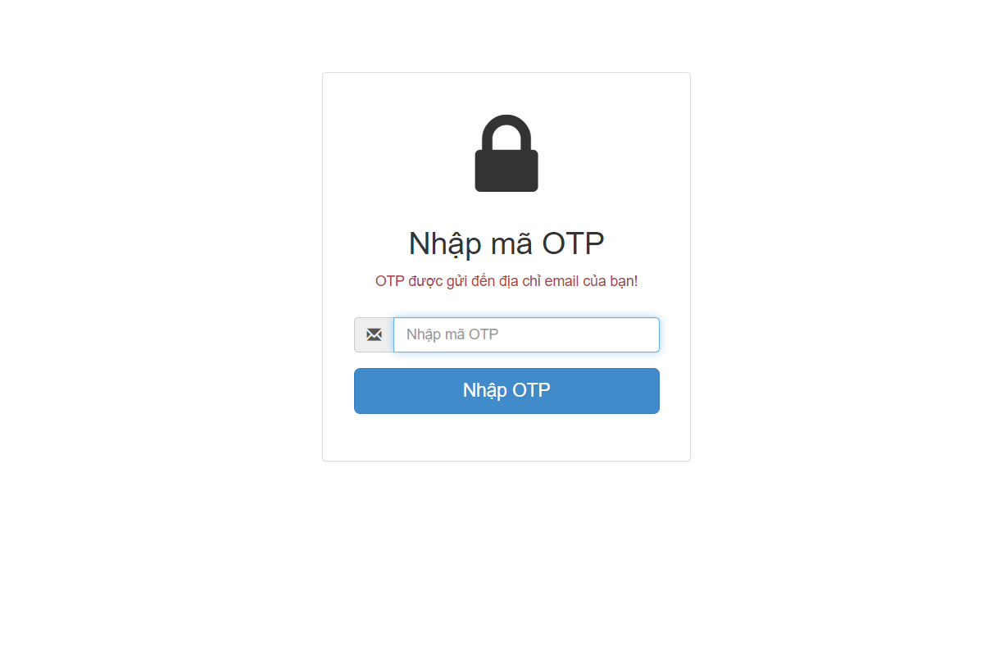

● **Function Details**: đợi xem sao.

### **d. Change password**

● **Function trigger**: This function is triggered when the user clicks “Tài khoản của tôi” from avatar in Homepage.

● **Function description**:User to change his password by entering current password as well as new password (twice)

● **Screen layout**: 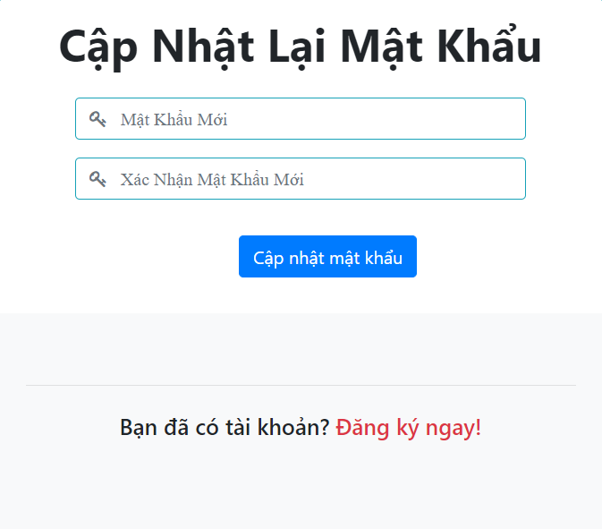

●  **Function Details**: User enters the old password and enters the desired new password (twice),then clicks the "Thay đổi" button. If the old password is wrong, or 2 new passwords that are not the same will receive a notification. When the old password is entered correctly and the 2 new passwords are the same, the password change is successful

### **e. User Profile**

● **Function trigger**: This function is triggered when the user clicks “Tài khoản của tôi” from Home

● **Function description:** The user can edit his/her profile information, including the registered user information and the avatar image.

● **Screen layout:** 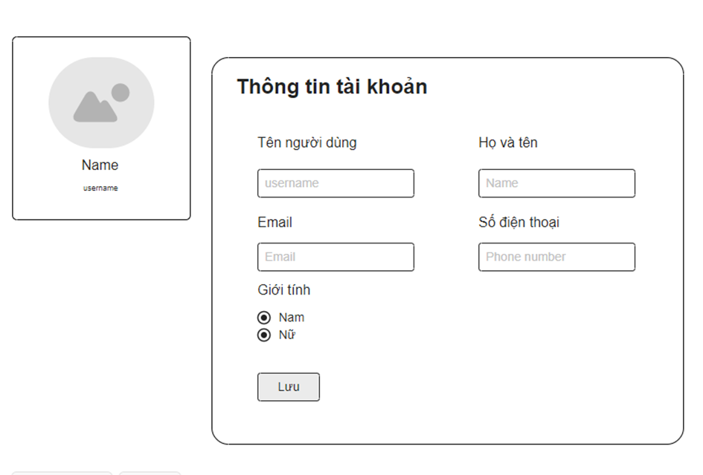

● **Function Details**:

○ The user can edit his/her profile information.

○ Clicking on "Lưu" will take you to save information for the user.

○ Clicking on "Đổi mật khẩu" will take you to the change password screen for user.

○ Clicking on "Quay lại" will take you to the homepage screen for the user.

## 3. Customer feature

### **a. Order Details**

● **Function trigger:**The Order Details screen for customers is typically triggered when a customer selects a specific order from their order history or when they need to view the details of a particular order they have placed. This screen can be accessed through the customer's account portal, order confirmation emails, or order tracking interfaces.

● **Function description:** The Order Details screen provides customers with comprehensive information about their selected order. It allows customers to view and manage the details associated with their order, such as the list of selected services, pricing, quantities, order status, and any relevant timestamps. The function of this screen is to provide customers with a clear overview of their order, facilitating transparency, tracking, and any necessary actions related to the order.

● **Screen layout:** simulated prototype of screen, below sample is for User profile screen

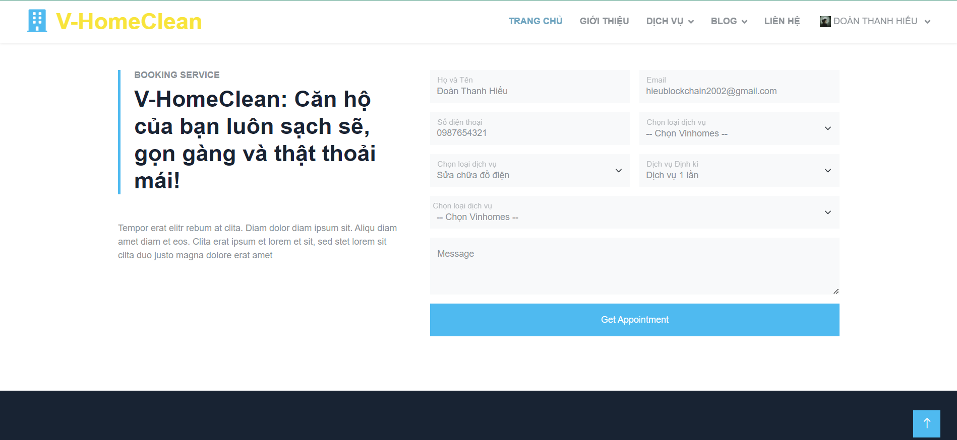

● **Function Details**:

**Order Information:**

The screen presents general information about the order, such as the order number, order date, and any relevant timestamps.

It may also display additional details like the order status, payment status, and any tracking numbers or shipment details if applicable.

**Service Details:**

The screen provides a list of the selected services included in the order.

Each service is typically presented with its name, description, pricing, quantities, and any custom attributes associated with the service.

**Pricing and Total:**

Customers can view the pricing details associated with each service, including any discounts, taxes, or additional charges.

The screen usually presents a total amount reflecting the overall cost of the order.

**Order Status Updates:**

If the order is still in progress or has not been fulfilled, the screen may display the current order status.

Customers may be able to track the progress of their order through various stages if such information is available.

**Delivery or Pickup Information:**

If applicable, the screen may display delivery or pickup details associated with the order.

This information can include the address, place, estimated arrival time, ...

**Order Notes or Instructions:**

The Order Details screen may include any notes or instructions provided by the customer during the order placement.

This feature allows customers to review any special requests, delivery instructions, or additional information related to their order.

**Order Cancellation or Modifications:**

Depending on the business's policies, customers may be able to cancel or modify their order directly from the Order Details screen if the order has not been processed or fulfilled yet.

This functionality enables customers to make changes to the order, update quantities, or remove selected services.

**Contact Customer Support:**

The screen may provide contact information or a link to customer support channels for customers to seek assistance or resolve any issues related to their order.

### **b. Order Contact**

**Function trigger:** Triggered when customers need to input or edit contact information for the order receiver.

**Function description:** Allows customers to provide accurate contact details for effective order fulfillment and communication with the seller. Collects essential information like name, phone number, email address, and delivery address.

● **Screen layout:** simulated prototype of screen, below sample is for User profile screen

● **Function Details**:

**Contact Information Form:**

The screen presents a form with fields for customers to input or update the contact details of the order receiver. Fields commonly include the receiver's name, phone number, email address, and delivery address.

**Editing Existing Information:**

If the screen is accessed for an existing order, it may display the current contact information by default. Customers can edit the existing details as needed, such as updating the receiver's name, phone number, or delivery address.

**Save or Update Contact Information:**

After inputting or editing the contact details, customers typically have an option to save or update the information. Clicking this option ensures that the newly provided or modified contact information is associated with the order.

**Continue to Payment or Review:**

Once the contact information is inputted or edited, the screen may provide a button or link to proceed to the next step in the order process, such as the payment page or order review.

### **c. Order Completion**

**Function description:** The Order Completion screen serves as a confirmation and summary of the customer's completed order. It provides essential information to the customer, including order details, payment confirmation, delivery information, and any additional instructions or next steps.

**Screen layout:** simulated prototype of screen, below sample is for User profile screen

**Payment Confirmation:** The screen confirms that the payment for the order has been successfully processed.

**Order Status:** The screen may indicate the current status of the order, such as "Confirmed," "In Progress," or "Finished." This helps customers track the progress of their order and provides an indication of when they can expect to receive their items.

**Additional Instructions or Next Steps:** Depending on the nature of the order or business policies, the screen may include any additional instructions or next steps for the customer.

### **d. Feedback**

**Function trigger:** The Feedback screen for customers is typically triggered when a customer chooses to provide feedback or review for a product, service, or overall experience. This screen can be accessed through various touch points such as order completion screens, post-purchase emails, or dedicated feedback forms within the customer's account portal.

**Function description:** The Feedback screen allows customers to share their comments, opinions, and ratings regarding their experience. It provides a platform for customers to provide valuable feedback that can help businesses improve their offerings and address any concerns or issues.

**Screen layout:**

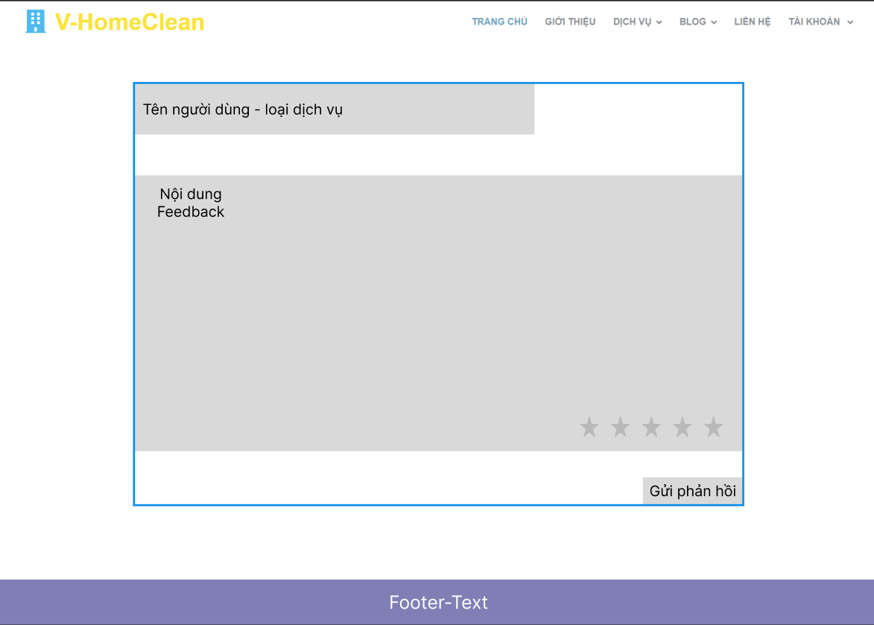

**Function Details**:

**Rating System:** The screen may feature a rating system, such as stars or a numerical scale, that allows customers to rate their experience or the specific product or service they are providing feedback for.

**Comment Section:** The screen provides a text input area or comment section where customers can type and submit their feedback, comments, or suggestions. Customers can provide detailed information about their experience, highlight specific aspects they liked or disliked, and provide suggestions for improvement.

**Edit or Update Feedback (if applicable):** Customers may have the ability to edit or update their feedback within a certain time frame after submission. This allows customers to make changes or additions to their comment if they realize they have missed important details or want to provide further information.

## 4. Admin feature

### **a. Admin Dashboard**

**Function trigger**: When a user logs in as Admin, the page is automatically redirected here.

**Function description**: Show dashboard.

**Screen layout**:

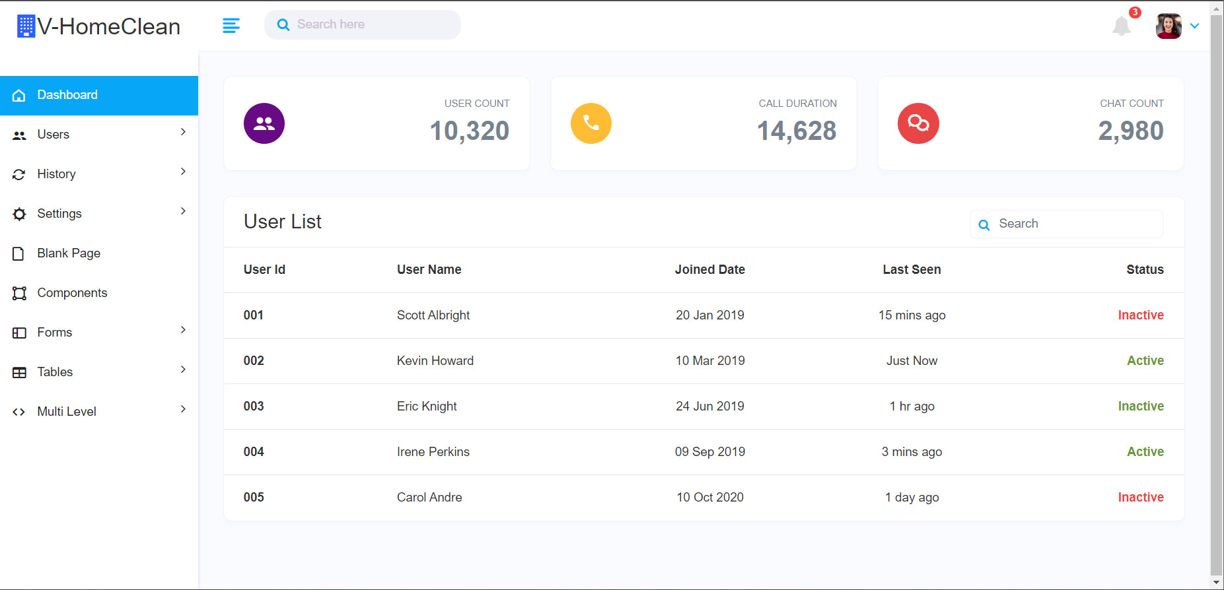

● **Function Details**:

- Graphs & Statistics of User use Service, Revenue.

- List all Users in system

### **b. User List**

**Function trigger**: ● When a user logs in as Admin and admin clicks on “User”.

● **Function description**: Show the User list.

● **Screen layout**: 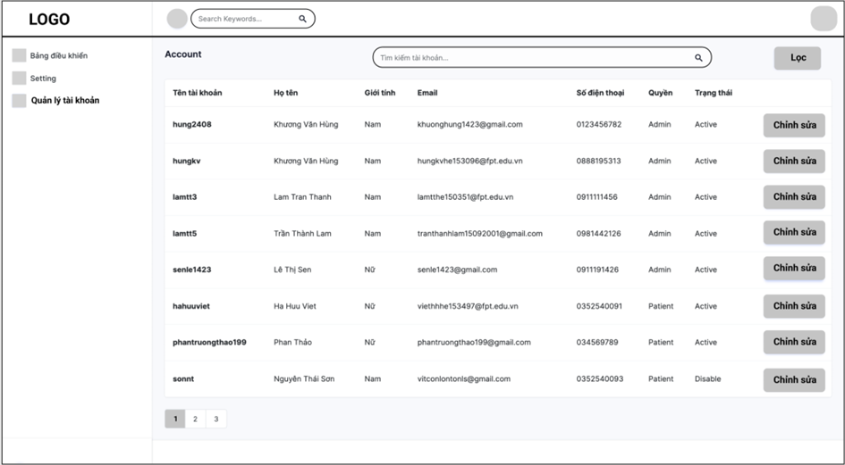

**Function Details**:

* List of Users in the system:
  + Show columns: Id, name, joined date, last seen, status.
  + Admin can Search users by name, filter them by user id & user name.

### **c. User Details**

● Function trigger: This function is activated when the Admin clicks on button “detail user”

● Function description: display user information

● Screen layout:

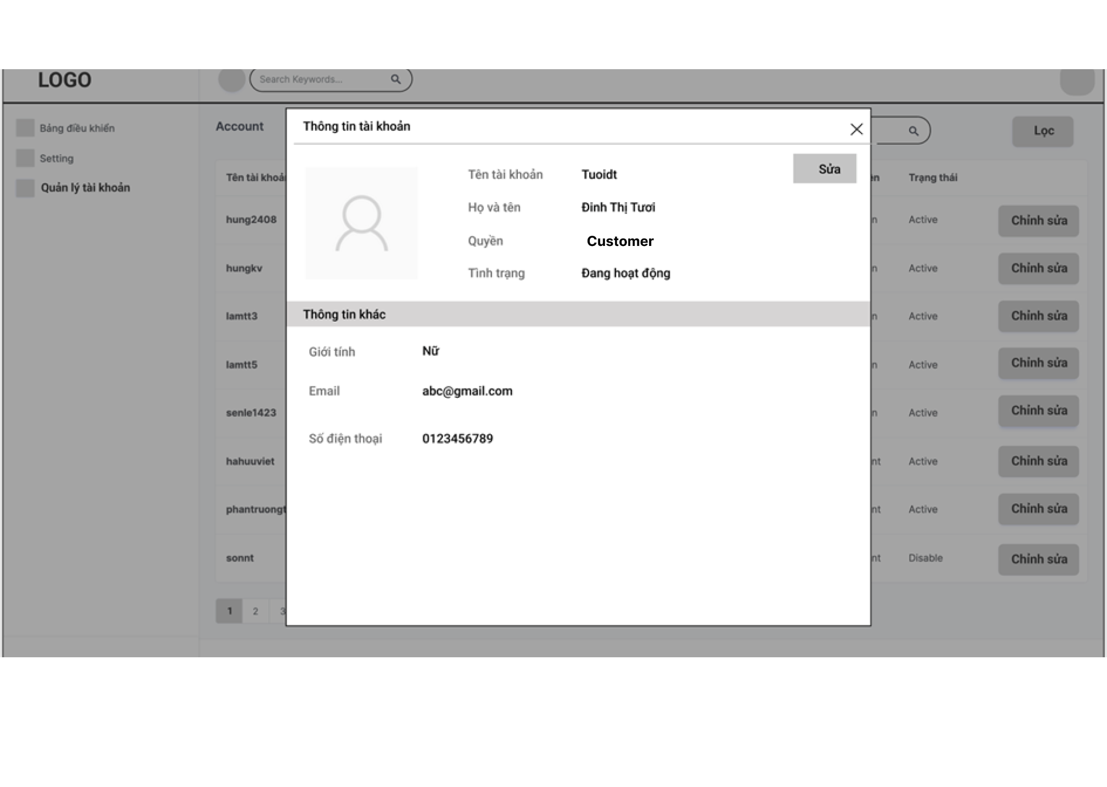

● **Function Details:** "View details of a specific User(chosen from the Users List screen);

- The following information of the doctor is shown: fullname, gender, email, DOB, phone, role, image, Status,

- The user can also edit the user information.

### **d. Staff List**

● **Function trigger**: ● When a user logs in as Admin and Admin clicks on “Staff”.

● **Function description**: Show the Staff list.

● **Screen layout**:

● **Function Details**:

* List of Users in the system:
  + Show columns: Id, name, joined date, last seen, status.
  + Admin can Search user by name, filters them by user id & user name.

## 5. Manager feature

### **a. Post List**

* **Function trigger:** this function is triggered when Manager click Blogs button on website that intended for manager
* **Function description:** List, filter, search, show, hide, view, add new or edit existing blog(s).
* **Screen layout**: 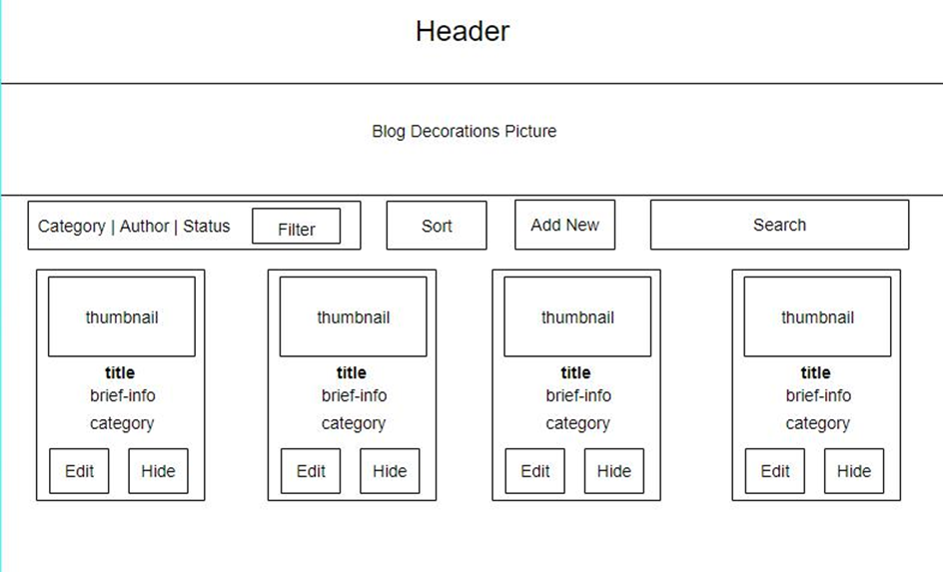
* **Function details**:
* Display: display a list of posts that have been created by users or employees. This list can show information like title, author, post date, status (approved/unapproved), etc.
* View post details: show the detail of the selected post from the list including content, images, reviews, comments.
* Search: Search the Blog based on related characters

### **b. Post Details**

* **Function trigger:** This function is triggered when Manager clicks a title of the blog list that display on the Blog List website
* **Function description:** view and edit the details of a specific blog
* **Screen layout:**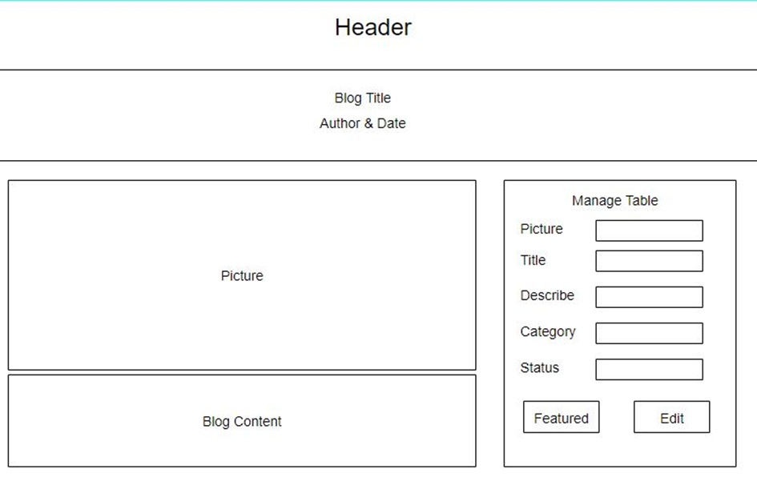
* **Function details:**
* Display: display the information’s details include title, body, image, author, post date, status, etc.
* Comment management: view and manage comments related to posts. Management can browse, delete or edit comments from users or employees.
* Browsing posts: This function allows management to browse posts before publishing them. Management can confirm the validity of the post, edit the content (if necessary)
* Delete Posts: This function allows management to delete posts that are no longer valid or inappropriate. Management can confirm deletion and remove posts from the list.
* Edit Posts: edit things related to the selected post.

### **c. Feedbacks List**

* **Function trigger:** This function is triggered when Manager clicks a Feedback button that display on the Manager Menu
* **Function description:** List feedback of users
* **Screen layout**:

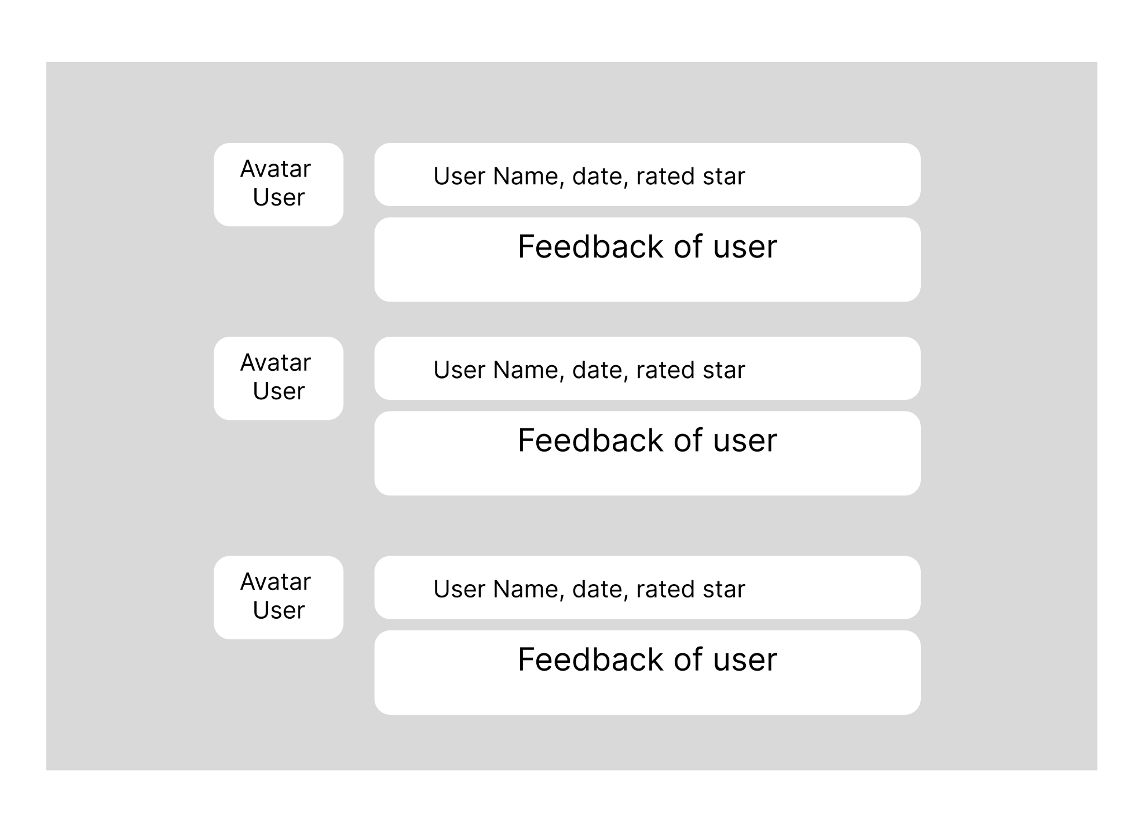

* **Function details:**
* Display: list the feedback of the users that are ordered service.
* Sort and filter: includes options to sort and filter the response list based on different criteria.
* Notifications: To notify manager about the feedback of the user that ordered service
* Search: Search the feedback base on based on related characters

### **d. Service List**

* **Function trigger:** This function is triggered when Manager clicks a Service list button that display on the Manager Menu
* **Function description:** List, filter, search, show, hide, view, add new or edit existing services
* **Screen layout:**

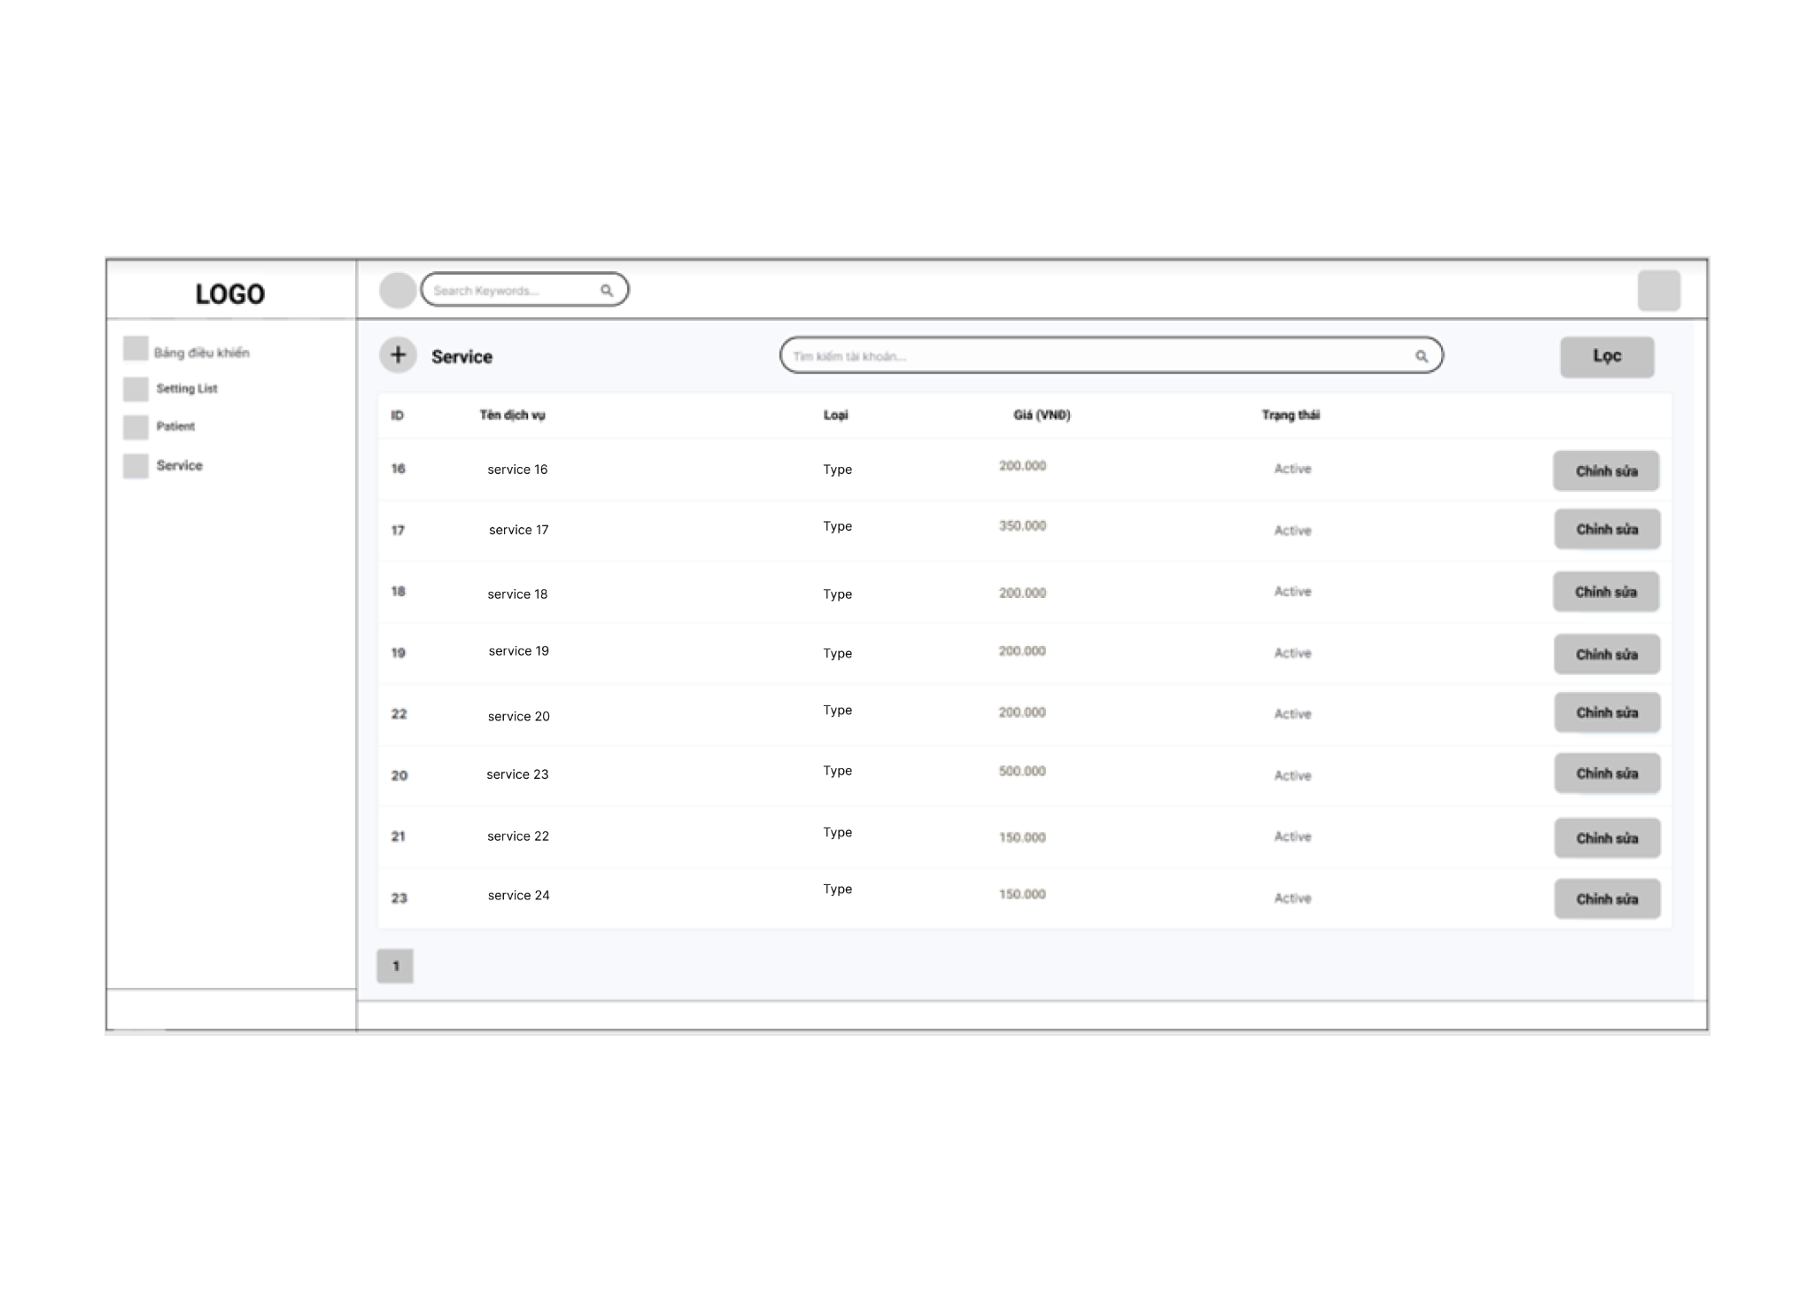

* **Function details:**
* Display: list the existing services.
* Sort and filter: includes options to sort and filter the response list based on different criteria.
* Search: Search the service base on based on related characters
* Add: add new service

### **e. Service Details**

* **Function trigger:** This function is triggered when Manager clicks a title of the Service that display on the Service List website
* **Function description:** view and edit the details of a specific service
* **Screen layout:**

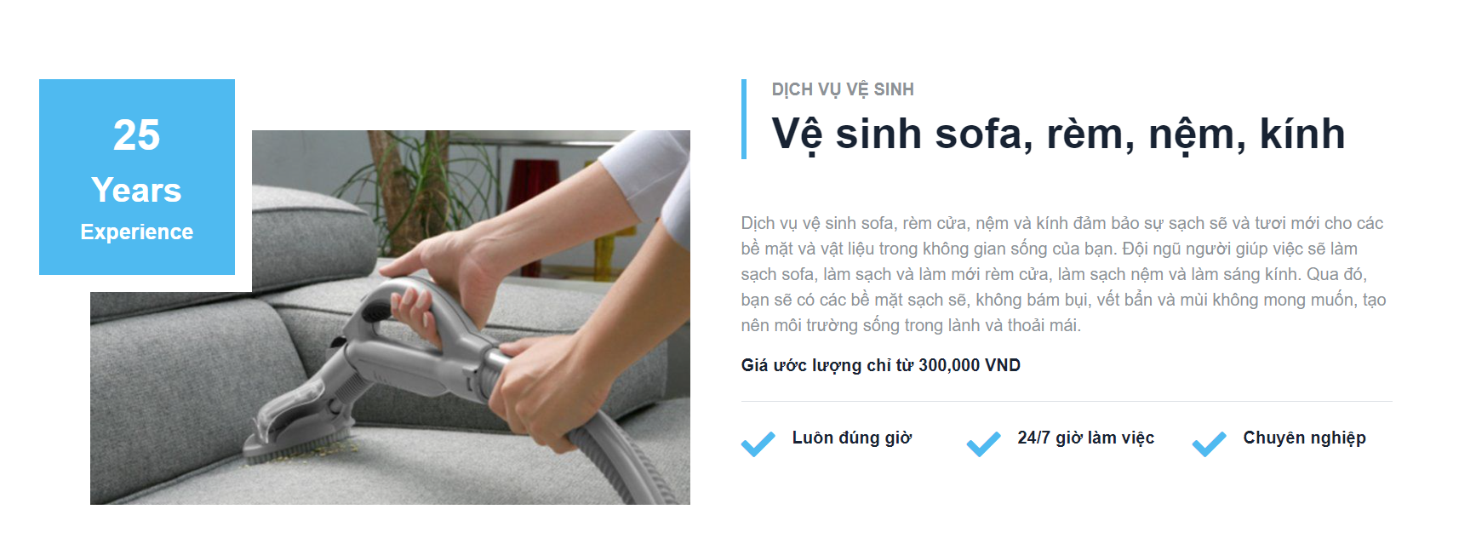

* **Function details:**
* Display: display the information’s details of the service
* Edit: edit things related to the selected service

### **f. Staff List**

* **Function trigger:** This function is triggered when Manager clicks a Staff button on the Manager Menu
* **Function description:** List, filter, search, show, hide, view, add new or edit existing staff.
* **Screen layout:** 
* **Function details:**
* Display: display the list of Staff including name, email, the service the employee does, salary.
* Sort and filter: includes options to sort and filter the response list based on different criteria.
* Search: Search the service based on related characters.
* Add: add new staff.

### **h. Customer List**

* **Function trigger:** This function is triggered when the Manager clicks a Customer button on the Manager Menu.
* **Function description:** List, filter, search, show, hide, view, add new or edit existing customer.
* **Screen layout:** 
* **Function details:**
* Display: display the list of Customers including name, order, contact information.
* Sort and filter: includes options to sort and filter the response list based on different criteria.
* Search: Search the customer based on related characters.
* Add: add new customer.

### **k. Customer Details**

* **Function trigger:** This function is triggered when the Manager clicks a name of the Customer.
* **Function description:** view and edit the details of a specific customer.
* **Screen layout:**



* **Function details:**
* Display: display the information’s details of the customer
* Edit: edit things related to the selected customer

## 6. Staff feature

### **a.Service List**

**Function Trigger:** Staff members accessing and managing the list of services.

**Function Description:** Provides staff members with a comprehensive view and management capabilities for the services offered by the business or organization

**Screen layout:**



**Function Details**:

**Service Listing**: Display a list of services with relevant details.

**Filtering:** Allow staff members to narrow down the list of services based on criteria.

**Search**: Enable staff members to search for specific services by name or keywords.

**Service Details**: Provide comprehensive information about selected services.

### **b. Service Details**

**Function trigger**: Triggered when a staff member selects a specific service or needs to view service details for administrative or operational purposes.

**Function description**: Provides comprehensive information about a specific service, including its description, pricing, duration, availability, and other relevant details. Allows staff members to view and manage the details associated with the selected service.

**Screen layout:** simulated prototype of screen, below sample is for User profile screen

**Function Details**:

**Service Information:** Displays detailed information about the selected service, including its name, description, category, pricing, duration, and custom attributes.

**Service Availability:** Provides information about the service's availability, including days and times it is offered.

**Pricing and Packages:** Presents details about the service's pricing structure, including base price, additional charges, and available packages or discounts.

**Terms and Conditions:** Includes any specific requirements or restrictions associated with the service, such as cancellation policies or health considerations.

**Related Services:** Displays connected or complementary services related to the selected service.

**Service History:** Provides a summary or log of the service's past bookings, modifications, and customer feedback.

### **c .Order Details**

**Order Information:** The screen presents detailed information about the selected order.

**Customer Details:** Staff members can access the customer's contact information.

**Order Items:** The screen provides a list of order items.

**Payment Status:** Staff members can check the payment status of the order.

**Order Notes or Instructions:** The Order Details screen may include additional notes or instructions.

**Order Status Updates:** Staff members can update the status of the order.

**Actions or Operations:** The screen may include action buttons or options.

### **e. Feedback List**

● **Function trigger**: The Feedback List screen for staff members is typically triggered when staff members need to access and manage a list of feedback received from customers or users. This screen can be accessed through staff management systems, administrative dashboards, or feedback management interfaces.

● **Function description**: The Feedback List screen provides staff members with an overview of the feedback received from customers or users. It allows staff members to efficiently manage, track, and respond to the feedback. The function of this screen is to enable staff members to perform tasks such as listing feedback, filtering feedback based on criteria, searching for specific feedback, showing or hiding certain feedback, and viewing detailed information about each feedback entry.

● **Screen layout**: simulated prototype of screen, below sample is for dashboard screen.



● **Function Details**:

**Feedback Listing:** The screen displays a list of feedback entries received from customers or users.

**Filtering:** Staff members can utilize filtering options to narrow down the list of feedback based on specific criteria.

**Search:** The screen provides a search functionality that allows staff members to search for specific feedback by customer name, keywords, or other relevant criteria.

**Feedback Details:** Clicking on a feedback entry in the list opens a detailed view or pop-up window displaying comprehensive information about the selected feedback.

**Tagging or Categorization:** Staff members may have the ability to assign tags or categories to each feedback entry for organizational purposes.

**Show/Hide Feedback:** Depending on the system's capabilities, staff members may have the option to show or hide certain feedback entries from the list.

**Responding to Feedback:** The Feedback List screen may include options for staff members to respond to customer feedback directly from the screen.