**Phạm Đặng Thanh Trung 522H0148**

HOẠT ĐỘNG 1:Wokwi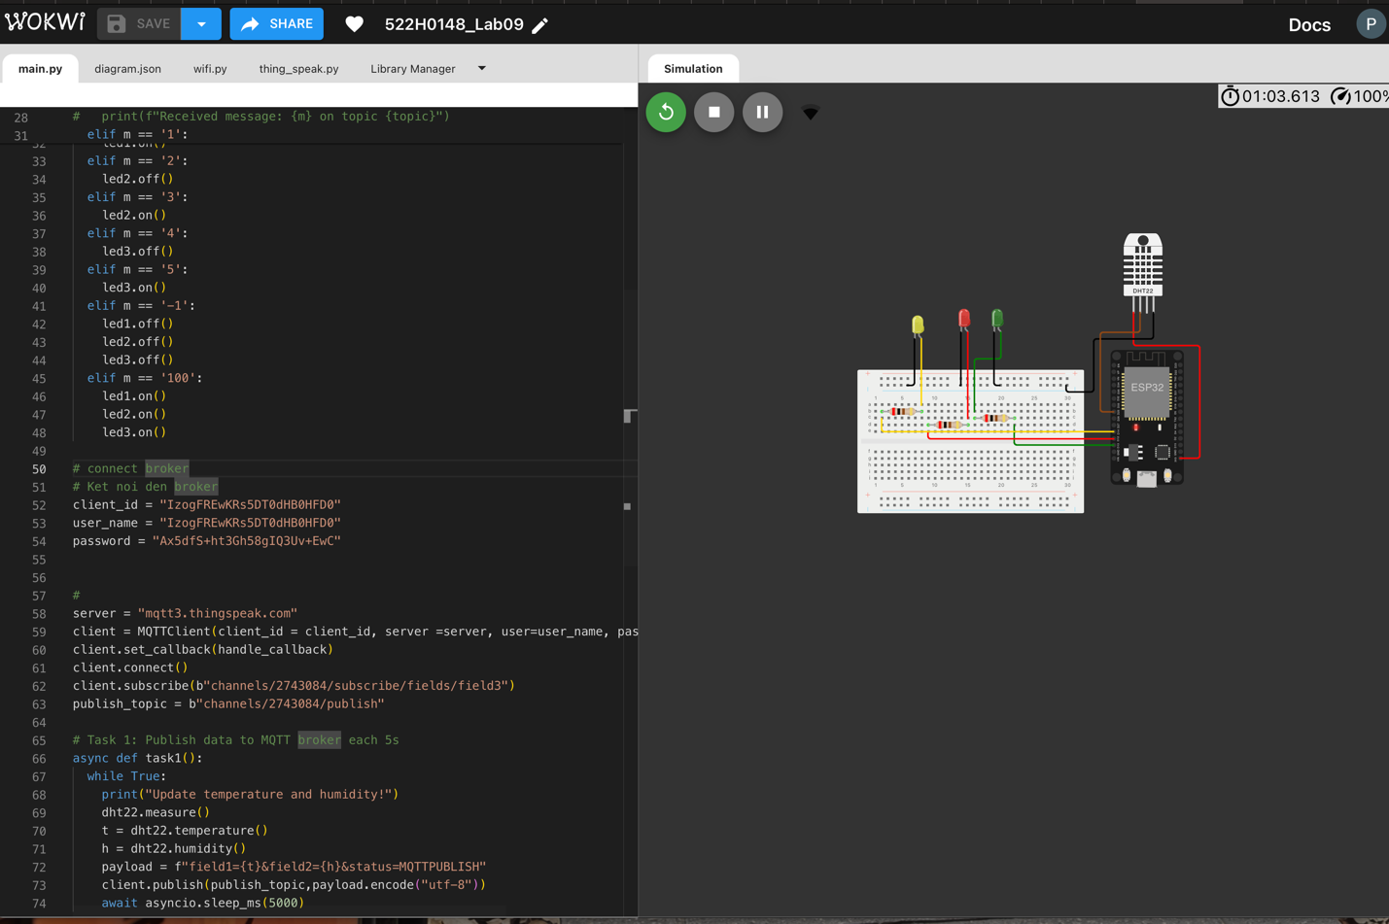

<https://wokwi.com/projects/414427931283198977>

Hoạt động 2: Thingspeak

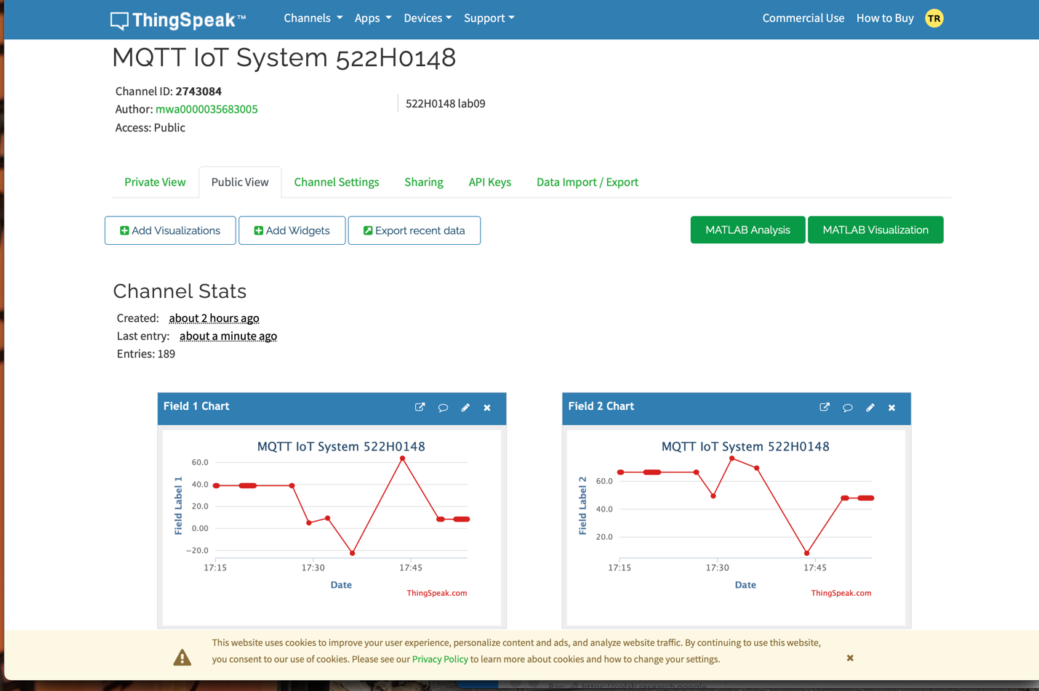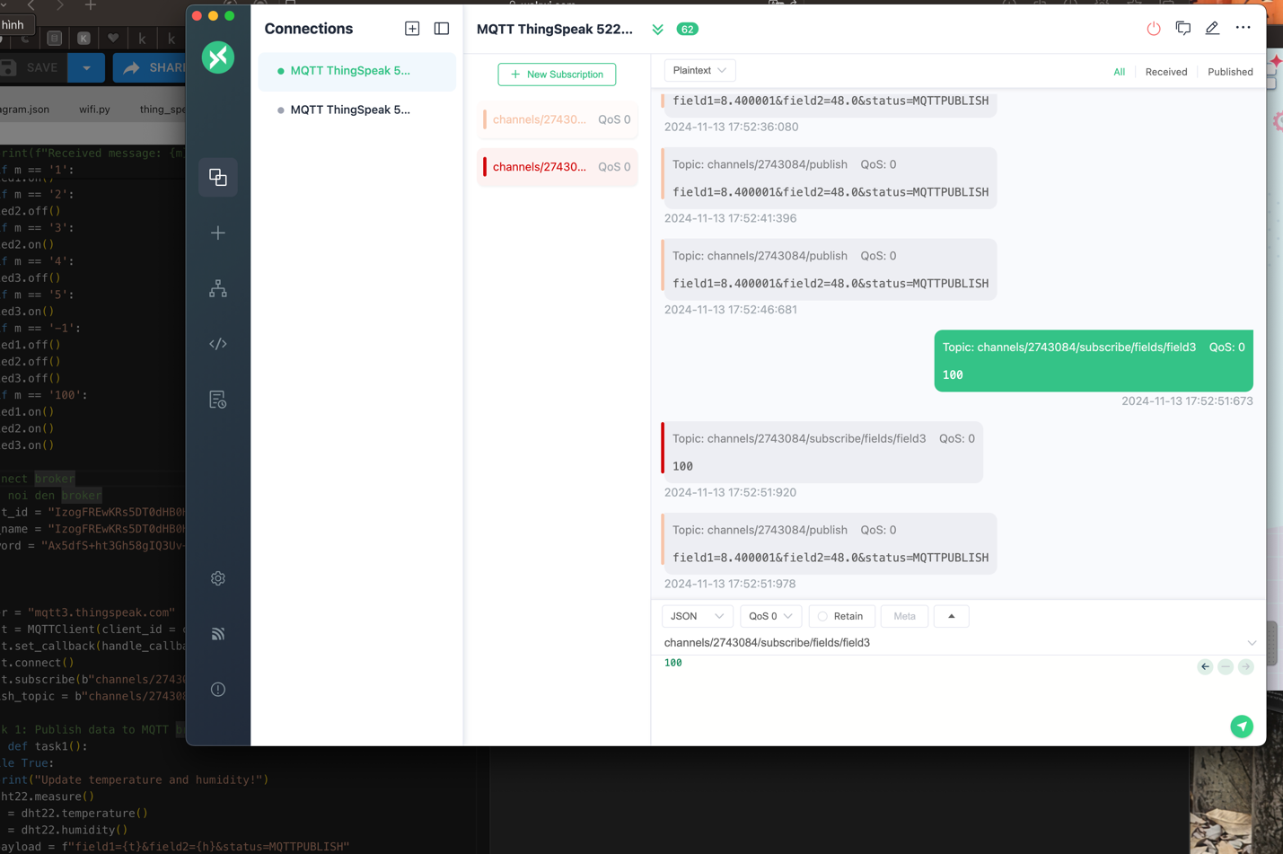

https://thingspeak.mathworks.com/channels/2743084