Simulação de Caminho de Dados do Processador MIPS de 32 Bits
Emerson C. Silva¹, Manoel B. Neto¹
¹Universidade Federal do Rio Grande do Norte (UFRN)
costtasemerson@gmail.com,

1. Introdução
All full papers and posters (short papers) submitted to some SBC conference, including any supporting documents, should be written in English or in Portuguese. The format paper should be A4 with single column, 3.5 cm for upper margin, 2.5 cm for bottom margin and 3.0 cm for lateral margins, without headers or footers. The main font must be Times, 12 point nominal size, with 6 points of space before each paragraph. Page numbers must be suppressed.
Full papers must respect the page limits defined by the conference. Conferences that publish just abstracts ask for one-page texts.

2. Referencial Teórico
The first page must display the paper title, the name and address of the authors, the abstract in English and “resumo” in Portuguese (“resumos” are required only for papers written in Portuguese). The title must be centered over the whole page, in 16 point boldface font and with 12 points of space before itself. Author names must be centered in 12 point font, bold, all of them disposed in the same line, separated by commas and with 12 points of space after the title. Addresses must be centered in 12 point font, also with 12 points of space after the authors’ names. E-mail addresses should be written using font Courier New, 10 point nominal size, with 6 points of space before and 6 points of space after.
The abstract and “resumo” (if is the case) must be in 12 point Times font, indented 0.8cm on both sides. The word Abstract and Resumo, should be written in boldface and must precede the text.

3. Metodologia
In some conferences, the papers are published on CD-ROM while only the abstract is published in the printed Proceedings. In this case, authors are invited to prepare two final versions of the paper. One, complete, to be published on the CD and the other, containing only the first page, with abstract and “resumo” (for papers in Portuguese).

4. Resultados
Nessa sessão serão descritos os resultados obtidos com a simulação fornecida. Com a leitura do arquivo de programa foi possível analisar o comportamento de três comandos básicos: ADDI, ADD e SUB. Ao executar o primeiro commando no simulador, vemos o estado dos registrados na figura abaixo.
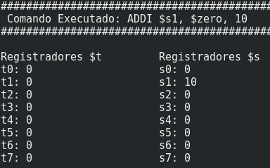
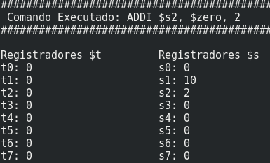
Figura: Estado dos Registradores após ADDI
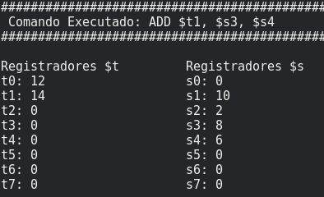
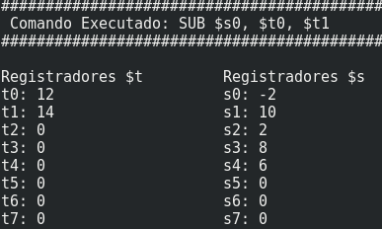

Referencias
Boulic, R. and Renault, O. (1991) “3D Hierarchies for Animation”, In: New Trends in Animation and Visualization, Edited by Nadia Magnenat-Thalmann and Daniel Thalmann, John Wiley & Sons ltd., England.
Dyer, S., Martin, J. and Zulauf, J. (1995) “Motion Capture White Paper”, http://reality.sgi.com/employees/jam_sb/mocap/MoCapWP_v2.0.html, December.
Holton, M. and Alexander, S. (1995) “Soft Cellular Modeling: A Technique for the Simulation of Non-rigid Materials”, Computer Graphics: Developments in Virtual Environments, R. A. Earnshaw and J. A. Vince, England, Academic Press Ltd., p. 449-460.
Knuth, D. E. (1984), The TeXbook, Addison Wesley, 15th edition.
Smith, A. and Jones, B. (1999). On the complexity of computing. In Advances in Computer Science, pages 555–566. Publishing Press.

