**МІНІСТЕРСТВО ОСВІТИ І НАУКИ УКРАЇНИ**

**НАЦІОНАЛЬНИЙ ТЕХНІЧНИЙ УНІВЕРСИТЕТ УКРАЇНИ «КПІ»**

**ІНСТИТУТ ПРИКЛАДНОГО СИСТЕМНОГО АНАЛІЗУ  
КАФЕДРА СИСТЕМНОГО ПРОЕКТУВАННЯ**

Лабораторна робота №1

З курсу: «Проектування інформаційних систем»

Виконав:

Студент ІV курсу

Групи ДА-22

Сарапулов Віктор

Київ – 2015

MyNote

Software Requirements Specification

24/09/2015

Sarapulov Viktor

# Revision History

|  |  |  |  |
| --- | --- | --- | --- |
| **Date** | **Description** | **Author** | **Comments** |
| 24/09/2015 | Version 1.0 | Sarapulov Viktor |  |
| 25/10/2015 | Version 2.0 | Sarapulov Viktor |  |
| 5/11/2015 | Version 2.1 | Sarapulov Viktor |  |
|  |  |  |  |

**Table of Contents**

Revision History 3

1. Introduction 5

1.1 Purpose 5

1.2 Scope 5

1.3 Definitions, Acronyms, and Abbreviations 5

1.4 References 5

1.5 Overview 5

2. General Description 5

2.1 Product Perspective 5

2.2 Product Functions 5

2.3 User Characteristics 6

2.4 General Constraints 6

3. Specific Requirements 6

3.1 External Interface Requirements 6

3.1.1 User Interfaces 6

3.2 Functional Requirements 6

3.2.1 Save the note to a DB. 6

3.3 Use Cases 6

3.3.1 Use Case #1 Input note 6

3.3.1 Use Case #1 Note is saved 6

3.3.2 Use Case #2 Note is not saved 6

3.3.3 Use Case #3 Output note. 6

3.4 Non-Functional Requirements 6

3.4.1 Performance 6

3.4.2 Reliability 7

3.4.3 Availability 7

3.4.4 Security 7

3.4.5 Maintainability 7

3.4.6 Portability 7

3.5 Inverse Requirements 7

3.6 Design Constraints 7

3.7 Logical Database Requirements 7

4. Analysis Models 8

4.1 Sequence Diagrams 8

5. Change Management Process 8

6. Tests 9

6.1 Input note and try to save it. 9

6.2 Input note and try to save it without existing table in database. 9

6.3 Open an existing note. 9

6.4 Open note that does not exists. 9

6.5 Change note. 9

6.6 Input text with different tabulation and chars. 9

# 

# 1. Introduction

## 1.1 Purpose

*The purpose of this document is to prepare software requirements specification of “MyNote” app.*

## 1.2 Scope

*The software name: MyNote.*

*This app will save the input expression to a DataBase (SQLite). Only the logic will be developed and covered by unit-tests.*

## 1.3 Definitions, Acronyms, and Abbreviations

*“MyNote” – the name of this project.*

*API – application programming interface.*

*APP – application.*

*Dataflow programming - programming paradigm that models a program as a directed graph of the data flowing between operations, thus implementing dataflow principles and architecture.*

## 1.4 References

*No references.*

## 1.5 Overview

*The rest of this SRS describes general and specific features of application to implement. The main aspect of this description will be dedicated to user-application interaction and considering possible system limitations.*

# 2. General Description

## 2.1 Product Perspective

*This product is a part of a thesis project. After “MyNote” will be developed more complicated example of using dataflow paradigm, it will be implemented into thesis project. Also, in future there might be some future versions with GUI.*

## 2.2 Product Functions

This application should represent a solution of our task (save some notes in DB) via dataflow paradigm..

## 2.3 User Characteristics

Everybody can be the final user of this program.

## 2.4 General Constraints

*On users computer must be installed some interpreter with dataflow support.*

# 3. Specific Requirements

## 3.1 External Interface Requirements

### 3.1.1 User Interfaces

*An application doesn’t contain graphical forms. User will interact with program via console.*

## 3.2 Functional Requirements

### 3.2.1 Save the note to a DB.

3.2.1.1 Introduction

A final user can to read and edit saved information.

3.2.1.2 Inputs

User inputs String-format information.

3.2.1.3 Processing

Saving the note to DB.

3.2.1.4 Outputs

This function should print notes from DB in the same format and same tabulation as it was inputted.

3.2.1.5 Error handling

Display an error message about disability to save the note.

## 3.3 Use Cases

### 3.3.1 Use Case #1 Input note

User starts the program, input note.

### 3.3.1 Use Case #1 Note is saved

User saves his note.

### 3.3.2 Use Case #2 Note is not saved

User get an error message.

### 3.3.3 Use Case #3 Output note.

User can get the chosen information.

## 3.4 Non-Functional Requirements

### 3.4.1 Performance

It depends on the length of the query.

### 3.4.2 Reliability

Code should have 85% coverage by unit-test.

### 3.4.3 Availability

This logic should have 100% availability.

### 3.4.4 Security

There is not any security requirement.

### 3.4.5 Maintainability

Time for returning program to the normal mode may not exceed 0.1 second.

### 3.4.6 Portability

This code must run on any platform with dataflow interpreter.

## 3.5 Inverse Requirements

There is not any inverse requirement.

## 3.6 Design Constraints

There is not any design constrain.

## 3.7 Logical Database Requirements

User must have an Internet connection.

# 4. Analysis Models

## 4.1 Sequence Diagrams

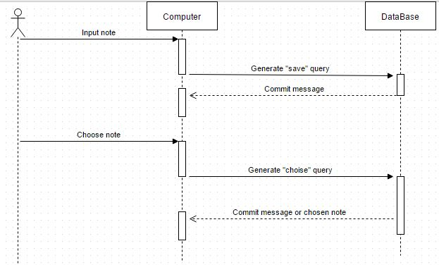

# 5. Change Management Process

This document will be submitted for review to the client. After that, he should give an informative feedback, and whether accept or reject this. If rejected, the engineer will make changes and then submit this document again, with other revision version.

# 6. Tests

### 6.1 Input note and try to save it.

*There must be a message about success operation.*

### 6.2 Input note and try to save it without existing table in database.

*There must be a message about an error.*

### 6.3 Open an existing note.

*The note have to be outputted and shown via console.*

### 6.4 Open note that does not exists.

*There must be a message about an error.*

### 6.5 Change note.

*The note have to update in your database.*

### 6.6 Input text with different tabulation and chars.

*Tabulation have to be saved too. If there will be system chars of database as ‘’ or “”, they must not corrupt a computer query to DB.*

### 6.7 Save note with an existing name.

*There have to be a message that this file is already exists and does user have to overwrite it.*