Supporting Information:

Electrochemistry Training Modules For

*A Practical Beginner’s Guide to Cyclic Voltammetry*

Table of Contents

Safety Considerations 1

Overview of Modules 1

General Considerations 2

Module 1 3

*Open Circuit Potential Measurements of Ferrocene/Ferrocenium Solutions: Evolution with Solution Composition*

Module 2 5

*Experimental Determination of the Uncompensated Resistance*

Module 3 8

*Cyclic Voltammetry of Ferrocene: Influence of the Concentration of Electrolyte on the Peak-to-Peak Separation as an Indication of Solution Resistance*

Module 4 10

*Cyclic Voltammetry of Ferrocene: Measuring a Diffusion Coefficient*

Module 5 12

*Cyclic Voltammetry of Oxygen: Evaluating Electrochemical Reversibility*

Module Solutions 14

**Safety Considerations**

As is true of any chemical experiment, proper personal protective equipment needs to be worn when performing an electrochemical experiment. Little current is actually passed during an experiment, however, precautions should be taken when combining “wet chemistry” and electricity.

While it is the default setting on some instruments, make sure the potentiostat “disconnects” from the cell in between experiments so that the wires are not “live” while arranging and connecting the cables to the cell.

**Overview of Modules**

**Modules**

1. Open Circuit Potential Measurements of Ferrocene/Ferrocenium Solutions: Evolution with Solution Composition
2. Experimental Determination of the Uncompensated Resistance
3. Cyclic Voltammetry of Ferrocene: Influence of the Concentration of Electrolyte on the Peak-to-Peak Separation as an Indication of Solution Resistance
4. Cyclic Voltammetry of Ferrocene: Measuring a Diffusion Coefficient
5. Cyclic Voltammetry of Oxygen: Evaluating Electrochemical Reversibility

**General equipment, materials and supplies required**

General Electrochemical Instrumentation

* Potentiostat
* Accompanying electrochemical leads
* Computer with instrument control software

Electrochemical Cell

* Standard voltammetry cell with 3 electrode ports
* Small Teflon stirbar

Electrodes

* Working electrode
  + *Example:* 1 or 3 mm glassy carbon disk electrode
* Counter electrode
  + *Example:* 3 mm glassy carbon disk electrode, 3 mm Pt disk electrode, or Pt wire
* Reference electrode
  + Ag+/0 pseudo-reference electrode in fritted compartment

Materials for Electrochemical solutions

* Acetonitrile
* Electrolyte: tetrabutylammonium hexafluorophosphate ([NBu4][PF6])

**General Considerations**

* *The modules assume that the main text has been read. In particular, the modules assume that the experimenter understands how to reference data to an internal standard (e.g. the Fc+/Fc couple) after data collection, as well as definitions such as peak current and peak potential.*
* *All modules require electrochemical measurements be run under inert atmosphere. This can be accomplished either by performing experiments in an inert atmosphere glovebox or by sparging solutions thoroughly with N2 and allowing N2 to flow over the top of the solution during experiments. Remember solutions must be sparged after the addition of any additional reagents. Modules are presented assuming solutions will be sparged with N2 unless otherwise noted. If desired, the following instructions can be added to any module: “*Sparge your solution with N2 for 5 min. When complete, allow N2 to flow over the top of your solution.”
* *The modules below assume a 20 mL voltammetry cell operating with 10 mL of electrolyte solution. If your voltammetry cell has a larger volume, scale all solutions accordingly.*
* *All working and disk-based counter electrodes should be polished thoroughly before use.*
* *It is recommended that solutions be stirred in between measurements to renew the layer of solution near the surface of the electrode. However, during CV measurements the only contribution to mass transport is diffusion: always turn off stirring and let the solution settle before recording CV data.*
* *Solutions to the modules are provided at the end of this document.*

**Module 1 — Open Circuit Potential Measurements of Ferrocene/Ferrocenium Solutions: Evolution with Solution Composition**

**Materials**

* Ferrocene
* Ferrocenium hexafluorophosphate
* One 50 mL and three 10 mL volumetric flasks
* 50, 200 and 500 µL syringes

**Procedures**

Pretreatment of Electrodes and Ferrocene/Ferrocenium (Fc/Fc+) stock solution preparation

* Polish two working and one counter electrode. Note: only one working glassy carbon electrode is used for this experiment but sometimes electrodes foul so having extra is good practice.
* Prepare 50 mL of 250 mM [NBu4][PF6] acetonitrile solution.
* Assemble your electrochemical cell.
* Pretreat your working electrodes by performing cyclic voltammetry in ca. 10 mL of the electrolyte solution (6 segments between 1 V and −2.5 V at 250 mV/s, i.e. 3 cycles.)
* Prepare a stock solution of 2.0 mM ferrocene (Fc) in a 10 mL volumetric using your electrolyte solution as the solvent.
* Prepare a stock solution of 2.0 mM ferrocenium hexafluorophosphate ([Fc]PF6) in a 10 mL volumetric using your electrolyte solution as the solvent.

Open Circuit Potential (OCP) measurements

* Using electrolyte solution, dilute 250 µL of the 2.0 mM ferrocene stock solution in a 10 mL volumetric flask to yield a 50 µM ferrocene solution. Prepare an electrochemical cell with this solution.
* ***While the solution is stirring***, perform an open circuit potential (OCP) measurement on the 50 µM ferrocene solution. Most potentiostats will either measure it continuously, or have a pre-built method for OCP measurement. If none exist, simply apply a constant current of 0 A for 10s and observe the evolution of the potential. If the OCP measure is not stable, wait a minute or two (it may take up to ten minutes) for your electrode to equilibrate with the solution and remeasure the OCP. Stop stirring.
* **Immediately** record a cyclic voltammogram of the ferrocene to use as your internal reference.
* Add 50 µL of the 2.0 mM ferrocenium hexafluorophosphate stock solution. ***While the solution is stirring,*** measure the OCP.
* Stop stirring and record a voltammogram of the ferrocene to use as your internal reference.
* Continue adding aliquots of ferrocenium hexafluorophosphate and record the OCP and a cyclic voltammogram after 100, 150, 200, 250, 350, 450, 600, 1000, 1500, 2000, and 2500 µL total of addition.

**Analysis and Questions**

1. What is the peak-to-peak separation of the reversible Fc+/Fc couple? How many electrons are involved in this process?
2. On one of your cyclic voltammograms of ferrocene, label E1/2 and indicate where Fc and Fc+ are the major species at the electrode surface.
3. Reference your open circuit potential measurements to ferrocene.
4. Plot OCP (or Ecell) vs ln(Q) where Q = $\frac{\left[Fc^{+}\right]}{\left[Fc\right]}$. What information can we gain from the slope and y-intercept of this line? Hint: use the Nernst equation.

If you were asked to visually find the OCP of the cell when Q = 3 using only the plot of OCP vs ln(Q), it would be difficult (unless you are really great at natural logarithms!). The following questions, however, will illustrate an alternative way to plot data that is visually perceptive.

1. We will abbreviate the mole fraction of ferrocene as $χ_{Fc}$. Plot $χ_{Fc}$ vs OCP where: $χ_{Fc}=\frac{n_{Fc}}{n_{Fc}+n_{{Fc}^{+}}}$.What shape does this curve have?

For example, after 100 μL of the 2.0 mM [Fc]PF6 solution have been added, a total of (100x10-6 L)(2x10-3 M) = 2.0x10-7 mol [Fc]PF6 are in the electrochemical cell. The number of moles in 10 mL of 50 μM Fc remains constant (0.010 L * 50x10-6 mol/L = 5.0x10-7 mol) for the duration of the experiment. Knowing these two values, we can calculate $χ_{Fc}$.

1. Look carefully at the plot you generated in Question 5 and the shape of the curve. Based on the curvature of the graph, what would be the appropriate function to fit your data with? Fit your data using this function. What parameters within the Nernst equation can we determine from this graph? Hint: it will be helpful to substitute into the Nernst equation and then solve for $χ_{Fc}$ ­ as a function of the open circuit potential. How close are these parameters to literature values?

**Module 2 — Experimental Determination of the Uncompensated Resistance**

*Some potentiostats have a built-in function to determine the uncompensated resistance. If that function is not available, the following method can be used. Consult your manufacturer’s manual to learn more about measuring uncompensated resistance.*

This module is constructed as a step-by-step guide to help estimate the uncompensated resistance. It requires the use of a double potential step chronoamperometry or cyclic step chronoamperometry experiment. In contrast to cyclic voltammetry experiments where the applied potential is scanned between two potentials (and back) during the experiment, the applied potential is *stepped* between two potentials in a chronoamperometry experiment. The current resulting from this rapid step in potential is measured by the potentiostat as a function of time. For this module, a significant number of data points must be recorded *prior* to the first step; therefore a double potential step (or cyclic step) chronoamperometry experiment is utilized where the first step maintains the same applied potential as the resting potential applied during the induction period.

**Materials**

* One 20 mL volumetric flask

**Procedure**

Pre-treatment of Electrodes

* Prepare 20 mL of a 50 mM [NBu4][PF6] acetonitrile solution
* Assemble your electrochemical cell, adding 10 mL of your 50 mM electrolyte solution.
* Pretreat your working electrodes by performing cyclic voltammetry in ca. 10 mL of the electrolyte solution (6 segments between 1 V and −2.5 V at 250 mV/s).

Calculating the Theoretical Ohmic Drop

* Identify a flat region of the voltammogram from the voltammograms collected during the pretreatment, where only non-Faradaic (capacitive) current is observed (For example, 0 to 50 mV. The directions below are based on this range.).
* Set up a double potential step chronoamperometry (DPSCA) or cyclic step chronoamperometry (CSCA) experiment in which two consecutive potential steps can be applied. The goal of this experiment is to apply a potential step and measure the change in current immediately after the change in potential. However, as noted above, a significant number of data points must be collected *before* this potential step, thus a two-step experiment is utilized in which the first step is essentially a long induction period during which data are collected.
* Turn off iR compensation.
* Two potential steps are setup: the first ‘step’ is to 0 mV (or the potential determined above) for a duration of 8 ms (this ‘step’ can be the same resting potential as the induction period); the second step to 50 mV (or the potential determined above) for a duration of 16 ms. Refer to your instrument manual for specific parameters. It might be necessary to modify parameters to allow the potentiostat to perform quicker acquisition of data; set parameters to allow for the fastest data acquisition and highest resolution (number of points) available. We also suggest specifying potential and current ranges (not autorange), and removing the relaxation time periods in order to maximize the number of data points that can be collected within the experiment. If necessary on your potentiostat, set the stability filter to manual with the highest cutoff frequency possible (e.g. 550 kHz). High stability filters allow quick acquisition of data at the price of feedback loop instability within the potentiostat. Since we want to make sure that we do not overcompensate our uncompensated resistance, this filter will allow us to see any small amount of noise or signal change when the potentiostat loses control of the electrochemical cell.
* Remember, these parameters allow you to move from an applied potential where no chemical reactions occur to another applied potential where no chemical reactions occur. Thus, any recorded current will be capacitive and can be assigned to the charging of the double layer which is dependent upon the electrode capacitance and the solution resistance.
* Perform the double step experiment. You should expect to see a response similar to the following Figure 2.1:

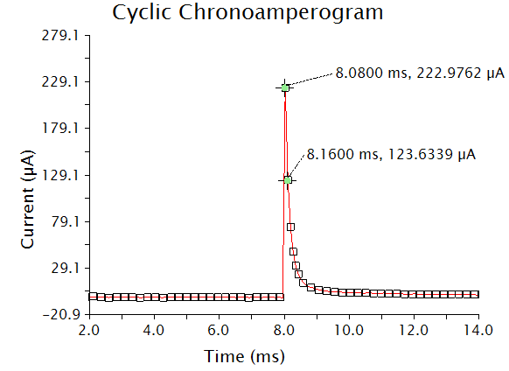

**Figure 2.1.** Example double potential step or cyclic step chronoamperogram.

* Calculate the slope of the line formed between the first two data points after the second potential step. In the data in Figure 2.1,the slope is −1.242 A/s.
* Determine the y-intercept (i0), accounting for the 8 ms time offset. Since the potential step in Figure 2.1 was not performed until t = 8 ms, all x values are offset by 8 ms. For example, the first crosshair at t = 8.08 ms, 222.9762 μA becomes the point t = 0.08 ms, 222.9762 μA. To find the initial current io (the y-intercept of the plot in Figure 2.1), use y = mx + b where x = 0.08 ms, y = 222.9762 μA, and m = −1.242 A/s. Solve for b.
* Having calculated the change in current upon stepping up the potential, use Ohm’s law to calculate the theoretical uncompensated resistance of the solution (Ru): Ru = ΔE/i0 (Unit of Ru is Ohms (Ω) where Ω = V/A). This value is an estimate. The following step will help refine this value.

Determining the Experimental Ohmic Drop

* If possible on your potentiostat, turn the iR compensation feature on, and input the Ru value determined experimentally.
* Perform the double potential step experiment again. Lower the Ru value if the data is oscillatory (like that shown in Figure 2.2a). Raise the Ru value if no oscillations are seen (Figure 2.2b). Continue in this fashion until you reach the highest Ru value that does not provoke oscillations. This is your experimental Ru.

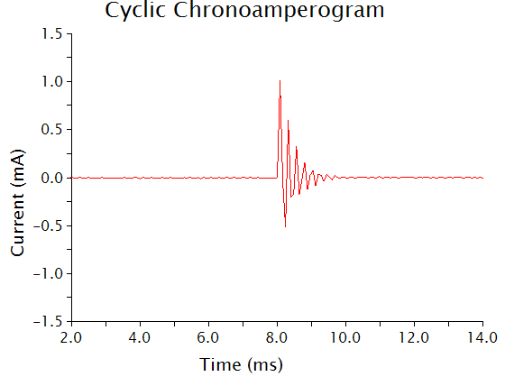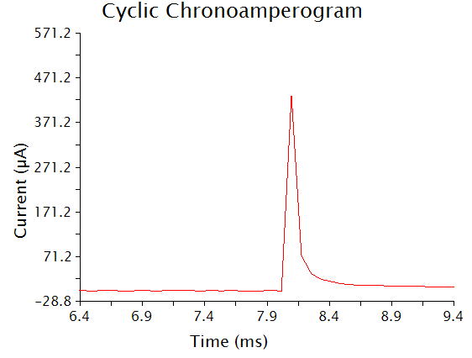

**b)**

**a)**

**Figure 2.2.** Cyclic (or double potential step) chronoamperograms that demonstrate a) oscillations and b) no oscillations.

**Module 3 — Cyclic Voltammetry of Ferrocene: Influence of the Concentration of Electrolyte on the Peak-to-Peak Separation as an Indication of Solution Resistance**

**Materials**

* Ferrocene
* Two 20 mL volumetric flasks
* Three 10 mL volumetric flask

**Procedure**

Pre-treatment of Electrodes and Preparation of Ferrocene Solutions

* Prepare 20 mL of a 50 mM [NBu4][PF6] acetonitrile solution.
* Prepare 20 mL of a 250 mM [NBu4][PF6] acetonitrile solution.
* Assemble your electrochemical cell, adding 10 mL of your 50 mM electrolyte solution.
* Pretreat your working electrodes by performing cyclic voltammetry in ca. 10 mL of the electrolyte solution (6 segments between 1 V and −2.5 V at 250 mV/s).
* Prepare 10 mL of a 1 mM ferrocene solution in 50 mM electrolyte.
* Prepare 10 mL of a 1 mM ferrocene solution in 250 mM electrolyte.

Scan Rate Dependence Measurements

* Assemble your electrochemical cell, adding 10 mL of your 1 mM ferrocene solution in 50 mM electrolyte.
* Record a voltammogram of the ferrocene solution between 0 V and 0.5 V at 100 mV/s.
* Adjust your potential window to ensure the ferrocene wave fits well within the window and re-record the voltammogram.
* Record voltammograms in this window for scan rates of 50, 100, 200, 500, 1000, 2000, 5000, and 10,000 mV/s, stirring between each scan and allowing the solution to settle completely before reocrding the subsequent voltammogram. As you change your scan rate, be certain to ensure the current range, which may be set to *auto*, is appropriate for your data.

Correcting forOhmic Drop through the Potentiostat software

* Measure the uncompensated resistance of your cell following the procedure in Module 2. (Note: you may need to specific applied potentials you step to, based on the potential at which current flows in response to the ferrocene now in solution. Be sure to identify a flat region of the voltammetric response as directed in Module 2 and use the limits of this region as your step potentials.)
* In your potentiostat instrument control software, turn *on* the ohmic drop correction, inputting the uncompensated resistance (Ru) value you determined if prompted. This will set the software to account for uncompensated resistance. *Each potentiostat is different—consult your manual to determine how to apply the ohmic drop correction.*
* Re-record voltammograms of a 1 mM ferrocene solution in 50 mM electrolyte solution with scan rates of 50, 100, 200, 500, 1000, 2000, 5000, and 10,000 mV/s, stirring between each can and allowing the solution to settle completely before beginning each scan.

Minimizing Ohmic Drop with Solutions Containing High Electrolyte Concentration.

* Replace the cell solution with 10 mL of your 1 mM ferrocene solution in 250 mM electrolyte.
* Turn *off* the ohmic drop correction.
* Record voltammograms of this ferrocene solution with scan rates of 50, 100, 200, 500, 1000, 2000, 5000, and 10,000 mV/s, stirring between each experiment and allowing the solution to settle completely before beginning each scan.

**Questions**

1. Compare your volammograms for 50 mM electrolyte solution (no ohmic drop correction), 50 mM electrolyte solution (with ohmic drop correction), and 250 mM electrolyte solution. What do you observe?
2. Determine the potentials corresponding to the anodic and cathodic peaks for each voltammogram. Plot the peak potential for the anodic and cathodic peaks minus the E1/2 value (Ep,a – E1/2, Ep,c – E1/2) vs. the log of the scan rate (log(υ), υ in V s-1). This plot is often referred to as a “Trumpet Plot.”
3. How did the peak separation vs. log(υ) compare for the three experiments?
4. What can you conclude about the effects of ohmic drop?

**Module 4 — Cyclic Voltammetry of Ferrocene: Measuring a Diffusion Coefficient**

*This module can be performed with the solutions prepared and data collected for Module 3*

**Materials**

* Ferrocene
* One 20 mL volumetric flask
* One 10 mL volumetric flask

**Procedure**

Pre-treatment of Electrodes and Preparation of Ferrocene Solutions

* Prepare 20 mL of a 250 mM [NBu4][PF6] acetonitrile solution.
* Assemble your electrochemical cell, adding 10 mL of your electrolyte solution.
* Prepare 10 mL of a 1 mM ferrocene solution in the 250 mM electrolyte.
* Pretreat your working electrodes by performing cyclic voltammetry in ca. 10 mL of the electrolyte solution (6 segments between 1 V and −2.5 V at 250 mV/s).

Scan Rate Dependence Measurements

* Re-assemble your electrochemical cell, with 10 mL of your 1 mM ferrocene solution.
* Record a voltammogram of the ferrocene solution between 0 V and 0.5 V at 100 mV/s.
* Adjust your potential window as necessary.
* Record voltammograms in this adjusted window for scan rates of 50, 100, 200, 500, 1000, 2000, 5000, and 10,000 mV/s, stirring between each scan and allowing the solution to settle completely before beginning each scan. As you change your scan rate, be certain to ensure the current range, which may be set to *auto*, is appropriate for your data.

**Questions**

1. Using the Randles–Sevcik equation, calculate the diffusion coefficient of ferrocene. Plotting the peak current vs. the square root of the scan rate (υ1/2) will be helpful.
2. What is the literature value of the diffusion coefficient for ferrocene? How does your calculated value compare?
3. If you have already performed Module 3, determine the diffusion coefficient using each of the three sets of voltammograms you collected above: 50 mM electrolyte solution (no ohmic drop correction), 50 mM electrolyte solution (with ohmic drop correction), and 250 mM electrolyte solution. Did you get the same value for each data set?
4. With the literature diffusion coefficient data, use the Randles–Sevcik equation to calculate the concentration of ferrocene in the solution. How closely does it match the concentration you were aiming for?
5. Which parameters influence the accuracy of the measurement of a diffusion coefficient? What steps would you take to minimize the error in this measurement?

**Module 5 —** **Cyclic Voltammetry of Oxygen: Evaluating Electrochemical Reversibility**

**Materials**

* Ferrocene
* One 10 mL volumetric flask

**Procedure**

Pre-treatment of Electrodes

* Prepare 10 mL of a 250 mM [NBu4][PF6] acetonitrile solution.
* Assemble your electrochemical cell, adding 10 mL of your electrolyte solution.
* This module should *not* be performed in a glovebox. Sparge your solution with N2 for 5 min. When complete, allow N2 to flow over the top of your solution.
* Pretreat your working electrodes by performing cyclic voltammetry in ca. 10 mL of the electrolyte solution (6 segments between 1 V and −2.5 V at 250 mV/s).

Scan Rate Dependence of Oxygen Reduction

* Under an N2 atmosphere, add ferrocene (ca. 1 mM) to the cell and record a voltammogram of the ferrocene solution between 0 V and 1 V at 100 mV/s.
* Sparge your electrolyte-containing solution (without ferrocene) with compressed air (or oxygen) for 5 min. After sparging, ensure that your sample is not being actively stirred.
* Record a voltammogram of the oxygen-saturated solution between 0 V and –1.5 V at 100 mV/s. If you see fit, apply ohmic drop compensation when recording these voltammograms (however, the high electrolyte concentration utilized should minimize the need for additional ohmic drop correction).
* Your potential window should contain a broad wave. Adjust your potential window as necessary so that it spans +/– 100 mV on either side of this wave.
* Record voltammograms in this window for scan rates of 50, 100, 200, 500, 1000, 2000, 5000, and 10,000 mV/s, stirring between each scan and allowing the solution to settle completely before beginning to record the subsequent voltammogram. As you change your scan rate, be certain to ensure the current range, which may be set to *auto*, is appropriate for your data.
* Sparge your solution with N2 for 5 min, add ferrocene, and record a voltammogram of the solution between 0 V and 1 V at 100 mV/s. Overlay the ferrocene voltammogram with the one recorded at the beginning of the experiment. If the E1/2 of the ferrocene peaks overlay perfectly, then the reference electrode used was stable during the entire experiment. While not ideal, this setup allows the O2 data to be referenced to ferrocene, even though ferrocenium slowly decomposes in CH3CN in the presence of O2 (For reference, see: DOI: 10.1016/j.jorganchem.2005.02.009)

**Questions**

1. Plot the voltammograms you have collected, referencing to ferrocene.
2. Determine the potentials corresponding to the anodic and cathodic peaks for each voltammogram. Plot the peak potential for the anodic and cathodic peaks minus the E1/2 value (Ep,a – E1/2, Ep,c – E1/2) vs. the log of the scan rate (log(υ), υ in V s-1). This plot is often referred to as a “Trumpet Plot.”
3. What do you notice about the peak-to-peak separation as a function of scan rate? How does the peak-to-peak separation as a function of scan rate differ between oxygen and ohmic-drop corrected ferrocene (Module 3)?
4. Acknowledging that you minimized ohmic drop, what gives rise to the large peak-to-peak separation in these data? Why does the separation increase with scan rate?

**Module Solutions**

**Module 1**

**Solutions**

1. What is the peak-to-peak separation of the reversible Fc+/Fc couple? How many electrons are involved in this process?

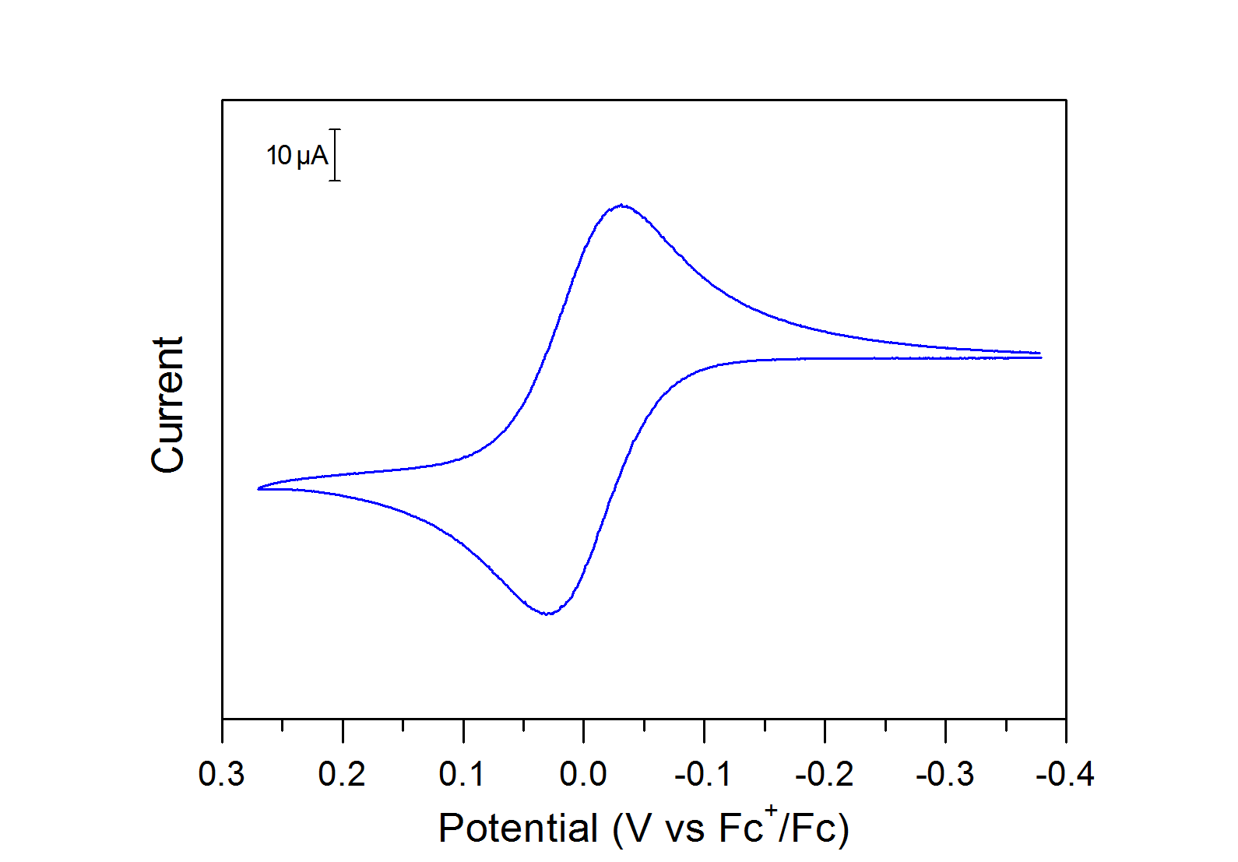

[Fc] > [Fc+]

[Fc] < [Fc+]

**Figure S1.1.** Voltammogram of a ferrocene solution, referenced to ferrocene. The dashed red line indicates E1/2.

From the referenced voltammogram of Fc in Figure S1.1, the peak-to-peak separation is 60 mV.

The reaction is: $Fc⇌{Fc}^{+}+e^{-}$.

It is a one-electron process. This is consistent with the value of the peak-to-peak separation, which is expected to be 57 mV at room temperature for a reversible, fast one-electron transfer.

1. On one of your cyclic voltammograms of ferrocene, label E1/2 and indicate where Fc and Fc+ are the major species at the electrode surface.

At the beginning of the scan, the potential is negative of the E1/2: Fc is the major species. Once the potential is positive of the E1/2, Fc+ is the major species. Figure S1.1 has been annotated accordingly.

1. Reference your open circuit potential measurements to ferrocene.

A CV was taken after each OCP. For each CV taken, the E1/2 of ferrocene is determined (versus the reference electrode). This E1/2 value is subtracted from the corresponding OCP measurement to reference the OCP to the ferrocene/ferrocenium couple. This is repeated for each OCP measurement.

1. Plot OCP (or E) vs ln(Q) where Q = $\frac{\left[Fc^{+}\right]}{\left[Fc\right]}$. What information can we gain from the slope and y-intercept of this line? Hint: use the Nernst equation.

The OCP data collected can be plotted as a function of ln(Q):

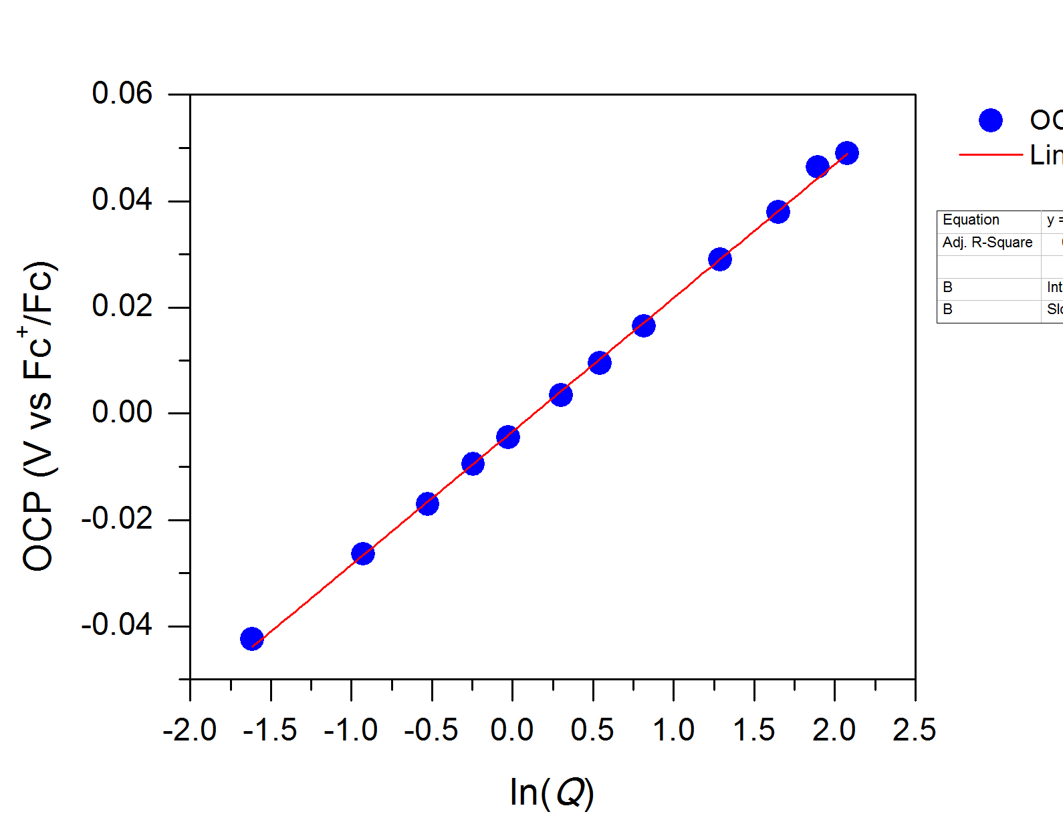

**Figure S1.2:** Plot of the cell potential (from the OCP measurements) as a function of ln(Q).

Following the Nernst equation we have: $E= E_{1/2}+ \frac{RT}{nF}\ln\left(Q\right)$.

where: $Q= \frac{[{Fc}^{+}]}{[Fc]}$

When [Fc] = [Fc+], ln(Q) = 0 and the equation becomes E = E1/2. From the data collected, the y-intercept gives E1/2. Here E1/2 = −0.003 V, which is remarkably close to the theoretical value of 0 V.

1. We will abbreviate the mole fraction of ferrocene as $χ_{Fc}$. Plot $χ_{Fc}$ vs OCP where: $χ_{Fc}=\frac{n_{Fc}}{n_{Fc}+n_{{Fc}^{+}}}$.What shape does this curve have?

We now consider the molar fraction of ferrocene and ferrocenium, $χ_{Fc}$ defined as:

$$χ_{Fc}=\frac{n_{Fc}}{n_{Fc}+n_{{Fc}^{+}}}$$

$$\frac{1}{χ_{Fc}}=\frac{n_{Fc}+n_{{Fc}^{+}}}{n_{Fc}}=1+ \frac{n_{{Fc}^{+}}}{n_{Fc}}$$

Going back to our expression of Q, we have:

$$Q= \frac{[{Fc}^{+}]}{[Fc]}= \frac{\left[{Fc}^{+}\right]}{1}×\frac{1}{\left[Fc\right]}= \frac{n_{{Fc}^{+}}}{V}×\frac{V}{n_{Fc}}= \frac{n_{{Fc}^{+}}}{n_{Fc}}$$

Which overall gives:

$$Q=\frac{1}{χ_{Fc}}-1$$

Going back to the Nernst equation yields:

$$E= E_{1/2}+ \frac{RT}{nF}\ln\left(Q\right)$$

$$E= E_{1/2}+ \frac{RT}{nF}\ln\left(\frac{1}{χ_{Fc}}-1\right)$$

Solving for $x_{Fc}$ yields:

$$χ_{Fc}= \frac{1}{e^{\frac{(E-E_{1/2})nF}{RT})}+1}$$

Plotting 𝝌Fc as a function of the open circuit potential E thus yields the plot (blue circles):

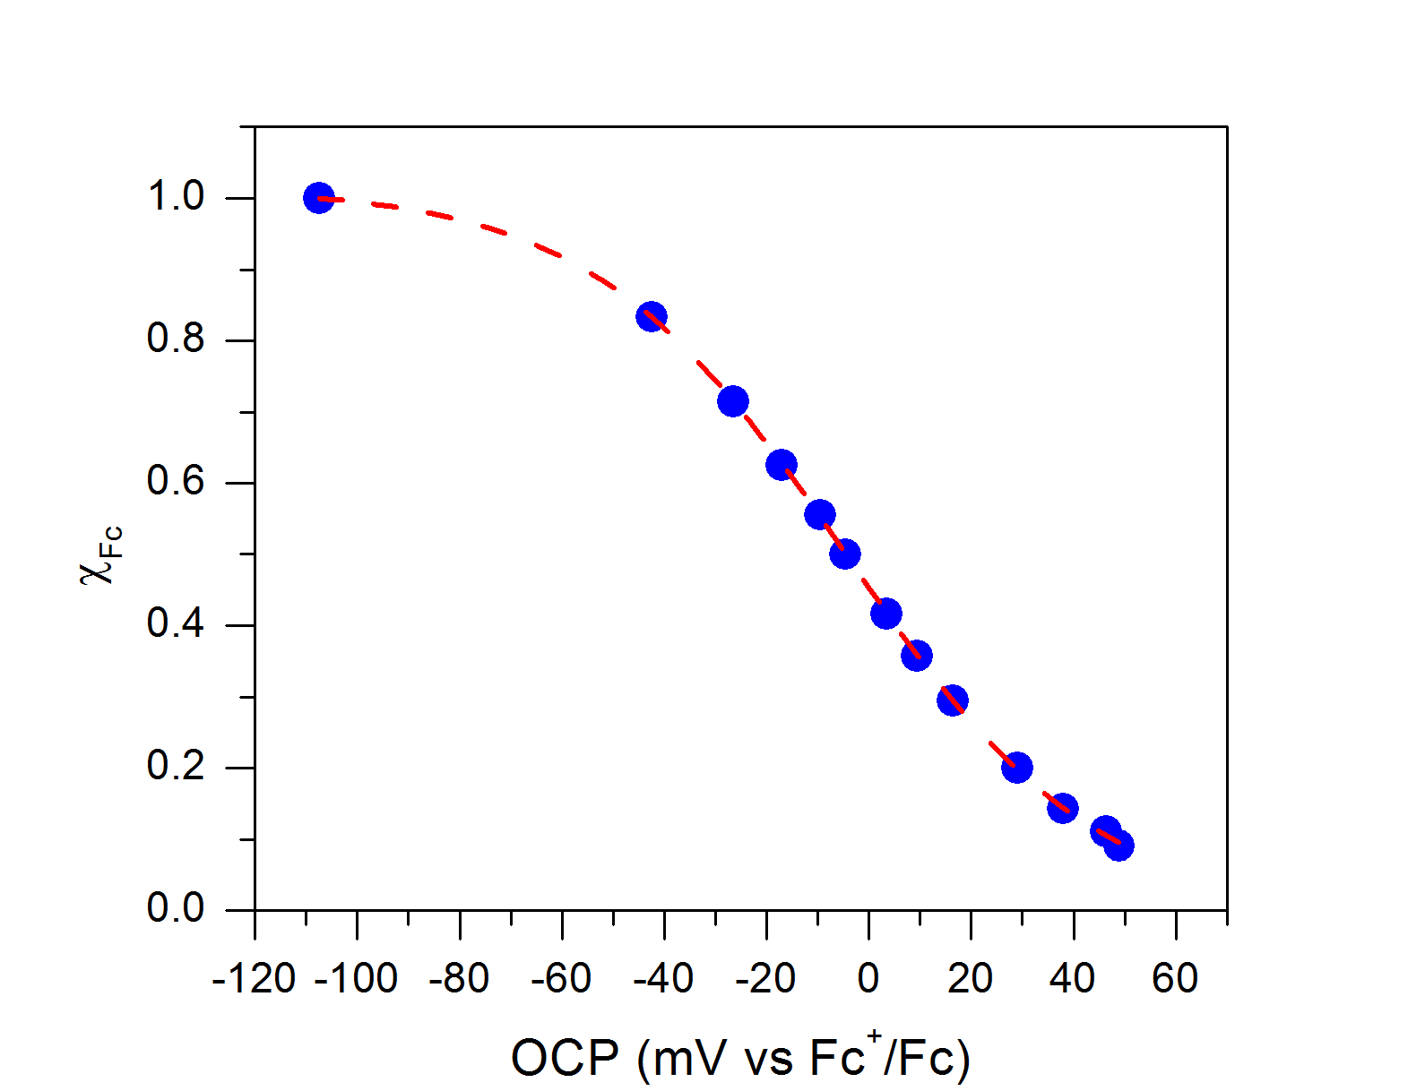

**Figure S1.3**: Plot of 𝝌Fc as a function of the open circuit potential.

5

1. Look carefully at the plot you generated in Question 5 and the shape of the curve. Based on the curvature of the graph, what would be the appropriate function to fit your data with? Fit your data using this function. What parameters within the Nernst equation can we determine from this graph? Hint: it will be helpful to substitute into the Nernst equation and then solve for $χ_{Fc}$ ­ as a function of the open circuit potential. How close are these parameters to literature values?

This curve can be fitted to a sigmoid. Most data analysis software will offer the option of a simple boltzman fit, of the general equation:

$$y= B+\frac{(A-B)}{e^{\frac{(x-x_{0})}{dx}}+1}$$

comparing this expression with our equation, we obtain (red trace in Figure S1.3):

|  |  |  |  |
| --- | --- | --- | --- |
| Boltzman fitting parameters | Values obtained from data fitting | corresponding experimental parameters | Expected  experimental value |
| x | *variable* | E | E |
| y | *variable* | $$χ_{Fc}$$ | $$χ_{Fc}$$ |
| A | 1.02 | 1 | 1 |
| B | -0.007 | 0 | 0 |
| dx | 24.6 | RT/nF | 25.7 |
| x0 | 4.9 mV |  | 0 V |

(T = 25°C)

The results from the fit are in agreement with the expected values.

**Module 2**

Module 2 is constructed as a step-by-step guide. Here is another example of data obtained for such an experiment:

After performing the potential step experiment, the following chronoamperogram is obtained:

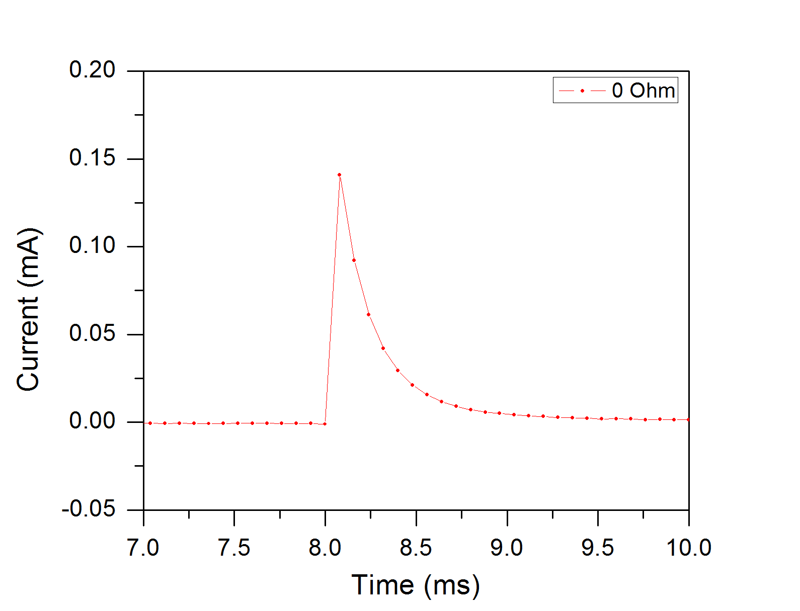

**Figure S2.1**: Experimental result of the step experiment with no iR compensation.

The first two data points following the step have the following characteristics:

x1 = 8.08 ms y1 = 0.1409 mA

x2 = 8.16 ms y2 = 0.0919 mA

The line between these two data points is of the equation $y=mx+b$ with the slope being:

$$slope=m= \frac{y_{2}-y_{1}}{x_{2}-x_{1}}= \frac{0.0919-0.1409}{8.16-8.08}= -0.6125 mA/ms$$

We are trying to determine $i_{0}$ the current response right as the potential is stepped. This corresponds to determining the y-intercept b, after taking into account the 8 ms time offset.

Knowing x1, y1 and the slope a, we can extract:

$$i_{0}= y_{1}-m\left(x_{1}-8 ms\right)=0.1409-\left(-0.6125×0.08\right)= 0.1899 mA$$

We can now estimate the uncompensated resistance Ru:

We can now refine this estimate with an iR compensation feature by looking for the highest resistance which does not cause oscillations. Based on Figure S2.2, this value is 215 Ohms.

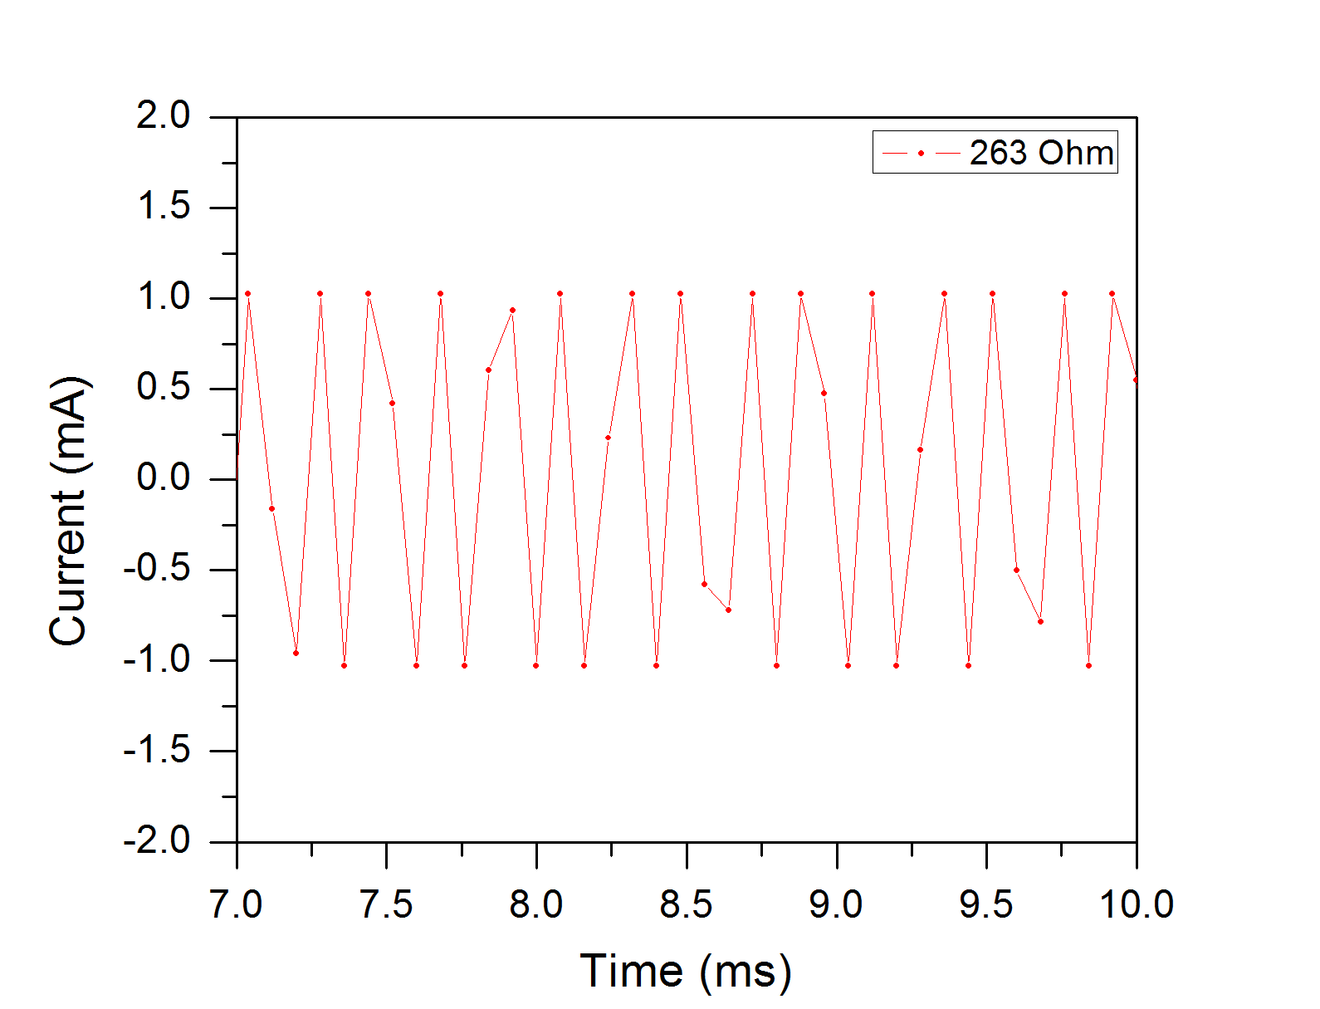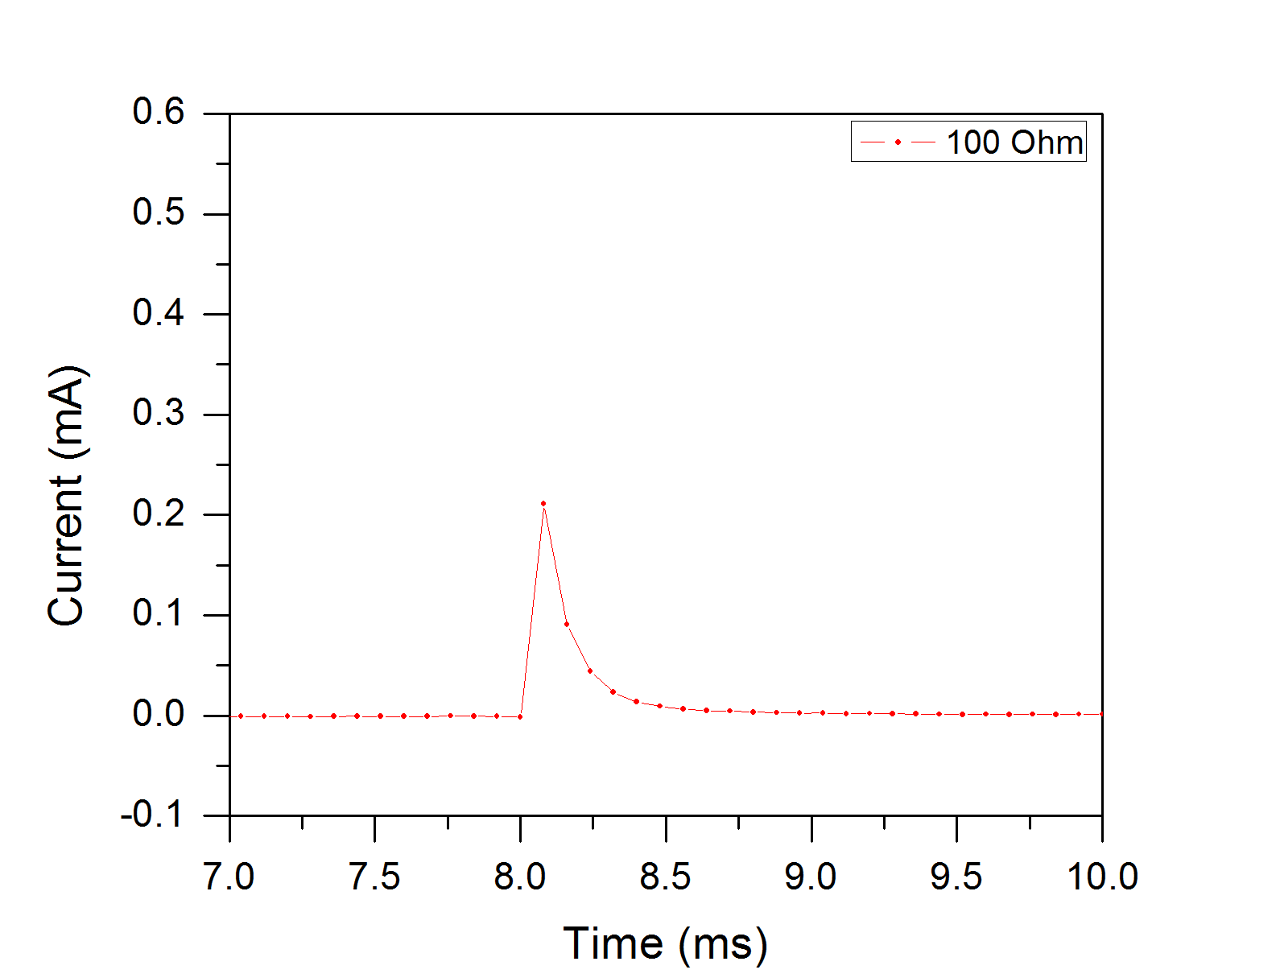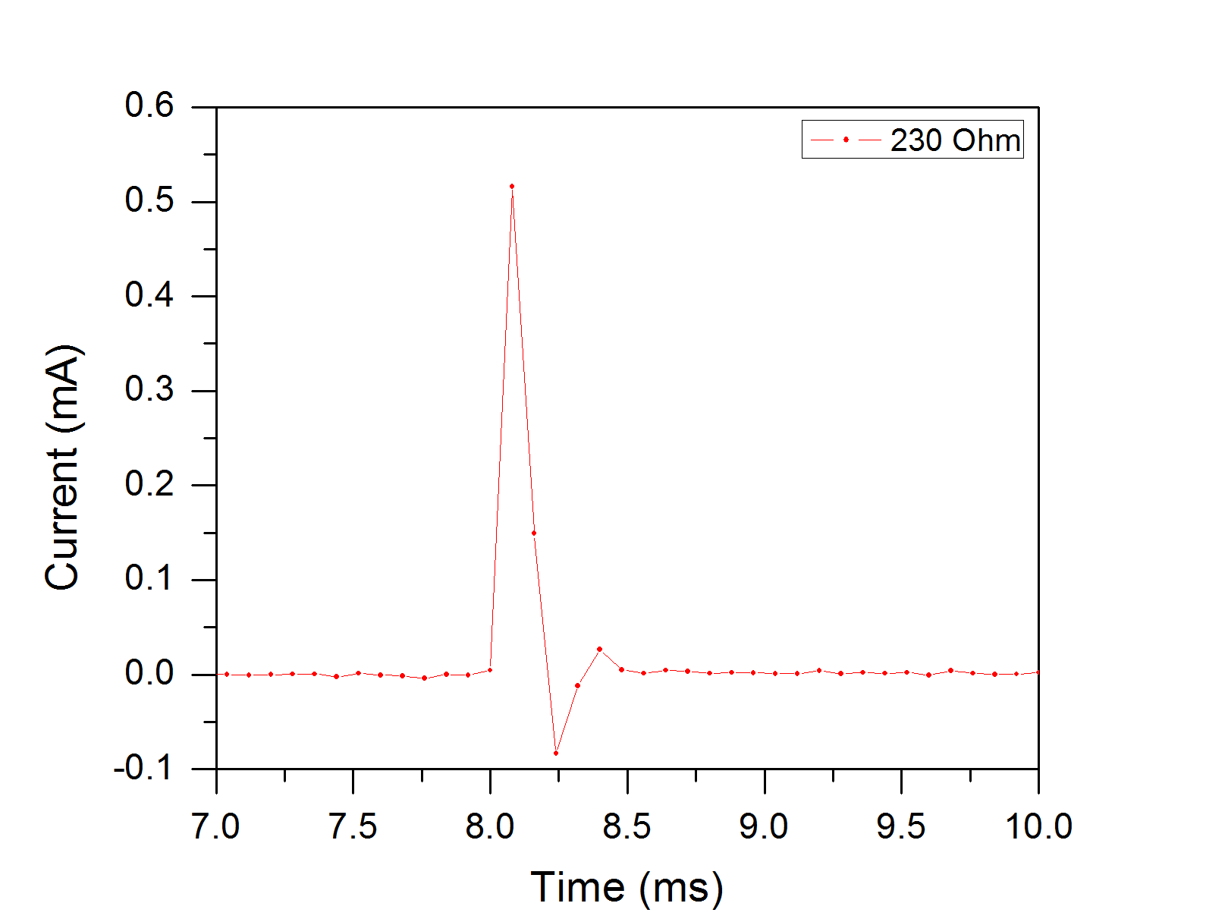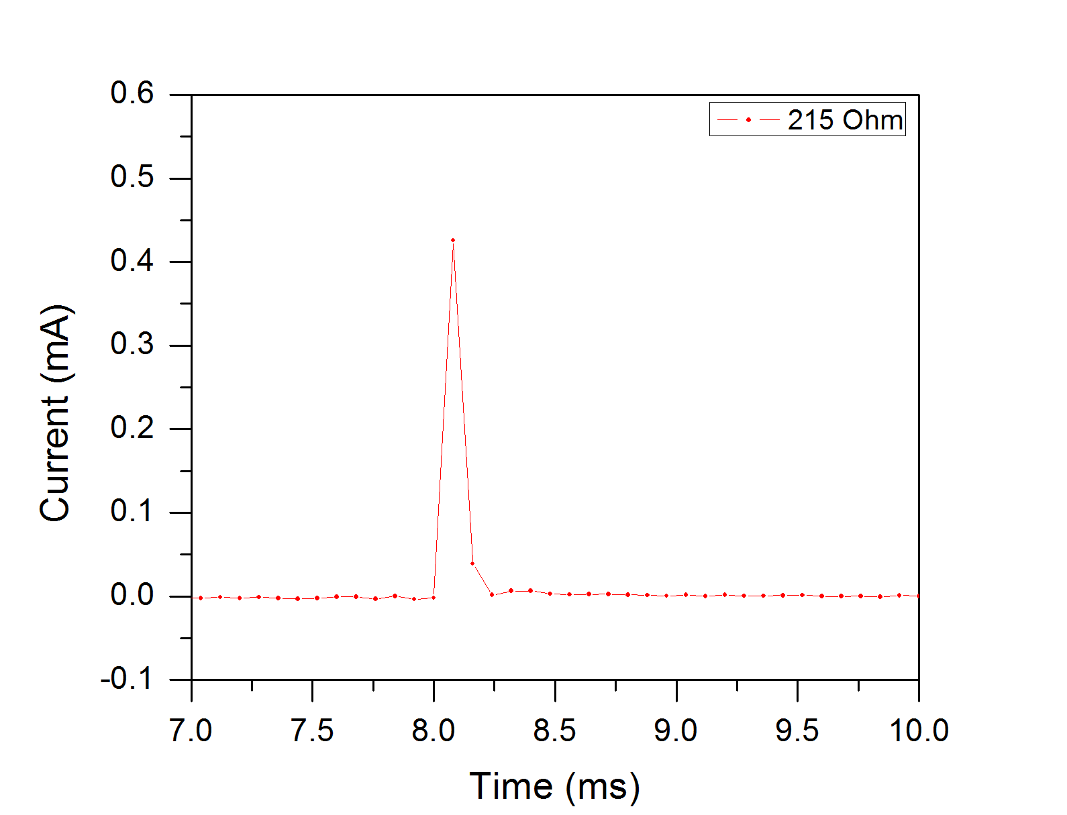 **Figure S2.2:** Step experiments with various degrees of resistance compensation.

**Module 3**

**Solutions**

1. Compare your voltammograms for 50 mM electrolyte solution (no ohmic drop correction), 50 mM electrolyte solution (with ohmic drop correction), and 250 mM electrolyte solution. What do you observe?

The data collected from the three data sets is referenced and plotted:

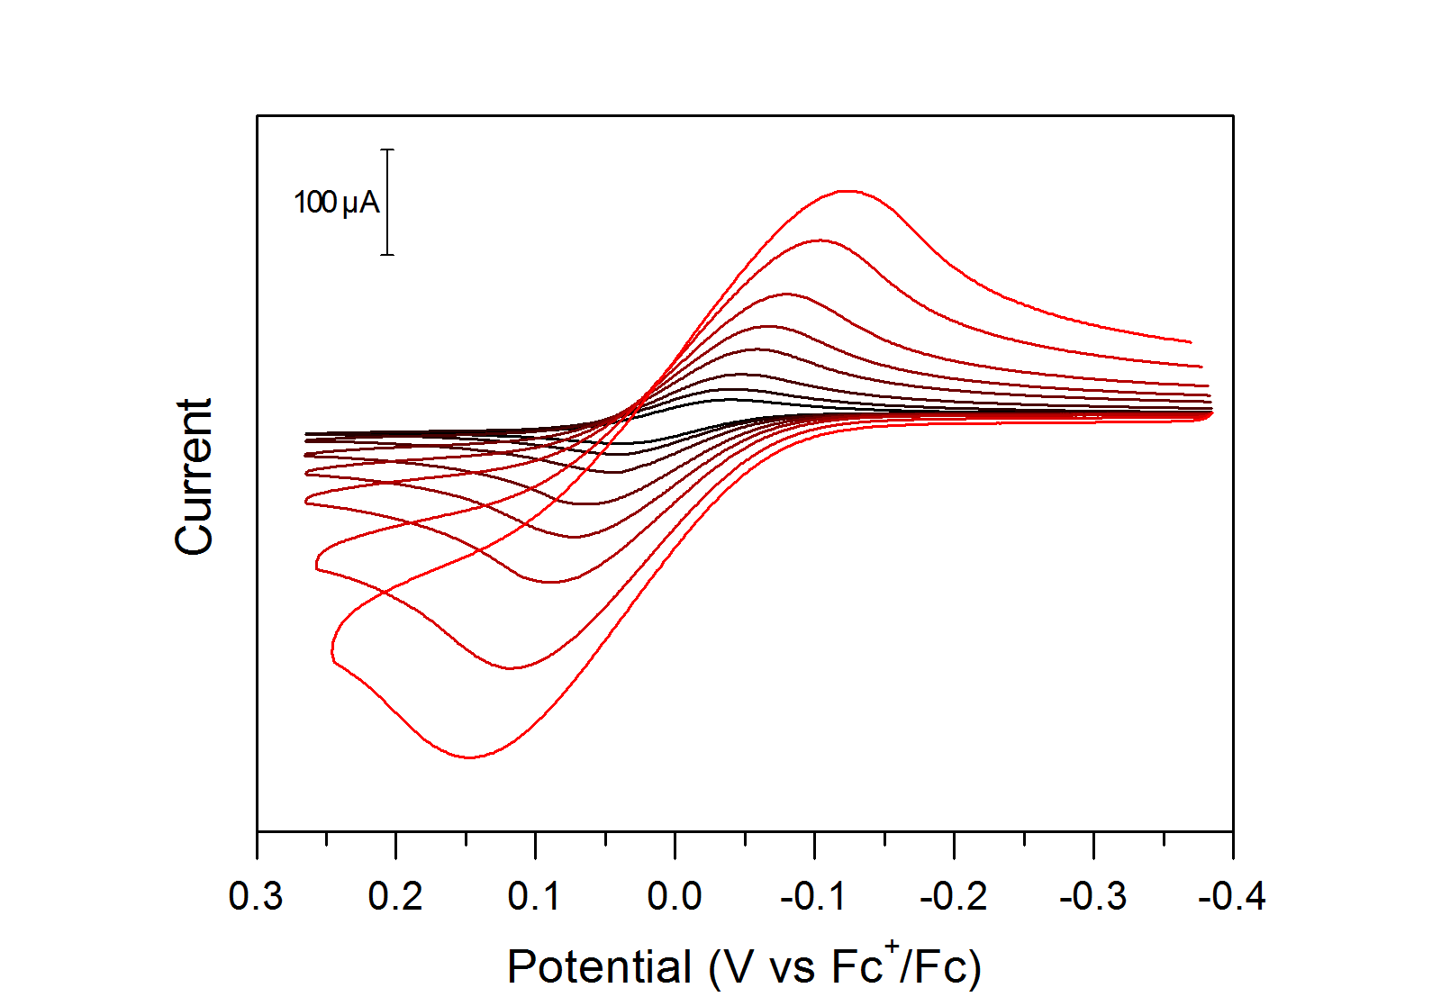 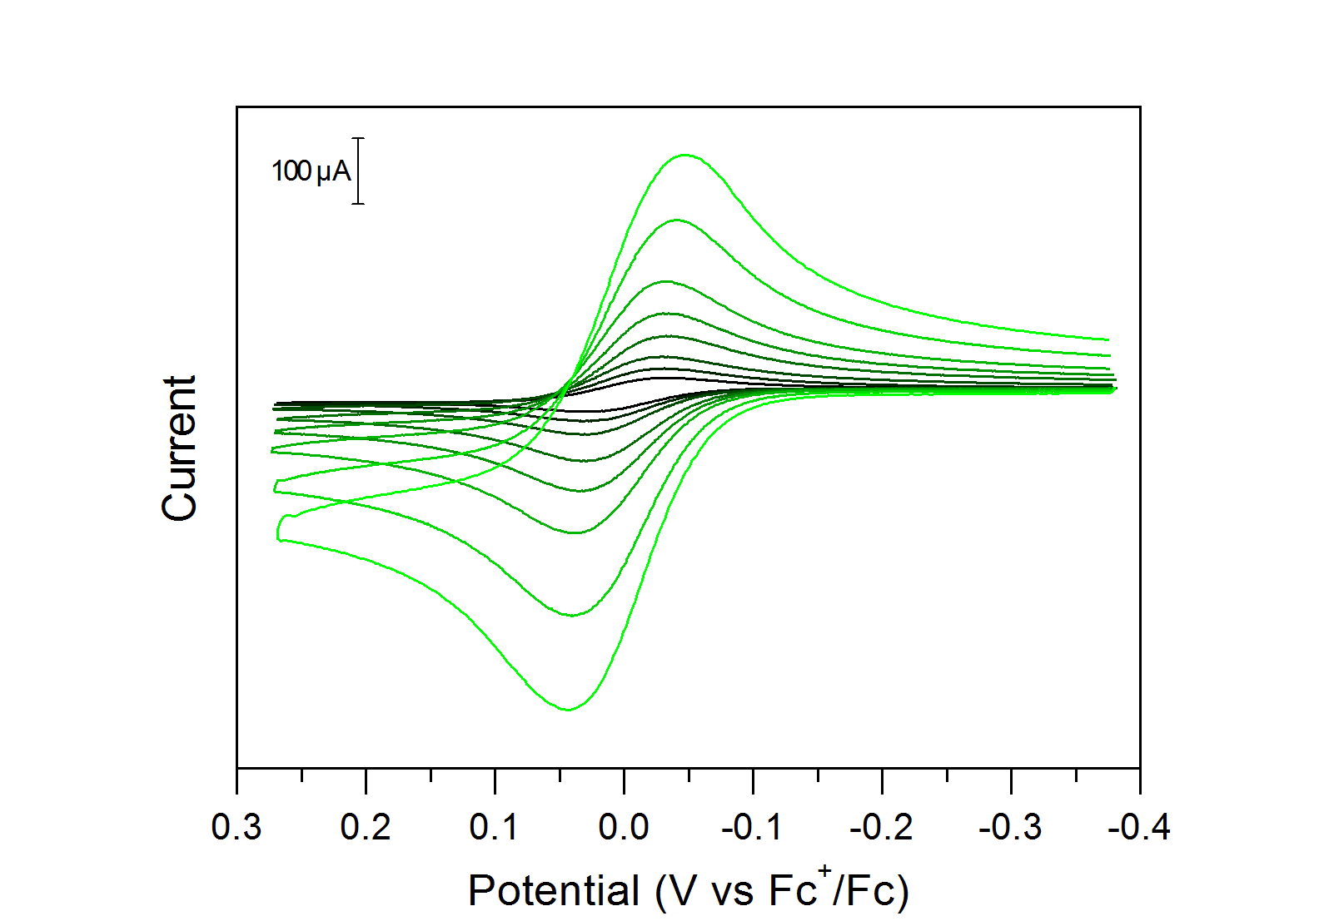

**Figure S3.1**: Cyclic voltammograms at 0.05, 0.1, 0.2, 0.5, 1, 2, 5 and 10 V/s of a 1 mM ferrocene solution in CH3CN with 50 mM of [NBu4][PF6] as supporting electrolyte. The data was collected without (red, left) and with (green, right) ohmic drop compensation. Data collected on a 3 mm diameter glassy carbon working electrode, with a platinum counter electrode and a silver wire pseudo-reference electrode in a fritted compartment.

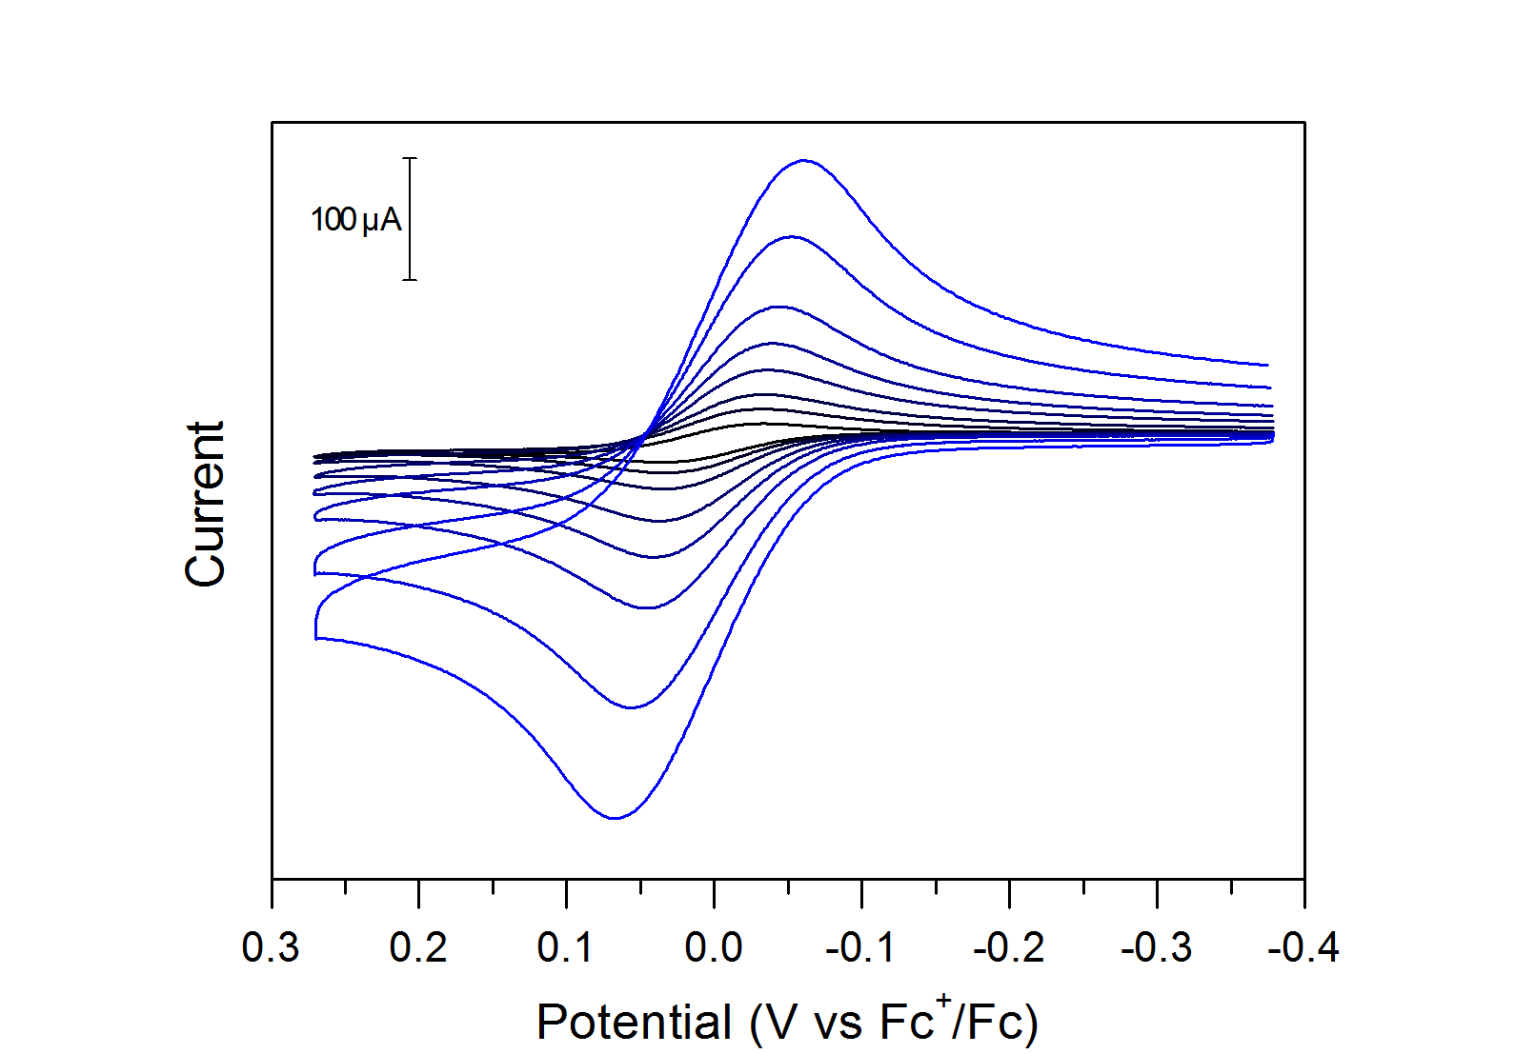

**Figure S3.2**: Cyclic voltammograms at 0.05, 0.1, 0.2, 0.5, 1, 2, 5 and 10 V/s of a 1 mM ferrocene solution in CH3CN with 250 mM of [NBu4][PF6] as supporting electrolyte. No ohmic drop compensation was used. Data collected on a 3 mm diameter glassy carbon working electrode, with a platinum counter electrode and a silver wire pseudo-reference electrode in a fritted compartment.

As the electrolyte concentration increases from 50 to 250 mM, the peak-to-peak separation between the anodic and cathodic traces decreases. This suggests that the electron transfer is faster in higher electrolyte concentrations. Since the electrolyte concentration influences the conductivity of the solution, one hypothesis is that at 50 mM the solution is too resistive and influences the heterogeneous electron transfer rate constant. Comparing the effect of iR compensation at 50 mM electrolyte concentration shows a similar effect as the electrolyte concentration on the peak-to-peak separation: with the ohmic drop corrected data, the peak-to-peak separation with the 50 mM electrolyte is a lot smaller, and qualitatively similar to the data collected at 250 mM of electrolyte.

1. Determine the potentials corresponding to the anodic and cathodic peaks for each voltammogram. Plot the peak potential for the anodic and cathodic peaks minus the E1/2 value (Ep,a – E1/2, Ep,c – E1/2) vs. the log of the scan rate (log(υ), υ in V s-1). This plot is often referred to as a “Trumpet Plot.”

For each voltammogram, the peak potential is measured in the anodic and cathodic traces and a trumpet plot is generated

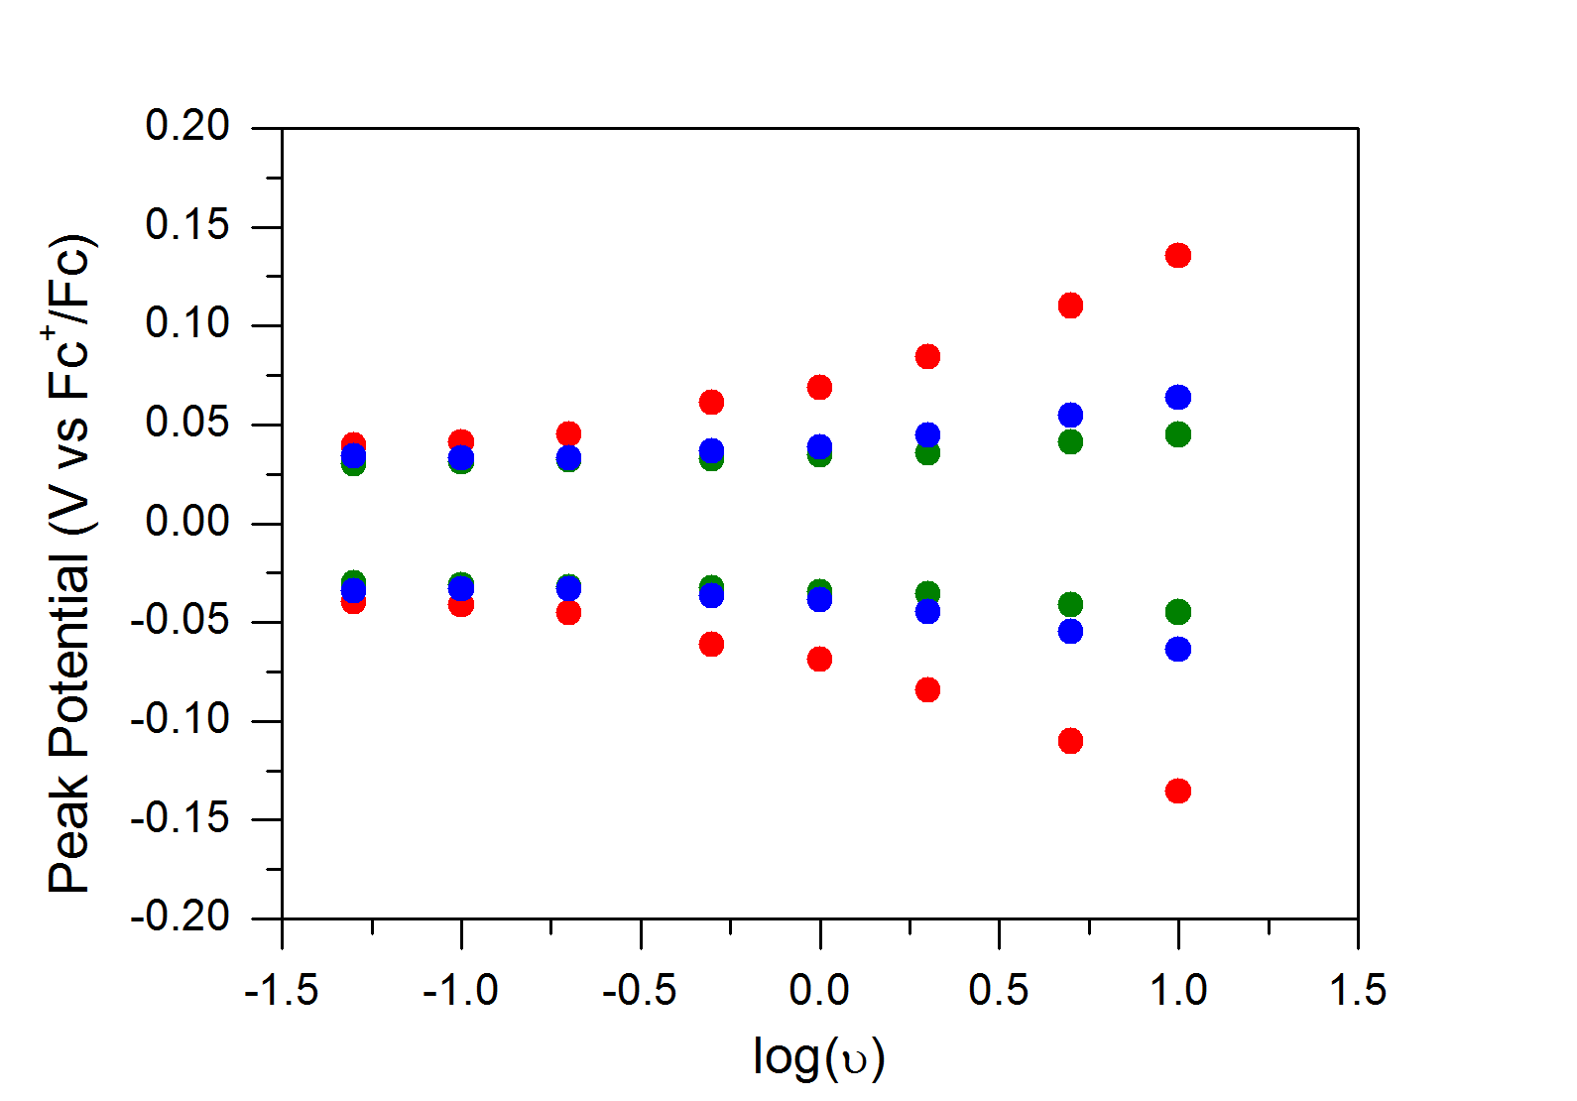

**Figure S3.3**: Plot of the anodic and cathodic peak potentials as a function of the log of scan rate (“trumpet plot”) for the three datasets: 50 mM electrolyte concentration uncompensated (red), compensated (green) and 250 mM electrolyte uncompensated (blue).

1. How did the peak separation vs. log(υ) compare for the three experiments?

For the three experiments, the peak separation increases with scan rate. At all scan rates, the peak-to-peak separation is largest for the uncompensated 50 mM electrolyte sample. At slow scan rates (up to 200 mV/s) the peak separation for the iR compensated 50 mM electrolyte and uncompensated 250 mM electrolyte are identical. As the scan rate is increased, there is a small deviation between these two data sets.

1. What can you conclude about the effects of ohmic drop?

Ohmic drop has dramatic effects on the peak potential and peak separation observed in the data. The effect of ohmic drop become more problematic as the scan rate is increased. Increasing the electrolyte concentration diminishes the uncompensated resistance by improving the overall conductivity of the solution. Even at 250 mM [NBu4][PF6] concentration in CH3CN, the effect of ohmic drop can be seen at fast scan rates. Potentiostat features to compensate for ohmic drop during data collection helps mitigate the effect of the uncompensated resistance.

**Module 4**

**Solutions**

1. Using the Randles–Sevcik equation, calculate the diffusion coefficient of ferrocene. Plotting the peak current vs. the square root of the scan rate (υ1/2) will be helpful.

The Randles–Sevcik equation is:

$$i_{p}=0.4463nFAC^{0}{\left(\frac{nFυD}{RT}\right)}^{1/2}=\left[0.4463nFAC^{0}{\left(\frac{nFD}{RT}\right)}^{1/2}\right]υ^{1/2}$$

with the following parameters:

|  |  |
| --- | --- |
| $$i_{p}$$ | peak current (A) |
| $$n$$ | number of electrons |
| $$A$$ | electrode surface area (cm2) |
|  | analyte concentration (mol cm-3) |
|  | scan rate (V/s) |
|  | diffusion coefficient (cm2 s-1) |
|  | Faraday’s constant (C mol-1) |
|  | gas constant (J K-1 mol-1) |
|  | temperature (K) |

The experiment was performed at 303 K on a 0.0707 cm2 area electrode. Plotting $i_{p}$ vs $υ^{1/2}$ as suggested yields the following graph for the data recorded at 250 mM electrolyte concentration:

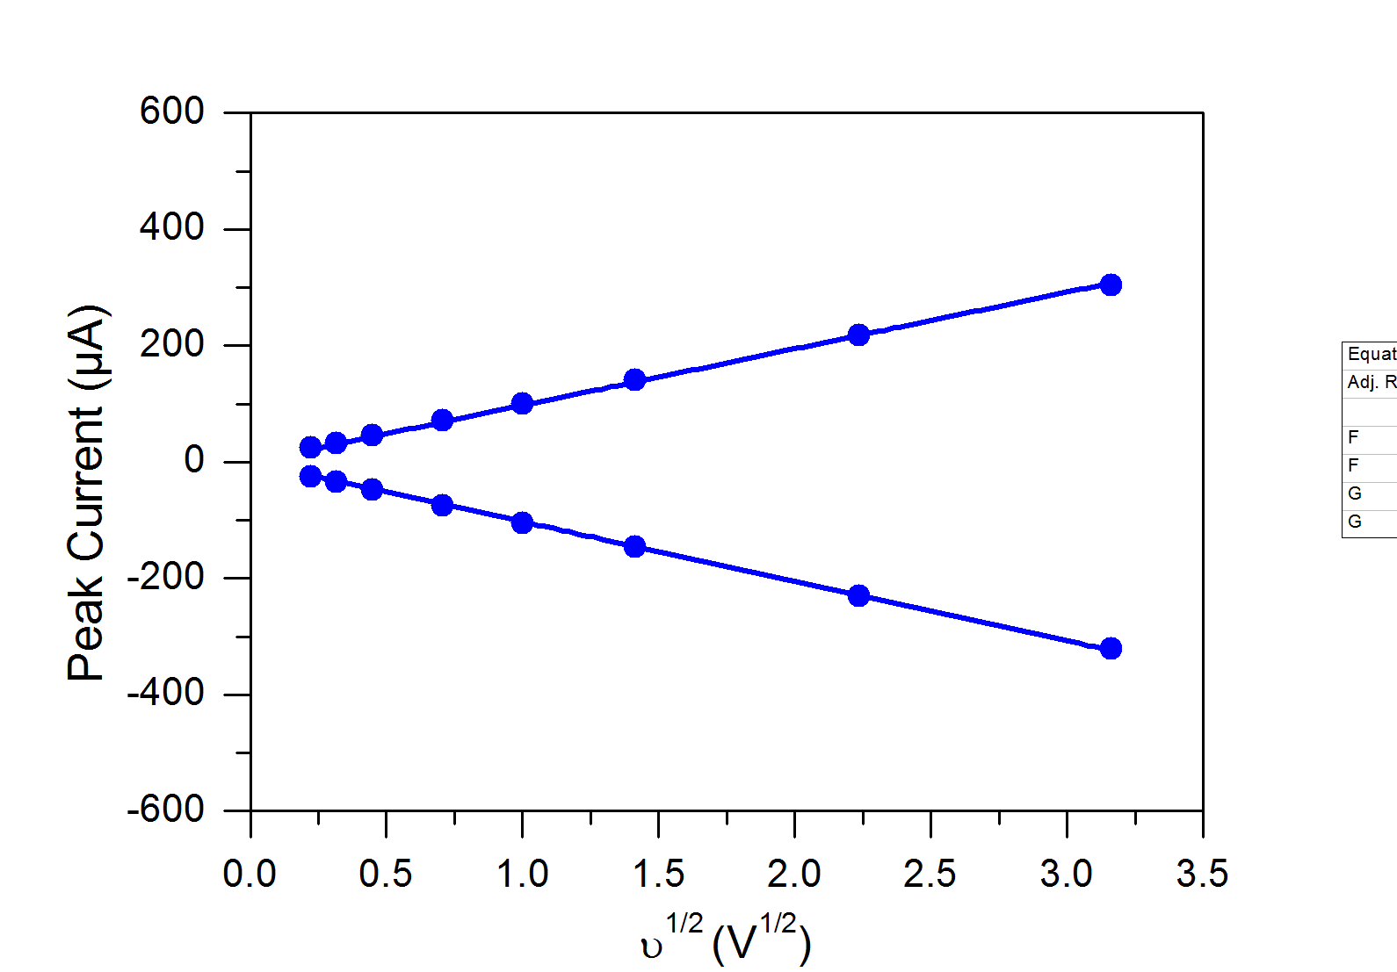

**Figure S4.1:** Plot for the peak current $i_{p}$ as a function of the square root of the scan rate $υ^{1/2}$ for the data set at 250 mM electrolyte concentration.

Both the anodic and cathodic traces were used for this graph. It is worth noting that this would give the diffusion coefficient of ferrocene and ferrocenium respectively. In most cases the diffusion coefficients for the oxidized and reduced species have similar values.

A linear fit ($i_{p}=slope × υ^{1/2}$) yields slopes for the cathodic peaks of −102.5 10-6 A V1/2 (R2 = 0.999) and the anodic peaks of 97.4 10-6 A V1/2 (R2 = 0.999).

We can thus extract the diffusion coefficient D from the theoretical value of the slope:

$$slope=\left[0.4463nFAC^{0}{\left(\frac{nFD}{RT}\right)}^{\frac{1}{2}}\right]$$

$$D={\left(\frac{slope}{0.4463nFAC^{0}}\right)}^{2}\frac{RT}{nF}$$

Which gives a diffusion coefficient of 2.7 10-5 cm2 s-1 for ferrocene (and 2.9 10-5 cm2 s-1 for ferrocenium) in the conditions of the experiment.

1. What is the literature value of the diffusion coefficient for ferrocene? How does your calculated value compare?

The diffusion coefficient of ferrocene under the conditions of the experiment is reported as 2.24 10-5 cm2 s-1 (and 2.16 10-5 cm2 s-1 for ferrocenium). (For reference, see: DOI: 10.1016/j.jelechem.2010.07.006)

The experimental values are relatively close to the literature values.

1. If you have already performed Module 3, determine the diffusion coefficient using each of the three sets of voltammograms you collected above: 50 mM electrolyte solution (no ohmic drop correction), 50 mM electrolyte solution (with ohmic drop correction), and 250 mM electrolyte solution. Did you get the same value for each data set?

The same plots for the two data sets at 50 mM electrolyte with (red) and without (green) ohmic drop correction are presented below:

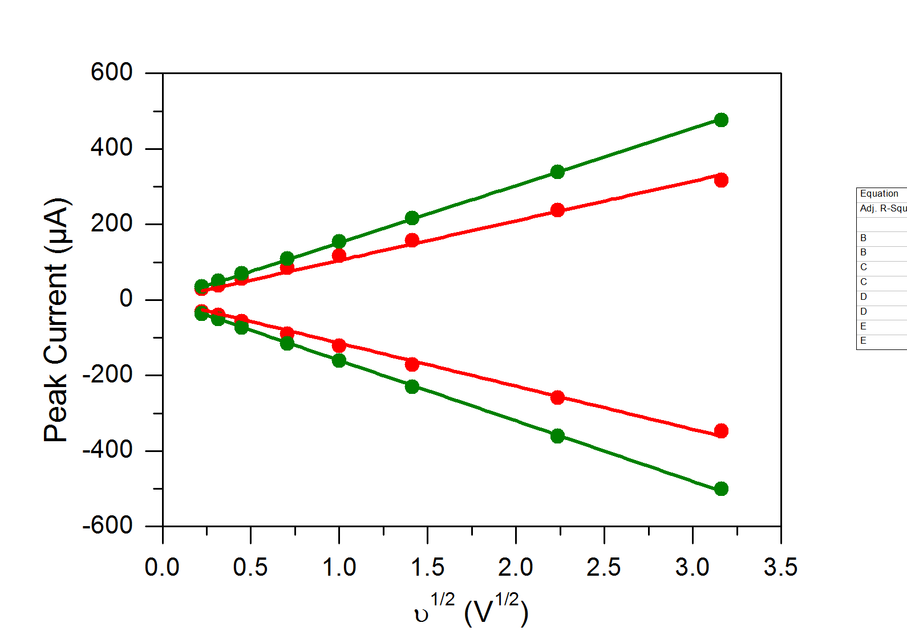

**Figure S4.2:** Plot for the peak current $i_{p}$ as a function of the square root of the scan rate $υ^{1/2}$ for the data sets at 50 mM electrolyte concentration, compensated (red) or not (green) for the ohmic drop.

The slopes of this graph for the anodic and cathodic traces are used to determine the diffusion coefficient which are all summarized below:

|  |  |  |
| --- | --- | --- |
|  | DFc (cm2 s-1) | DFc+ (cm2 s-1) |
| 250 mM electrolyte | 2.7 10-5 | 2.9 10-5 |
| 50 mM electrolyte | 6.4 10-5 | 6.3 10-5 |
| 50 mM compensated electrolyte | 2.8 10-5 | 3.4 10-5 |

1. With the literature diffusion coefficient data, use the Randles–Sevcik equation to calculate the concentration of ferrocene in the solution. How closely does it match the concentration you were aiming for?

From the Randles–Sevcik equation:

$$i_{p}=0.4463nFAC^{0}{\left(\frac{nFυD}{RT}\right)}^{\frac{1}{2}}$$

We can extract the concentration of the analyte:

$$C^{0}= \frac{i_{p}}{0.4463nFA}{\left(\frac{RT}{nFυD}\right)}^{\frac{1}{2}}$$

Which, in the case of ferrocene gives:

$C^{0}=\frac{i_{p}}{0.4463FA}\sqrt{\frac{RT}{υFD}}$ which can also be written as: $C^{0}=\frac{\left|slope\right|}{0.4463FA}{\left(\frac{RT}{FD}\right)}^{1/2}$

For the three datasets of Module 3, using the average slope for the forward CV trace, we obtain:

|  |  |
| --- | --- |
|  | [Fc] (mM) |
| 250 mM electrolyte | 1.09 |
| 50 mM electrolyte | 1.69 |
| 50 mM compensated electrolyte | 1.12 |

1. Which parameters influence the accuracy of the measurement of a diffusion coefficient? What steps would you take to minimize the error in this measurement?

As we have seen above, the diffusion coefficient can be extracted from CV data using the equation:

$$D={\left(\frac{slope}{0.4463nFAC^{0}}\right)}^{2}\frac{RT}{nF}$$

Where the “slope” contains the peak current and scan rate information. An accurate measurement for the diffusion coefficient thus requires a precise value for the concentration of the analyte, as well as the surface area of the electrode and the temperature.

**Module 5**

**Solutions**

1. Plot the voltammograms you have collected, referencing to ferrocene.

After referencing the data to ferrocene, the CVs collected are plotted below:

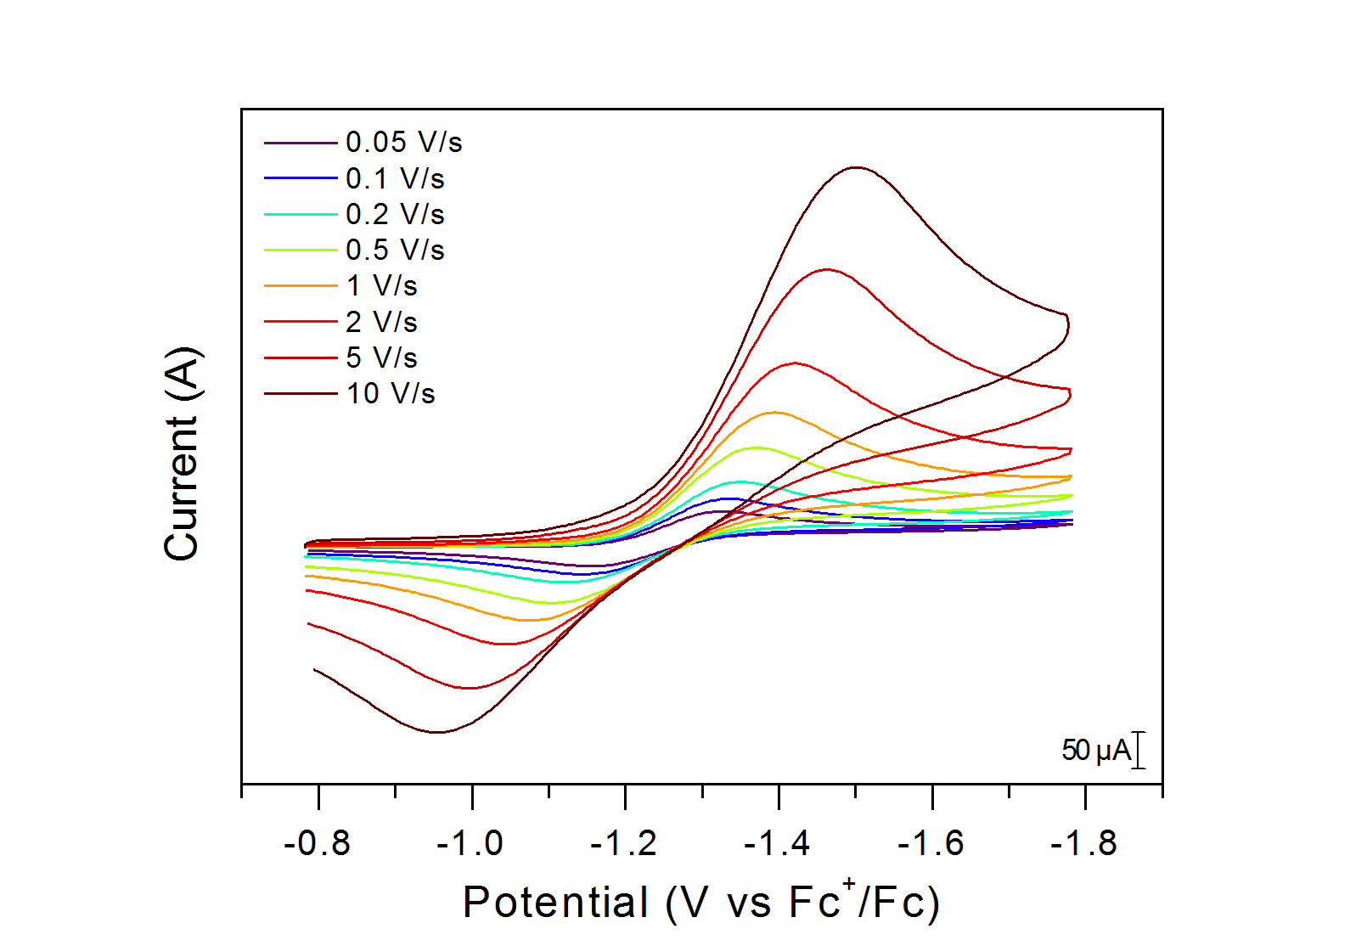

**Figure S5.1**: Voltammograms of the reduction of O2 in CH3CN with 250 mM of [NBu4][PF6] at various scan rates. Data collected on a 3 mm diameter glassy carbon working electrode, with a platinum counter electrode and a silver wire pseudo-reference electrode in a fritted compartment.

1. Determine the potentials corresponding to the anodic and cathodic peaks for each voltammogram. Plot the peak potential for the anodic and cathodic peaks minus the E1/2 value (Ep,a – E1/2, Ep,c – E1/2) vs. the log of the scan rate (log(υ), υ in V s-1). This plot is often referred to as a “Trumpet Plot.”

The peak potential (in V vs E1/2) as a function of log(υ) is plotted below.

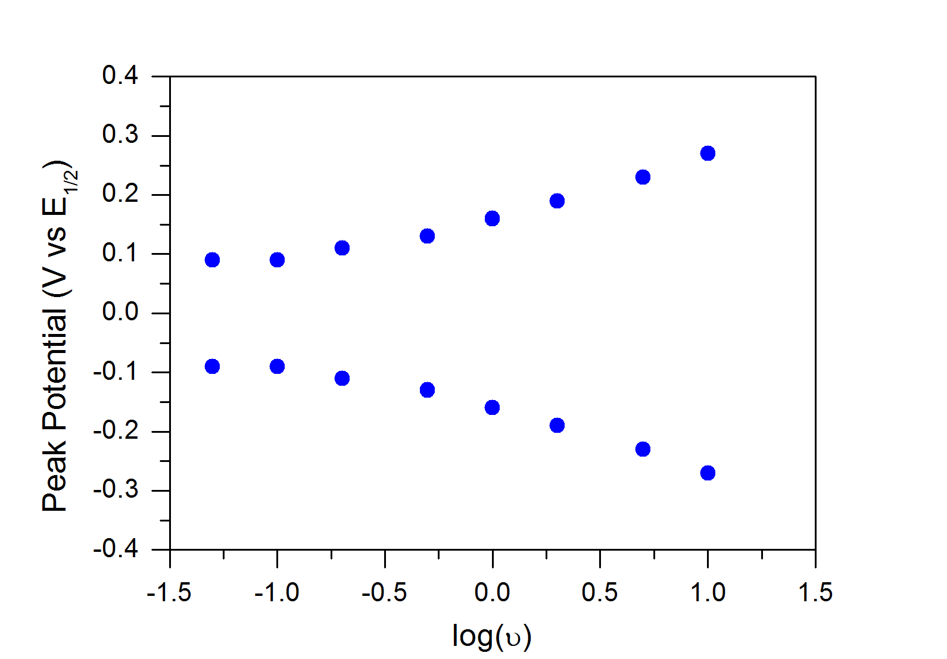

**Figure S5.2**: Corresponding trumpet plot for data in Figure S5.1.

1. What do you notice about the peak-to-peak separation as a function of scan rate? How does the peak-to-peak separation as a function of scan rate differ between oxygen and ohmic-drop corrected ferrocene (Module 3)?

The peak-to-peak separation is close to 200 mV even at the lowest scan rate tested, and the separation is almost 600 mV at 10V/s. This is in stark contrast with the data collected for ferrocene in Module 3 in the ohmic drop corrected data where even at the fastest scan rate of 10 V/s the separation was only 100 mV.

1. Acknowledging that you minimized ohmic drop, what gives rise to the large peak-to-peak separation in these data? Why does the separation increase with scan rate?

Efforts to minimize Ohmic drop (with a high electrolyte concentration) means that it is likely not the cause of the large peak-to-peak separation observed. This suggests that O2 reduction under these conditions is electrochemically irreversible.