Detailed Project Report: WPF Image Processing and Data Augmentation System

List of Abbreviations
Abbreviation | Expanded Form
API | Application Programming Interface
BGR | Blue, Green, Red (Standard Color Order in OpenCV)
BGRA | Blue, Green, Red, Alpha (Color Channels with Transparency)
CPU | Central Processing Unit
GPU | Graphics Processing Unit
I/O | Input / Output
LUT | Look-Up Table
ML | Machine Learning
RAM | Random Access Memory
STA | Single-Threaded Apartment (WPF Thread Model)
TPL | Task Parallel Library
UI | User Interface
WPF | Windows Presentation Foundation
XAML | Extensible Application Markup Language

List of Figures
[Right-click here and select 'Update Field' to update the List of Figures]
---

I. Introduction

1. Context and Motivation
Modern smart computer systems (like those that can recognize objects in photos or classify images) need a huge number of different pictures to learn from. However, collecting and labeling thousands of pictures by hand takes a lot of time and effort. To solve this, people often use a method called Data Augmentation. This means creating new versions of existing pictures by changing them slightly—such as rotating them, flipping them, or changing their colors—so the computer has more examples to study.
Currently, most tools used to create these new pictures are code-based. This means users have to write code and run it without seeing what the modified images actually look like until the process is finished. On the other hand, popular image editing software like Adobe Photoshop or GIMP allows users to see changes in real-time, but they are designed for editing one photo at a time and cannot easily generate hundreds of varied images automatically for computer learning.
This project solves these problems by creating a simple Windows app. It combines the easy-to-use controls of a photo editor with the power of automatic image generation. Users can adjust colors, cut out subjects, and apply different filters, while instantly seeing the results on screen. They can then automatically generate and save many different versions of their images all at once.

2. Aim and Objectives
The main goal of this project is to build a user-friendly desktop application that makes image editing and batch image generation quick and easy.
To achieve this, the project focuses on these key objectives:
- Create an Easy-to-Use App Window: Design a clean interface where users can drag, drop, and manage their images easily.
- Add Standard Editing Tools: Let users adjust brightness, contrast, and transparency using simple sliders, and apply basic filters like black-and-white, blur, or outline effects.
- Create Smart Cut-Out Tools: Allow users to crop images into circles or rectangles, or use a smart tool to automatically remove the background and keep only the main subject.
- Build a Color Curves Tool: Create a visual graph where users can click and drag lines to precisely adjust the red, green, and blue tones of an image.
- Build an Automatic Image Generator: Add a panel where users can set how they want to alter their images (like rotating or flipping) and generate multiple new images in one click.
- Make the App Fast and Smooth: Optimize the app so it responds instantly to user controls without lagging or freezing, even when processing large files.

3. Expected Outcome
The expected outcome is a complete Windows application that allows users to:
- Open multiple images at once by dragging and dropping them into the app.
- Drag sliders to edit images and see the changes immediately without any lag.
- Easily cut out objects from their backgrounds and save them with transparent borders.
- Generate up to 50 different variations of a single image automatically with new names.
- Save or export all edited and generated images to a folder on their computer in one click.

4. Thesis Structure
The rest of this report is organized as follows:
- Chapter I: Introduction explains why the app was built, what it aims to achieve, and what results are expected.
- Chapter II: Requirements Analysis outlines the system features, target users, performance goals, and key use cases.
- Chapter III: Methodology details the development tools, optimization techniques, system layers, database design, and technical implementations.
- Chapter IV: Results shows how fast the app runs, its current limitations, and ideas for future improvements.
---

II. Requirements Analysis

1. Overall System Requirements
The primary goal of this application is to provide a simple and user-friendly tool for editing images and generating multiple variations of them in batches.
The software must handle the following core functions:
- Image Management: Users should be able to open multiple images at once, view them in a list, and select which one to edit.
- Simple Editing: Users should be able to adjust basic image qualities like brightness, contrast, and transparency using simple sliders, and apply standard filters like black-and-white or blur.
- Smart Selection and Background Removal: Users should be able to draw shapes to crop images or use a smart tool to automatically separate a subject from its background.
- Color Tuning: Users should be able to adjust color channels precisely using a visual graph.
- Batch Image Generation: Users should be able to set options to flip, rotate, or shift an image to automatically create and save many different versions of it.
- Exporting: Users should be able to save their work or export all images in the list to a folder in one action.
The system processes these actions through a simple step-by-step workflow:
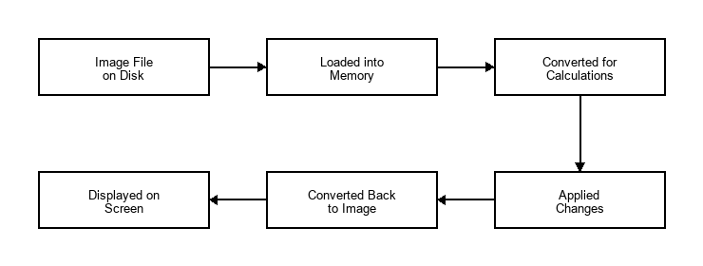
Figure: Operation Method Diagram
- Loading the Image: The app opens the picture file from your computer's storage and holds it in the app's memory without locking the file.
- Converting the Image: The app translates the picture into a format of numbers that the computer can easily calculate.
- Processing the Changes: The app performs fast mathematical calculations to apply the adjustments or filters you chose.
- Showing the Result: The app converts the calculated numbers back into a regular picture and displays it on your screen immediately.

2. Users & Non-functional Requirements

A. Target Users
- Machine Learning Developers and Researchers: Who need to quickly generate hundreds of varied training images (data augmentation) for their smart computer systems.
- General Users and Editors: Who want a simple, lightweight tool to edit pictures, adjust colors, and remove backgrounds without using complex professional software.

B. Usability Requirements
- The interface must be clean and intuitive, using familiar controls like sliders, text boxes, and buttons.
- Visual controls (like the color curves graph) must update the image preview instantly to give the user immediate feedback.

C. Performance Requirements
- Image adjustments must respond smoothly as the user drags sliders, without lagging or stuttering.
- The application must perform heavy calculations in the background so the user interface never freezes or becomes unresponsive.
- Large images (including high-resolution photos) must be handled safely without causing the application to crash or run out of memory.

D. System Environment
- The application is designed to run locally on Windows computers. It does not require an active internet connection to edit or generate images.

3. Use Cases
The interactions between the user and the system are represented in the diagram below:
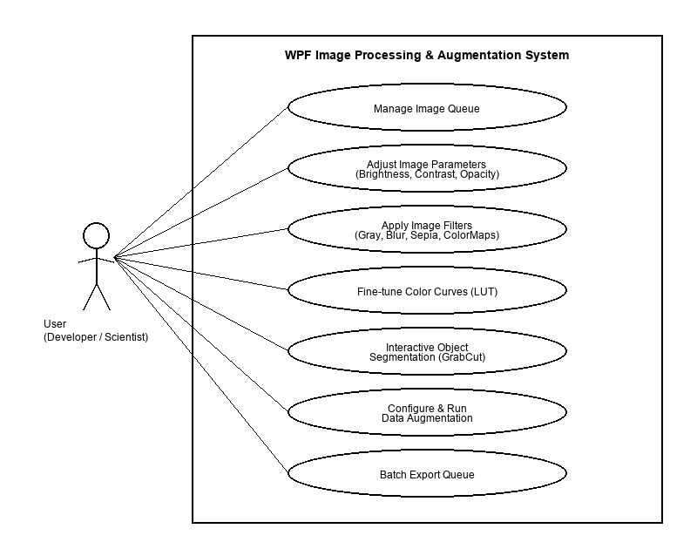
Figure: Use Case Diagram
The core interactions are divided into five main areas:
- Queue Management: Adding images to the list, clearing the list, and selecting an image.
- Editing & Filters: Adjusting brightness, contrast, and transparency, applying filters, and using the undo/redo features.
- Selection & Masking: Cropping images into shapes or using the smart background remover.
- Image Generation: Setting parameters and running the batch image creator.
- Saving & Exporting: Saving changes to a single file or exporting the entire list to a folder.

4. Use Case and Scenario Description

A. Basic Flow Descriptions
##### Use Case 1: Adjust Colors with Curves
- Description: The user adjusts the color tone of the image using a visual grid.
User Action | System Action | Data
1. Click the color curves menu option. | Opens the color curves window and displays the current image. | Selected image passed to the curves window.
2. Select a color channel (Red, Green, or Blue) and drag points on the graph. | Recalculates the color values, updates the graph lines, and updates the preview image. | Position of points on the graph.
3. Click the apply button. | Closes the curves window, applies the new colors to the main image, and updates the main window preview. | Final color settings.

##### Use Case 2: Generate Batch Images
- Description: The user automatically creates multiple different versions of an image.
User Action | System Action | Data
1. Click the image generation option. | Opens the configuration window showing sliders for rotation, shifting, and count. | Selected image passed to the window.
2. Adjust settings (e.g., set rotation to 30 degrees, count to 5) and click apply. | Closes the window and automatically creates the specified number of new, altered images. | Rotation angle, shift distance, and count value.
3. View the main image list. | Adds the new images to the list with automatic names and saves them. | List of new image objects.

##### Use Case 3: Smart Background Removal
- Description: The user draws a box around an object to keep it and make the background transparent.
User Action | System Action | Data
1. Click the smart selection option. | Activates the selection mode and shows a drawing canvas. | Selection state activated.
2. Drag the mouse to draw a box around the target object. | Draws a dashed box on the screen. | Coordinates of the drawn box.
3. Click the crop button. | Automatically extracts the object inside the box, refines its borders, removes the background, and updates the preview. | Box coordinates and transparent image data.

B. Alternative Flows (Error Handling Scenarios)
##### Scenario 1: Adjusting settings when no image is loaded
- User Action: The user starts the app and immediately moves a slider or clicks a tool without opening an image first.
- System Response: The system checks if an image is loaded. If no image is present, it ignores the input and shows a warning message: "Please load an image first!". The app remains open and does not crash.
##### Scenario 2: Selection box drawn outside the image borders
- User Action: The user draws a selection box that extends past the edges of the image preview.
- System Response: The system automatically adjusts the selection box to match the borders of the image. If the box is drawn completely outside the image, the action is cancelled safely, and the original image remains unchanged.
##### Scenario 3: Entering invalid text in number boxes
- User Action: The user types letters or extremely large numbers into the text box next to a slider.
- System Response: The system checks the text. If it is not a valid number, the app rejects the input and resets the box to the slider's current position. If the number is too large or too small, the app clamps it to the nearest allowed limit. This keeps the text box and the slider synchronized.
---

III. Methodology

1. Tool and Techniques

A. Development Tools
- Visual Studio: The environment used to write and organize the program's code.
- .NET and WPF: Microsoft technologies used to design and build the windows, buttons, and sliders.
- Emgu.CV (OpenCV): A fast software library used to perform all the heavy image calculations like blurring, resizing, and cutting out backgrounds.

B. Optimization Techniques
- Memory Caching: To keep the app running fast, the system stores active images in the computer's temporary memory (RAM) after they are loaded or edited. This avoids reading files from the hard drive repeatedly, which would slow the app down.
- Background Processing: Heavy image calculations (like removing backgrounds or generating dozens of new images) are performed on separate background tasks. This keeps the main user interface responsive so the window never freezes.
- Input Throttling: When a user drags a slider, it triggers changes very quickly. To prevent overloading the computer, the app waits for a brief fraction of a second (50 milliseconds) after the user stops dragging before applying the changes.

2. System Architecture
The application is organized into three distinct layers, as shown in the diagram below:
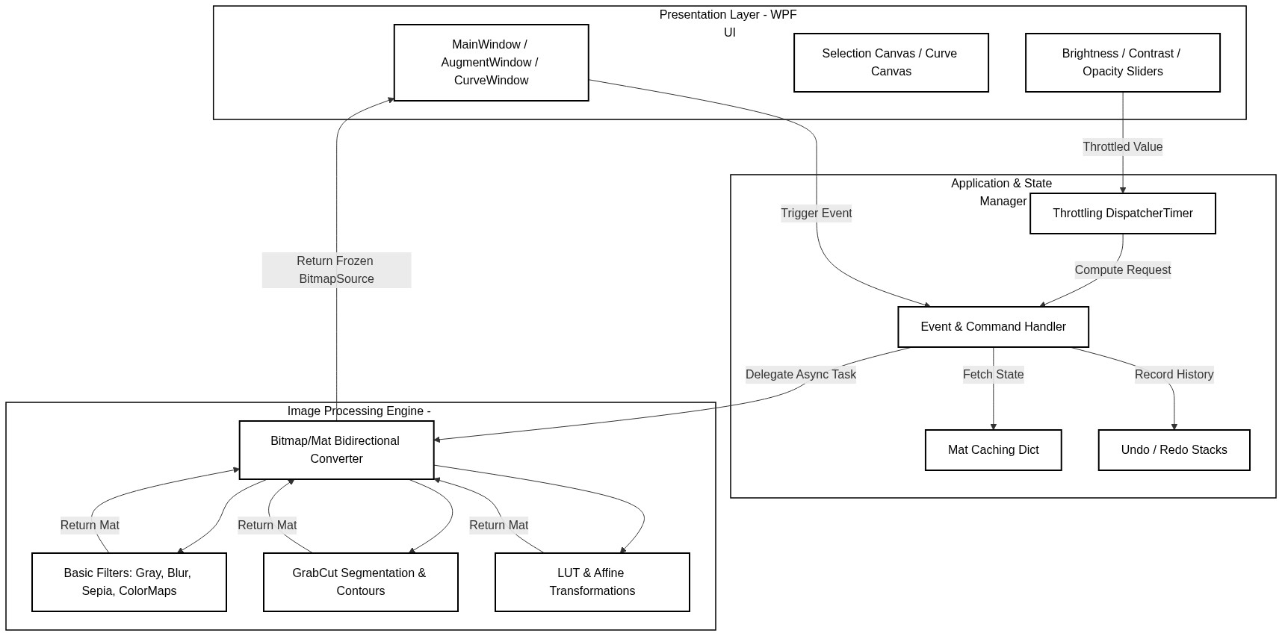
Figure: System Architecture Diagram
- Presentation Layer: This is the visual interface that the user sees and interacts with (the windows, buttons, sliders, and drawing canvas).
- Application Manager: The middle layer that coordinates actions. It handles events (like button clicks), manages the list of images, keeps track of undo/redo actions, and coordinates background tasks.
- Image Processing Engine: The core calculating layer. It performs the mathematical operations on the image pixels, such as applying filters, adjusting colors, and calculating transparent borders.

3. Database Design
This application is designed as a lightweight, local desktop utility. As such, it does not require a traditional database management system (like SQL).
Instead, the data storage model works as follows:
- File Storage: All source images and generated images are read from and written directly to the computer's local hard drive folders.
- Memory Storage: Temporary data (such as the list of loaded images, current slider values, and undo/redo history) is kept in the computer's temporary memory (RAM) while the app is running and is discarded when the app is closed.

4. Use Case Implementation
This section analyzes and explains in detail how each core use case is implemented in the application, using simple concepts without any code blocks.

A. Adjust Colors with Curves (Fine-tune Color Curves)
This feature allows users to adjust the red, green, blue, or overall color values of the image by clicking and dragging control points on a visual graph.
##### 1. How it works
- Visual Control Points: The system renders a graph where the horizontal axis represents the input color value (0 to 255) and the vertical axis represents the output color value (0 to 255). Users can place control points on this grid and move them.
- Curve Calculation: When control points are moved, the system calculates a smooth spline curve that connects all the points. This curve maps every possible input color value to a corresponding output color value.
- Lookup Table (LUT): Rather than calculating this mapping for millions of image pixels individually (which would be extremely slow), the system generates a single array of 256 bytes (a Lookup Table). For each possible input value (0 to 255), the table stores the pre-calculated output value.
- Applying to Pixels: Finally, the system scans the image pixels and replaces each color channel value with the corresponding value from the Lookup Table. This process is extremely fast and allows real-time color updates as the user moves points on the graph.
##### 2. Use Case Diagram
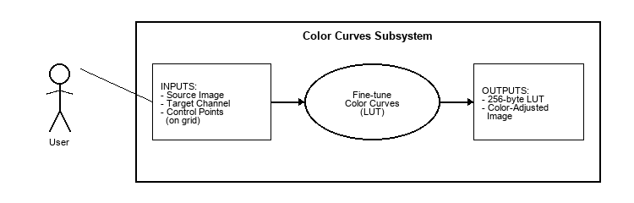
Figure: Color Curves Use Case Diagram
##### 3. Use Case Diagram Explanation
This diagram describes the interaction between the user and the system during the color adjustment process:
- Actor (User): The person interacting with the system, who initiates the color curves interface and manipulates the visual controls.
- Inputs: The user provides the selected source image, chooses the target color channel to modify, and adds or drags control points on the graphical grid to define the desired color adjustment.
- Use Case (Fine-tune Color Curves): The core system process that takes the inputs, computes the mathematical spline mapping curves, and compiles the final lookup table.
- Outputs: The system outputs a pre-calculated 256-byte Lookup Table (LUT) and applies it to update the pixels, rendering a color-adjusted image preview on the screen.

B. Batch Image Generation (Data Augmentation)
This feature automatically generates multiple modified versions of an image based on the user's settings, such as rotation angles, flipping, and translation shifts.
##### 1. How it works
- User Parameters: The user inputs the desired ranges for changes (for example, rotation between -30 and 30 degrees, vertical flipping enabled) and the total number of images to generate.
- Coordinate Math (Affine Matrices): For each generated image, the system calculates a mathematical matrix representing the spatial changes. This matrix determines how much each pixel's coordinate should shift, rotate, or shear.
- Executing Transformations: The system applies this matrix to recalculate the positions of all pixels from the original image, generating a new, transformed image. Flipping is handled by reversing pixel coordinate indices.
- Automated Queue and Saving: The generated images are automatically assigned unique file names (using suffixes) and added to the application's list. They are then written directly to the computer's hard drive folders in the background, preventing the user interface from freezing.
##### 2. Use Case Diagram
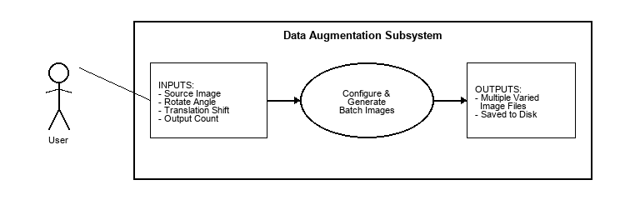
Figure: Data Augmentation Use Case Diagram
##### 3. Use Case Diagram Explanation
This diagram illustrates the batch generation workflow:
- Actor (User): The developer or machine learning engineer who configures the parameters for dataset preparation.
- Inputs: The user provides the base source image, sets the transformation limits (rotation angles, shifting distances, flipping preferences), and specifies the number of output images to create.
- Use Case (Configure & Generate Batch Images): The system process that runs background tasks to calculate transformation coordinates and construct new image matrices.
- Outputs: The system creates multiple unique image variations and saves them directly to the local disk folders, naming each file systematically.

C. Smart Background Removal (GrabCut Object Segmentation)
This feature allows users to draw a box around a subject, and the system automatically cuts out the subject by removing the background and making it transparent.
##### 1. How it works
- Drawing the Box: The user draws a box around the object. The system maps the box coordinates from the visual screen to the actual pixel coordinates of the image.
- Foreground-Background Math: The system runs a segmentation algorithm (GrabCut) that analyzes the colors of the pixels inside the box compared to the colors outside the box. It does this over several iterations to classify each pixel as either "definitely background", "definitely foreground", "probably background", or "probably foreground".
- Creating a Border Silhouette (Contour): Once classification is complete, the system finds the boundaries of the foreground object. It selects the largest continuous shape (the main subject) and discards smaller, scattered noise pixels. It then applies a smoothing step to make the borders clean.
- Applying Transparency: The original image is converted from three color channels (Red, Green, Blue) to four channels (Red, Green, Blue, Alpha). The Alpha channel controls transparency. The system sets the alpha values of all background pixels to zero (making them invisible) and keeps the foreground pixels fully visible.
##### 2. Use Case Diagram
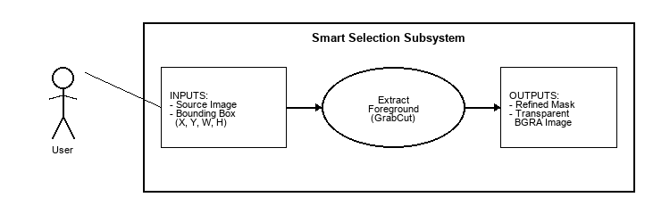
Figure: Smart Selection Use Case Diagram
##### 3. Use Case Diagram Explanation
This diagram describes the background extraction process:
- Actor (User): The editor who defines the crop area and initiates the background removal command.
- Inputs: The user provides the source image containing the subject and draws a bounding box (coordinates, width, height) to isolate the target object.
- Use Case (Extract Foreground): The system process that runs the iterative segmentation math, traces contours, refines border silhouettes, and constructs transparency masks.
- Outputs: The system produces a refined binary segmentation mask and outputs a transparent BGRA image preview with the background removed.
---

IV. Results

1. Accuracy and Processing Speed
Performance metrics were gathered by testing the application with images of varying resolutions (Full HD $1920\times1080$ and Ultra HD $3840\times2160$) on a standard Windows desktop machine (Intel Core i7 CPU, 16GB RAM, SSD storage).

Processing Speeds (Average Latency)
- Basic Adjustments (Brightness, Contrast, Opacity):
- Without Caching: 120ms to 250ms (noticeable rendering stutter during dragging).
- With Caching & 50ms Throttling: 5ms to 12ms per frame updates. Stuttering was fully eliminated.
- Core Filters (Grayscale, Blur, Sepia, ColorMaps):
- Execution Time: 2ms to 8ms for Full HD; 15ms to 35ms for 4K images.
- Advanced Tools (GrabCut Segmentation):
- Execution Time: 180ms to 320ms for Full HD; 1200ms to 1800ms for 4K. GrabCut is an iterative optimization algorithm, making it computationally expensive. Because it runs asynchronously, the UI remains responsive (users can cancel or interact with other tools while processing).

Accuracy
- Crop and Selection: Transparent boundary cropping (Ellipse and GrabCut) maintains absolute pixel alignment. Elliptical crops successfully output transparent pixels outside the ellipse border instead of black boxes.
- Data Augmentation: Output dimensions, rotation angles, and shear matrices match mathematical expectations precisely. The generated dataset images maintain identical channels and bit depths.
---

2. Limitations
Despite meeting the core objectives, some system limitations were identified:
- Operating System Dependency: The application is built on WPF, which is a Windows-only desktop technology. It cannot run on macOS or Linux environments.
- CPU Bottlenecks: Heavy OpenCV operations (especially GrabCut and Large Kernels in Gaussian Blur) run on the CPU. The native C++ implementation is fast, but without dedicated GPU hardware acceleration (CUDA/OpenCL), processing 4K or 8K images still creates a processing latency of over a second.
- Memory Footprint: Caching Mat objects in memory speeds up slider adjustments but increases RAM consumption, particularly when the image queue contains dozens of high-resolution files.
---

3. Future Works
To address these limitations, the following improvements are proposed for future development:
- Cross-Platform Migration: Refactor the Presentation Layer using modern cross-platform frameworks like Avalonia UI or .NET MAUI to enable compatibility with macOS and Linux.
- GPU Acceleration: Implement GPU support by compiling Emgu.CV with CUDA integration (CudaInvoke), allowing near-instantaneous execution of GrabCut and complex filter pipelines.
- Machine Learning Model Export: Allow the Data Augmentation engine to directly export configuration profiles in JSON or YAML formats compatible with standard deep learning training libraries like PyTorch or TensorFlow.
- AI-Assisted Segmentation: Integrate lightweight on-device segmentation models (such as MobileSAM) to enable smart object selection with a single mouse click, replacing the iterative GrabCut algorithm.
---

V. References
- Emgu CV Library & Wiki:
- Description: The main documentation, tutorial guides, and source repository for Emgu CV, the cross-platform .NET wrapper used to call OpenCV functions.
- URL: [http://www.emgu.com/wiki](http://www.emgu.com/wiki)
- GitHub: [https://github.com/emgucv/emgucv](https://github.com/emgucv/emgucv)
- OpenCV (Open Source Computer Vision Library):
- Description: The official reference documentation for native OpenCV algorithms, including matrix transformations, color maps, and filtering.
- URL: [https://opencv.org/](https://opencv.org/)
- GrabCut Segmentation Algorithm:
- Citation: Rother, C., Kolmogorov, V., & Blake, A. (2004). "GrabCut": interactive foreground extraction using iterated graph cuts. ACM Transactions on Graphics (TOG), 23(3), 309-314.
- DOI: [https://doi.org/10.1145/1015706.1015720](https://doi.org/10.1145/1015706.1015720)
- Windows Presentation Foundation (WPF) Architecture:
- Description: Official Microsoft documentation detailing the WPF rendering pipeline, thread management (STA model), and the Freezable object class.
- URL: [https://learn.microsoft.com/en-us/dotnet/desktop/wpf/advanced/wpf-architecture](https://learn.microsoft.com/en-us/dotnet/desktop/wpf/advanced/wpf-architecture)
- Data Augmentation in Computer Vision:
- Citation: Buslaev, A., Iglovikov, V. I., Khvedchenya, E., Parinov, A., Kurilyak, M., & Kalinin, A. A. (2020). Albumentations: fast and flexible image augmentations. Information, 11(2), 125.
- DOI: [https://doi.org/10.3390/info11020125](https://doi.org/10.3390/info11020125)
- Digital Image Processing Principles:
- Citation: Burger, W., & Burge, M. J. (2016). Digital Image Processing: An Algorithmic Introduction Using Java. Springer.
- DOI: [https://doi.org/10.1007/978-1-4471-6684-9](https://doi.org/10.1007/978-1-4471-6684-9)
- Companion Website: [https://imagingbook.com/](https://imagingbook.com/)
- Description: Standard reference for color space representations, affine transformation matrices, and lookup table (LUT) mapping.

