***TEST 2***

**PAPER 1: READING AND WRITING** (1 hour 30 minutes)

**READING**

**PART 1**

**Questions 1 – 5**

* Look at the text in each question.
* What does it say?
* Mark the letter next to the correct question – **A**, **B** or **C** – **on your answer sheet**.

**Example**:

**0**



***REGENCY CAMERAS***

**Buy two films and get one**

**FREE**

1. Buy three films for the price of two.
2. Get a free film with every one you buy.
3. Films bought here are printed free.

|  |  |  |  |
| --- | --- | --- | --- |
| **Part 1** | | | |
| 0 | A | B | C |

**Answer:**

**1 Jennie has to**

**Jennie,**

**The garage rang – your new tyres have arrived. The can’t fit them until next week. Please let them know today which day will be convenient.**

1. ask another garage to fit tyres.
2. arrange a time for the garage to fit the new tyres.
3. collect the new tyres from the garage.

**2 What does Mrs. Swan want to do today?**

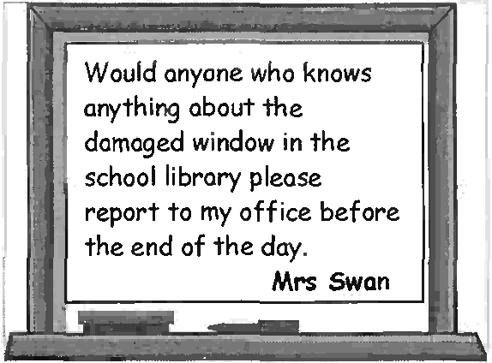

Would anyone who knows anything about the damaged window in the school library please report to my office before the end of the day.

**Mrs. Swan**

1. repair damage done to the library.
2. discover how a window got broken.
3. find out who uses the library.

**3**

FOR SALE

Gremlin Computer Game

(ages 8 and above)

Unwanted gift – box unopened

🕿 282137

1. The owner of the computer game that is for sale has never used it.
2. The computer game is for sale because the owner is too old for it.
3. The person selling the computer game no longer wants to play with it.

**4**

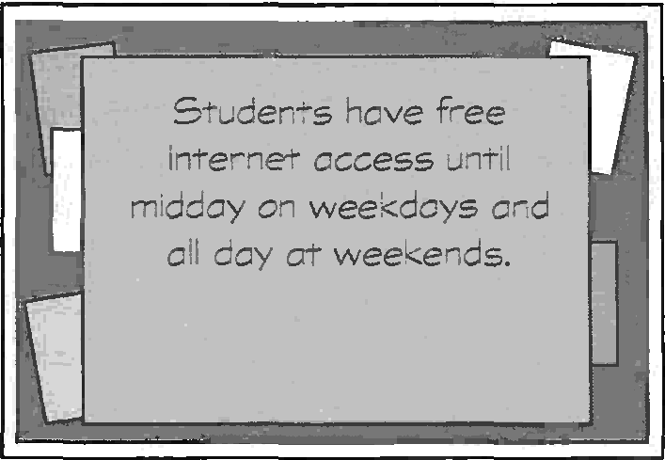

Students have free internet access until midday on weekdays and all day at weekends.

1. There is a charge for internet access at weekends.
2. Students must always pay to use the internet in the afternoons.
3. It doesn’t cost anything to use the internet on weekday mornings.

**5 Amanda regrets that she**

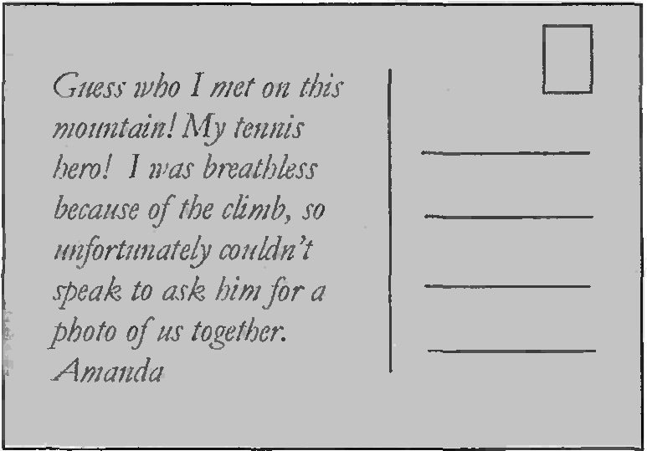

Guess who I met on this mountain! My tennis hero! I was breatbless because of the climb, so unfortunately couldn’t speak to ask him for photo of us together.

Amanda

1. didn’t recognize her tennis here from his photo.
2. couldn’t climb high enough to photograph her tennis hero.
3. didn’t have her photograph taken with her tennis hero.

**PART 2**

**Question 6 – 10**

* The people below all visiting the same city in Britain and want to find a suitable hotel.
* On the opposite page there are descriptions of eight hotels.
* Decide which hotel would be the most suitable for the following people.
* 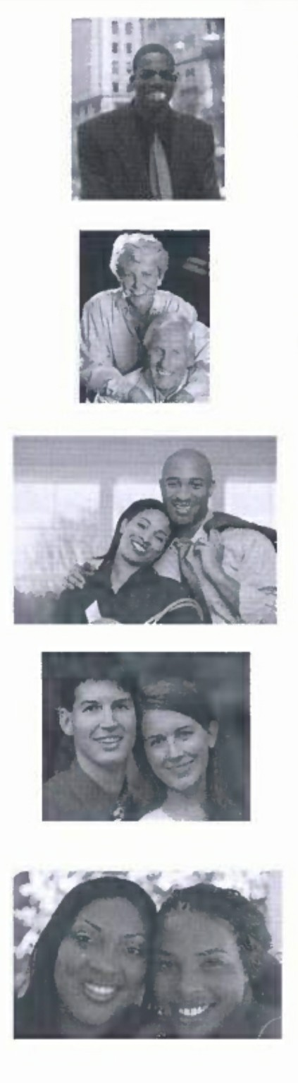For question **6-10**, mark the correct **(letters A-H)** on your answer sheet.

**6** Stephen is looking for a top-quality hotel which is convenient for the airport, to hold a meeting with visiting German publishers. They will stay overnight and want to take some exercise outdoors after the meeting.

**7** Karl and Monika want to stay in the city centre overnight at a hotel offering good local food. The next morning they plan to see the main sights. They are not worried about the cost of the hotel.

**8** James and Denise want a modern, medium-priced hotel in the city, but will eat out during their stay. They also want to see some films in the evenings, somewhere near their hotel.

**9** David and Katrina have just started work after leaving college and haven’t got much money, so they want a reasonably priced hotel. They like country walks and watersports.

**10** Sue and Belinda want to stay somewhere in the city centre that offers a variety of evening entertainment within the hotel, including live music.

**HOTELS**

|  |  |
| --- | --- |
| 1. The **Salisbury Hotel** is a top hotel with a health club, swimming pool, shops and a fully-equipped business centre. Within the hotel are three international restaurants, one with a French chef. The hotel is conveniently located close to the motorway, though airport users should allow plenty of time because traffic is usually heavy. | 1. The **Cumberland Hotel** is well placed for sightseeing on a busy city street, in a district which is full of interesting shops. Rooms are expensive but comfortable and the hotel serves excellent food, typical of the area.   A piano player entertains guests every night in the bar. |
| 1. The **Rathmore Hotel** offers good value accommodation, with wonderful English food in the restaurant. The hotel is well- known for its small orchestra which plays while guests have dinner. It is on the eastern edge of the city but special sightseeing buses are available to take guests into the centre (the trip takes over an hour in traffic). | 1. The **Russell Hotel** is close to the airport, and has quiet, comfortable rooms. However, the journey to the city centre can take time, and prices are above average. Delicious local food is served in the restaurant, and its conference rooms and business facilities are excellent. The hotel is surrounded by woodland, offers a golf course, and there are pleasant walks around the nearby lake. |
| 1. The newly-built **Aviemore Hotel** is small but in the centre of the city’s cinema, restaurant and nightclub district. Rooms are clean, comfortable and reasonably priced, although the food is rather basic. There is an electronic games arcade in the hotel. | 1. The **Padnal** is an older hotel in the heart of the cix, with ground-floor rooms opening onto a county-style garden. Prices are reasonable.   There is a sports centre and a small cinema and nightclub. A band performs even evening in the hotel restaurant, where excellent French food is served. Airport buses pick up from the hotel |
| 1. The **Westmore Hotel** is in beautiful countryside to the east of the city. It is peaceful and inexpensive, although the accommodation is basic. There are opportunities nearby for sailing and diving, and a lot of interesting routes to explore on foot. | 1. Although the prices at the **Grange Hotel** are higher than at many city-centre hotels, it has a lot to offer. It shares a modern complex with nightclubs, cinemas, shops and conference facilities, 20 kilometres west of the centre. Trains run from the nearby railway station to the city centre and the airport, although journeys can take up to an hour. |

**Questions 11 – 20**

* Look at the sentences below about tourist flights over the continent of Antarctica.
* Read the text on the opposite page to decide if each sentence is correct or incorrect.
* If it is correct, mark **B** on your answer sheet.
* If it is not correct, mark **B** on your answer sheet.

**11** Sightseeing flights to Antarctica are available for a limited period each year. b

**12** You may have to book a flight without being certain when it will happen. a

**13** Passengers have views of Antarctic scenery for more than half their flight. b

**14** Passengers can speak to people who have experience of working in Antarctica. a

**15** Special video equipment operates during the whole flight. a

**16** People are asked to stay sitting down so that everybody can see better. b

**17** There is an advantage in sitting on one particular side of the plane. b

**18** Before departure, the pilot chooses between a number of possible routes. a

**19** A special attraction of the trip is having clear views of Antarctic wildlife. b

**20** Passengers have the chance to put on clothes designed for travel in Antarctica. a

**ANTARCTICA SIGHTSEEING FLIGHTS WEBSITE**

Next fright 31 December!

Welcome to the website. Here is all you need to know before booking a flight.

During the brief Antarctic summer, Antarctica Sightseeing Flights takes tourists in a full-size passenger plane (Boeing 747) from Sydney, Australia, over the continent of Antarctica and back.

Flight dates for next year are not definite yet, but if you make a booking now, your deposit is transferable if we need to change the day.

**Questions**

These are answers to the most frequently asked questions about Antarctica Sightseeing Flights.

*How long is the flight?*

The average flight is 12 hours. About four hours into the flight, we usually see the first see ice and icebergs. We spend four hours over Antarctica and the remaining time travelling home. One the way to and from the environment and history, and answer questions. A camera next to the pilot, which is linked to the video system in board, gives you a pilot’s eye view throughout, from take-off to landing.

*Will I get a seat next to a window?*

All passengers are given two boarding passes. At the halfway point of the flight, passengers are asked to move the seat shown on the second boarding pass. Business and first class passengers will have a window seat for half of the flight and a next-to-window seat for the other half. Economy passengers will have a window scat or the seat next to a window seat for half of the flight and an end of row’ scat for the other half of the fright. While over Antarctica, we encourage passengers to get up from their scats and move about the plane, allowing everyone to share the sightseeing opportunities. The pilot flics in long ‘figure 8s’ over various points of interest to allow these amazing sights to be seen equally well from both sides of the plane.

*What happens if the weather is bad?*

We leave 1 7 different approved flight plans. Our captain looks at the satellite cloud picture on the morning of the flight and selects the direction with promises the clearest views.

*Will I see penguins and other wildlife?*

As most Antarctic wildlife lives at sea level, over 3.000 metres below the plane, we can’t see them in any detail. We do not land on Antarctica, primarily for environmental reasons. To experience Antarctic wildlife, you would need to join a boat tour

*Can I take photograph?*

Definitely’! All cameras are welcome. We even provide a few fun onboard photo opportunities where you can experience what it is like to near Antarctica cold weather clothes.

**GALLERY >**

**FLIGHT FACT >**

**PRICE >**

**BOOK NOW >**

**PART 4**

**Questions 21—25**

* Read the text and questions below.
* For each question, mark the letter next to the correct answer — **A, B, C** or **D** on your answer sheet.

**Maria Mutola**

***Former 800* metres *Olympic champion***

In 1988, Maria Mutola was playing football as the only girl in an all-boys team in a local competition in Mozambique. ‘We won,’ she said. ‘At first no one thought it was a problem that I was a girl. But then the team we beat complained.’

The story appeared in a local newspaper and José Craveirinha, who had encouraged other African athletes, learnt about Maria. He went to meet her and found her kicking a ball around outside the football club. He realised immediately that she was fast. ‘He talked to me about athletics. I had no idea what he meant. The only sport I knew about was football. Then he bought me running shoes and took me training. It was such hard work and my legs really ached.’ But José visited her parents and persuaded them she could be successful and this would help end their poverty. They agreed to let him take her away to train.

In 1991, she finally accepted an invitation to train in the United States. She had refused previously because she knew she would miss her family. Her background was unlike those of the girls she met in the US. She explains, ‘They were good athletes but, while I worried about my parents having enough to eat, they worried about dresses and make-up. They knew very little about me and even less about my problems. But I knew I was lucky to be there. The trainers were brilliant and I learnt a lot.’

**21** What is the writer trying to do in the text?

1. persuade more Africans to take up athletics
2. describe how Maria became a top athlete
3. give information about Mozambique
4. explain how Maria manages to stay fit
5. José Craveirinha found out about Maria when
6. he went to watch a local football competition.
7. she was blamed for her team losing a football competition.
8. he saw an article about her role in a football match.
9. people complained about another member of her football team.

**23** When José first introduced Maria to athletics, she

1. didn’t know what was involved.
2. was worried about being injured.
3. was keen to learn everything he knew.
4. didn’t think her family would approve.

**24** What does Maria say about the girls she met in the United States?

1. They did not make full use of their abilities.
2. Their training programmes were less demanding than hers.
3. They did not show enough respect for the trainers.
4. Their experiences of life were very different from hers.

**25** What would Maria say about her life?

**A B**

José has made all my dreams possible. From the first day we met, I was certain I wanted to become a top athlete.

My life hasn’t always been easy but I’ve had many opportunities. Running is important to me and so is my family.

**C D**

The US has some wonderful training facilities, so I’m glad that I agreed to go when I was first offered the chance.

I regret becoming involved in athletics. It was horrible leaving Mozambique and my parents. I’d like to go back to football.

**PART 5**

**Questions 26—35**

* Read the text below and choose the correct word for each space.
* For each question, mark the letter next to the correct word — **A, B, C** or **D** — on your answer sheet.

**Example:**

|  |  |  |  |  |
| --- | --- | --- | --- | --- |
|  | | | | |
| 0 | A | B | C | D |

**0 A** made **B** turned **C** done **D** put

**Answer:**

|  |  |  |  |  |  |  |  |  |
| --- | --- | --- | --- | --- | --- | --- | --- | --- |
| **26** | **A** | involves | **B** | contains | **C** | includes | **D** | consists |
| **27** | **A** | well | **B** | long | **C** | soon | **D** | far |
| **28** | **A** | to | **B** | on | **C** | for | **D** | with |
| **29** | **A** | case | **B** | order | **C** | fact | **D** | place |
| **30** | **A** | varieties | **B** | collections | **C** | sets | **D** | differences |
| **31** | **A** | seasons | **B** | times | **C** | years | **D** | dates |
| **32** | **A** | distant | **B** | rare | **C** | small | **D** | slim |
| **33** | **A** | cost | **B** | price | **C** | value | **D** | charge |
| **34** | **A** | all | **B** | some | **C** | most | **D** | every |
| **35** | **A** | shall | **B** | need | **C** | can | **D** | ought |

**HONEY**

Honey is a sweet liquid **(0)** ........................ by bees. It **(26)** .............. ........ of water and sugars. Bees may travel as **(27)** ........................ as seventy-five thousand kilometres and visit over two million flowers to produce just half a kilo of honey. The colour and flavour of honey depend **(28)** ........................ †he type of flower visited. In **(29)** ……….., there are more than three hundred **(30)** ..................... of honey.

The lighter-coloured ones are generally milder in flavour than darker honey.

In ancient **(31)** ........................................., honey was the main sweet food, as sugar was very **(32)** ......................... Honey was of great **(33)** ……………….to the ancient Egyptians, who used it as payment.

Today, honey is produced and eaten in **(34)** ........................ part of the world. Research suggests that it prevents tiredness and improves athletic performance. However, honey is not just food - it **(35)** ........................ be taken for sore throats and is used in many skin and hair-care products.

**WR ITING**

**PART 1**

**Questions 1—5**

* Here are some sentences about visiting a zoo.
* For each question, complete the second sentence so that it means the same as the first.
* **Use no more than three words.**
* Write only the missing words on your answer sheet.
* You may use this page for any rough work.

**Example:**

1. I could read when I was four.

**I**……………………………………**able to read since I was four.**

**0** have been

**Answer:**

1. None of my friends enjoy reading as much as I do.

**I enjoy reading any o1 my friends**

1. I borrowed a very good book from my teacher.

**My teacher…………………………….................................me a very good book.**

1. It doesn’t matter to me if a book is long or short.

**I don’t ....................................................................... if a book is long or short.**

1. My mother finished War *and Peace* in only three weeks.

**It only……………………my mother three weeks to finish *War and Peace*.**

1. I am often given books as presents.

**People often…………………………………………me books as presents.**

**Part 2**

**Question 6**

Richard, your English friend, has sent you some birthday money for you to buy a new DVD.

**Write an email to Richard. In your email, you should**

* + **thank him for the present**
  + **tell him which DVD you are going to buy**
  + **explain why you have chosen this film.**

**Write 35—45 words on your answer sheet.**

**PART 3**

Write an answer **one** of the following questions (**7** or **8**).

Write your answer in about **100 words** on your answer sheet.

Mark the question number in the box at the top of your answer sheet.

**Question 7**

* This is part of a letter you receive from an English penfriend.



**My sister’s getting married next week and we are all excited about the wedding. Tell me about weddings in your country. What do people wear?**

**Do they eat special food?**

* Now write a letter, answering your penfriend’s question.
* Write your **letter** on your answer sheet.

**Question 8**

* Your teacher has asked you write a story for homework.
* Your story must begin with this sentence:

As the concert finished, I heard someone call my name.

* Write your **story** on your answer sheet.

**PAPER 2 LISTENING TEST** about 35 minutes

(including 6 minutes transfer time)

**PART 1**

**Questions 1-7**

* There are seven questions in this part.
* For each question there are three pictures and a short recording.
* Choose the correct picture and put a tick (✓) in the box below it.

**Example:** Where did the man leave his camera?

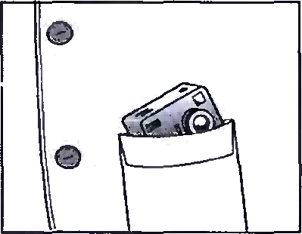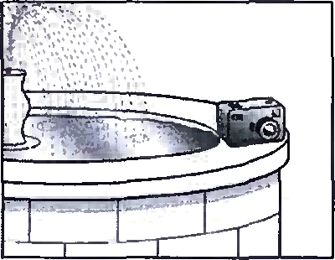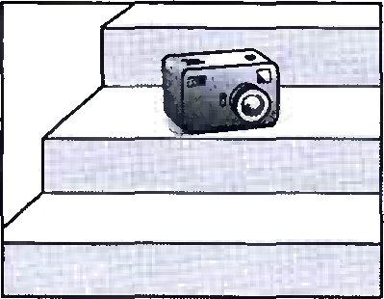

**A B C**

✓

1. Which sport will the woman learn on holiday?

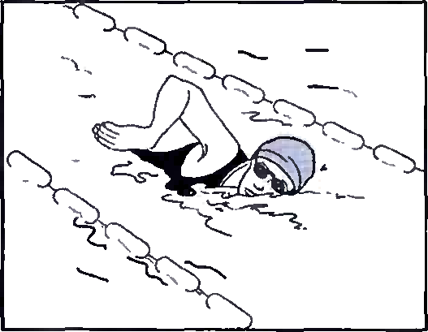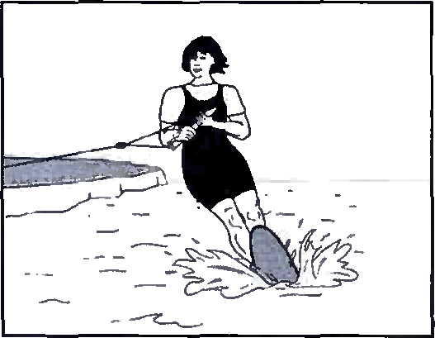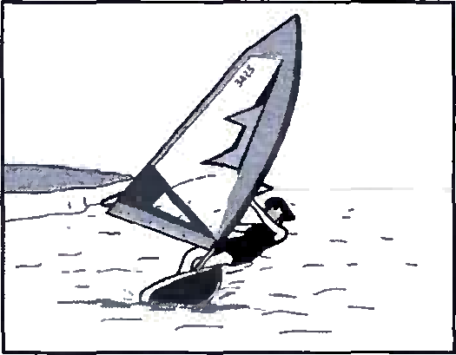

**A B C**

1. What does girl’s penfriend look like now?

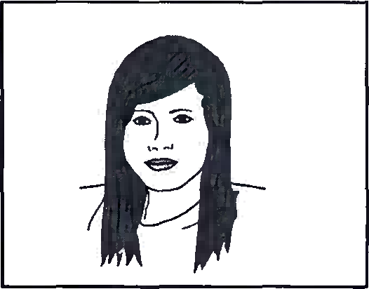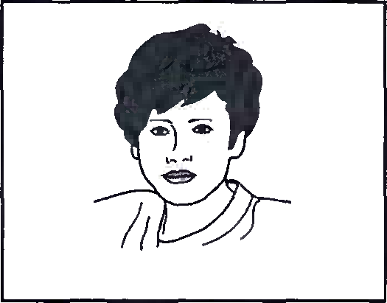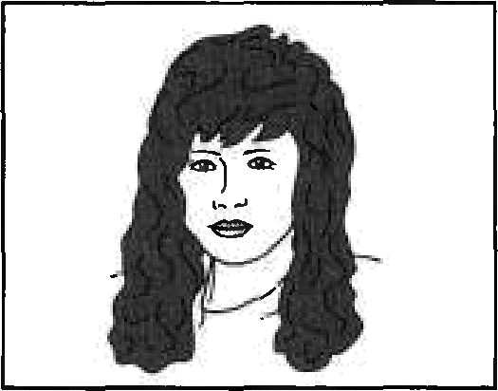

**A B C**

1. Which animals did the children see?

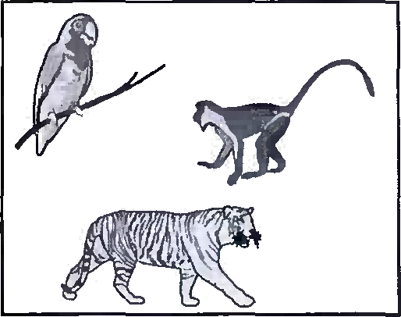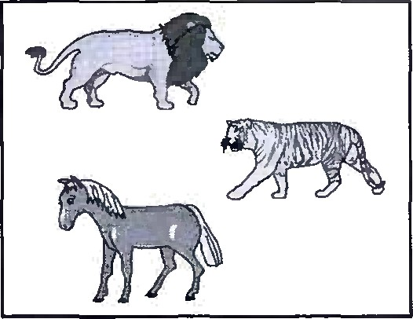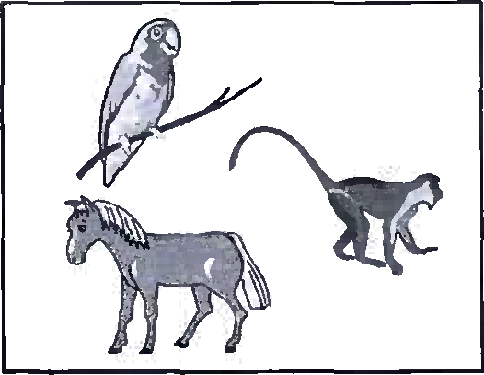

**A B C**

1. Which TV programme is on first?

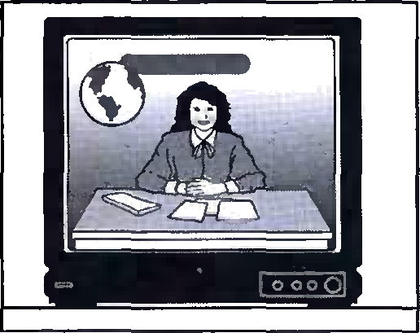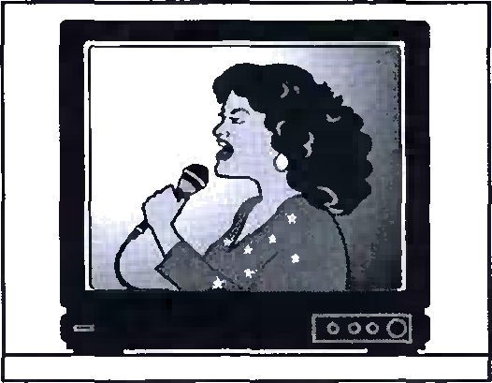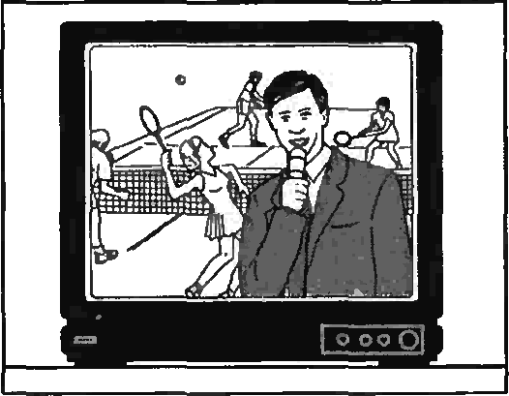

**A B C**

1. What does the boy decide to buy for his grandmother?

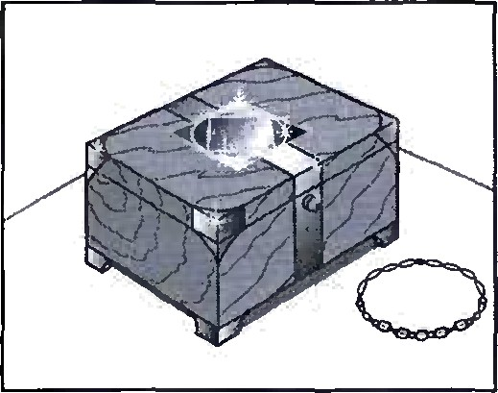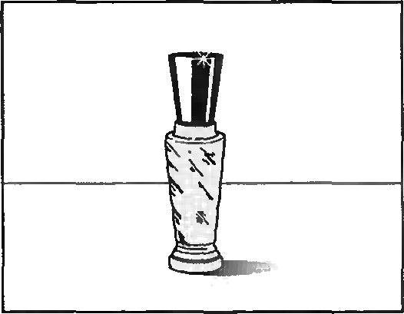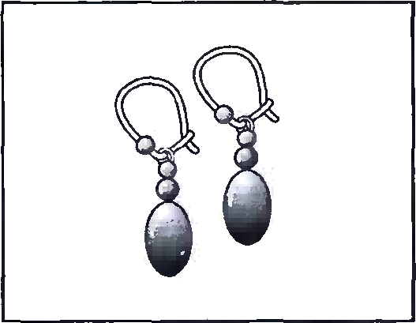

**A B C**

1. What time is the man’s appointment?

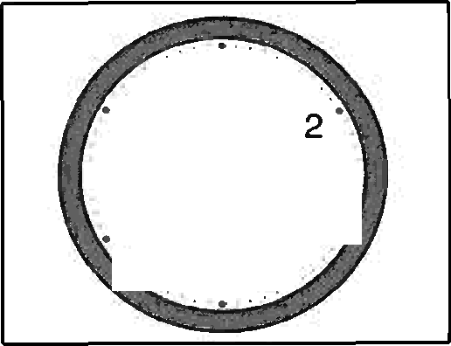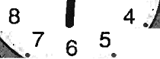

11 12 1

10

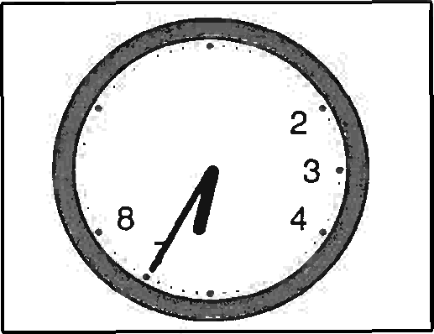

11 12 1

10

9

* 9

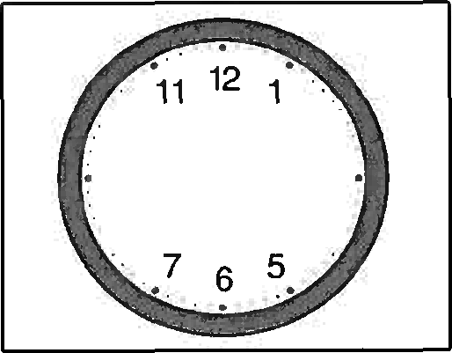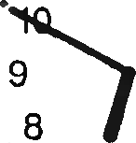

9

. 8

2

3 4

4

4.

**A B C**

**7** What has the woman lost?

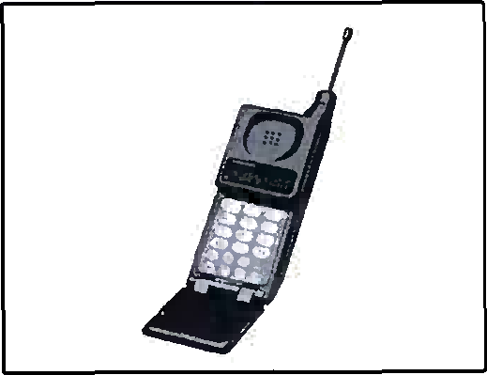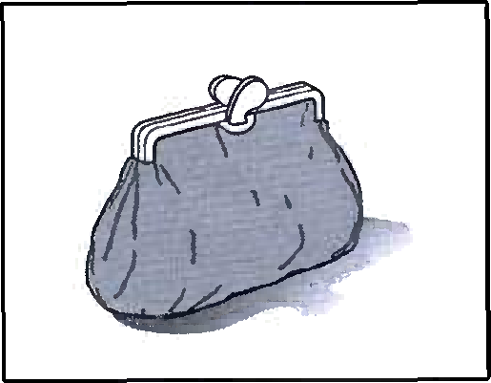

**A B C**

**PART 2**

**Question 8 -13**

* You will hear a man called Frank, talking on the radio about looking for ship that sank at sea long ago.
* For each question, put a tick (✓) in the correct box.

**8** The first old ship which F-rank found was

1. covered by rocks.
2. older than he first thought.
3. easy to find.

**9** Frank finds ships quickly because he

1. reads history books.
2. is a professional driver.
3. uses the latest equipment.

**10** What does Frank say about the ship called *The Seabird?*

1. It was built in 1859.
2. It sank in a storm.
3. It was badly made.

**11** Frank says his wedding ring

1. was made from gold he found

himself.

1. is worth £88,000.
2. was found by a friend.

**12** Frank’s wife believes he should

1. stop diving.
2. give things to museums.
3. sell some of his collection.

**13** How did Frank learn to dive?

1. by joining a diving club.
2. by going on a diving holiday.
3. by teaching himself.

**PART 3**

**Question 14 – 19**

* You will hear a man telling a group of students about a trip to the theatre.
* For each question, fill in the missing information in the numbered space.

Meet at 6.00 p.m. at the **(14)** ………………………of the school.

The name of the play is **(15)** …………………………

Get a copy of the play from the **(16)** …………………………

Each theatre ticket will cost **(17)** £…………………………

After theatre – have **(18)** ……………………and coffee.

On the return journey, the coach will stop at the

**(19)** ………………………and then the school.

**Trip to Staunton Theatre**

**PART 4**

**Questions 20—25**

* Look at the six sentences for this part.
* You will hear a conversation between a teenage boy, Alex, and his sister, Rose, about where to go to eat.
* Decide if each sentence is correct or incorrect.
* If it is correct, put a tick (✓) in the box under **A** for **YES**. If it is not correct, put a tick (✓) in the box under **B** for **NO**.

**A B**

YES NO

1. Alex and Rose’s mother have gone to their Grandad’s.
2. Alex tries to persuade Rose to cook supper.
3. Alex wants to eat in an expensive restaurant.
4. Alex likes some of the music at *Classic Express*.
5. Alex has eaten at *Classic Express* before.
6. Alex and Rose are going to walk to the restaurant together.

**About the Speaking test**

The Speaking test lasts about 10 to 12 minutes. You take the test with another candidate. There are two examiners in the room. One examiner talks to you and the other examiner listens to you. Both the examiners give you marks.

*Part 1*

The examiners introduce themselves and then one examiner asks you and your partner to say your names and spell them. This examiner then asks you questions about yourself, your daily life, interests, etc.

*Part 2*

The examiner asks you to talk about something together and gives you a drawing to help you.

*Part 3*

You each have a chance to talk by yourselves. The examiner gives you a colour photograph to look at and asks you to talk about it. When you have finished talking, the examiner gives your partner a different photograph to look at and to talk about.

*Part 4*

The examiner asks you and your partner to say more about the subject of the photographs in Part 3. You may be asked to give your opinion or to talk about something that has happened to you.

**PAPER 1 READING AND WRITING**

**READING**

*Part 1* 1B 2B 3A 4C 5C

*Part* 2 6D 7B 8E 9G 10F

*Part* 3 11A 12A 13B 14A 15A 16B 17B 18A 19B 20A

*Part* 4 21B 22C 23A

*Part* 5 26D 27D 28B 35C

**WRITING**

*Part 1*

1. (much) more than
2. (has) lent
3. mind/care/worry
4. took
5. give

**PAPER 2 LISTENING**

*Part 1* 1C 2B 3C 4B 5A 6B 7B

*Part 2* 8C 9C 10B 11A 12C 13A

*Part 3*

1. back gate
2. The Party
3. (school)secretary 17
4. £15.75
5. ice cream
6. bus station or bus stop

*Part* 4 20B 21B 22A 23A 24B 25A