***TEST 1***

**PAPER 1: READING AND WRITING** (1 hour 30 minutes)

**READING**

**PART 1**

**Questions 1 – 5**

* Look at the text in each question.
* What does it say?
* Mark the letter next to the correct question – **A**, **B** or **C** – **on your answer sheet**.

**Example**:

**0**



**Nothing value if left in this van at night**

1. Valuable objects are removed at night.
2. Valuables should not be left in the van.
3. This van is locked at night.

|  |  |  |  |
| --- | --- | --- | --- |
| **Part 1** | | | |
| 0 | A | B | C |

**Answer:**

1B 2A 3C 4A 5C

**1**

1. This part of the road will open again on 1st September.

**Road repairs starting here on 1st September for four weeks – expect delays**

1. Your journey may take longer on this road in September.
2. We are expecting more traffic on this road in September.

**2**

*Welcome to Hotel Maroc*

Dear Guest

Our holiday advisor is available in the lounge every day. 8-10 am for booking guided tours, museum/garden tickets, camel rides.

Enjoy your stay!

1. People staying at Hotel Maroc can arrange activities through the hotel.
2. Hotel Maroc’s holiday advisor accompanies guests on tours.
3. Daily sightseeing trips start from the Hotel Maroc.

**3**

**Online Booking Form**

Name ………………

Address ………………

No. of tickets ………………

Tickets booked within seven days of a performance are kept for collection.

1. Tickets will be sent to you within seven days of booking.
2. When booking, advise staff if your tickets are to be kept for collection.
3. We don’t post tickets booked one week or less before the performance.

**4**

|  |  |
| --- | --- |
| To | All players |
| From | Paul |
| The team is the same as last week – I’ve already checked everyone can play. Anyone needing a lift to Fyfiled can phone me | |

1. Players who have a problem getting to the Fyfield match should contact Paul**.**
2. Anyone who wants to play in the Fyfield game needs to speak.
3. Team members who are not available for the Fyfield match must phone Paul.

**5**

**IMPROVED SERVICE:**

From next month this bank will remain open until 2 pm on Saturday.

1. After next month the bank will open all weekend.
2. The bank closes at 2 pm on weekdays.
3. The bank will have longer opening hours in the future.

**PART 2**

**Question 6 – 10**

* The people below all want to watch a television programme.
* On the opposite page there are descriptions of eight television programmes.
* Decide which museum would be the most suitable for the following people.
* 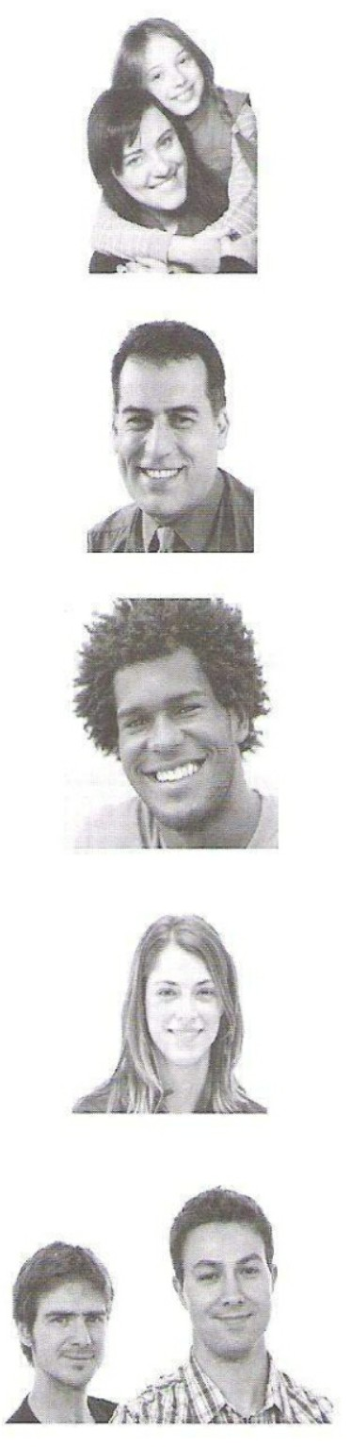For question **6-10**, mark the correct **(letters A-H)** on your answer sheet.

**6** Sandrine and her ten-year-old daughter, Daisy, love watching all kinds of dancing, especially of the dancers are famous entertainment. Daisy particularly likes the beautiful dresses the women wear.

**7** Tim has an amazing memory for facts on a range of topics. He enjoys testing himself against people taking part in quizzes on TV and wants to find out how to be on one himself.

**8** Simon enjoys murder mysteries, and likes the challenge of working out who did the crime before the identity of the murders is uncovered in the final scene.

**9** Mariella loves skiing and enjoys watching winter sports on television. She tries to improve her techniques by copying the professionals who take part in them.

**10**

Ned and Jake are computer programmers. The enjoy TV programmes that are funny give them a complete break from their work, especially if they are connected with football.

**ON TV TONIGHT**

|  |  |
| --- | --- |
| 1. **Below stairs**   New comedy series about Ray and Jen, who work in the IT section of a big company. Their office is in the basement while their bosses work in luxury upstairs. Reviews so far have been mixed. There are plenty of laughs, though some people may find the situations rather silly. | 1. **Whiteout**   All the latest action from the slopes, including men’s and women’s downhill racing, jumping, ice dance and ice hockey. Presented from the mountains by former footballer Neville Gray, with expert reports on speeds and distances. Figure skater Jayne Wilton comments on the dance performance. |
| 1. **Top Team**   A return of the jokey quiz show, in which teams of famous sports personalities and comedians have to give amusing answers to questions on a range of popular sports, not just football and tennis but winter sports too. Light-hearted entertainment for everyone. | 1. **Quicksteps**   Each week, well-known faces from the world of television team up with a professional partner to perform a range of classical and modern dances. You, the viewer, can vote for the best performance and the best costume, and each week’s winners will take part in the grand final later in the year. |
| 1. **Taskmaster**   Can you beat the four members of the public who answer general knowledge and specialist questions in the final of this year’s competition? Tonight’s specialist subjects include the history of winter sports, Latin American dances, detective novels and French history. There will be information about how to enter next year’s competition. | 1. **The Two Dancers**   Set in late 18th – century France, this drama tells of the relationship between two beautiful dancers who both love the same man. Although the ending is not unexpected, this drama is thoroughly entertaining all the way through. Worth watching just for the beautiful. |
| 1. **Inspector Blake**   A first – division football player has a beautiful wife, a big house and a bright future. When he’s found dead in his car near a local park, Blake discovers that he was less popular than it seemed. Set in the 1970s, this nail – biting drama will keep you guessing right until the end. | 1. **Madison**   This little-known musical is based on the true story of an American ice hockey team in the 1930s. the facts are historically accurate, even though the show is advertised as a musical comedy-thriller. Really only of interest to experts in the history of musicals or ice hockey fans. |

**PART 3**

**Questions 11 – 20**

* Look at the sentences below about a man who got lost in the Rocky Mountains.
* Read the text on the opposite page to decide if each sentence is correct or incorrect.
* If it is correct, mark **B** on your answer sheet.
* If it is not correct, mark **B** on your answer sheet.

**11** Bob Rigsby was in Canada in order to study its wildlife.

**12** On the first day of getting lost, Bob realised how serious his situation was.

**13** Bob has few problems finding something safe to eat in the mountains.

**14** On the fourth day, Bob recognised the place that he was in.

**15** Shirley thought that Bob sounded upset on the phone.

**16** It was the first time Bob had been missing for such a length of time.

**17** The first phone call that Shirley made was to the Canadian embassy.

**18** The hotel owner was worried while Bob was absent from the hotel.

**19** Employees from the hotel went to look for Bob.

**20** Bob says he regrets going into mountains on his own.

**Lost in the Rocky Mountains**

Fifty-four-year-old scientist Bob Rigsby was lost of for five days in Canada’s Rocky Mountains, and was only rescued after a mobile phone call to his wife, Shireley, over 8,000 km away in England.

Bob, a British wildlife expert, had been in Vancouver, Canada, giving a talk at a conference

on the environment. When it was over, he travelled to the Rocky Mountains and checked into The Maple Leaf hotel. He then set off on a short walk to look at the local plant and animal life. After a couple of hours, he realised he had taken a wrong turning on the mountain path, but was sure he could easily get back to the hotel. Even when night fell, he remained confident.

But, after walking for several hours the next day, it became clear to Bob that he was in trouble. ‘I had my mobile phone with me, but the battery was almost dead. I thought I could probably male just one call but I didn’t know the number of my hotel and I didn’t want to worry my family unless I really had to.’ Bob carried on walking for three more days. He knew which wild plants he could safely eat and he had little trouble finding them. When he was thirsty he drank from streams.

On the fourth day, he reached a forest that he knew he had walked through the previous day. His heart sank. He realised it was hopeless and decide to call his family in England. ‘He was quite calm when he spoke to me on the phone,’ says Shirley. ‘He appeared to be in control of the situation, in spite of everything. He’d been lost a few times before, but never for so many days – that’s why this time was different.’ She immediately contacted The Maple Leaf hotel, after a quick call to the Canadian embassy in London to get its phone number. ‘We’re always anxious if our guests are away for a long time,’ says Greg McCaffrey, the hotel’s owner. ‘but that week several of our English visitors had gone to the city for a few days to watch hockey games, and we thought Mr. Rigsby had gone too.’ As soon as Shirley phoned, hotel staff called the rescue service, who sent out a search party for the scientist. They found him in a cave some hours later, very tired, but, apart from some cuts and scratches, quite unhurt.

‘I’ve learnt my lesson,’ says Bob. ‘I admit I was stupid to set off like what without a guide. I never want an experience like that again!’

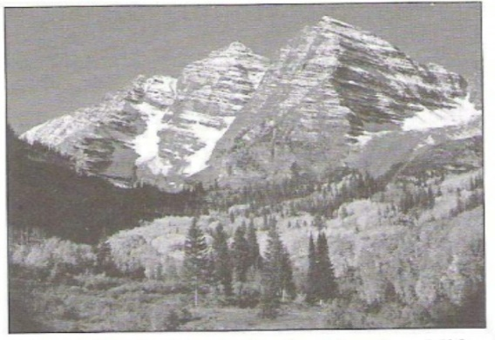

**PART 4**

**Questions 21—25**

* Read the text and questions below.
* For each question, mark the letter next to the correct answer — **A, B, C** or **D** on your answer sheet.

**Open – air Theatre**

In Britain, the ancient tradition of open – air performances is still alive and well. Cornwall has some of Britain’s oldest working theatres, with one open – air theatre actually built into a cliff, a project only recently complete.

Two actors, Dave James and Muriel Thomas, came

from Long theatres to join a theatre company called Coastline. They now regularly perform in just such a theatre, by the sea. ‘One thing about performing outside is we never know what’ll happen. For example, if a bird lands on stage, we can’t act as if it’s not there – the audience are all watching it. So we just bring the bird into the play, too. Once, about 30 dolphins came past, jumping out of the water and showing off. The audience were all chatting about them instead of watching the play, so the actors just gave up for a while and watched the dolphins, too.’

The weather can also be difficult. ‘Sometimes it’s been so bad,’ says Muriel, ‘that we’ve asked the audience if they really want to stay. But usually they sit with their coat and umbrellas and say, “Yes, please carry on!” They must feel it isn’t much fun, but no one’s returned their ticket so far!’

Coastline’s director, John Barnack, works hard to introduce people to theatre. ‘Many people think of theatres as clubs where they don’t belong and are not welcome,’ he explains/ ‘sitting in the open air changes that feeling. The audience are far more involved – they aren’t sitting in the dark, at a distance like in normal theatres, and that improves that actors’ performances, too. I’m very proud of the works they’ve done so far.’

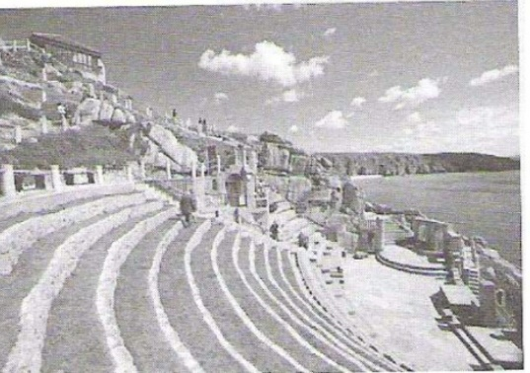

**21** What is the write trying to do in the text?

1. Follow the development of open – air theatre in Britain
2. Describe how one open air theatre was built
3. Explain what it’s like to work in an open – air theatre
4. Warn readers about the disadvantages of attending open – air performance
5. When plays are disturbed by local wildlife, the actor
6. Change their performance to include it.
7. Carry on as though nothing had happened.
8. Stop and have a chat with the audience.
9. Cancel the rest of the performance.

**23** What is the audience’s attitude to bad weather during performance?

1. They worry about the actors getting wet.
2. They said that it stops them enjoying the play.
3. They accept it as they have come well-prepared.
4. They feel they should have their money back.

**24** What does John Barnack say about outdoor theatre?

1. He’s afraid the atmosphere is more stressful for actors.
2. He’s happy that the audience feel comfortable being there.
3. He’s worried that it creates between actors and audience.
4. He welcomes the distance it creates between actors and audience.

**25** What would an actor from the Coastline company write in his or her diary?

**A B**

A difficult performance today – it was pouring with rain. Luckily the audience couldn’t see my face in the dark …

The theatre looks so old it’s hard to imagine they’ve just finished it. I’d prefer to be by the sea while I’m performing though …

**C D**

I’m glad I moved from the London theatre scene. But I don’t think our director is satisfied with what we’ve done so far …

I’m keeping a tradition going and it tests my acting skills, as I never know what unexpected things I’ll have to deal with …

**PART 5**

**Questions 26—35**

* Read the text below and choose the correct word for each space.
* For each question, mark the letter next to the correct word — **A, B, C** or **D** — on your answer sheet.

**Example:**

|  |  |  |  |  |
| --- | --- | --- | --- | --- |
|  | | | | |
| **0** | **A** | **B** | **C** | **D** |

**0 A** was **B** is **C** has **D** had

**Answer:**

**Alexander Graham Bell**

Alexander Graham Bell (0) ……………… born in Scotland I 1847. His father, an expert on speech, (26) ……………a way of teaching how words (27) ………… be pronounced. He translated the (28) ………… of words into straight or curvy lines.

Alexander (29) ………… to be a teacher and, when his

mother went deaf, he started to be (30) ………… in how

deaf people communicate. In 1870, because his children

were in poor health, Alexander and his family moved to the United States. He hoped that a warner (31) …………would be better for the whole family. It was while he was teaching deaf children there (32) ………… he invented a new machine. It was very (33) ………… to the human ear itself, and Bell discovered it could carry human speech (34) ………… a wire from one place to another. It was not long before the telephone was a part of (35) ………… our lives!

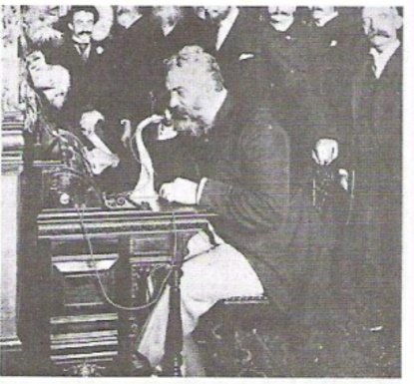

|  |  |  |  |  |  |  |  |  |
| --- | --- | --- | --- | --- | --- | --- | --- | --- |
| **26** | **A** | grew | **B** | built | **C** | developed | **D** | worked |
| **27** | **A** | ought | **B** | should | **C** | might | **D** | would |
| **28** | **A** | calls | **B** | voices | **C** | noises | **D** | sounds |
| **29** | **A** | trained | **B** | became | **C** | educated | **D** | taught |
| **30** | **A** | amazed | **B** | interested | **C** | surprised | **D** | excited |
| **31** | **A** | geography | **B** | season | **C** | climate | **D** | weather |
| **32** | **A** | so | **B** | because | **C** | since | **D** | that |
| **33** | **A** | likely | **B** | similar | **C** | same | **D** | accurate |
| **34** | **A** | above | **B** | about | **C** | same | **D** | around |
| **35** | **A** | any | **B** | each | **C** | along | **D** | every |

**WR ITING**

**PART 1**

**Questions 1—5**

* Here are some sentences about the Santiago Bernabéu football stadium in Spain.
* For each question, complete the second sentence so that it means the same as the first.
* **Use no more than three words.**
* Write only the missing words on your answer sheet.
* You may use this page for any rough work.

**Example:**

1. The Santiago Bernabéu stadium is close to the centre of Madrid.

**The Santiago Bernabéu stadium is** **…………………. the centre of Madrid.**

**Answer:**

**0** far from

1. Last week, one of my friends visited the Santiago Bernabéu football stadium.

**Last week, a friend of** ....................................................**visit the Santiago Bernabéu.**

1. He had not been to this stadium before.

**It** ……………………………………**the first time he had been to this stadium.**

1. It costs €9 to go on a tour of the stadium.

**You have to** … **€9 to go on a tour of the stadium.**

1. A visit to the dressing room is included in the tour.

**The tour** ……………………………………………**a visit to the dressing room.**

1. No other football stadium in Madrid is as big as Santiago Bernabéu.

**Santiago Bernabéu** ……………………….... **any other football stadium in Madrid.**

**Part 2**

**Question 6**

You’ve just bought something new for your bedroom.

**Write an email to your friend Teresa. In your email, you should**

* + **Describe what you have bought**
  + **explain why you need it**
  + **say where you’re going to put it.**

Write **35—45 words** on your answer sheet**.**

**PART 3**

Write an answer **one** of the following questions (**7** or **8**) in this part.

Write your answer in about **100 words** on your answer sheet.

Tick the box (Question 7 or Question 8) on your answer sheet to show which question you have answered.

**Question 7**

* This is part of a letter you receive from an English penfriend.



**I enjoy my new job but I sit at a computer all day now. I don’t get much exercise. What do think I should do to keep fit?**

* Now write a letter, giving your friend some advice about keeping fit.
* Write your **letter** on your answer sheet.

**Question 8**

* Your English teacher has asked you to write a story.
* Your story must begin with this sentence:

*When I sat down, I discovered I was next to someone very famous*.

* Write your **story** in about 100 words on your answer sheet.

**PAPER 2 LISTENING TEST** about 35 minutes

(including 6 minutes transfer time)

**PART 1**

**Questions 1-7**

* There are seven questions in this part.
* For each question there are three pictures and a short recording.
* Choose the correct picture and put a tick (✓) in the box below it.

**Example:** Where is the girl’s hat?

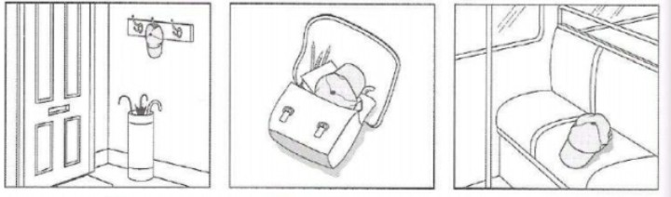

**A B C**

✓

1. How will the book their flights?

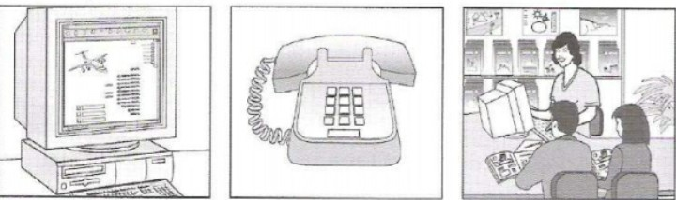

**A B C**

1. What has the daughter forgotten to bring on holiday?

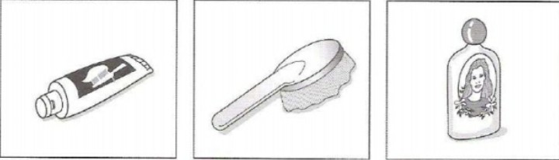

**A B C**

1. What will the man and woman do on Sunday?

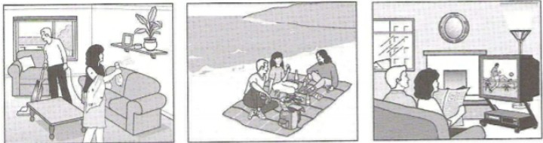

**A B C**

1. Which blouse does the girl decide to buy?

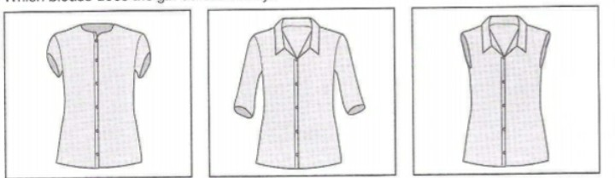

**A B C**

1. When is the girl having a party?

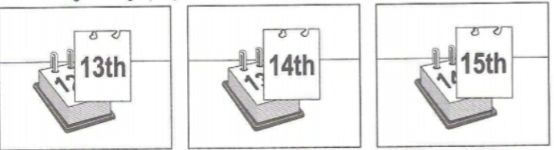

**A B C**

1. Where is the motorcycle race going to finish?

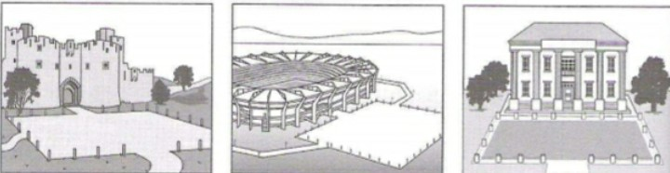

**A B C**

**7** What will the woman repair next?

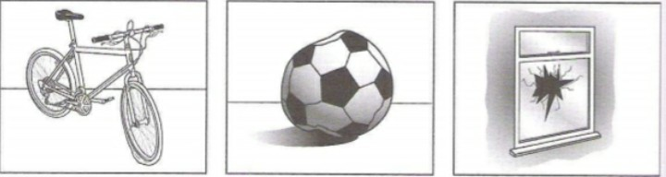

**A B C**

**PART 2**

**Question 8 -13**

* You will hear an interview with a man called Robin Marshall, who has written a book about Argentina.
* For each question, put a tick (✓) in the correct box.

**8** What was Robin’s job in Argentina?

1. translator.
2. tour guide.
3. travelling salesman.

**9** On Robin’s last trip to Argentina, the weather was

1. colder than he expected.
2. suitable for what he planned
3. different from the forecasts he heard.

**10** What did Robin buy from the market he visited?

1. a picture
2. a chair
3. a record

**11** How did Robin feel during the dance performance he saw?

1. He wanted to get up and dance.
2. He wished he had continued his

dance classes.

1. He was sad he didn’t dance well.

**12** What did Robin do while he stayed in the village?

1. He went on a bus tour
2. He went into the forest.
3. He went on a river trip.

**13** What did Robin like about his favourite place?

1. the wildlife
2. the view
3. the peace

**PART 3**

**Question 14 – 19**

You will hear a radio presenter talking about museum where you can see a new film.

For each question, fill in the missing information in the numbered space.

**FILM AT THE SCIENCE MUSEUM**

**The Film**

Country it is about: **(14)** ………………

Day it is on: Sunday

Time last performance starts: **(15)** ………………

**Other things to do at the museum**

* use the **(16)** …………… in the basement
* see a model **(17)** …………… on the first floor
* try the café on the **(18)** ……………… floor

**How to get free tickets for the film**

* send an email before 12 o’clock on **(19)** ……………….

**PART 4**

**Questions 20-25**

* Look at the six sentences for this part.
* You will hear two neighbours, a woman, Natasha, and a man, Colin, talking about running.
* Decide if each sentence is correct or incorrect.
* If it is correct, put a tick (✓) in the box under **A** for **YES**. If it is not correct, put a tick (✓) in the box under **B** for **NO**.

A B

YES NO

1. Natasha has decided to take the day off work to go running.
2. Colin found running to work was bad for his health.
3. Natasha would prefer to go running outside the city.
4. Natasha would like to wear her sports clothes at work.
5. Natasha will run in the big race because she hopes to win it.
6. Colin and Natasha will prepare for the pig race together.

***Key***

**PAPER 1 READING AND WRITING**

**READNING**

Part 1

1B 2A 3C 4A 5C

PART 2

6D 7E 8G 9B 10C

PART 3

11B 12A 13A 14A 15B 16A 17A 18B 19B 20A

PART 4

21C 22A 23C 24B 25D

PART 5

26C 27B 28D 29A 30B 31C 32D 33B 34C 35C

**WRITING**

PART 1

1. mine
2. was
3. pay/spend/(just/only)
4. (also) includes
5. (even) larger/bigger than

**PAPER 2 LISTENING**

PART 1

1C 2C 3B 4B 5A 6C 7B

PART 2

8C 9B 10A 11A 12C 13C

PART 3

14 Greenland

15 Five/5 o’clock (p.m/.in the afternoon)

5pm

17.00 (hours)

5.00pm

16 computer(s)

17 space(-)ship

18 top/highest

19 F/fri(day)

PART 4

20B 21A 22A 23B 24B 25B