**COMP1682 Project Proposal**

**An Investigation on How to Protect Children Online from Paedophiles**

**xxxx**

**BSC Computing**

**xxxx**

# 1. Overview

According to the Journal Adolescent Health 63 (Madigan et al., 2018) Studies have found that one out of five youth experience unwanted online exposure to sexually explicit material, and one out of nine youth experience unwanted online solicitation of sexual nature. This shows that the internet in not a safe place for children and teenagers to communicate with each other, for this reason a project will be done to help prevent this issue.

In a recent study done by IWF (2017) shows that Europe now hosts the majority of child sexual abuse webpages (60%), with north America in second place (33%). Some teenagers use online chatting websites that promote ads to enter chat rooms for sexual purposes and this can be accessed very easily.

The main purpose of this project is to make sure children and teenagers can communicate online safely, this will be done by creating a system where the system is based on getting data from the database where all the messages and posts will be saved, only admins will have access to this and they will not be able to have complete access to the data. Once the admin logs in, they will be able to search for specific keywords from a list within the database for example the admin will search (send me your pictures) then the system will show all the data with the user ID and their username to be able to know which user sent that message.

This project tends to help users under the age of 19 to communicate with each other as safely as possible, even though there are many platforms to do so like Instagram and Facebook, but this is exactly what makes it easy for paedophiles and predators to attack these teenagers and get away with it. This will be done by creating a web application where users will be able to post on their profile, communicate with other users through private texting or in groups.

# 2. Aim

This project aims to provide users under the age of 19 a platform to interact with each other through a website where they will be protected as much as possible from paedophiles and other predators.

# 3. Objectives

## 3.1. Research Report

The research that will be carried here would be on how paedophiles approaches their victims using some of the real chat that was done by them, analyse it and come up with the most commonly used words to make a list that will be used for the system.

The estimated time is given in days.

**3.1.1.** Researching the paedophiles behaviour. [5]

**3.1.2.** Research how paedophiles attract children to chat with them. [6]

**3.1.3.** Research on chat applications. [2]

**3.1.4.** Research on communications among children via digital means. [2]

**3.1.5.** Research how other websites tend to protect their users from predators. [3]

**3.1.6.** Analyse the paedophiles chats with their victim. [9]

**3.1.7.** Output the results of the most common used words. [2]

**3.1.8.** Create a list for all the keywords that has been found in the research for the system. [1]

**3.1.9.** Write project proposal. [22]

**3.1.10.** Write introduction. [1]

**3.1.11.** Write a literature review. [8]

**3.1.12.** Compare 2-3 similar products according to CRM. [8]

**3.1.13.** Research methodologies that fits with this project. [3]

## 3.2. Design Documentation

This will involve creating all the necessary diagrams to be able to visualise the functional requirements for the system and the website.

**3.2.1.** Write the key functional and non-functional requirements. [5]

**3.2.2.** Document the use of HCI. [3]

**3.2.3.** Create use case diagram, how the user will interact with the application. [6] **3.2.4.** Create the database schema. [4]

## 3.3. Product Implementation

A web application will be developed in addition to the system, an investigation will be carried regarding the technologies that will be used in order to develop the system and the web application.

**3.3.1.** Create the database. [10]

**3.3.2.** Create a web application prototype which will be used by the user. [35]

**3.3.3.** Create a system which will be used by the staff. [30]

**3.3.4.** Document the steps of the implementation. [3]

**3.3.5.** Explain how to use the system with screenshots. [1]

## 3.4. Testing

Both the system and web application will undergo some testing to ensure that the product will meet the user requirements.

**3.4.1.** Create a test plan. [3]

**3.4.2.** Test the system based on the plan. [15]

**3.4.3.** Get feedback from real users. [2]

**3.4.4.** Update the system based on the test results and feedback. [20]

**3.4.5.** Document the results of black box and white box testing. [5] **3.4.6.** Write the issues and how it was fixed. [2]

## 3.5. Evaluation Report

Produce a report which will contain all the research and the documentation for the product implementation.

**3.5.1.** Compare the product against the requirements. [5]

**3.5.2.** Write an evaluation of the product. [2]

**3.5.3.** Write down what went right and wrong as well as strengths and weaknesses. [3]

**3.5.4.** Ask questions, get feedback. [7]

**3.5.5.** Update the report and submit. [5]

**3.6. Project Framework or Any Methodology used:**

Agile software development methods are considered to fit most with the project, because of its benefits and flexibility in making changes as stated by Novoseltseva (2017) “*In Agile development, testing is integrated during the cycle, which means that there are regular check-ups to see that the product is working during the development. This enables the product owner to make changes if needed and the team is aware if there are any issues.”*

One of the benefits is that there are iterations which breaks down the work into short cycles where parts of the project is done one at a time, feedback should be given after each iteration which makes the user an important actor in this project. The methodologies considered are DSDM, Scrum and Extreme Programming. DSDM is taken in consideration because of it 8 principles which fits with the project, the goal here is to deliver what the user needs which is the system with its requirements and to make sure to deliver these requirements on time the timebox approach will be used, priorities the requirements and always meet the deadlines. According to Buehring (2019) the design documentation and testing will be important in terms of the quality, once the requirements are defined and prioritised the system should be delivered incrementally. Since the project needs to be tested and is dependent on feedback, this makes it a perfect fit with iteratively development. As for communications a meeting will be conducted once every week before the deadline to get feedback, and to maintain all this the project must aligned to the project aims.

The Scrum approach is very similar to DSDM, but scrum has sprints that last one to two weeks to deliver software on regular basis. As stated by Eriksson (2018) Extreme Programming it focuses on improving the quality and responsiveness to evolving customer requirements, the principles of this methodology are very close to DSDM and Scrum.

More research will be carried in the future to make a final decision on which methodology to use.

# 4 Legal, Social, Ethical and Professional

The first legal issue to consider is the protection of the user data which will be stored in our database thus the “Data Protection Act (2018)” should be applied.

According to GDPR (2018) “Where the child is below the age of 16 years, such processing shall be lawful only if and to the extent that consent is given or authorised by the holder of parental responsibility over the child.” In this case whenever a user sign up for an account and the age is under 16 the user will be asked to enter their parents email address and phone number, this will make it easier for us to contact the parents and let them give us consent by sending them an email to confirm their consent as well as sending them updates regarding their child online safety.

The social media has become part of our life thus making it a source of talking which is becoming a habit for both adults, teenagers and children and there is no way of knowing whether they are safe online or not. The website that will be developed will have a social impact by raising awareness regarding all the predators that are online looking for victims, the website will help to let them communicate as safely as we can with the help of their parents which can be done together to make the predators aware that we are monitoring the users and there will be a price for whoever tries and act against the rules.

Another big issue with the system is the user confidentiality and privacy which goes against the Human Rights Act (1998) because the system will have access and view their messages. Everyone has the right to be respected of their privacy therefore it is against the law to break it, to prevent this the system will only have access when a keyword matches with the message that has been sent. If the results match the keyword and the message line is against the website rule then further investigation will be done, if not then there will be no access to their messages at all.

The website will be aligned with the World Wide Web Consortium W3C (2019), through its Web Accessibility Initiative (WAI) guidelines. For example, the visual content should such as text and pictures should be adjustable to the browsing device and the colours should fit with the requirements for colour blind people. All the guidelines will be applied in the system to make sure it fits the user requirements when using the website or the system.

# 5 Planning (see appendix A)

The plan has been made by creating all the objectives for this project using Gantt chart with the estimated hours and days. As it is shown on figure 1 the project will start by researching and then design documentation, the next step will be the implementation the system will be designed based on the requirements that has made in order to make the system compatible with the user. The system will be tested using the plan (this will be done later) and getting feedback from real users, after the results the system will be updated depending on the results to satisfy the user requirements, hence the time is not enough to get more feedback and testing as the methodology requires but this will help the system to meet the user requirements and expectations as much as possible.

# 6 Initial References

1. Buehring, S. (2019). *The DSDM Principles: A Visual Guide.* Available at: [https://www.knowledgetrain.co.uk/agile/the-dsdmprinciples](https://www.knowledgetrain.co.uk/agile/the-dsdm-principles) (Accessed: 28/10/2019).
2. Novoseltseva, E. 2017. *The benefits You Get by Doing Agile Project Management.. Available at:* [https://apiumhub.com/techblog-barcelona/benefits-of-agile-project-management/](https://apiumhub.com/tech-blog-barcelona/benefits-of-agile-project-management/) (Accessed: 27/10/2019).
3. Eriksson, U. (2019). *Agile vs. Scrum: Differences Between Scrum and Agile Development.* Available at:

<https://dzone.com/articles/agile-vs-scrum-differences-between-scrum-and-agile>(Accessed: 28/10/2019).

1. GDPR. (2018). *Conditions applicable to child's consent in relation to information society services*. Available at: [https://gdprinfo.eu/art-8-gdpr/](https://gdpr-info.eu/art-8-gdpr/) (Accessed: 25/10/2019).
2. IWF. (2017). *Latest Internet Watch Foundation report shows Europe now hosts 60% of child sexual abuse webpages. Available at:* <https://www.iwf.org.uk/news/latest-internet-watch-foundation-report-shows-europe-now-hosts-60-of-child-sexual-abuse>(Accessed 27/10/2019).
3. Madigan, S. Villani, V. Azzopardi, C. Laut, D. Smith, T. Temple, J. Browne, D. and Dimitropoulos, G. 2018*. The prevalence of unwanted online sexual exposure and solicitation among youth: a meta-analysis.* Canada: Elsevier. Available at:

<https://www.jahonline.org/article/S1054-139X(18)30134-4/addons>(Accessed: 21/10/2019).

1. Human Rights Act. 1998. *Human Rights Act 1998.* Available at:

<http://www.legislation.gov.uk/ukpga/1998/42/schedule/1/part/I/chapter/7>(Accessed: 28/10/2019).

1. W3C. 2019. *W3C Accessibility Standards Overview*. Available at: <https://www.w3.org/WAI/standards-guidelines/>(Accessed: 28/10/2019).

# 7 Bibliography

1. Elzinga, P. Wolff, K. and Poelmans, J. 2012*. Analyzing Chat Conversations of Pedophiles with Temporal Relational Semantic Systems.* Available at:

[https://www.researchgate.net/publication/261427844_Analyzing_Chat_Conversations_of_Pedophiles_with_Temporal_Relat ional_Semantic_Systems](https://www.researchgate.net/publication/261427844_Analyzing_Chat_Conversations_of_Pedophiles_with_Temporal_Relational_Semantic_Systems) (Accessed: 15/10/2019).

1. Gunawan, F. Ashianti, L. Candra, S. and Soewito, B. 2016. *Detecting Online Child Grooming Conversation.* Indonesia: KICSS. Available at: <https://www.researchgate.net/publication/317692642_Detecting_online_child_grooming_conversation>(Accessed: 30/09/2019).
2. Kontostathis, A. Edwards, L. Bayzick, J. McGhee, I. *Leatherman, A. and Moore, K. 2009. Comparison of Rule-Based to Human Analysis of Chat Logs.* USA: Ursinus College. Available at: [https://www.semanticscholar.org/paper/Comparison-of-Rulebased-to-Human-Analysis-of-Chat-Kontostathis-Edwards/8c50e2b9d0bc638f525b08b4ae67641108a9d956](https://www.semanticscholar.org/paper/Comparison-of-Rule-based-to-Human-Analysis-of-Chat-Kontostathis-Edwards/8c50e2b9d0bc638f525b08b4ae67641108a9d956) (Accessed: 19/10/2019).
3. Pranoto, H. Gunawan, F. and Soewito, B. 2015*. Logistic Models for Classifying Online Grooming Conversation.* Indonesia: Science Direct. Available at: <https://www.sciencedirect.com/science/article/pii/S1877050915020657#!>(Accessed: 08/10/2019).
4. Upadhyay, A. Chaudhari, A. and Arunesh. Ghale, S. 2017. *Detection and Prevention measures for Cyberbullying and Online Grooming.* India: International Conference on Inventive Systems and Control.

# Appendix A

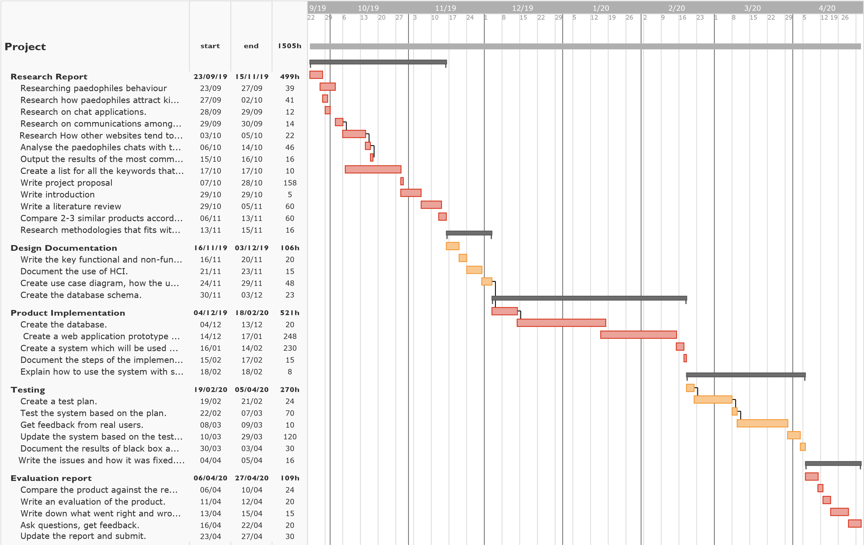

**Figure 1.** a Gantt Chart showing the estimated time (Hours) for all the objectives that must be done within the time given in order to complete the system.