LAB REPORT – Authentication & Session Management
Student name: Hồ Thiên Trường
Course: Web Application Development
Lab: 6
System Overview
The Student Management System supports two roles:
Admin:
- Access dashboard
- Add/Edit/Delete students
- View student list

User:
- View student list only
- Cannot access dashboard
- Cannot modify student data

Database Setup
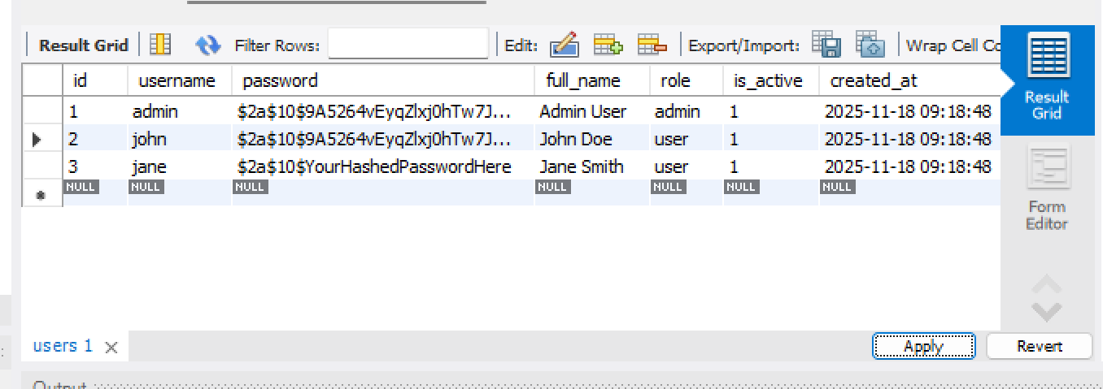

UserDAO – Authentication
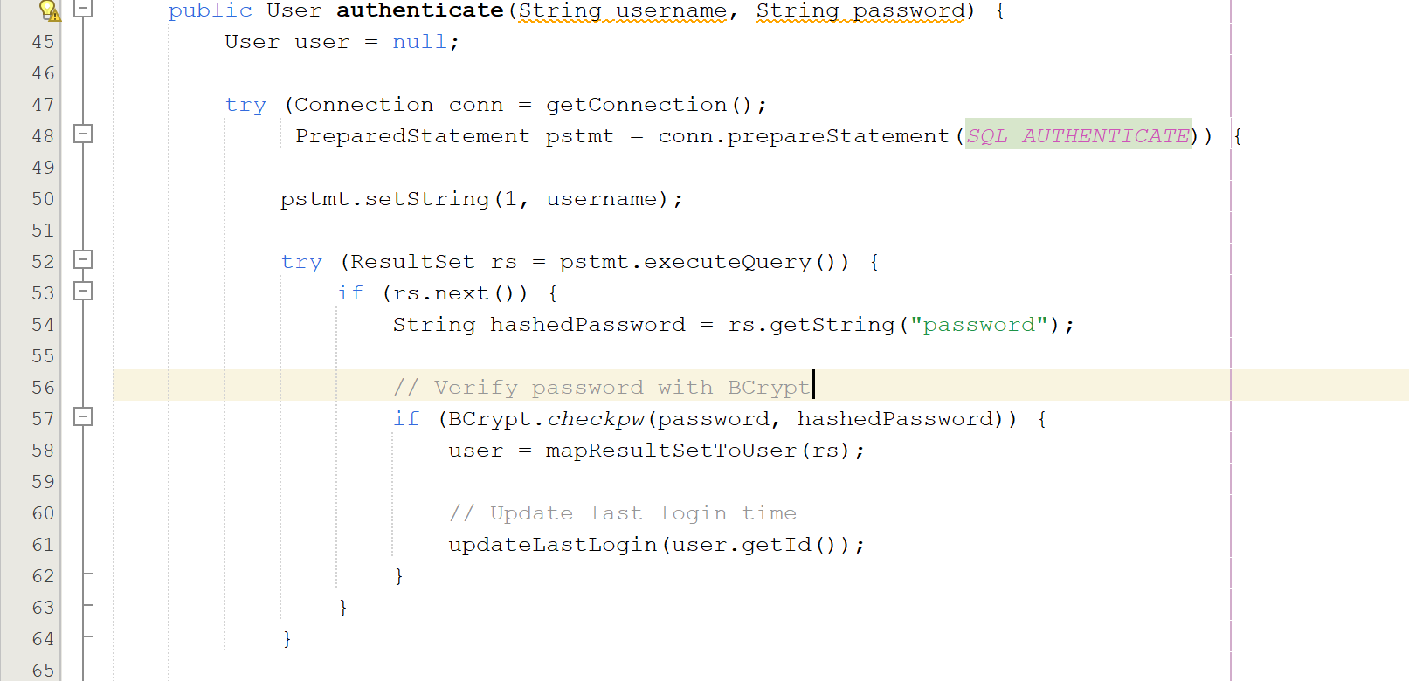

LoginController

GET /login
- Show login page
- If already logged in → redirect to dashboard

POST /login
- Validate input
- Call UserDAO.authenticate()
- If valid → create session
- Store:

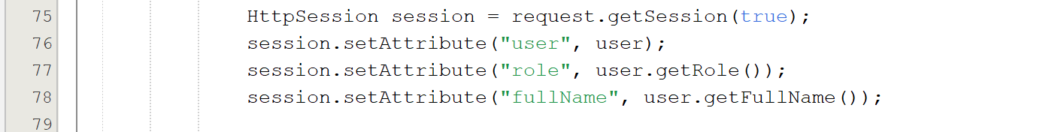

Redirect:
- admin → dashboard
- user → student list
If invalid → return to login.jsp with error message

DashboardController

User:
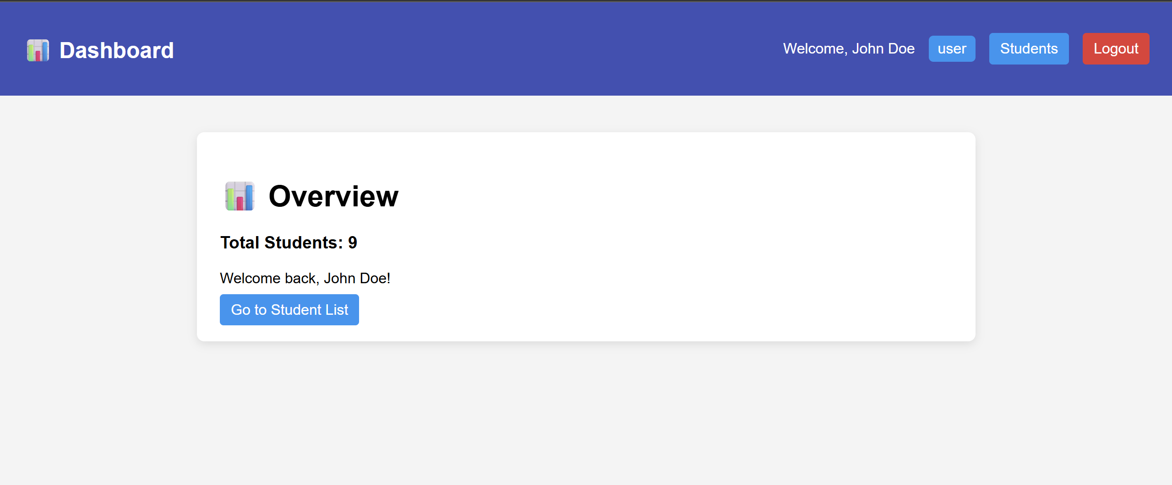

Admin:
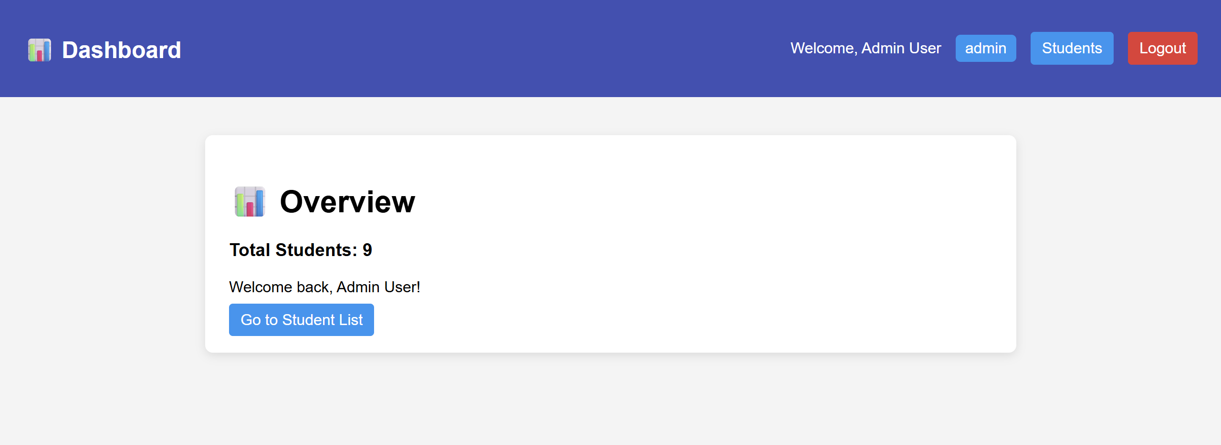

StudentController
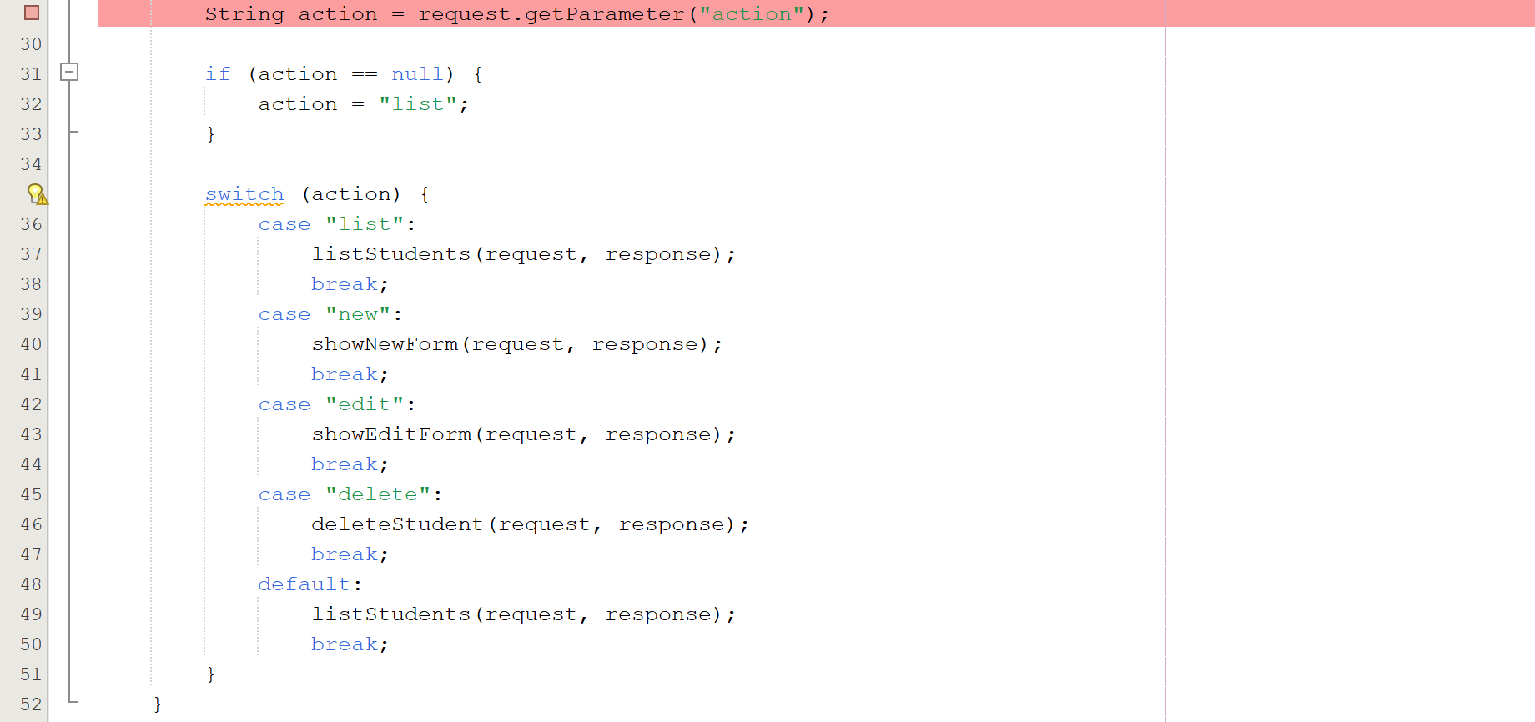

?action=list
?action=new
?action=edit&id=...
?action=delete&id=...

Filters
AuthFilter
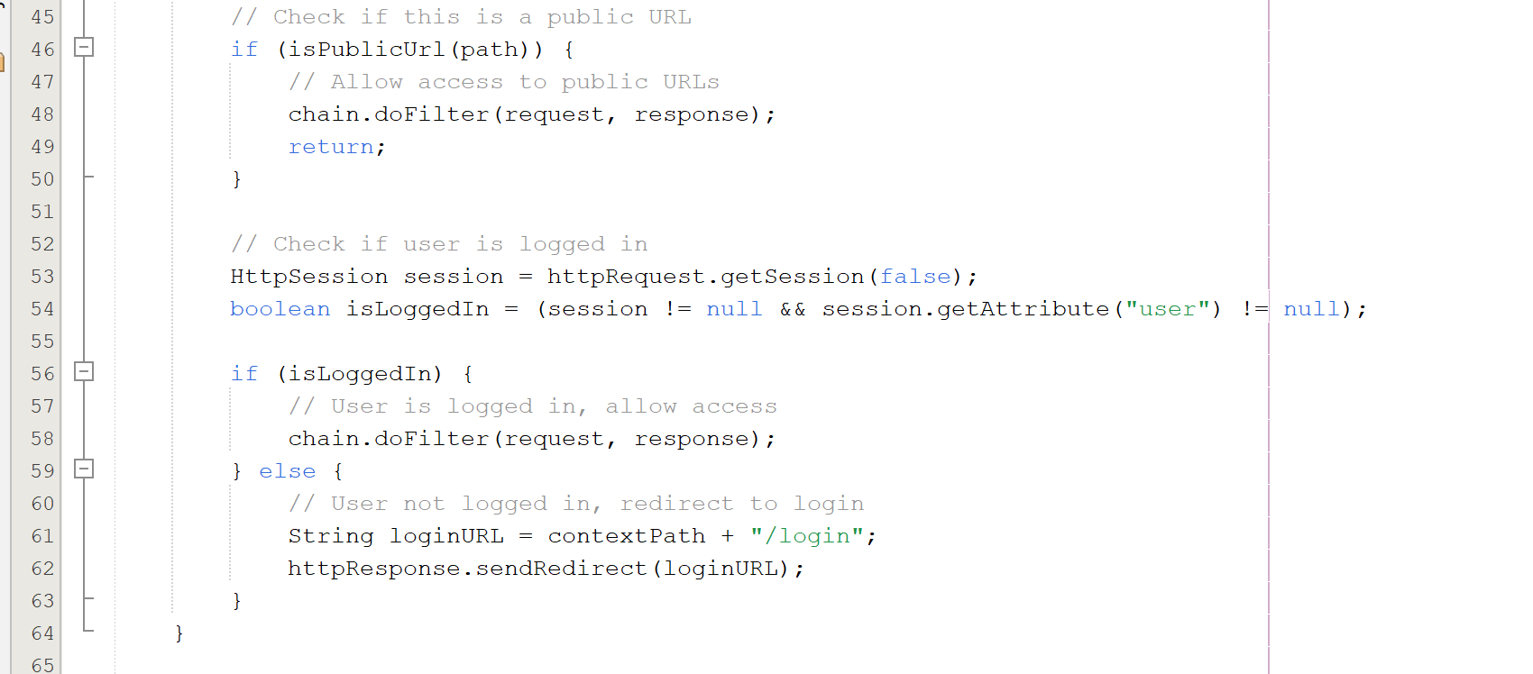

AdminFilter

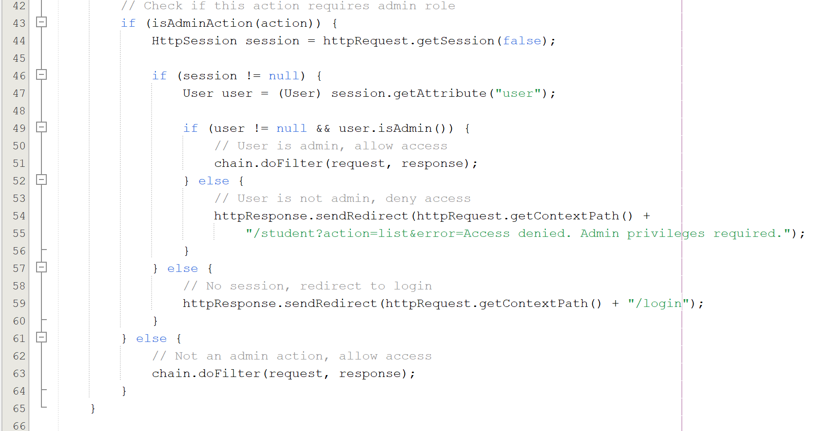

JSP + JSTL

Example: show Edit/Delete only for admins:
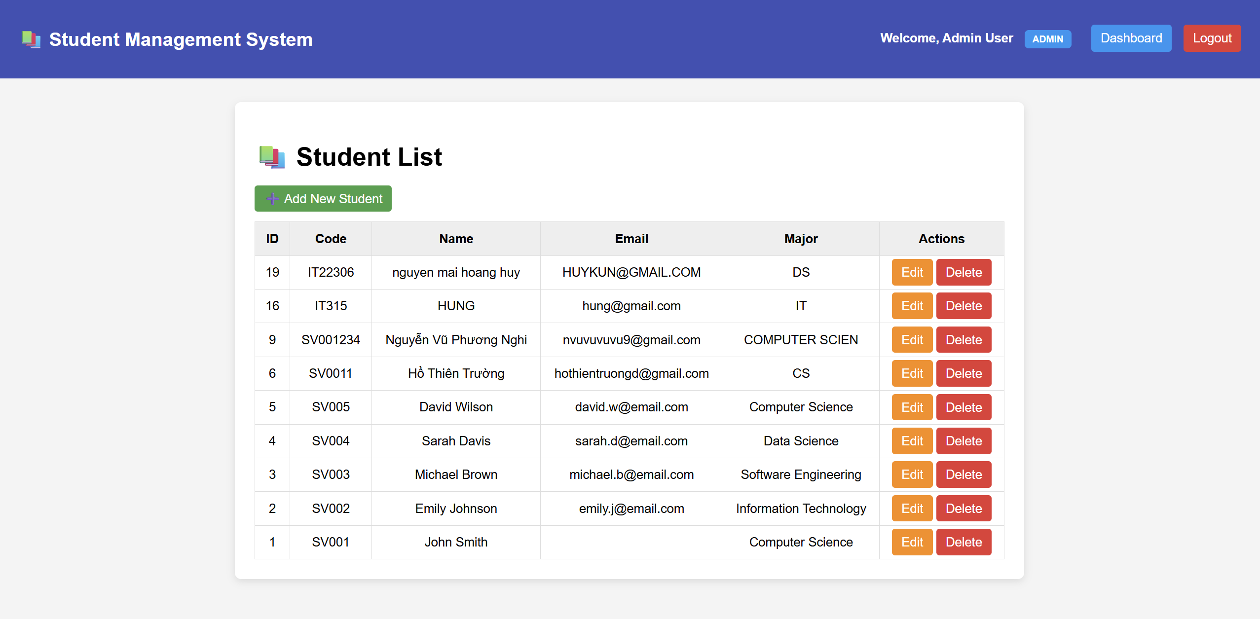

Workflow

- Authentication Workflow

- User enters username/password in login.jsp
- POST → /login
- LoginController:
  - validate input
  - call UserDAO.authenticate()
  - if correct → create session
  - if incorrect → return to login.jsp
- Redirect user based on role

login.jsp → LoginController → UserDAO → Session Created → Redirect

- Authorization Workflow

Admin
- Can access dashboard
- Can add/edit/delete students
User
- Cannot access dashboard
- Cannot modify student data

DEMO

Admin:

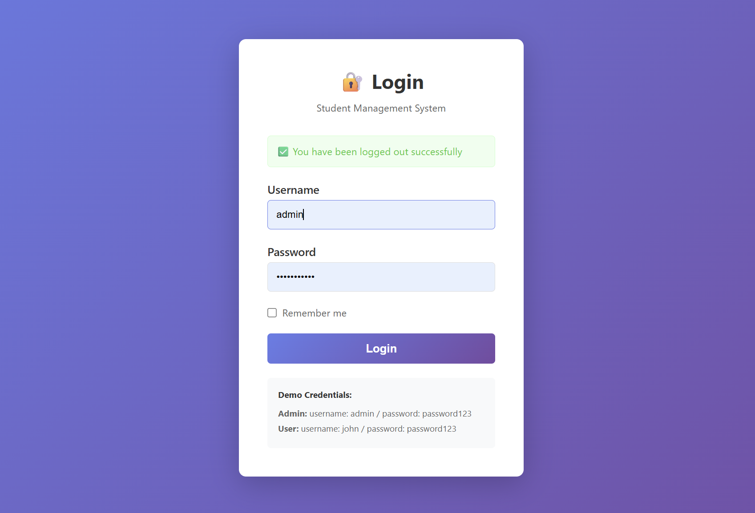

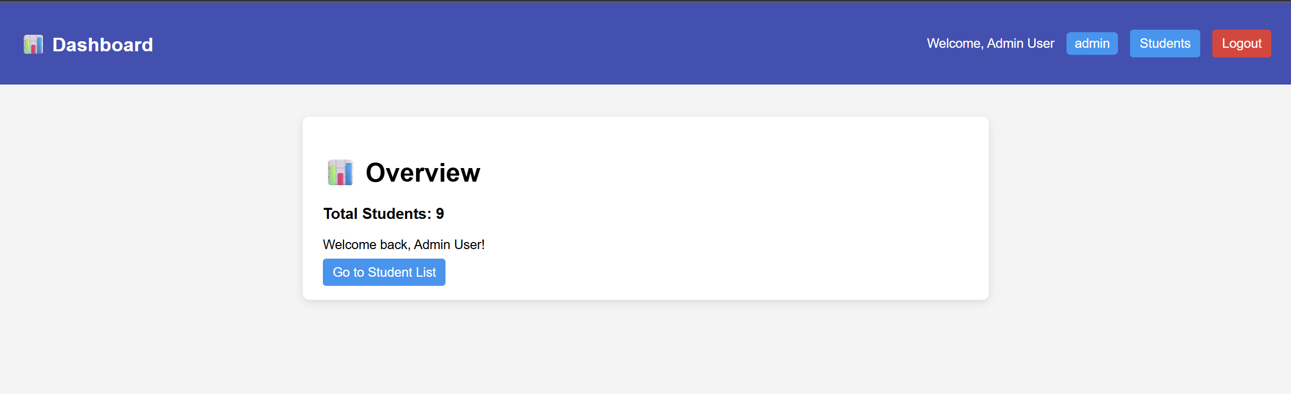

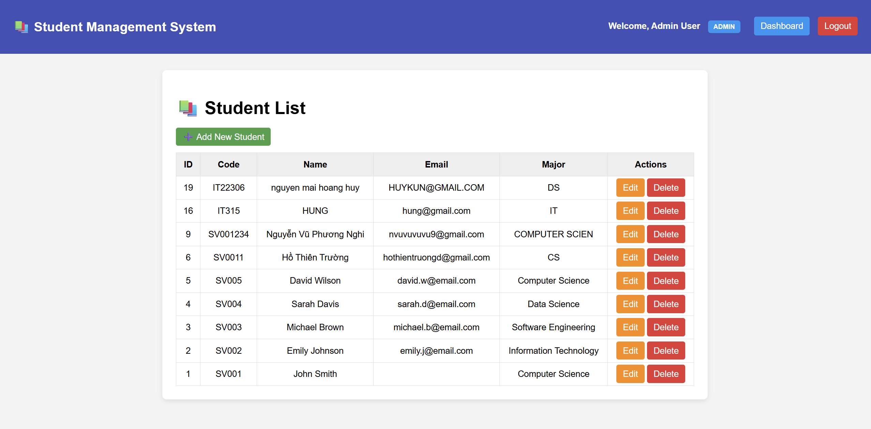

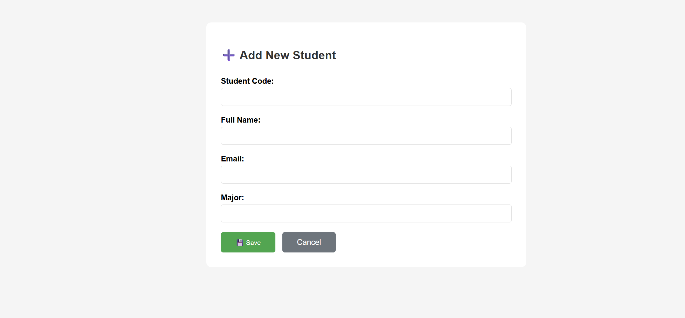

User:
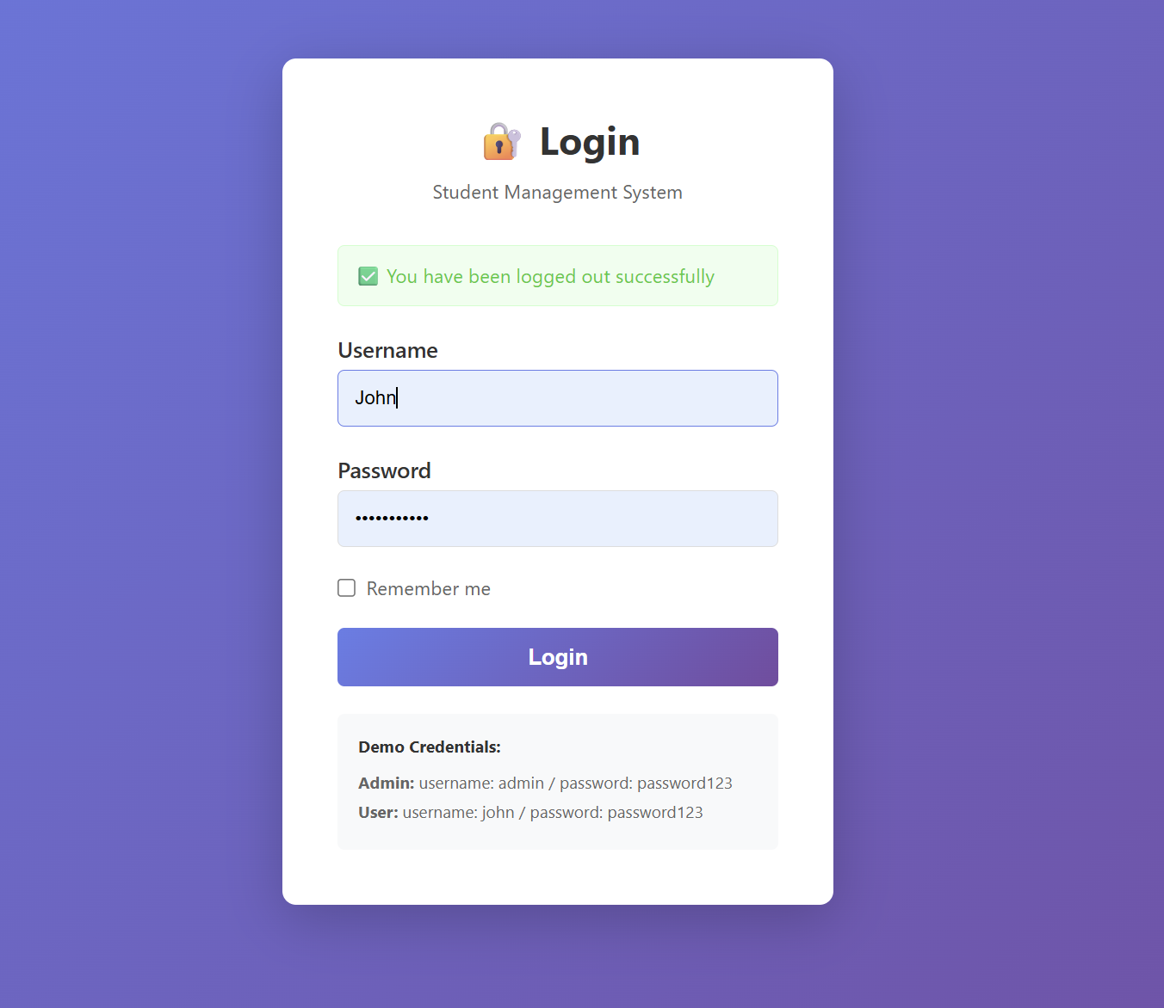

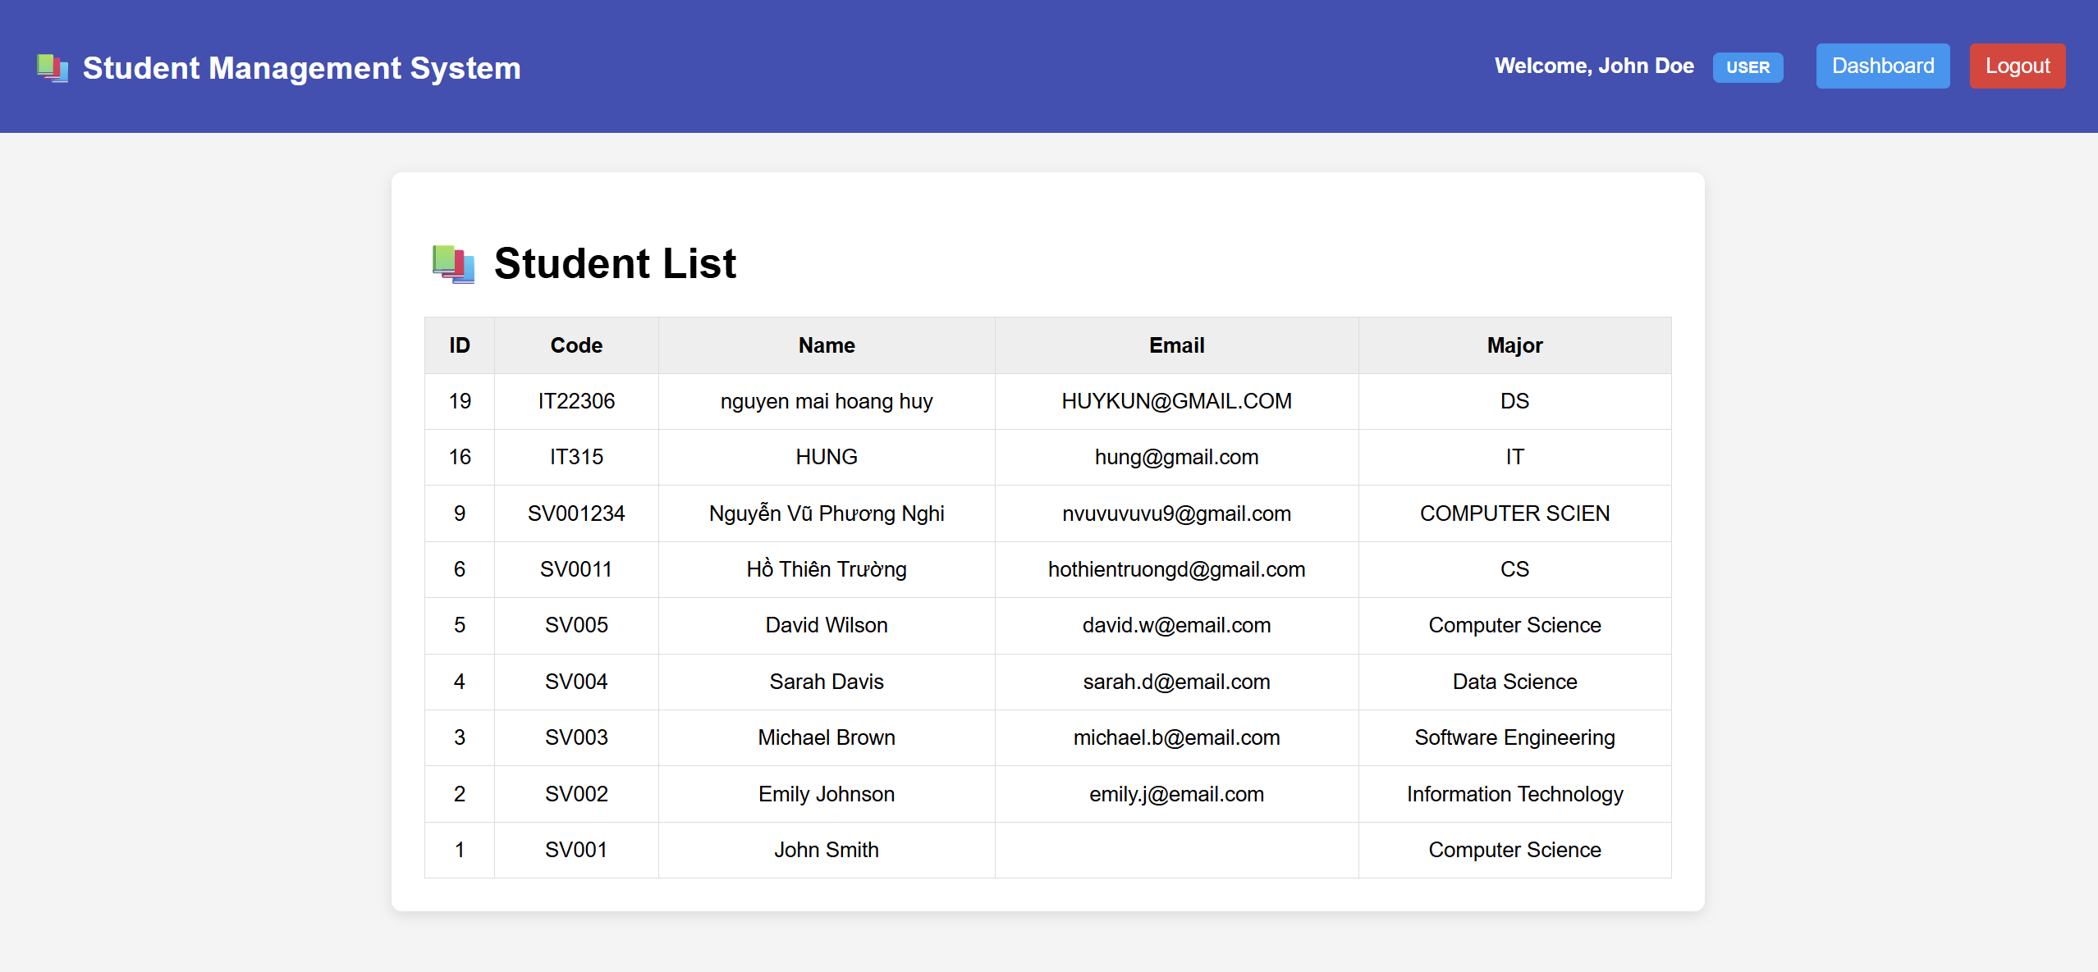

Homework

EXERCISE 5: AUTHENTICATION FILTER (12 points)

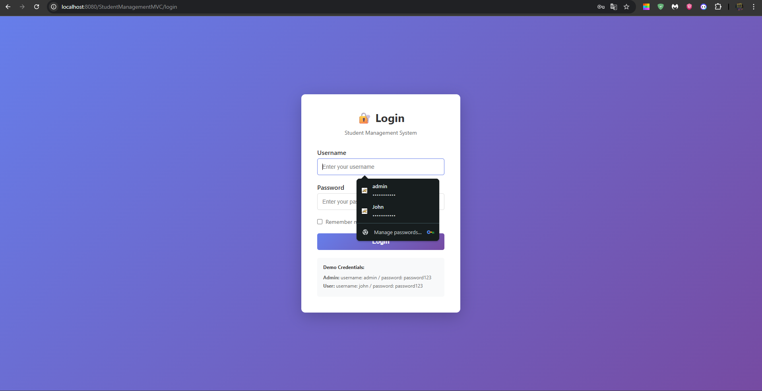

  - It requires login first then it access to student page
  - Workflow:
Request received
→ Filter intercepts the request
→ Extract URI, context path, and relative path
→ Check if path matches any PUBLIC_URL
→ If public → Allow request (chain.doFilter) → End
→ Get current session (getSession(false))
→ Check if session contains user attribute
→ If logged in → Allow request (chain.doFilter) → End
→ If not logged in → Redirect to /login → End

Session Validation:

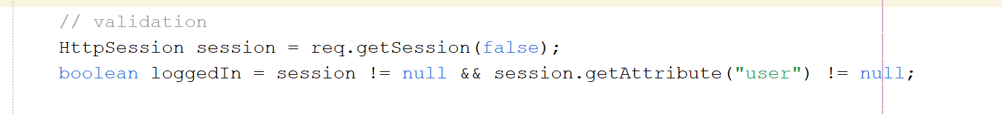

Authentication enforcement:

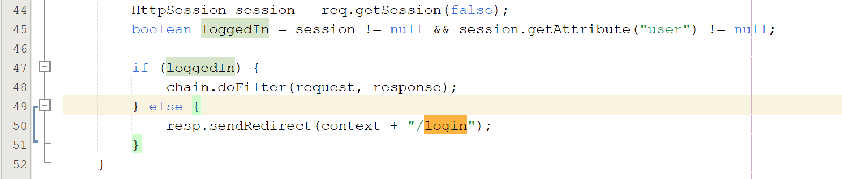
EXERCISE 6: ADMIN AUTHORIZATION FILTER (10 points)
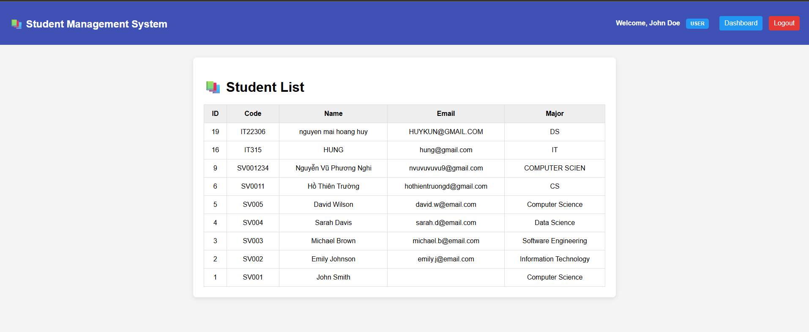

Users do not have the admin role for admin actions. In admin page, they have right to view the Student List while the user cannot.
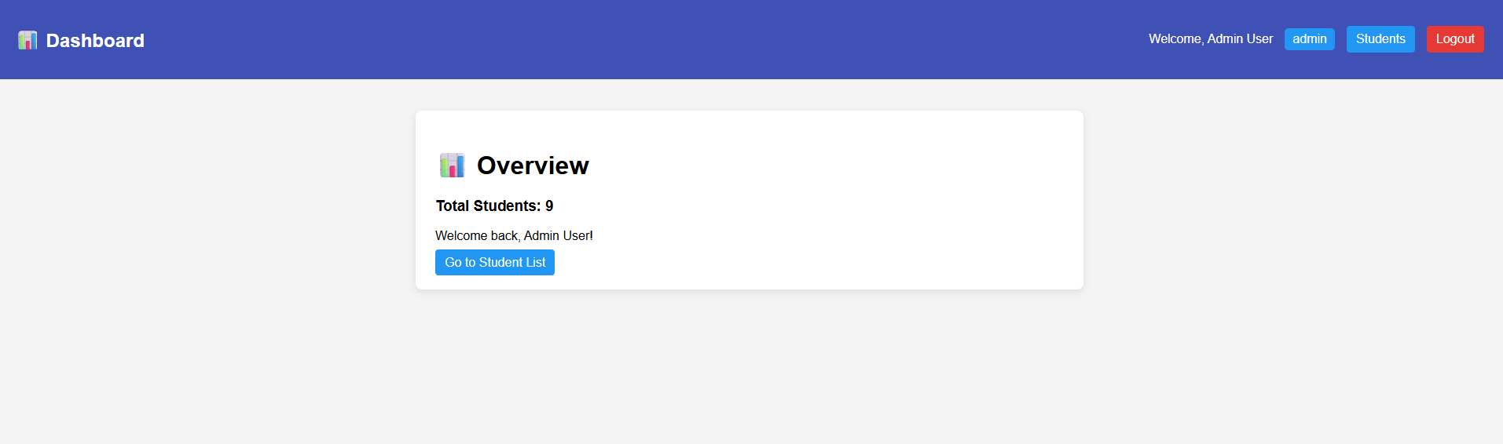

  - Workflow:
→ Extract action parameter
→ Check if action is in ADMIN_ACTIONS
→ If not an admin action → Allow request (chain.doFilter) → End
→ Retrieve current session (getSession(false))
→ Check if session exists
→ If no session → Redirect to /login → End
→ Get user object from session
→ Check if user is admin (user.isAdmin())
→ If admin → Allow request (chain.doFilter) → End
→ If not admin → Redirect to /student?action=list&error=Access denied. Admin privileges required.
→ End

- Admin actions:
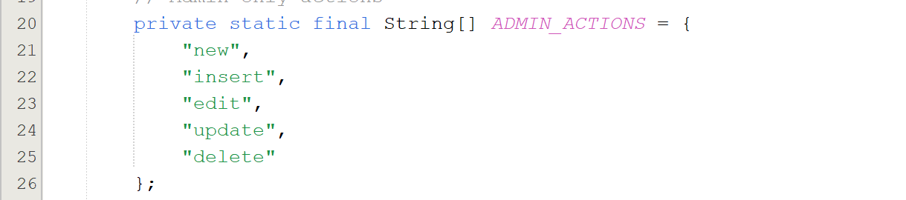

Extracting request action:

Checking if the action requires admin & Getting session and user:
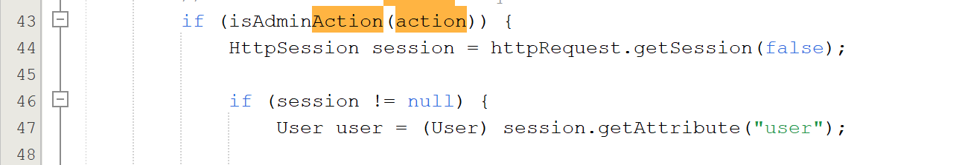

Allow admin & Deny non-admin access, Redirect to login when no session:
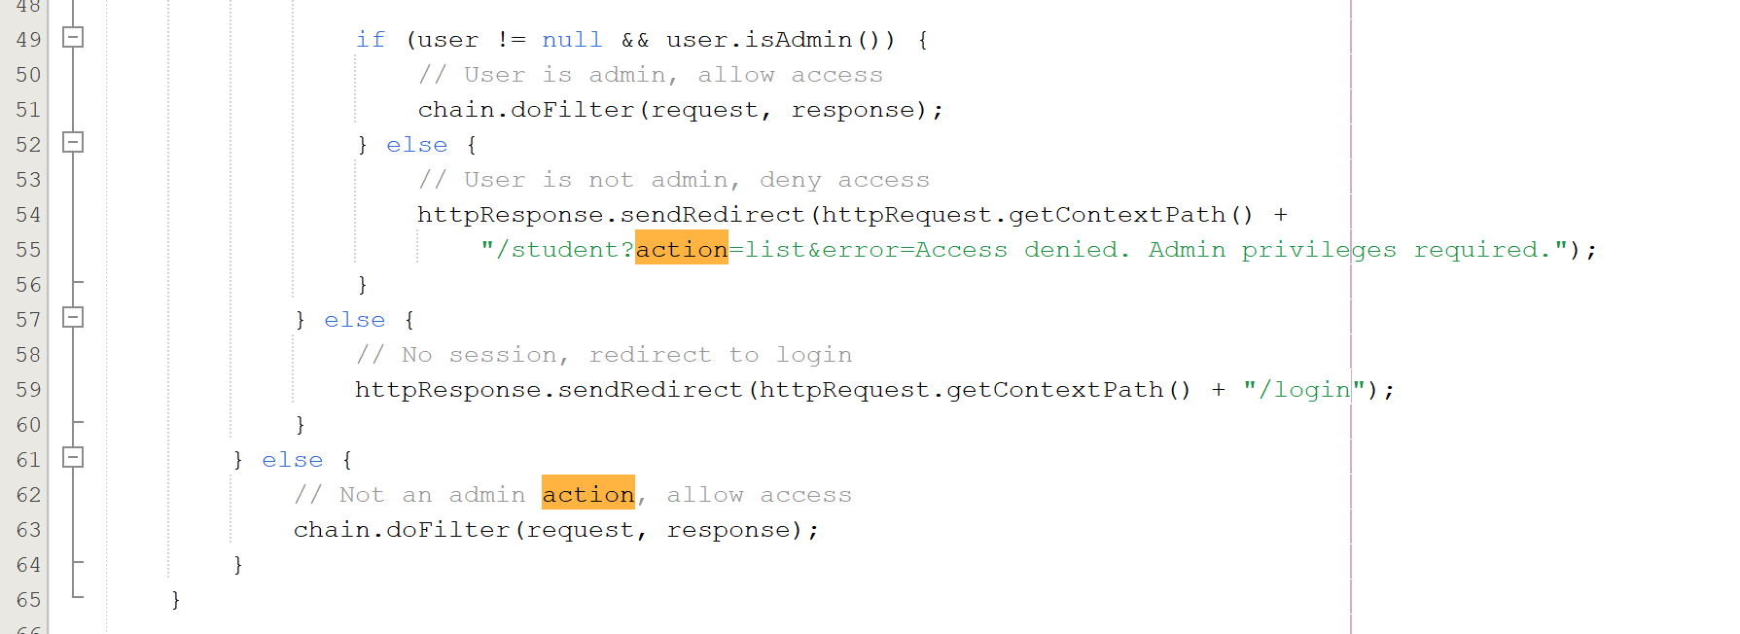

EXERCISE 7: ROLE-BASED UI (10 points)

  - Workflow:
→ Extract action parameter
→ Check if action is in ADMIN_ACTIONS
→ If action is NOT admin-only → Allow request (chain.doFilter) → End
→ Retrieve session using getSession(false)
→ Check if session exists
→ If no session → Redirect to /login → End
→ Get user object from session
→ Check if user.isAdmin()
→ If user is admin → Allow request → End
→ If user is NOT admin
→ Redirect to: /student?action=list&error=Access denied. Admin privileges required.
→ JSP receives error parameter
→ Student List page displays error message inside error box
→ End

- Block non-admin + send error message back to JSP
- Error message:
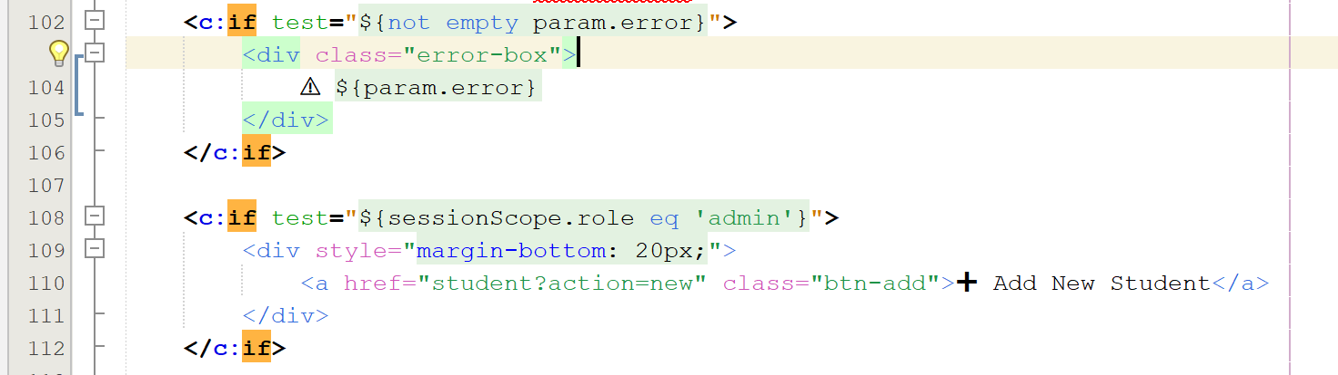

Send error notification:
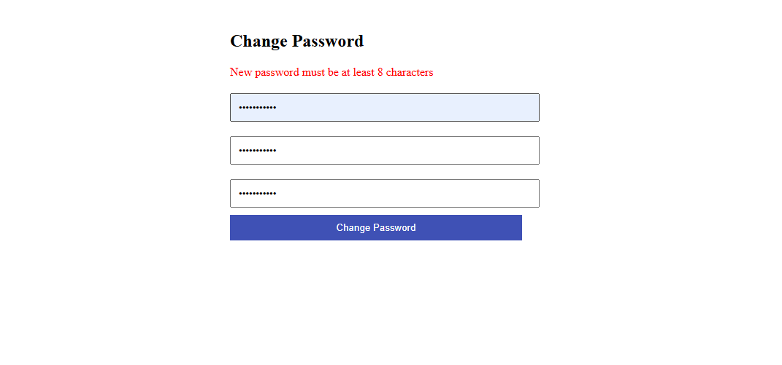

Change password successfully:
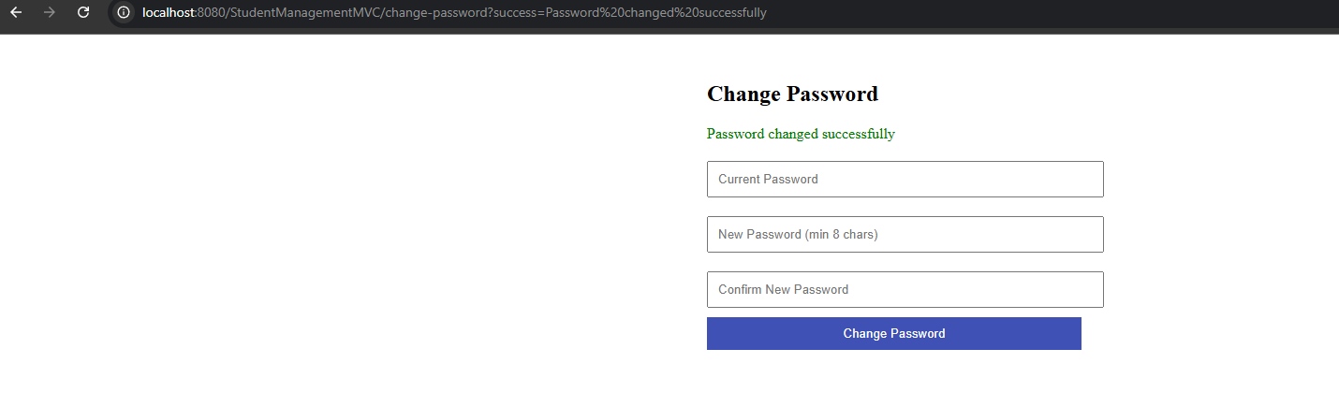
After change password:
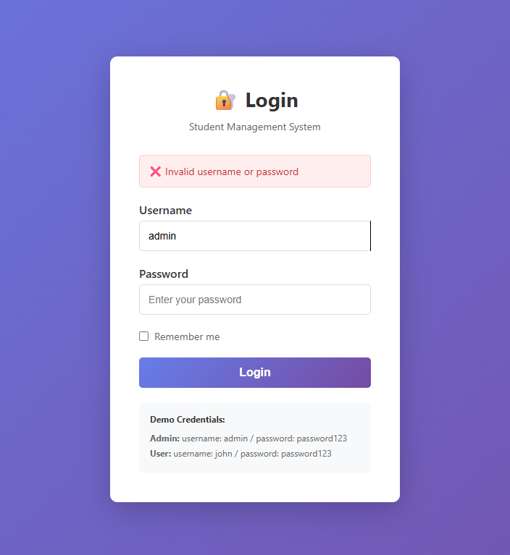
Workflow:

→ Browser sends GET request to /change-password
→ ChangePasswordController.doGet() is called
→ Controller forwards to views/change-password.jsp
→ JSP displays the change password form
→ User submits form (POST)

POST /change-password received
→ ChangePasswordController.doPost() runs
→ Retrieve current session
→ Check if user is logged in
→ If not logged in → redirect to /login → End

Extract form parameters:
- currentPassword
- newPassword
- confirmPassword

Validate current password
→ Call userDAO.checkPassword(userId, currentPassword)
→ If incorrect → redirect with error=Incorrect current password → End

Validate new password length
→ Check if newPassword.length >= 8
→ If too short → redirect with error=New password must be at least 8 characters → End

Validate confirmation match
→ Compare newPassword and confirmPassword
→ If not match → redirect with error=Passwords do not match → End

Hash new password using BCrypt
→ Call UserDAO.hashPassword(newPassword)
→ Generate secure salted hash

Update password in database
→ Call userDAO.updatePassword(userId, hashedPassword)
→ If update successful → redirect with success=Password changed successfully
→ If update fails → redirect with error=Failed to update password

JSP displays success/error message
→ End

