Student name: Hồ Thiên Trường – ITCSIU22306
LAB7_practice
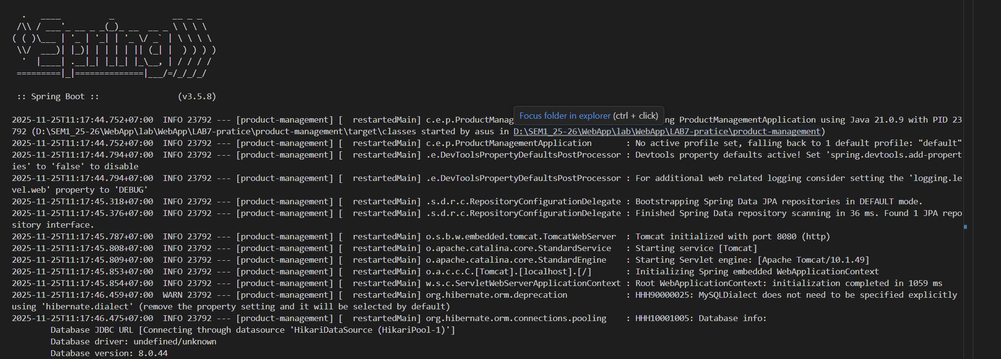
Test URLs:
- List all products: http://localhost:8080/products
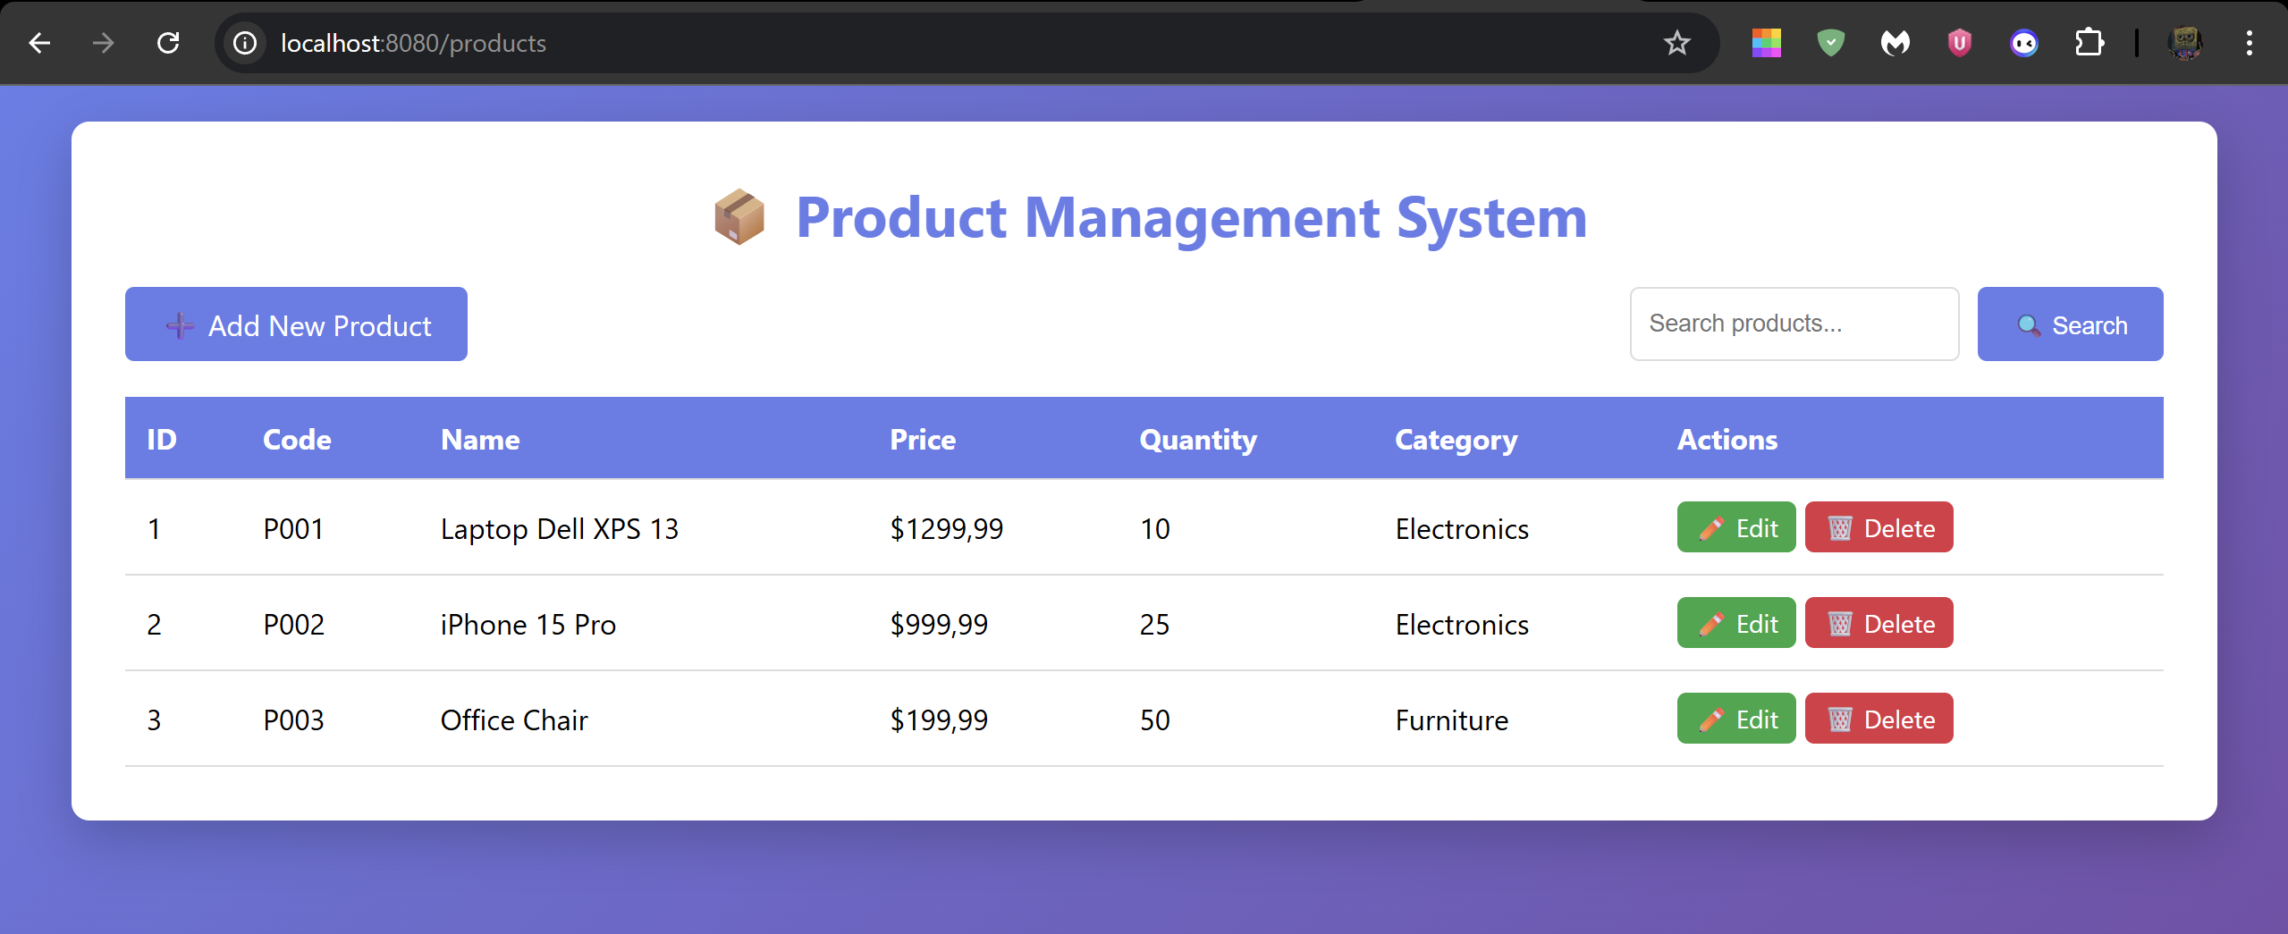
- Add new product: http://localhost:8080/products/new
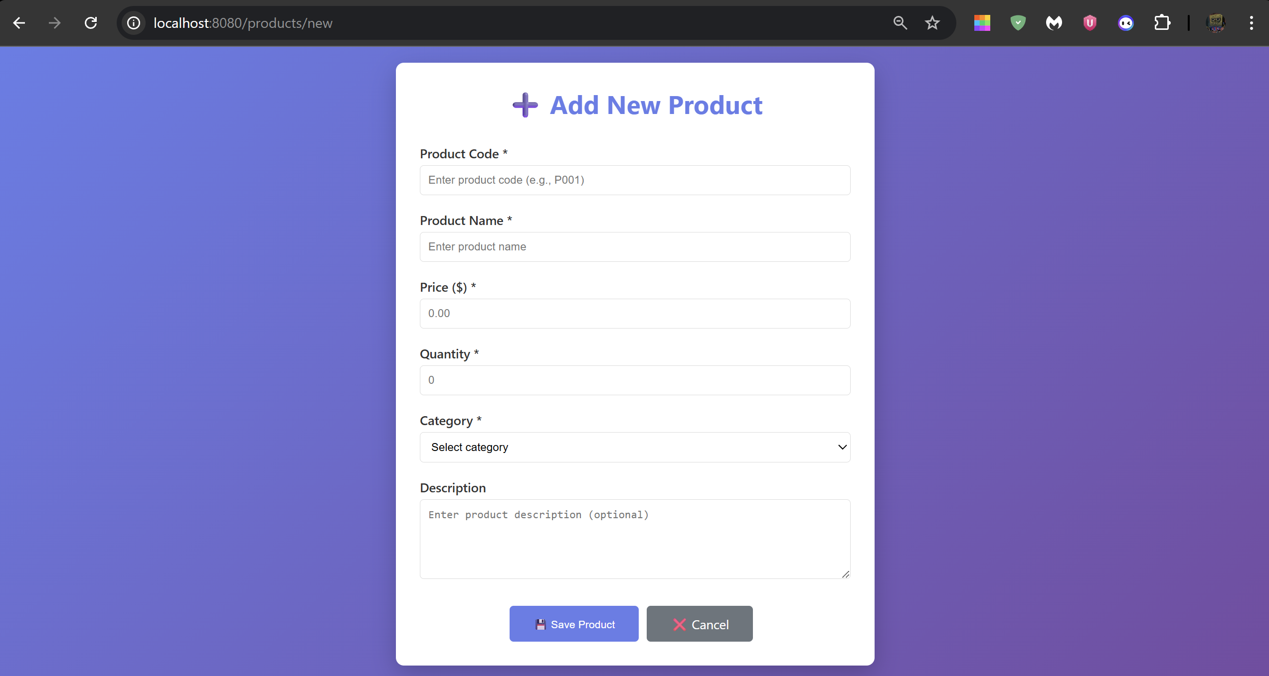
- Edit product (ID=1): http://localhost:8080/products/edit/1
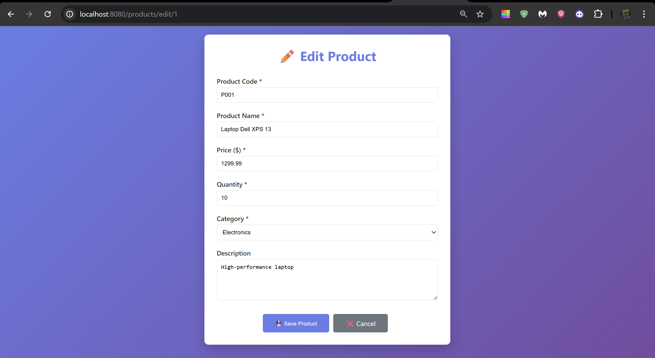
- Search products: http://localhost:8080/products/search?keyword=laptop
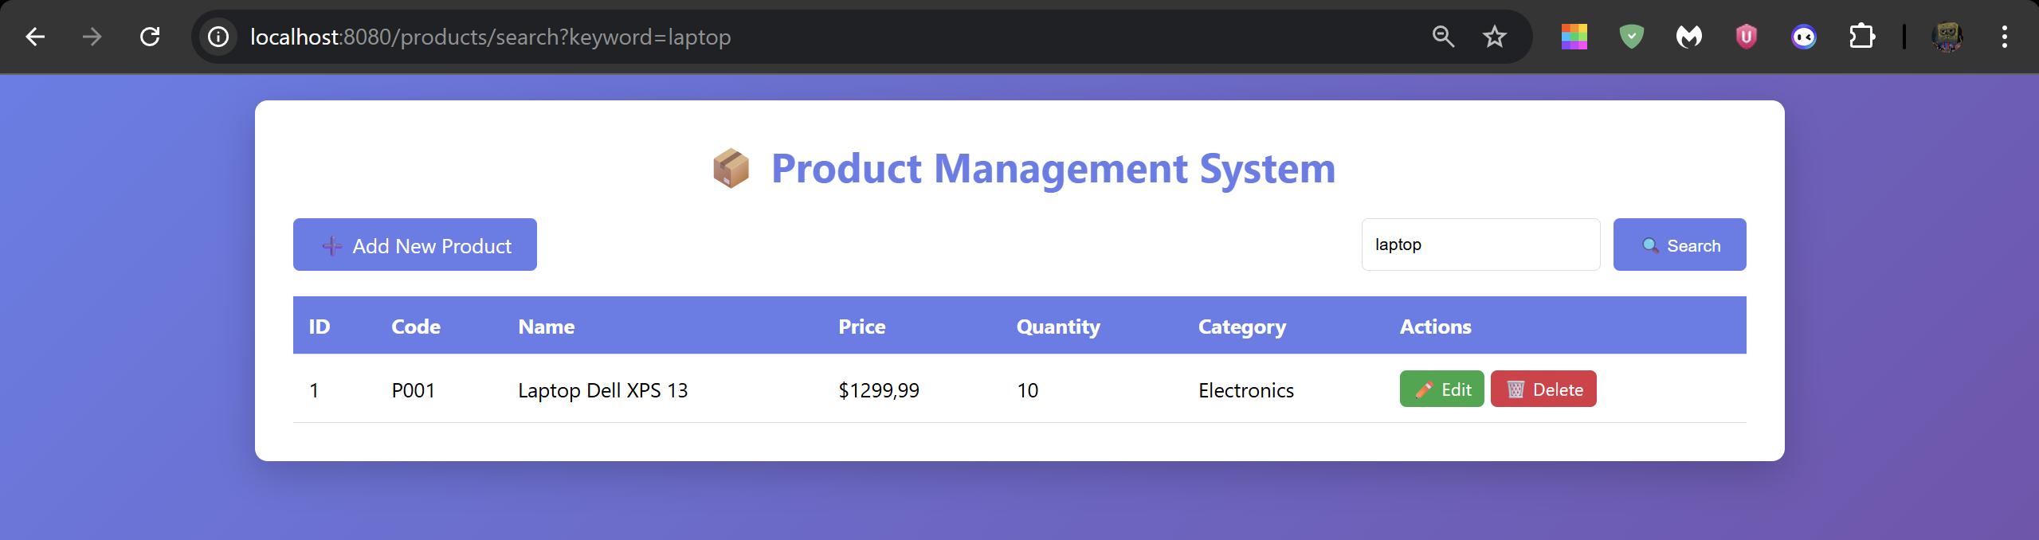
- Delete product (ID=1): http://localhost:8080/products/delete/1
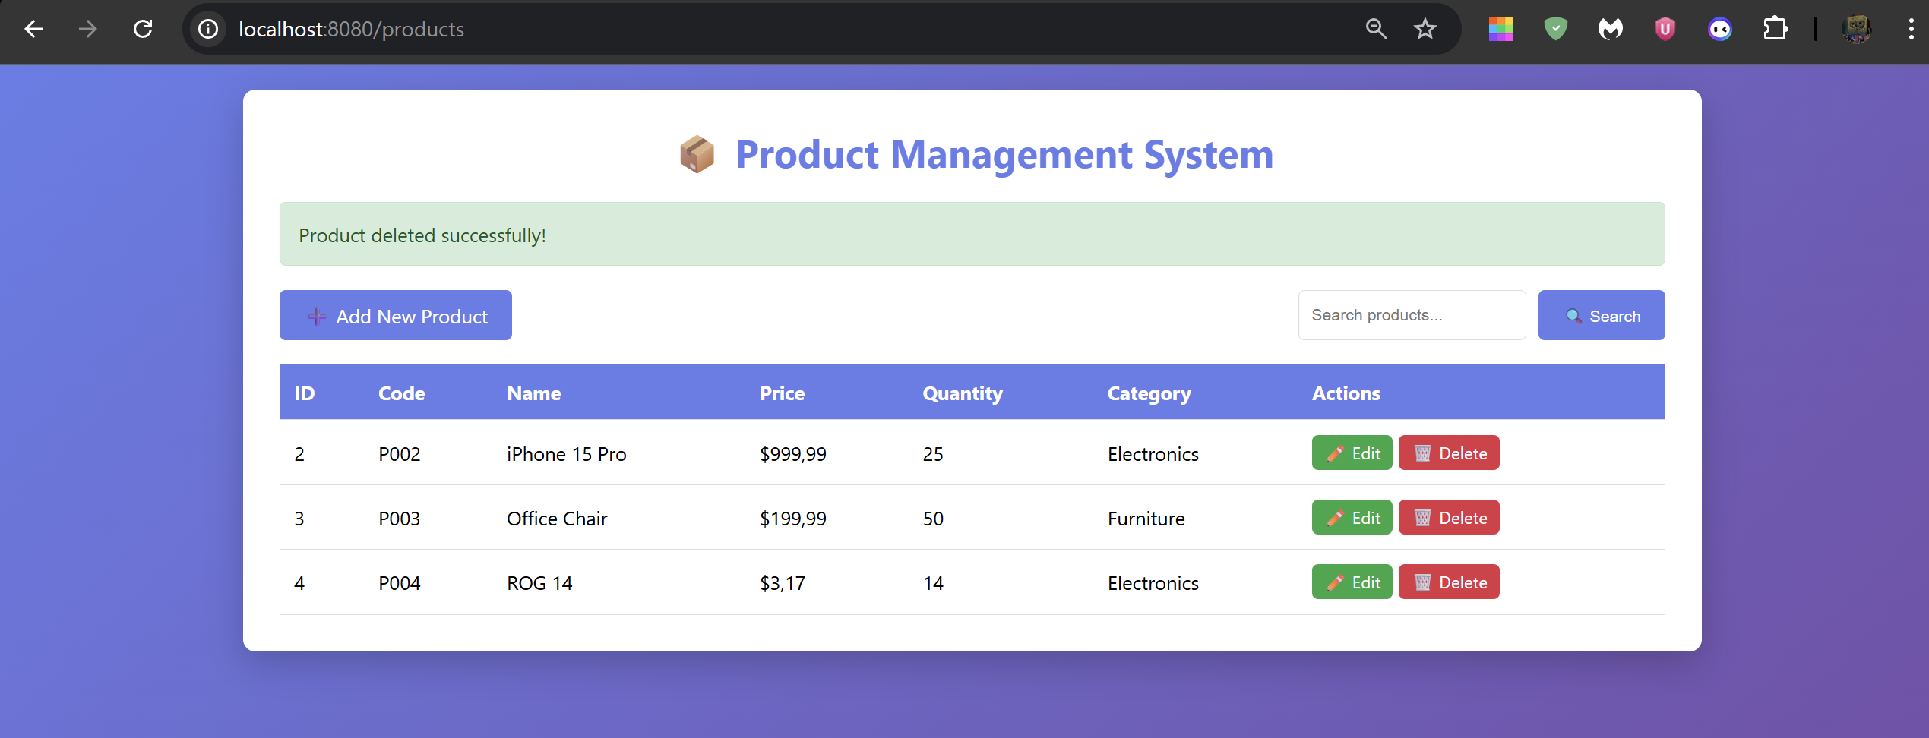

Workflow:
- List Products
User → /products
→ ProductController.listProducts()
→ ProductService.getAllProducts()
→ ProductRepository.findAll()
→ Database
→ ProductController
→ product-list.html (render)

- Add New Product
User → /products/new
→ ProductController.showNewForm()
→ product-form.html (empty form)

User submits form
↓
POST /products/save
→ ProductController.saveProduct()
→ ProductService.saveProduct()
→ ProductRepository.save()
→ Database
→ Redirect /products

- Edit Product
User → /products/edit/{id}
→ ProductController.showEditForm()
→ ProductService.getProductById()
→ ProductRepository.findById()
→ Database
→ product-form.html (filled with product data)

User submits update
↓
POST /products/save
→ ProductService.saveProduct()
→ ProductRepository.save()
→ Database
→ Redirect /products

- Delete Product
User → /products/delete/{id}
→ ProductController.deleteProduct()
→ ProductService.deleteProduct()
→ ProductRepository.deleteById()
→ Database
→ Redirect /products

- Search Products
User → /products/search?keyword=...
→ ProductController.searchProducts()
→ ProductService.searchProducts()
→ ProductRepository.findByNameContaining()
→ Database
→ product-list.html (filtered results)

- Categorize Products
User triggers category filter
→ ProductService.getProductsByCategory()
→ ProductRepository.findByCategory()
→ Database
→ product-list.html

