Student name: Hồ Thiên Trường _ ITCSIU22306
LAB 8 practice :
EXERCISE 1: PROJECT SETUP & ENTITY
- Task 1.1: Create Spring Boot Project (5 points)
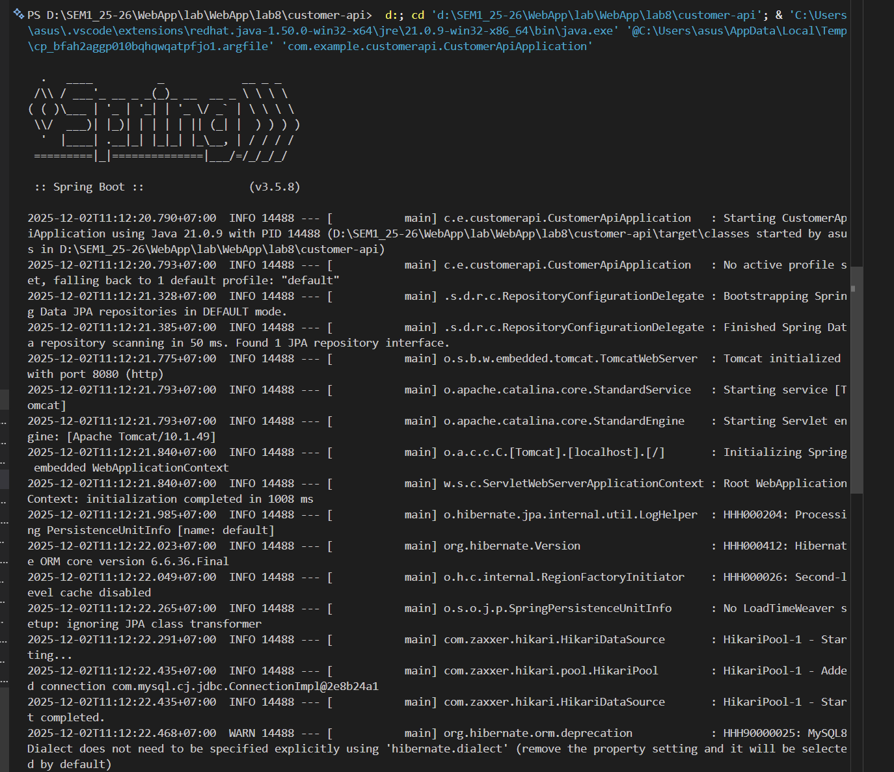
- Task 1.2: Database Setup (5 points)
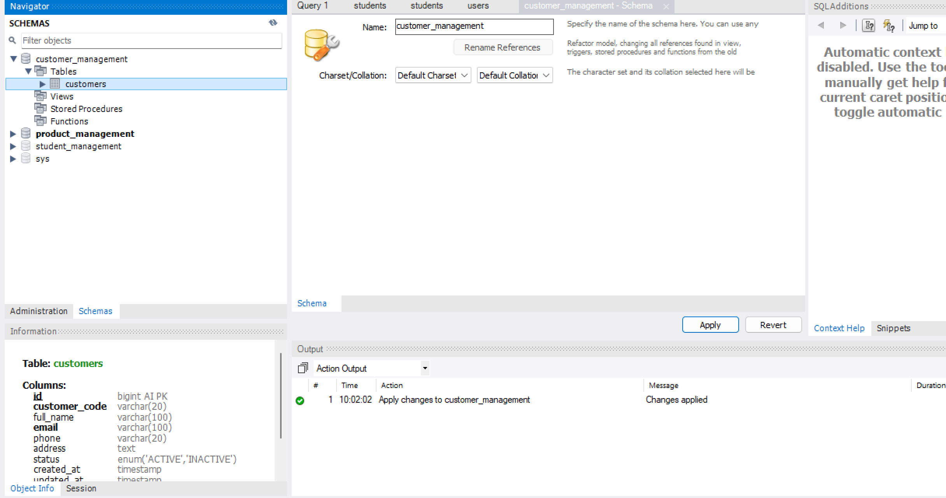
Task 1.3: Create Customer Entity

