Student name: Hồ Thiên Trường _ ITCSIU22306
Lab08:
Part B: Homework
Task 5.1: Search Customers (6 points)
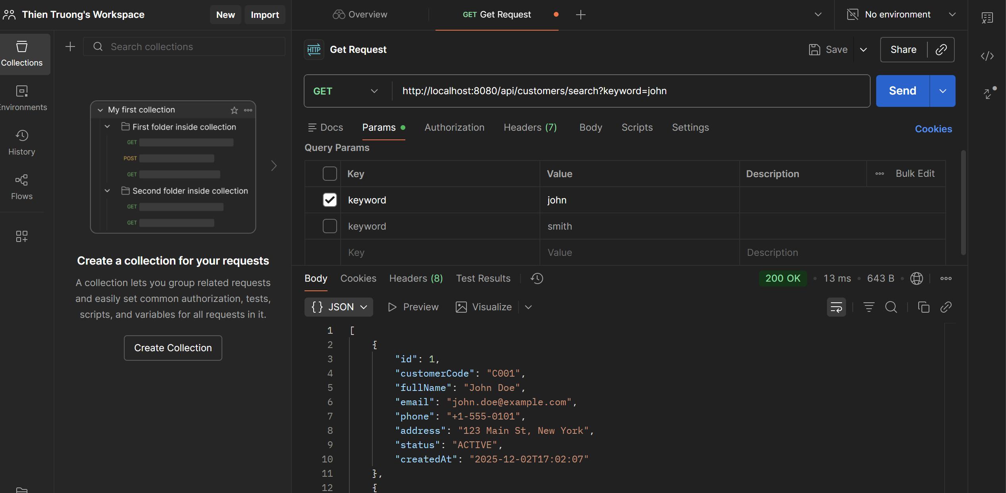
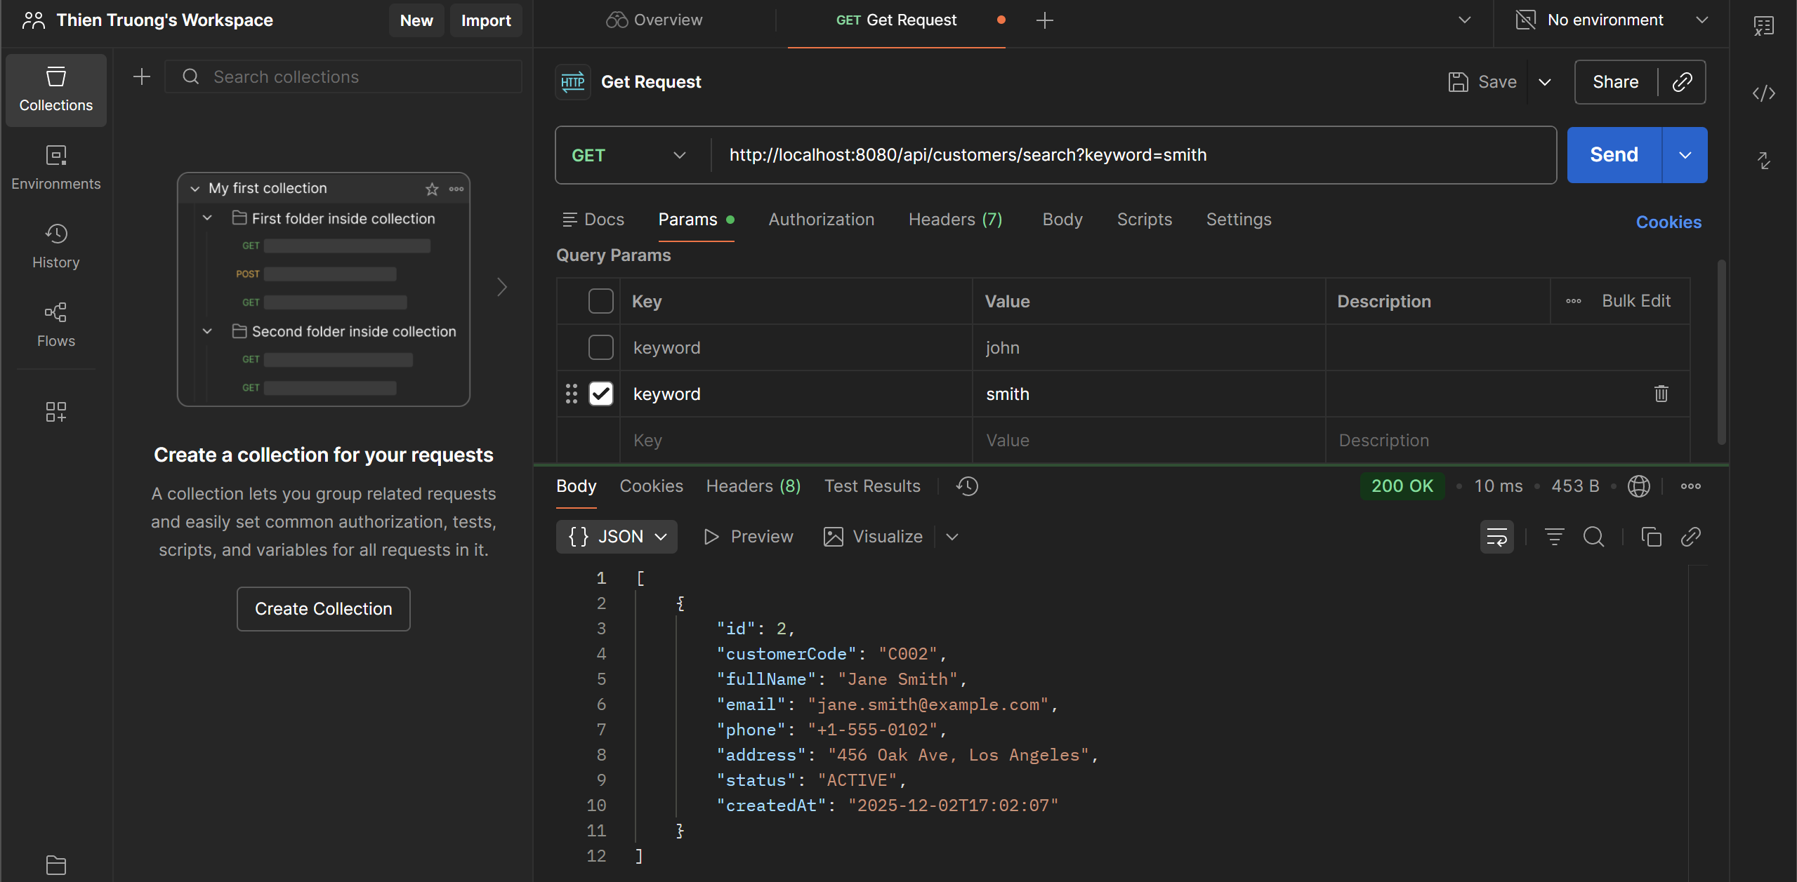
- Workflow:
- Implemented repository search: case-insensitive LIKE on fullName, email, customerCode.
- Exposed service method to map results to CustomerResponseDTO.
- Added controller endpoint GET /api/customers/search?keyword=....
- Verified via Postman: correct URL, single keyword param returns 200 OK with matching records.

Repository:
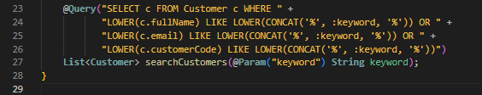
Service Interface:
ServiceImpl:
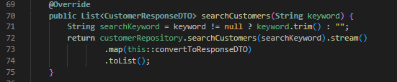
Controller:
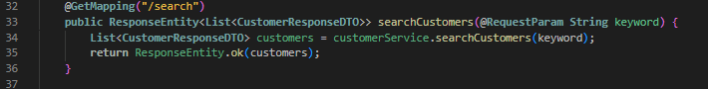
Task 5.2: Filter by Status (3 points)
- http://localhost:8080/api/customers/status/ACTIVE
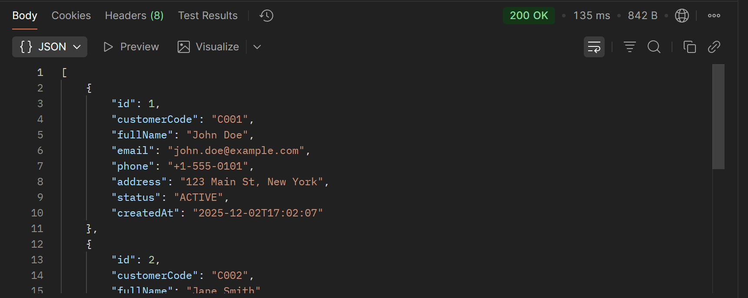
- http://localhost:8080/api/customers/status/INACTIVE
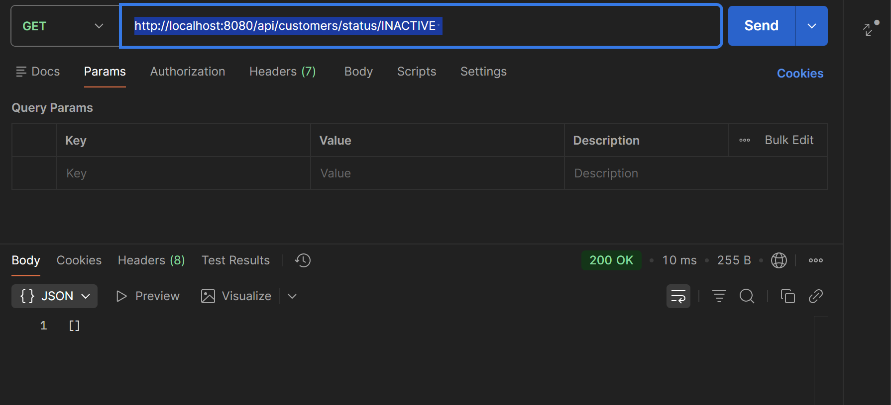
- Workflow:
- Added a status filter endpoint.
- Controller maps GET /api/customers/status/{status} to the service, service parses the path variable into CustomerStatus (ACTIVE/INACTIVE), queries the repository via findByStatus, and maps entities to CustomerResponseDTO.
- Invalid status throws ResourceNotFoundException

CustomerServiceImpl:
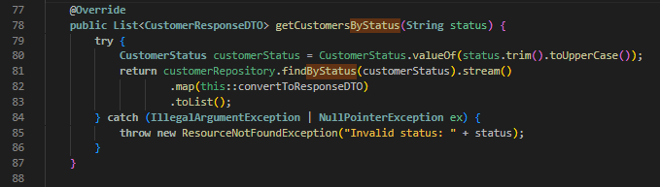
- parses the incoming status string to CustomerStatus (uppercasing/trim), calls findByStatus, maps entities to CustomerResponseDTO; throws ResourceNotFoundException on invalid status input.

CustomerRestController:
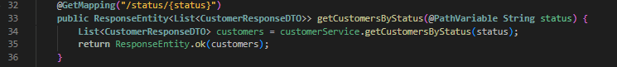
- exposes GET /api/customers/status/{status} endpoint, delegates to the service, and returns the filtered list in the HTTP response.

Task 5.3: Advanced Search with Multiple Criteria (3 points)
- http://localhost:8080/api/customers/advanced-search?name=john&email=@example.com&status=ACTIVE
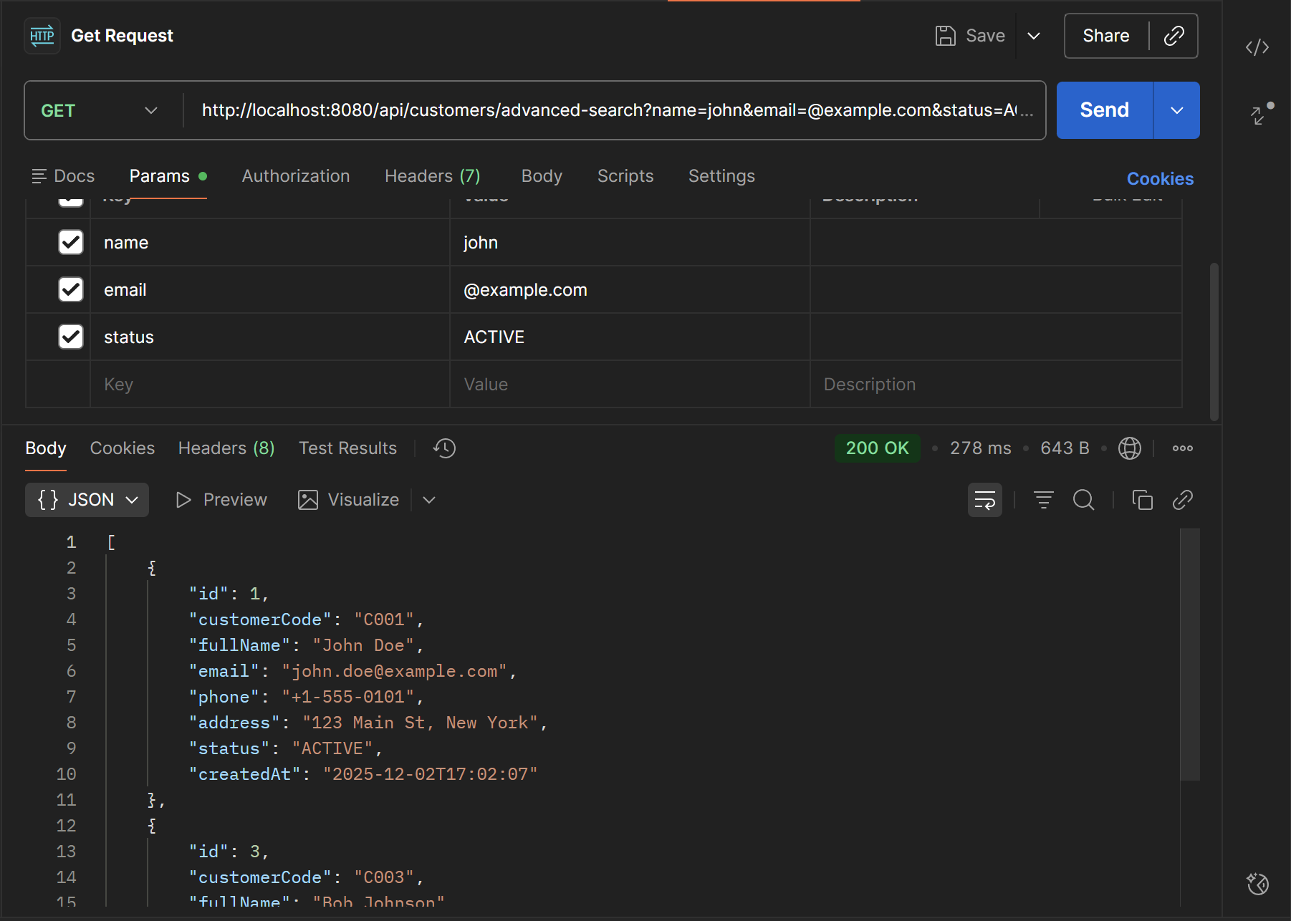
- Workflow: Implemented advanced search with optional name, email, and status filters. Added a repository query that tolerates null filters, service logic to normalize/validate inputs and map to DTOs, and a controller endpoint to expose GET /api/customers/advanced-search.

CustomerRepository:
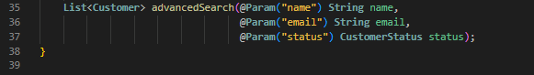
CustomerService:
- Added advancedSearch(String name, String email, String status): service contract for multi-criteria search.

CustomerServiceImpl:
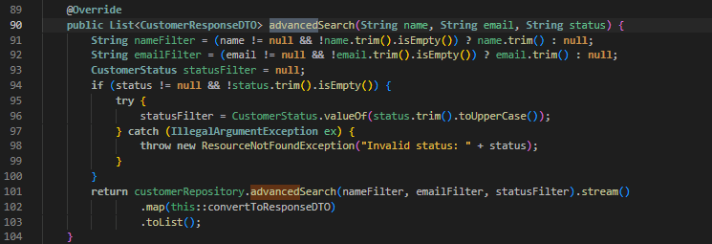
- trims optional params, converts status string to CustomerStatus (throws ResourceNotFoundException on invalid), delegates to repository advancedSearch, maps entities to CustomerResponseDTO.

CustomerRestController:
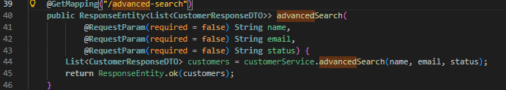
- endpoint accepting optional name, email, status query params, returning the filtered customer list.

- http://localhost:8080/api/customers/advanced-search?name=john&email=@example.com&status=INACTIVE
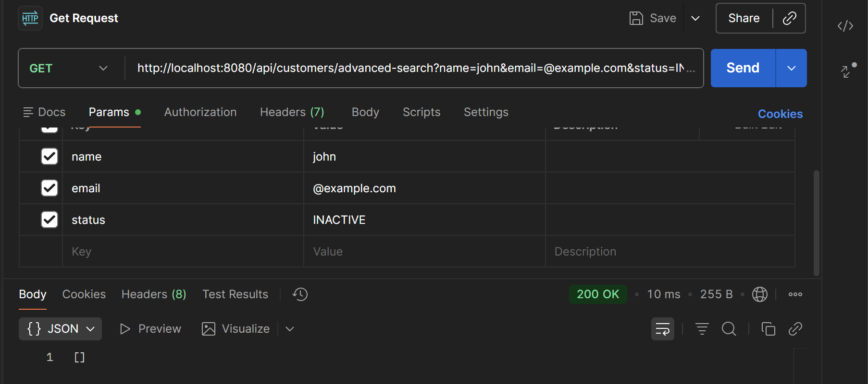
- How it works: Any combination of the three query params is accepted; blank/omitted params are ignored. Status must be ACTIVE or INACTIVE.

EXERCISE 6: PAGINATION & SORTING (10 points)
Task 6.1: Add Pagination (5 points)

- http://localhost:8080/api/customers?page=0&size=5
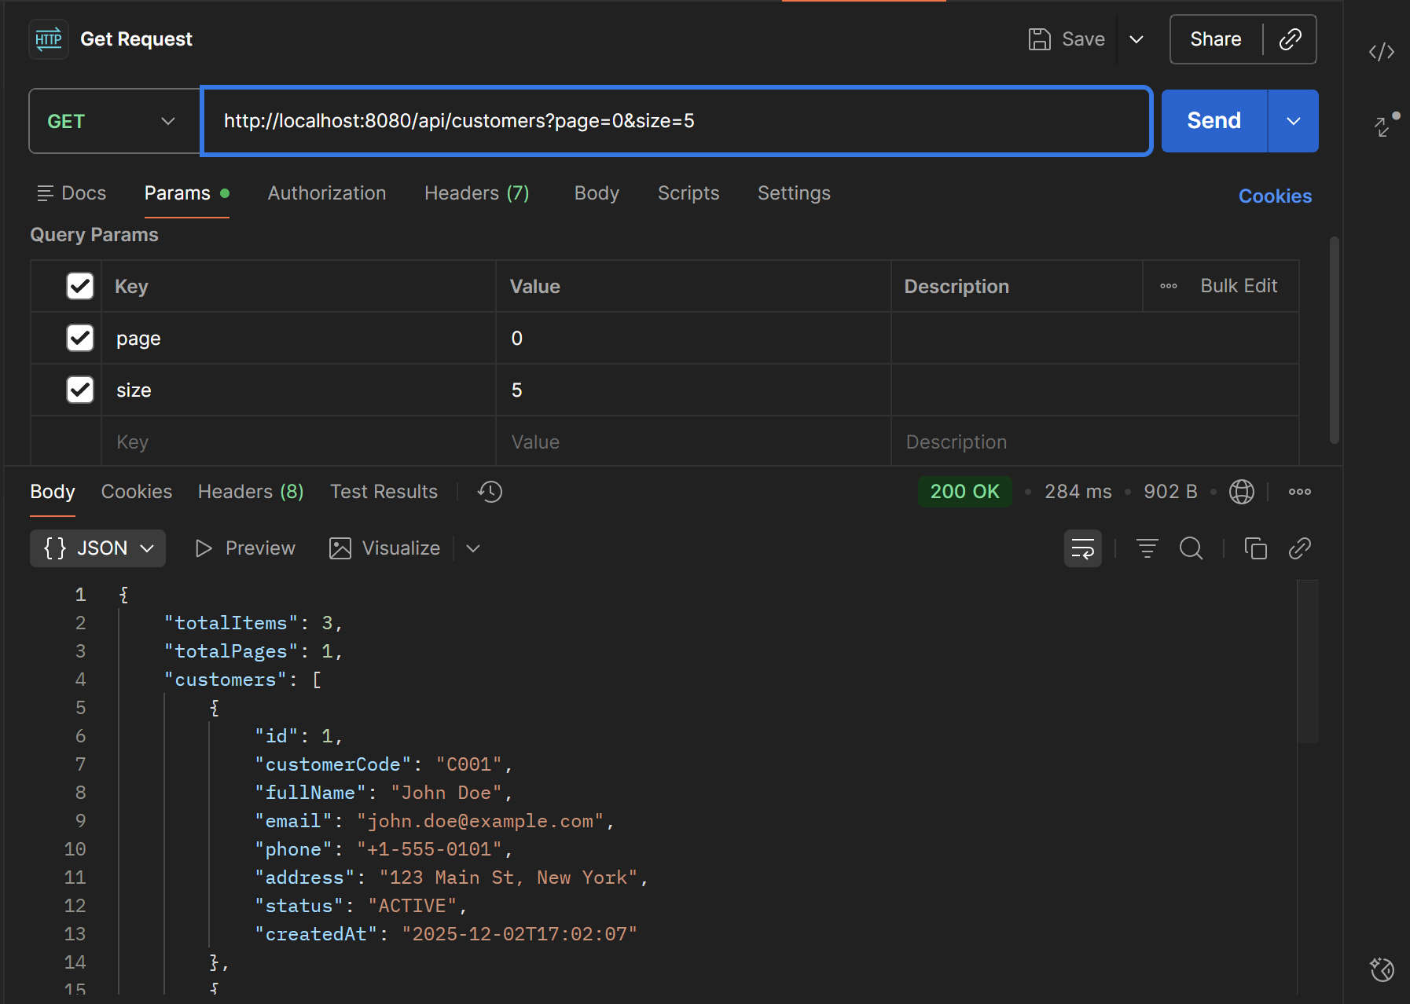
- http://localhost:8080/api/customers?page=1&size=10
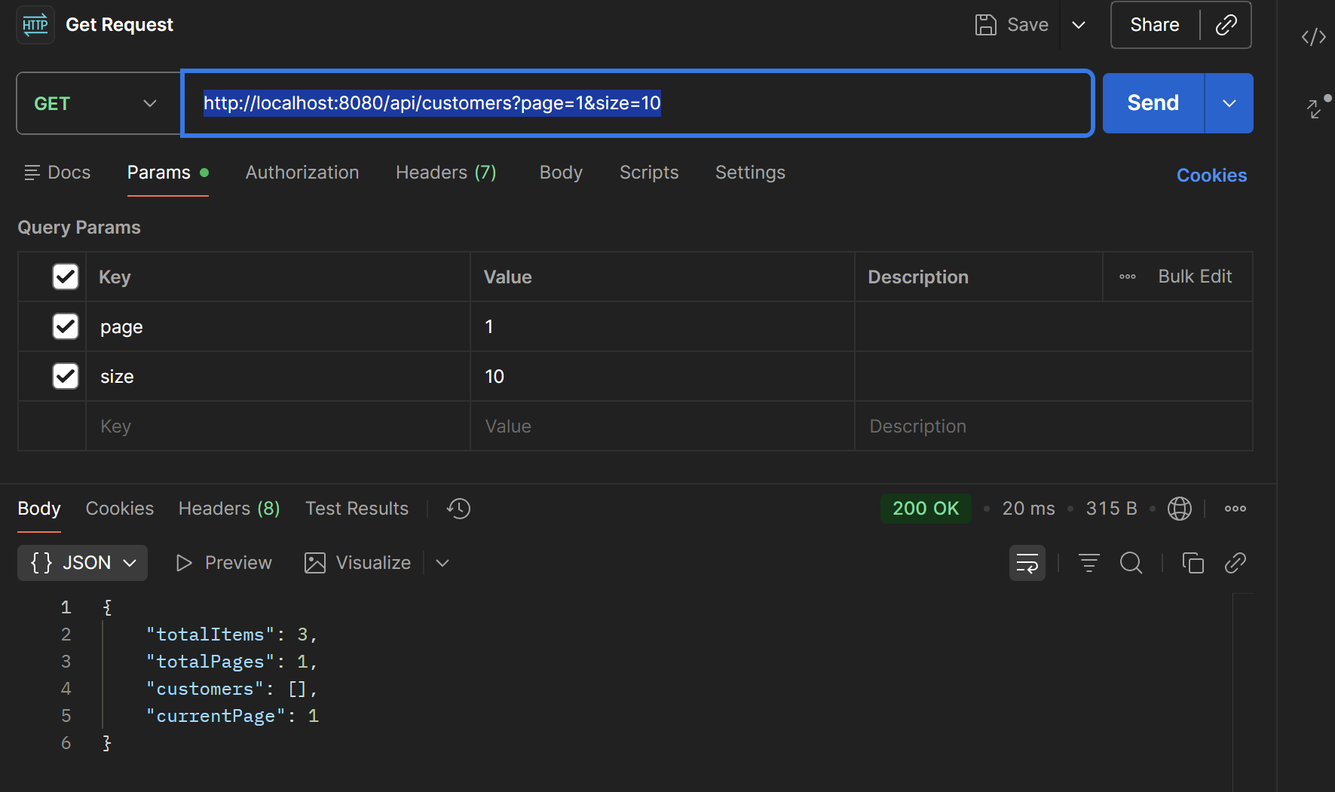
- Workflow: Customer list now supports pagination. Controller accepts page/size query params, service fetches a Page<Customer> via Spring Data, maps to CustomerResponseDTO, and the controller returns pagination metadata plus the current page’s customers.

- How it works:
- Client calls GET /api/customers?page=0&size=5 (defaults page=0, size=10 if omitted).
- Service builds PageRequest and calls findAll(Pageable).
- Response body: { customers, currentPage, totalItems, totalPages }

CustomerService:
- exposes a paginated list contract: Page<CustomerResponseDTO> getAllCustomers(int page, int size).

CustomersServiceImpl:
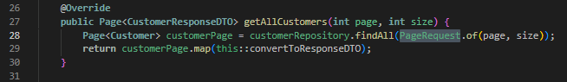
- builds a PageRequest from page/size, fetches Page<Customer>, maps it to Page<CustomerResponseDTO> via convertToResponseDTO.

CustomerRestController:
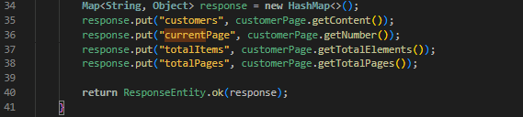
- GET /api/customers now accepts page and size, constructs a response map with customers, currentPage, totalItems, totalPages.

Task 6.2: Add Sorting (3 points)
- http://localhost:8080/api/customers?sortBy=fullName&sortDir=asc&page=0&size=5

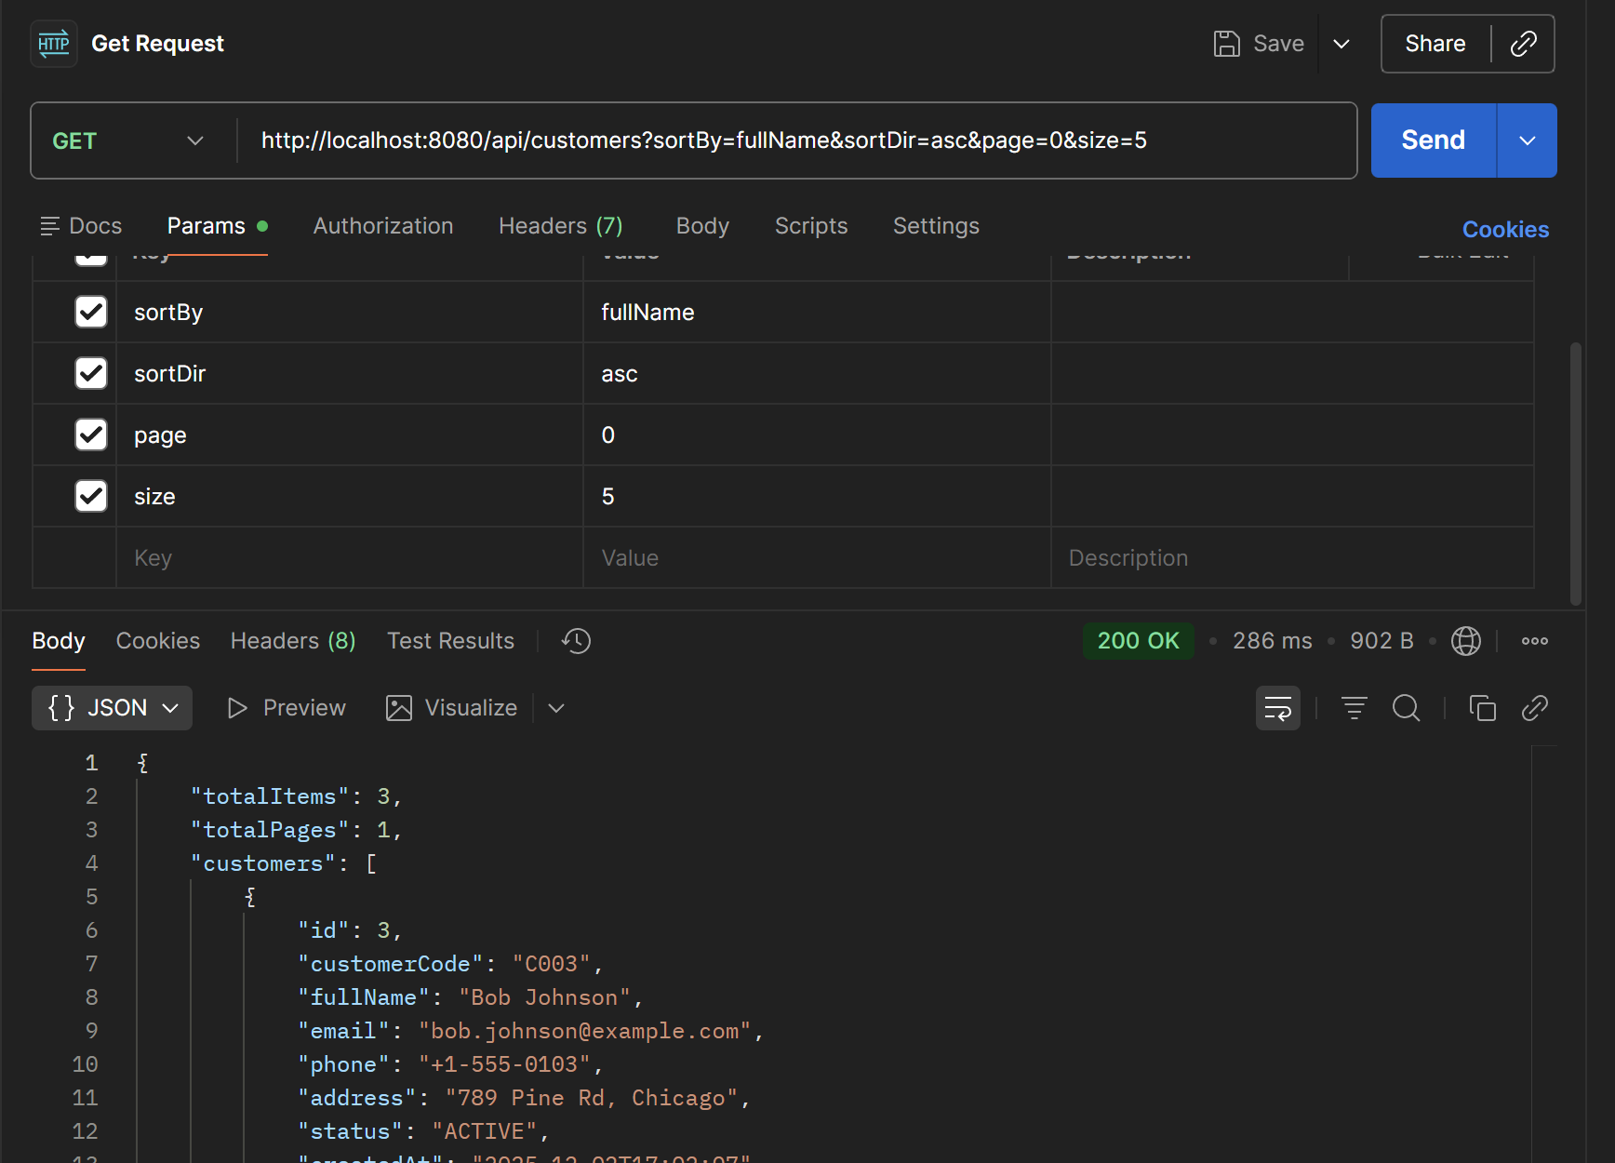

- http://localhost:8080/api/customers?sortBy=createdAt&sortDir=desc&page=1&size=10
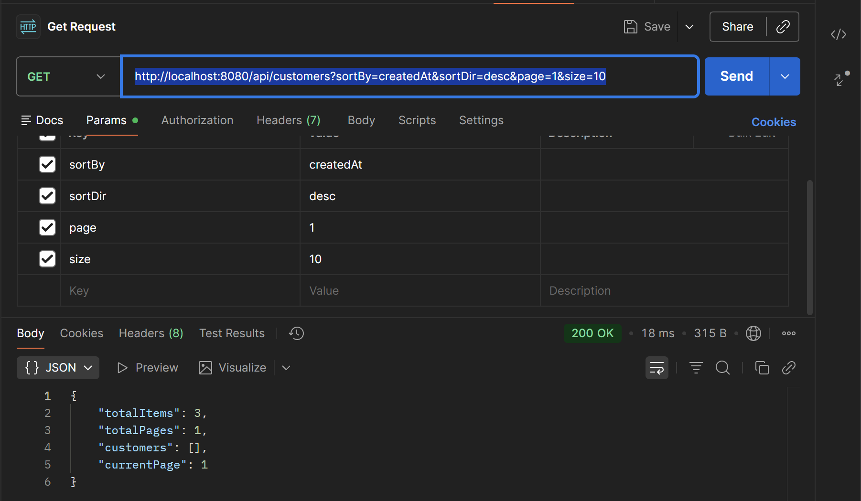
- Workflow: Customer list now supports pagination and sorting. Controller accepts page/size plus optional sortBy/sortDir, calls service, and returns paged content with metadata. Service builds a PageRequest with Sort (defaults to id, asc unless sortDir=desc) and maps the Page<Customer> to Page<CustomerResponseDTO>.
CustomerService:
- Adds Page<CustomerResponseDTO> getAllCustomers(int page, int size, String sortBy, String sortDir); — service contract for paged, sortable customer retrieval.

CustomerServiceImpl:
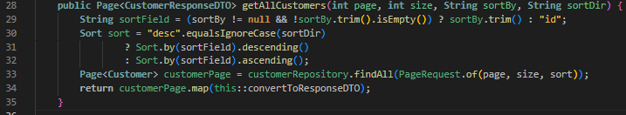
- Implements the above: normalizes sortBy (default id), builds Sort from sortDir, uses PageRequest.of(page, size, sort), and maps to DTOs.

CustomerRestController:
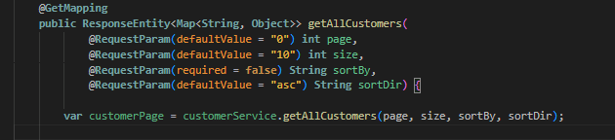
- GET /api/customers now takes page, size, sortBy, sortDir; calls the service; returns a map containing customers, currentPage, totalItems, totalPages.

Task 6.3: Combine Pagination and Sorting (2 points)
- http://localhost:8080/api/customers?page=0&size=5&sortBy=fullName&sortDir=asc
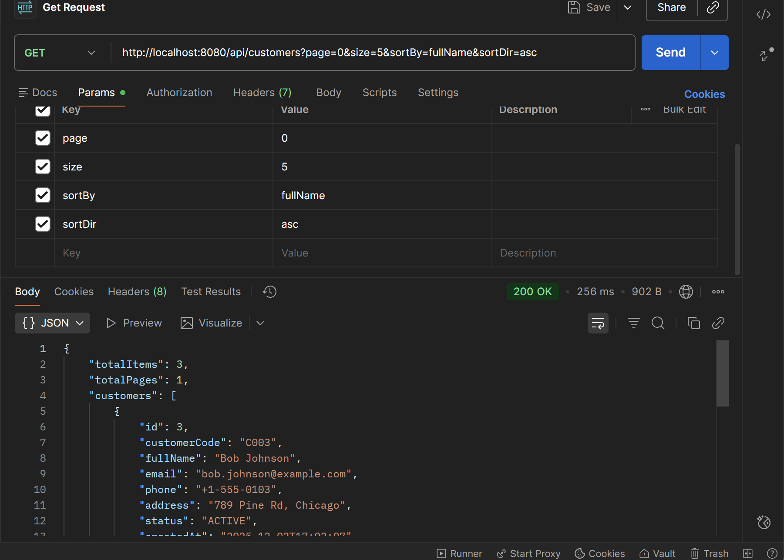
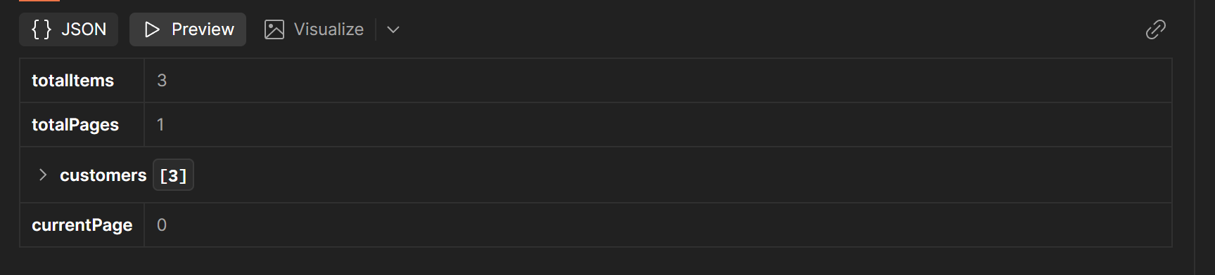
EXERCISE 7: PARTIAL UPDATE WITH PATCH (10 points)
Task 7.1: Create Update DTO (3 points)
CustomerUpdateDTO.java
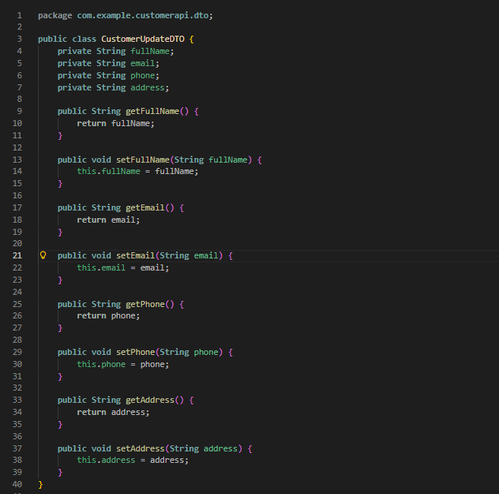
Task 7.2: Implement PATCH Endpoint (5 points)
http://localhost:8080/api/customers/1
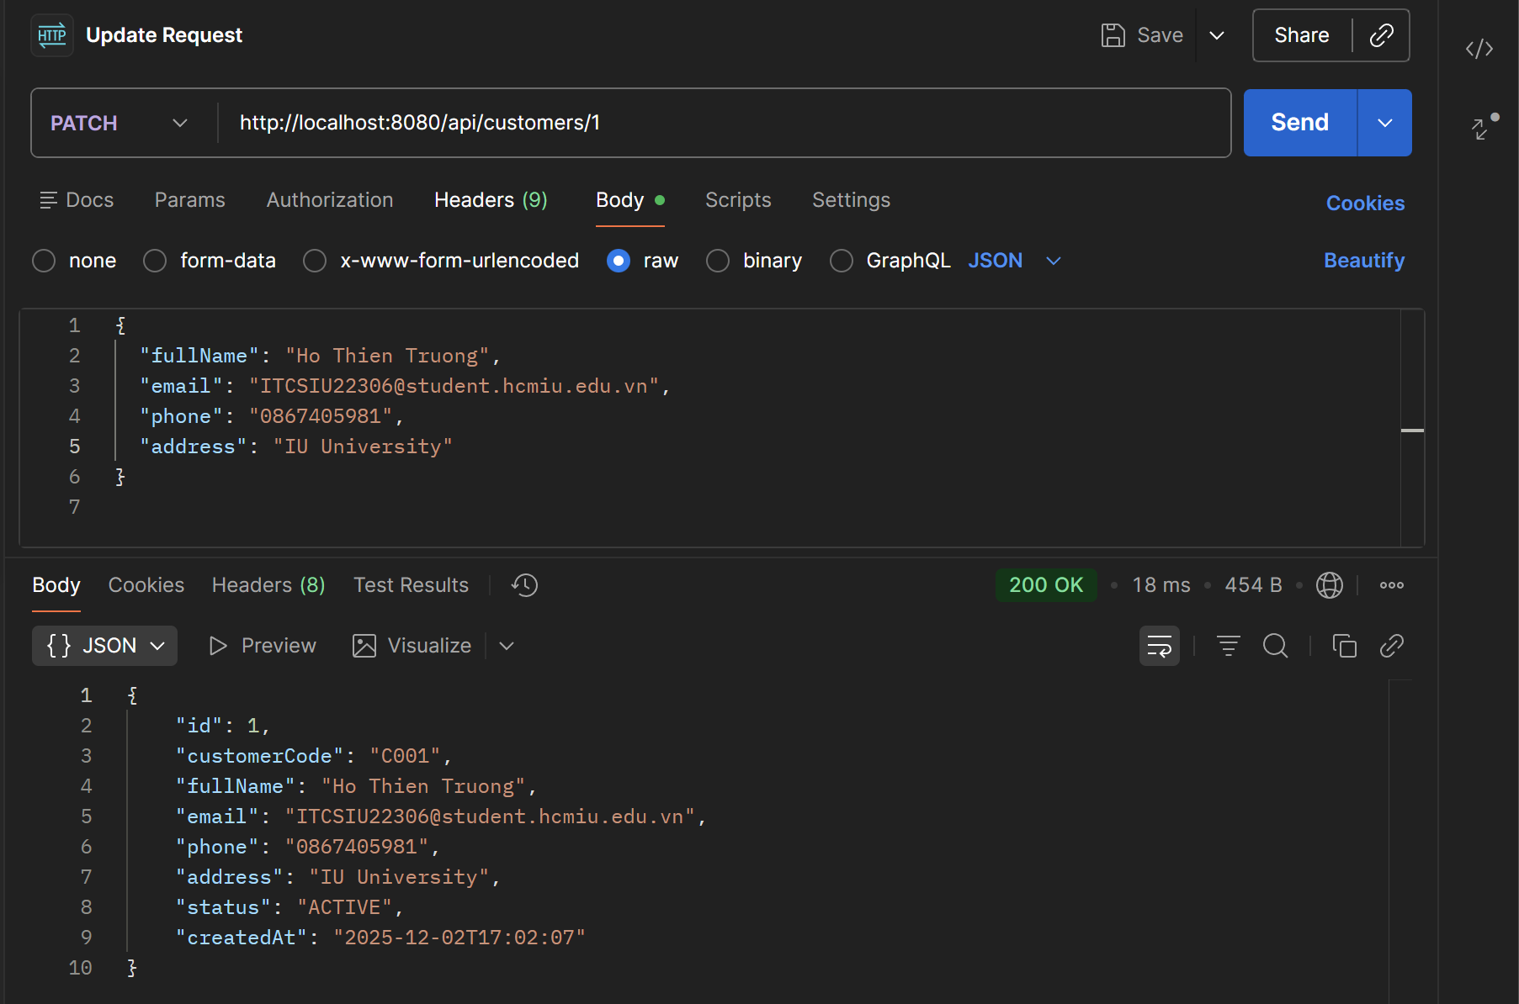
- Workflow: Added partial customer updates via PATCH. Controller accepts CustomerUpdateDTO, service loads the customer, updates only non-null fields, saves, and returns the updated DTO.

CustomerService:
- adds CustomerResponseDTO partialUpdateCustomer(Long id, CustomerUpdateDTO updateDTO); to the service contract.

CustomerServiceImpl:
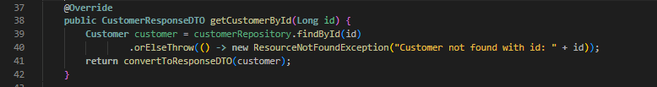
- implements partial update: fetches customer or throws ResourceNotFoundException, sets only non-null fields from CustomerUpdateDTO (fullName/email/phone/address), saves, maps to response DTO.

CustomerRestController:
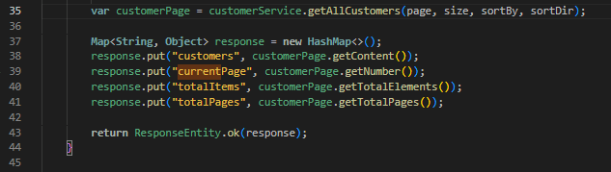
- @PatchMapping("/{id}") endpoint that delegates to the service and returns the updated customer.

CustomerUpdateDTO:
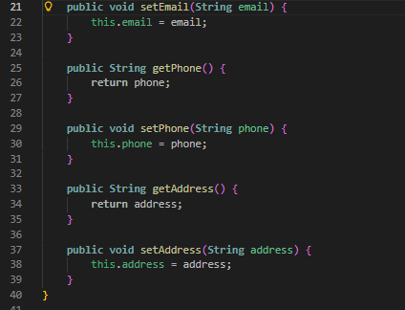
- optional fields (fullName, email, phone, address) for partial updates.
Task 7.3: Test PATCH vs PUT (2 points)
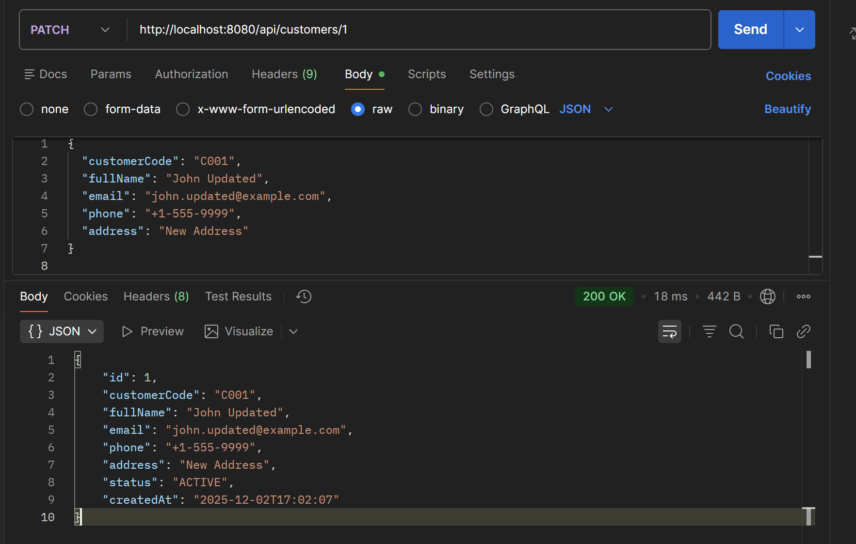
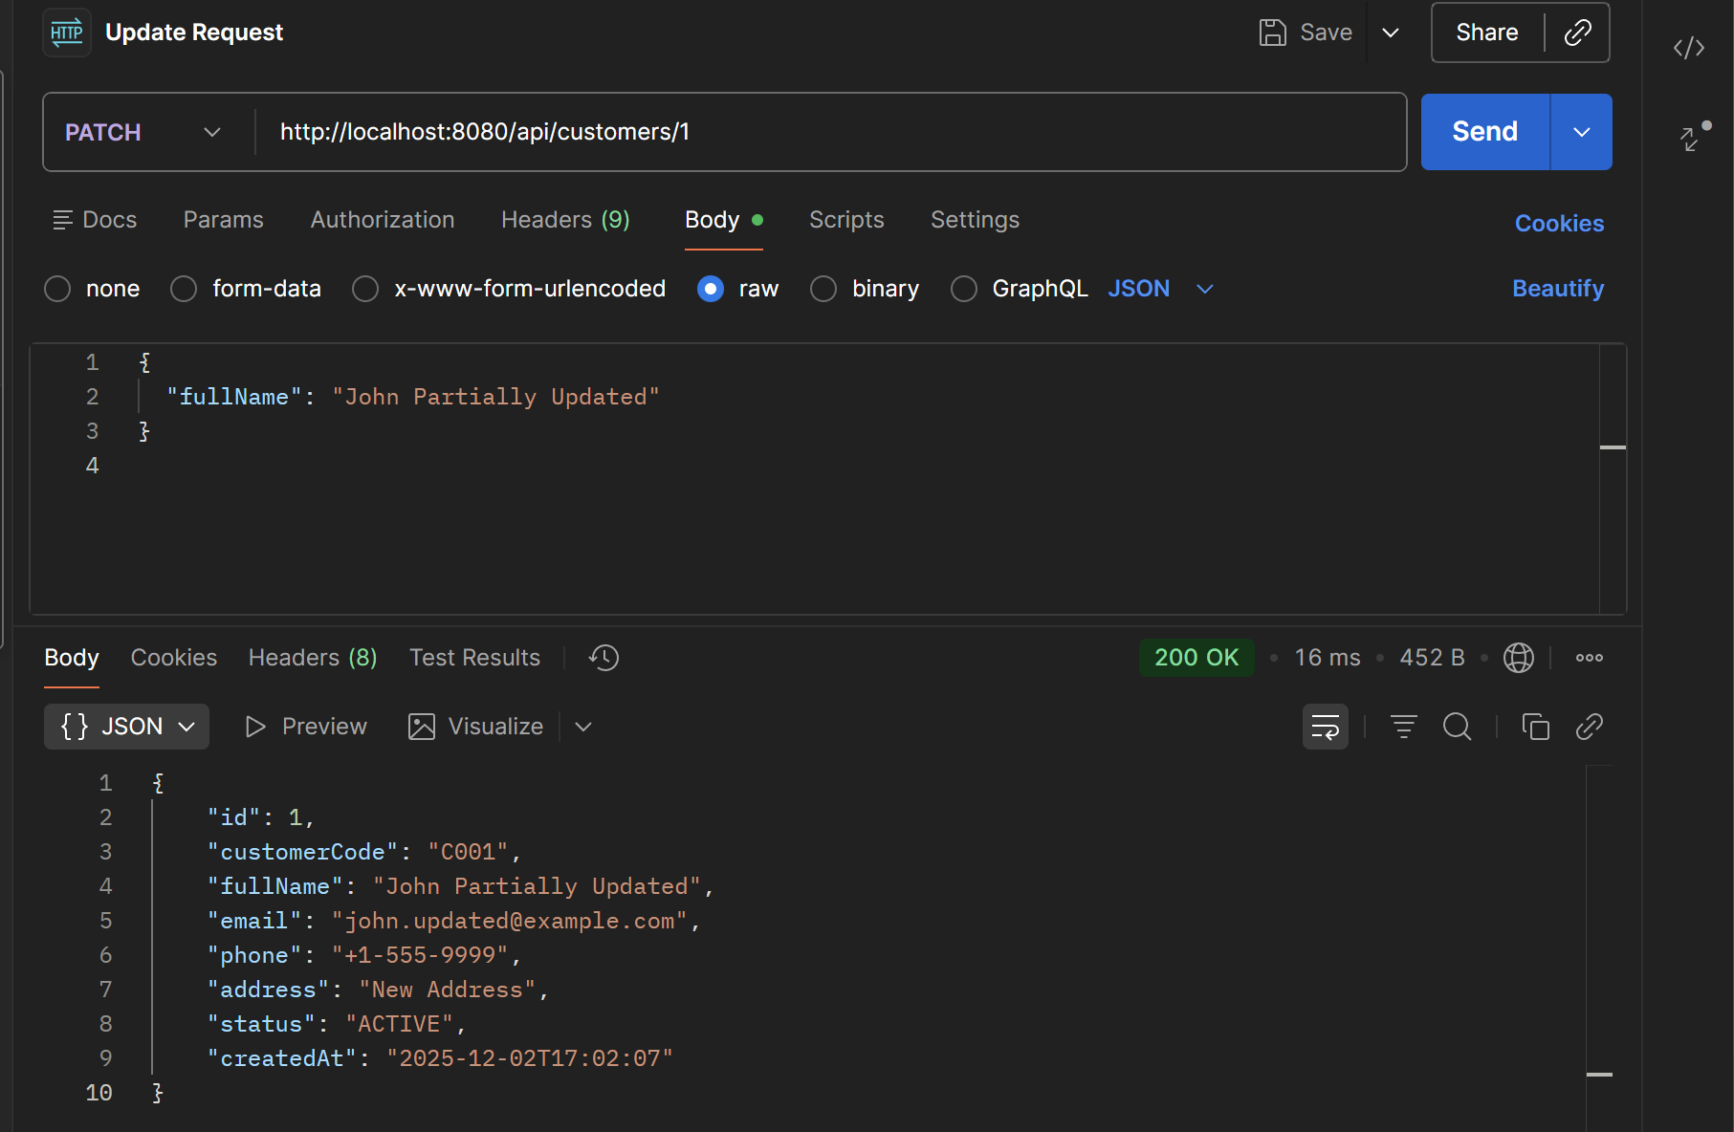
EXERCISE 8: API DOCUMENTATION (8 points)
Task 8.1: Create Postman Collection (4 points)
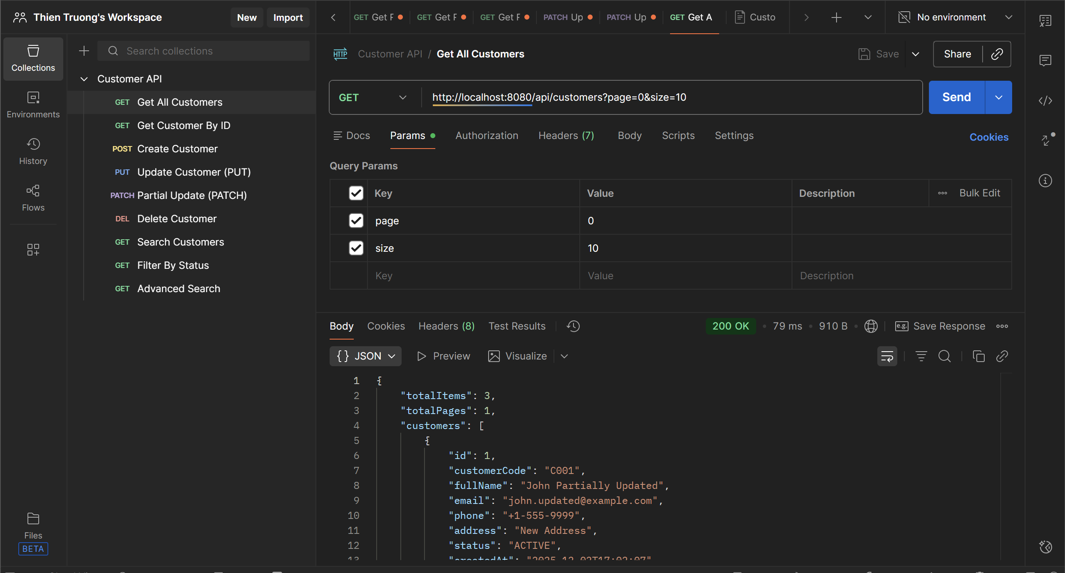

Task 8.2: Document API Responses (2 points)
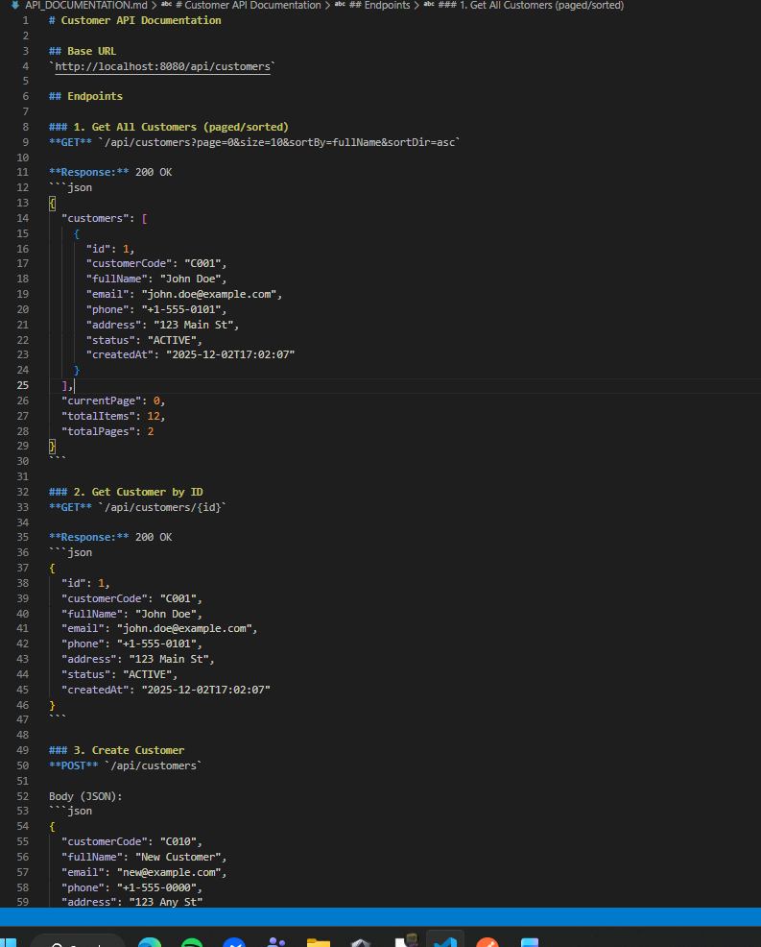

Task 8.3: Add Examples for Each Status Code (2 points)
- covering 200, 201, 400 (validation), 404, 409 (duplicate), and 500 responses with sample payloads for each.
