

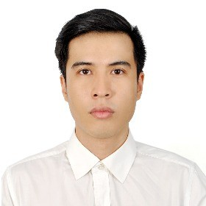






NGUYỄN SUM
CUSTOMER SERVICE

INFORMATION
Male 16/01/1990
0339114135
sumnguyen619@gmail.com
61 Truong son street, p17 , district 10 , HCM city

EDUCATION

2005-200
CAREER GOALS
- Applying Customer Service, can bring a lot of benefits to customers as well as value for sustainable development for company. From here, I want to help the Company have many close customers & expand the ability to customers relationship skill.
8

Tri An High School
Student Student

2015 Saigon Tourist Hospitality College
Business management Student

SKILLS
Office information
2022-2025

Hoa Sen University
Business management student

Communication skill

WORKING EXPERIENCE

CERTIFICATES
- western culinary certification from Saigon Tourist Hospitality College.

HOBBIES
- History and culture
- Traveling
- Reading books, listening to music
2017-2019

2019-2021

2022-2024

Intercontinental Saigon Hotel
Position: Cook
.

Royal Caribbean Ship
Position: Cook
.

Boxing Saigon Company
Position: Sale and Cs
.

REFERENCES
Vuong Cong Khanh Boxing Saigon Company
Phone number: 0903696295

FURTHER INFORMATION
I like communication, and i can keep clam with any negative situation that come to customer.
I also always keep good emotion during all day working.

