1.

COLUMN member_name FORMAT a10

COLUMN member_unique_name FORMAT a10

COLUMN member_caption_name FORMAT a10

COLUMN member_description_name FORMAT a10

COLUMN level_name FORMAT a10

COLUMN parent_level_name FORMAT a10

COLUMN parent_unique_name FORMAT a10

COLUMN city FORMAT a10

COLUMN country FORMAT a10

SELECT * FROM Order_Product_av HIERARCHIES (Address_hier)

ORDER BY Address_hier.hier_order;

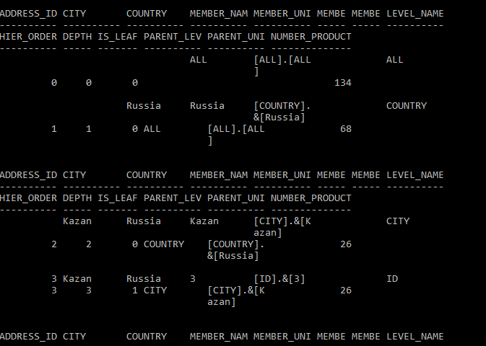

Only report some columns:

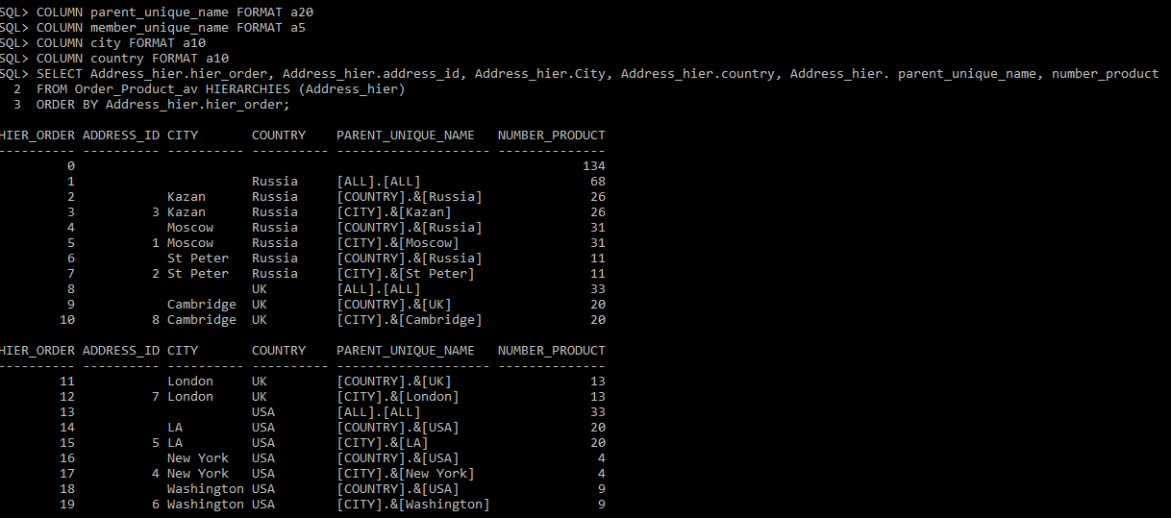

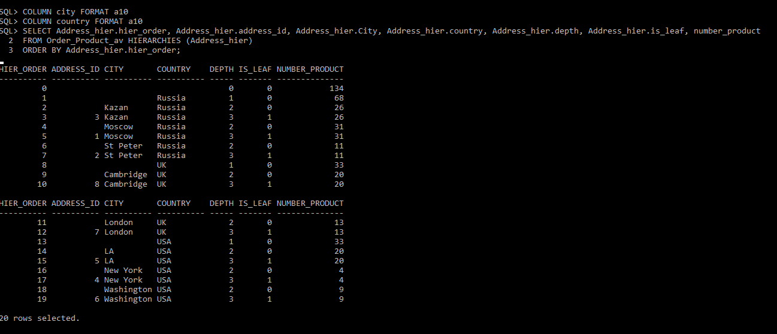

2.

SET PAGESIZE 0 -- no column headings

BREAK ON Country SKIP 1 -- insert blank lines each time the value changes in the column

COLUMN Country FORMAT a15

COLUMN Product_name FORMAT a10

SELECT CASE

WHEN Country is null THEN 'AVG of all:'

When Country = 'Russia' and Product_name is null THEN '=====Russia:'

When Country = 'USA' and Product_name is null THEN '=====USA:'

When Country = 'UK' and Product_name is null THEN '=====UK:'

When Country = 'Russia' THEN 'Russia'

When Country = 'USA' THEN 'USA'

WHEN Country = 'UK' THEN 'UK'

END Country

, t.Product_name, CASE

WHEN Country is null THEN Total/3

ELSE Total

END

FROM

(SELECT a.Country, p.Product_name, SUM (p.Product_Price*op.Number_Product) Total, grouping_id (a.Country, p.Product_name) Grouping_id

FROM Products p

INNER JOIN Order_Product op ON op.Product_id = p.Product_id

INNER JOIN Orders o ON op.Order_id = o.Order_id

INNER JOIN SalesPersons s ON o.Person_id = s.Person_id

INNER JOIN Address_Store a ON a.Address_id = s.Address_id

GROUP BY ROLLUP (a.Country, p.Product_name)) t

ORDER BY t.Grouping_id desc, t.Country desc, t.Total desc;

