Bai 1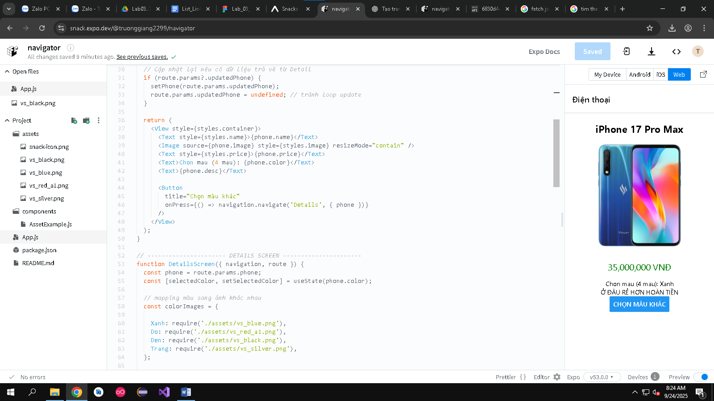

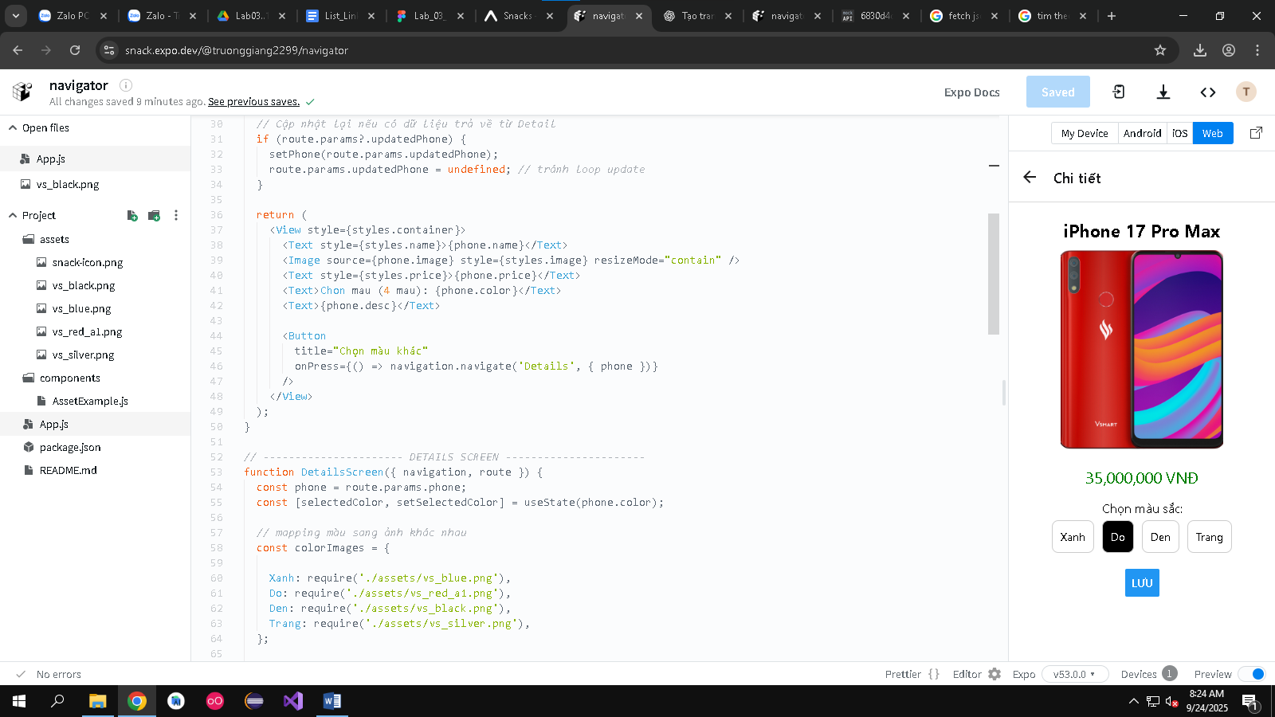

Bai 2

 const [data, setData] = useState([]);

  useEffect(() => {

    fetch('https://6830d4dc6205ab0d6c3a907d.mockapi.io/api/product')

      .then((res) => res.json())

      .then((json) => setData(json))

      .catch((err) => console.log(err));

  }, []);

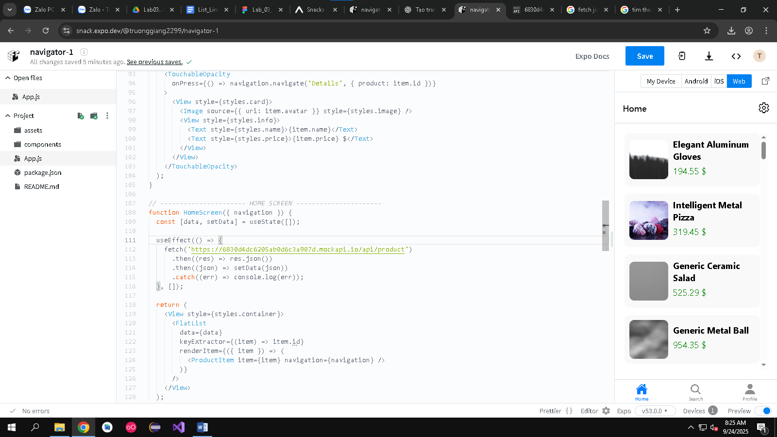

Bai 3

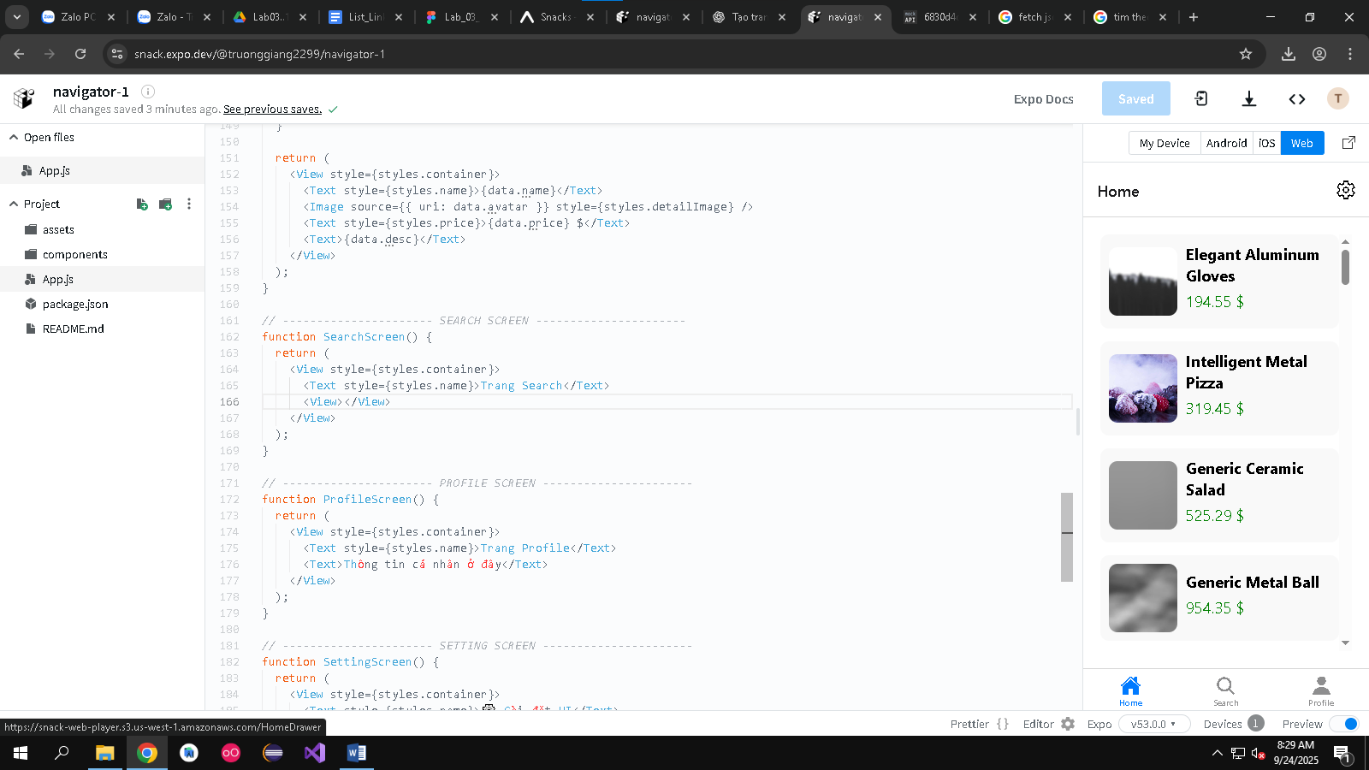

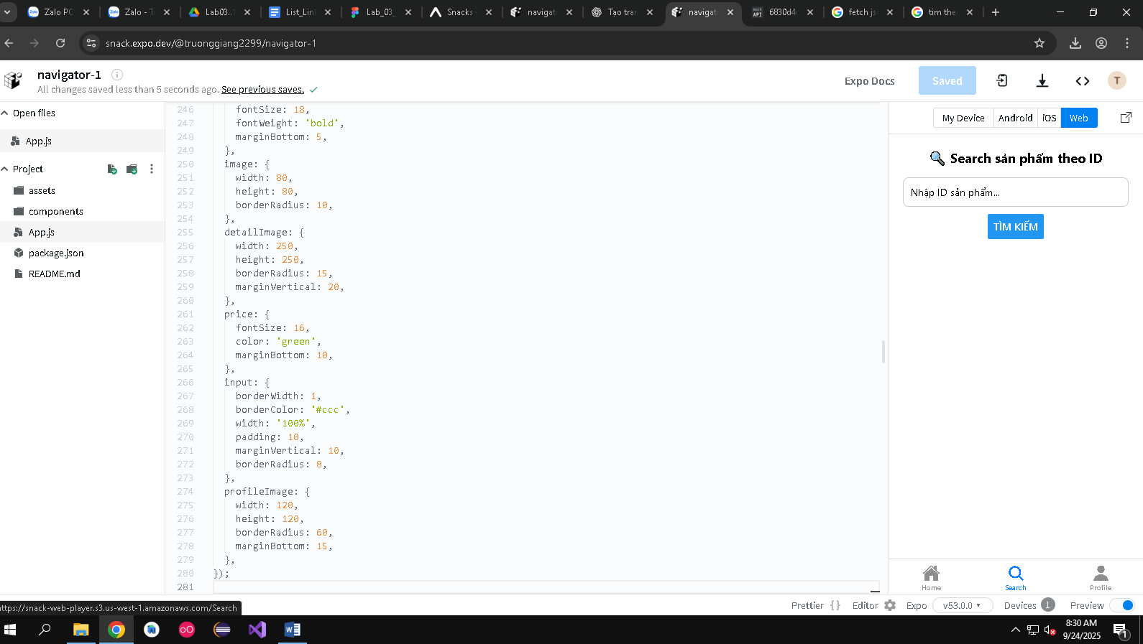

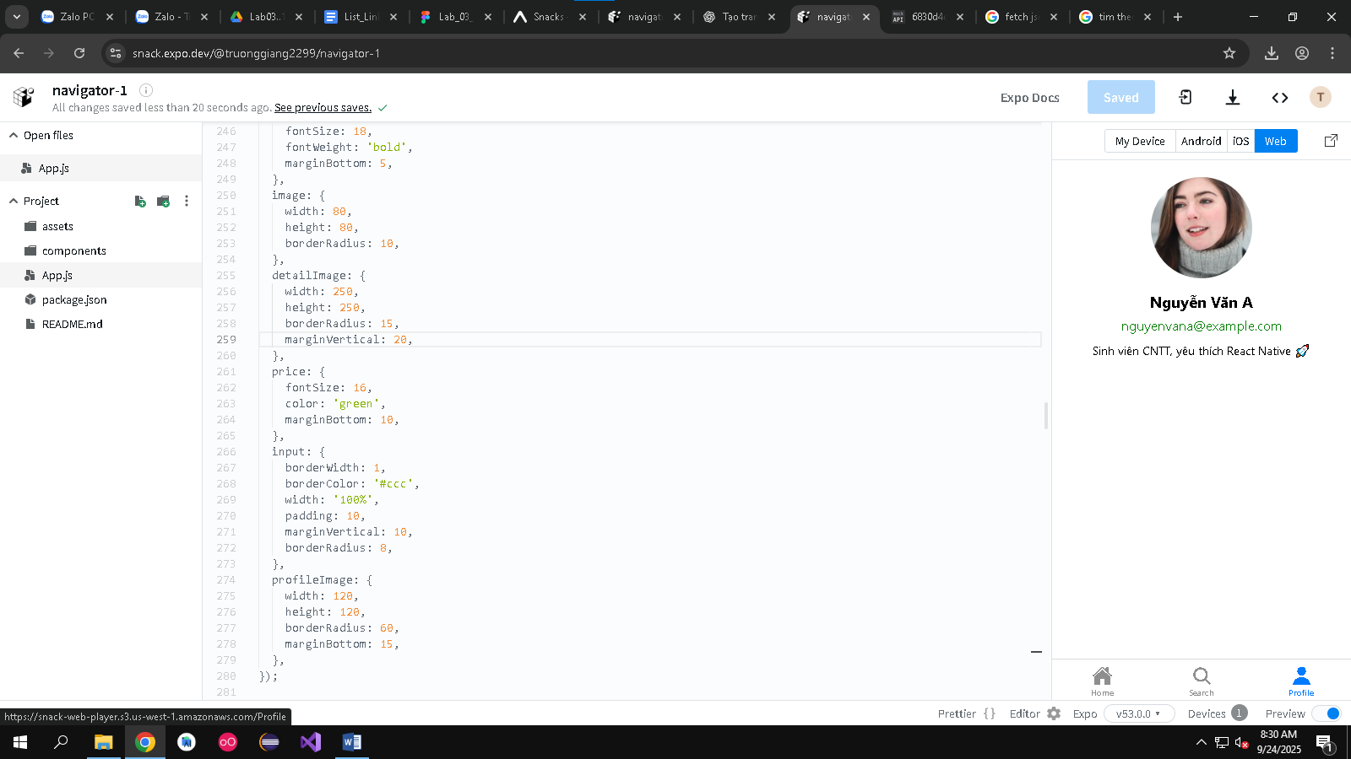

Bai 4

 const { product } = route.params;   *// id sản phẩm*

  const [data, setData] = useState(null);

  useEffect(() => {

    fetch(`https://6830d4dc6205ab0d6c3a907d.mockapi.io/api/product/${product}`)

      .then((res) => res.json())

      .then((json) => setData(json))

      .catch((err) => console.log(err));

  }, [product]);

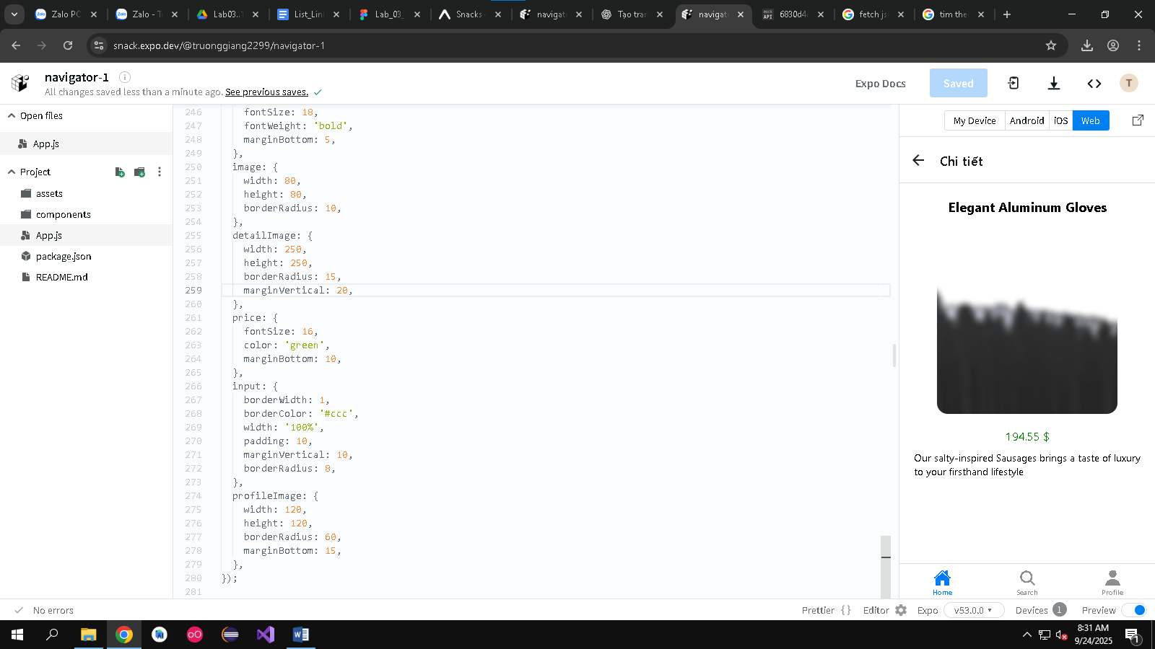

Bai 5:  
