- The personal human microbiome.
  - Do samples differ in composition by subject-id (i.e., across individual)?

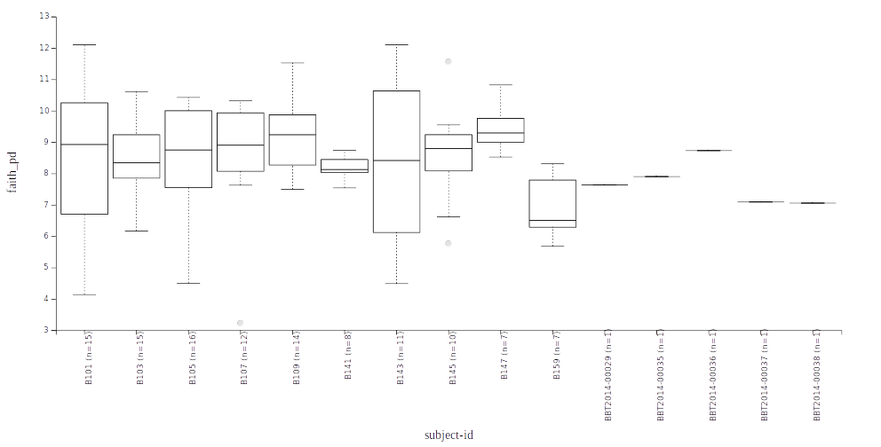
file:///tmp/qiime2/truongphi/data/0074479d-43a9-4b4b-a930-dc24360ef0b5/data/index.html

  - Do samples differ in richness by subject-id?
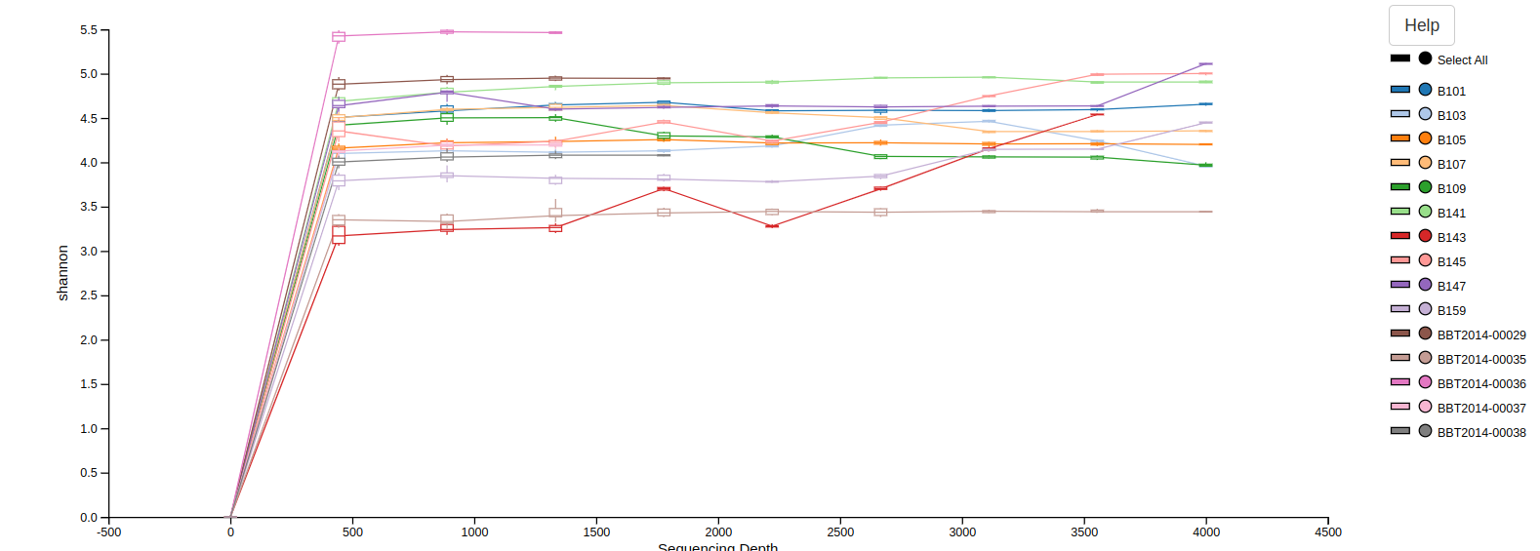
file:///tmp/qiime2/truongphi/data/76b31a3b-d858-4e6d-b3dc-11e0a083cfbe/data/index.html
  - Do samples differ in evenness by subject-id?
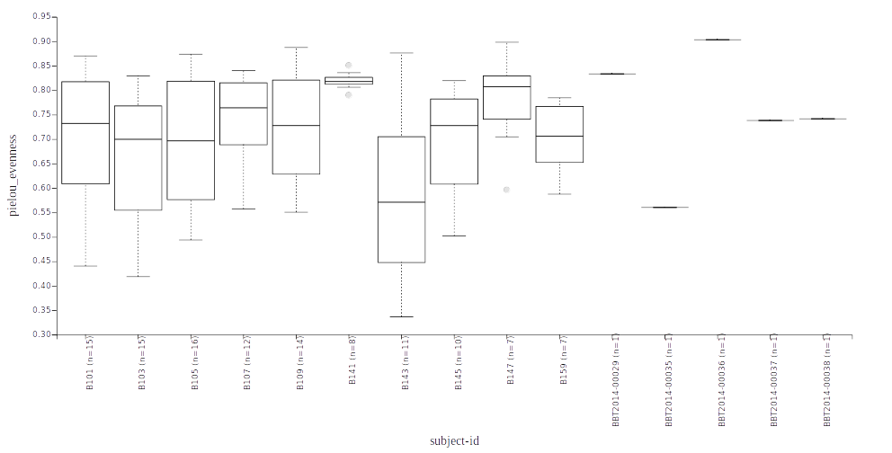
file:///tmp/qiime2/truongphi/data/523a34cf-a045-4e96-b49e-cc45fa224224/data/index.html
  - Do richness, evenness, composition, and UniFrac distance change in individuals between baseline and the end of the study? Does this differ between individuals receiving FMT and control subjects? (Hint: try the paired difference/distance methods described in the q2-longitudinal tutorial.)
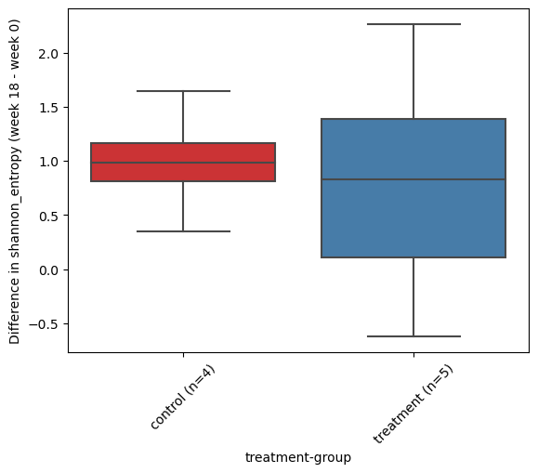
file:///tmp/qiime2/truongphi/data/329839dc-ed78-47e6-a231-c3e1fe837c0a/data/index.html

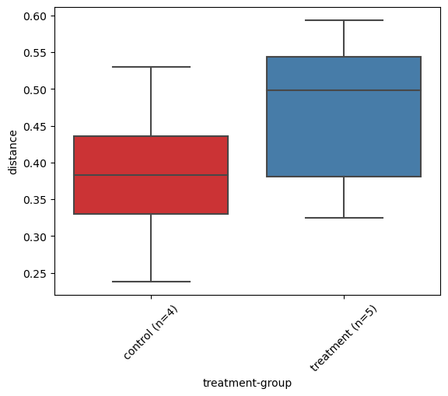
file:///tmp/qiime2/truongphi/data/3263d530-0f44-4cac-a70e-3360bd5d1df2/data/index.html
  - Do richness, evenness, composition, and UniFrac distance change over time and in relation to FMT treatment and other subject metadata? Are these metrics more variable over time in treatment or control groups? (Hint: these questions concern longitudinal measurements.)
- Microbiota engraftment.
  - At approximately what week in the study do microbiome samples in individuals who receive treatment appear most similar to FMT donors in terms of unweighted UniFrac distances? (Hint: Try plotting the data with qiime emperor plot. Pay close attention to the color tab and visibility menu.)
  - At approximately what week in the study do microbiome samples in individuals who receive treatment appear most similar to FMT donors in terms of Bray-Curtis distances?
  - Is this pattern stronger based on unweighted UniFrac or Bray-Curtis distance? Based on how you know about these metrics, what does this suggest to you about what is changing in the microbiome with fecal microbiota transplant? Use the Jaccard and weighted UniFrac distance Emperor plots to help you refine this idea.
- Experimental design: Comparing stool and swab sample collection methods.
  - What feature(s) differ most in abundance between the stool and swab samples? What taxonomy is associated with those feature ids based on their best BLAST hits, and based on the results of Naive Bayes feature classification with the QIIME 2 q2-feature-classifier plugin?
  - Is the microbial composition of stool and swab samples significantly different based on either unweighted UniFrac or Bray-Curtis distances between samples (yes, no, or not possible to say with the current information)?
  - Do the donated fecal material samples appear more similar in composition to the stool or swab samples?
  - Does community richness differ between stool samples and swab samples? Does community evenness differ between stool samples and swab samples?
- How many samples were sequenced in each sequencing run? Do you observe any systematic differences in the samples across sequencing runs?

