# Architecture Software

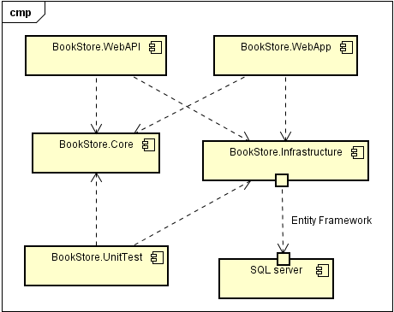

## 1. BookStore.Core

Define two entities which are **Book** and **Author**. We can use this project for domain entities and interfaces for database operations

## 2.BookStore.Infrastructure

In this project we must define

* Database configuration: We can refer our connectionstring for database connection and other database configuration.
* Database operations: Repositories – we’re defining here database operations of Inforations/Entities/Objects we’re dealing with in Core Project. For each entity we can separate class file as a repository or we can include all operations in a single repository class.
* Libraries: What libraries we’re going to use perform database operations. Such as **Entity Framework** library or **Drapper** (Micro ORM) or any other technology

## BookStore.WebAPI – Web Service

By instantiating and referencing our previous infrastructure project in this project, and with some configurations we can publish all the operations which are included in infrastructure project as web services. Here we are publishing those as HTTP methods. We identify those HTTP methods as APIController methods.

Server Side – BookStore.Core and BookStore.Infrastructure.

Bridge – BookStore.WebAPI

Client Side – BookStore.WebApp

## BookStore.WebApp

As mentioned above, in this project we are creating front end client applications as a web application. Here I use ASP.NET MVC 5 and Bootstrap for our task.

# User Interface