* Objective
* Introduction & Background
  + What is PBX?
  + What is IP-PBX?
  + Why need IP-PBX?
  + What is SIP?
  + What is RTP/RTCP?
  + How IP-PBX, SIP, RTP/RTCP are connected?
  + Advantages of VoIP
  + What is roll of Raspberry PI in this project?
* Obstacles
  + Learning curve Asterisk
  + Too much Third Party Software
  + Eduroam not accessible by Raspberry Pi
* Method
  + Experiments (within eduroam - wireless network)
    - Users communicating within a Lab
    - Users communicating within a same floor
    - Users communicating within a same building
    - Users communicating within different buildings
  + Analytic metrics
    - Packet send/receive – Loss metric
    - Network delay
      * Jitter - sip show channelstats
* Expectation at final submission
* Conclusion
* Future direction

Intro/Background

* Private Branch Exchange (PBX) is a technology which allows telephones to call each other, forwarding audio and controlling call behavior. While other technologies can provide similar services, PBX technology is designed for calls within a private institution.
* With the advent of the internet, Voice over IP (VoIP) was created, allowing for telephone services to be provided over IP networks instead of standard telephone networks. Today, IP networks are so cheap and widespread that it is more cost efficient to use them for telephony than standard phone networks.
* IP-PBX was made to act as a PBX for VoIP services, as a traditional PBX does not interact with IP networks.
* IP-PBX is vital for IP telephony services, as without it, no two VoIP callers can connect to each other. IP-PBX can handle SIP messaging to manage call setup and RTP packages to relay audio data between callers and callees.
* The natural characteristics of IoT scenarios and the reason IP-based PBX paradigm is suitable for IoT.
* communication within a limited area, while still maintaining access to the entities outside.
* The protocols involve PBX communication.
* SIP,
* RTP/RTCP
* SIP
* Provides the fundamentals of the PBX communication
* Standard SIP
* 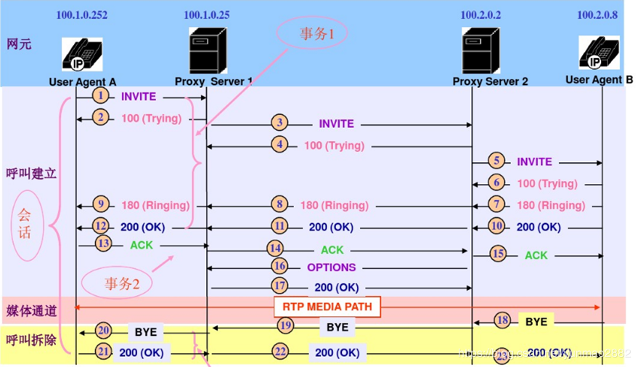
* In IP-based PBX implemented in the local network, the two proxy servers may merge into one.
* SIP components:
  + Model: session or pager
  + Format: request/status line, header, body
* From the SIP perspective, point out the core factors for a multimedia session: id, authentication, proxy, distance/hop count
* RTP/RTCP
  + RTP carries the media streams, while RTCP is used to monitor transmission statistics and quality of service
  + RTP: sensitive to packet delays and less sensitive to packet loss
  + Elements for RTP: sequence number, timestamp, source identifier, contributor identifier for multiple source
  + RTCP allows the recipients so that they can send feedback to the source or sources.
* IP-PBX and SIP and RTP/RTCP
  + SIP and RTP/RTCP act as the backbone of IP-PBX.
  + SIP allows for calls to be started, connecting different callers together and allowing for complex behaviors such as putting callers on hold.
  + RTP/RTCP allows for an effective means of forwarding audio data between callers and the control of this forwarding.
* Raspberry Pi
  + A weak single board computer, very popular, efficient with energy usage, and cheap.
  + Relatively weak computer, has 4 processors and 4 GB memory, but powerful enough to act as an IP PBX and connect a large number of callers.
  + Effective purchase to act as an IP PBX for a small business starting with or switching to VoIP as main means of telephony.