Here’s the solution for **Week 2’s Task:**

import java.util.ArrayList;

import java.util.Scanner;

public class TodoListApp {

private ArrayList<String> todoList = new ArrayList<>();

public void displayList() {

if (todoList.isEmpty()) {

System.out.println("Your to-do list is empty.");

} else {

System.out.println("To-Do List:");

for (int i = 0; i < todoList.size(); i++) {

System.out.println((i + 1) + ". " + todoList.get(i));

}

}

}

public void addTask(String task) {

todoList.add(task);

System.out.println("Task added: " + task);

}

public void removeTask(int taskIndex) {

if (taskIndex >= 0 && taskIndex < todoList.size()) {

String removedTask = todoList.remove(taskIndex);

System.out.println("Task removed: " + removedTask);

} else {

System.out.println("Invalid task index. Task not removed.");

}

}

public static void main(String[] args) {

TodoListApp todoApp = new TodoListApp();

Scanner scanner = new Scanner(System.in);

int choice;

do {

System.out.println("\nMenu:");

System.out.println("1. Display To-Do List");

System.out.println("2. Add Task");

System.out.println("3. Remove Task");

System.out.println("4. Quit");

System.out.print("Enter your choice: ");

choice = scanner.nextInt();

scanner.nextLine(); // Consume the newline character

switch (choice) {

case 1:

todoApp.displayList();

break;

case 2:

System.out.print("Enter the task to add: ");

String taskToAdd = scanner.nextLine();

todoApp.addTask(taskToAdd);

break;

case 3:

System.out.print("Enter the index of the task to remove: ");

int taskIndexToRemove = scanner.nextInt();

scanner.nextLine(); // Consume the newline character

todoApp.removeTask(taskIndexToRemove - 1); // Adjust for 0-based index

break;

case 4:

System.out.println("Goodbye!");

break;

default:

System.out.println("Invalid choice. Please try again.");

}

} while (choice != 4);

scanner.close();

}

}

**Output:**

1. 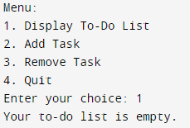
2. 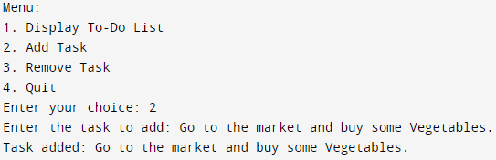
3. 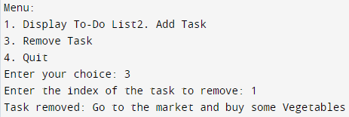
4. 