Software Requirement Specification

For

Database Version Tracking

Version 1.0

Created by: Trupti Bhandari

Organization: SE2 India

Date: 26/08/2020

Introduction

Executive Summary:
Problem Statement:

  - To manage the Database change request and to track each query, which is executed by a user during the release for enhancements / defects.

  - To manage the detail of intake/defect/enhancement and to track database changes and to maintain the information, which can be helpful in future

Solution:

- First whenever there is request for database change, the request is created by using request page.
- Then the approver gets the email regarding DB change request and status of request is pending and stored in csv file.
- Using an approver page approver can approve or reject or ignore request.
- If the request gets approved or rejected by approver the user gets the appropriate message.
- The approved requests are stored in .sql file.
- After running the script code all the commands not ran before in .sql file gets executed and log file is generated.

Purpose and Scope:
The purpose of this application is to help the developers to track the executed DB queries during a releases. This version management application will help to rectify the query bugs in initial phase, which will reduce the later risk of bug or failure of continues release. The scope is limited to employees of organization only.

Target Market Overview
This product is intended for developers and whoever can access database at the organization so that they can track the database changes made by different people as database is accessed by more than one person.

Naming Conventions:
SQL - Structured Query Language
CSV - Comma Seperated Values
DB- Database System

Software Overview

Workflow

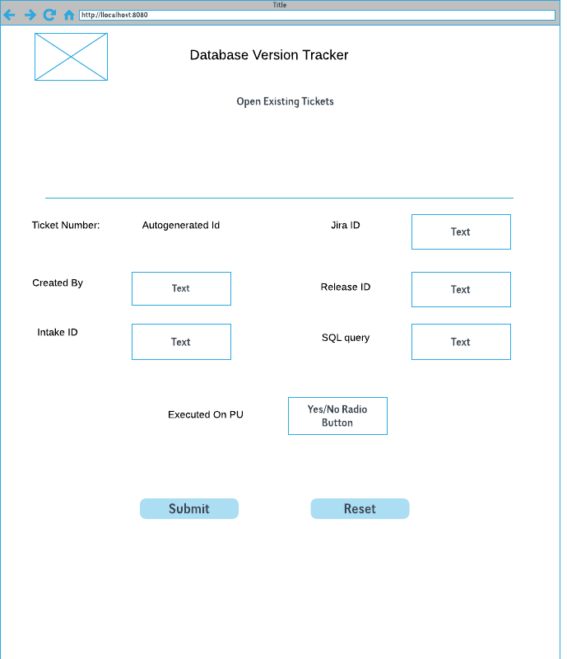
Request Page to create request
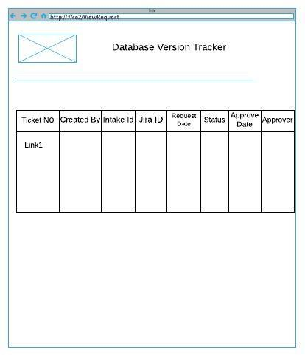

View Page with all the details of ticket.

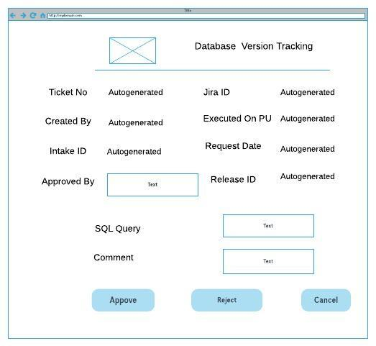
Approver Page to approve /reject request

Design and Implementation Constraints
- The log file generated should not be more than 1 MB otherwise new log file is generated.
- The approve or reject button should only work if the approvers’ mail id is verified.
- Ticket Number should be auto-generated.
- If the query in .sql file is already executed it should be skipped.

Technical Requirements

Hardware Interfaces
Supported Operating Systems: Windows, Linux
RAM: 4 GB
Processor: core i3 +

Software Interfaces
Frontend Requirement: Angular JS 1.5
Backend Requirement: Spring Boot, Java 8
Database: Oracle SQL Server 12C
Server: Apache Tomcat 8+

Communications Interface:
Protocol Used: HTTP protocol
Google chrome extension: Postman

Functional Requirements

- Request Page: The user should be able to create a request ticket with following attributes:

- Ticket Number Text input
- Created By Text input
- Intake ID Text input
- Jira ID Text input
- Sql Query Text input
- Release ID Text input
- Executed on PU? Radio Button(Yes/No)

- View Page: The user should be able to view the existing tickets with following attributes:

- Clickable links to view the ticket using ticket No. (Hyperlink to other page)
- Intake ID Auto generated
- Jira ID Auto generated
- Sql Query Auto generated
- Release ID Auto generated
- Created By Auto generated
- Status (Pending/Approved/Rejected) Auto generated

3. Approval Page:

The approver who is authenticated only should be able to approve or reject the request with following features:

- Approved By Auto generated
- Jira ID Auto generated
- Sql Query Auto generated
- Release ID Auto generated
- Executed on PU? Radio Button disabled
- Intake Id Auto generated
- Comment (if necessary) Text input

If the approver approves the request it should be stored inside .sql file and status to be updated as ‘Approved’ in .csv file.

If the approver rejects the request it’s status only should be updated as ‘Rejected’ in .csv file.

4. E-Mail System:

After the user submits the request approver should get the message via email and a link to approve or reject request.

5. Script:

The entries in .sql file should be executed and stored in database table with following attributes:

- Ticket number
- Intake Id,
- Created By
- Approved by, system time

Other Nonfunctional Requirements

Performance Requirements:
- While executing the script to execute the SQL queries from .SQL file only those queries not executed are ran. Others are to be skipped for better performance.
- REST API calls are getting executed within seconds.

Safety Requirements:
- The approval or rejection of a request is valid only when the approver mail id is verified.

